DD-390 Conveyor Belt Metal
Foreign Object Detector
OPERATION MANUAL
Conveyor-type Metal Detector · Operation Manual

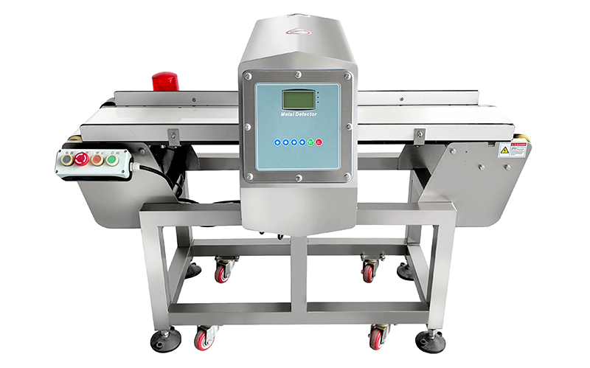

──────────────────────────────────
Document Version: V4.0 — June 2026
Applicable Models: DD-390 Series Conveyor Metal Detectors
Manufacturer: SameGram Equipment Co., Ltd.
IMPORTANT: READ THIS MANUAL CAREFULLY BEFORE OPERATING THE EQUIPMENT

1. Introduction

1.1 About This Manual
This manual provides a comprehensive guide to the installation, operation, and maintenance of the DD-390 Series Conveyor Belt Metal Foreign Object Detector. It is intended for operators, setup managers, and maintenance personnel responsible for the day-to-day use of this equipment.
Please read this manual thoroughly before using the DD-390. Keep this manual together with the product for future reference. Should you have any questions not addressed in this document, please contact SameGram Technical Support (see Chapter 25).

1.2 Product Overview
The DD-390 Series is a high-performance, dual-frequency conveyor-type metal detector engineered for inspecting food, pharmaceutical, chemical, and other industrial products for metallic contamination. Featuring an imported German control unit and advanced digital signal processing technology, the DD-390 delivers reliable detection of ferrous (Fe), non-ferrous (Non-Fe), and stainless steel (SUS) contaminants with exceptional accuracy and stability.

1.3 Key Features
• Dual-frequency / multi-frequency detection: Manufacturable at multiple frequencies based on product characteristics, with product detection data storage for multiple products — broad application range.
• The core uses leading digital technology and an original imported chip, with the detection coil molded in one piece using a potting process — high detection accuracy, stable performance, strong resistance to external interference, and a service life over 10 years.
• Intelligent recognition: self-learning and memory functions automatically recognize and memorize product characteristics; operating speed 1–100 m/min (speed adjustment required), effectively eliminating interference from high-oil, high-salt, high-temperature, high-speed, and high-moisture "product effects".
• Dialog-style LCD display with a simple keypad interface and multi-language support (Chinese, English, Spanish, French, German, Italian, and more); inspects multiple products with different signal characteristics, with a single setup delivering extremely high accuracy — no re-adjustment required.
• Unique XR™ (IXR) intelligent tracking function for effectively detecting stainless steel contaminants in moist products.
• Storage for 200+ product detection parameters for rapid product changeover, plus 1500-event log recording for full HACCP traceability.
• Modular components for easier cleaning, replacement, and maintenance.
• Various reject devices available on request (air blowing, push rod, flip plate, etc.), with lightweight, large-package, and heavy-duty body designs.
• All stainless steel (SUS304) construction with excellent dustproof and waterproof performance.

1.4 Important Notes on Detection Capability
Warning | The metal detector cannot guarantee detection of all metals under all conditions. Detection capability depends on the type of inspected product (size, shape, conductivity, moisture content, temperature), the type of metal contaminant (material, shape, orientation, size), and the installation environment. The actual metal detection capability is based on the specifications issued before equipment delivery or the values confirmed at the time of delivery and installation.

2. Safety Instructions

2.1 General Safety Guidelines
Warning | Failure to follow these safety instructions may result in personal injury, equipment damage, or product contamination. All personnel must read and understand this section before operating or servicing the equipment.

• Only trained and authorized personnel may operate, set up, or maintain this equipment.
• Do not wear metal items (rings, watches, bracelets, belt buckles) during operation, as they disturb the magnetic field and may cause false detections or mask real contaminants.
• Keep the area around the detection head clear of moving metal objects, including tools, trolleys, and cleaning equipment.
• This is a precision instrument and must not be handled roughly; rough handling will affect equipment integrity, causing faults or reduced detection accuracy.

2.2 Electrical Safety
Warning | The power supply must be a dedicated circuit, isolated from noise-generating equipment such as large motors and packaging machines. Connect to a socket close to the power source.

Warning | To avoid danger, install a circuit breaker between the main power supply and this equipment. If used in a humid environment, a residual current device (leakage circuit breaker) must be installed.

• Ensure AC mains supply fluctuation does not exceed ±10% of rated voltage.
• Verify that the supply voltage matches the rating label on the equipment before connecting.
• The equipment power consumption is low; a 220 V lighting circuit is recommended rather than a 380 V machinery power circuit. Do not connect to loads that may cause voltage interruption or drop.
• Do not use an AC supply fed by large motor VFDs, as they cause interference and unnecessary false alarms.
• Never use a megohmmeter (high-resistance meter) to check wiring.

2.3 Operational Safety
• Proper grounding must be implemented on all metal detection systems to ensure safety and performance.
• Ensure the mains power is disconnected before wiring or maintenance.
• Ground all enclosures and conduits; provide a grounding joint between all metal conduits.
• Connect shielded wires only where indicated.
• Check that all electrical connections are secure.
• All conduits must enter through the bottom of the enclosure, never through the top or sides.

2.4 Cleaning Safety
Warning | ALWAYS unplug the power cord before cleaning the equipment. Failure to do so may result in electric shock, equipment damage, or unintended conveyor startup.

• Use soft plastic brushes or soft cloths. Never use metal brushes or other hard tools.
• Use neutral detergent. Never use organic solvents such as thinner or benzene.

3. Technical Specifications

3.1 General Specifications
Parameter | Specification
Product Model | DD-390 (4012)
Overall Machine Dimensions | 1350 (L) × 802 (W) × 950 (H) mm (customizable)
Effective Detection Channel | 400 (W) × 120 (H) mm
Conveyor Belt Width | 350 mm
Conveyor Belt Ground Clearance | 700 ± 50 mm (adjustable)
Conveyor Belt | Food-grade PU belt, removable for cleaning and replacement
Detection Sensitivity (empty belt surface) | Fe Φ0.8 mm / Non-Fe Φ1.2 mm / SUS316 Φ1.5 mm
Production Speed | 1–100 m/min (adjustable); fixed speed 25 m/min
Control Panel | Flat keypad-style LCD display
Casing Material | Stainless Steel SUS304, compliant with HACCP / GMP / FDA / CAS
Ingress Protection | IP66 (probe); other parts IP54 (optional)
Storage | 200 product recipes; 1500 event logs
Conveyor Direction | Facing the display, from left to right
Power Supply | AC 220 V ±10%, single phase, grounded; 47–65 Hz; 100 W (max)
Ambient Temperature | -10 °C to 40 °C; product temperature -10 °C to 55 °C
Relative Humidity | 20%–80%, non-condensing
Languages | Chinese, English, Spanish, French, German, Italian, and more
Outputs | 6 relay outputs; relays 250 V AC 2 A (max), 50 V DC 1 A (max)
Output Functions | Reject 1, Reject 2, Fault, Alarm, Warning, QA Light
Certifications | CE (EMC + MD + LVD), RoHS compliant

3.2 Detection Sensitivity Reference
Metal Type | Empty Machine Detection Sensitivity | Notes
Fe (Ferrous) | Φ ≥ 0.8 mm sphere | Reference baseline; easiest metal to detect
Non-Fe (Copper, Brass, Aluminum) | Φ ≥ 1.2 mm sphere | Non-ferrous metals; ~1.5× the Fe detectable diameter
SUS316 (Non-magnetic stainless steel) | Φ ≥ 1.5 mm sphere | Most difficult to detect; ~2× the Fe diameter

Notice | Detection sensitivity is obtained by placing the test card in the middle of the conveyor belt and passing it through the detection channel. Actual detection sensitivity may vary depending on the characteristics of the product being tested or the working environment; the actual detection sensitivity should be taken as the standard.

3.3 Environmental Requirements
Condition | Requirement | Remark
Ambient Temperature | -10 °C to 40 °C | No direct sunlight; no heating appliances nearby; non-frostable
Relative Humidity | 20%–80% | Non-condensing, non-frostable; 80% below 31 °C, decreasing linearly
Max Surface Temperature | 60 °C | —
Vibration | Minimal | Keep away from vibration sources and unstable surfaces
Dust Level | Low | Install in a clean, low-dust environment
Corrosive Agents | None | Free from volatile flammables, corrosive gases, or liquids
Location | Indoor or outdoor | Avoid direct sunlight on the channel; direct sunlight may cause problems

4. Machine Overview

4.1 System Components
The DD-390 conveyor metal detector consists of the following main components:
• Detection head (search head) — contains the transmitter coil and receiver sensors; the detection channel interior is completely sealed.
• Conveyor system — food-grade PU belt, removable for cleaning.
• Control unit — LCD display + 4 operation keys + 3 indicator lights (red, green, yellow).
• Reject device (optional) — air blowing, push rod, or flip plate for automatic rejection of metal-contaminated products.
• Photoelectric sensor (optional) — detects product presence for synchronized inspection and rejection.

4.2 Detection Principle
The metal detector detects metal by measuring two effects: resistive and reactive.
• Resistive effect: Conductive materials and many food products are conductive. Salt combined with moisture produces a resistive effect that must be overcome to detect small metal contaminants.
• Reactive effect: Both ferromagnetic and conductive materials produce a reactive effect. Iron is both conductive and ferromagnetic; the effect of small iron particles is ferromagnetic, contrasting strongly with metals like copper (a good electrical conductor).

4.3 Product Effect
The electromagnetic signal generated by a product passing through the detection field is called the product effect. It varies greatly between products:
• Dry products: Produce very little or zero product effect. Examples: some tablets, biscuits, candy, chocolate, dry powders, oil-based products (e.g., peanut butter), cereals.
• Moist products: Produce a large product effect. Examples: bread, buns, cakes, meat, dairy products.
• Metal-film products: Products packaged in metalized film typically require a lower detection head frequency.
• Product phase angle: The detector measures magnetic field changes from both resistive and reactive components. A "clean" product changes the two components proportionally, allowing the detector to distinguish product characteristics from metal. When metal is present, the ratio of the two components is no longer constant, triggering detection.

5. Installation

5.1 Installation Conditions
Before installing the DD-390, confirm the installation site meets the following conditions:
• Ambient temperature -10 °C to 40 °C, relative humidity 20%–80%, non-condensing, non-frostable.
• Keep away from vibration sources and unstable surfaces.
• Install in a clean, low-dust environment, away from corrosive gases or liquids.
• Avoid direct sunlight on the detection channel.
• No large moving metal objects or strong electromagnetic interference sources nearby.

5.2 Handling Instructions
Warning | The metal detector is a sensitive instrument and must not be handled roughly. Rough handling will affect equipment integrity, causing faults or reduced detection accuracy.

• Use a forklift or hoist to move the equipment smoothly, avoiding severe vibration and impact.
• After the equipment has been transported or moved, the probe should be re-commissioned by a suitably qualified field service representative.

5.3 Installation Precautions
• After positioning the equipment, check the height alignment with upstream and downstream conveyors.
• Adjust the supporting feet so there are no gaps between the feet and the ground, eliminating shaking or wobble.
• After adjustment, tighten all locking nuts securely with a wrench.
• Verify that products transfer smoothly across all conveyor junctions without tipping, jamming, or falling.

5.4 Power Supply and Grounding
• The power plug must be properly grounded to avoid electric shock and ensure stable operation.
• Grounding wire: Use a soft copper wire with a diameter of at least 1.6 mm, or a metal wire of equivalent strength and corrosion resistance.
• Ground impedance must be less than 100 Ω.
• Do not share the ground connection with equipment that generates electrical noise.

6. Electrical Connection

6.1 Power Connection
The DD-390 requires a stable single-phase AC power supply. Follow these guidelines for connection:
• Verify that the supply voltage matches the rating label on the equipment (AC 220 V ±10%, single phase, grounded).
• Use the supplied power cord or an equivalent rated cable.
• Ensure the power outlet is properly grounded with impedance < 100 Ω.
• A dedicated circuit breaker, rated per the equipment label, must be installed in the supply line.

6.2 I/O Interface Connections
The DD-390 provides 6 configurable relay output interfaces for integration with external devices:
Interface | Type | Function
Reject 1 Output | Relay (dry contact) | Controls the primary reject mechanism (pneumatic pusher, air blast, flap gate)
Reject 2 Output | Relay (dry contact) | Controls a secondary reject or diverter mechanism
Fault Output | Relay (dry contact) | Equipment fault status signal output
Alarm Output | Relay (dry contact) | Drives external alarm indicators (stack light, buzzer)
Warning Output | Relay (dry contact) | Warning status signal output
QA Light Output | Relay (dry contact) | Quality assurance indicator light control

Notice | Relay contact ratings: 250 V AC 2 A (max), 50 V DC 1 A (max). Do not exceed these ratings when connecting external loads.

6.3 Grounding Requirements
Warning | Proper grounding is essential for both operator safety and detection performance. Inadequate grounding may result in erratic operation, false alarms, or reduced detection sensitivity.

• Use a dedicated ground rod if the building ground is unreliable.
• Ground wire cross-section: minimum 1.6 mm diameter copper or equivalent conductor.
• Do not connect the ground to structural steel that may not provide a reliable earth path.
• Periodically verify ground resistance to ensure it remains below 100 Ω.

7. Control Panel & Interface

7.1 Control Panel Overview
The main components of the DD-390 control panel are:
• Display screen (LCD).
• Three indicator lights (red, green, and yellow).
• Green Confirm key.
• Red Return/Exit key.
• Four white triangular navigation keys (up, down, left, right).

7.2 Indicator Lights
The indicator lights give a quick overview of the detector's functional status:
Light | Status | Meaning
Red | Flashes once | Indicates excessive product effect
Red | Steady on | Indicates equipment fault
Green | On | Indicates a product is present in the search head
Yellow | On | Indicates a contaminant has been detected in the product

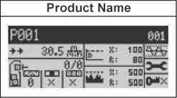
Figure 7-0: Indicator Lights and Control Panel

7.3 Key Functions
Key | Function
Confirm key (green) | Press to select or start one of the detector's functions
Return/Exit key (red) | Press to stop one of the detector's functions, or return to the previous menu; press repeatedly to return to the main menu
Navigation keys (four white triangles) | Navigate through menus and sub-menus; increase/decrease numbers and select characters and settings in input screens

7.4 Main Menu
The main menu screen typically appears as follows:
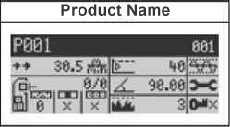
Figure 7-1: DD-390 Main Menu Screen
If the IXR function is enabled (see Chapter 15), the main menu appears as follows:
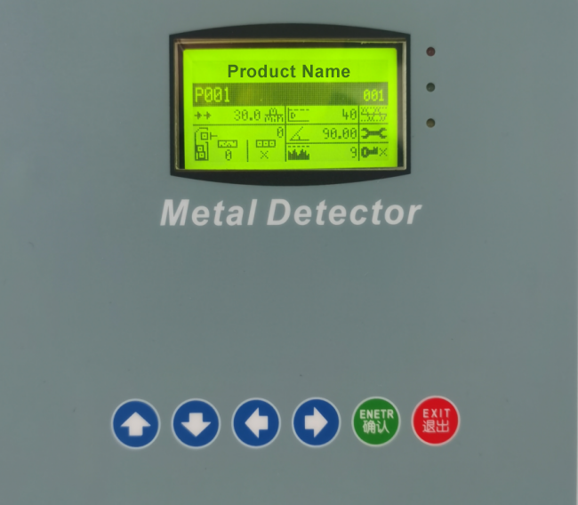
Figure 7-2: Main Menu with IXR Enabled

8. Product Setup

8.1 Naming a Product
This function allows you to name the product being inspected. Procedure:
• 1. Ensure the main menu is displayed.
• 2. Press the Confirm key; the Product Calibration menu appears.
• 3. Press the Down navigation key to highlight the "Edit Product Name" function.
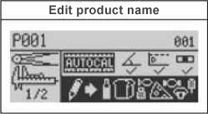
Figure 8-1: Product Calibration Menu
• 4. Press the Confirm key; the keyboard screen appears.
• 5. Use the keyboard screen to type a name for the product being inspected.
• 6. Highlight the "Exit and Save" key (bottom-right corner) and press the Confirm key to exit the keyboard screen.
Note | Use clear, descriptive product names (e.g., "Frozen Fish Fillet 1kg" or "Bread Loaf 500g") to facilitate quick identification during product changeovers. Avoid generic names that could cause operator confusion.

8.2 Changing Application Modes
The DD-390 can be manually configured for four different application modes:
• Conveyor application
• Gravity-fall application
• Pipeline application
• Pharmaceutical (Rx) application
Note | Factory mode access is required to confirm settings for your specific working environment (e.g., conveyor application). To switch to a different application mode (e.g., Rx), contact the factory.

8.3 Product Parameters Overview
Each product stores the following configurable parameters, set automatically by the full product calibration function and fine-tunable manually if needed:
Parameter | Description | Set By
Phase Angle | Phase angle for discriminating product effect from metal signals | Auto / Manual
Detection Threshold (X / R) | Detection limit; lower values = higher sensitivity to metal | Auto / Manual
Detection Frequency / Gain | Operating frequency and amplification of the received signal | Auto / Manual
Reject Distance / Delay | Time from metal detection to reject device activation | Manual
Reject Duration | Time the reject device remains active per detection event | Manual
Photoelectric Polarity | Trigger polarity of the photoelectric input signal | Manual

9. Conveyor Application Setup
For a typical conveyor application, the most commonly used functions are listed below.

9.1 Package Length
This is the length of the product being inspected (mm or inches). Procedure:
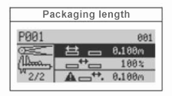
Figure 9-1: Packaging length
• 1. Ensure the main menu is displayed.
• 2. Press the Confirm key; the Full Product Calibration screen appears.
• 3. Navigate to page 2 of this menu.
• 4. Highlight the "Package Length" function.
• 5. Press the Confirm key; an input screen appears.
• 6. Type the package length (mm or inches).

9.2 Non-Packaged Distance
In most conveyor applications, it is best to enter the same value for Package Length and Non-Packaged Distance (mm or inches). Procedure:
• 1. Ensure the screen shown in the "Package Length" section is displayed.
• 2. Highlight the "Non-Packaged Distance" function.
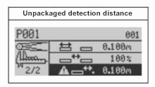
Figure 9-2: Non-Packaged Distance Setting
• 3. Press the Confirm key; an input screen appears.
• 4. Type the non-packaged distance (mm or inches).

9.3 Package Spacing
Package spacing is expressed as a percentage of the non-packaged distance, best set to 100%. When there is uncertainty about which package is contaminated, adjusting the package spacing lets you fine-tune whether the detector rejects one product unit or two. Procedure:
• 1. Ensure the screen shown in the "Package Length" section is displayed.
• 2. Highlight the "Package Spacing" function.
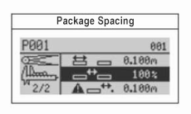
Figure 9-3: Package Spacing Setting
• 3. Press the Confirm key; an input screen appears.
• 4. Type the package spacing (as a percentage).

9.4 Product Speed
This function enters the conveyor speed (for conveyor applications) or the product flow speed in the chute or pipe (for gravity-feed and pipeline applications). Procedure:
• 1. Ensure the main menu is displayed.
• 2. Highlight the "Product Speed" menu.
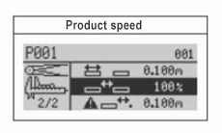
Figure 9-4: Product Speed Setting
• 3. Press the Confirm key; an input screen appears.
• 4. Type the belt speed (m/min or ft/min).

9.5 Photoelectric Sensor to Detector Distance
This is the distance from the photoelectric sensor (on the upstream or "infeed" side of the detector) to the infeed side of the search head. Procedure:
• 1. Ensure the main menu is displayed.
• 2. Navigate to the "System and Tools" menu.
• 3. Press the Confirm key.
• 4. Navigate to page 3 of the menu.
• 5. Highlight the "Photoelectric Sensor Setup" menu.
• 6. Press the Confirm key; the "Photoelectric Distance and Head Width" menu appears.
• 7. Highlight the "Infeed Photoelectric Distance" function.
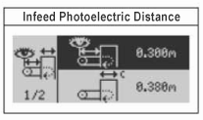
Figure 9-5: Photoelectric Sensor Distance Setting
• 8. Press the Confirm key; an input screen appears.
• 9. Type the distance from the photoelectric sensor to the controller (mm or inches).

9.6 Photoelectric Input Polarity
Since a photoelectric sensor is either dark-activated or light-activated, this function tells the detector how to interpret the signal from your specific sensor. Procedure:
• 1. Ensure the main menu is displayed.
• 2. Navigate to the "System and Tools" menu.
• 3. Press the Confirm key.
• 4. Navigate to page 2 of the menu.
• 5. Highlight the "Inputs and Outputs" menu.
• 6. Press the Confirm key.
• 7. Highlight the "Inputs" menu.
• 8. Press the Confirm key; the Input Setup menu appears.
• 9. On page 1, highlight the "Infeed Photoelectric Input" menu. The "+2" symbol indicates the sensor is connected to input No. 2 on the terminal board with positive polarity.
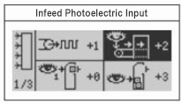
Figure 9-6: Photoelectric Input Polarity Setting
• 10. To change these settings, press the Confirm key; an input screen appears.
• 11. Use the navigation keys to select the appropriate input (1–6) and polarity.

10. Reject Device Configuration

10.1 Photoelectric Trigger Definition for Reject
This function selects which part of the product triggers the reject device. It is typically used for products longer than six inches. Rejection can be triggered in three ways:
• By the leading edge of the product:
Figure 10-1: Leading-Edge Trigger
• On page 1 of the Reject menu, highlight the "Reject 1 Distance/Delay" function.
• 5. Press the Confirm key; an input screen appears.
• By the middle of the product length:

Figure 10-2: Middle-of-Product Trigger
• 6. Type the appropriate distance (mm or inches). To set a delay instead, first highlight the "m→s" (or "ft→s") function, press the Confirm key to select "Delay" (time parameter), then set it in minutes and seconds.
• By the entire length of the product:
Figure 10-3: Full-Length Trigger
• 1. Ensure the main menu is displayed.
• 2. Highlight the "Reject" menu.
• 3. Press the Confirm key.
• 4. Navigate to page 2 of the menu.
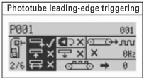
Figure 10-4: Photo Registration Menu
• 5. Press the Right navigation key to select the photo registration menu.
• 6. To change this setting, press the Confirm key repeatedly until a check mark appears next to the part of the product that will trigger the reject device.

10.2 Reject Device Distance
This function enters the distance from the downstream edge of the search head to the center of the primary (Reject 1) device (mm or inches). Procedure:
• 1. Ensure the main menu is displayed.
• 2. Highlight the "Reject" menu.
• 3. Press the Confirm key.
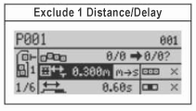
Figure 10-5: Reject Device Distance Setting

10.3 Reject Device Signal Duration
This function sets the duration of the signal required to activate the Reject 1 device (in seconds and hundredths of a second). Procedure:
• 1. Ensure the screen shown in the "Reject Device Distance" section is displayed.
• 2. Highlight the "Reject 1 Duration" function.
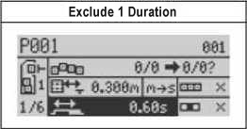
Figure 10-6: Reject Duration Setting
• 3. Press the Confirm key; an input screen appears.
• 4. Type the appropriate duration (minutes and seconds). To set the duration as a distance instead, highlight the "s→m" (or "s→ft") function, press the Confirm key to select a distance parameter, then type the distance (mm or inches).
Notice | To verify reject timing: place a metal test piece on a product, run it through, and confirm the reject device activates at the correct moment to remove only the contaminated product. Adjust timing parameters as needed and re-test until consistent.

11. Calibration

11.1 Full Product Calibration
Full Product Calibration lets the detector learn to recognize your uncontaminated product and sets the following basic parameters:
• Phase angle setting
• Detection threshold
Procedure:
• 1. Ensure the product name is highlighted on the main menu.
• 2. Press the Confirm key; the "Full Product Calibration" function is automatically highlighted.
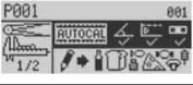
Figure 11-1: Full Product Calibration
Warning | Ensure that the products used for calibration are confirmed to be free of metal contaminants. If a contaminated product is inadvertently used during the learning process, the system will calibrate incorrectly, potentially masking future detections.

11.2 X/R Threshold Calibration
This calibration establishes a noise baseline for the detector; it must be performed with the conveyor running and no product present in the search head. Procedure:
• 1. Ensure the main menu is displayed.
• 2. Highlight the "Frequency and Gain" menu.
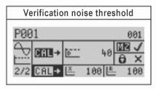
Figure 11-2: Frequency and Gain Menu
• 3. Ensure the conveyor is running and uncontaminated product is passing through the search head.
• 4. Press the Confirm key; a monitor screen appears. During calibration, a series of frequency/gain mini-screens may appear; they pause the calibration while the detector searches for the best frequency/gain settings for your product. When this happens, press the Confirm key to restart. When calibration is complete, the main menu appears.
• 3. Press the Confirm key.
• 4. Navigate to page 2 of the menu.
• 5. Navigate to the "Calibrate Noise Threshold" menu. (Note: the calibration function background should now be highlighted in black.)
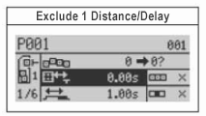
Figure 11-3: Calibrate Noise Threshold
• 6. Press the Confirm key; a monitor screen appears. When the screen reappears showing the calibrated X and R threshold values, calibration is complete.
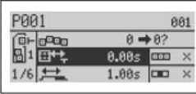
Figure 11-4: Calibrated X/R Threshold Values
Typical values for these thresholds are as follows:
Threshold | Typical Value
X Threshold | < 300
R Threshold | < 100

11.3 Auto Calibration
For optimal auto calibration, follow these steps:
• Conveyor running at normal production speed.
• Spacing between packages at least one metal detector head width.
• 30–50 uncontaminated packages passing through the detector head.
• 1. Confirm the main menu is displayed and the "Product Name" (or a previously entered name) is highlighted.
• 2. Press the Confirm key; the "Full Product Calibration" menu appears.
• 3. Highlight the "Auto Calibration" function and begin passing uncontaminated product through the head. After auto calibration is complete, press the Return key several times to return to the main menu.
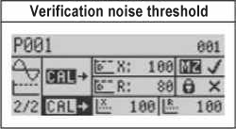
Figure 11-5: Auto Calibration Complete

12. Gravity Feed & Pipeline Applications
For a typical gravity-feed or pipeline application, the most commonly used functions are listed below.

12.1 Reject Delay
This function is normally set to 0.00 seconds; it tells the gate to close immediately when a contaminant is detected. If there is a long distance between the gate and the search head, a longer delay may be needed. Procedure:
• 1. Ensure the main menu is displayed.
• 2. Navigate to the "Reject" menu.
• 3. Press the Confirm key.
• 4. On page 1 of the Reject menu, highlight the "Reject 1 Distance/Delay" function.
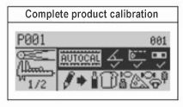
Figure 12-1: Gravity-Feed Reject Delay
• 5. Press the Confirm key; an input screen appears.
• 6. Type the appropriate reject delay (in seconds and hundredths of a second).

12.2 Reject Duration
This is the time the gate remains closed to divert contaminated product to the waste chute; normally set to 3 seconds. Procedure:
• 1. Navigate to the screen shown in the "Reject Delay" section.
• 2. Highlight the "Reject 1 Duration" function.
• 3. Press the Confirm key; an input screen appears.
• 4. Type the appropriate reject duration (in seconds and hundredths of a second).

13. Pipeline Application
The main function settings for a typical pipeline metal detector application are given below.

13.1 Reject Delay
This function is normally set to 0.00 seconds; it tells the gate to close immediately when a contaminant is detected. If there is a long distance between the gate and the search head, a longer delay may be needed. Procedure:
• 1. Ensure the main menu is displayed.
• 2. Navigate to the "Reject" menu.
• 3. Press the Confirm key.
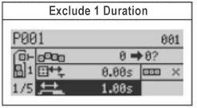
Figure 13-1: Pipeline Application Reject Delay

14. Pharmaceutical (Rx) Application
The main function settings for a typical pharmaceutical metal detector application are given below.

14.1 Reject Delay
This function is normally set to 0.00 seconds; it tells the reject flap to close immediately when a contaminant is detected. If there is a long distance between the reject flap and the search head, a longer delay may be needed. Procedure:
• 1. Ensure the main menu is displayed.
• 2. Navigate to the "Reject" menu.
• 3. Press the Confirm key.
• 4. On page 1 of the Reject menu, highlight the "Reject 1 Distance/Delay" function.
Figure 14-1: Rx Application Reject Delay
• 5. Press the Confirm key; an input screen appears.
• 6. Type the appropriate reject delay (in seconds and hundredths of a second).

14.2 Reject Duration
This is the time the reject flap remains closed to divert contaminated product; normally set to 0.15 seconds. Procedure:
• 1. Navigate to the screen shown in the "Reject Delay" section.
• 2. Highlight the "Reject 1 Duration" function.
Figure 14-2: Rx Application Reject Duration
• 3. Press the Confirm key; an input screen appears.
• 4. Type the appropriate reject duration (in seconds and hundredths of a second).

15. IXR Intelligent Tracking Function

15.1 IXR Overview
The IXR (Intelligent Tracking XR) function effectively detects stainless steel contaminants in moist products, and identifies the phase angle of metal contaminants present in different packages of moist and dry products. IXR is typically used for conveyor metal detector applications and is not yet available for pipeline applications.
Notice | To use IXR, a photoelectric sensor (or other product-detection trigger) must be installed at the infeed. IXR is not yet available for gravity-fall and Rx pharmaceutical applications.

15.2 Parameter Setup Before Using IXR
Before using IXR, the following parameters must be configured:
• Package product length
• "Detect non-packaged" distance
• Infeed photoelectric distance
• Photoelectric trigger mode
For optimal performance, the photoelectric trigger should be set to trigger at the middle of the product length. See Section 10.1 "Photoelectric Trigger Definition for Reject" and press the Confirm key to select triggering by the "middle" of the product length.

15.3 Activating IXR
To activate IXR, follow these steps:
• 1. Ensure the main menu is displayed.
• 2. Highlight the "System and Tools" menu.
• 3. Press the Confirm key.
• 4. Highlight the "IXR" menu.
• 5. Press the Confirm key.
• 6. Highlight the "Activate IXR" function.
Figure 15-1: Activating IXR
• 7. Press the Confirm key; a check mark appears (like the other IXR option), indicating IXR is now activated.
• 8. Press the Return key repeatedly to return to the main menu, which now appears as shown below.
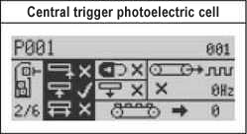
Figure 15-2: Main Menu After IXR Activation

15.4 Calibrating IXR
During calibration, ensure normal product is used and the conveyor runs at the same speed. The calibration process has 2 parts:
• Learn the X and R noise thresholds.
• Learn the detection thresholds (X and R signal values).
• 1. Confirm the main menu is displayed.
• 2. Highlight the "Frequency and Gain" menu.
• 3. Press the Confirm key and navigate to page 2.
• 4. Highlight the "Calibrate Noise Threshold" function.
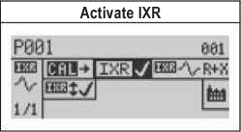
Figure 15-3: Calibrating IXR
• 5. Confirm the conveyor is at normal production speed. Press the Confirm key; a monitor screen appears while the detector measures the X and R noise thresholds (approximately 20 seconds).

15.5 Auto Calibrating IXR
For optimal auto calibration, follow these steps:
• Conveyor running at normal production speed.
• Spacing between packages at least one metal detector head width.
• 30–50 uncontaminated packages passing through the detector head.
Figure 15-4: Auto Calibrating IXR
• 1. Confirm the main menu is displayed and the "Product Name" (or a previously entered name) is highlighted.
• 2. Press the Confirm key; the "Full Product Calibration" menu appears.
• 3. Highlight the "Auto Calibration" function and begin passing uncontaminated product through the head. After auto calibration is complete, press the Return key several times to return to the main menu.

16. Detection Sensitivity

16.1 Understanding Sensitivity
The sensitivity of a metal detector is defined as the diameter of the smallest metal sphere that can be reliably detected at the geometric center of the detection aperture — the point of weakest sensitivity. Sensitivity is categorized into two types:
• Maximum Sensitivity — the highest theoretical sensitivity achievable under ideal laboratory conditions, with no product present in the aperture.
• Product Detection Sensitivity — the highest sensitivity achievable when detecting metal contaminants within an actual product. This is the practical, real-world value relevant for production operations.

16.2 Factors Affecting Sensitivity
Factor | Description | Impact
Product Effect | The product's own electromagnetic signal (affected by moisture, fat, temperature, acidity, salinity, size, and orientation) | Higher product effect → Lower sensitivity
Metal Type | Ferrous vs. Non-Ferrous vs. Stainless Steel | SUS316 is hardest; Fe is easiest
Metal Shape | Spherical, wire-like, flat fragment, or irregular | Sphere = smallest detectable; wire is orientation-dependent
Metal Orientation | Direction of the contaminant as it passes through the field | Worst-case orientation determines practical sensitivity
Aperture Size | Dimensions of the detection head opening | Larger aperture → Reduced sensitivity
Environment | EMI, vibration, temperature fluctuation, moving metal nearby | Unstable environment → Lower usable sensitivity
Packaging | Metallized film or foil packaging | Metal in packaging interferes with detection

16.3 Metal Type Detection Comparison
Category | Magnetic? | Examples | Relative Detectability
Ferrous (Fe) | Yes | Carbon steel, iron, mild steel | Easiest — reference baseline
Non-Ferrous | No | Copper, lead, brass, bronze, aluminum | Moderate — ~1.5× Fe sphere diameter
Stainless Steel (magnetic) | Yes | SUS430, some 400-series | Similar to ferrous
Stainless Steel (non-magnetic) | No | SUS302, SUS304, SUS316 | Most difficult — ~1.5–2× Fe sphere diameter

17. System Configuration

17.1 System and Tools Menu
System-level settings on the DD-390 are accessed via the "System and Tools" menu, including:
• Inputs and Outputs — configure photoelectric inputs (1–6) and their polarity.
• Photoelectric Sensor Setup — configure photoelectric distance and head width.
• Frequency and Gain — calibrate X/R thresholds and select detection frequency.
• IXR — activate and calibrate the intelligent tracking function.
• Application Mode — confirm conveyor/gravity/pipeline/Rx application mode.

17.2 Logging Functions
The DD-390 can record production data and detection events for HACCP traceability. Logging functions include:
• Reject Total — view the cumulative reject count on the main interface.
• Reject History — view each reject record page by page.
• Stores up to 1500 event logs.

18. HACCP Validation Procedure

18.1 HACCP and Metal Detection
Metal foreign body detection is a Critical Control Point (CCP) in HACCP (Hazard Analysis and Critical Control Points) plans. The metal detector is the most effective instrument for ensuring that products leaving your facility are free from metal contamination.
The primary objectives of HACCP in relation to metal detection are:
• Identify where metal contamination risks exist in your production line.
• Establish critical limits for metal detection (minimum detectable contaminant size per metal type).
• Implement monitoring procedures (daily verification tests with certified test pieces).
• Define corrective actions when detection capability fails or equipment malfunctions.
• Maintain verification records for regulatory audits and quality assurance compliance.

18.2 Establishing Critical Limits
For each product inspected by the DD-390, establish and document the following critical limits in your HACCP plan:
• Ferrous (Fe) test piece size that must be reliably detected.
• Non-Ferrous (copper, brass, aluminum) test piece size that must be reliably detected.
• Stainless Steel (SUS304 or SUS316) test piece size that must be reliably detected.

18.3 HACCP Validation Procedure
Perform the following validation procedure when commissioning a new product, after any significant product change, or during periodic HACCP reassessment:
• 1. Set up the product using the Full Product Calibration / Auto Calibration procedure (see Chapter 11).
• 2. Obtain certified HACCP test pieces (Fe, Non-Fe, SUS) of the sizes specified in your HACCP plan.
• 3. Attach each test piece to a product sample and pass it through the detector. Repeat each test at least 3 times per test piece type to confirm consistency.
• 4. Test at multiple positions: place the test piece at the leading edge, center, and trailing edge of the product. Also test with the test piece on top, inside, and underneath the product.
• 5. Record all test results in your HACCP validation log, including date, time, product name, test piece type and size, and pass/fail result for each test.
• 6. If any test piece fails to trigger detection, re-run Auto Calibration or manually adjust parameters until reliable detection is achieved at all positions.
Warning | If the detector cannot reliably detect the required HACCP test piece sizes after adjustment, do NOT proceed with production. Contact SameGram Technical Support for assistance. Document the non-conformance and corrective actions taken.

18.4 Record Keeping Requirements
• Detection alarm time records — time-stamped log of every metal detection event, retrievable via the logging function.
• Product switching records — history of all product changeovers with timestamps.
• Production counters — total production and total inspection counts per product.

19. Daily Verification Test

19.1 Operation Sensitivity Test
Purpose: Verify that the equipment operation sensitivity meets requirements.
Method: Test according to the steps below. Acceptance criteria: the test piece is detected and the machine stops.
# | Test Step | Expected Result | Pass/Fail | Remark
1 | From left to right, the keys are Run, Stop, Emergency Stop, and Power. A beep sounds when the Power key is pressed. | Beep sound confirmed | □Yes □No | 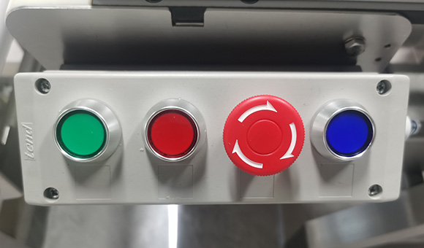
2 | Operate the keys | Keys respond correctly | □Yes □No | 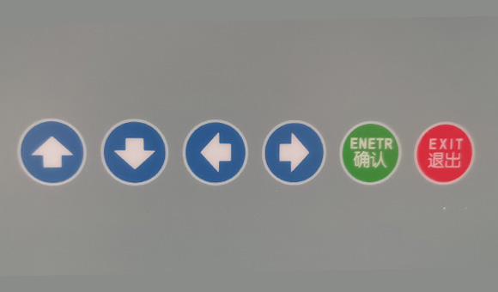
3 | Display the product menu | Product menu displayed | □Yes □No | 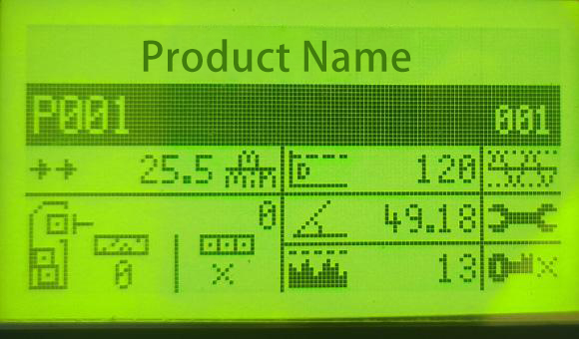
4 | Press the Confirm key to enter product recipe, product calibration (self-learning), and name | Menu entered | □Yes □No | 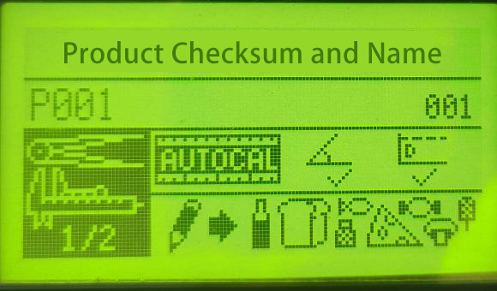
5 | Press the Confirm key to enter full product calibration | Full calibration screen displayed | □Yes □No | 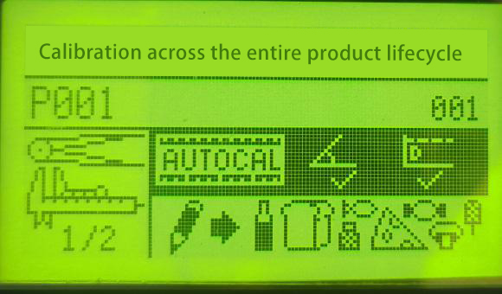
6 | Test the empty-machine effect — wait for the progress bar to complete (usually runs twice) | Progress bar completes | □Yes □No | 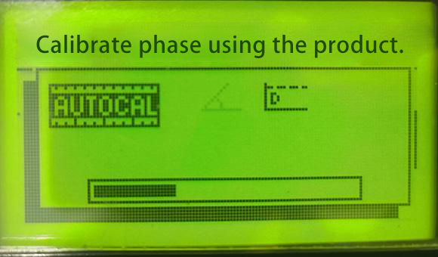
7 | After learning is complete, return to the main interface | Main interface displayed | □Yes □No | 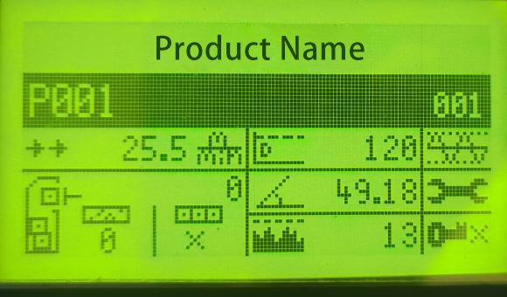
8 | Place the test piece for detection | Test card detected; alarm and stop | □Yes □No
Figure 19-1: Control Panel Keys
Figure 19-2: Operation Keys
Figure 19-3: Product Menu
Figure 19-4: Product Calibration Menu
Figure 19-5: Full Product Calibration
Figure 19-6: Empty-Machine Test Progress

19.2 Product Operation Test
Purpose: Verify that the equipment can automatically reject metal-contaminated products.
Method: Test according to the steps below. Acceptance criteria: metal-contaminated products are rejected automatically; normal products pass.

# | Test Step | Expected Result | Pass/Fail | Remark
1 | Display the screen for creating a new product recipe | New product recipe screen displayed | □Yes □No
2 | Enter the product self-learning and name interface | Interface entered | □Yes □No
3 | Enter the "Self-Learning" interface | Self-learning screen displayed | □Yes □No
4 | While the product is learning, before the progress bar completes, pass the product to be inspected as many times as possible | Learning in progress | □Yes □No
5 | After auto-learning completes, return to the main interface | Main interface displayed | □Yes □No
6 | Pass the product once more and observe the peak value. The peak must not exceed the threshold; press the Confirm key to reset to zero | Peak value ≤ threshold | □Yes □No | 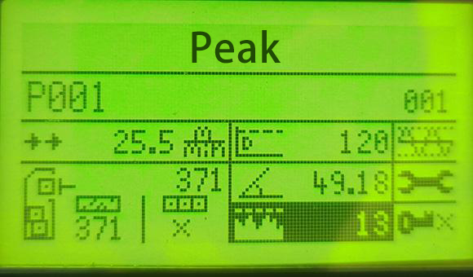
7 | Check the detection threshold — the learned value can usually be used at 30% lower, ensuring normal products do not cause false alarms | No false alarms | □Yes □No | 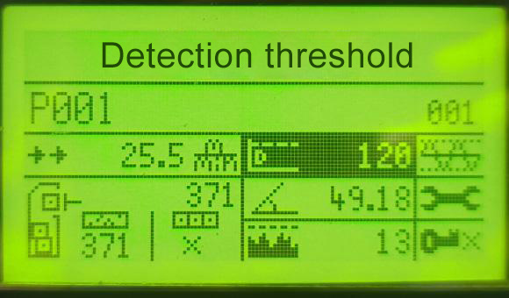
8 | Self-learning complete | No false alarm when running empty | □Yes □No
Figure 19-7: Peak Value Observation
Figure 19-8: Detection Threshold

19.3 Sample Detection Test
Purpose: Verify that the equipment has metal detection capability and can detect metal foreign objects in samples.

# | Test Step | Expected Result | Pass/Fail | Remark
1 | From the main interface, press the Run key | Conveyor starts running | □Yes □No
2 | Pass a normal product and observe the peak value change | Peak value observed | □Yes □No
3 | Place a ferrous (Fe) test ball into the material and pass it through the machine | Test ball detected and machine stops | □Yes □No
4 | Repeat test step 3 times | Fe ball detected each time | □Yes □No
5 | Place a non-ferrous (Non-Fe) test ball into the material and pass it through | Test ball detected and machine stops | □Yes □No
6 | Repeat test step 3 times | Non-Fe ball detected each time | □Yes □No
7 | Place a stainless steel (SUS) test ball into the material and pass it through | Test ball detected and rejected | □Yes □No
8 | Repeat test step 3 times | SUS ball detected each time | □Yes □No
9 | Pass a normal product again | Passes normally | □Yes □No

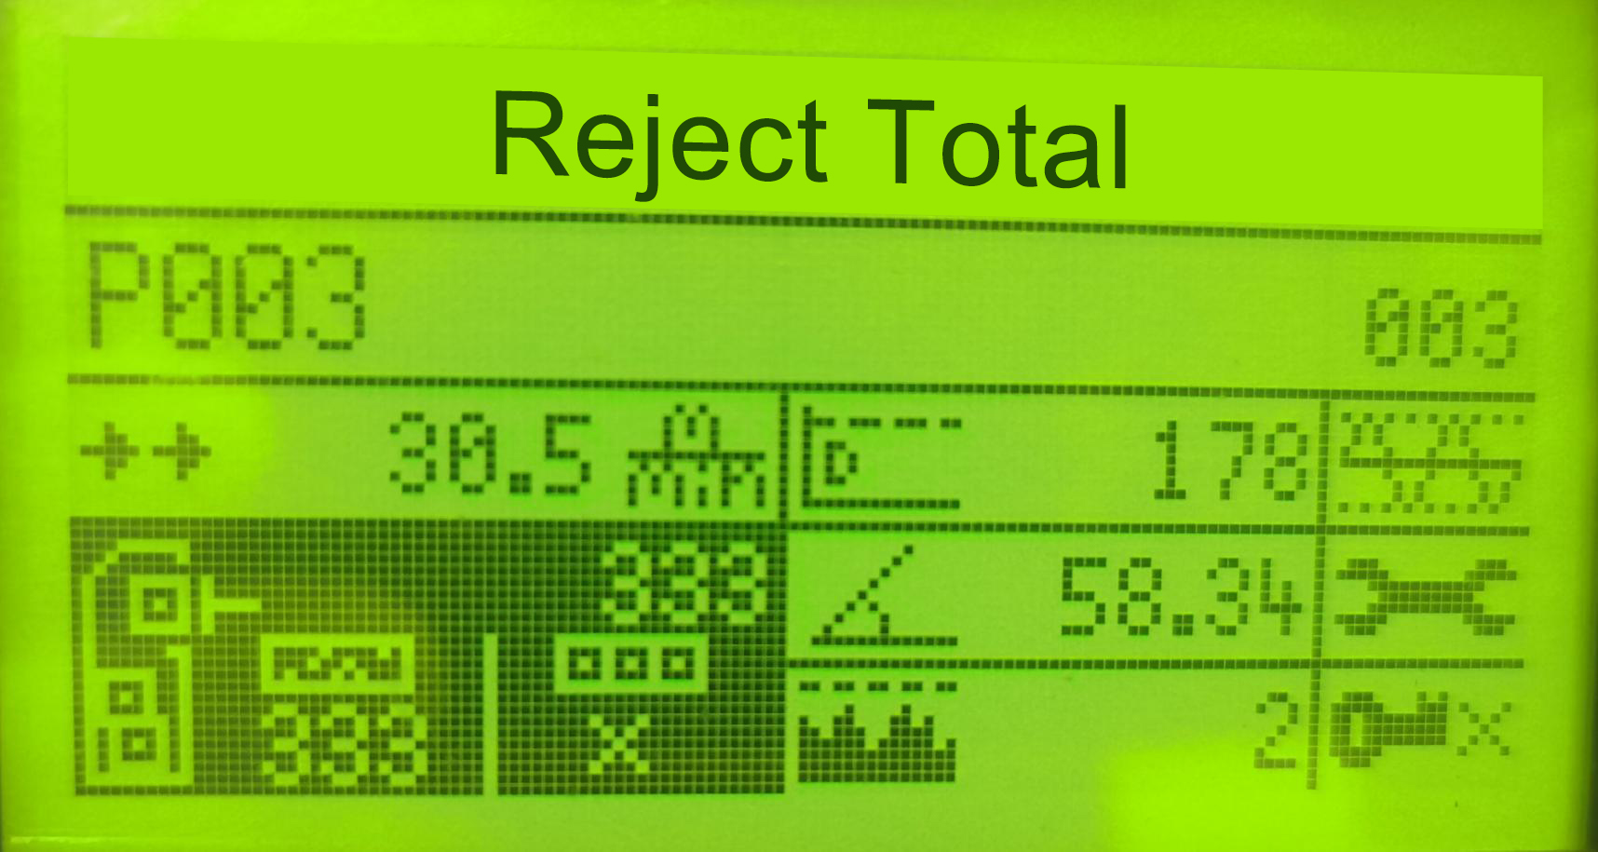
Figure 19-9: Ferrous Test Ball Detection
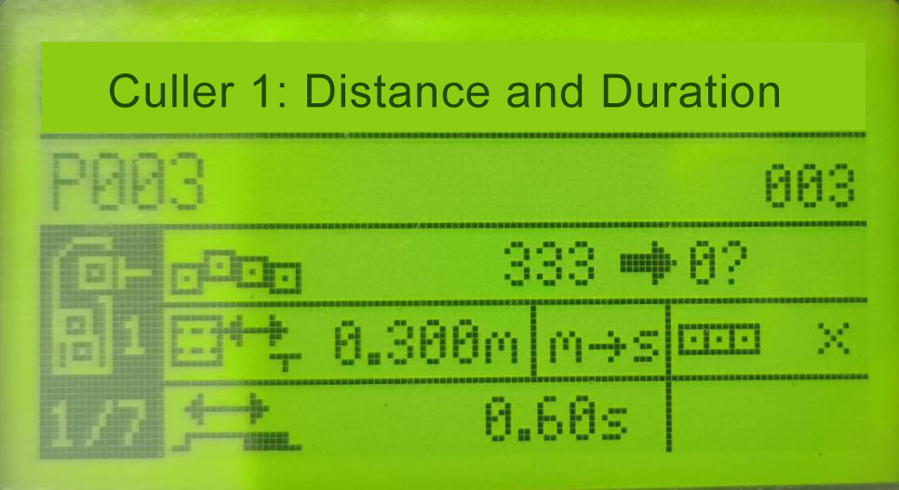
Figure 19-10: Repeated Test Ball Detection
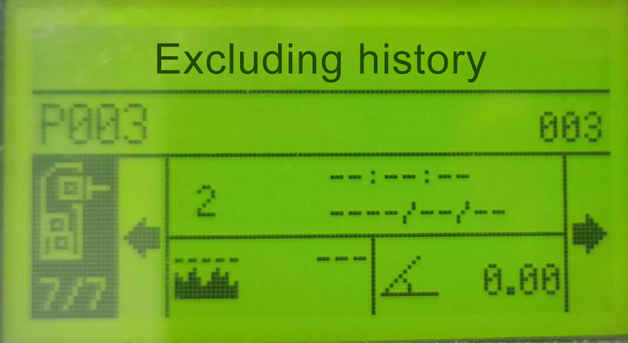
Figure 19-11: Non-Ferrous Test Ball Detection

19.4 Log Function Verification
Purpose: Verify that the equipment has a logging function.
# | Test Step | Expected Result | Pass/Fail | Remark
1 | Enter Reject Total from the main interface | Cumulative reject count displayed | □Yes □No
2 | Select pagination | Can view page by page | □Yes □No
3 | Go to page 7, view reject history | Reject records viewable | □Yes □No

19.5 Daily Inspection Checklist
Perform ALL of the following checks before starting production each day or shift:
Check | Item | Pass Criteria
Visual Inspection | Inspect the entire machine for physical damage, loose fasteners, or foreign objects on the conveyor belt | No visible damage; all guards and covers in place
Cleanliness | Check the detection aperture and conveyor belt for product residue, debris, or buildup | Aperture and belt are clean and free from residue
Conveyor Belt | Verify belt is properly tensioned, tracking correctly, and free from cracks or fraying | Belt runs smoothly without slipping or wandering
Fe Test Piece | Pass certified Fe test piece through detector on/inside a product sample | Detector alarms/stops/rejects reliably
Non-Fe Test Piece | Pass certified Non-Fe test piece through detector on/inside a product sample | Detector alarms/stops/rejects reliably
SUS Test Piece | Pass certified SUS test piece through detector on/inside a product sample | Detector alarms/stops/rejects reliably
Reject Device | Confirm reject mechanism (if fitted) operates correctly and removes the test product | Reject device activates and product is diverted
Qualified Product Flow | Run 3–5 clean products through without test pieces | No false alarms; products pass normally

19.6 Weekly Inspection Items
• Remove the conveyor belt and check the end faces for cracking.
• Check belt running condition — no abnormal sounds and no creeping.
• Inspect all electrical connections for tightness, corrosion, or insulation damage.
• Verify ground connection integrity — resistance must remain < 100 Ω.
• Clean cooling fans and ventilation openings to prevent dust accumulation and overheating.

20. Production Operation

20.1 Startup Procedure
• 1. Verify the power cord is properly connected and grounding is secure (resistance < 100 Ω).
• 2. Turn on the main power switch and circuit breaker.
• 3. Allow the equipment to warm up for at least 30 minutes. This is essential for stable detection performance — do not skip this step, especially during morning startup when ambient temperature may have changed significantly.
• 4. Select the correct product from the product menu.
• 5. Perform the complete Daily Verification Test (see Chapter 19).
• 6. If all checks pass, start production.

20.2 During Production
• Monitor the indicator lights and display, observing product effect magnitude and system stability.
• When an alarm occurs, follow your standard operating procedure: stop the conveyor (if not already stopped), remove the rejected product, re-inspect by passing it through again in different orientations, isolate the product if the alarm repeats, and record the alarm event.
• Do not wear metal items during operation.
• Keep the area around the detection head clear of moving metal objects.

20.3 Product Changeover
• 1. Press Stop to halt the conveyor.
• 2. Select the new product.
• 3. Verify all product parameters (phase, threshold, reject timing, detection mode) are correct for the new product.
• 4. Perform a complete verification test with the appropriate certified test pieces for the new product.
• 5. If all tests pass, resume production.
Notice | If the new product has not been previously set up, perform the Full Product Calibration (Chapter 11) and HACCP validation (Chapter 18) before starting production.

20.4 Shutdown Procedure
• 1. Press Stop to halt the conveyor.
• 2. Record the final production and inspection counts if required by your quality system.
• 3. Turn off the main power switch.
• 4. Perform the after-operation cleaning procedure (see Chapter 21).

21. Maintenance & Cleaning

21.1 Daily Maintenance
• Visual inspection — physical damage and cleanliness.
• Conveyor belt condition — tracking, tension, and surface integrity.
• Detection sensitivity verification with certified Fe, Non-Fe, and SUS test pieces.
• Reject device functional check (if fitted).
• Display cleanliness check.

21.2 Cleaning Precautions
Approved Cleaning Materials:
• Soft plastic brushes or soft cloths for sweeping and wiping.
• Neutral detergent (pH-neutral) diluted in warm water (below 40 °C).
• Clean water for rinsing.
PROHIBITED Cleaning Materials:
• Metal brushes, steel wool, abrasive scrubbers, or scouring pads.
• Organic solvents: thinner, toluene, benzene, acetone, or similar — do NOT use for routine cleaning.
• High-pressure water jets or steam cleaners (unless equipment is specifically IP-rated for such cleaning).
• Bleach or strong acidic/alkaline cleaners that may corrode stainless steel or damage seals.
Cleaning Procedure:
• 1. Unplug the power cord.
• 2. Remove loose debris with a soft brush or cloth.
• 3. Apply neutral detergent solution with a soft cloth or sponge.
• 4. Pay special attention to the detection head aperture interior and the conveyor belt-to-frame junction areas, where debris tends to accumulate.
• 5. Rinse thoroughly with clean water to remove all detergent residue.
• 6. Dry all surfaces with a clean, soft cloth to prevent water spots.

21.3 Stainless Steel Maintenance
Although stainless steel (SUS304) has excellent corrosion resistance, it is not completely immune to rusting. Rust on stainless steel is typically surface contamination rather than material corrosion, caused by: adhesion of atmospheric iron powder or metal particles, exposure to corrosive gases or salt-laden air, galvanic corrosion from contact with dissimilar metals, and accumulation of contaminants that damage the passive chromium oxide film.
Rust Removal Methods:
• Light rust from iron powder or salt: Wipe with a sponge or soft cloth dipped in neutral detergent or soapy water. Rinse thoroughly and dry completely.
• Stubborn contamination (fingerprints, adhesive residue): Use a soft cloth lightly moistened with alcohol, gasoline, or acetone. Wipe clean and rinse with water afterward.
• For persistent rust spots, use a dedicated stainless steel cleaner following the manufacturer's instructions.

22. Conveyor Belt Removal & Installation

22.1 Removal Procedure
Warning | Ensure the equipment is powered off and the power plug is disconnected before beginning belt removal.

• Step 1: Loosen the 4 buckles (latches) located on the outside of the machine body.
• Step 2: Lift the belt conveyor unit upward from the side of the drive shaft to release tension on the motor drive belt (synchronous belt).
• Step 3: Disconnect the drive belt (synchronous belt) from the motor pulley.
• Step 4: After the drive belt is fully disengaged, lift the belt conveyor unit upward and away from the frame.
• Step 5: Remove the belt conveyor unit by sliding it out from the side of the detection head. Exercise extreme caution to avoid damaging the resin liner inside the detection aperture.

22.2 Reinstallation Procedure
To reinstall the conveyor belt assembly, reverse the removal procedure:
• 1. Carefully position the belt conveyor unit back into the frame, guiding it through the detection head aperture without contacting the resin liner.
• 2. Re-engage the drive belt (synchronous belt) onto the motor pulley, ensuring proper alignment.
• 3. Lower the belt conveyor unit into its operating position, ensuring the drive belt has adequate tension.
• 4. Secure all 4 buckles (latches) on the outside of the machine body. Verify each latch is fully engaged.
• 5. Manually rotate the belt to verify it tracks correctly and does not rub against the frame or detection head.
• 6. Reconnect the power, run the conveyor briefly, and confirm smooth, quiet operation before resuming production.

22.3 Belt Inspection During Removal
• Belt end faces — Check for cracking, fraying, delamination, or uneven wear.
• Belt surface — Inspect for cuts, embedded debris, excessive wear, or chemical damage.
• Belt pallet (support plate) — Clean thoroughly and inspect for wear grooves or damage.
• Drive pulley and idler rollers — Check for product debris buildup on the roller surfaces.
• Drive belt (synchronous belt) — Inspect for cracking, stretching, or missing teeth. Replace if any damage is found.

23. Troubleshooting

23.1 Common Issues and Solutions
The following table lists common operational issues, their likely causes, and recommended solutions. If a problem persists after following these steps, contact SameGram Technical Support.
Problem | Possible Cause(s) | Recommended Solution
False alarms (no metal present) | Strong magnetic/EM interference nearby; unstable power supply; large moving metal objects near detector; dirty or worn conveyor belt; incorrect or degraded grounding | Identify and remove EMI source or relocate detector; install power line filter or voltage stabilizer; clear area around detection head of all moving metal; clean belt thoroughly or replace if worn; verify ground impedance < 100 Ω
Reduced detection sensitivity | Product temperature changed (partial thaw); product formulation/moisture changed; dirt accumulation in detection aperture; environmental temperature fluctuation; component drift over time | Re-run Auto Calibration for current product condition; stabilize frozen product temperature before inspection; clean detection aperture and conveyor belt; allow full 30-min warm-up and re-calibrate; contact Technical Support if persistent
Signal fluctuation with no product present | Ground vibration; electrical noise on power line; nearby equipment interference; loose internal connections | Relocate to vibration-free area or reduce sensitivity; use dedicated filtered power circuit; increase distance from interfering equipment; contact Technical Support for internal inspection
Equipment does not power on | Power cord disconnected or damaged; circuit breaker tripped; internal fuse blown; main power switch not turned on | Check power cord connection and condition; reset breaker and investigate cause; contact Technical Support for fuse replacement; verify main power switch is ON
Conveyor belt not running | Stop pressed or E-stop activated; drive belt disengaged or broken; motor overload protection triggered; obstruction in conveyor mechanism | Press Run and check emergency stop; inspect drive belt and re-engage or replace; remove obstruction and reset overload; check for jammed products
Reject device not activating | Reject mode not configured for this product; reject delay/duration set incorrectly; pneumatic supply disconnected (air-operated); reject mechanism mechanically jammed | Set reject mode in product parameters; adjust reject delay and duration; check air supply lines and pressure; inspect and free the reject mechanism
Display unresponsive | Screen surface dirty or wet; system requires restart; internal hardware fault | Clean display with soft, dry cloth; power cycle (off 10 s, then on); contact Technical Support if persistent
Red indicator steady on | Equipment fault | Power cycle; contact Technical Support if persistent
Red indicator flashes once | Excessive product effect | Re-run Full Product Calibration / Auto Calibration

24. Frequently Asked Questions (FAQ)
Q1: What is a metal detector and how does it work?
A metal detector is an electronic instrument designed to detect the presence of metal contaminants. It consists of a transmitter coil and receiving sensors arranged in a balanced configuration. When metal passes through the electromagnetic field generated by the transmitter, the received signal changes. The digital signal processor analyzes this change to determine whether it is caused by metal. If metal is confirmed, the system triggers the configured alarm or reject action.
Q2: Why should I use a metal detector?
There are two primary reasons: (1) Equipment Protection — preventing metal contaminants from damaging valuable downstream machinery such as mills, slicers, pulverizers, and cutting machines. (2) Product Quality Assurance — ensuring your final product is free from metal contamination, protecting consumer safety and your brand reputation.
Q3: Where should the metal detector be installed on my production line?
For equipment protection, install as close as possible to the inlet of the equipment being protected. For final product inspection, install at the end of the production line, after all processing steps. If the final packaging contains metal (foil, metallized film) or is too large for adequate sensitivity, install the detector immediately before the packaging machine.
Q4: What is "product effect"?
All products generate an electromagnetic signal when passing through the detection field — this is the product effect. Factors affecting product effect include: moisture content, fat content, temperature, acidity (pH), salinity, product orientation, and product volume. Products with low product effect allow higher detection sensitivity. The DD-390's Auto Calibration function analyzes and compensates for product effect.
Q5: What is sensitivity and how is it measured?
Sensitivity is defined as the diameter of the smallest metal sphere that can be reliably detected at the center of the detection aperture (the point of weakest sensitivity). Two types exist: Maximum Sensitivity (theoretical, no product present) and Product Detection Sensitivity (practical, with product present). The product detection sensitivity is the value relevant for production operations and HACCP compliance.
Q6: What are the different types of metals and how detectable are they?
Ferrous metals (carbon steel, iron) are magnetic and easiest to detect. Non-ferrous metals (copper, lead, brass, bronze, aluminum) are non-magnetic and moderately difficult to detect. Non-magnetic stainless steels (SUS302, SUS304, SUS316) are the most difficult to detect — typically requiring a sphere diameter 1.5 to 2 times larger than ferrous metals for reliable detection.
Q7: Can the machine detect burnt, rusted, or oxidized metal?
Yes, burnt or rusted metal can be detected because the metal core remains conductive. However, detection sensitivity varies depending on the shape, size, and orientation of the contaminant. Very small particles or thin flakes of rusted metal may pass undetected.
Q8: Can non-metal foreign objects (glass, stone, plastic, bone) be detected?
No. The DD-390 metal detector can ONLY detect metallic contaminants. It cannot detect glass, stone, plastic, bone, wood, rubber, ceramic, or any other non-metallic foreign objects. For comprehensive foreign object detection, consider complementary inspection technologies such as X-ray systems.
Q9: Why does frozen food temperature affect detection sensitivity?
Compared with completely frozen products, partially thawed products exhibit significantly higher product effect due to increased free water content and ionic mobility. The influence of moisture and salt content becomes greater as the product warms, resulting in reduced detection sensitivity. For consistent results, maintain frozen products at a uniform, stable temperature during inspection, and re-run Auto Calibration if temperature conditions change.
Q10: Can I wear rings, watches, or other jewelry during operation?
No. Metal rings, watches, bracelets, and other metallic personal items will disturb the magnetic field and may cause false detections or mask real contaminants. All operators must remove metallic personal items before working near the metal detector.
Q11: Why do the signal bars move even when no product is passing through?
The metal detector senses extremely small changes in the electromagnetic field. Moving metal objects nearby, equipment generating strong magnetic fields, electrical interference, or a dirty/worn conveyor belt can all cause signal fluctuations. Keep the area around the detection head clear of moving metal and ensure the belt is clean and in good condition.
Q12: Can the equipment be used immediately after power-on?
No. To ensure stable and accurate detection, the metal detector must be allowed to warm up for at least 30 minutes after startup. This is especially important when the indoor temperature has changed significantly (e.g., morning startup after overnight cooling). The electronic components require thermal stabilization to achieve rated performance.

25. Technical Support

25.1 Contact Information
Item | Details
Manufacturer | SameGram Equipment Co., Ltd.
Product Series | DD-390 Series Conveyor Metal Detector
Support Email | sale@samegram.com
Support WhatsApp | +86 137 1236 8272
Website | www.samegram.com

25.2 Before Contacting Support
• Equipment model number and serial number (located on the rating label affixed to the control cabinet).
• A detailed description of the problem — what is happening, when it occurs, and any error messages displayed.
• The product being inspected at the time of the issue, and whether the problem occurs with all products or only a specific one.
• Recent changes to the production environment, product formulation, equipment location, or settings.
• Results of the most recent Daily Verification Test before the issue occurred.
• Photographs or video of the issue, if available.

25.3 Recommended Spare Parts
Part | Recommended Qty | Replacement Interval / Notes
Conveyor Belt (PU, food-grade) | 1 | Replace annually or when cracking/wear is visible
Drive Belt (synchronous belt) | 1 | Replace if cracked, stretched, or missing teeth
Power Cord | 1 | Replace immediately if damaged or frayed
Fuse Set (per rating label) | 1 set | Replace only with identical rating fuses
HACCP Test Piece Set (Fe, Non-Fe, SUS) | 1 set each | Certified reference standards; replace if lost or damaged
Display Cleaning Cloth | 2 | Microfiber; dedicated for display use only

25.4 Warranty Information
SameGram provides a standard warranty on all DD-390 series equipment. Warranty terms are specified in your purchase agreement and cover defects in materials and workmanship under normal use conditions.
The warranty does NOT cover:
• Damage caused by improper installation, unauthorized modifications, or repairs by non-approved personnel.
• Damage from use of non-approved cleaning agents, solvents, or methods.
• Operation outside the specified environmental conditions (temperature, humidity, voltage).
• Damage caused by metal contamination that the detector was not configured or capable of detecting.
• Normal wear and tear of consumable parts: conveyor belts, drive belts, fuses, and cleaning materials.

25.5 Certifications
The DD-390 Series Conveyor Metal Detector is certified to the following international standards:
Certification | Directive / Standard | Scope
CE - EMC | 2014/30/EU | Electromagnetic Compatibility
CE - MD | 2006/42/EC | Machinery Directive (Machine Safety)
CE - LVD | 2014/35/EU | Low Voltage Directive (Electrical Safety)
RoHS | 2011/65/EU | Restriction of Hazardous Substances

— END OF DOCUMENT —

DD-390 Conveyor Metal Detector — Operation Manual | V4.1 | June | 2026 SameGram | All Rights Reserved

