Automatic Weighing & Labeling Machine
User Manual
Model: SCL-7030L1
For terminal operation, routine parameter settings, and basic maintenance

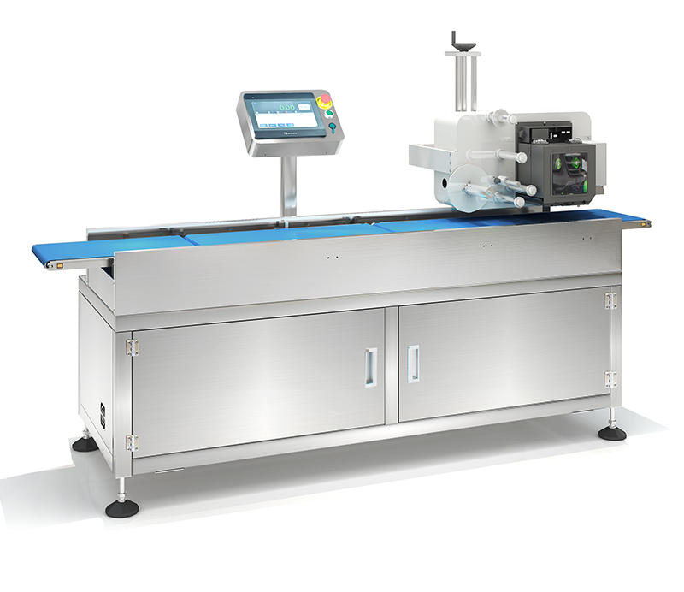
Figure 1 SCL-7030L1 outline and main functional units (outline for reference only; the contract shall prevail)

Document Version: V2.0 | Compiled Date: 2026-09
Document Control & Usage Instructions
Item | Content
Document Name | SCL-7030L1 Automatic Weighing & Labeling Machine User Manual
Applicable Model | SCL-7030L1
Machine Purpose | Performs dynamic weighing and acceptance on continuously conveyed products, and performs real-time printing and top-surface labeling on qualified products
Intended Users | Machine operators, production line supervisors, machine maintenance personnel, and after-sales engineering personnel
Basis of Compilation | SCL-7030L1 product technical agreement; standard printer software user manual; SCL series operation manual V2.0; CE conformity certificate ICR/VC/HS2608242
Version | V2.0
Language | English

Table of Contents
1. Product Overview
2. Technical Specifications
3. Machine Components & Workflow
4. Safety Instructions
5. Installation, Pre-start Checks & Shutdown
6. HMI & Basic Operation
7. Weighing Platform Setup & Calibration
8. Recipe Management & Weight Acceptance Parameters
9. Printing & Labeling Settings
10. Rejection & PLC Parameter Description
11. Data Statistics & Reports
12. Daily Cleaning & Maintenance
13. Common Faults & Troubleshooting
14. Label & Product Compatibility Requirements
15. After-sales Service & Warranty
16. Operator Quick Checklist

1. Product Overview
The SCL-7030L1 is an automatic weighing & labeling machine that integrates speed matching, dynamic weighing, rejection, real-time printing, and top-surface labeling. After a product enters the machine through the infeed section, it is weighed on the weighing platform; products outside the weight range of the current recipe are rejected, while qualified products proceed to the printing & labeling section, where the printing system generates a label and automatically applies it to the product packaging surface.
This machine has passed EU CE conformity verification (Certificate No. ICR/VC/HS2608242); see Section 2.3 for certification details.
1.1 Main Functions
Function | Description
Dynamic Weighing | Performs weight detection on products continuously passing over the weighing platform.
Weight Acceptance | Determines whether a product is qualified based on the qualified minimum and qualified maximum values set in the recipe.
Automatic Rejection | Rejects non-conforming products at the preset rejection position.
Real-time Printing | Prints the date and production batch number according to the current recipe, and can print barcodes as required.
Automatic Labeling | Applies the label to the product packaging surface using top-surface wipe-on labeling.
Data Statistics | Supports viewing current production data and querying data by time.

1.2 Machine Components
Unit | Function
Speed Matching Unit | Adjusts the product conveying pitch and product spacing to provide conditions for stable weighing and labeling.
Weighing Unit | Performs dynamic weight detection on products.
Rejection Unit | Removes products whose weight does not meet the current recipe requirements from the production flow.
Printing & Labeling Unit | Generates labels in real time and completes top-surface labeling of products.

2. Technical Specifications
2.1 Main Technical Specifications
Item | Specification
Machine Model | SCL-7030L1
Labeling Accuracy | ±5 mm (excluding product and label errors)
Labeling Speed | 50–60 pcs/min (depending on product, label size, infeed speed, and machine model)
Labeling Method | Top-surface labeling (Wipe-on)
Weighing Range | 200–3000 g
Weighing Accuracy | 200–1000 g: ±1–2 g; 1000–3000 g: ±2–3 g
Detectable Product Size | 150–320 (L) × 120–220 (W) × 50–120 (H) mm
Infeed Conveyor Size | 500 (L) × 300 (W) mm
Weighing Platform Conveyor Size | 700 (L) × 300 (W) mm
Printing Section Conveyor Size | 1500 (L) × 300 (W) mm
Overall Machine Size | 2700 (L) × 800 (W) × 1600 (H) mm (for reference only)
Conveying Height Above Floor | 750 mm, adjustable ±50 mm
Frame/Enclosure | Weighing platform and enclosure: SUS304 stainless steel; others are machined aluminum alloy parts and aluminum profile frames
Conveying Direction | From right to left when facing the display
Power Supply | AC 220–240 V, 50 Hz (configuration for Australian customer)
Data Interface | USB interface; Ethernet communication port
Operating Environment | −10–45 °C; 90% R.H., no condensation
Air Supply | 0.5–0.8 MPa

💡 Tip: Actual weighing accuracy depends on factors such as product size, weight, condition, throughput, and on-site vibration and airflow. Machine speed depends on the product weighing pitch, product length, and accuracy requirements; the product spacing must be greater than one weighing platform length.

2.2 Main Configuration
Component/System | Configuration
Control System | SameGram weighing real-time print & apply labeling control system V1.0.5
Load Cell | Custom load cell by ZEMIC (Zhonghang Electronic Measuring)
Photoelectric & Conveying | SICK photoelectric sensors; blue PU food-grade conveyor belt
Electrical Components | Schneider Electric switches
Operator Terminal | 10-inch Yancai industrial PC
Drive | Jingyan motors; Nidec inverter
Pneumatic & Adjustment | AirTAC pneumatic fittings; servo adjustment mechanism
Bearings | NSK
Printing System | Shinuorui print engine
PLC | Siemens PLC

2.3 Certification Information (CE)
This machine has passed EU CE conformity verification (VoC, Verification of Conformity) and complies with the following EU regulations/directives and harmonized standards:
Item | Content
Certificate No. | ICR/VC/HS2608242
Product Name | Weighing & Weight Inspection Equipment
Covered Models | SCL series (including SCL-7030L1), etc.
Trademark / Manufacturer | SameGram / SameGram Equipment Co., Ltd.
Issuing Body | ICR (icrqa.com)
Testing Body | Shenzhen BKC Testing Co., Ltd.
Issue Date | 2026-08-26
Valid Until | 2031-08-25

Applicable Regulations / Directives:
Category | Regulation / Directive
Machinery (MR) | (EU) 2023/1230 (as supplementary assessment to Directive 2006/42/EC; 2006/42/EC remains the mandatory legal basis until 2027-01-20)
Low Voltage (LVD) | 2014/35/EU
Electromagnetic Compatibility (EMC) | 2014/30/EU

Applicable Harmonized Standards:
Standard | Description
EN ISO 12100:2010 | Safety of machinery — General principles for design — Risk assessment and risk reduction
EN ISO 13849-1:2023 | Safety of machinery — Safety-related parts of control systems
EN 60204-1:2018+A1:2025 | Safety of machinery — Electrical equipment of machines
EN IEC 61000-6-4:2019 | Electromagnetic compatibility (EMC) — Emission standard for industrial environments
EN IEC 61000-3-2:2019+A1:2021+A2:2024 | Limits for harmonic current emissions
EN 61000-3-3:2013+A1:2019+A2:2021 | Voltage fluctuations and flicker
EN IEC 61000-6-2:2019 | Electromagnetic compatibility (EMC) — Immunity standard for industrial environments

📝 Note: This certificate is a voluntary Verification of Conformity (VoC) and does not constitute EC/EU type examination by a Notified Body; where applicable for placing on the European market, type examination by a Notified Body may still be required. Specific conformity shall be subject to the accompanying Declaration of Conformity (DoC) and test reports (BKC26085083HS, BKC26085084HE).
3. Machine Components & Workflow
3.1 Machine Layout
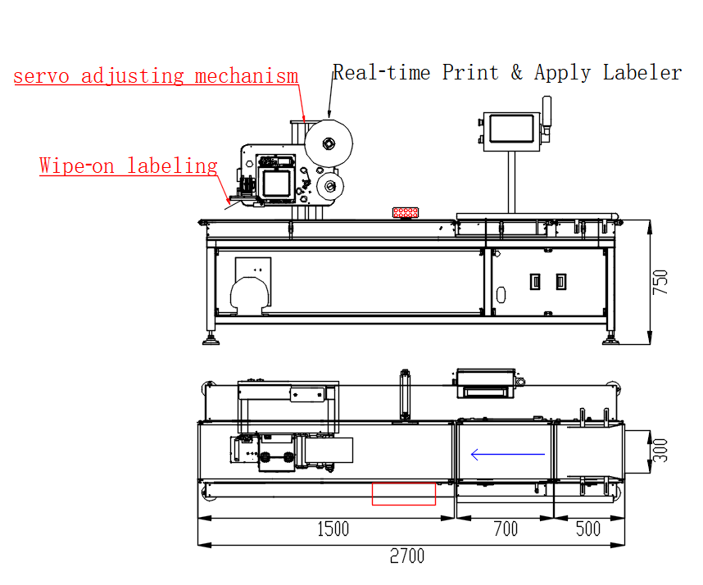
Figure 2 Machine layout, dimensions, and functional units
• When facing the display, the product conveying direction is from right to left.
• Infeed section length approx. 500 mm; weighing platform section length approx. 700 mm; printing section length approx. 1500 mm.
• The printer position can be adjusted by switching recipes to match the label position requirements of different products.
• The conveying height above floor is 750 mm, adjustable within ±50 mm.
3.2 Standard Workflow
Step 1: The product enters the infeed conveyor and is conveyed toward the weighing platform.
Step 2: The product enters the weighing platform for dynamic weighing.
Step 3: The system compares the real-time weight against the qualified minimum and qualified maximum values of the current recipe.
Step 4: Non-conforming products are rejected by the pusher; qualified products continue into the printing & labeling section.
Step 5: The printer generates a label from its buffer and applies it to the product packaging surface.
Step 6: After labeling is complete, the product moves to the next station.
📝 Note: Typical application: the current technical agreement specifies the product as cherries, and other products may be used in the future. Therefore, when changing products, reconfirm the product dimensions, weight range, label size, product spacing, speed, and recipe parameters.

4. Safety Instructions
⚠ Warning: Failure to follow the safety precautions in this chapter may result in personal injury, equipment damage, or product contamination. All personnel must read and understand this chapter before operating or servicing the machine.
4.1 Safety Symbols
Symbol | Meaning
⚠ Warning | Ignoring this warning may result in serious personal injury or equipment damage.
⚠ Caution | Ignoring this notice may result in personal injury or equipment damage.
📝 Note | Operating tips or supplementary information for correct use.
💡 Tip | Suggestions to improve operating efficiency.

4.2 Operator Requirements
• Only personnel who have received machine training are allowed to operate, modify parameters, calibrate, and maintain the machine.
• Before operation, become familiar with the conveying direction, weighing zone, rejection zone, printing & labeling zone, and the location of the emergency stop device.
• While the machine is running, do not put hands, tools, or other objects into moving areas such as the conveyor belt, rejection mechanism, or labeling mechanism.
• If the machine produces abnormal noise, abnormal vibration, continuous false rejection, or labeling faults, stop operation and inspect it according to the fault handling procedure.
4.3 Electrical Safety
• Before connecting or disconnecting any electrical wiring, switch off the main power and perform the Lockout/Tagout (LOTO) procedure.
• Confirm that the supply voltage matches the rating plate (AC 220–240 V, 50 Hz); never energize the machine with an incorrect voltage.
• The machine must be reliably grounded; the grounding resistance must be less than 100 Ω.
• A circuit breaker must be installed between the main supply and the machine; in damp environments, a residual current device (RCD / earth-leakage breaker) must be installed.
• The installation environment must be dry; prevent moisture, water vapor, or conductive liquids from entering the control cabinet.
• Do not open the control cabinet or modify internal wiring without authorization; contact SameGram service personnel for repairs.
• If damaged cables or aged insulation are found, stop the machine immediately and notify maintenance personnel.
4.4 Mechanical Safety
• While the machine is running, do not bring hands or any part of the body close to moving parts (conveyor belt, drive mechanism, rejection device, labeling mechanism).
• While the machine is running, do not remove or bypass the guards.
• If abnormal operation is found (abnormal noise, excessive vibration, unusual odor, smoke), press the emergency stop button immediately and investigate.
• During maintenance, switch off the main power and wait until all moving parts have fully stopped before proceeding.
• Do not clean the belt surface or adjust sensor positions while the conveyor is running.
• During operation, keep hands, loose clothing, and long hair away from the label peeling and application mechanism.
4.5 Labeling System Safety
• The labeling/printing mechanism contains heated components (thermal printhead) whose temperature may exceed 60 °C during operation; allow the printhead to cool for at least 2 minutes before touching it.
• Do not put hands into the labeling mechanism while the machine is running; the labeling arm moves rapidly and may cause pinch injuries.
• Use only SameGram-specified label rolls and ribbons; non-approved consumables may damage the printhead or cause print quality problems.
• When replacing label rolls or ribbons, ensure the machine is stopped and the printhead has cooled down.
• Do not manually pull the label web from the dispensing edge while the machine is running; this may cause misalignment, label jamming, or damage to the label feeding mechanism.
• Keep the printhead clean; a dirty printhead degrades print quality and shortens its service life.
4.6 Pneumatic Safety
• The air supply pressure must be kept between 0.5–0.8 MPa; excessive pressure may damage the cylinders and labeling mechanism.
• Before servicing pneumatic components, shut off the air supply and release residual pressure in the lines.
• Ensure all pneumatic fittings are securely connected to prevent high-pressure air leaks.
• Regularly inspect the air filter (FRL unit) and drain accumulated water in a timely manner.
4.7 Emergency Stop Procedure
The machine is equipped with an emergency stop button. Press the emergency stop button immediately in the following situations:
• A person is injured or at risk of injury.
• The machine operates abnormally or is out of control.
• Fire, smoke, or unusual odor.
• Label jamming or mechanical blockage that cannot be safely cleared during operation.
• Any situation that endangers the machine or personnel safety.
After the emergency stop is pressed, all motion stops immediately (including the conveyor motor, label printer, and labeling mechanism). After clearing the fault, release the emergency stop button by rotating it clockwise, then restart the machine following the normal procedure.
📝 Note: It is recommended to test the emergency stop button function at least once a week to ensure it remains effective.
4.8 Safety Principles for Parameter Modification & Calibration
• Parameters such as speed, weighing accuracy, I/O, PLC actions, and reject delay directly affect machine operation and should only be modified by trained personnel.
• After modifying a recipe, always save it and verify the weighing, rejection, printing, and labeling results using trial-run products.
• The technical documentation clearly states that some parameters such as speed, accuracy, belt speed, and I/O have already been commissioned and are generally not recommended for operators to modify on their own.
• Before performing empty scale calibration, confirm that the weighing platform is free of products and external interference.
• When performing load calibration, place the standard weight at the center of the weighing platform and execute load calibration after confirming the reading is stable.
5. Installation, Pre-start Checks & Shutdown
5.1 Unpacking Inspection
After unpacking, check all items against the packing list. If any item is missing or damaged, do not proceed with installation; contact the SameGram distributor or service representative immediately.
No. | Item | Qty | Remarks
1 | Weighing & labeling machine (main unit) | 1 | —
2 | Power cord | 1 | AC 220 V
3 | Operation manual (this document) | 1 | —
4 | Packing list | 1 | —
5 | Calibration weights | Per order | Optional
6 | Label roll (sample) | 1 | Optional
7 | Ribbon roll (sample) | 1 | Optional
8 | Communication cable | Per order | Optional

5.2 Positioning & Leveling
• Choose a location away from vibration sources (air compressors, presses, forklifts, etc.); ground vibration directly affects weighing accuracy.
• Ensure the floor is level (within 2 mm per 1 m) and able to bear the machine weight.
• Ensure adequate working space: at least 800 mm on the operator side and at least 500 mm on the maintenance side.
• Adjust the four adjustable feet so the weighing conveyor is level both longitudinally and laterally; tighten the lock nuts after leveling.
• Remove all shipping bolts, foam pads, and transport fixtures from the weighing conveyor, load cell assembly, and label printing module (keep them for future transport).
• Align with upstream/downstream conveyors; the maximum step height between belt surfaces must not exceed 2 mm, and confirm products pass smoothly without tipping, jamming, or falling.
• Avoid direct sunlight, heaters, and air-conditioner outlets blowing directly onto the machine.
5.3 Power Supply & Grounding
• Confirm the supply voltage matches the rating plate (AC 220–240 V, 50 Hz).
• Install a dedicated circuit breaker for the machine; do not share the power supply with high-power inductive loads.
• The grounding conductor cross-section must not be smaller than that of the main supply conductors; the grounding resistance must be less than 100 Ω.
• Before connecting power, confirm the main circuit breaker is in the OFF position.
5.4 Air Supply Connection
• Connect the plant compressed-air supply to the FRL (filter-regulator) unit and adjust the pressure to 0.5–0.8 MPa.
• Install a shut-off valve upstream of the FRL to isolate the air supply during maintenance.
• Use soap solution to check all pneumatic fittings for leaks.
• Regularly drain the FRL water bowl to prevent moisture from entering the pneumatic cylinders.

5.5 Pre-start Checks
Check Item | Acceptance Criterion
Machine installed stably | All four feet leveled and locked; no foreign objects on the conveyor and weighing platform area
Product matches recipe | Product size, weight, and label size match the current recipe
Air supply pressure | Within 0.5–0.8 MPa
Power supply | AC 220–240 V, 50 Hz
Label material | Print label material installed correctly; print content consistent with the current product recipe
Product spacing | Product spacing greater than one weighing platform length
Safety area | No personnel or obstacles in the rejection area and subsequent stations
Guards | All guards and covers in place; emergency stop button released

5.6 Start-up Operation
• Power on the machine and enter the control system.
• Confirm the current recipe is correct.
• To run only the conveyor for inspection, use Motor Start; this mode does not perform weighing, labeling, or rejection.
• After confirming the conveying direction, product position, and belt operation are normal, use Start to launch the full production process.
• First perform a trial run with a small number of products to check the weighing results, accept/reject decision, rejection position, print content, and labeling position.
• After confirming the trial run is normal, proceed to continuous production.
💡 Tip: On first start-up, run the machine unloaded for at least 5 minutes to reach thermal equilibrium before calibration and production, to ensure stable weighing.
5.7 Shutdown Operation
• Stop feeding products into the machine.
• Wait for the products inside the machine to complete the current conveying and labeling process.
• Use Stop to halt the full production process.
• If necessary, stop the motors and switch off the machine power.
• After production, perform inspections according to the on-site cleaning and maintenance requirements.

6. HMI & Basic Operation
6.1 Main Interface
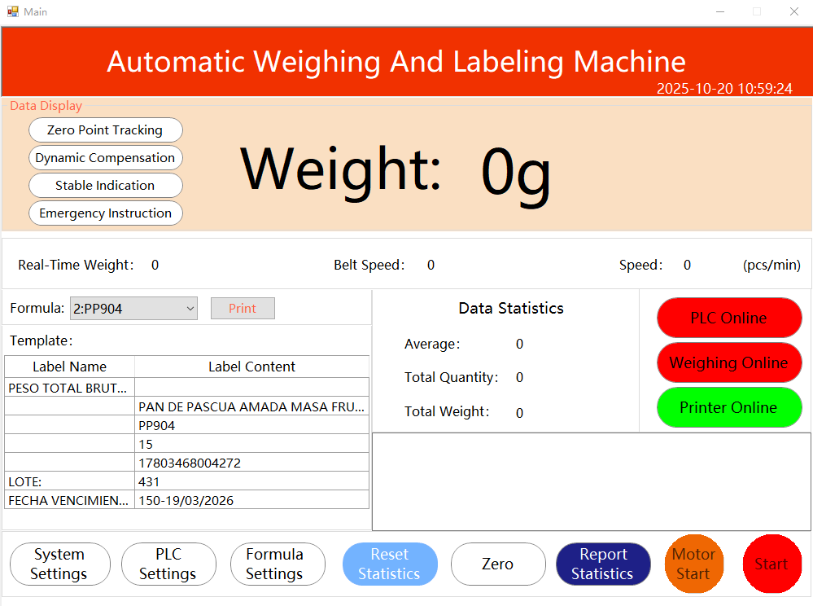
Figure 3 Control system main interface
The main interface is the primary operating interface of the machine. It is displayed automatically after system initialization, providing clear status information at a glance and access to all key functions. The function buttons on the main interface are described as follows:
Interface Function | Description
System Settings | Weighing module and weighing platform calibration settings.
PLC Settings | PLC action settings and rejection action debugging.
Recipe Settings | Recipe settings for print content, speed, accuracy, and accept range.
Reset Statistics | Resets the data statistics.
Zero | Resets the real-time weight value to zero.
Report Statistics | View product data for the current date, or query data by time.
Motor Start / Motor Stop | Starts/stops only the conveyor; does not perform weighing, labeling, or rejection.
Start / Stop | Starts/stops the full production process, including weighing, acceptance, print & apply labeling, and related rejection actions.
6.2 Operating Recommendations
Daily operating principle: operators mainly use functions such as recipe selection/confirmation, Zero, Start/Stop, and Report Statistics; system calibration, PLC, I/O, and low-level speed parameters should be handled by trained engineering personnel.

7. Weighing Platform Setup & Calibration
⚠ Warning: Calibration is the most critical operation for ensuring weighing accuracy. Perform calibration on a level, stable, vibration-free surface. Do not touch the conveyor or place any objects on the weighing platform during calibration.
7.1 Empty Scale Calibration
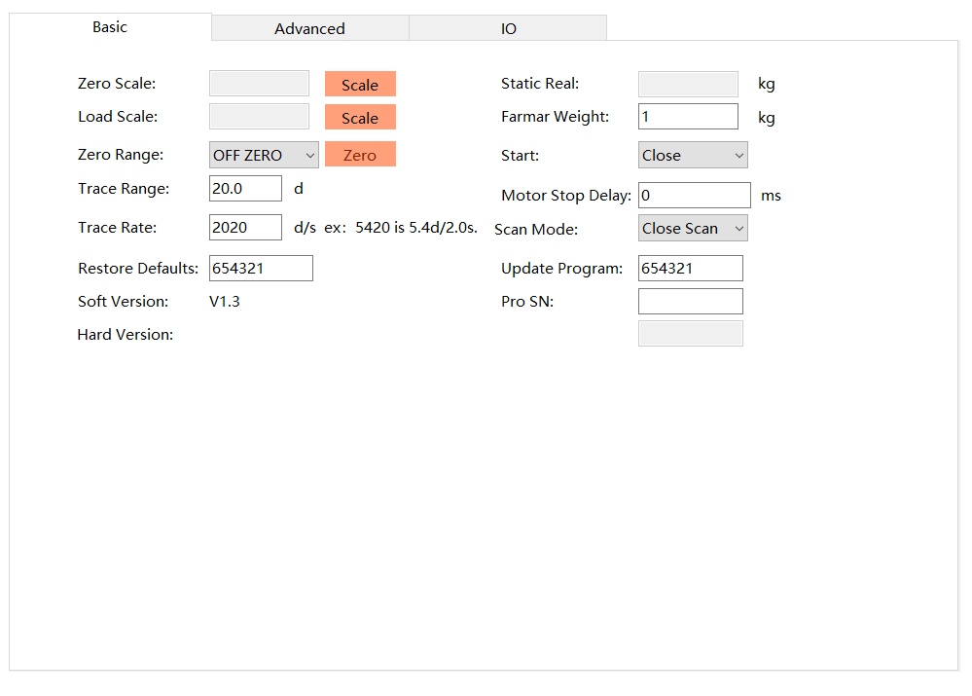
Figure 4 Weighing platform setup interface
• Confirm there are no products, tools, or other external interference on the weighing platform conveyor.
• Enter System Settings / Weighing Platform Setup.
• Confirm the weighing platform is in a stable state.
• Click Empty Scale Calibration to perform empty scale calibration.
7.2 Load Calibration
• Enter the standard weight value in the calibration interface.
• Place the standard weight at the center of the weighing platform.
• After the weight stabilizes, click Load Calibration.
• After calibration is complete, remove the standard weight and verify using actual products.
📝 Note: Always complete the empty scale calibration first, then set the weight value and perform load calibration; if the zero calibration is incorrect, the span calibration will also be incorrect. The actual calibration procedure shall follow the machine's current software version.
7.3 Belt Speed Calibration
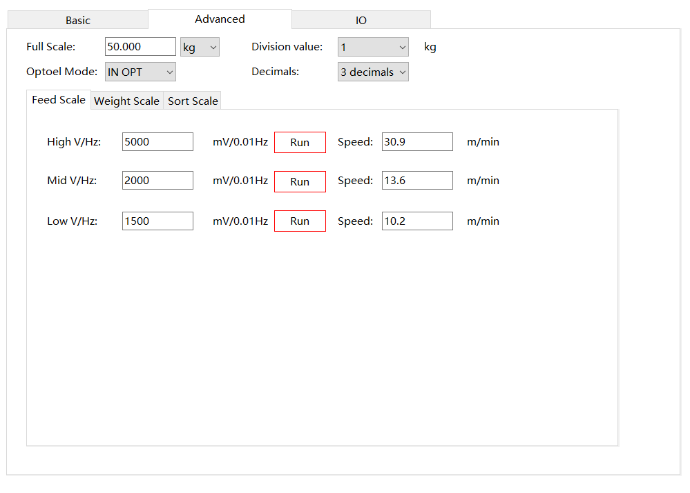
Figure 5 Belt speed calibration interface
The existing software documentation indicates this page has already been adjusted and normally does not need to be modified. If adjustment is truly required, it should be performed by engineering personnel, and the weighing, rejection, and labeling synchronization must be re-verified after adjustment.
7.4 I/O Output Settings
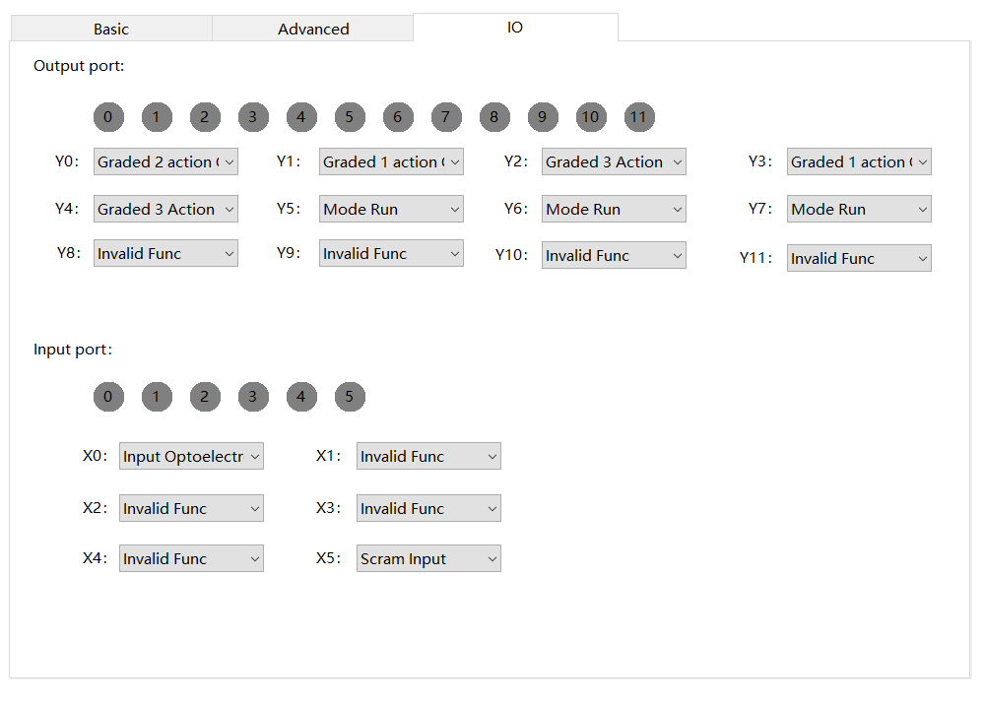
Figure 6 I/O output settings interface
The existing software documentation indicates this page has already been adjusted and normally does not need to be modified. Do not arbitrarily change output functions without first confirming the I/O mapping.

8. Recipe Management & Weight Acceptance Parameters
8.1 Basic Recipe Modification Procedure
• Enter Recipe Settings.
• Select the recipe to be modified.
• Click Modify Recipe.
• Modify the relevant parameters.
• After finishing, you must click Save Recipe to save.
• Verify with a small number of products to confirm that weighing, acceptance, printing, and labeling all function normally.
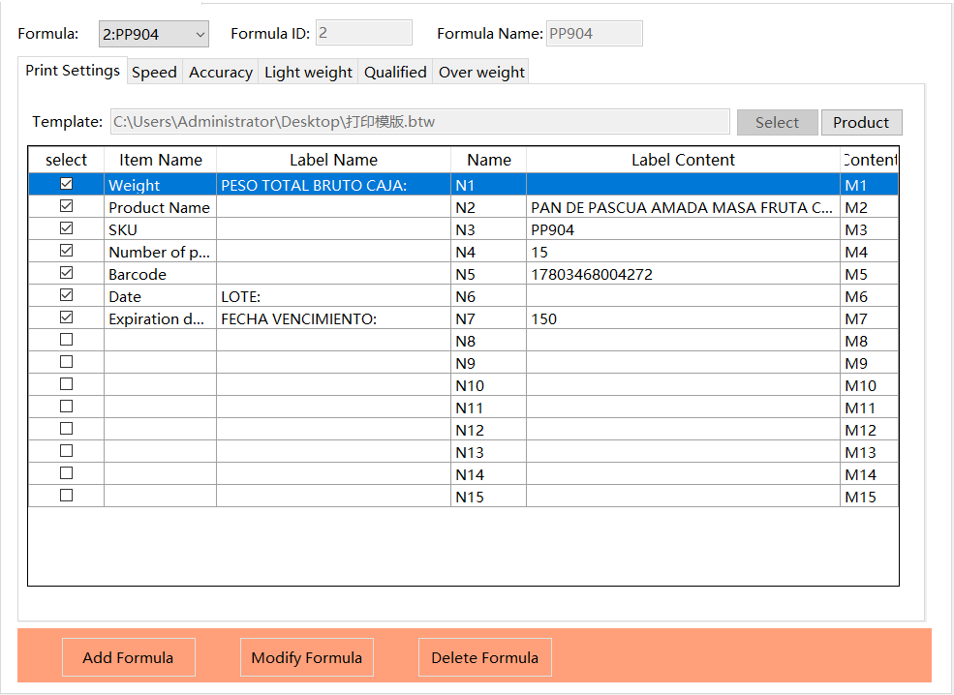
Figure 7 Recipe & print content settings interface
8.2 Print Content
The print content can be modified according to product requirements. The typical label content specified in the existing project documentation includes: date and production batch number; a barcode is sometimes required.
8.3 Speed Parameters
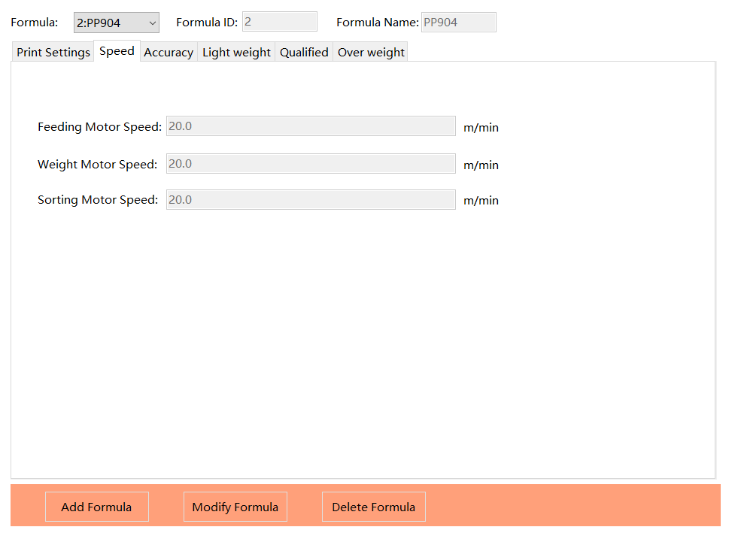
Figure 8 Speed settings interface
The software documentation indicates the motor speed has already been set and is generally not recommended to be modified. The machine technical agreement also notes that speed is related to the product weighing pitch, product length, and accuracy.
8.4 Accuracy & Dynamic Weighing Parameters
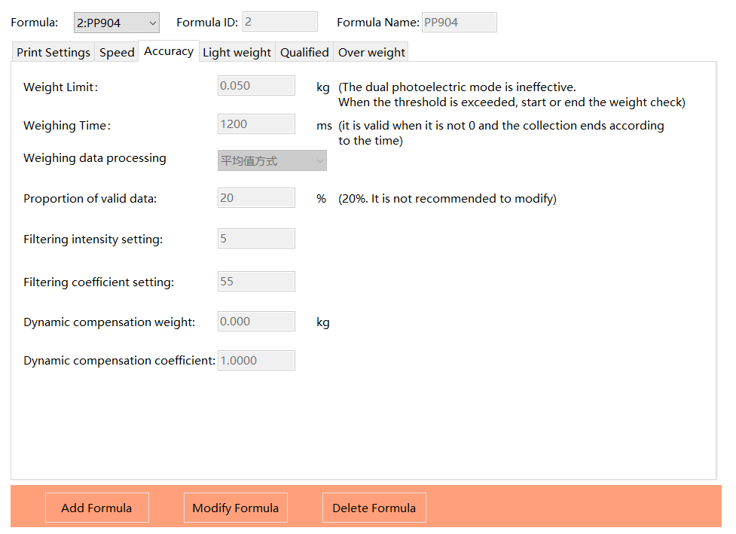
Figure 9 Accuracy / Light weight / Overweight parameter interface
Accuracy is a product weighing-related parameter and is generally not recommended to be modified. Dynamic compensation and other dynamic compensation parameters are also machine commissioning parameters and should be adjusted by engineering personnel based on the actual product and site conditions.
8.5 Accept Range Settings
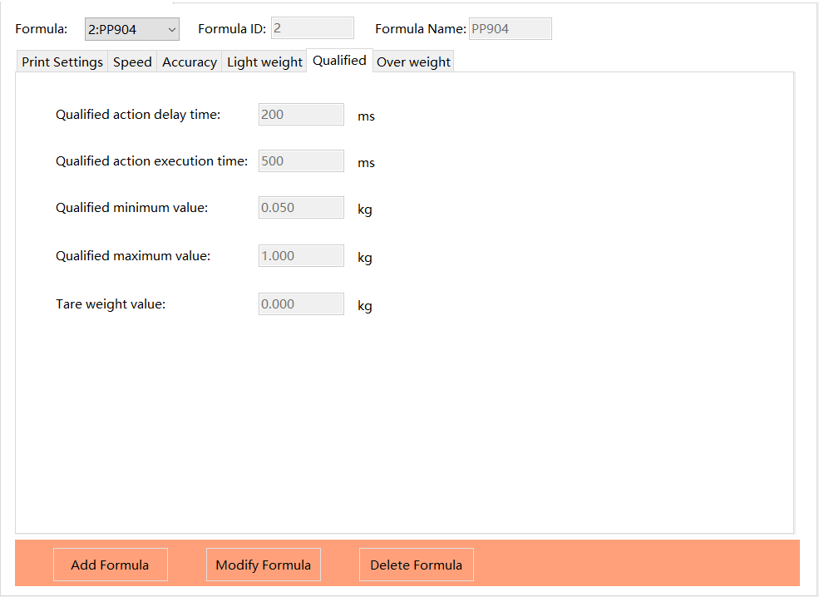
Figure 10 Qualified settings interface
Parameter | Definition
Qualified action delay | The delay time from the completion of the weighing time count to the qualified green light turning on.
Qualified action execution time | The duration the qualified green light remains on.
Qualified minimum value | The lower limit of the product's qualified weight.
Qualified maximum value | The upper limit of the product's qualified weight.
Tare weight value | The product tare weight; can be set directly.

9. Printing & Labeling Settings
9.1 Label Print Content
Current project documentation: date and production batch number; some products may require a barcode. The label content should be consistent with the customer's production and traceability requirements. After modifying print fields, perform a trial print before continuous production.
9.2 Label Size
Item | Size
Project main label | 105 × 60 mm
Adaptable label size (listed in documentation) | 135 × 63 mm
Adaptable label size (listed in documentation) | 136.7 × 70 mm
Adaptable label size (listed in documentation) | 50 × 79.5 mm
Adaptable label size (listed in documentation) | 50 × 70 mm

📝 Note: The label sizes come from this project's technical agreement. Different label sizes affect printing, label dispensing, labeling position, and speed; on-site verification should be performed after changing label specifications.
9.3 Printer Position Adjustment
• The printer position can be adjusted to the corresponding position by switching recipes.
• After adjustment, confirm the relative position of the label and the product surface through a trial run.
• Do not put hands directly into the printing or labeling mechanism for adjustment while the machine is running.
9.4 Barcode Printing Notes
The printing system supports printing one-dimensional barcodes on labels. When using barcodes such as GS1-128, application identifier (AI) data mapping such as weight and price can be configured through the label template. The specific barcode format and mapping method shall follow the current software version and the customer's traceability requirements.
9.5 Priority Checks for Printing/Labeling Faults
• Whether the current recipe is correct.
• Whether the print content is correct and has been saved.
• Whether the label material and size match the current recipe.
• Whether the product spacing meets the machine requirements.
• Whether the printer position and labeling position are correct.
• Whether the product speed has changed.
10. Rejection & PLC Parameter Description
10.1 PLC Settings Page
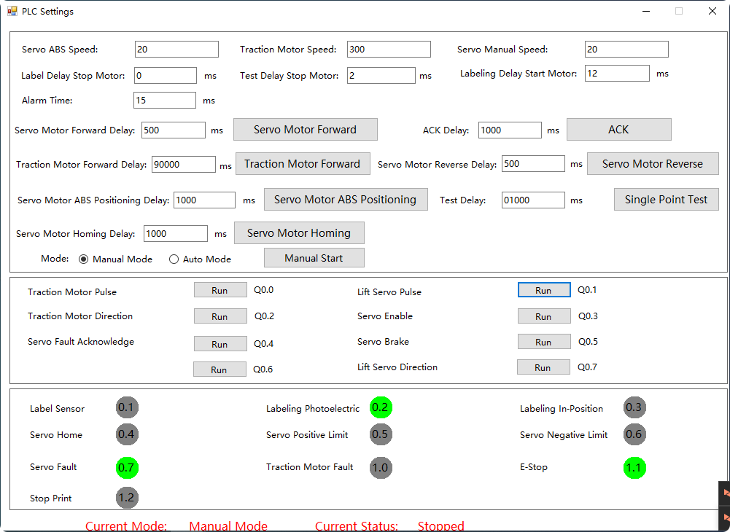Figure 11 PLC action debugging page
This page is used for PLC rejection action debugging; the reject execution time can be adjusted and the PLC status observed. PLC settings may only be modified by qualified SameGram service personnel or trained system integrators.
10.2 Reject Delay for Non-conforming Products
Reject delay refers to the delay time corresponding to a rejection action, normally set at the time point required for the actual rejection position of the non-conforming product; an earlier or later position may be used depending on site conditions. When the checkweigher motor speed changes, the corresponding reject delay should also be re-adjusted.
10.3 Reject Execution Time
The reject execution time corresponds to the action duration of a rejection mechanism; the documentation notes that this execution time does not include the duration of the action itself.
10.4 Precautions
⚠ Warning: Reject delay is directly related to conveying speed, product spacing, and product position. After modification, verification must be performed using known good and bad products to confirm that no false rejection, missed rejection, or misplaced rejection occurs.
11. Data Statistics & Reports
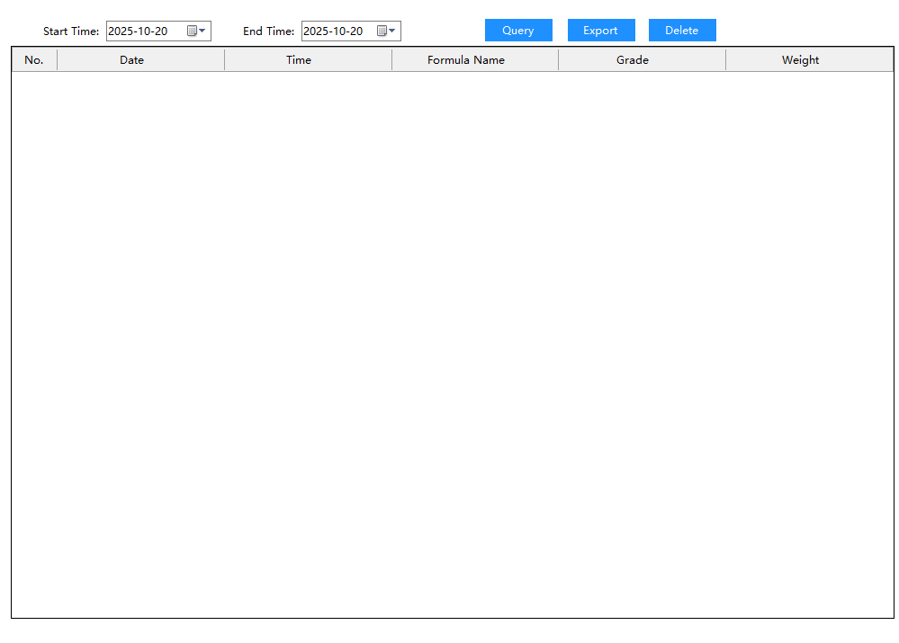
Figure 12 Data statistics report interface
11.1 Viewing Reports
Report Statistics is used to view production data. The system supports viewing product data for the current date and, according to the software documentation, querying data by time range.
11.2 Data Query & Export
• Enter the Report Statistics interface.
• Set the start date/time and end date/time to query.
• The query results are displayed in table form with summary statistics.
• Data can be exported in CSV format via the USB interface (the USB drive must be formatted as FAT32).
📝 Note: The specific fields and export method of the report data shall follow the current software version interface. Export a backup before deleting data; deleted data cannot be recovered.

12. Daily Cleaning & Maintenance
⚠ Warning: Before any maintenance work, always switch off the main power and perform Lockout/Tagout (LOTO). Maintenance during machine operation is strictly prohibited.
12.1 Maintenance Schedule
Maintenance Task | Daily | Weekly | Monthly | Quarterly | Yearly
Inspect conveyor belt for damage, wear, or contamination | ✓
Clean the weighing conveyor belt surface | ✓
Inspect photoelectric sensors and clean lenses | ✓
Confirm zero calibration (unloaded) | ✓
Check label and ribbon stock | ✓
Clean the printhead with alcohol swabs |  | ✓
Inspect and clean conveyor rollers and pulleys |  | ✓
Check conveyor belt tension and tracking |  | ✓
Check all fasteners for looseness |  | ✓
Inspect pneumatic fittings and drain the FRL water bowl |  | ✓
Clean the labeling mechanism and peel plate |  | ✓
Inspect cable connections and cable routing |  |  | ✓
Confirm full-scale calibration using calibration weights |  |  | ✓
Inspect labeling mechanism cylinders for wear |  |  | ✓
Clean inside the control cabinet and check connections |  |  |  | ✓
Replace the air filter element |  |  |  | ✓
Full performance check of load cells |  |  |  |  | ✓
Inspect and replace worn conveyor belts |  |  |  |  | ✓
Replace the thermal printhead |  |  |  |  | ✓
Perform calibration verification using certified weights |  |  |  |  | ✓

12.2 Cleaning Specifications
Approved cleaning materials:
• Soft plastic brush or soft cloth (for sweeping and wiping).
• Neutral detergent (pH neutral) dissolved in warm water (below 40 °C).
• Clean water for rinsing.
• Soft, dry microfiber cloth for the touchscreen.
• Isopropyl alcohol swabs for cleaning the printhead.
Prohibited cleaning materials:
• Metal brushes, steel wool, abrasive scrubbers, or scouring pads.
• Organic solvents (thinners, toluene, benzene, acetone; except alcohol used for cleaning the printhead).
• High-pressure water jets or steam cleaners.
• Bleach or strong acid/alkali cleaners that may corrode stainless steel or damage seals.
Cleaning procedure:
• Unplug the power and allow the printhead to cool for at least 2 minutes.
• Remove loose debris with a soft brush or soft cloth.
• Apply neutral detergent solution with a soft cloth or sponge.
• Pay special attention to areas prone to debris accumulation, such as the weighing conveyor surface, the labeling mechanism, and the joints between the conveyor and the frame.
• Rinse thoroughly with clean water to remove all detergent residue, then wipe dry with a clean soft cloth.
• Ensure the conveyor is completely dry before resuming operation.
⚠ Warning: Do not spray water directly onto the control cabinet, load cell, printhead, or electrical components. For food-contact applications, use industry-recognized food-grade detergents.
12.3 Label Printer Maintenance
12.3.1 Printhead Cleaning
• Switch off the machine power and allow the printhead to cool for at least 2 minutes.
• Open the print compartment cover and remove the ribbon (if thermal transfer is used).
• Gently wipe the printhead heating elements with isopropyl alcohol swabs.
• After the alcohol has completely evaporated (about 30 seconds), reinstall the ribbon and close the compartment cover.
• Clean the printhead once a week; increase the cleaning frequency if print quality deteriorates.
12.3.2 Platen Roller Cleaning
• Switch off the machine power, open the print compartment, and remove the label roll.
• Wipe with alcohol swabs while manually rotating the platen roller to remove adhesive residue or label debris from the roller surface.
12.3.3 Label Sensor Cleaning
The label gap sensor is used to detect the gaps between labels on the label roll. If the sensor becomes dirty, label feeding may malfunction. After switching off the power, gently clean the sensor lens with a swab moistened with a small amount of alcohol, then wipe dry with a clean swab.
12.4 Maintenance Authority
Personnel | Scope of Responsibility
Operator | Daily cleaning, visual inspection, recipe selection, and basic operation.
Maintenance Personnel | Mechanical adjustment, pneumatic inspection, and transmission component maintenance.
Engineering Personnel | Weighing calibration, PLC/I/O, speed, dynamic compensation, and low-level parameter adjustment.

13. Common Faults & Troubleshooting
Refer to the table below to diagnose and troubleshoot common problems. If the problem persists after applying the recommended measures, contact SameGram technical support.
13.1 Weighing & Acceptance Problems
Symptom | Priority Check | Recommended Action
Unstable real-time weight | External interference on the weighing platform; product condition; site vibration/airflow | Clear the weighing platform and perform empty scale calibration; confirm stable product conveying; have engineering personnel check parameters if necessary.
Qualified products are rejected | Qualified min/max values; recipe; weighing accuracy | Confirm the current recipe and accept range; verify using products of known weight.
Non-conforming products are not rejected | Reject delay; conveying speed; PLC status | Confirm whether the speed has changed; re-calibrate the reject delay; have engineering personnel check PLC actions.
Rejection position offset | Conveying speed; product spacing; reject delay | After a speed change, re-adjust the corresponding delay and run a trial.
Unstable static weight reading | Machine not leveled; load cell overloaded or damaged; external vibration | Re-level all feet; check the load cell; eliminate the vibration source.
Weight reading drifts over time | Zero drift caused by temperature change; zero tracking not configured | Warm up for ≥5 minutes and re-zero; have engineering personnel configure zero tracking.

13.2 Label Printing & Labeling Problems
Symptom | Priority Check | Recommended Action
Label position offset | Printer position; product size; label size; conveying speed | Adjust the printer position according to the current recipe and perform a trial application.
Incorrect print content | Current recipe; print fields; whether the recipe is saved | Click Modify Recipe to make changes, then click Save Recipe and redo a trial print.
Labels not printing | Whether the label roll is empty; whether the ribbon is empty; printhead status | Replace the label roll/ribbon; check the printhead connection; contact technical support if necessary.
Poor print quality (blurred/incomplete) | Dirty printhead; wrinkled ribbon; uneven printhead pressure | Clean the printhead with alcohol swabs; realign the ribbon; adjust the printhead pressure.
Label jamming in the labeling mechanism | Incorrect label web threading; adhesive on the peel plate; timing misalignment | Re-thread the label web as illustrated; clean the peel plate; adjust the labeling timing.
Barcode cannot be scanned | Print resolution too low; barcode size too small; insufficient contrast | Enlarge the barcode size; check the ribbon and printhead; ensure flat label application.
Label weight does not match display | Incorrect template data mapping; communication delay; recipe mismatch | Confirm template field mapping; check communication settings; confirm the correct recipe is active.

13.3 Mechanical & System Problems
Symptom | Priority Check | Recommended Action
Conveyor not running | Power; Motor Start/Stop status; control system status | Confirm machine power and control status; if still abnormal, have maintenance personnel inspect.
Abnormal pneumatic rejection | Air supply pressure; air circuit; PLC action | Confirm the air supply is within 0.5–0.8 MPa; check the pneumatic actuator and PLC status.
Motor does not run after pressing START | Emergency stop triggered; loose motor connector; shutdown time too short | Release the emergency stop button; re-seat the motor connector; after an abnormal stop, wait about 1 minute before restarting.
Conveyor belt slips or tracks off | Insufficient belt tension; worn drive pulley | Adjust the belt tensioner; replace the drive pulley.
HMI prompts to release the emergency stop | Emergency stop button pressed | Rotate the emergency stop button clockwise to release.
USB export fails | USB drive not formatted as FAT32; USB drive full | Format the USB drive as FAT32; free up USB drive space.
Touchscreen unresponsive | Protective film causing touch offset; HMI controller fault | Remove the protective film and recalibrate the touch; restart the HMI.

14. Label & Product Compatibility Requirements
14.1 Current Project Product
The technical agreement notes: the current product is cherries, and other products may be used later. Therefore, the actual optimal operating parameters of this machine shall be determined by the specific product and label conditions.

14.2 Items to Confirm When Changing Products
Confirmation Item | Requirement
Product size | Length, width, and height within 150–320 × 120–220 × 50–120 mm
Product weight | Within the 200–3000 g weighing range
Product spacing | Meets the requirement of being greater than one weighing platform length
Label size | Matches the machine's current configuration
Application surface | Suitable for top-surface wipe-on application
Print fields | Confirm print field requirements such as date, batch number, and barcode
Parameter reset | Confirm whether the accept weight range, speed, and reject delay need to be re-set

15. After-sales Service & Warranty
15.1 Warranty Terms
• The complete machine and accessories are provided with a one-year free warranty service according to the company's technical agreement.
• All circuit boards are provided with a 2-year free replacement warranty.
• Lifetime maintenance.
• For equipment or component damage caused by product design, installation workmanship, materials, or product quality, free replacement and repair are provided within the warranty period; after one year, replacement part charges are applied as agreed in the technical agreement.
• Installation, commissioning, and operator training are provided according to customer needs, along with maintenance guidance and regular follow-up visits.
15.2 Warranty Coverage & Exclusions
This warranty does not cover the following: damage caused by improper installation, unauthorized modification, or repair by non-authorized personnel; damage caused by using non-approved consumables, detergents, or methods; operation outside the specified environmental conditions; and normal wear of consumable parts (conveyor belt, printhead, ribbon, labels, fuses, cleaning supplies, etc.). For warranty service, please provide the machine serial number and proof of purchase. Do not attempt to disassemble or repair the machine yourself, as this may void the warranty.
15.3 Contact Information
Contact Information | Content
Company | SameGram Equipment Co., Ltd.
Address | No. 33, Sanjiang Industrial Zone, Hengli Town, Dongguan City, Guangdong Province, China
Website | www.samegram.com
Technical Agreement Contact | Yan Shaoqing
Technical Agreement Contact Phone | +8613712368272
Technical Agreement Contact Email | sale@samegram.com

16. Operator Quick Checklist
Confirm each item against this table before production, during production, and after shutdown, and check the corresponding status.
Check Item | Before Start-up | During Production | After Shutdown
Power supply AC 220–240 V / 50 Hz | □ | □ | □
Air supply 0.5–0.8 MPa | □ | □ | □
Weighing platform free of external interference | □ | □ | □
Current recipe correct | □ | □ | □
Product weight range correct | □ | □ | □
Product spacing meets requirements | □ | □ | □
Label size/material correct | □ | □ | □
Print date/batch/barcode correct | □ | □ | □
Qualified products pass normally | □ | □ | □
Non-conforming products rejected normally | □ | □ | □
Labeling position normal | □ | □ | □
Machine and conveying area clean | □ | □ | □

Thank you for choosing SameGram.
Document Version V2.0 | © 2026 SameGram Equipment Co., Ltd. | All Rights Reserved

