Automatic Weighing and Real-Time Label Printing Machine
OPERATION MANUAL
Document Version: V2.0 — August 2026
Applicable Models: SCL Series Weighing and Labeling Machines
Manufacturer: SameGram Equipment Co., Ltd.
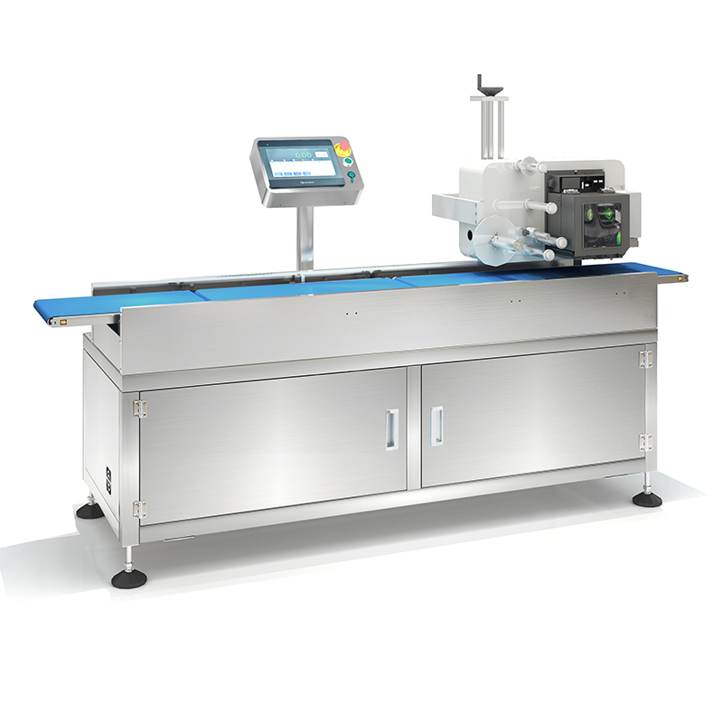Images are for reference only; the actual product shall prevail.
IMPORTANT: READ THIS MANUAL CAREFULLY BEFORE OPERATING THE EQUIPMENT

Document Information
Item | Details
Document Version | V2.0
Release Date | August 2026
Applicable Model | SCL Series (e.g., SCL-8050L30)
Language | English
Confidentiality | Controlled Document

Revision History
Version | Date | Description | Author
V1.0 | 2025-03 | Initial draft release | SameGram Engineering
V2.0 | 2026-08 | Full restructure to international standard; added product overview, safety, installation, commissioning, HMI guide, label printing, troubleshooting, and maintenance chapters | SameGram Engineering

Table of Contents
- 1. Introduction
- 1.1 About This Manual
- 1.2 Intended Audience
- 1.3 Symbol Legend
- 1.4 Product Overview
- 1.5 Key Features
- 1.6 Application Industries
- 1.7 Storage and Transportation Requirements
- 2. Safety Instructions
- 2.1 General Safety Guidelines
- 2.2 Personnel Requirements
- 2.3 Electrical Safety
- 2.4 Mechanical Safety
- 2.5 Labeling System Safety
- 2.6 Emergency Stop Procedure
- 2.7 Pneumatic Safety
- 3. Technical Specifications
- 3.1 General Specifications
- 3.2 Weighing Performance
- 3.3 Label Printing Specifications
- 3.4 Environmental Requirements
- 4. Machine Overview
- 4.1 System Components
- 4.2 Operating Principle
- 4.3 Nameplate Information
- 5. Installation
- 5.1 Unpacking Inspection
- 5.2 Site Preparation
- 5.3 Step-by-Step Installation Procedure
- 5.4 Power Supply and Grounding
- 5.5 Pneumatic Supply Connection
- 6. Commissioning and Start-Up
- 6.1 Pre-Start Checklist
- 6.2 First Power-On Procedure
- 7. HMI Operation Guide
- 7.1 Login and Access Levels
- 7.2 Home Screen Overview
- 7.3 Main Interface Elements
- 8. System Settings
- 8.1 Weighing Calibration
- 8.2 Device Settings
- 8.3 Motor and Speed Settings
- 8.4 IO Settings
- 8.5 PLC Settings
- 9. Recipe and Product Settings
- 9.1 Recipe Management
- 9.2 Speed Settings
- 9.3 Precision Settings
- 9.4 Auto-Learning
- 9.5 Qualification (Sorting) Settings
- 10. Label Printing Configuration
- 10.1 Print Content Setup
- 10.2 Label Template Management
- 10.3 Barcode and QR Code Printing
- 10.4 Print Verification
- 11. Report and Statistics
- 12. Communication Interfaces
- 12.1 RS485 Modbus RTU
- 12.2 Modbus TCP (Ethernet)
- 12.3 Industrial Protocol Integration
- 13. Troubleshooting
- 14. Maintenance and Cleaning
- 14.1 Maintenance Schedule
- 14.2 Cleaning Guidelines
- 14.3 Label Printer Maintenance
- 15. Recommended Spare Parts
- 16. Appendices
- Appendix A — Unit Conversion Table
- Appendix B — Maintenance Record Log
- Appendix C — Technical Support
- Appendix D — Glossary of Terms

1. Introduction

1.1 About This Manual
This manual provides comprehensive information for the installation, operation, calibration, label printing configuration, and maintenance of the SameGram SCL Series Automatic Weighing and Real-Time Label Printing Machine. Please read this manual in its entirety — especially the Safety chapter — before installing or operating the equipment.
Keep this manual together with the product for future reference. Should you have any questions not addressed in this document, please contact SameGram Technical Support (see Appendix C).
⚠ WARNING: Ensure all safety content in Chapter 2 has been read and understood before operating this equipment. Failure to observe safety precautions may result in personal injury or equipment damage.

1.2 Intended Audience
This manual is intended for the following personnel:
- Equipment Operators — Personnel responsible for day-to-day operation, product changeover, and basic monitoring.
- System Administrators — Personnel responsible for system parameter configuration, calibration, and recipe management.
- Maintenance Technicians — Qualified personnel responsible for preventive maintenance, troubleshooting, and component replacement.
- System Integrators — Engineers responsible for integrating the equipment into production lines and communication networks.

1.3 Symbol Legend
The following symbols are used throughout this manual to highlight important information:
Symbol | Meaning
⚠ WARNING | Ignoring this warning may cause serious personal injury or death.
⚠ CAUTION | Ignoring this notice may cause personal injury or equipment damage.
📝 NOTE | Operational tip or supplementary information for correct use.
💡 TIP | Suggestions for improving operational efficiency.

1.4 Product Overview
The SameGram SCL Series Automatic Weighing and Real-Time Label Printing Machine is a high-precision, integrated system that combines dynamic checkweighing with on-demand label printing and application. Designed for end-of-line packaging automation, the SCL Series enables seamless synchronization of weighing, label generation, and label application in a single compact footprint.
The system employs a high-resolution digital load cell combined with an advanced DSP (Digital Signal Processor) signal processing algorithm to achieve high-speed, high-accuracy dynamic weighing. Weight data is synchronized in real time with the label printing module, ensuring that every label printed reflects the actual measured weight of the corresponding product. This real-time data synchronization eliminates label-weight mismatch errors and supports full product traceability.
The SCL Series is part of SameGram’s modular combination system family, which can be further equipped with metal detection, barcode scanning, or inkjet marking modules to establish comprehensive industrial inspection and traceability applications. The modular structure enhances flexibility while reducing equipment footprint and maintenance costs.
By supporting real-time data tracking and process control, the system helps customers reduce production risks, optimize workflow, and strengthen market competitiveness. It is a compact, efficient, and intelligent solution for modern manufacturing environments.

1.5 Key Features
- Real-Time Weight-to-Label Synchronization: Weight data is transmitted to the label printer in real time, ensuring every label matches the actual product weight with zero lag.
- High-Speed Dynamic Weighing: Belt speed up to 120 m/min with dynamic accuracy of ±0.1 g to ±2.0 g (product and speed dependent), ensuring minimal weight error at high throughput.
- Integrated Label Printing and Application: On-demand thermal transfer or direct thermal printing with automatic label application, supporting barcode, QR code, weight, date, and custom text fields.
- Print and Verify Functionality: Built-in barcode and QR code validation after printing ensures label accuracy, regulatory compliance, and export readiness.
- Multi-Recipe Management: Supports up to 100 product recipes with quick switchover, each storing independent speed, precision, label template, and qualification parameters.
- Intelligent Filtering: Adaptive DSP digital filtering algorithm (intensity and coefficient adjustable) to suppress vibration interference and stabilize weight readings.
- Auto-Learning: Automatic parameter learning for fast product setup — the system samples the product and calculates optimal weighing parameters automatically.
- Comprehensive Statistics: Real-time under/accept/over-weight data with USB export in CSV format; supports full traceability across MES/ERP systems.
- User-Friendly Interface: 7-inch or 10-inch colour TFT touchscreen HMI with multi-language support and password-protected access control.
- Food-Grade Construction: 304 stainless steel frame with hygienic design; food-grade PU conveyor belt; washdown-ready for dusty or wet environments (IP54 standard, IP65 optional).
- Flexible Communication: Supports RS485 Modbus RTU, Ethernet Modbus TCP, TCP data stream, and integration with Ethernet/IP and Profinet networks.
- Modular Design: Flexible layout adapts to specific space, speed, and inspection requirements. Supports label-only, label + scan, or weigh-price labeler configurations.

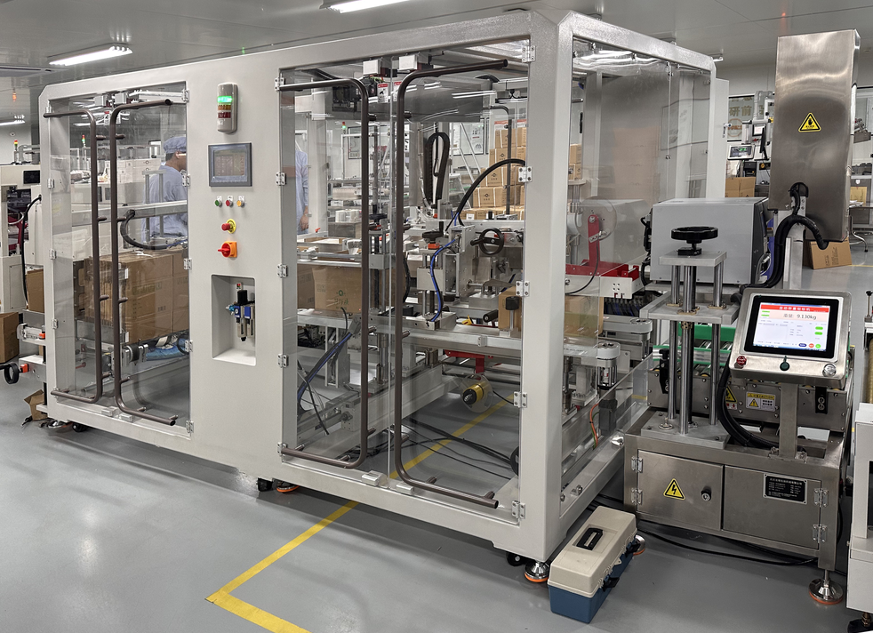
Figure 1-1: Multi-Function Integration — Modular Combination System

1.6 Application Industries
The SCL Series is widely used across multiple industries for net content inspection, under/over-weight detection, product grading, and automated labeling:
Industry | Industry | Industry | Industry
Food Processing | Pharmaceutical | Personal Care / Cosmetics | Chemical
Beverage | Hardware / Metal Parts | E-Commerce Logistics | Agricultural Products

Typical applications include:
- Net-weight labeling of pre-packaged food products
- Weight-graded labeling for agricultural produce (e.g., fruit, vegetables)
- Compliance labeling for pharmaceutical and personal care products
- Variable-weight labeling for fresh meat, seafood, and dairy products
- Shipping and logistics labeling with real-time weight data
- Production line traceability with barcode/QR code integration
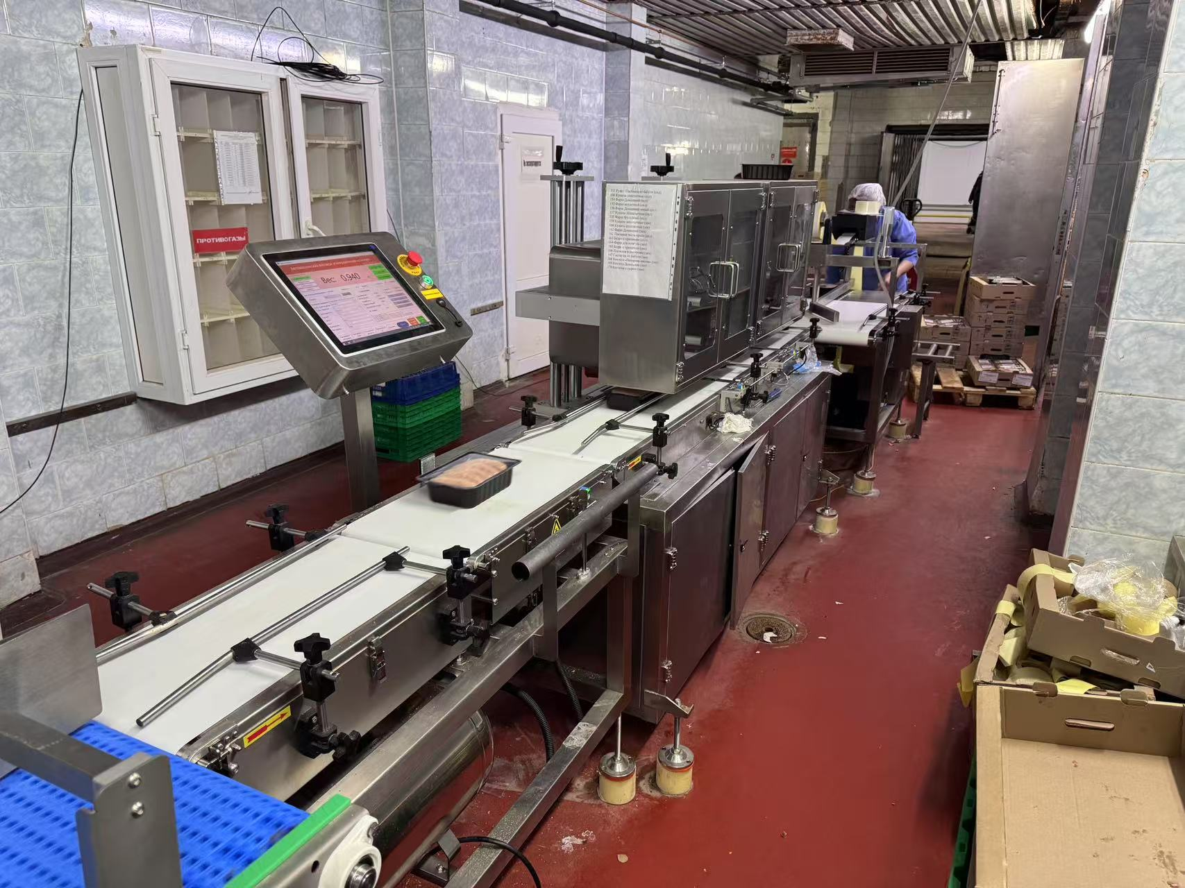
Figure 1-2: Application — Fresh Produce Automated Labeling

1.7 Storage and Transportation Requirements
Parameter | Requirement
Storage Temperature | -20°C to +60°C
Storage Humidity | 5% to 95% RH (non-condensing)
Transport Vibration | Max. 1G (horizontal)
Packaging | Original factory packaging with anti-vibration and moisture protection

2. Safety Instructions
⚠ WARNING: Failure to follow these safety instructions may result in personal injury, equipment damage, or product contamination. All personnel must read and understand this section before operating or servicing the equipment.

2.1 General Safety Guidelines
- This equipment must be used only for its intended purpose as described in this manual. Any unauthorized modification or use beyond the specified scope is prohibited.
- Do not operate the equipment in explosive atmospheres or in the presence of flammable gases or vapors.
- Keep the working area around the machine clean, dry, and free of obstructions. Ensure adequate lighting for safe operation.
- Do not use the equipment if it is damaged or malfunctioning. Tag out the equipment and notify maintenance personnel immediately.
- All safety guards, covers, and interlocks must be in place and functional before operating the equipment.
- Keep this manual accessible to all operators and maintenance personnel at all times.

2.2 Personnel Requirements
- Operators: Trained personnel familiar with this manual and basic safety knowledge. Operators may perform routine production operations, recipe selection, and basic monitoring.
- Maintenance Technicians: Hold electromechanical maintenance qualifications; familiar with industrial equipment maintenance procedures and electrical safety.
- Installation Engineers: Hold electromechanical installation qualifications; familiar with industrial automation equipment installation standards.
- Administrators: Responsible for system parameter configuration; hold system administrator account credentials.
⚠ WARNING: Inspection, installation, adjustment, and repair of this equipment must be performed by qualified personnel with professional knowledge. Operation by unqualified persons may result in equipment damage or serious personal injury.

2.3 Electrical Safety
- Before connecting or disconnecting any electrical wiring, shut off the main power switch and apply Lockout/Tagout (LOTO) procedures.
- Confirm that the equipment supply voltage matches the nameplate voltage. Never energize with mismatched voltage.
- The equipment must be reliably earthed. The cross-sectional area of the earth conductor must not be less than that of the main supply conductor. Ground impedance must be less than 100 Ω.
- The power supply must be a dedicated circuit, isolated from noise-producing equipment such as large motors and packaging machines.
- Install a circuit breaker between the main power supply and this equipment. In humid environments, a residual current device (RCD / leakage circuit breaker) must be installed.
- The installation environment must be dry. Prevent moisture, water vapour, or conductive liquids from entering the control cabinet.
- All electrical wiring must be completed by qualified electricians. Unqualified persons are prohibited from connecting wiring.
- Do not open the control cabinet or modify internal wiring without authorization. Contact SameGram service personnel for repairs.
- If damaged cables or degraded insulation are found, shut down immediately and notify maintenance personnel.
- Do not route the power cord in multiple directions or place heavy objects on it. Keep the power cord away from heating appliances.

2.4 Mechanical Safety
- During equipment operation, do not place hands or any part of the body near moving parts (belts, drive mechanisms, rejection devices, label applicator mechanism).
- Do not remove or bypass safety guards while the equipment is running.
- If abnormal operation is observed (unusual noise, excessive vibration, odour, smoke), press the Emergency Stop button immediately and investigate.
- During maintenance, shut off the main power and wait for all moving parts to come to a complete stop before proceeding.
- Do not clean the belt surface or adjust sensor positions while the belt is running.
- When repositioning the equipment, disconnect power first and ensure sufficient personnel to prevent tipping.
- Keep hands, loose clothing, and long hair away from the label dispensing and application mechanism during operation.

2.5 Labeling System Safety
- The label printer mechanism contains heated components (thermal print head). Allow the print head to cool for at least 2 minutes after operation before touching.
- Do not reach into the label applicator mechanism while the machine is running. The applicator arm moves rapidly and can cause pinch injuries.
- Use only label rolls and ribbons (for thermal transfer printing) specified by SameGram. Non-approved consumables may damage the print head or cause print quality issues.
- When replacing label rolls or ribbons, ensure the machine is stopped and the print head is cool.
- Do not manually pull the label tape from the dispenser while the machine is running — this can cause misalignment, jams, or damage to the feed mechanism.
- Keep the print head clean. A dirty print head can cause poor print quality and may overheat, shortening its service life.
⚠ CAUTION: The thermal print head reaches temperatures exceeding 60°C during operation. Always allow it to cool before handling to avoid burn injuries.

2.6 Emergency Stop Procedure
The equipment is fitted with an Emergency Stop button located on the front of the control cabinet. Press the Emergency Stop button IMMEDIATELY in the following situations:
- Personnel injury or risk of injury
- Abnormal equipment action or loss of control
- Fire, smoke, or unusual odour
- Label jam or mechanical obstruction that cannot be safely cleared during operation
- Any situation endangering equipment or personnel safety
After pressing the Emergency Stop, all movements cease immediately, including conveyor motors, label printer, and applicator mechanism. After resolving the fault, rotate the Emergency Stop button clockwise to release, then restart the equipment using the normal procedure.
📝 NOTE: Test the Emergency Stop button function regularly to ensure it is always operational. Testing at least once per week is recommended.

2.7 Pneumatic Safety
If the equipment is fitted with a pneumatic label applicator or rejection device:
- Air supply pressure must be maintained between 0.4 and 0.8 MPa. Excessive pressure may damage cylinders and applicator mechanisms.
- Before servicing pneumatic components, shut off the air supply and release residual pressure in the pipework.
- Ensure all pneumatic fittings are firmly connected to prevent high-pressure air leaks.
- Inspect air filters regularly and drain accumulated water promptly.

3. Technical Specifications

3.1 General Specifications
Parameter | Specification
Product Model | SCL Series (e.g., SCL-8050L30)
Manufacturer | SameGram Equipment Co., Ltd.
Weighing Range | 10 g – 6000 g (model dependent)
Dynamic Accuracy | ±0.1 g – ±2.0 g (depends on product weight and belt speed)
Belt Speed | 10 – 120 m/min (adjustable)
Max. Throughput | Up to 300 products/min (product and gap dependent)
Min. Product Length | 50 mm
Min. Product Gap | 100 mm (at maximum speed)
Load Cell Resolution | 0.01 g
Display Resolution | 0.1 g (g unit); 0.001 kg (kg unit)
Filter Algorithm | Adaptive DSP digital filter (intensity / coefficient adjustable)
Auto Zero Tracking | Configurable range and rate
Dynamic Compensation | Manual offset and coefficient adjustable
No. of Product Recipes | Up to 100
Classification Levels | 1 – 7 sorting levels
Data Memory | Up to 1,000,000 weighing records
Data Export | USB flash drive (CSV format)
Display | 7" / 10" colour TFT touchscreen, multi-language
Casing Material | Stainless Steel SUS304
Conveyor Belt | Food-grade PU belt, removable for cleaning
IP Rating | IP54 (standard); IP65 (optional)
Power Supply | AC 220V ±10%, 50/60 Hz, Single Phase
Power Consumption | 200 – 800 W (configuration dependent)
Operating Temperature | 0°C to +40°C (32°F to 104°F)
Operating Humidity | ≤ 90% RH, non-condensing
Warm-up Time | Minimum 5 minutes
Certifications | CE (EMC + MD + LVD), RoHS compliant

3.2 Weighing Performance
Parameter | Specification
Weighing Principle | Dynamic strain gauge load cell with DSP processing
Weighing Range | 10 g – 6000 g (model dependent)
Accuracy Class | Per OIML R-51 Class X(1) / Y(a) (configurable)
Static Accuracy | ±0.05 g (at rest, calibrated)
Dynamic Accuracy | ±0.1 g (light products < 500 g); ±0.5–2.0 g (heavier products)
Repeatability | S ≤ 1/3 of maximum permissible error
Speed Range | 10 – 120 m/min, independently adjustable per conveyor section
Motor Control | Analogue voltage output or RS485 Modbus RTU
Photoelectric Trigger | Dual-photoelectric / Photo-in / Photo-out / None (configurable)

3.3 Label Printing Specifications
Parameter | Specification
Printing Method | Thermal transfer (standard) / Direct thermal (optional)
Print Resolution | 203 dpi (8 dots/mm) standard; 300 dpi (12 dots/mm) optional
Print Width | Up to 108 mm (standard); wider formats available
Print Speed | Up to 150 mm/s
Label Width Range | 25 mm – 120 mm
Label Roll Diameter | Max. Ø 200 mm (outer)
Core Diameter | Ø 40 mm (standard)
Ribbon Roll | Max. Ø 80 mm; ribbon save function supported
Barcode Support | Code 39, Code 128, EAN-13, EAN-8, UPC-A, ITF-14, GS1-128
2D Code Support | QR Code, Data Matrix
Label Content Fields | Product name, weight, unit price, total price, date, time, batch number, barcode, QR code, logo, custom text
Label Application Method | Pneumatic tamp / air-blow / wipe-on (configuration dependent)
Label Verification | Integrated barcode/QR scanner for post-print verification (optional)
Template Management | Up to 100 label templates, editable via HMI or USB import

3.4 Environmental Requirements
Parameter | Requirement
Ambient Temperature | 0°C – +40°C (32°F – 104°F)
Ambient Humidity | 20% – 85% RH (non-condensing)
Altitude | ≤ 2000 m above sea level
Floor Vibration | No significant vibration sources nearby (>0.5G isolation recommended)
Air Quality | No corrosive gases; dust level ≤ Class 8 (ISO 14644-1)
Lighting | Adequate illumination for safe operation
Installation Floor | Level, solid, load-bearing capacity ≥ 500 kg/m²
Power Supply Fluctuation | ±10% of nominal voltage
Air Conditioning | Do not direct hot/cold air from AC vents at the equipment

4. Machine Overview

4.1 System Components
The SCL Series Automatic Weighing and Labeling Machine comprises the following main assemblies:
No. | Component Name | Function Description
① | Feed Conveyor | Guides products from the upstream line onto the weigh section; provides spacing control
② | Weigh Conveyor | Core weighing zone with high-precision load cell for dynamic weight measurement
③ | Label Printing Module | Thermal transfer / direct thermal printer for on-demand label generation with real-time weight data
④ | Label Applicator | Automatically applies printed labels to products (pneumatic tamp, air-blow, or wipe-on type)
⑤ | Reject / Exit Conveyor | Transports labeled products to the exit; diverts non-conforming products if rejection is configured
⑥ | Load Cell | High-precision strain gauge sensor converting weight into an electrical signal
⑦ | Touchscreen HMI | Human–machine interface for parameter setting, status monitoring, label editing, and data query
⑧ | Control Cabinet | Houses PLC/main control board, inverters, switching power supplies, printer controller, and I/O terminals
⑨ | Emergency Stop Button | Safety device; immediately stops all equipment movements in an emergency
⑩ | Photoelectric Sensors | Detect product entry/exit of the weighing zone, triggering weight calculation and label synchronization
⑪ | Label Verification Scanner (optional) | Verifies printed barcode/QR code after application, ensuring label accuracy and traceability
⑫ | Machine Frame | 304 stainless steel welded structure supporting all components; fitted with adjustable levelling feet

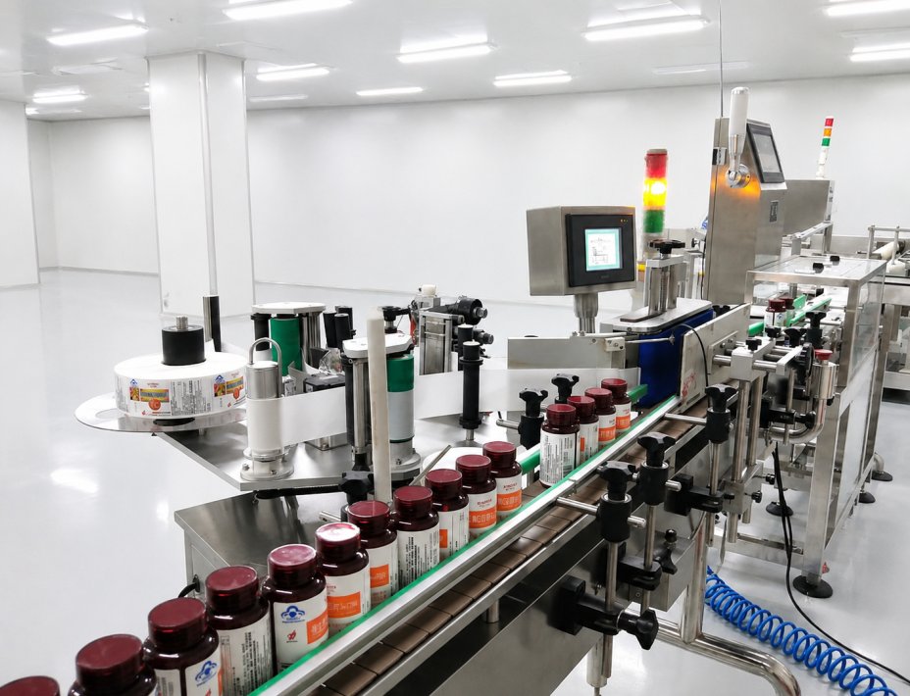Figure 4-1: Weighing and Labeling Module Integration

4.2 Operating Principle
The SCL Series operates through a synchronized multi-stage process that integrates weighing, label printing, and label application:
Step 1 – Product Entry: The upstream conveyor feeds products onto the Feed Conveyor, which controls product spacing and alignment.
Step 2 – Photoelectric Trigger: Photoelectric sensor 1 detects the leading edge of the product and starts the weighing timer.
Step 3 – Dynamic Weighing: As the product passes through the Weigh Conveyor, the load cell captures the dynamic weight signal. The DSP applies adaptive filtering and compensation to calculate the actual product weight.
Step 4 – Result Classification: The system compares the measured weight against the configured limits (Under / Accept / Over) and classifies the result.
Step 5 – Label Data Generation: The measured weight data is transmitted to the label printing module in real time. The system populates the active label template with weight, unit price, total price, date/time, barcode, and other configured fields.
Step 6 – Label Printing: The thermal printer prints the label with the synchronized weight data. The printed label is dispensed and ready for application.
Step 7 – Label Application: The label applicator applies the printed label to the product at the precise moment, synchronized with conveyor speed and product position.
Step 8 – Label Verification (optional): If a verification scanner is installed, the system reads the printed barcode/QR code and verifies it against the expected data. Mismatches trigger an alarm and/or rejection.
Step 9 – Rejection Action: If the product is classified as non-conforming or label verification fails, the rejection device diverts the product from the line.
Step 10 – Data Recording: All weighing results, label prints, and verification outcomes are logged. Statistics (under/accept/over count, total weight, label count) are updated in real time and can be exported to USB or transmitted to MES/ERP systems.
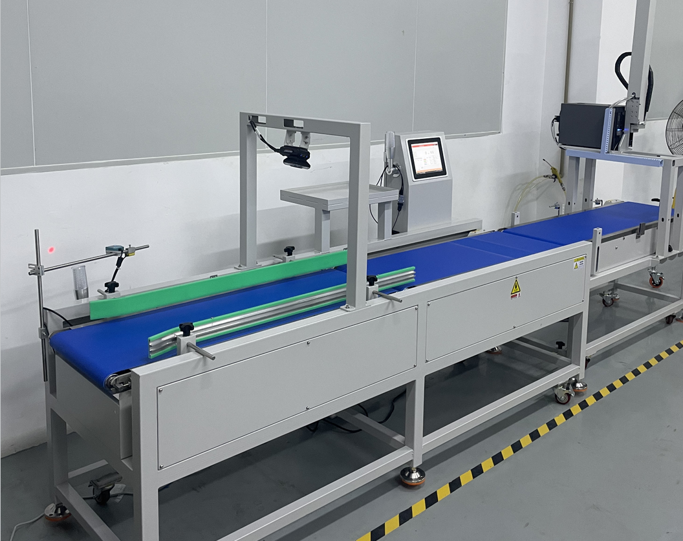Figure 4-2: Checkweigher, Labeler, and Code Scanning Combination System

4.3 Nameplate Information
The nameplate is affixed to the side of the control cabinet. It contains the following information:
Field | Description
Manufacturer | SameGram Equipment Co., Ltd.
Model | SCL Series (e.g., SCL-8050L30)
Power Supply | AC 220V ±10%, 50/60 Hz
Power Rating | Approx. 200–800 W (depending on configuration)
IP Rating | IP54 (standard); IP65 (optional)
Serial No. | Unique identifier for warranty and service tracking
Manufacture Date | Year and month of manufacture

5. Installation

5.1 Unpacking Inspection
After unpacking, inspect all items against the packing list:
No. | Item | Qty | Remark
1 | Weighing and Labeling Machine (main unit) | 1
2 | Power cable | 1 | AC 220V
3 | Instruction Manual (this document) | 1
4 | Calibration Certificate | 1
5 | Packing List | 1
6 | Calibration weight(s) | As ordered | Optional
7 | Label roll (sample) | 1 | Optional
8 | Ribbon roll (sample, for thermal transfer) | 1 | Optional
9 | Communication cable | As ordered | Optional

⚠ CAUTION: If any item is missing or damaged, do not proceed with installation. Contact your SameGram distributor or service representative immediately.

5.2 Site Preparation
- Select a location away from vibration sources (compressors, stamping machines, forklifts, etc.). Floor vibration can directly affect weighing accuracy.
- Ensure the floor is level (≤ 2 mm over 1 m) and capable of supporting the equipment weight.
- Ensure adequate access space: minimum 800 mm on the operator side, 500 mm on the maintenance side.
- Verify that the power supply voltage and frequency match the nameplate.
- Install a dedicated circuit breaker for the equipment. Do not share power with heavy inductive loads.
- Ensure the earth (ground) conductor is properly installed with impedance < 100 Ω.
- Prepare the pneumatic air supply (0.4–0.8 MPa) if pneumatic label applicator or rejection device is fitted.
- Avoid direct sunlight, heating appliances, and air conditioning vents blowing directly onto the equipment.

5.3 Step-by-Step Installation Procedure
Step 1: Position the Equipment
Move the machine into position using a forklift or pallet truck. Ensure the machine is aligned with the upstream and downstream conveyors. The conveyor belt surface of the SCL should be at the same height as the adjacent line conveyors.
Step 2: Level the Machine
Adjust the four levelling feet so that the weighing belt is level in both longitudinal and transverse directions. Use a precision level on the weigh conveyor frame. Tighten the locking nuts after levelling.
Step 3: Remove Transit Packing
Remove all transit bolts, foam inserts, and shipping restraints from the weigh conveyor, load cell assembly, and label printing module. Retain these items for future transport.
Step 4: Connect Line Conveyors
Align the upstream and downstream conveyors with the SCL machine. A maximum step height of 2 mm is permissible between conveyor surfaces. Verify that products transfer smoothly across all conveyor junctions without tipping, jamming, or falling.
Step 5: Install Label Roll and Ribbon
Open the label printer compartment. Thread the label roll through the print mechanism according to the diagram inside the compartment cover. If using thermal transfer printing, install the ribbon roll and thread it past the print head. Close the printer compartment and verify smooth label feed by manually advancing a few labels.
Step 6: Connect the Earth (Ground)
Connect the equipment earth terminal to the facility earth bus bar using a conductor of appropriate cross-sectional area (minimum 1.6 mm diameter copper or equivalent).
Step 7: Connect Power Supply
Connect the AC 220V power cable to the input terminal of the control cabinet. Ensure the main circuit breaker is in the OFF position before connecting. Verify supply voltage matches the nameplate rating.
Step 8: Connect Pneumatic Supply (if applicable)
Connect the plant air supply (0.4–0.8 MPa) to the FRL (Filter-Regulator-Lubricator) unit inlet. Check all fittings for air-tightness.
Step 9: Connect Communication Cables (if applicable)
Connect RS485, Ethernet, or other communication cables as required by the system integration.

5.4 Power Supply and Grounding
- The power plug must be properly grounded to avoid electric shock and ensure stable operation.
- Grounding wire: Use a soft copper wire with a diameter of at least 1.6 mm, or a metal wire of equivalent strength and corrosion resistance.
- Ground impedance must be less than 100 Ω.
- Do not share the ground connection with equipment that generates electrical noise (large motors, inverters, welding equipment).
- Use a dedicated ground rod if the building ground is unreliable.
- Periodically verify ground resistance to ensure it remains below 100 Ω.

5.5 Pneumatic Supply Connection
- Connect the plant compressed air supply to the FRL unit. Ensure the pressure is regulated to 0.4–0.8 MPa.
- Install an air shut-off valve upstream of the FRL for maintenance isolation.
- Check all pneumatic fittings for leaks using soapy water solution.
- Drain the FRL water trap regularly to prevent moisture from entering pneumatic cylinders.

6. Commissioning and Start-Up

6.1 Pre-Start Checklist
Before switching on the equipment for the first time, verify each of the following:
Check | Item | Pass Criteria
☐ | Equipment is correctly levelled | Precision level reads within ±0.5 mm/m in both directions
☐ | All transit bolts and shipping restraints removed | No foreign objects or restraints on weigh conveyor or label module
☐ | Power supply voltage and frequency match the nameplate | 220V AC ±10%, 50/60 Hz confirmed
☐ | Earth (ground) conductor is connected | Ground impedance < 100 Ω
☐ | No loose objects on or near the conveyors | Visual inspection confirmed
☐ | All guards and covers are in place | Visual inspection confirmed
☐ | Emergency Stop button is released | Rotated clockwise to release position
☐ | Air supply pressure within 0.4–0.8 MPa | Pressure gauge reads within range (if pneumatic fitted)
☐ | Communication cables connected and secure | All connectors tightened
☐ | Label roll installed and threaded correctly | Label feeds smoothly through print mechanism
☐ | Ribbon installed correctly (thermal transfer models) | Ribbon feeds smoothly, properly aligned
☐ | Calibration weights available | Appropriate weight for the working range

6.2 First Power-On Procedure
- Turn the key-switch or main isolator on the control cabinet to the ON position.
- The touchscreen HMI will display the start-up splash screen. Wait approximately 30 seconds for the system to initialise.
- After initialisation, the main operation interface (Home Screen) is displayed.
- Check that all motor status indicators on the HMI show correct states.
- Press the START button; verify that all conveyor belts run smoothly and that no abnormal noise or vibration is present.
- Verify that the label printer initializes correctly and that a test label can be printed.
- Allow the equipment to run for at least 5 minutes to reach thermal equilibrium before performing calibration.
- Perform the weighing calibration procedure (see Chapter 8.1).
- Configure the label template and print settings (see Chapter 10).
- Run test products through the machine to verify weighing, printing, and application accuracy.

7. HMI Operation Guide

7.1 Login and Access Levels
The system employs a multi-level access control system. Different access levels present different settings menus. Default credentials are:
Access Level | Default Password | Access Scope
Equipment Operator | (none — confirm directly) | Basic operation: start/stop, recipe selection, data view, label printing monitoring
System Administrator | 222222 | Full settings: calibration, device config, motor, IO, speed correction, recipe management, label template editing
Super Administrator | 111111 | Manufacturer-level debugging, module parameter restoration, firmware update

📝 NOTE: It is strongly recommended to change the default Administrator and Super Administrator passwords after initial commissioning to prevent unauthorized access.
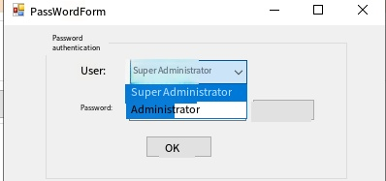
Figure 7-1: HMI Login and Access Level Selection Screen

7.2 Home Screen Overview
The Home Screen is the primary operating screen of the SCL Series. It provides at-a-glance status information and access to all key functions. After system initialization, the Home Screen is displayed automatically.
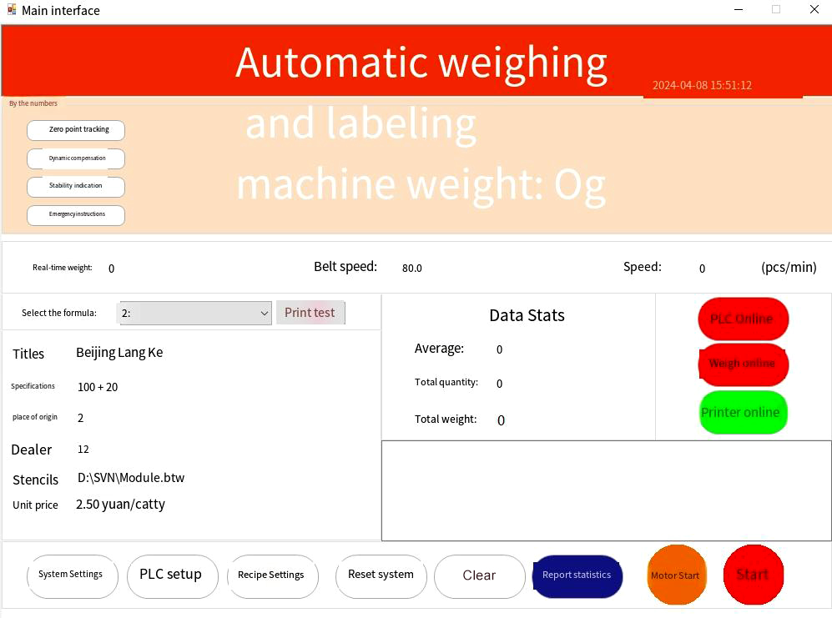
Print content, which can be modified in the [Recipe Settings] screen
The status of each device. Red means unconnected, green means successful
Figure 7-2: SCL Series Home Screen
The Home Screen displays the following items:
# | Item | Description
1 | System Status | Current operating status: "Stop", "Running", or "Alarm"
2 | Current Weight | Real-time weight display of the product currently on the weigh conveyor
3 | Classification Result | Indicates whether the current product is Under / Accept / Over
4 | Batch Statistics | Running totals of Under, Accept, and Over count and cumulative weight
5 | Recipe Name | Name of the currently active product recipe
6 | Upper / Lower Limit | Current accepted weight range (configured in the recipe)
7 | Label Status | Current label printing status: "Ready", "Printing", "Label Out", "Ribbon Out"
8 | Print Count | Total number of labels printed in the current batch
9 | System Time | Current date and time
10 | START / STOP | Starts or stops all conveyor motors, weighing function, and label printing
11 | Settings Menu | Opens the settings panel (access level dependent)
12 | Recipe Selection | Quick switch between saved product recipes
13 | Manual Zero | Manual zero reset button (visible only if Manual Zero Clearing is enabled)
14 | Report | Access to report and statistics screen

7.3 Main Interface Elements
The main interface is organized into the following functional areas:

7.3.1 Status Display Area
The top section of the screen shows real-time system status. The weight display shows the current reading from the load cell in the configured unit (g or kg). The classification indicator changes colour based on the result:
- Green (Accept): Product weight is within the configured acceptance range.
- Red (Under): Product weight is below the minimum accept weight.
- Yellow (Over): Product weight is above the maximum accept weight.

7.3.2 Statistics Display Area
The statistics panel shows running totals for the current production batch:
- Total products weighed
- Accept count and percentage
- Under count and percentage
- Over count and percentage
- Total labels printed
- Total labels failed verification (if scanner fitted)

7.3.3 Label Printing Status Area
This area displays the current state of the label printing module:
- Ready: Printer is idle and ready to print.
- Printing: A label is currently being printed.
- Label Out: Label roll is empty or not detected. Replace the label roll.
- Ribbon Out: Ribbon roll is empty or not detected (thermal transfer models only). Replace the ribbon.
- Print Head Error: Print head temperature abnormal or hardware fault. Contact maintenance.

7.3.4 Operation Buttons
Button | Function
START | Starts all conveyor motors, weighing function, and label printing. The button illuminates green when running.
STOP | Stops all conveyor motors and label printing. The button illuminates red when stopped.
Settings | Opens the settings menu (requires login if password protection is enabled).
Recipe | Opens the recipe selection screen for quick product changeover.
Report | Opens the report and statistics screen.
Manual Zero | Performs a manual zero reset of the load cell (visible only if enabled in settings).
Test Print | Prints a test label using the currently active template for verification.

8. System Settings
System Settings are accessible from the Home Screen by tapping the Settings icon. Access to certain settings requires Administrator or Super Administrator login.
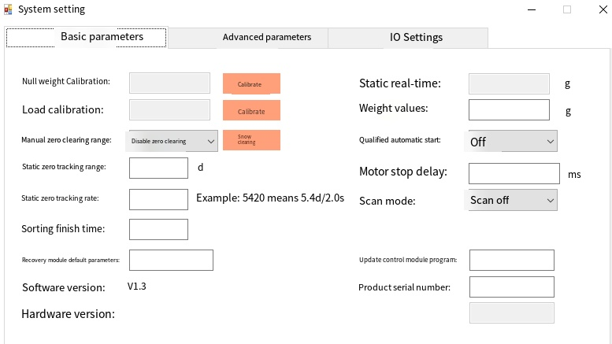
Figure 8-0: System Settings Menu Overview (Admin Login Required)

8.1 Weighing Calibration
Calibration is the most critical procedure for ensuring weighing accuracy. The SCL Series uses a two-point calibration method: No-Load (Zero) calibration and Loading (Span) calibration.
⚠ CAUTION: Perform calibration on a level, stable surface with no vibration. Do not touch the conveyor belt or place any objects on the weigh conveyor during calibration.

8.1.1 No-Load (Zero) Calibration
No-Load calibration establishes the zero reference point of the empty scale table.
- Ensure the weigh conveyor belt is running and no product is present.
- Navigate to System Settings → Weighing Settings.
- Tap "No-Load Calibration".
- The system captures the zero reference and confirms completion.

8.1.2 Loading (Span) Calibration
Loading calibration establishes the span reference using a known calibration weight.
- Select a calibration weight appropriate to the working range (typically 50–80% of full span).
- Enter the nominal value of the calibration weight in the "Weight Value" field.
- Clear all items from the weighing table, then tap "No-Load Calibration" first (if not already done).
- Place the calibration weight corresponding to the entered weight value on the weighing table.
- Tap "Loading Calibration".
- Wait for the weight reading to stabilise, then the system captures the span reference.
- Remove the calibration weight after the calibration is confirmed.
📝 NOTE: Always perform no-load calibration before loading calibration. If the zero calibration is incorrect, the span calibration will also be incorrect.

8.1.3 Zero Tracking Settings
Parameter | Description
Manual Zero Clearing Range | Sets the range of manual zero clearing (relative to the maximum/minimum range as a percentage). Default: disabled (manual zero button not shown on main interface).
Zero Tracking Range | The range of index values in which the zero value can be automatically tracked. Default value: 0 (zero tracking disabled). When non-zero, the system automatically corrects small zero drift within the specified range.
Zero Tracking Rate | The rate at which zero drift is corrected. Input format example: 5.4D/2.0s indicates the zero value can be tracked within 5.4 index values within 2 seconds. Default: 0 (disabled).

8.1.4 Module Parameter Management
Parameter | Description
Restore Default Parameters | Enter code 123456 to restore all module parameters to factory defaults. Restart is required for changes to take effect.
Update Control Module Program | Enter code 123456 to initiate a firmware update of the control module. Use only when instructed by SameGram Technical Support.

⚠ WARNING: Restoring default parameters will erase all custom configurations, including recipes and calibration data. Ensure a backup has been made before performing this operation.

8.2 Device Settings
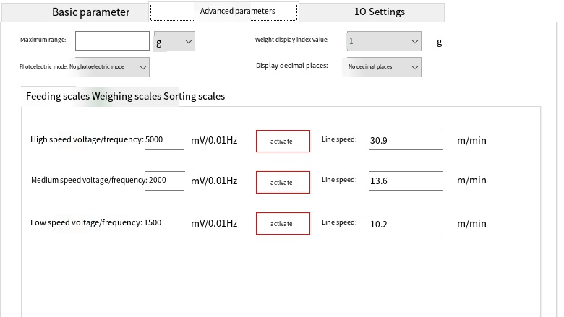
Figure 8-1: Device Settings Screen (Admin Required)
Parameter | Description
Maximum Range | The maximum weighing capacity of the scale table. Weight unit can be selected: g or kg.
Weight Display Index Value | The weight value increment used for smooth display, achieving stable weight readout. Options: 1 g, 2 g, 5 g, 10 g, 20 g, 50 g, 100 g, 200 g. Default: 1 g.
Display Decimal Places | Sets the number of decimal places for weight display: no decimal, 1 decimal, 2 decimals, or 3 decimals.
Photoelectric Mode | Sets the photoelectric trigger logic based on the device wiring configuration: None / Dual-photoelectric mode / Photo-in mode / Photo-out mode. The corresponding indicator light appears on the operation interface after setting.

8.3 Motor and Speed Settings
The motor speed calibration procedure involves measuring the actual belt linear speed at different voltage/frequency levels using a tachometer:
- High-speed setting: Input the high voltage and frequency values, then tap "Start". Use a tachometer to measure the belt linear speed and enter the measured value.
- Medium-speed setting: Input the medium voltage and frequency values, then tap "Start". Measure and enter the belt linear speed.
- Low-speed setting: Input the low voltage and frequency values, then tap "Start". Measure and enter the belt linear speed.
Motor control type supports:
- Analogue Voltage Output: No configuration required on this page; speed is controlled by analogue voltage directly.
- RS485 Modbus RTU: Configure the frequency register address, start register address, start value, and stop value for each inverter (Feed / Weigh / Reject conveyor).

8.4 IO Settings
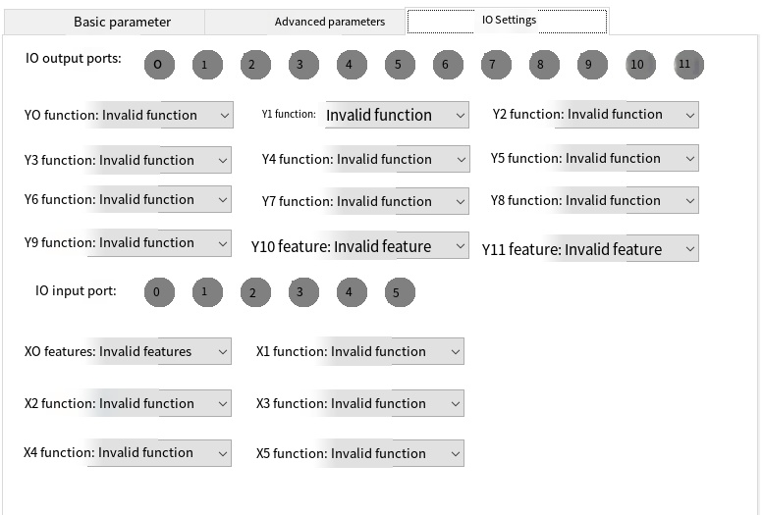
Figure 8-2: IO Settings Screen (Admin Required)
The IO Settings screen allows debugging and configuration of all input/output ports:
Parameter | Description
IO Monitor Panel | Click the corresponding IO port number to toggle its debug state. When the indicator lights up, the IO port is connected/active.
Y0 – Y11 (Output Functions) | Set the output function of each I/O port. Assignable functions include: running status, over-count alarm, detection failure alarm, sort level 1–7 actuators, label printer trigger, applicator activation, verification scanner trigger.
X0 – X5 (Input Functions) | Set the input function of each I/O port. Assignable functions include: start button, stop button, photoelectric in, photoelectric out, clear alarm, forward/reverse full-bin detection, label supply sensor.

8.5 PLC Settings
The PLC Settings screen provides access to the internal PLC configuration. This includes communication parameters, logic timing, and interlock configurations for the integrated weighing, printing, and sorting operations. PLC settings should only be modified by qualified SameGram service personnel or trained system integrators.
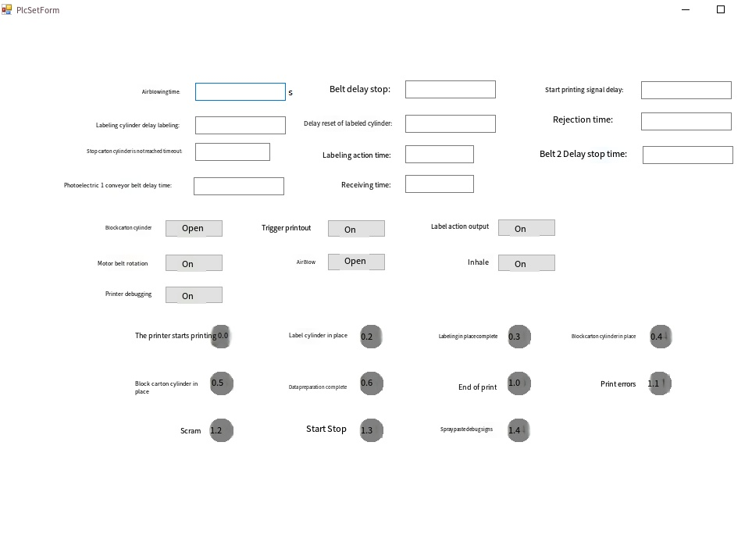
Figure 8-3: PLC Settings Screen (Super Admin Required)

9. Recipe and Product Settings
Recipe Settings allow the creation, modification, and management of product-specific configurations. Each recipe stores independent parameters for speed, precision, qualification limits, and label template selection. The system supports up to 100 product recipes.

9.1 Recipe Management
The Recipe Management screen provides full CRUD (Create, Read, Update, Delete) functionality for product recipes:
- Add: Create a new recipe by copying an existing recipe or starting from default values.
- Delete: Remove an unused recipe. This action cannot be undone.
- Modify: Edit the parameters of an existing recipe.
- Query: Search and view saved recipes by name or number.
💡 TIP: Use clear, descriptive recipe names (e.g., "Frozen Fish Fillet 500g" or "Bread Loaf 800g") to facilitate quick identification during product changeovers. Avoid generic names that could cause operator confusion.
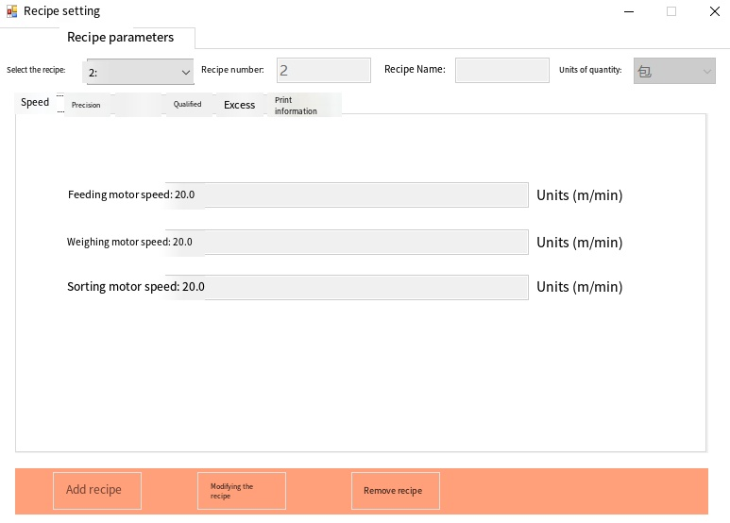
Figure 9-0: Recipe Management Screen

9.2 Speed Settings
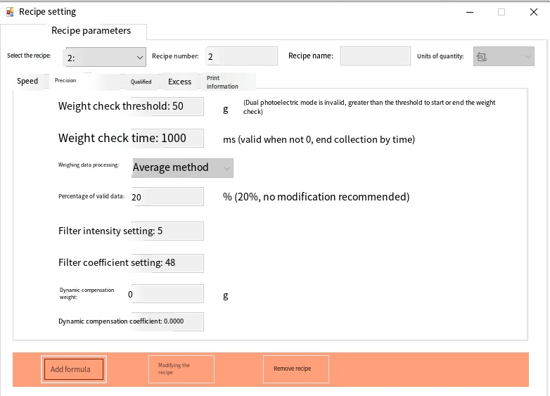
Figure 9-1: Recipe — Speed Settings
Parameter | Description
Recipe Name | Enter the product name. Recommended: 16 characters or fewer.
Quantity Unit | Default is "Package". Can be changed to bags, boxes, pieces, bottles, cans, etc.
Belt Speed | Individual speed settings for Feed Conveyor, Weigh Conveyor, and Reject Conveyor motors. Adjusting speed controls overall throughput and affects dynamic accuracy.

9.3 Precision Settings
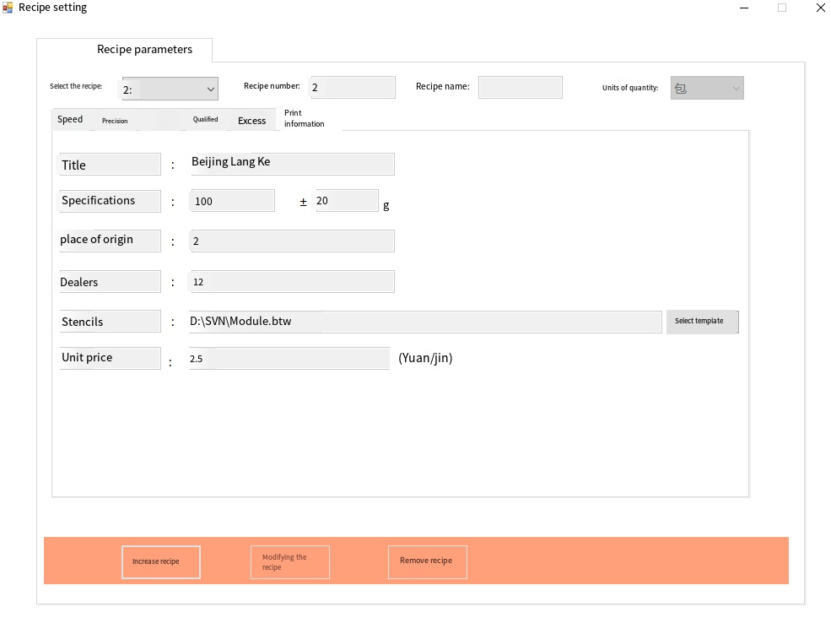
Figure 9-2: Recipe — Precision Settings
Parameter | Description
Speed | Set the speed value for the current recipe (applies to all conveyor sections proportionally).
Weight Check Weighing Threshold | When the weight is greater than this threshold, the system performs weight check. Products below this threshold are ignored.
Weighing Data Processing | Default: Maximum value method. Can be set to Average value method, with configurable percentage of valid data.
Filter Intensity | Controls the smoothing level of the weight signal. Default: 5. Range: 3–18. Higher values provide more smoothing but slower response.
Filter Coefficient | Adjusts the DSP filter sensitivity. Default: 45. Range: 30–100. Higher values provide better noise rejection.
Dynamic Compensation Value | When there is a weight deviation in dynamic weighing compared to static reference, adjust this value to compensate. Positive or negative offset.
Dynamic Compensation Coefficient | Multiplier for dynamic compensation. Default: 1. Range: 1–100.
Weight Check Time | Sets the sorting/inspection time window. When non-zero, the module automatically ends the current detection after the specified time elapses from object detection.

9.4 Auto-Learning
The Auto-Learning function automatically determines the optimal weighing parameters for a specific product. The system samples the product as it passes through the weigh conveyor and calculates the best filter, threshold, and compensation settings.
Parameter | Description
Learn Standard Weight | The static weight of the product to be learned (measured on a reference scale).
Weighing Threshold (learning) | Set to approximately 25% of the learn standard weight.
Filter Coefficient (pre-learning) | Set to ≥80 before starting; automatically adjusted after learning.
Learning Stop Delay | Time (seconds) to auto-stop after learning is complete.
Learning Iterations | Number of times the system samples the product. More iterations = higher accuracy.

Auto-Learning Procedure:
- Weigh a sample product on a calibrated static reference scale and record the weight.
- Enter the recorded weight as the "Learn Standard Weight".
- Set the Weighing Threshold to approximately 25% of the learn standard weight.
- Set the Filter Coefficient to ≥80.
- Set the Learning Iterations (recommended: 10–20 for optimal accuracy).
- Tap "Start". The conveyor begins running.
- Pass the sample product through the weigh conveyor for the specified number of iterations.
- The system automatically calculates and saves the optimal parameters.

9.5 Qualification (Sorting) Settings
Parameter | Description
Minimum Accept Weight | Lower limit of the accepted weight range.
Maximum Accept Weight | Upper limit of the accepted weight range.
Action Delay Time | Delay between classification result and rejection actuator trigger. Must be recalculated if motor speed changes.
Action Execution Time | Duration of the rejection actuator pulse.
Max. Reject Bin Count | Alarm when the cumulative rejection count exceeds this value (0 = disabled).
Max. Reject Bin Weight | Alarm when the cumulative rejection weight exceeds this value (0 = disabled).

The SCL Series supports multiple rejection device types depending on product characteristics and line layout:
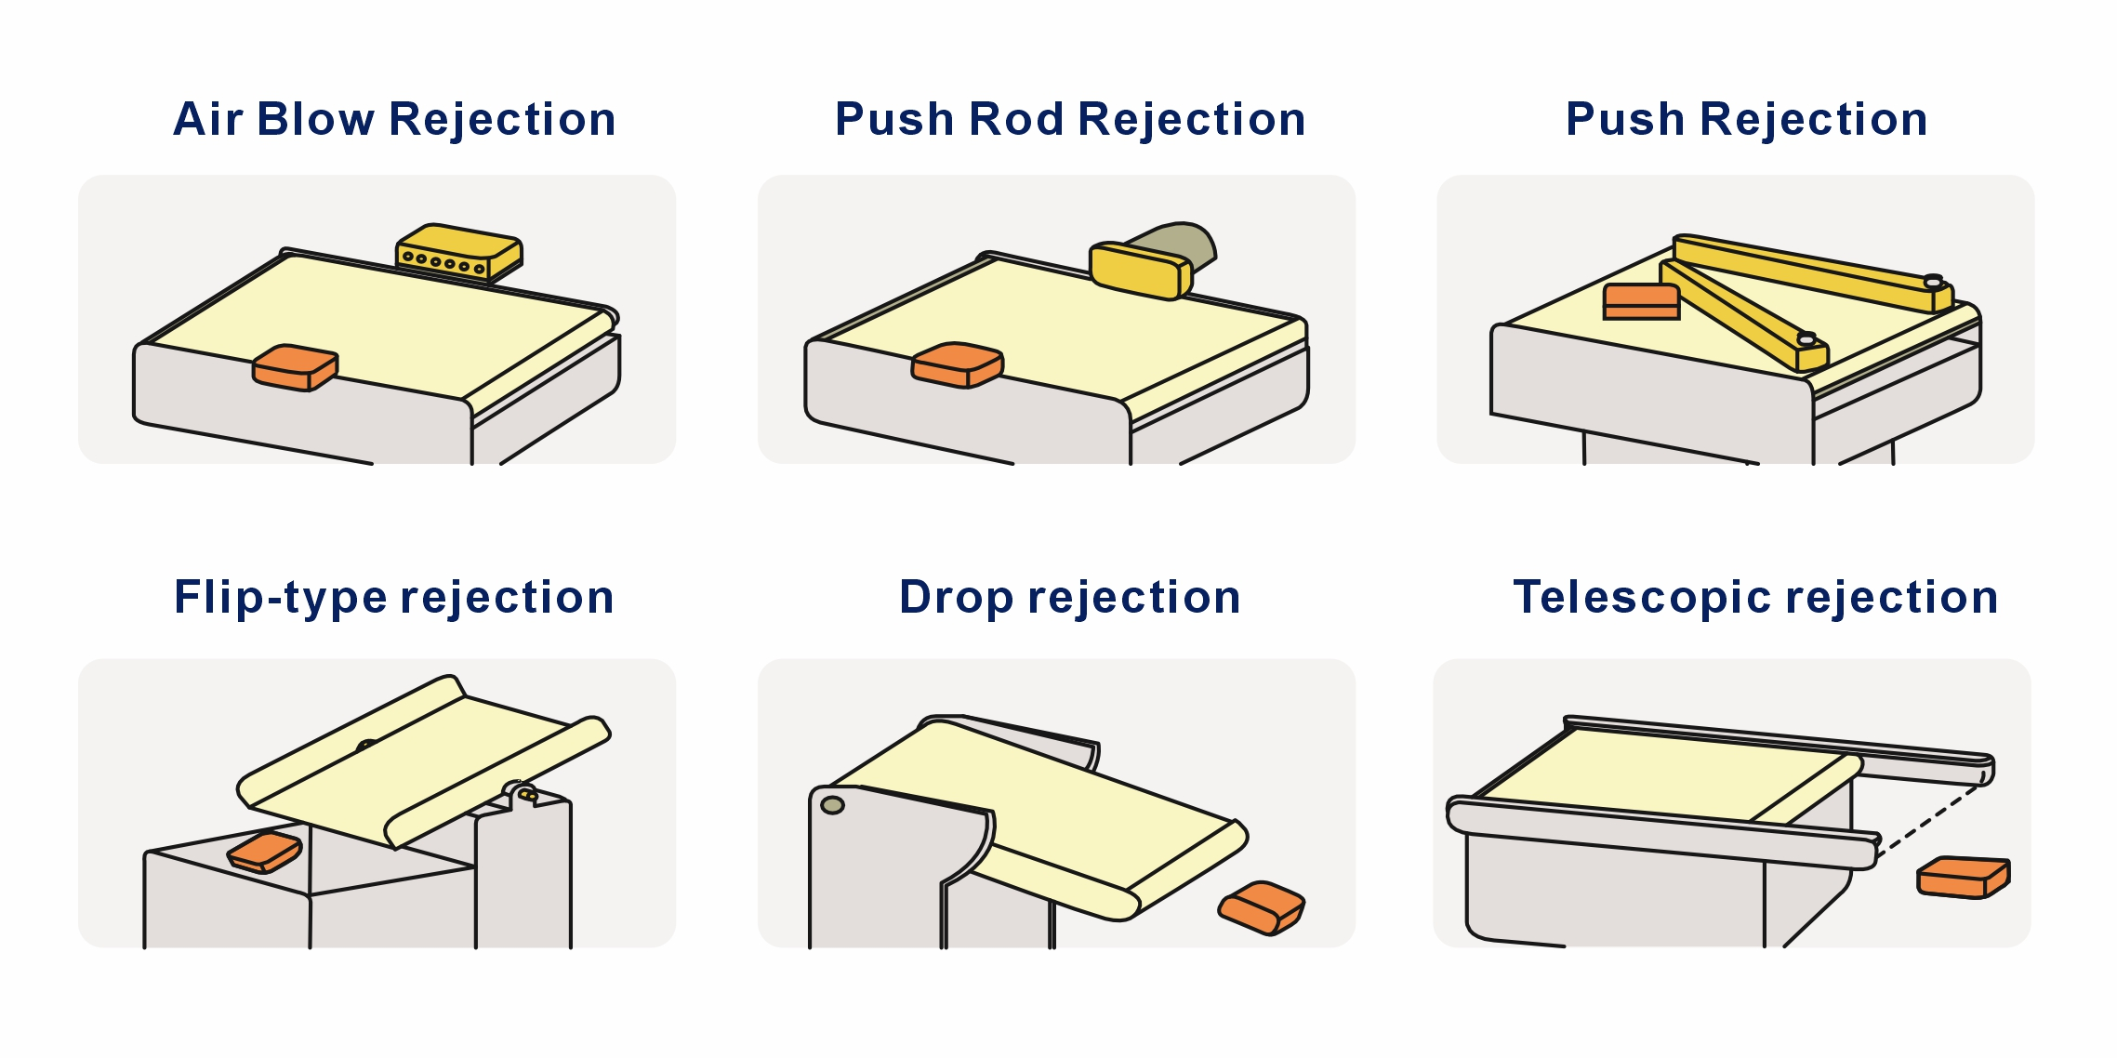

Figure 9-3: Rejector System

10. Label Printing Configuration
The Label Printing Configuration module controls how weight data and other product information are formatted, printed, and applied to products. This is the core differentiating feature of the SCL Series — real-time synchronization between the weighing system and the label printer.

10.1 Print Content Setup
The Print Content Setup screen allows configuration of what data fields are included on each printed label. Available data fields include:
Field | Description
Product Name | Text field from the active recipe name or custom entry
Net Weight | Real-time measured weight from the load cell (automatically populated)
Unit Price | Configurable price per unit weight (kg or g)
Total Price | Automatically calculated: Net Weight × Unit Price
Date / Time | System date and time at the moment of weighing
Batch Number | Configurable batch identifier for traceability
Barcode | 1D barcode encoding weight or product ID (Code 128, EAN-13, GS1-128, etc.)
QR Code | 2D QR code encoding product data, traceability URL, or custom payload
Logo | Company or product logo image (imported via USB)
Custom Text | Up to 5 user-defined text fields (e.g., ingredients, storage instructions, country of origin)

To configure print content, navigate to Recipe Settings → Print Content, then select the template path and enable/disable individual fields as required.
Figure 10-1: Print Content Setup Screen

10.2 Label Template Management
The system supports up to 100 label templates. Templates can be:
- Created: Using the built-in label editor on the HMI touchscreen.
- Imported: Via USB flash drive from a PC-based label design software.
- Modified: Field positions, font sizes, and barcode parameters can be adjusted.
- Assigned: Each recipe can be linked to a specific label template.
Label Template Configuration Steps:
- Navigate to Recipe Settings → Set Print Content.
- Select the template path from the available template list.
- Tap "Edit Template" to open the label editor.
- Drag and position data fields on the label canvas.
- Adjust font size, barcode dimensions, and field alignment.
- Tap "Save" to store the template.
- Tap "Test Print" to print a sample label for verification.

10.3 Barcode and QR Code Printing
The SCL Series supports printing of both 1D barcodes and 2D codes on labels:
Type | Supported Formats | Typical Use
1D Barcode | Code 39, Code 128, EAN-13, EAN-8, UPC-A, ITF-14, GS1-128 | Product identification, weight encoding, POS scanning
QR Code | Standard QR Code | Traceability links, product information, anti-counterfeiting
Data Matrix | ECC 200 | Pharmaceutical serialization, small-label applications

When using GS1-128 barcodes, the system supports application identifiers (AI) for weight (AI 310x), price (AI 392x), and other GS1 data fields. Configure the barcode data mapping in the label template editor.

10.4 Print Verification
If the SCL Series is equipped with an integrated barcode/QR verification scanner, the system performs post-print verification of every label:
- The label is printed and applied to the product.
- The product passes the verification scanner position on the conveyor.
- The scanner reads the printed barcode/QR code.
- The system compares the scanned data against the expected data (weight, product ID, batch number).
- If the data matches, the product proceeds to the exit conveyor.
- If the data does not match (verification failure), the system triggers an alarm and the rejection device diverts the product.
📝 NOTE: Print verification ensures label accuracy, regulatory compliance, and export readiness. It is strongly recommended for applications in pharmaceutical, food, and export-oriented production lines.

11. Report and Statistics
The Report and Statistics screen provides comprehensive production data management. All weighing records, label print counts, and verification results are logged and can be queried, deleted, or exported.
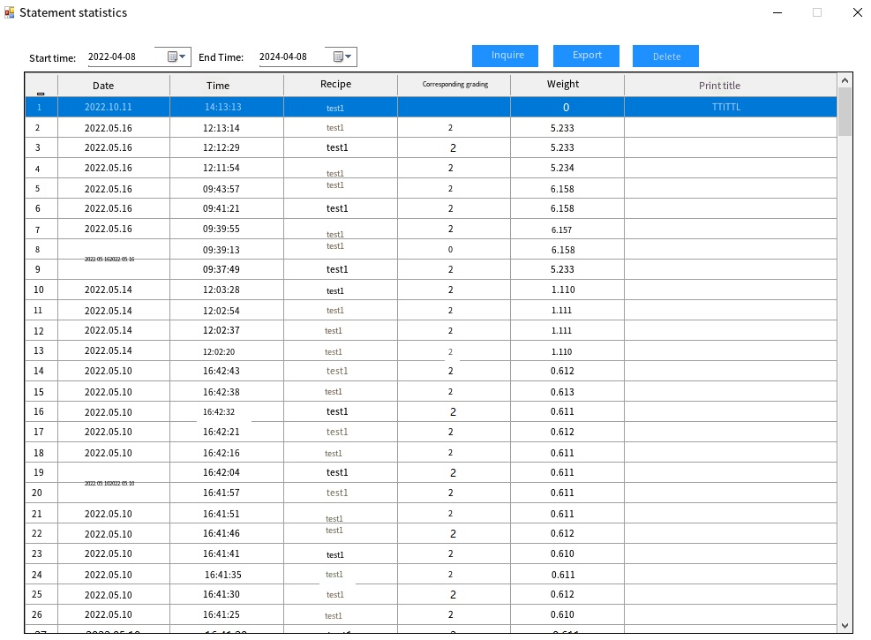
Figure 11-1: Report and Statistics Screen

11.1 Data Display
The Data Report displays all weighing records with the following information:
Field | Description
Timestamp | Date and time of each weighing event
Recipe Name | Active product recipe at time of weighing
Measured Weight | Actual dynamic weight recorded
Classification | Grade 1 = Under, Grade 2 = Accept, Grade 3 = Over
Label Printed | Yes / No — whether a label was printed for this product
Verification Result | Pass / Fail / N/A (if scanner fitted)

11.2 Data Query
Retrieve historical data by specifying a time frame:
- Navigate to the Report screen.
- Tap "Query".
- Set the start date/time and end date/time.
- Tap "Confirm" to retrieve all records within the specified period.
- The results are displayed in tabular form with summary statistics.

11.3 Data Deletion
Delete stored data based on a time frame:
- Navigate to the Report screen.
- Tap "Delete".
- Set the start date/time and end date/time for the deletion range.
- Confirm the deletion when prompted.
⚠ WARNING: Deleted data cannot be recovered. Ensure that necessary data has been exported before deletion. "Delete All Data" clears all saved weighing records permanently.

11.4 Data Export
Export the data displayed in the report to a CSV file on a USB flash drive:
- Insert a USB flash drive (FAT32 format) into the USB port on the control cabinet.
- Navigate to the Report screen.
- Query the desired data by time frame.
- Tap "Export".
- Select export mode: Overwrite or Append.
- The system generates a CSV file and saves it to the USB drive.
- A confirmation message is displayed when export is complete.
The exported CSV file contains all weighing records and can be opened in spreadsheet software (Microsoft Excel, Google Sheets, etc.) for further analysis, archiving, or submission to quality management systems.

12. Communication Interfaces
The SCL Series supports multiple industrial communication protocols for integration with factory control systems, MES/ERP platforms, and other production line equipment.

12.1 RS485 Modbus RTU
Default communication parameters:
Parameter | Default Value
Baud Rate | 9600 bps (configurable: 4800, 9600, 19200, 38400, 115200)
Data Bits | 8
Parity | None
Stop Bits | 1
Protocol | Modbus RTU (standard function codes 03/06/10 supported)

12.2 Modbus TCP (Ethernet)
Default connection parameters:
Parameter | Default Value
IP Address | 192.168.1.100 (configurable)
Port | 502 (standard Modbus TCP port)
Protocol | Modbus TCP (function codes 03/06/10)

Refer to the separate document "MODBUS TCP Communication Address Table" for the complete register map.

12.2.1 TCP Continuous Data Stream
In TCP stream mode, the machine sends a 31-byte data packet to the configured host IP address each time a product is weighed and labeled. The packet format is as follows:
Byte | Content | Description
1 | 0xAA | Start byte (fixed)
2 | Device No. | Device identifier
3–4 | Sequence No. | Packet counter (increments per product, rolls over at 65535)
5–8 | Weight (g) | 32-bit float, big-endian; actual dynamic weight in grams
9 | Grade | 1 = Under, 2 = Accept, 3 = Over
10–13 | Lower Limit | 32-bit float; configured lower acceptance limit (g)
14–17 | Upper Limit | 32-bit float; configured upper acceptance limit (g)
18–21 | Under Count | 32-bit integer; cumulative under-weight count
22–25 | Accept Count | 32-bit integer; cumulative accepted count
26–29 | Over Count | 32-bit integer; cumulative over-weight count
30 | Status | Bit 0: Running; Bit 1: Alarm; Bit 2: Label Printing; Bits 3–7: reserved
31 | 0x55 | End byte (fixed)

12.3 Industrial Protocol Integration
The SCL Series supports seamless integration with factory control systems through the following protocols:
Protocol | Interface | Typical Application
Ethernet/IP | Ethernet | Allen-Bradley / Rockwell PLC integration
Profinet | Ethernet | Siemens PLC integration
Modbus TCP | Ethernet | Universal industrial communication
Modbus RTU | RS485 | Serial communication with legacy systems
TCP Data Stream | Ethernet | Real-time data push to MES/ERP host

By supporting real-time data tracking and process control, the SCL Series enables full product traceability across MES/ERP systems for audits, recalls, and supply chain transparency.

13. Troubleshooting
Refer to the table below to diagnose and resolve common problems. If a problem persists after following the recommended corrective actions, contact SameGram Technical Support.

13.1 Weighing Issues
No. | Symptom | Possible Cause | Corrective Action
1 | Power indicator not illuminated | 1. Incorrect power supply  2. Circuit breaker tripped  3. Fuse blown | 1. Connect correct supply voltage  2. Reset circuit breaker  3. Replace fuse with same rating
2 | Unstable static weight reading | 1. Equipment not level  2. Load cell overloaded or damaged  3. External vibration | 1. Re-level all four feet  2. Inspect load cell; replace if necessary  3. Eliminate vibration source
3 | Large dynamic weighing deviation | 1. Filter coefficient too low  2. Valid data percentage too low  3. Belt speed too high for product length | 1. Increase filter coefficient (range 30–100)  2. Increase valid data percentage  3. Reduce belt speed
4 | Large difference between static and dynamic weight | Dynamic compensation parameters incorrect | Re-run dynamic compensation; adjust Dynamic Compensation Value and Coefficient
5 | Static weight inaccurate | Span calibration not performed or incorrect | Perform no-load and loading calibration per Chapter 8.1
6 | No weight data after product detected | 1. Photoelectric sensor position shifted  2. Photoelectric sensor damaged | 1. Re-position sensor; verify trigger pulse on HMI IO monitor  2. Replace sensor
7 | Weight reading drifts over time | 1. Temperature change causing zero drift  2. Zero tracking not configured | 1. Allow warm-up ≥ 5 min; re-zero if necessary  2. Configure Zero Tracking Range and Rate

13.2 Label Printing Issues
No. | Symptom | Possible Cause | Corrective Action
8 | Label not printing | 1. Label roll empty  2. Ribbon roll empty (thermal transfer)  3. Print head fault  4. IO output not assigned | 1. Replace label roll  2. Replace ribbon roll  3. Check print head connection; contact support  4. Verify IO Y-output assignment in IO Settings
9 | Poor print quality (faded or incomplete) | 1. Dirty print head  2. Ribbon wrinkling or misaligned  3. Print head pressure uneven  4. Incorrect print speed setting | 1. Clean print head with alcohol swab  2. Re-align ribbon; check ribbon feed path  3. Adjust print head pressure balance  4. Reduce print speed
10 | Label jam in applicator | 1. Label roll incorrectly threaded  2. Label adhesive on peel plate  3. Applicator timing misaligned | 1. Re-thread label roll per diagram  2. Clean peel plate with alcohol  3. Adjust applicator timing in recipe settings
11 | Barcode/QR code not scannable | 1. Print resolution too low  2. Barcode dimensions too small  3. Print contrast insufficient  4. Label surface wrinkled | 1. Increase print resolution (300 dpi option)  2. Enlarge barcode dimensions in template  3. Check ribbon supply and print head  4. Ensure smooth label application
12 | Weight on label does not match display | 1. Label template data mapping error  2. Communication delay between weighing and printing modules  3. Recipe mismatch | 1. Verify template field mapping  2. Check PLC communication settings  3. Verify correct recipe is active

13.3 Mechanical and System Issues
No. | Symptom | Possible Cause | Corrective Action
13 | Motors do not run after pressing START | 1. Stop time too short after abnormal shutdown  2. Motor connector loose  3. Emergency Stop engaged | 1. Wait at least 1 minute after abnormal shutdown before restarting  2. Re-seat motor connector  3. Release Emergency Stop button
14 | Rejection device does not actuate | 1. Air supply pressure too low (pneumatic)  2. Action delay time incorrect  3. IO output not assigned | 1. Increase air pressure to 0.4–0.8 MPa  2. Recalculate and adjust action delay  3. Verify IO Y-output assignment
15 | HMI prompts to release Emergency Stop | Emergency Stop button is depressed | Rotate the Emergency Stop button clockwise to release it
16 | Conveyor belt slipping or mis-tracking | 1. Belt tension insufficient  2. Drive pulley worn | 1. Adjust belt tensioner  2. Replace drive pulley
17 | USB export fails | 1. USB drive not formatted as FAT32  2. USB drive full | 1. Format USB drive as FAT32  2. Free up space on USB drive
18 | Modbus TCP communication fails | 1. IP address conflict  2. Port 502 blocked by firewall | 1. Assign a unique IP address  2. Open port 502 on the host firewall
19 | Touchscreen unresponsive | 1. Screen protector causing touch offset  2. HMI controller fault | 1. Remove screen protector; recalibrate touch if needed  2. Restart HMI; contact SameGram if issue persists
20 | Label verification failure rate high | 1. Scanner position shifted  2. Scanner lens dirty  3. Print quality degraded | 1. Re-position scanner  2. Clean scanner lens  3. Address print quality per Row 9 above

14. Maintenance and Cleaning
⚠ WARNING: Always switch off the main power supply and apply Lockout/Tagout (LOTO) before performing any maintenance work. Never perform maintenance while the equipment is running.

14.1 Maintenance Schedule
Task | Daily | Weekly | Monthly | Quarterly | Annual
Check belt for damage, wear, or contamination | ✓
Clean weigh conveyor belt surface | ✓
Inspect photoelectric sensors; clean lenses | ✓
Verify zero calibration (no-load) | ✓
Check label supply and ribbon supply levels | ✓
Clean print head with alcohol swab |  | ✓
Check and clean conveyor rollers and pulleys |  | ✓
Inspect belt tension and tracking; adjust if needed |  | ✓
Check all fasteners for tightness |  | ✓
Inspect pneumatic fittings; drain FRL water trap |  | ✓
Clean label applicator mechanism and peel plate |  | ✓
Check cable glands and cable routing for damage |  |  | ✓
Verify full-span calibration with calibration weight |  |  | ✓
Lubricate bearings and chain (if fitted) |  |  | ✓
Inspect label applicator cylinder for wear |  |  | ✓
Clean interior of control cabinet; check connections |  |  |  | ✓
Replace air filter element (if fitted) |  |  |  | ✓
Full load cell performance check |  |  |  |  | ✓
Inspect and replace worn conveyor belt |  |  |  |  | ✓
Replace thermal print head |  |  |  |  | ✓
Calibration verification by certified weights |  |  |  |  | ✓
Firmware and software update check |  |  |  |  | ✓

14.2 Cleaning Guidelines
⚠ WARNING: ALWAYS unplug the power cord before cleaning the equipment. Failure to do so may result in electric shock, equipment damage, or unintended conveyor startup.
Approved Cleaning Materials:
- Soft plastic brushes or soft cloths for sweeping and wiping.
- Neutral detergent (pH-neutral) diluted in warm water (below 40°C).
- Clean water for rinsing.
- Soft, dry microfiber cloth for the touchscreen.
- Isopropyl alcohol swabs for print head cleaning.
Prohibited Cleaning Materials:
- Metal brushes, steel wool, abrasive scrubbers, or scouring pads.
- Organic solvents: thinner, toluene, benzene, acetone (except for print head cleaning with alcohol).
- High-pressure water jets or steam cleaners (unless equipment is specifically IP65-rated for such cleaning).
- Bleach or strong acidic/alkaline cleaners that may corrode stainless steel or damage seals.
Cleaning Procedure:
- Unplug the power cord and allow the print head to cool for at least 2 minutes.
- Remove loose debris with a soft brush or cloth.
- Apply neutral detergent solution with a soft cloth or sponge.
- Pay special attention to the weigh conveyor belt surface, label applicator mechanism, and conveyor belt-to-frame junction areas where debris tends to accumulate.
- Rinse thoroughly with clean water to remove all detergent residue.
- Dry all surfaces with a clean, soft cloth to prevent water spots.
- For food-contact applications, use food-grade cleaning agents approved for your industry.
- Ensure the belt is completely dry before resuming operation.
Do not spray water directly onto the control cabinet, load cell, print head, or electrical components.

14.3 Label Printer Maintenance
The label printing module requires specific maintenance to ensure consistent print quality and reliable operation:

14.3.1 Print Head Cleaning
- Power off the machine and allow the print head to cool for at least 2 minutes.
- Open the printer compartment cover.
- Remove the ribbon (if thermal transfer).
- Gently wipe the print head element (the thin black line on the print head) with an isopropyl alcohol swab.
- Allow the alcohol to evaporate completely (approximately 30 seconds).
- Reinstall the ribbon and close the compartment cover.
Perform print head cleaning weekly, or more frequently if print quality degrades.

14.3.2 Platen Roller Cleaning
- Power off the machine.
- Open the printer compartment and remove the label roll.
- Rotate the platen roller manually while wiping with an alcohol swab.
- Remove any adhesive residue or label debris from the roller surface.
- Reinstall the label roll and close the compartment.

14.3.3 Label Sensor Cleaning
The label gap sensor detects the gap between labels on the roll. If the sensor becomes dirty, label feeding may become erratic:
- Power off the machine.
- Locate the label gap sensor (typically positioned where the label web exits the print mechanism).
- Gently clean the sensor lens with a cotton swab lightly moistened with alcohol.
- Dry with a clean cotton swab.

15. Recommended Spare Parts
The following spare parts are recommended to be held on-site to minimise downtime. Order spare parts by contacting your SameGram service representative and quoting the part number and your equipment serial number.
Part Name | Qty Recommended | Remark
Conveyor belt (weigh section) | 1 | Replace annually or when worn
Load cell | 1 | Critical spare; model-specific
Photoelectric sensor (emitter) | 2 | Model-specific
Photoelectric sensor (receiver) | 2 | Model-specific
Thermal print head | 1 | Replace annually or after approximately 30 km of printing
Platen roller | 1 | Replace when worn or when label feed becomes inconsistent
Label applicator cylinder (pneumatic) | 1 | If pneumatic applicator fitted
Solenoid valve | 1 | If pneumatic applicator or rejection fitted
Fuse (main circuit) | 3 | Same rating as installed
Fuse (control circuit) | 3 | Same rating as installed
Air filter element | 2 | Replace quarterly
Touch screen protective film | 5 | Replace as needed
Rejection air cylinder | 1 | If pneumatic rejection fitted

📝 NOTE: Always quote the equipment serial number and model number when ordering spare parts. Contact SameGram at: sale@samegram.com or call the hotline listed in Appendix C.

16. Appendices

Appendix A — Unit Conversion Table
Unit (From) | Unit (To) | Multiply By
gram (g) | kilogram (kg) | ÷ 1000
gram (g) | pound (lb) | ÷ 453.592
gram (g) | ounce (oz) | ÷ 28.3495
kilogram (kg) | pound (lb) | × 2.20462
metre/min | feet/min | × 3.28084
MPa | bar | × 10
MPa | psi | × 145.038
°C | °F | × 1.8 + 32

Appendix B — Maintenance Record Log
Date | Maintenance Performed | Parts Replaced | Technician | Next Due

Appendix C — Technical Support
For technical support, contact SameGram:
Item | Details
Manufacturer | SameGram Equipment Co., Ltd.
Product Series | SCL Series Automatic Weighing and Labeling Machine
Service Email | sale@samegram.com
Technical Hotline | +86 137 1236 8272
Website | www.samegram.com

When contacting support, please have the following information ready:
- Equipment model number and serial number (located on the rating label affixed to the control cabinet).
- Firmware version (displayed on the HMI: Settings → About Equipment).
- A detailed description of the problem — what is happening, when it occurs, and any error messages displayed.
- The product being processed at the time of the issue, and whether the problem occurs with all products or only a specific one.
- Recent changes to the production environment, product formulation, equipment location, or settings.
- Results of the most recent calibration and verification test before the issue occurred.
- Photographs or video of the issue, if available.

Warranty Information
SameGram provides a standard warranty on all SCL Series equipment. Warranty terms are specified in your purchase agreement and cover defects in materials and workmanship under normal use conditions.
The warranty does NOT cover:
- Damage caused by improper installation, unauthorized modifications, or repairs by non-approved personnel.
- Damage from use of non-approved cleaning agents, solvents, or methods.
- Operation outside the specified environmental conditions (temperature, humidity, voltage).
- Normal wear and tear of consumable parts: conveyor belts, drive belts, print heads, ribbons, labels, fuses, and cleaning materials.
- Damage caused by using non-approved label rolls or ribbons.
For warranty service, contact SameGram Technical Support with your equipment serial number and proof of purchase. Do not attempt internal repairs — this may void your warranty.

Certifications
The SCL Series is certified to the following international standards:
Certification | Directive / Standard | Scope
CE - EMC | 2014/30/EU | Electromagnetic Compatibility
CE - MD | 2006/42/EC | Machinery Directive (Machine Safety)
CE - LVD | 2014/35/EU | Low Voltage Directive (Electrical Safety)
RoHS | 2011/65/EU | Restriction of Hazardous Substances

Appendix D — Glossary of Terms
Term | Definition
Checkweigher | An automatic weighing machine that measures the weight of products moving along a conveyor and classifies them as under, accept, or over weight.
Load Cell | A transducer that converts a force (weight) into an electrical signal.
DSP | Digital Signal Processor; used in this system for real-time weight signal filtering and calculation.
Thermal Transfer Printing | A printing method that uses a heated ribbon to transfer ink onto label material, producing durable, long-lasting prints.
Direct Thermal Printing | A printing method that uses heat to darken heat-sensitive label material directly, without ribbon. Suitable for short-life labels.
Label Applicator | A mechanical or pneumatic device that automatically applies printed labels to products on the conveyor.
Print Head | The thermal printing element that generates heat to transfer ink (thermal transfer) or darken label material (direct thermal).
Platen Roller | The rubber roller that presses label material against the print head for even printing.
Recipe / Formula | A named set of parameters (speed, accuracy, limits, label template) configured for a specific product.
Dynamic Compensation | A correction factor applied to the raw dynamic weight to account for systematic measurement bias.
Zero Tracking | Automatic correction of small drifts in the zero reading of the load cell.
Modbus RTU | A serial communication protocol widely used in industrial automation, communicating over RS485 wiring.
Modbus TCP | The Modbus protocol adapted for use over Ethernet/TCP-IP networks.
LOTO | Lockout/Tagout; a safety procedure to ensure that a machine is properly shut off and cannot be accidentally restarted during maintenance.
IP54 | Ingress Protection rating: dust protection level 5 (dust protected) and water protection level 4 (splash protected).
GS1-128 | A barcode standard (formerly UCC/EAN-128) that uses Application Identifiers to encode data such as weight, price, and batch numbers.
MES/ERP | Manufacturing Execution System / Enterprise Resource Planning; factory-level software systems for production management and data traceability.
OIML R-51 | International standard for automatic gravimetric filling instruments and checkweighers, defining accuracy classes.

Thank you for choosing SameGram.
Document Version V2.0 | © 2026 SameGram Equipment Co., Ltd. | All Rights Reserved

