DD-360 SERIES
Conveyor Belt Metal
Foreign Object Detector
OPERATION MANUAL
────────────────────────────────────────────────────────────
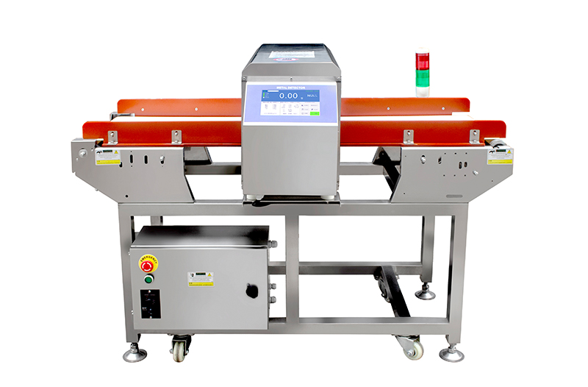
Document Version: V4.0 — June 2026
Applicable Models: DD-360 Series Conveyor Metal Detectors
Manufacturer: SameGram Equipment Co., Ltd.
IMPORTANT: READ THIS MANUAL CAREFULLY BEFORE OPERATING THE EQUIPMENT

Table of Contents
1. Introduction
1.1 About This Manual
1.2 Product Overview
1.3 Key Features
1.4 Important Notes on Detection Capability
2. Safety Instructions
2.1 General Safety Guidelines
2.2 Electrical Safety
2.3 Operational Safety
2.4 Cleaning Safety
3. Technical Specifications
3.1 General Specifications
3.2 Detection Sensitivity Reference
3.3 Environmental Requirements
4. Machine Overview
4.1 System Components
4.2 Detection Principle
4.3 Dual-Channel Detection
5. Installation
5.1 Installation Conditions
5.2 Installation Precautions
5.3 Conveyor Belt Height Alignment
5.4 Power Supply and Grounding Connection
6. Electrical Connection
6.1 Power Connection
6.2 I/O Interface Connections
6.3 Grounding Requirements
7. Touchscreen Interface
7.1 Main Page Overview
7.2 Signal Strength Display
7.3 Menu Navigation
8. Product Setup
8.1 Selecting a Product
8.2 Registering a Product Name
8.3 Product Parameters Overview
9. Auto Learning Procedure
9.1 What is Auto Setup?
9.2 Performing Auto Setup
9.3 When to Perform Auto Setup
10. Manual Parameter Adjustment
10.1 Accessing Manual Settings
10.2 Manual Adjustment Guidelines
10.3 Manual Adjustment Workflow
10.4 Product Parameter Settings
11. Detection Sensitivity
11.1 Understanding Sensitivity
11.2 Factors Affecting Sensitivity
11.3 Metal Type Detection Comparison
11.4 Determining Benchmark Sensitivity
12. Reject Device Configuration
12.1 Detection Response Modes
12.2 Reject Timing Configuration
12.3 Photoelectric Sensor Configuration
13. System Configuration
13.1 System Parameters
13.2 Password Management
13.3 Detection Log Configuration
13.4 Detection Log Query
14. HACCP Validation Procedure
14.1 HACCP and Metal Detection
14.2 Establishing Critical Limits
14.3 HACCP Validation Procedure
14.4 Record Keeping Requirements
15. Daily Verification Test
15.1 Purpose and Importance
15.2 Before-Operation Checklist
15.3 After-Operation Cleanup
15.4 Weekly Inspection Items
16. Production Operation
16.1 Startup Procedure
16.2 During Production
16.3 Product Changeover
16.4 Shutdown Procedure
16.5 Special Considerations for Bulk Products
17. Maintenance & Cleaning
17.1 Daily Maintenance
17.2 Cleaning Precautions
17.3 Stainless Steel Maintenance
18. Conveyor Belt Removal & Installation
18.1 Removal Procedure
18.2 Reinstallation Procedure
18.3 Belt Inspection During Removal
19. Troubleshooting
19.1 Common Issues and Solutions
20. Frequently Asked Questions (FAQ)
21. Technical Support
21.1 Contact Information
21.2 Before Contacting Support
21.3 Recommended Spare Parts
21.4 Warranty Information
21.5 Certifications

1. Introduction
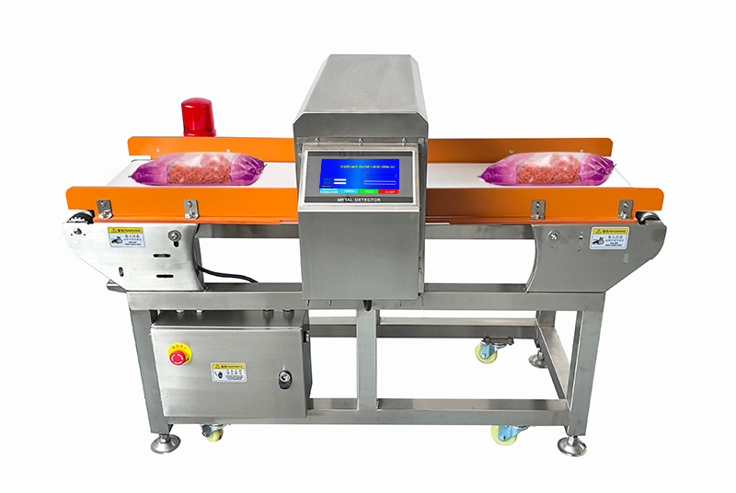
Figure 1-1: DD-360 Conveyor Belt Metal Detector — Front View

1.1 About This Manual
This manual provides a comprehensive guide to the installation, operation, and maintenance of the DD-360 Series Conveyor Belt Metal Foreign Object Detector. It is intended for operators, setup managers, and maintenance personnel responsible for the day-to-day use of this equipment.
Please read this manual thoroughly before using the DD-360. Keep this manual together with the product for future reference. Should you have any questions not addressed in this document, please contact SameGram Technical Support (see Chapter 19).

1.2 Product Overview
The DD-360 Series is a high-performance conveyor-type metal detector engineered for inspecting food products, pharmaceuticals, textiles, and other industrial goods for metallic contamination. Utilizing advanced dual-channel digital signal processing (DSP) technology, the DD-360 delivers reliable detection of ferrous, non-ferrous, and stainless steel contaminants with exceptional accuracy.

1.3 Key Features
- Dual-channel detection (CHX / CHY) with real-time signal strength visualization on the color touchscreen.
- Intuitive touchscreen HMI with multi-language support and password-protected access control.
- Automatic Product Learning (Auto Setup) — rapid, one-touch calibration for new products.
- Manual parameter adjustment for fine-tuning sensitivity, phase angle, and gain to optimize detection.
- Configurable reject device timing with photoelectric sensor synchronization.
- Built-in detection log with time-stamped alarm records and product switching history for HACCP compliance.
- Robust stainless steel (SUS304) construction with food-grade PU conveyor belt, removable for cleaning.
- CE Certified (EMC + Machinery Directive + Low Voltage Directive) and RoHS compliant.

1.4 Important Notes on Detection Capability
WARNING | The metal detector cannot guarantee detection of all metals under all conditions. Detection capability depends on the type of inspected product (size, shape, conductivity, moisture content, temperature), the type of metal contaminant (material, shape, orientation, size), and the installation environment. The actual metal detection capability is based on the specifications issued before equipment delivery or the values confirmed at the time of delivery and installation.
2. Safety Instructions

2.1 General Safety Guidelines
WARNING | Failure to follow these safety instructions may result in personal injury, equipment damage, or product contamination. All personnel must read and understand this section before operating or servicing the equipment.

2.2 Electrical Safety
- The power supply must be a dedicated circuit, isolated from noise-producing equipment such as large motors and packaging machines. Connect to a socket close to the power source.
- Install a circuit breaker between the main power supply and this equipment. In humid environments, a residual current device (RCD / leakage circuit breaker) must be installed.
- The power plug must be properly grounded. Use a soft copper grounding wire with a diameter of at least 1.6 mm, or a metal wire of equivalent strength and corrosion resistance. Ground impedance must be less than 100 Ω.
- Do not route the power cord in multiple directions or place heavy objects on it — this may crush the cord and cause fire or electric shock.
- Keep the power cord away from heating appliances. Before unplugging, turn off the power switch first, then hold the plug firmly and pull it out.

2.3 Operational Safety
- Remove all metallic personal items (rings, watches, bracelets, keys, etc.) before operating the equipment. Metal objects worn by the operator will disturb the magnetic field and may cause false detections.
- When the equipment is interconnected with other machinery (front/rear conveyor belts, etc.), ground each device separately to avoid ground loops. Do not daisy-chain ground connections.
- Allow the equipment to warm up for at least 30 minutes after startup before performing detection operations. This is especially important when indoor temperature has changed significantly (e.g., morning startup).
- Do not operate the equipment with guards or covers removed.
- Keep hands, loose clothing, and long hair away from moving conveyor parts during operation.

2.4 Cleaning Safety
- Always unplug the power cord before cleaning the equipment.
- Use only soft plastic brushes or soft cloths for cleaning. Never use metal brushes or abrasive scrubbers.
- Use neutral detergent only. Do not use organic solvents such as thinner, toluene, benzene, or acetone for routine cleaning.
- Wash with warm water below 40 °C (applicable to waterproof-rated equipment only).

3. Technical Specifications

3.1 General Specifications
Parameter | Specification
Product Model | DD-360 Series
Weight Range | 3 – 14 kg
Maximum Detection Speed | 5 pcs/min (adjustable; depends on product spacing)
Item Size (Max) | 400 (L) × 400 (W) × 250 (H) mm
Detection Channel Size | 550 (W) × 300 (H) mm
Overall Machine Dimensions | 1400 (L) × 907 (W) × 1195 (H) mm (for reference only)
Conveyor Belt Ground Clearance | 800 mm (±50 mm height adjustable)
Casing Material | Stainless Steel SUS304
Conveyor Belt | Food-grade PU belt, removable for cleaning and replacement
Detection Channels | Dual channel (CHX + CHY)
Detection Modes | Stop and Audible/Visual Alarm
Component Units | Metal Detection Unit
Storage Recipes | 200 detector recipes
Conveyor Direction | Facing the display screen, from left to right
Display | Color touchscreen LCD
Reject Output | Configurable delay and duration timing via touchscreen
Data Logging | Detection alarm time records, product switching records, USB download
Password Protection | Configurable access control: factory, engineer, operator levels
Power Supply | AC 220 – 240 V ±10%, Single Phase
Operating Temperature | -10 °C to 45 °C (14 °F to 113 °F)
Operating Humidity | ≤ 90% RH, non-condensing, non-frostable
Warm-up Time | Minimum 30 minutes
Certifications | CE (EMC + MD + LVD), RoHS compliant
The DD-360 Series Conveyor Belt Metal Foreign Object Detector is designed for end-of-production-line inspection. It detects metallic impurities that may have been introduced into products or raw materials during the production process, including iron and non-magnetic metals (gold, silver, copper, aluminum, stainless steel, and other non-ferrous metals), thereby improving product safety and reducing hazards.
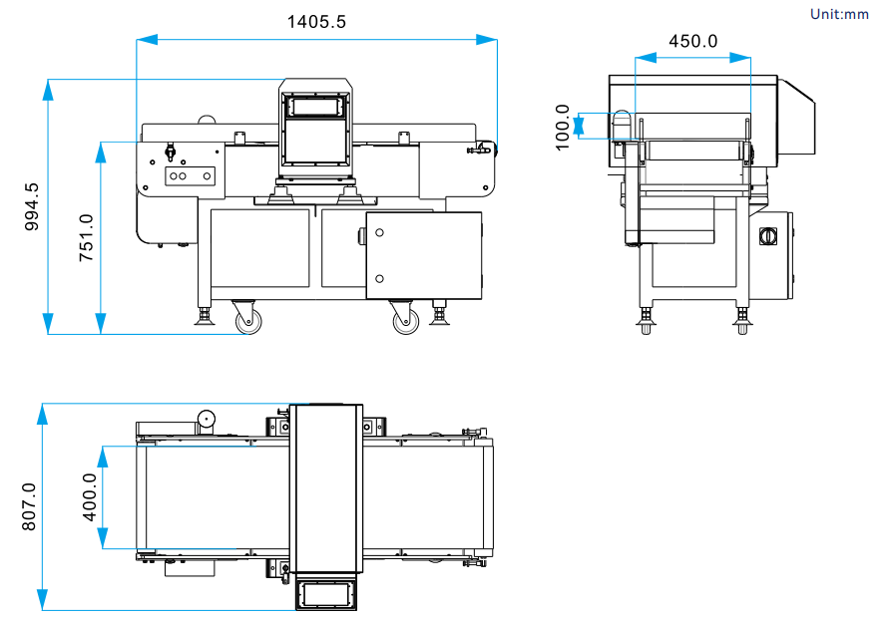
Figure 3-1: DD-360 Dimensions Reference (Actual product shall prevail)

3.2 Detection Sensitivity Reference
The following table provides empty-machine detection sensitivity values under standard test conditions. Actual in-product sensitivity depends on product characteristics (size, weight, moisture content, temperature), contaminant orientation, and installation environment. Accuracy is related to product size, weight, condition, throughput, and environmental vibration and wind force.
Metal Type | Empty Machine Detection Sensitivity | Notes
Fe (Ferrous) | Φ ≥ 3.0 mm sphere | Reference baseline; easiest metal to detect
Non-Fe (Copper, Brass, Aluminum) | Φ ≥ 3.5 mm sphere | Non-ferrous metals; approximately 1.2× the Fe detectable diameter
SUS (Stainless Steel 304/316) | Φ ≥ 4.0 mm sphere | Non-magnetic stainless steel; most difficult to detect (~1.3× the Fe diameter)

3.3 Environmental Requirements
Condition | Requirement | Remark
Ambient Temperature | -10 – 45 °C (14 – 113 °F) | No direct sunlight; no heating appliances nearby; non-frostable
Humidity | ≤ 90% RH | Non-condensing, non-frostable
Vibration | Minimal | Keep away from vibration sources and unstable surfaces
Dust Level | Low | Install in a clean, low-dust environment
Corrosive Agents | None | Free from volatile flammables, corrosive gases, or liquids
Air Conditioning | Not direct | Do not direct hot/cold air from AC vents at the detector head
Note: The dimension drawing is for reference only; the final product shall prevail. Non-standard customization is available upon request. For detailed dimensional drawings, refer to the DD-360 Dimensional Drawing (DD-360尺寸图.dwg) or contact SameGram technical support.

4. Machine Overview

4.1 System Components
The DD-360 conveyor metal detector comprises the following main assemblies:
- Detection Head (Probe) — Houses the transmitter and receiver coils that generate and sense the electromagnetic field within the detection aperture.
- Conveyor System — Food-grade PU belt driven by an electric motor, transporting products through the detection zone at a controlled speed.
- Touchscreen Control Unit — HMI (Human-Machine Interface) for all operational controls, product management, parameter configuration, and system settings.
- Reject Device (Optional) — Pneumatic or mechanical device for automatically diverting contaminated products from the production line.
- Control Cabinet — Contains the main controller, digital signal processor, power supply module, and I/O interface terminals.
- Frame & Support Structure — Adjustable-height stainless steel frame with locking casters or fixed mounting feet for stable positioning.

4.2 Detection Principle
The DD-360 operates on the balanced coil (three-coil) principle:
- A central transmitter coil generates a high-frequency electromagnetic field within the detection aperture.
- Two identical receiver coils, positioned symmetrically above and below the aperture, produce a balanced (null) signal when no metal is present.
- When a metal contaminant passes through the field, it disturbs the electromagnetic balance, inducing a signal in the receiver coils.
- The digital signal processor (DSP) analyzes the signal's amplitude and phase components to discriminate between the product's own "material effect" and actual metal contaminants.
- If metal is detected, the system triggers the configured response: conveyor stop, audible/visual alarm, and/or reject device activation.

4.3 Dual-Channel Detection
The DD-360 employs dual-channel signal processing (CHX and CHY), enabling simultaneous analysis of both the resistive and reactive components of the detected signal. This dual-channel approach significantly improves the system's ability to distinguish between the product effect (material effect) and actual metal signals, resulting in:
- Higher detection sensitivity, especially for difficult-to-detect non-magnetic stainless steels.
- Fewer false rejects caused by product effect variations.
- More stable operation across varying product temperatures and compositions.

5. Installation

5.1 Installation Conditions
Install the equipment in a location that meets ALL of the following conditions:
- (1) Temperature between 0 °C and 40 °C (32 °F – 104 °F).
- (2) Humidity within 30–85% RH, non-condensing.
- (3) No direct sunlight; no heating appliances such as stoves or heaters nearby.
- (4) Power supply voltage fluctuation within +10% / -15% of nominal.
- (5) Away from vibration sources and locations not prone to vibration.
- (6) Low-dust environment.
- (7) Free from volatile flammable materials, corrosive gases, and salt water.
- (8) Air conditioner hot/cold air does not blow directly onto the equipment.

5.2 Installation Precautions
WARNING | The power supply must be a dedicated circuit, isolated from noise-generating equipment such as large motors and packaging machines. Connect to a socket close to the power source.

- Do not wire the power cord in multiple directions. Heavy objects placed on the power cord can crush it and cause fire or electric shock.
- Keep the power cord away from heating appliances.
- When the equipment is interconnected with other machinery (front/rear conveyor belts, etc.), ground each device separately to avoid ground loops. Malfunctions may occur if interconnected devices share ground paths.

5.3 Conveyor Belt Height Alignment
Adjust the plane height between the DD-360 and the front/rear conveyor belts to the same level:
- 1. Place the equipment in position and check the height alignment with upstream and downstream conveyors.
- 2. Adjust the supporting feet so there are no gaps between the feet and the ground, eliminating any shaking or wobble.
- 3. After adjustment, tighten all locking nuts securely with a wrench.
- 4. Verify that products transfer smoothly across all conveyor junctions without tipping, jamming, or falling.

5.4 Power Supply and Grounding Connection
WARNING | To avoid danger, install a circuit breaker between the main power supply and this equipment. If used in a humid environment, a residual current device (leakage circuit breaker) must be installed.

- The power plug must be properly grounded to avoid electric shock and ensure stable operation.
- Grounding wire: Use a soft copper wire with a diameter of at least 1.6 mm, or a metal wire of equivalent strength and corrosion resistance.
- Ground impedance must be less than 100 Ω.
- Do not share the ground connection with equipment that generates electrical noise.

6. Electrical Connection

6.1 Power Connection
The DD-360 requires a stable single-phase AC power supply. Follow these guidelines for connection:
- Verify that the supply voltage matches the rating label on the equipment before connecting.
- Use the supplied power cord or an equivalent rated cable.
- Ensure the power outlet is properly grounded with impedance < 100 Ω.
- A dedicated circuit breaker, rated per the equipment label, must be installed in the supply line.

6.2 I/O Interface Connections
The DD-360 provides configurable input/output interfaces for integration with external devices:
Interface | Type | Function
Reject Device Output | Relay (dry contact) | Controls pneumatic pusher, air blast, flap gate, or other reject mechanism
Alarm Output | Relay (dry contact) | Drives external alarm indicators (stack light, buzzer, beacon)
Photoelectric Sensor Input | Digital input | Product presence detection for synchronized inspection timing
Remote Start/Stop | Digital input | External run/stop control from upstream equipment or control panel

6.3 Grounding Requirements
WARNING | Proper grounding is essential for both operator safety and detection performance. Inadequate grounding may result in erratic operation, false alarms, or reduced detection sensitivity.

- Use a dedicated ground rod if the building ground is unreliable.
- Ground wire cross-section: minimum 1.6 mm diameter copper or equivalent conductor.
- Do not connect the ground to structural steel that may not provide a reliable earth path.
- Periodically verify ground resistance to ensure it remains below 100 Ω.

7. Touchscreen Interface

7.1 Main Page Overview
The main (Home) page is the primary operating screen of the DD-360. It provides at-a-glance status information and access to all key functions.
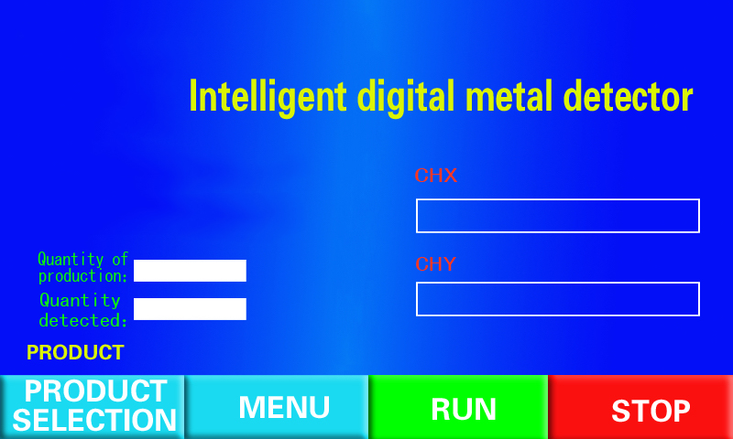
Figure 7-1: DD-360 Main (Home) Page
The main page displays the following items:
# | Item | Description
1 | Product Number | Currently selected product serial number, e.g., "Product 000".
2 | Product Name | Registered product name, e.g., "Fish 1kg".
3 | System Time | Current date and time, e.g., "2017-11-20 19:40:10".
4 | Device Status | Current operating status: "Stop", "Running", or "Alarm".
5 | Product Counters | "Total Production" and "Total Inspection" counts for the active product.
6 | Operation Buttons | [Product] — Change product; [Menu] — Settings; [Run] / [Stop] — Conveyor control.
7 | Signal Strength Bars | Dual-channel signal display (CHX & CHY) with numeric values. Red bar = alarm threshold exceeded.

7.2 Signal Strength Display
The DD-360 uses dual-channel detection. CHX and CHY represent the two independent detection channels:
- The cursor bar graphically indicates the signal strength of each channel in real time.
- The numeric value displayed beside each bar shows the specific signal strength reading.
- When a cursor bar lights up in RED and reaches the detection threshold, the system triggers an alarm and stops the conveyor (or activates the reject device, depending on configuration).
Monitoring the signal strength bars during operation helps operators understand product effect magnitude and system stability. A stable, low signal during normal product flow indicates optimal setup.

7.3 Menu Navigation
Press the [Menu] button on the main page to access the configuration menu. The menu is organized into the following sections:
Menu Section | Sub-Items | Function
Product Settings | Product Name Registration  Auto Setup  Manual Setting  Product Parameters | Configure and manage product-specific detection parameters
System Configuration | System Parameters  Password Management | Adjust system-wide settings and access control
Detection Log | Log Settings  Log Query | Configure data recording and view alarm/switch history

8. Product Setup

8.1 Selecting a Product
To select or change the active product:
- 1. Press the [Product] button on the main page. The [Product Change] screen is displayed.
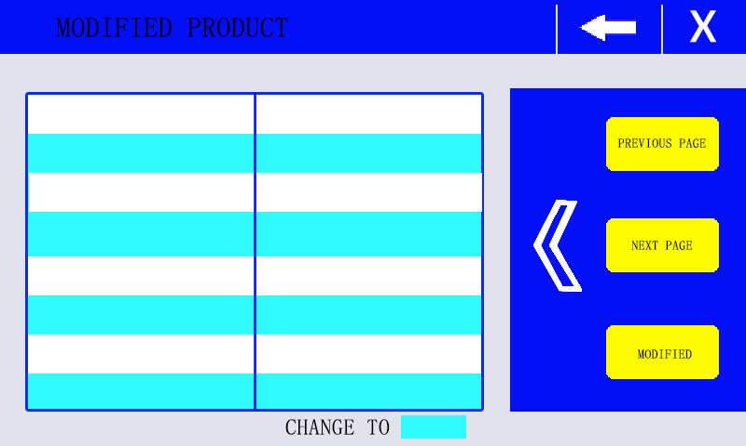
Figure 8-1: Product Change Screen
- 2. Use the cursor to navigate to the desired product serial number.
- 3. Press the [Change] key to confirm the selection.
The selected product's parameters (sensitivity, phase, gain, reject timing, etc.) are loaded and applied immediately upon confirmation.

8.2 Registering a Product Name
To register a new product name:
- 1. Press the [Menu] key on the main page to open the Menu screen.
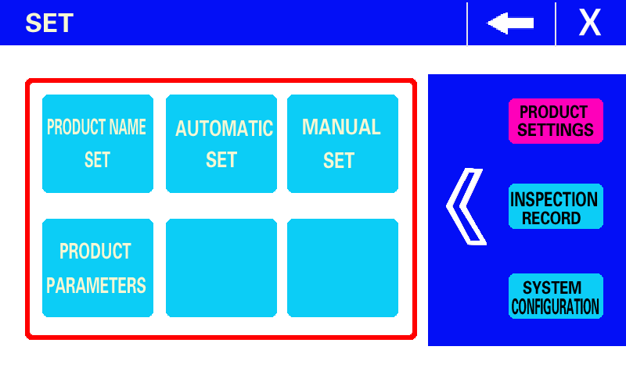
Figure 8-2: Menu Screen
- 2. Under [Product Settings], select [Product Name Registration]. The registration screen is displayed.
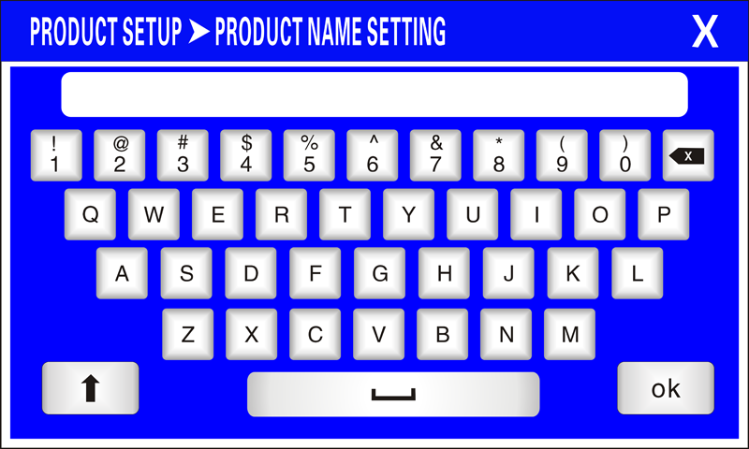
Figure 8-3: Product Name Registration Screen
- 3. Enter the desired product name using the on-screen keyboard.
- 4. Press [OK] to save the product name.
NOTE | Use clear, descriptive product names (e.g., "Frozen Fish Fillet 1kg" or "Bread Loaf 500g") to facilitate quick identification during product changeovers. Avoid generic names that could cause operator confusion.

8.3 Product Parameters Overview
Each product stores the following configurable parameters. These are set automatically by the Auto Setup function and can be fine-tuned manually if needed:
Parameter | Description | Set By
Sensitivity Value | Detection threshold; higher values = higher sensitivity to metal | Auto / Manual
Gain Value | Signal amplification factor applied to the received signal | Auto / Manual
Phase Value | Phase angle for discriminating product effect from metal signals | Auto / Manual
Detection Mode | Response when metal is detected: Stop, Alarm, or Reject | Manual
Reject Delay Time | Time from metal detection to reject device activation | Manual
Reject Duration | Time the reject device remains active per detection event | Manual
Photoelectric Switch | If ON, alarm only when product covers the photoelectric sensor | Manual
Detection Time | Time window from sensor coverage to product exit (valid with PE switch ON) | Manual

9. Auto Learning Procedure

9.1 What is Auto Setup?
The Auto Setup (Auto Learning) function automatically determines the optimal detection parameters for a specific product. The system analyzes the product's material effect (the electromagnetic signal generated by the product itself) as it passes through the detection head, then calculates the best sensitivity, phase, and gain settings to maximize metal detection capability while minimizing false rejects.

9.2 Performing Auto Setup
Follow these steps to perform automatic parameter setting:
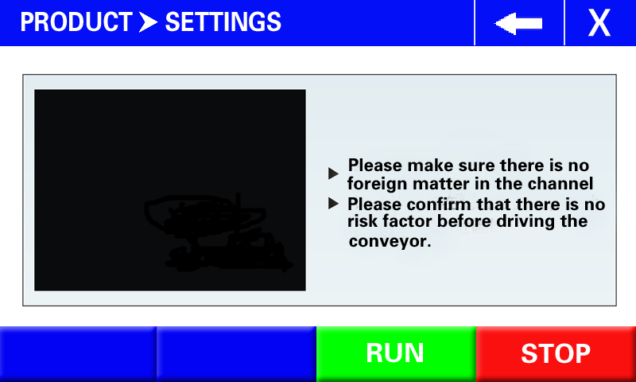
Figure 9-1: Auto Setup Screen
- 1. Press the [Menu] key on the main page to open the Menu screen.
- 2. Under [Product Settings], select [Auto Setup]. The Auto Setup screen is displayed.
- 3. Press the [Run] key. The conveyor will start running.
- 4. When the prompt "Incoming Product" appears, insert the product into the detection head. The product must pass through at least once. For best results, pass multiple samples through the detector.
- 5. After approximately 12 seconds, the automatic setting is completed. The conveyor will stop automatically.
- 6. The calculated parameters (sensitivity, phase, gain) are automatically saved for the current product.
WARNING | Ensure that the products used for Auto Setup are confirmed to be free of metal contaminants. If a contaminated product is inadvertently used during the learning process, the system will calibrate incorrectly, potentially masking future detections.

NOTE | For optimal results, pass the product through the detection head multiple times during Auto Setup. This allows the system to build a more accurate statistical profile of the product's material effect, accounting for natural variations in size, orientation, and temperature.

9.3 When to Perform Auto Setup
Auto Setup should be performed in any of the following situations:
- When setting up a new product for the first time.
- When the product formulation, recipe, size, or packaging has changed.
- When the product temperature has changed significantly (e.g., switching between frozen and thawed product).
- After relocating the equipment to a new position or after significant environmental changes.
- When false reject rates increase or detection sensitivity appears to have degraded.
- After major maintenance or component replacement affecting the detection head or conveyor.

10. Manual Parameter Adjustment

10.1 Accessing Manual Settings
To manually adjust product parameters after Auto Setup:
- 1. Press the [Menu] key on the main page to open the Menu screen.
- 2. Under [Product Settings], select [Manual Setting]. The Manual Setting screen is displayed.
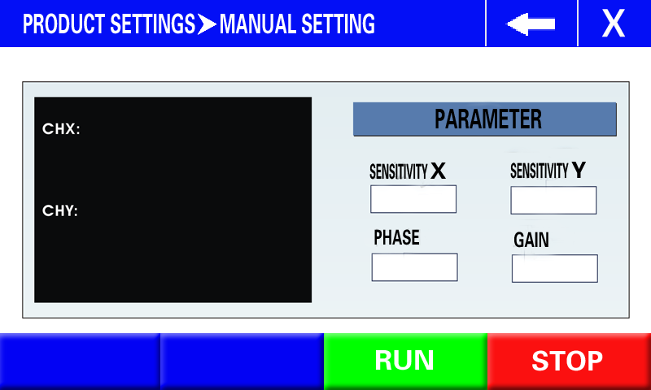
Figure 10-1: Manual Setting Screen
- 3. Adjust the desired parameters while observing the real-time signal strength display on the right side of the screen.
NOTE | Normally, manual adjustment of automatically calculated parameters is not necessary. The Auto Setup values are optimized for reliable detection. However, fine-tuning may be appropriate to address specific production conditions or challenging products.

10.2 Manual Adjustment Guidelines
- Pressing the [Run] button in the Manual Setting screen will NOT trigger an alarm or stop the conveyor. This mode is for signal observation only — it allows you to see how parameter changes affect signal strength without interrupting production flow.
- Adjust parameters in small increments and observe the effect on signal strength before making further changes.
- If the signal strength for the product alone (without metal test piece) is consistently high, try adjusting the Phase value to better cancel the product effect.
- If detection of small metal test pieces is insufficient, gradually increase the Sensitivity value while monitoring for any false triggers on clean product.

10.3 Manual Adjustment Workflow
Follow this systematic workflow for manual parameter adjustment:
- Step 1: Run the conveyor with clean product only (no test pieces). Observe the CHX and CHY signal bars — they should remain low and stable.
- Step 2: If the signal bars are elevated (close to the alarm threshold) with clean product, adjust the Phase value to reduce the product effect signal.
- Step 3: Place a certified metal test piece on or inside a product sample and pass it through. Confirm the signal bars clearly exceed the alarm threshold.
- Step 4: If the test piece does not trigger detection reliably, increase the Sensitivity value and/or adjust the Gain.
- Step 5: Repeat Steps 3–4 with test pieces placed at leading edge, center, and trailing edge of the product until reliable detection is achieved at all positions.
- Step 6: Run 10–20 clean products through to verify no false rejects occur under normal production conditions.

10.4 Product Parameter Settings
In the Menu screen, under [Product Settings] → [Product Parameters], the following detailed parameter screen is displayed:
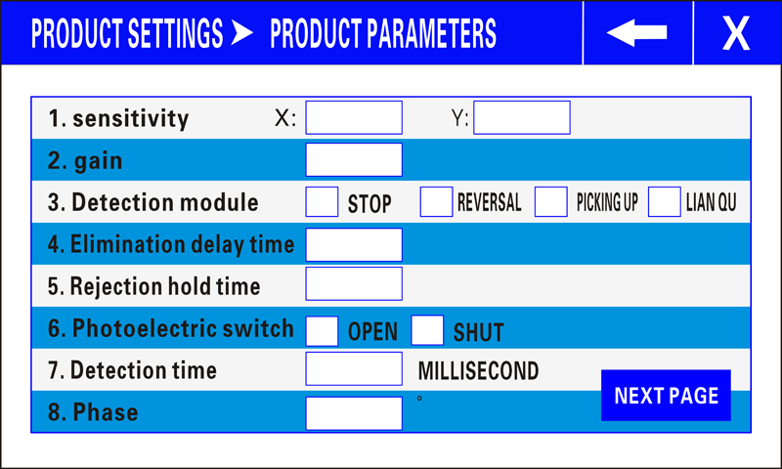
Figure 10-2: Product Parameters Screen
The configurable parameters and their functions:
- (1) Sensitivity Value, Gain Value, Phase Value — These are normally set by Auto Setup and do not require manual adjustment. Adjust only when fine-tuning is needed based on actual production conditions.
- (2) Detection Mode — Determines the system response when metal is detected: Stop conveyor only, Alarm only, or Reject (activate reject device).
- (3) Reject Delay Time — The time period from when the detector identifies a metal contaminant to when the reject device begins its action. This compensates for the physical distance between the detection point and the reject station.
- (4) Reject Duration Time — The time period the reject device remains active. Must be long enough to fully remove the contaminated product.
- (5) Photoelectric Switch — If set to "On", the system only generates an alarm when the product is covering the photoelectric sensor. This prevents false triggers during gaps between products.
- (6) Detection Time — Valid only when the photoelectric switch is ON. Defines the time window from when the product covers the sensor until the product exits the detection head.

11. Detection Sensitivity

11.1 Understanding Sensitivity
The sensitivity of a metal detector is defined as the diameter of the smallest metal sphere that can be reliably detected at the geometric center of the detection aperture — the point of weakest sensitivity. Sensitivity is categorized into two types:
- Maximum Sensitivity — The highest theoretical sensitivity achievable under ideal laboratory conditions, with no product present in the aperture.
- Product Detection Sensitivity — The highest sensitivity achievable when detecting metal contaminants within an actual product. This is the practical, real-world sensitivity and is the value relevant for production operations.

11.2 Factors Affecting Sensitivity
Multiple factors influence the achievable detection sensitivity:
Factor | Description | Impact
Material Effect | The product's own electromagnetic signal (affected by moisture, fat, temperature, acidity, salinity, size, and orientation) | Higher material effect → Lower sensitivity
Metal Type | Ferrous (magnetic) vs. Non-Ferrous vs. Stainless Steel | SUS316 is hardest; Fe is easiest
Metal Shape | Spherical, wire-like, flat fragment, or irregular | Sphere = smallest detectable; wire is orientation-dependent
Metal Orientation | Direction of the contaminant as it passes through the field | Worst-case orientation determines practical sensitivity
Aperture Size | Dimensions of the detection head opening | Larger aperture → Reduced sensitivity
Environment | EMI, vibration, temperature fluctuation, moving metal nearby | Unstable environment → Lower usable sensitivity
Packaging | Metallized film or foil packaging | Metal in packaging interferes with detection

11.3 Metal Type Detection Comparison
Category | Magnetic? | Examples | Relative Detectability
Ferrous (Fe) | Yes | Carbon steel, iron, mild steel | Easiest — reference baseline
Non-Ferrous | No | Copper, lead, brass, bronze, aluminum | Moderate — ~1.5× Fe sphere diameter
Stainless Steel (magnetic) | Yes | SUS430, some 400-series | Similar to ferrous
Stainless Steel (non-magnetic) | No | SUS302, SUS304, SUS316 | Most difficult — ~1.5–2× Fe sphere diameter

11.4 Determining Benchmark Sensitivity
To establish the optimal benchmark sensitivity for each product in your HACCP plan:
- 1. Attach certified Fe and SUS test pieces to sample products and confirm reliable detection at all positions (leading, center, trailing).
- 2. If the product has a strong material effect (high moisture, salt content, temperature variation, or irregular shape), the sensitivity benchmark will need to be reduced accordingly.
- 3. Consider temperature effects — partially thawed frozen products exhibit significantly higher material effect than fully frozen products.
- 4. Document the benchmark sensitivity for each product and verify it during daily checks (see Chapter 14).
- 5. If the required sensitivity cannot be achieved for a particular product, consider using a smaller detection aperture or contacting SameGram Technical Support for guidance.

12. Reject Device Configuration

12.1 Detection Response Modes
The DD-360 supports three configurable detection response modes, selectable per product:
Mode | System Response | Best For
Stop Mode | Conveyor stops immediately upon metal detection. Operator must manually remove the contaminated product and press [Run] to resume. | Manual inspection stations; low-speed lines
Alarm Mode | Audible/visual alarm is triggered. Conveyor may stop or continue (configurable). Operator investigates and removes contaminated product. | Lines with operator attendance
Reject Mode | Reject device is automatically activated to divert the contaminated product from the production line without stopping the conveyor. | High-speed automated lines; unattended operation

12.2 Reject Timing Configuration
When using Reject Mode, two critical timing parameters must be correctly configured:
- Reject Delay Time — The period from the moment the detector identifies a metal contaminant to the moment the reject device begins its action. This compensates for the conveyor travel distance between the detection point and the reject station. Set too short → reject activates before product arrives; set too long → contaminated product passes the reject point.
- Reject Duration Time — The period the reject device remains active during each rejection cycle. Must be long enough to ensure the contaminated product is fully removed from the conveyor. Set too short → incomplete rejection; set too long → good products may also be diverted.
NOTE | To verify reject timing: place a metal test piece on a product, run it through, and confirm the reject device activates at the correct moment to remove only the contaminated product. Adjust timing parameters as needed and re-test until consistent.

12.3 Photoelectric Sensor Configuration
The optional photoelectric (PE) sensor enables synchronized product-gated detection:
- When the Photoelectric Switch parameter is set to "On", the system only evaluates signals when a product is actually covering the PE sensor. This prevents false alarms during gaps between products on the conveyor.
- The Detection Time parameter (valid only when PE switch is ON) defines the time window from when the product leading edge covers the PE sensor until the product trailing edge exits the detection head. The system monitors signals only within this window.
- Correct PE sensor configuration is essential for high-speed lines where product spacing is tight and reject timing precision is critical.

13. System Configuration

13.1 System Parameters
To access system-level settings, press [Menu] → [System Configuration] → [System Parameters]:
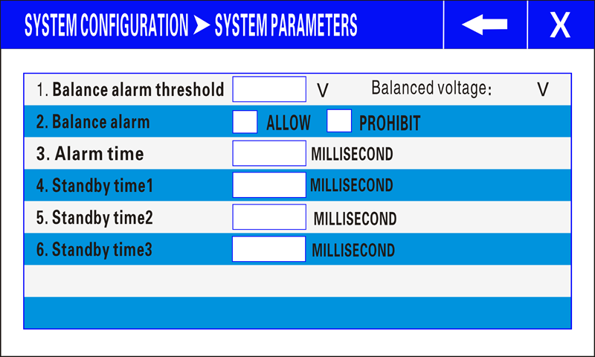
Figure 13-1: System Parameters Screen
Key system parameters:
- (1) Balance Voltage — This value reflects the electrical balance state of the detection head coils. It is primarily used by manufacturers for diagnostics and debugging. Do not modify unless instructed by SameGram Technical Support.
- (2) Alarm Time — The duration the warning light/beacon remains illuminated after a metal detection event. If set to "9999", the alarm latches on indefinitely until the operator presses [Stop] or [Run] to cancel.
- (3) Other Parameters — Reserved for future use or manufacturer configuration. Do not modify.

13.2 Password Management
To configure password protection, press [Menu] → [System Configuration] → [Password Management]:
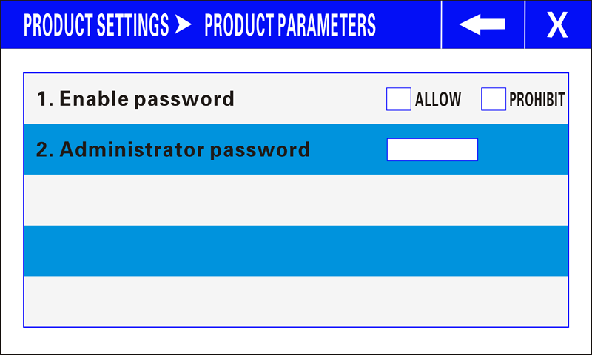
Figure 13-2: Password Management Screen
- On this page, you can enable or disable the password function and set a custom password.
- If password protection is set to "Allow", the system will prompt for the password whenever the [Product] or [Menu] buttons are pressed on the main page.
WARNING | You must remember the password you set. If the password is lost, contact SameGram Technical Support for recovery assistance. Do not share the password with unauthorized personnel.

13.3 Detection Log Configuration
The DD-360 can record production data and detection events for HACCP compliance. To configure logging, press [Menu] → [Detection Log] → [Set]:
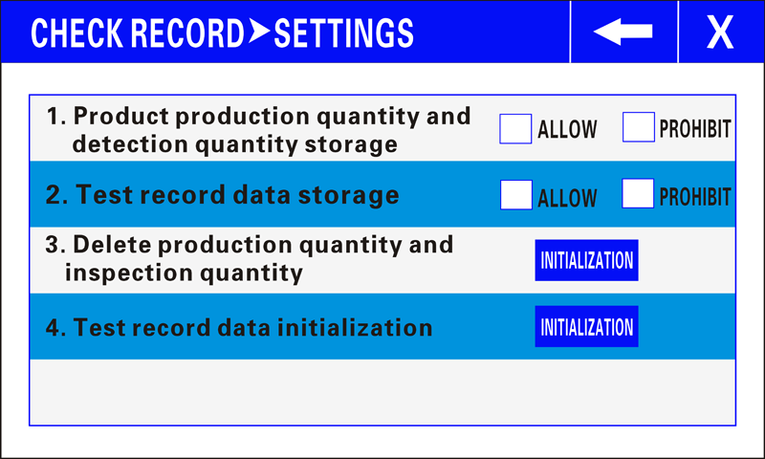
Figure 13-3: Detection Log Settings Screen
Available logging options:
- (1) Product Production Quantity & Checkout Quantity — If set to "Allow", the production and inspection counters are displayed on the main page.
- (2) Test Record Data Storage — If set to "Allow", the system stores the timestamp of each alarm event, which can be retrieved on the query page.
- (3) Delete Production/Inspection Quantity — Click the corresponding "Initialize" button to reset the product counters to zero.
- (4) Initialize Detection Record Data — Click the corresponding "Initialize" button to clear all stored alarm time records.

13.4 Detection Log Query
To view stored records, press [Menu] → [Detection Log] → [Query]:
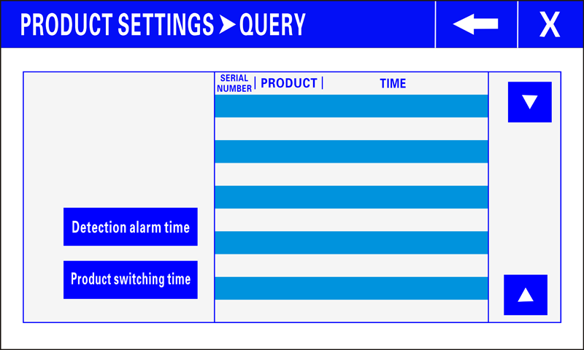
Figure 13-4: Detection Log Query Screen
- Click [Detect Alarm Time] to view the timestamped alarm records for each product.
- Click [Product Switching Time] to view the history of product changeovers, including timestamps and which products were selected.

14. HACCP Validation Procedure

14.1 HACCP and Metal Detection
Metal foreign body detection is a Critical Control Point (CCP) in HACCP (Hazard Analysis and Critical Control Points) plans. The metal detector is the most effective instrument for ensuring that products leaving your facility are free from metal contamination.
The primary objectives of HACCP in relation to metal detection are:
- Identify where metal contamination risks exist in your production line.
- Establish critical limits for metal detection (minimum detectable contaminant size per metal type).
- Implement monitoring procedures (daily verification tests with certified test pieces).
- Define corrective actions when detection capability fails or equipment malfunctions.
- Maintain verification records for regulatory audits and quality assurance compliance.

14.2 Establishing Critical Limits
For each product inspected by the DD-360, establish and document the following critical limits in your HACCP plan:
- Ferrous (Fe) test piece size that must be reliably detected.
- Non-Ferrous (copper, brass, aluminum) test piece size that must be reliably detected.
- Stainless Steel (SUS304 or SUS316) test piece size that must be reliably detected.
These limits must be achievable with the DD-360 configured for the specific product and verified through testing. All operators must be trained on the critical limits for each product they process.

14.3 HACCP Validation Procedure
Perform the following validation procedure when commissioning a new product, after any significant product change, or during periodic HACCP reassessment:
- 1. Set up the product using the Auto Setup procedure (see Chapter 9).
- 2. Obtain certified HACCP test pieces (Fe, Non-Fe, SUS) of the sizes specified in your HACCP plan.
- 3. Attach each test piece to a product sample and pass it through the detector. Repeat each test at least 3 times per test piece type to confirm consistency.
- 4. Test at multiple positions: place the test piece at the leading edge, center, and trailing edge of the product. Also test with the test piece on top, inside, and underneath the product.
- 5. Record all test results in your HACCP validation log, including date, time, product name, test piece type and size, and pass/fail result for each test.
- 6. If any test piece fails to trigger detection, re-run Auto Setup or manually adjust parameters until reliable detection is achieved at all positions.
WARNING | If the detector cannot reliably detect the required HACCP test piece sizes after adjustment, do NOT proceed with production. Contact SameGram Technical Support for assistance. Document the non-conformance and corrective actions taken.

14.4 Record Keeping Requirements
The DD-360's built-in data logging supports HACCP record-keeping requirements:
- Detection alarm time records — Time-stamped log of every metal detection event, retrievable via [Detection Log] → [Query] → [Detect Alarm Time].
- Product switching records — History of all product changeovers with timestamps, retrievable via [Detection Log] → [Query] → [Product Switching Time].
- Production counters — Total production and total inspection counts per product, visible on the main page when enabled.
Ensure logging is enabled (see Chapter 13.3) and that records are periodically reviewed and archived according to your facility's document retention policy.

15. Daily Verification Test

15.1 Purpose and Importance
Daily verification testing confirms that the metal detector is functioning correctly at the start of each production period and can reliably detect the specified metal test pieces. This is a critical component of HACCP compliance and forms part of your due diligence defense.

15.2 Before-Operation Checklist
Perform ALL of the following checks before starting production each day or shift:
Check # | Item | Procedure | Pass Criteria
1 | Visual Inspection | Inspect the entire machine for physical damage, loose fasteners, or foreign objects on the conveyor belt. | No visible damage; all guards and covers in place.
2 | Cleanliness | Check the detection head aperture and conveyor belt for product residue, debris, or buildup. | Aperture and belt are clean and free from residue.
3 | Conveyor Belt | Verify belt is properly tensioned, tracking correctly, and free from cracks or fraying. | Belt runs smoothly without slipping or wandering.
4 | Fe Test Piece | Pass certified Fe test piece through detector on/inside a product sample. | Detector alarms/stops/rejects reliably.
5 | Non-Fe Test Piece | Pass certified Non-Fe test piece through detector on/inside a product sample. | Detector alarms/stops/rejects reliably.
6 | SUS Test Piece | Pass certified SUS test piece through detector on/inside a product sample. | Detector alarms/stops/rejects reliably.
7 | Reject Device | Confirm reject mechanism (if fitted) operates correctly and removes the test product. | Reject device activates and product is diverted.
8 | Qualified Product Flow | Run 3–5 clean products through without test pieces. | No false alarms; products pass normally as [OK].

15.3 After-Operation Cleanup
After production is completed each day:
- Remove the conveyor belt and thoroughly clean both the front and back surfaces.
- Clean the conveyor belt pallet (support plate) and the area beneath the belt.
- Wipe down the detection head aperture interior with a soft cloth and neutral detergent.
- Clean the touchscreen with a soft, dry microfiber cloth.
- Record any anomalies observed during the production run in the maintenance log.

15.4 Weekly Inspection Items
Perform the following additional inspections once per week:
- Remove the conveyor belt and inspect both end faces for cracking, delamination, or fraying.
- Check the conveyor belt running condition — listen for abnormal sounds and watch for creeping or slipping.
- Inspect all electrical connections for tightness, signs of corrosion, or insulation damage.
- Verify ground connection integrity — resistance must remain < 100 Ω.
- Clean cooling fans and ventilation openings to prevent dust accumulation and overheating.

16. Production Operation

16.1 Startup Procedure
Follow this procedure each time the equipment is started for production:
- 1. Verify the power cord is properly connected and the grounding is secure (resistance < 100 Ω).
- 2. Turn on the main power switch and circuit breaker.
- 3. Allow the equipment to warm up for at least 30 minutes. This is essential for stable detection performance — do not skip this step, especially during morning startup when ambient temperature may have changed significantly.
- 4. Select the correct product from the [Product Change] screen.
- 5. Perform the complete Daily Verification Test (see Chapter 15).
- 6. If all checks pass, press [Run] to begin production.

16.2 During Production
While the DD-360 is in normal operation:
- Monitor the signal strength bars (CHX and CHY) on the main page. Consistent, stable signals at low levels indicate normal operation. Any sudden changes should be investigated.
- Observe the product counters (Total Production / Total Inspection) to track throughput.
- When an alarm occurs, follow your standard operating procedure:
- • Stop the conveyor if it has not already stopped automatically.
- • Remove the rejected product from the line.
- • Re-inspect the product by passing it through the detector again in different orientations.
- • If the alarm repeats, isolate the product for further investigation or disposal.
- • Record the alarm event in your HACCP log.
- Do not wear metal items (rings, watches, bracelets, belt buckles) during operation.
- Keep the area around the detection head clear of moving metal objects, including tools, trolleys, and cleaning equipment.

16.3 Product Changeover
When switching to a different product:
- 1. Press [Stop] to halt the conveyor.
- 2. Press [Product] and select the new product from the list.
- 3. Verify that all product parameters (sensitivity, phase, gain, reject timing, detection mode) are correct for the new product.
- 4. Perform a complete verification test with the appropriate certified test pieces for the new product.
- 5. If all tests pass, press [Run] to resume production.
NOTE | If the new product has not been previously set up, perform the Auto Setup procedure (Chapter 9) and HACCP validation (Chapter 14) before starting production.

16.4 Shutdown Procedure
At the end of production:
- 1. Press [Stop] to halt the conveyor.
- 2. Record the final production and inspection counts if required by your quality system.
- 3. Turn off the main power switch.
- 4. Perform the after-operation cleaning procedure (see Chapter 15.3).

16.5 Special Considerations for Bulk Products
When inspecting bulk (unpackaged, loose) items:
- If a reject device is connected, ensure the reject duration is configured long enough for complete removal of the contaminated item from the product stream.
- When the conveyor stops due to a metal detection event, remove ALL bulk items from the conveyor belt before restarting. Residual items may also be contaminated — do not assume only one item is affected.
- For irregularly shaped products, pass them through in multiple orientations during verification testing to confirm detection at all possible angles.

17. Maintenance & Cleaning

17.1 Daily Maintenance
Refer to Chapter 15 (Daily Verification Test) for the complete daily inspection checklist. Key daily maintenance tasks include:
- Visual inspection for physical damage and cleanliness.
- Conveyor belt condition check — tracking, tension, and surface integrity.
- Detection sensitivity verification with certified Fe, Non-Fe, and SUS test pieces.
- Reject device functional check (if fitted).
- Touchscreen cleanliness check.

17.2 Cleaning Precautions
WARNING | ALWAYS unplug the power cord before cleaning the equipment. Failure to do so may result in electric shock, equipment damage, or unintended conveyor startup.

Approved Cleaning Materials:
- Soft plastic brushes or soft cloths for sweeping and wiping.
- Neutral detergent (pH-neutral) diluted in warm water (below 40 °C).
- Clean water for rinsing.
- Soft, dry microfiber cloth for the touchscreen.

PROHIBITED Cleaning Materials:
- Metal brushes, steel wool, abrasive scrubbers, or scouring pads.
- Organic solvents: thinner, toluene, benzene, acetone, or similar — do NOT use for routine cleaning.
- High-pressure water jets or steam cleaners (unless equipment is specifically IP-rated for such cleaning).
- Bleach or strong acidic/alkaline cleaners that may corrode stainless steel or damage seals.
Cleaning Procedure:
- 1. Unplug the power cord.
- 2. Remove loose debris with a soft brush or cloth.
- 3. Apply neutral detergent solution with a soft cloth or sponge.
- 4. Pay special attention to the detection head aperture interior and the conveyor belt-to-frame junction areas, where debris tends to accumulate.
- 5. Rinse thoroughly with clean water to remove all detergent residue.
- 6. Dry all surfaces with a clean, soft cloth to prevent water spots.

17.3 Stainless Steel Maintenance
Although stainless steel (SUS304) has excellent corrosion resistance, it is not completely immune to rusting. Rust on stainless steel is typically surface contamination rather than material corrosion, caused by:
- Adhesion and accumulation of atmospheric iron powder or metal particles.
- Exposure to corrosive gases or salt-laden air (coastal or industrial environments).
- Galvanic corrosion from contact with dissimilar metals.
- Accumulation of contaminants that, when exposed to moisture, damage the passive chromium oxide film on the stainless steel surface.
Rust Removal Methods:
- Light rust from iron powder or salt: Wipe with a sponge or soft cloth dipped in neutral detergent or soapy water. Rinse thoroughly and dry completely.
- Stubborn contamination (fingerprints, adhesive residue): Use a soft cloth lightly moistened with alcohol, gasoline, or acetone. Apply sparingly, wipe clean, and rinse with water afterward.
- For persistent rust spots, use a dedicated stainless steel cleaner following the manufacturer's instructions.
With regular care and prompt attention to any signs of surface contamination, stainless steel will maintain its appearance and corrosion resistance indefinitely.

18. Conveyor Belt Removal & Installation

18.1 Removal Procedure
The conveyor belt assembly is designed to be removable for cleaning the back of the belt and the conveyor belt pallet. Follow these steps in the exact order specified:
WARNING | Ensure the equipment is powered off and the power plug is disconnected before beginning belt removal.

- Step 1: Loosen the 4 buckles (latches) located on the outside of the machine body.
- Step 2: Lift the belt conveyor unit upward from the side of the drive shaft to release tension on the motor drive belt (synchronous belt).
- Step 3: Disconnect the drive belt (synchronous belt) from the motor pulley.
- Step 4: After the drive belt is fully disengaged, lift the belt conveyor unit upward and away from the frame.
- Step 5: Remove the belt conveyor unit by sliding it out from the side of the detection head. Exercise extreme caution to avoid damaging the resin liner inside the detection aperture.

18.2 Reinstallation Procedure
To reinstall the conveyor belt assembly, reverse the removal procedure:
- 1. Carefully position the belt conveyor unit back into the frame, guiding it through the detection head aperture without contacting the resin liner.
- 2. Re-engage the drive belt (synchronous belt) onto the motor pulley, ensuring proper alignment.
- 3. Lower the belt conveyor unit into its operating position, ensuring the drive belt has adequate tension.
- 4. Secure all 4 buckles (latches) on the outside of the machine body. Verify each latch is fully engaged.
- 5. Manually rotate the belt to verify it tracks correctly and does not rub against the frame or detection head.
- 6. Reconnect the power, run the conveyor briefly, and confirm smooth, quiet operation before resuming production.

18.3 Belt Inspection During Removal
Each time the conveyor belt is removed, take the opportunity to inspect the following:
- Belt end faces — Check for cracking, fraying, delamination, or uneven wear.
- Belt surface — Inspect for cuts, embedded debris, excessive wear, or chemical damage.
- Belt pallet (support plate) — Clean thoroughly and inspect for wear grooves or damage.
- Drive pulley and idler rollers — Check for product debris buildup on the roller surfaces.
- Drive belt (synchronous belt) — Inspect for cracking, stretching, or missing teeth. Replace if any damage is found.

19. Troubleshooting

19.1 Common Issues and Solutions
The following table lists common operational issues, their likely causes, and recommended solutions. If a problem persists after following these steps, contact SameGram Technical Support.
Problem | Possible Cause(s) | Recommended Solution
False alarms  (no metal present) | • Strong magnetic/EM interference nearby  • Unstable power supply  • Large moving metal objects near detector  • Dirty or worn conveyor belt  • Incorrect or degraded grounding | • Identify and remove EMI source or relocate detector  • Install power line filter or voltage stabilizer  • Clear area around detection head of all moving metal  • Clean belt thoroughly; replace if worn  • Verify ground impedance < 100 Ω; improve if needed
Reduced detection  sensitivity | • Product temperature changed (partial thaw)  • Product formulation/moisture changed  • Dirt accumulation in detection aperture  • Environmental temperature fluctuation  • Component drift over time | • Re-run Auto Setup for current product condition  • Stabilize frozen product temperature before inspection  • Clean detection aperture and conveyor belt  • Allow full 30-min warm-up; re-calibrate  • If persistent, contact Technical Support
Signal bars fluctuate  with no product present | • Ground vibration affecting detector  • Electrical noise on power line  • Nearby equipment generating interference  • Loose internal connections | • Relocate to vibration-free area or reduce sensitivity  • Use dedicated filtered power circuit  • Increase distance from interfering equipment  • Contact Technical Support for internal inspection
Equipment does  not power on | • Power cord disconnected or damaged  • Circuit breaker tripped  • Internal fuse blown  • Main power switch not turned on | • Check power cord connection and condition  • Reset breaker; investigate cause if it trips again  • Contact Technical Support for fuse replacement  • Verify main power switch is in ON position
Conveyor belt  not running | • [Stop] button pressed or E-stop activated  • Drive belt disengaged or broken  • Motor overload protection triggered  • Obstruction in conveyor mechanism | • Press [Run]; check emergency stop status  • Inspect drive belt; re-engage or replace  • Remove obstruction; reset overload protection  • Check for jammed products on belt
Reject device  not activating | • Reject mode not configured for this product  • Reject delay/duration set incorrectly  • Pneumatic supply disconnected (air-operated)  • Reject mechanism mechanically jammed | • Set Detection Mode to "Reject" in Product Parameters  • Adjust Reject Delay and Duration timing values  • Check air supply lines and pressure  • Inspect and free the reject mechanism
Touchscreen  unresponsive | • Screen surface is dirty or wet  • System software requires restart  • Internal hardware fault | • Clean touchscreen with soft, dry microfiber cloth  • Power cycle: turn off, wait 10 seconds, turn on  • If problem persists, contact Technical Support

20. Frequently Asked Questions (FAQ)
Q1: What is a metal detector and how does it work?
A metal detector is an electronic instrument designed to detect the presence of metal contaminants. It consists of a transmitter coil and receiving sensors arranged in a balanced configuration. When metal passes through the electromagnetic field generated by the transmitter, the received signal changes. The digital signal processor analyzes this change to determine whether it is caused by metal. If metal is confirmed, the system triggers the configured alarm or reject action.
Q2: Why should I use a metal detector?
There are two primary reasons: (1) Equipment Protection — preventing metal contaminants from damaging valuable downstream machinery such as mills, slicers, pulverizers, and cutting machines. (2) Product Quality Assurance — ensuring your final product is free from metal contamination, protecting consumer safety and your brand reputation.
Q3: Where should the metal detector be installed on my production line?
For equipment protection, install as close as possible to the inlet of the equipment being protected. For final product inspection, install at the end of the production line, after all processing steps. If the final packaging contains metal (foil, metallized film) or is too large for adequate sensitivity, install the detector immediately before the packaging machine.
Q4: What is "material effect" or "product effect"?
All products generate an electromagnetic signal when passing through the detection field — this is called the material effect or product effect. It is similar in nature to a metal signal. Factors affecting material effect include: moisture content, fat content, temperature, acidity (pH), salinity, product orientation, and product volume. Products with low material effect allow higher detection sensitivity. The DD-360's Auto Setup function analyzes and compensates for material effect.
Q5: What is sensitivity and how is it measured?
Sensitivity is defined as the diameter of the smallest metal sphere that can be reliably detected at the center of the detection aperture (the point of weakest sensitivity). Two types exist: Maximum Sensitivity (theoretical, no product present) and Product Detection Sensitivity (practical, with product present). The product detection sensitivity is the value relevant for production operations and HACCP compliance.
Q6: What are the different types of metals and how detectable are they?
Ferrous metals (carbon steel, iron) are magnetic and easiest to detect. Non-ferrous metals (copper, lead, brass, bronze, aluminum) are non-magnetic and moderately difficult to detect. Non-magnetic stainless steels (SUS302, SUS304, SUS316) are the most difficult to detect — typically requiring a sphere diameter 1.5 to 2 times larger than ferrous metals for reliable detection.
Q7: Can the machine detect burnt, rusted, or oxidized metal?
Yes, burnt or rusted metal can be detected because the metal core remains conductive. However, detection sensitivity varies depending on the shape, size, and orientation of the contaminant. Very small particles or thin flakes of rusted metal may pass undetected.

Q8: Can non-metal foreign objects (glass, stone, plastic, bone) be detected?
No. The DD-360 metal detector can ONLY detect metallic contaminants. It cannot detect glass, stone, plastic, bone, wood, rubber, ceramic, or any other non-metallic foreign objects. For comprehensive foreign object detection, consider complementary inspection technologies such as X-ray systems.
Q9: Why does frozen food temperature affect detection sensitivity?
Compared with completely frozen products, partially thawed products exhibit significantly higher material effect due to increased free water content and ionic mobility. The influence of moisture and salt content becomes greater as the product warms, resulting in reduced detection sensitivity. For consistent results, maintain frozen products at a uniform, stable temperature during inspection, and re-run Auto Setup if temperature conditions change.
Q10: Can I wear rings, watches, or other jewelry during operation?
No. Metal rings, watches, bracelets, and other metallic personal items will disturb the magnetic field and may cause false detections or mask real contaminants. All operators must remove metallic personal items before working near the metal detector.
Q11: Why do the signal bars move even when no product is passing through?
The metal detector senses extremely small changes in the electromagnetic field. Moving metal objects nearby, equipment generating strong magnetic fields, electrical interference, or a dirty/worn conveyor belt can all cause signal fluctuations. Keep the area around the detection head clear of moving metal and ensure the belt is clean and in good condition.
Q12: Can the equipment be used immediately after power-on?
No. To ensure stable and accurate detection, the metal detector must be allowed to warm up for at least 30 minutes after startup. This is especially important when the indoor temperature has changed significantly (e.g., morning startup after overnight cooling). The electronic components require thermal stabilization to achieve rated performance.
Q13: Why might in-house inspection pass but customer receiving inspection fail?
The most common reason is the difference in detection head (aperture) size. Manufacturers often use larger detection heads for bulk or in-line testing, while customers may use smaller bench-top detectors for individual package inspection. Smaller apertures generally provide higher sensitivity. To minimize discrepancies, use the smallest practical aperture size that accommodates your product dimensions.
Q14: How can we detect small metal objects like needles in large meat products?
Large, thick products are challenging because they require a large detection aperture, which reduces sensitivity. To detect small metal foreign objects like injection needles, we recommend: (1) cutting products into smaller pieces before inspection, (2) using the smallest possible detection head matched to the product size, and (3) passing products through in multiple orientations during both setup and production.
Q15: Can wire-like fragments from metal brushes or screens be detected?
Wire-like metal fragments are orientation-dependent in their detectability. Even if a fragment is relatively long, if its cross-sectional diameter is very small and it passes through the field in the least detectable orientation, it may go undetected. For best results, pass products through the detector in multiple orientations during verification testing to characterize the worst-case detection capability.
Q16: What special precautions apply to bulk (unpackaged) product inspection?
When a reject device is used with bulk products, ensure sufficient reject duration for complete removal. When the conveyor stops due to metal detection, remove ALL bulk items from the belt before restarting — residual items may also be contaminated. Do not assume only a single item is affected by a detection event.
Q17: How can I prevent metal foreign objects from passing through undetected?
Implement sensitivity benchmark management for each product, perform thorough daily verification tests with certified test pieces at multiple positions, train all operators on proper test procedures, and maintain detailed records of all tests and detection events. Consistent, documented verification is the most effective defense against undetected contaminants.
Q18: What causes false alarms in metal detectors?
Common causes include: strong magnetic or electromagnetic interference from nearby equipment, unstable power supply, incorrect installation (poor grounding), large moving metal objects near the detector, dirty or worn conveyor belts, and ground vibration. Systematically eliminate each potential cause to resolve persistent false alarm issues.

21. Technical Support

21.1 Contact Information
Item | Details
Manufacturer | SameGram
Product Series | DD-360 Series Conveyor Metal Detector
Support Email | sale@samegram.com
Support WhatsApp | +86 137 1236 8272
Website | www.samegram.com

21.2 Before Contacting Support
To help us resolve your issue as quickly as possible, please have the following information ready:
- Equipment model number and serial number (located on the rating label affixed to the control cabinet).
- A detailed description of the problem — what is happening, when it occurs, and any error messages displayed.
- The product being inspected at the time of the issue, and whether the problem occurs with all products or only a specific one.
- Recent changes to the production environment, product formulation, equipment location, or settings.
- Results of the most recent Daily Verification Test before the issue occurred.
- Photographs or video of the issue, if available.

21.3 Recommended Spare Parts
We recommend keeping the following spare parts on hand to minimize downtime:
Part | Recommended Qty | Replacement Interval / Notes
Conveyor Belt (PU, food-grade) | 1 | Replace annually or when cracking/wear is visible
Drive Belt (synchronous belt) | 1 | Replace if cracked, stretched, or missing teeth
Power Cord | 1 | Replace immediately if damaged or frayed
Fuse Set (per rating label) | 1 set | Replace only with identical rating fuses
HACCP Test Piece Set (Fe, Non-Fe, SUS) | 1 set each | Certified reference standards; replace if lost or damaged
Touchscreen Cleaning Cloth | 2 | Microfiber; dedicated for touchscreen use only

21.4 Warranty Information
SameGram provides a standard warranty on all DD-360 series equipment. Warranty terms are specified in your purchase agreement and cover defects in materials and workmanship under normal use conditions.
The warranty does NOT cover:
- Damage caused by improper installation, unauthorized modifications, or repairs by non-approved personnel.
- Damage from use of non-approved cleaning agents, solvents, or methods.
- Operation outside the specified environmental conditions (temperature, humidity, voltage).
- Damage caused by metal contamination that the detector was not configured or capable of detecting.
- Normal wear and tear of consumable parts: conveyor belts, drive belts, fuses, and cleaning materials.
For warranty service, contact SameGram Technical Support with your equipment serial number and proof of purchase. Do not attempt internal repairs — this may void your warranty.

21.5 Certifications
The DD-360 Series Conveyor Metal Detector is certified to the following international standards:
Certification | Directive / Standard | Scope
CE - EMC | 2014/30/EU | Electromagnetic Compatibility
CE - MD | 2006/42/EC | Machinery Directive (Machine Safety)
CE - LVD | 2014/35/EU | Low Voltage Directive (Electrical Safety)
RoHS | 2011/65/EU | Restriction of Hazardous Substances
Copies of the original CE and RoHS certificates, along with detailed test reports, are available upon request from SameGram.
— END OF DOCUMENT —
DD-360 Conveyor Metal Detector — Operation Manual | V4.0 | June | 2026 SameGram | All Rights Reserved

