Dynamic Checkweigher
Instruction Manual
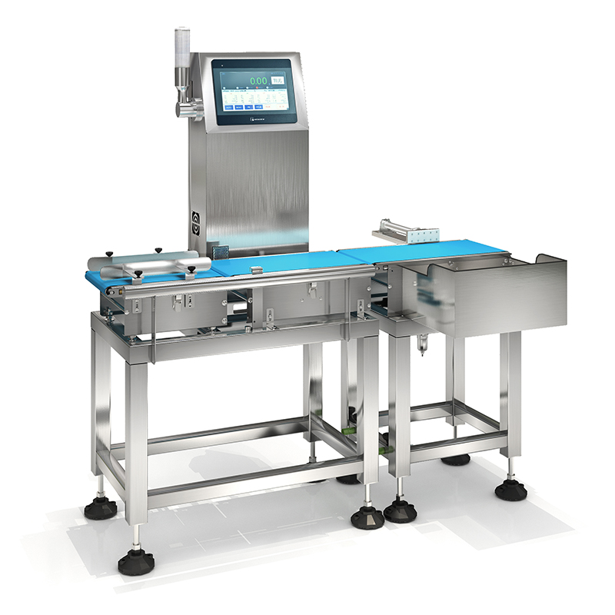

Document Version | V2.0
Release Date | June 2026
Applicable Model | SC1 Series
Language | English
Confidentiality | Controlled Document

This document is protected by SameGram copyright. Product images are for reference only; the contract shall prevail. Unauthorized reproduction or distribution is strictly prohibited.
Document Revision History

Version | Date | Description | Author | Approved
V1.0 | 2014-01 | Initial release | SameGram Engineering | —
V1.0.3 | 2023-06 | Added IO function description; motor control Modbus RTU option | SameGram Engineering | —
V2.0 | 2026-06 | Full restructure to international standard; added installation, commissioning, calibration, and maintenance chapters | SameGram Engineering | —

Chapter 1 Introduction

1.1 About This Manual
This manual provides complete information for the installation, operation, calibration, and maintenance of the SameGram Dynamic Checkweigher (SC1 Series). Please read this manual in its entirety — especially the Safety chapter — before installing or operating the equipment.
This manual is intended for the following personnel:
- Installation Engineers
- Operators
- Maintenance Technicians
- System Integrators
⚠ WARNING: Ensure all safety content in Chapter 2 has been read and understood before operating this equipment. Failure to observe safety precautions may result in personal injury or equipment damage.

1.2 Symbol Legend
Symbol | Meaning
⚠ WARNING | Ignoring this warning may cause serious personal injury or death.
⚠ CAUTION | Ignoring this notice may cause personal injury or equipment damage.
📝 NOTE | Operational tip or supplementary information for correct use.
💡 TIP | Suggestions for improving operational efficiency.

1.3 Product Overview
The SameGram Dynamic Checkweigher (SC1 Series) is a high-precision online weight inspection and sorting system designed for industrial production lines. It employs a high-resolution digital load cell combined with an advanced DSP signal processing algorithm to achieve high-speed, high-accuracy dynamic weighing.
The product is widely used in food, beverage, pharmaceutical, chemical, and personal care industries for net content inspection, under/over-weight detection, and product grading.
1.4 Applicable Industries
Industry | Industry | Industry | Industry
🍞 Food Processing | 💊 Pharmaceutical | 🧴 Personal Care / Cosmetics | 🧪 Chemical
🥤 Beverage | 🏭 Hardware / Metal Parts | 📦 E-Commerce Logistics | 🌾 Agricultural Products

1.5 Key Product Features
- ✓ High-Speed Detection: Belt speed up to 120 m/min for high-speed production lines
- ✓ High Accuracy: Dynamic weighing accuracy ±0.1 g (product and speed dependent)
- ✓ Multi-Recipe Management: Supports up to 100 product recipes with quick switchover
- ✓ Intelligent Filtering: Adaptive DSP filtering algorithm to suppress vibration interference
- ✓ Auto-Learning: Automatic parameter learning for fast product setup
- ✓ Multiple Communication Interfaces: Modbus RTU (RS485), Modbus TCP, TCP data stream
- ✓ Comprehensive Statistics: Real-time under/accept/over-weight data with USB export
- ✓ User-Friendly Interface: 7" / 10" colour touchscreen HMI
- ✓ Flexible Rejection: Supports air-blast, push-arm, and other rejection mechanisms
1.6 Storage & Transportation Requirements
Parameter | Requirement
Storage Temperature | -20°C to +60°C
Storage Humidity | 5% to 95% RH (non-condensing)
Transport Vibration | Max. 1G (horizontal)
Packaging | Original factory packaging with anti-vibration and moisture protection

Chapter 2 Safety Regulations

2.1 General Safety Requirements
This equipment has been designed and manufactured with full consideration for operator and maintenance personnel safety. Correct operation and maintenance are fundamental to ensuring safety. Please strictly observe the following safety procedures:
⚠ WARNING: Inspection, installation, adjustment, and repair of this equipment must be performed by qualified personnel with professional knowledge. Operation by unqualified persons may result in equipment damage or serious personal injury.

2.2 Personnel Requirements
• Operators: Trained personnel familiar with this manual and basic safety knowledge
• Maintenance Technicians: Hold electromechanical maintenance qualifications; familiar with industrial equipment maintenance procedures and electrical safety
• Installation Engineers: Hold electromechanical installation qualifications; familiar with industrial automation equipment installation standards
• Administrators: Responsible for system parameter configuration; hold system administrator account credentials
2.3 Electrical Safety
- Before connecting or disconnecting any electrical wiring, shut off the main power switch and apply Lockout/Tagout (LOTO) procedures.
- Confirm that the equipment supply voltage matches the nameplate voltage. Never energise with mismatched voltage.
- The equipment must be reliably earthed. The cross-sectional area of the earth conductor must not be less than that of the main supply conductor.
- The installation environment must be dry. Prevent moisture, water vapour, or conductive liquids from entering the control cabinet.
- All electrical wiring must be completed by qualified electricians. Unqualified persons are prohibited from connecting wiring.
- Do not open the control cabinet or modify internal wiring without authorisation. Contact SameGram service personnel for repairs.
- If damaged cables or degraded insulation are found, shut down immediately and notify maintenance personnel.
2.4 Mechanical Safety
- During equipment operation, do not place hands or any part of the body near moving parts (belts, drive mechanisms, rejection devices).
- Do not remove or bypass safety guards while the equipment is running.
- If abnormal operation is observed (unusual noise, excessive vibration, odour, smoke), press the Emergency Stop button immediately and investigate.
- During maintenance, shut off the main power and wait for all moving parts to come to a complete stop before proceeding.
- Do not clean the belt surface or adjust sensor positions while the belt is running.
- When repositioning the equipment, disconnect power first and ensure sufficient personnel to prevent tipping.
2.5 Emergency Stop Procedure
The equipment is fitted with an Emergency Stop button located on the front of the control cabinet. Press the Emergency Stop button IMMEDIATELY in the following situations:
- Personnel injury or risk of injury
- Abnormal equipment action or loss of control
- Fire, smoke, or unusual odour
- Any situation endangering equipment or personnel safety
After pressing the Emergency Stop, all movements cease immediately. After resolving the fault, rotate the Emergency Stop button clockwise to release, then restart the equipment using the normal procedure.
📝 NOTE: Test the Emergency Stop button function regularly to ensure it is always operational. Testing at least once per week is recommended.
2.6 Pneumatic Safety (if rejection cylinder is fitted)
- Air supply pressure must be maintained between 0.4 and 0.8 MPa. Excessive pressure may damage cylinders.
- Before servicing pneumatic components, shut off the air supply and release residual pressure in the pipework.
- Ensure all pneumatic fittings are firmly connected to prevent high-pressure air leaks.
- Inspect air filters regularly and drain accumulated water promptly.

Chapter 3 Equipment Overview

3.1 Equipment Components
No. | Component Name | Function Description
① | Feed Conveyor | Guides products from the upstream line onto the weigh section; provides spacing control
② | Weigh Conveyor | Core weighing zone with high-precision load cell for dynamic weight measurement
③ | Reject / Exit Conveyor | Transports weighed products to the rejection device or accepted-product exit
④ | Load Cell | High-precision strain gauge sensor converting weight into an electrical signal
⑤ | Touchscreen HMI | Human–machine interface for parameter setting, status monitoring, and data query
⑥ | Control Cabinet | Houses PLC/main control board, inverters, switching power supplies, and other core control elements
⑦ | Emergency Stop Button | Safety device; immediately stops all equipment movements in an emergency
⑧ | Reject Device | Rejects non-conforming products (air-blast / push-arm / swing-arm, depending on configuration)
⑨ | Photoelectric Sensor | Detects product entry/exit of the weighing zone, triggering the weight calculation
⑩ | Machine Frame | 304 stainless steel welded structure supporting all components; fitted with adjustable levelling feet

3.2 Operating Principle
Step 1 – Product Entry: The upstream conveyor feeds products onto the Feed Conveyor, which controls spacing.
Step 2 – Photoelectric Trigger: Photoelectric sensor 1 detects the leading edge of the product and starts the weighing timer.
Step 3 – Dynamic Weighing: As the product passes through the Weigh Conveyor, the load cell captures the dynamic weight signal; the DSP applies filtering and compensation to calculate the actual weight.
Step 4 – Result Classification: The system compares the measured weight against the configured limits (Under / Accept / Over) and classifies the result.
Step 5 – Rejection Action: If the product is classified as non-conforming, the rejection device actuates at the precise timing to divert the product.
Step 6 – Data Recording: All weighing results are logged. Statistics (under/accept/over count and weight) are updated in real time.
3.3 Nameplate Information
The nameplate is affixed to the side of the control cabinet. It contains the following information:
Field | Description
Manufacturer | SameGram Technology Co., Ltd.
Model | SC1 Series (e.g. SC1-3000, SC1-6000)
Power Supply | AC 220V ±10%, 50/60 Hz
Power Rating | Approx. 200–500 W (depending on configuration)
IP Rating | IP54 (standard); IP65 (optional)
Serial No. | Unique identifier for warranty and service tracking
Manufacture Date | Year and month of manufacture

Chapter 4 Technical Specifications

4.1 Performance Specifications
Parameter | Specification
Weighing Range | 10 g – 6000 g (model dependent)
Dynamic Accuracy | ±0.1 g – ±2.0 g (depends on product weight and belt speed)
Belt Speed | 10 – 120 m/min (adjustable)
Max. Throughput | Up to 300 products/min (product and gap dependent)
Min. Product Length | 50 mm
Min. Product Gap | 100 mm (at maximum speed)
Load Cell Resolution | 0.01 g
Display Resolution | 0.1 g (g unit); 0.001 kg (kg unit)
Filter Algorithm | Adaptive DSP digital filter (intensity / coefficient adjustable)
Auto Zero Tracking | Configurable range and rate
Dynamic Compensation | Manual offset and coefficient adjustable
No. of Product Recipes | Up to 100
Classification Levels | 1 – 7 sorting levels
Data Memory | Up to 1,000,000 weighing records
Data Export | USB flash drive (CSV format)
Display | 7" / 10" colour TFT touchscreen
Communication | RS485 Modbus RTU, Ethernet Modbus TCP, TCP data stream
Power Supply | AC 220 V ±10%, 50/60 Hz
Power Consumption | 200 – 500 W (configuration dependent)

4.2 Environmental Requirements for Installation
Parameter | Requirement
Ambient Temperature | 0°C – +40°C
Ambient Humidity | 20% – 85% RH (non-condensing)
Altitude | ≤ 2000 m above sea level
Floor Vibration | No significant vibration sources nearby (>0.5G isolation recommended)
Air Quality | No corrosive gases; dust level ≤ Class 8 (ISO 14644-1)
Lighting | Adequate illumination for safe operation
Installation Floor | Level, solid, load-bearing capacity ≥ 500 kg/m²

Chapter 5 Installation

5.1 Unpacking Inspection
After unpacking, inspect all items against the packing list:
No. | Item | Qty | Remark
1 | Dynamic Checkweigher (main unit) | 1
2 | Power cable | 1 | AC 220V
3 | Instruction Manual (this document) | 1
4 | Calibration Certificate | 1
5 | Packing List | 1
6 | Calibration weight(s) | As ordered | Optional
7 | Communication cable | As ordered | Optional

⚠ CAUTION: If any item is missing or damaged, do not proceed with installation. Contact your SameGram distributor or service representative immediately.

5.2 Site Preparation
- Select a location away from vibration sources (compressors, stamping machines, forklifts, etc.).
- Ensure the floor is level (≤ 2 mm over 1 m) and capable of supporting the equipment weight.
- Ensure adequate access space: minimum 800 mm on operator side, 500 mm on maintenance side.
- Verify that the power supply voltage and frequency match the nameplate.
- Install a dedicated circuit breaker for the equipment. Do not share power with heavy inductive loads.
- Ensure the earth (ground) conductor is properly installed.

5.3 Step-by-Step Installation Procedure
Step 1: Position the Equipment
Move the checkweigher into position using a forklift or pallet truck. Ensure the machine is aligned with the upstream and downstream conveyors.
Step 2: Level the Machine
Adjust the four levelling feet so that the weighing belt is level in both longitudinal and transverse directions. Use a precision level on the weigh conveyor frame. Tighten the locking nuts after levelling.
Step 3: Remove Transit Packing
Remove all transit bolts, foam inserts, and shipping restraints from the weigh conveyor and load cell assembly. Retain these items for future transport.
Step 4: Connect Line Conveyors
Align the upstream and downstream conveyors with the checkweigher. A maximum step height of 2 mm is permissible between conveyor surfaces.
Step 5: Connect the Earth (Ground)
Connect the equipment earth terminal to the facility earth bus bar using a conductor of appropriate cross-sectional area.
Step 6: Connect Power Supply
Connect the AC 220V power cable to the input terminal of the control cabinet. Ensure the main circuit breaker is in the OFF position before connecting.
Step 7: Connect Pneumatic Supply (if applicable)
Connect the plant air supply (0.4 – 0.8 MPa) to the FRL unit inlet. Check all fittings for air-tightness.
Step 8: Connect Communication Cables (if applicable)
Connect RS485, Ethernet, or other communication cables as required by the system integration.

Chapter 6 Commissioning & Start-Up

6.1 Pre-Start Checklist
Before switching on the equipment for the first time, verify each of the following:
☐ | Equipment is correctly levelled
☐ | All transit bolts and shipping restraints have been removed
☐ | Power supply voltage and frequency match the nameplate
☐ | Earth (ground) conductor is connected
☐ | No loose objects on or near the conveyors
☐ | All guards and covers are in place
☐ | Emergency Stop button is released (rotated clockwise)
☐ | Air supply pressure is within 0.4 – 0.8 MPa (if pneumatic rejection fitted)
☐ | Communication cables are connected and secure
☐ | Calibration weights are available

6.2 First Power-On Procedure
1. Turn the key-switch or main isolator on the control cabinet to the ON position.
2. The touchscreen HMI will display the start-up splash screen. Wait approximately 30 seconds for the system to initialise.
3. After initialisation, the main operation interface is displayed.
4. Check that all motor status indicators on the HMI show correct states.
5. Press the START button; verify that all conveyor belts run smoothly and that no abnormal noise or vibration is present.
6. Allow the equipment to run for at least 5 minutes to reach thermal equilibrium before performing calibration.

Chapter 7 HMI Operation Guide

7.1 Login & Access Levels
The system employs a three-level access control system. Different access levels present different settings menus. Default credentials are:
Access Level | Default Password | Access Scope
Equipment Operator | (none – confirm directly) | Basic operation: start/stop, recipe selection, data view
System Administrator | 111111 | Full settings: calibration, device config, motor, IO, speed correction
Super Administrator | Factory-set, not disclosed | Manufacturer-level debugging; not available to end users

📝 NOTE: It is strongly recommended to change the default System Administrator password after initial commissioning to prevent unauthorised access.

7.2 Main Interface Overview
After logging in, the main operation interface is displayed as shown below:
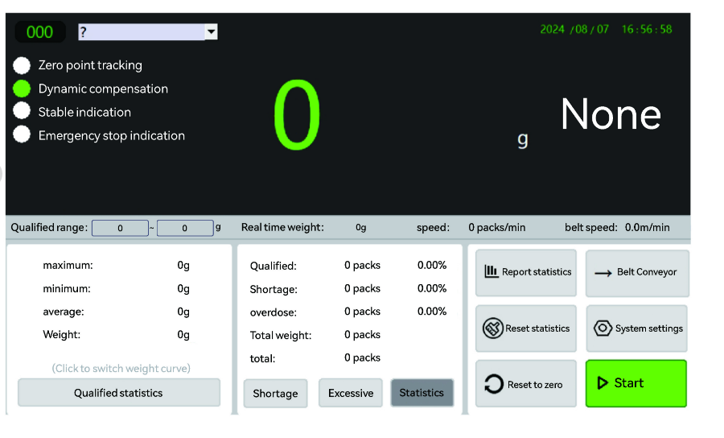
Figure 7-1 Main Operation Interface
Key elements of the main interface:
• START / STOP: Starts or stops all conveyor motors and the weighing function.
• Current Weight: Real-time weight display of the product currently on the weigh conveyor.
• Classification Result: Indicates whether the current product is Under / Accept / Over.
• Batch Statistics: Running totals of Under, Accept, and Over count and cumulative weight.
• Recipe Name: Name of the currently active product recipe.
• Upper / Lower Limit: Current accepted weight range (configured in the recipe).
• Settings Menu: Opens the settings panel (access level dependent).
7.3 System Settings – Login
Tap the Settings icon on the main interface to display the login screen:
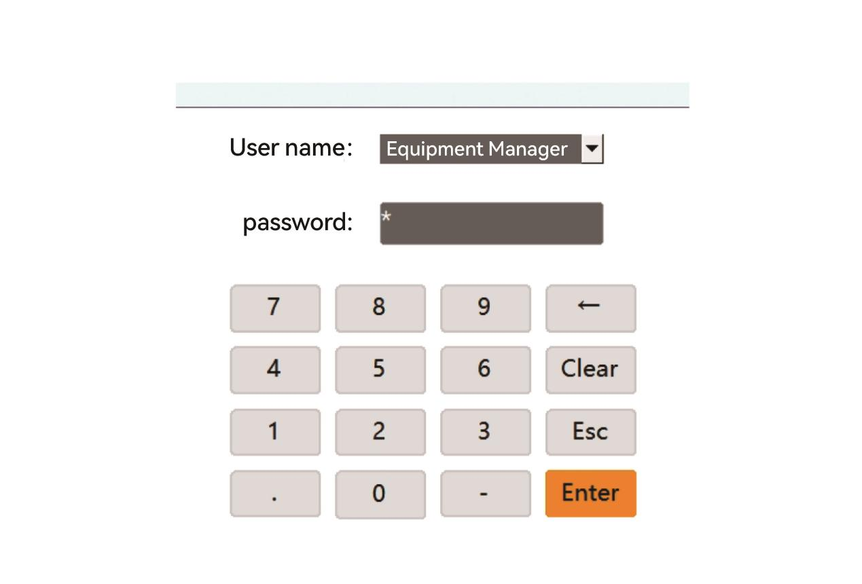
Figure 7-2 System Settings Login Screen

7.4 About Equipment (5.2.1)
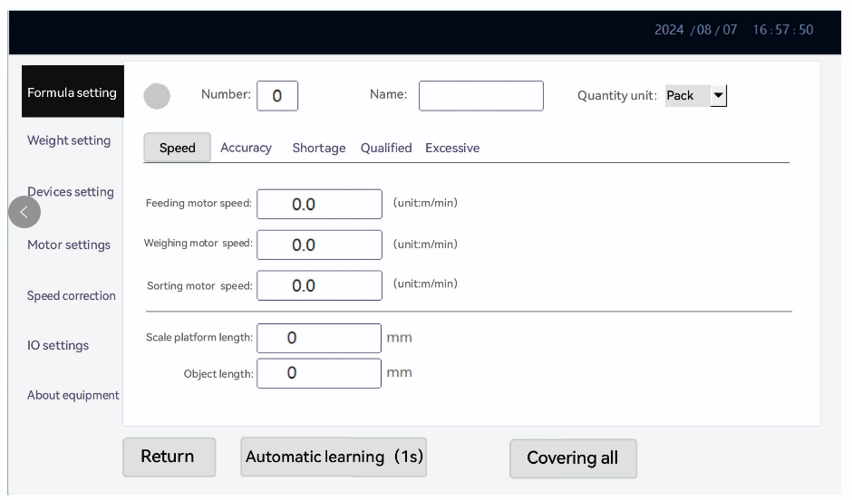
Figure 7-3 About Equipment Screen
• Change Password: Change the password for the currently logged-in user.
• Change Time: Update the system date and time.
• User Management: When logged in as System Administrator, manage users: add, delete, or modify Operator and Administrator accounts.
• Manufacturer Information: When logged in as System Administrator, enter equipment details: model, manufacturer name, production date, expiry date, service telephone, and website.
• Expiry Date: The system can be configured to automatically prevent start-up after the expiry date. After expiry, only the System Administrator can modify or clear this setting.

7.5 Recipe Settings (5.2.2)
7.5.1 Speed Settings
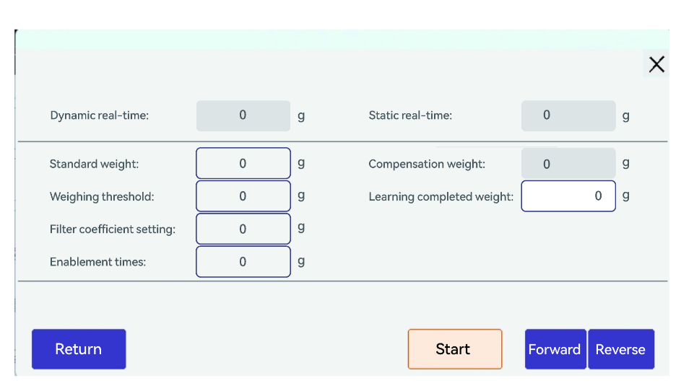
Figure 7-4 Recipe – Speed Settings
• Recipe Name: Enter the product name. Recommended: 16 characters or fewer.
• Quantity Unit: Default is "Package". Can be changed to bags, boxes, pieces, bottles, cans, etc.
• Belt Speed: Individual speed settings for Feed Conveyor, Weigh Conveyor, and Reject Conveyor motors. Adjusting speed controls overall throughput and affects dynamic accuracy.
The system supports up to 100 product recipes. Recipes can be switched, renamed, and configured with independent speed, accuracy, and qualification parameters.

7.5.2 Precision Settings
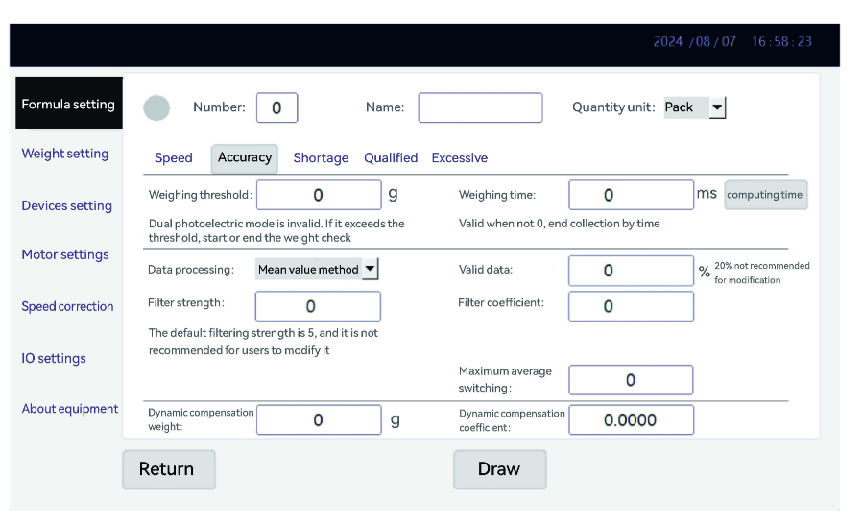
Figure 7-5 Recipe – Precision Settings
• Weighing Threshold: Minimum weight value for triggering a weighing measurement. Products below this threshold are ignored.
• Weighing Time Window: Time from photoelectric sensor trigger to weight data capture.
• Data Processing Method: Maximum value method (default) or average value method; configurable valid data percentage.
• Filter Intensity: Range 3–18; default 5. Higher values provide more smoothing but slower response.
• Filter Coefficient: Range 30–100; default 45.
• Dynamic Compensation Value: Offset applied to correct systematic dynamic weighing deviation.
• Dynamic Compensation Coefficient: Multiplier for dynamic compensation; default 1, range 1–100.

7.5.3 Auto-Learning
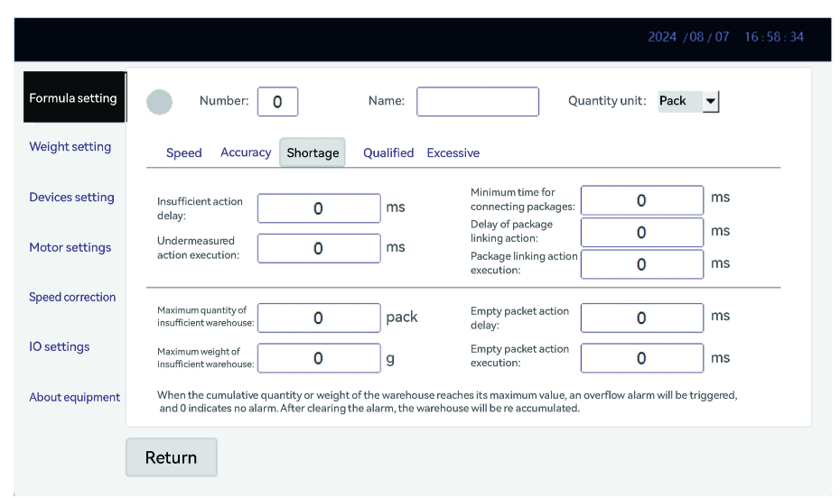
Figure 7-6 Auto-Learning Screen
• Learn Standard Weight: The static weight of the product to be learned.
• Weighing Threshold (learning): Set to approximately 25% of the learn standard weight.
• Filter Coefficient (pre-learning): Set to ≥80 before starting; automatically adjusted after learning.
• Learning Stop Delay: Time (seconds) to auto-stop after learning is complete.
• Learning Iterations: Number of times the system samples the product. More iterations = higher accuracy.

7.5.4 Qualification (Sorting) Settings
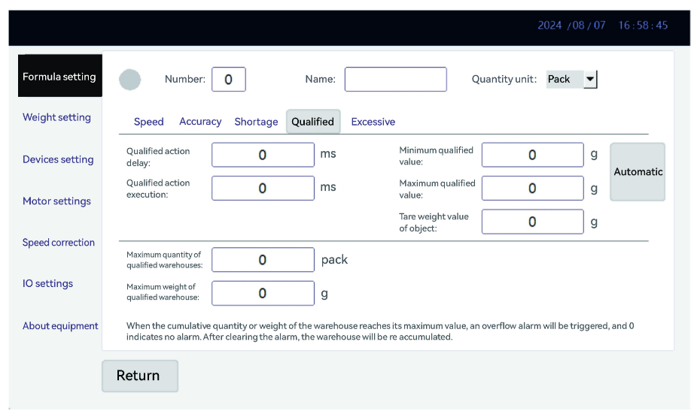
Figure 7-7 Qualification Settings
• Minimum Accept Weight: Lower limit of the accepted weight range.
• Maximum Accept Weight: Upper limit of the accepted weight range.
• Action Delay Time: Delay between classification result and rejection actuator trigger. Must be recalculated if motor speed changes.
• Action Execution Time: Duration of the rejection actuator pulse.
• Max. Reject Bin Count: Alarm when the cumulative rejection count exceeds this value (0 = disabled).
• Max. Reject Bin Weight: Alarm when the cumulative rejection weight exceeds this value (0 = disabled).

7.6 Weighing Settings (5.2.3)
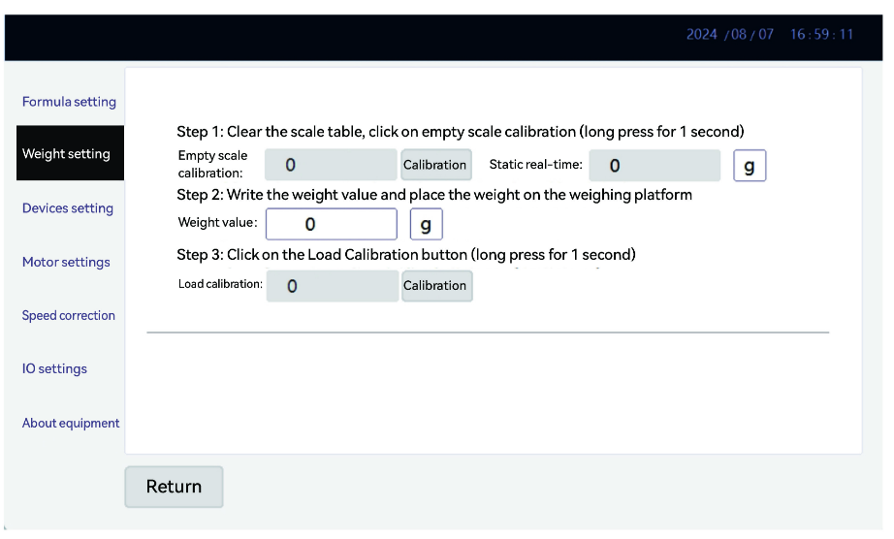
Figure 7-8 Weighing Settings
• No-Load Calibration: Calibrates the empty belt. See Chapter 8.
• Loading Calibration: Calibrates with a known weight placed on the belt. See Chapter 8.
• Weight Value: Enter the nominal value of the calibration weight used.
• Manual Reset Range: Percentage of span within which manual zero reset is permitted. Default: disabled.
• Zero Tracking Range: Number of graduation values over which automatic zero tracking is active. Default: 0.
• Zero Tracking Rate: Rate of zero drift correction, in graduation values per time interval.
• Continuous Alarm: Triggers an alarm when N consecutive products fall into the same classification (useful for detecting process drift).

7.7 Device Settings (5.2.4) ⚙ Admin Required
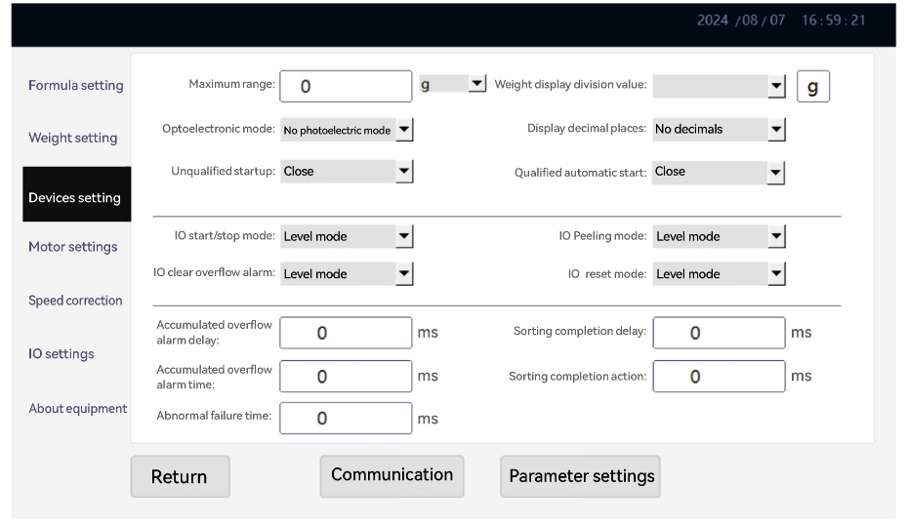
Figure 7-9 Device Settings
• Maximum Range: The maximum weighing capacity of the weigh platform. Supports g and kg units.
• Weight Display Graduation: Display resolution increment for smooth, stable weight readout.
• Decimal Places: For g unit: typically 1 decimal place; for kg unit: typically 3 decimal places.
• Photoelectric Mode: Sets the photoelectric trigger logic: None / Dual-photoelectric / Photo-in / Photo-out.
• IO Start Mode: Configures external start button: Level mode or Pulse mode.
• IO Stop Mode: Configures external stop button: Level mode or Pulse mode. (Invalid if IO Start is Level mode.)
• IO Clear Overflow Alarm Mode: Configures external button for clearing overflow alarms.
• Overflow Alarm Duration: Duration (ms) of the overflow alarm output signal.

7.8 Motor Settings (5.2.5) ⚙ Admin Required
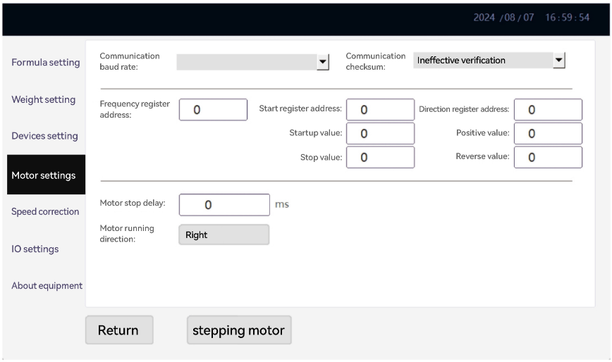
Figure 7-10 Motor Settings
Motor control type: supports Analogue Voltage Output and RS485 Modbus RTU.
• Analogue Voltage Output: No configuration required on this page; speed is controlled by analogue voltage directly.
• RS485 Modbus RTU: Configure the frequency register address, start register address, start value, and stop value for each inverter (Feed / Weigh / Reject conveyor).
7.9 Speed Correction (5.2.6) ⚙ Admin Required
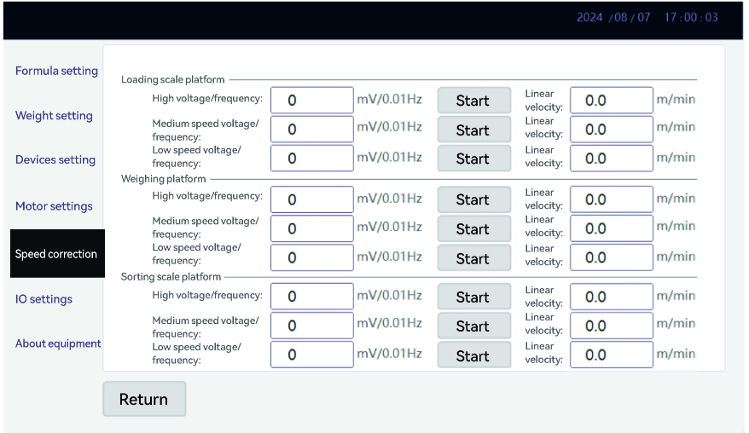
Figure 7-11 Speed Correction Table
Use a calibrated tachometer to measure the actual belt surface speed at each analogue voltage output level. Enter the measured values in the speed correction table. This enables accurate speed–to–voltage conversion for precise speed control.
7.10 IO Settings (5.2.7) ⚙ Admin Required
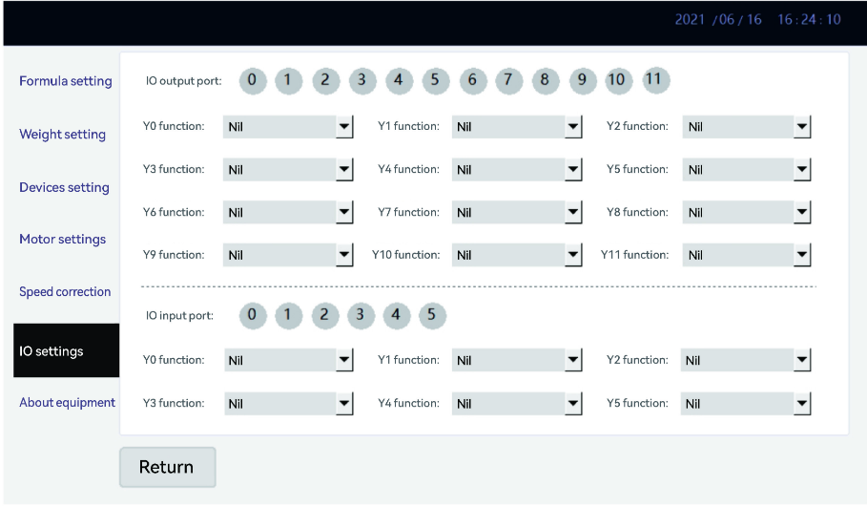
Figure 7-12 IO Settings
• IO Monitor Panel: Clicking on an IO port number toggles its debug state. A lit indicator means the port is active.
• Y0 – Y7 (Output Functions): Assignable to: Running status, Over-count alarm, Detection failure alarm, Sort level 1–7 actuators.
• X0 – X5 (Input Functions): Assignable to: Start button, Stop button, Photoelectric in, Photoelectric out, Clear alarm, Forward full-bin detection, Reverse full-bin detection.

7.11 Report & Statistics (5.2.8)
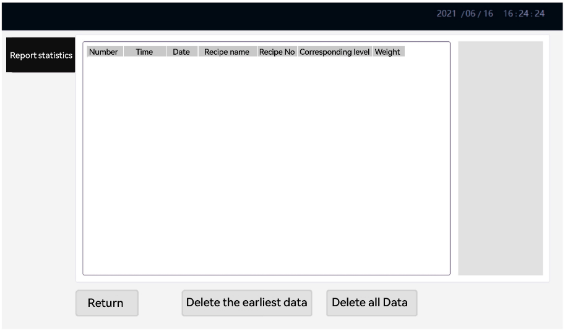
Figure 7-13 Report & Statistics
• Data Report: Displays all weighing records. Grade 1 = Under, Grade 2 = Accept, Grade 3 = Over. Historical data for any time period can be queried.
• Delete All Data: Clears all saved weighing records. This action is irreversible.
• Data Export: Set start and end dates, then export to USB flash drive in CSV format. Supports overwrite or append mode.

Chapter 8 Calibration Procedure

⚠ CAUTION: Perform calibration on a level, stable surface with no vibration. Do not touch the conveyor belt or place any objects on the weigh conveyor during calibration.

8.1 Pre-Calibration Checks
- Allow the equipment to warm up for at least 5 minutes after power-on.
- Confirm that the weigh conveyor belt is clean and free of debris.
- Confirm that no products are on the weigh conveyor.
- Log in as System Administrator.
- Navigate to Weighing Settings (5.2.3).
8.2 No-Load (Zero) Calibration
1. Ensure the weigh conveyor belt is running and no product is present.
2. Tap "No-Load Calibration" on the Weighing Settings screen.
3. The system captures the zero reference and confirms completion.
8.3 Loading (Span) Calibration
1. Select a calibration weight appropriate to the working range (typically 50–80% of full span).
2. Enter the nominal value of the calibration weight in the "Weight Value" field.
3. Carefully place the calibration weight in the centre of the weigh conveyor belt while it is running.
4. Tap "Loading Calibration".
5. Wait for the weight reading to stabilise, then the system captures the span reference.
6. Remove the calibration weight after the calibration is confirmed.
📝 NOTE: Always perform no-load calibration before loading calibration. If the zero calibration is incorrect, the span calibration will also be incorrect.
8.4 Dynamic Compensation
After span calibration, verify dynamic accuracy by passing known-weight products through the checkweigher and comparing the dynamic reading against a static reference:
1. Weigh 5–10 sample products on a reference scale and record the static weight.
2. Pass each sample through the checkweigher at normal operating speed.
3. Compare the average dynamic reading against the average static weight.
4. If a systematic offset exists, adjust the Dynamic Compensation Value in the Precision Settings accordingly.
5. Re-test with samples to verify the correction.
Dynamic Compensation Value calculation example:
Static reference weight (average) | 100.5 g
Dynamic reading (average) | 99.8 g
Deviation | -0.7 g
Set Dynamic Compensation Value to | +0.7 g

Chapter 9 Communication Interfaces

9.1 RS485 Modbus RTU
Default communication parameters:
Parameter | Default Value
Baud Rate | 9600 bps (configurable)
Data Bits | 8
Parity | None
Stop Bits | 1
Protocol | Modbus RTU (standard function codes 03/06/10 supported)

9.2 Modbus TCP (Ethernet)
Default connection parameters:
Parameter | Default Value
IP Address | 192.168.1.100 (configurable)
Port | 502 (standard Modbus TCP port)
Protocol | Modbus TCP (function codes 03/06/10)

Refer to the separate document "MODBUS TCP Communication Address Table" for the complete register map.

9.3 TCP Continuous Data Stream
In TCP stream mode, the checkweigher sends a 31-byte data packet to the configured host IP address each time a product is weighed. The packet format is as follows:
Byte | Content | Description
1 | 0xAA | Start byte (fixed)
2 | Device No. | Device identifier
3–4 | Sequence No. | Packet counter (increments per product, rolls over at 65535)
5–8 | Weight (g) | 32-bit float, big-endian; actual dynamic weight in grams
9 | Grade | 1 = Under, 2 = Accept, 3 = Over
10–13 | Lower Limit | 32-bit float; configured lower acceptance limit (g)
14–17 | Upper Limit | 32-bit float; configured upper acceptance limit (g)
18–21 | Under Count | 32-bit integer; cumulative under-weight count
22–25 | Accept Count | 32-bit integer; cumulative accepted count
26–29 | Over Count | 32-bit integer; cumulative over-weight count
30 | Status | Bit 0: Running; Bit 1: Alarm; Bits 2–7: reserved
31 | 0x55 | End byte (fixed)

Chapter 10 Troubleshooting

Refer to the table below to diagnose and resolve common problems:
No. | Symptom | Possible Cause | Corrective Action
1 | Power indicator not illuminated | 1. Incorrect power supply  2. Circuit breaker tripped  3. Fuse blown | 1. Connect correct supply voltage  2. Reset circuit breaker  3. Replace fuse with same rating
2 | Unstable static weight reading | 1. Equipment not level  2. Load cell overloaded or damaged | 1. Re-level all four feet  2. Inspect load cell; replace if necessary
3 | Large dynamic weighing deviation | 1. Filter coefficient too low  2. Valid data percentage too low  3. Belt speed too high for product length | 1. Increase filter coefficient (range 30–100)  2. Increase valid data percentage  3. Reduce belt speed
4 | Large difference between static and dynamic weight | Dynamic compensation parameters incorrect | Re-run dynamic compensation; adjust Dynamic Compensation Value and Coefficient
5 | Static weight inaccurate | Span calibration not performed or incorrect | Perform no-load and loading calibration per Chapter 8
6 | No weight data after product detected | 1. Photoelectric sensor position shifted  2. Photoelectric sensor damaged | 1. Re-position sensor; verify trigger pulse on HMI IO monitor  2. Replace sensor
7 | Motors do not run after pressing START | 1. Stop time too short after abnormal shutdown  2. Motor connector loose | 1. Wait at least 1 minute after abnormal shutdown before restarting  2. Re-seat motor connector
8 | Rejection device does not actuate | 1. Air supply pressure too low (pneumatic)  2. Action delay time incorrect  3. IO output not assigned | 1. Increase air pressure to 0.4–0.8 MPa  2. Recalculate and adjust action delay  3. Verify IO Y-output assignment in IO Settings
9 | HMI prompts to release Emergency Stop | Emergency Stop button is depressed | Rotate the Emergency Stop button clockwise to release it
10 | Conveyor belt slipping or mis-tracking | 1. Belt tension insufficient  2. Drive pulley worn | 1. Adjust belt tensioner  2. Replace drive pulley
11 | Weight reading drifts over time | 1. Temperature change causing zero drift  2. Zero tracking not configured | 1. Allow warm-up ≥5 min; re-zero if necessary  2. Configure Zero Tracking Range and Rate
12 | USB export fails | 1. USB drive not formatted as FAT32  2. USB drive full | 1. Format USB drive as FAT32  2. Free up space on USB drive
13 | Modbus TCP communication fails | 1. IP address conflict  2. Port 502 blocked by firewall | 1. Assign a unique IP address  2. Open port 502 on the host firewall
14 | Touchscreen unresponsive | 1. Screen protector causing touch offset  2. HMI controller fault | 1. Remove screen protector; recalibrate touch if needed  2. Restart HMI; contact SameGram if issue persists

Chapter 11 Maintenance Schedule

⚠ WARNING: Always switch off the main power supply and apply Lockout/Tagout (LOTO) before performing any maintenance work. Never perform maintenance while the equipment is running.

11.1 Maintenance Plan
Task | Daily | Weekly | Monthly | Quarterly | Annual
Check belt for damage, wear, or contamination | ✓
Clean weigh conveyor belt surface | ✓
Inspect photoelectric sensors; clean lenses | ✓
Verify zero calibration (no-load) | ✓
Check and clean conveyor rollers and pulleys |  | ✓
Inspect belt tension and tracking; adjust if needed |  | ✓
Check all fasteners for tightness |  | ✓
Inspect pneumatic fittings; drain FRL water trap |  | ✓
Check cable glands and cable routing for damage |  |  | ✓
Verify full-span calibration with calibration weight |  |  | ✓
Lubricate bearings and chain (if fitted) |  |  | ✓
Clean interior of control cabinet; check connections |  |  |  | ✓
Replace air filter element (if fitted) |  |  |  | ✓
Full load cell performance check |  |  |  |  | ✓
Inspect and replace worn conveyor belt |  |  |  |  | ✓
Calibration verification by certified weights |  |  |  |  | ✓
Firmware and software update check |  |  |  |  | ✓

11.2 Cleaning Guidelines
- Use a damp cloth with mild neutral detergent for belt and frame surfaces.
- Do not spray water directly onto the control cabinet, load cell, or electrical components.
- Do not use solvents (acetone, thinner) or abrasive cleaners on plastic or rubber components.
- For food-contact applications, use food-grade cleaning agents approved for your industry.
- Ensure the belt is completely dry before resuming operation.

Chapter 12 Recommended Spare Parts

The following spare parts are recommended to be held on-site to minimise downtime. Order spare parts by contacting your SameGram service representative and quoting the part number and your equipment serial number.
Part Name | Qty Recommended | Remark
Conveyor belt (weigh section) | 1 | Replace annually or when worn
Load cell | 1 | Critical spare; model-specific
Photoelectric sensor (emitter) | 2 | Model-specific
Photoelectric sensor (receiver) | 2 | Model-specific
Fuse (main circuit) | 3 | Same rating as installed
Fuse (control circuit) | 3 | Same rating as installed
Rejection air cylinder | 1 | If pneumatic rejection fitted
Solenoid valve | 1 | If pneumatic rejection fitted
Air filter element | 2 | Replace quarterly
Touch screen protective film | 5 | Replace as needed

📝 NOTE: Always quote the equipment serial number and model number when ordering spare parts. Contact SameGram at: sale@samegram.com or call the hotline listed on the back cover.

Appendices

Appendix A – Unit Conversion Table
Unit (From) | Unit (To) | Multiply By
gram (g) | kilogram (kg) | ÷ 1000
gram (g) | pound (lb) | ÷ 453.592
gram (g) | ounce (oz) | ÷ 28.3495
kilogram (kg) | pound (lb) | × 2.20462
metre/min | feet/min | × 3.28084
MPa | bar | × 10
MPa | psi | × 145.038

Appendix B – Maintenance Record Log
Date | Maintenance Performed | Parts Replaced | Technician | Next Due

Appendix C – Technical Support
For technical support, contact SameGram:
- Manufacturer: SameGram Equipment Co., Ltd.
- Service Email: sale@samegram.com
- Technical Hotline: +86 13712368272
- Website: www.samegram.com
- When contacting support, please have ready: Equipment model, serial number, firmware version, and a description of the issue.
Appendix D – Glossary of Terms
Term | Definition
Checkweigher | An automatic weighing machine that measures the weight of products moving along a conveyor and classifies them as under, accept, or over weight.
Load Cell | A transducer that converts a force (weight) into an electrical signal.
DSP | Digital Signal Processor; used in this system for real-time weight signal filtering and calculation.
Modbus RTU | A serial communication protocol widely used in industrial automation, communicating over RS485 wiring.
Modbus TCP | The Modbus protocol adapted for use over Ethernet/TCP-IP networks.
Recipe / Formula | A named set of parameters (speed, accuracy, limits) configured for a specific product.
Dynamic Compensation | A correction factor applied to the raw dynamic weight to account for systematic measurement bias.
Zero Tracking | Automatic correction of small drifts in the zero reading of the load cell.
LOTO | Lockout/Tagout; a safety procedure to ensure that a machine is properly shut off and cannot be accidentally restarted during maintenance.
IP54 | Ingress Protection rating: dust protection level 5 (dust protected) and water protection level 4 (splash protected).

Thank you for choosing Samegram Checkweigher

Document Version V2.0 | © 2026 SameGram | All Rights Reserved

