
2025.10.01

High-speed bulk material foreign object X-ray and color sorting integrated machine
Intelligent high-definition X-ray inspection machine
Multi-purpose foreign object inspection machine for packaging

X-Ray Foreign Object Detection Software Manual v3.4.1
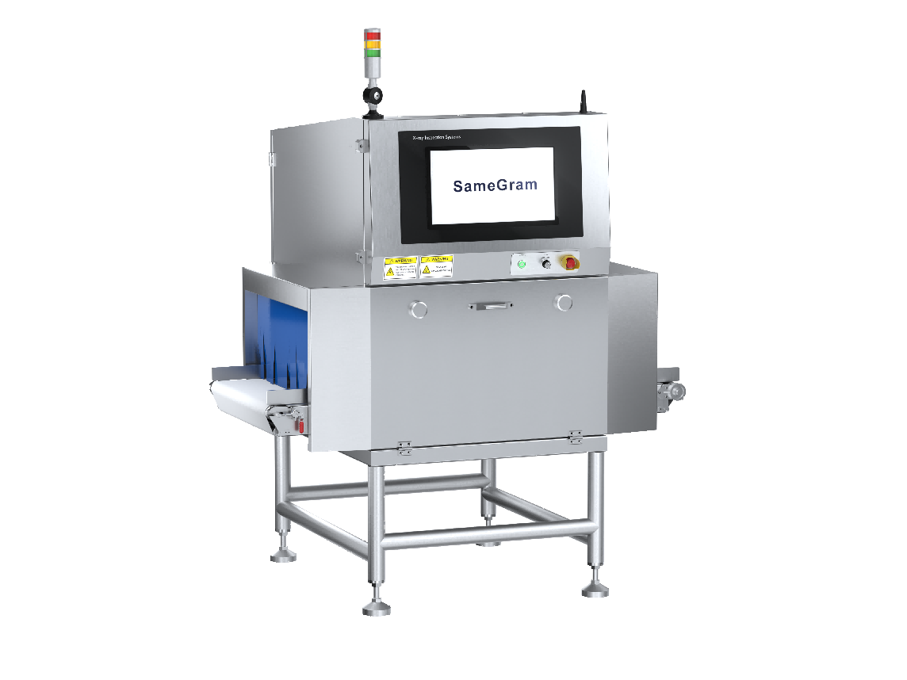
Table of contents
1 Product Overview ............................................................................. 3
1.1 Overview of X-ray Foreign Object Detector ................................. 3
1.2 Applicable Objects ......................................................................... 4
1.3 General Precautions ........................................................................ 4
1.4 Working Environment ..................................................................... 5
1.5 Safety Precautions ........................................................................... 5
2 Introduction to the Interactive Interface ............................................. 5
2.1 Permission Instructions .................................................................... 5
2.2 First Interface ................................................................................... 6
2.3 Product Selection ............................................................................. 7
2.4 Second Interface .............................................................................. 8
2.5 Third Interface ................................................................................. 9
3 Introduction to Main Operation Procedures ...................................... 16
3.1 When the Product Has Been Previously Entered ............................ 16
3.2 When the Product is a New Type ..................................................... 16
3.3 Self-Learning Function .................................................................... 17
3.4 Image Emphasis ............................................................................... 18
3.5 Maintenance Guide .......................................................................... 18
3.6 Turning Off the X-ray Foreign Object Detector .............................. 20
4 Permission Management ..................................................................... 20

Product Overview

Before installing, operating, maintaining, or servicing the equipment, please read and understand the contents of this manual carefully. To ensure proper operation and safety, please keep this manual safe for future reference.
While this manual lists as many potential hazards as possible, it is impossible to cover all possibilities. Therefore, when performing operations not listed in this manual, please consult your supplier or our after-sales service department for more information. When installing, operating, and maintaining/repairing the equipment, in addition to following the instructions in the user manual and on the equipment, always take adequate safety precautions.
This manual is copyrighted by SameGram and protected by copyright law. Unauthorized publication, copying, or reproduction of the contents of this manual is strictly prohibited without the written permission of SameGram.
While every effort has been made to ensure comprehensiveness in the preparation of this manual, if you encounter any ambiguities, errors, or questions during your reading, please provide the equipment model number and consult your supplier or after-sales service department.
When installing, operating, maintaining, and inspecting the equipment, please always follow the instructions and warnings listed in this manual. If you encounter any problems or have any questions, please contact your dealer or our after-sales service department immediately. Do not perform any operations before receiving the necessary guidance.
Please note that the contents of this manual are subject to change without notice. Therefore, when using the equipment, please always pay attention to the latest updates and revisions and ensure you have the latest version of the manual.
  - Overview of X-ray Foreign Object Detection Machine
X-ray foreign object detection machines are widely used in the food and industrial production sectors. Their functions include detecting foreign objects such as metals, glass, stones, bones, high-density rubber, and plastics. They provide high-standard enterprises with an important means of quality control and assurance during the production process.
  - Applicable Objects
This manual is intended for users of the XSS series X-Ray foreign object detection software, including technical operators and administrators (maintenance engineers).
  - General Precautions

- For electrical wiring work, please ensure that it is performed by qualified professionals with proper certification. Unauthorized personnel performing electrical wiring work will violate relevant laws and regulations. Incorrect electrical wiring may lead to dangerous situations such as fire, electric shock, and grounding failures.
- For safety, please ensure that the device is properly protectively grounded. It is recommended that you have a qualified professional with proper electrical wiring certification perform the protective grounding work to minimize the risk of electric shock from incorrect grounding.
- To ensure the normal operation and safety of the device, do not pour water onto it and avoid installing it in damp or condensation-prone areas. Unless the equipment is explicitly marked as waterproof, contact with water can lead to decreased performance, loss of function, malfunction, or even electric shock. Therefore, please take special care to avoid moisture contact with the device to ensure its normal operation and safe use.
- To ensure the safe operation of the device, please install it on a sturdy and level surface. Installing the device on an unstable or tilted location may cause decreased performance, malfunction, or even tipping over, resulting in personal injury. Therefore, please ensure the device is securely installed to prevent potential hazards and accidents.
- To ensure operational accuracy and personnel safety, please provide sufficient space for the operation and maintenance of the equipment. Insufficient space may lead to operational errors or accidental injuries. Therefore, when using the equipment, please ensure that there is enough space around it for necessary operation and maintenance, and that operators can work in a safe and comfortable environment.
- When operating the equipment, please wear appropriate work clothing and ensure that buttons or zippers are fastened securely. Choose non-slip shoes and tie your shoelaces. Avoid wearing any accessories, including ties and belts; if necessary, secure them with clips. Additionally, please completely cover your hair with a hat or hair cap. Failure to comply with these regulations may result in hair or fibers becoming mixed with the processed goods, causing foreign object contamination. Furthermore, foreign objects may become entangled inside the equipment, potentially causing injury. Therefore, please strictly adhere to these requirements to ensure food hygiene and personnel safety.
- For safety reasons, do not attempt to disassemble, repair, or modify the device unless explicitly instructed to do so in the user manual. Using tools such as screwdrivers and wrenches to disassemble, repair, or modify the device may result in electric shock, fire, or personal injury. For your safety, do not attempt to perform these operations yourself. If the device requires repair, please contact your dealer or our customer support department and have them perform the necessary repairs.
- Before operating the device, ensure that no items are placed on it to prevent contamination of the goods being processed and potential foreign object contamination. Placing items in the device may result in dangerous situations such as electric shock, fire, or personal injury.
- Before performing any maintenance or inspection on the equipment, always disconnect the power supply and wait at least 5 minutes. This is to ensure that any electrical charge inside the components is eliminated, preventing the risk of electric shock. Please remember this safety procedure to protect your personal safety.
- Please strictly follow the maintenance and inspection procedures clearly listed in the user manual. Do not perform any unauthorized or unspecified maintenance activities. This is to avoid potential risks of electric shock, fire, or personal injury. As a professional, please follow the prescribed procedures and guidelines to ensure safety.
- Unless in an emergency, do not turn off the main power switch during operation. Turning off the main power switch may result in the deletion of configuration data and statistics. Please operate with caution and ensure that necessary operations are performed within the appropriate maintenance window to avoid data loss and system failure.
  - Working Environment
Do not use the X-ray foreign object detector in the following environments to avoid equipment instability or even damage:
1. Locations with severe ground vibration or near vibration sources.
2. Environments with temperatures below -10°C or above 40°C, or humidity greater than 85%.
3. Power sources with voltage fluctuations greater than 10%.
4. Environments containing volatile fuels, corrosive gases, or dust.
  - Use of safety protection

1. This equipment is not explosion-proof; avoid external impacts during installation and use.

2. The equipment uses thickened steel plate shielding and a protective curtain to ensure radiation safety. During operation, never put your hands or other body parts inside the shielding curtain of the X-ray inspection machine, and never open the equipment casing.

3. An emergency stop button is located on the front of the equipment for immediate shutdown in case of emergencies.
  - Information regarding special risks
- Electrical system

Electrical systems, components, or materials may only be operated by qualified electricians, who must supervise other personnel; electrical operating procedures and accident prevention regulations must be followed!
If inspection, maintenance, or repair of a machine or system component is required, its power supply must be disconnected.
First, check that the component being disconnected is still energized, then ground it and ensure that any energized parts near it are insulated.
Electrical components of the machine/system must be thoroughly inspected regularly. Any malfunctions—such as loose connections or burnt cables—must be addressed immediately.
- pneumatic system
Pneumatic systems or their components can only be operated by personnel with relevant knowledge and experience.
Please regularly inspect all pipes and lines, hoses, and bolt connections to prevent leaks and visible damage! If any faults are found, address them immediately.
Before commencing repairs or maintenance, release the pressure from any compressed air lines, hoses, or system components that need to be opened.
Compressed air lines and hoses must be properly laid and assembled, conforming to installation regulations. The length and weight of the secured pipes and hoses must meet specific specifications.
- Equipment transportation
When loading or transporting machinery/systems, only use lifting and transport equipment and devices with sufficient load-bearing capacity! Experienced instructors must guide the lifting/lifting process!
Follow the operating manual, secure the lifting equipment properly, and lift the equipment/system.
Even when moving the machine/system a short distance, all power must be disconnected!
Before using the machine/system again, properly reconnect the power supply and all other wiring (such as compressed air units).

- Equipment Component Introduction

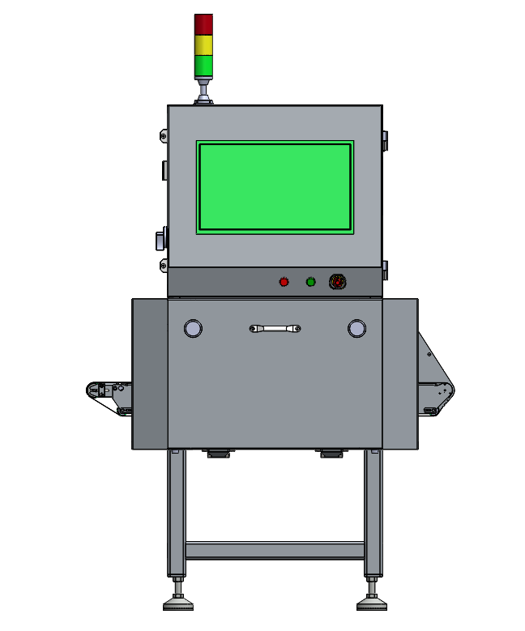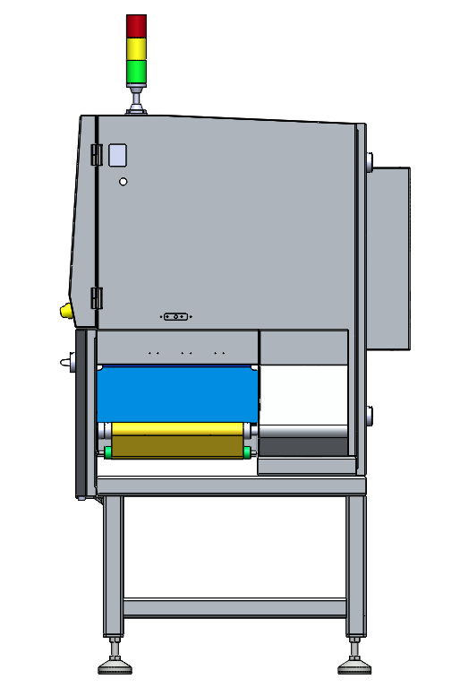
Protective curtain
Ray indicator
Lower door lock
indicator lights
Key switch
Emergency stop switch
Computer switch

- Introduction to the interactive interface
  - Permissions Description
Compared to administrators (maintenance engineers), technical operators do not have the permissions to exit to the desktop/delete the product or modify parameters.
  - First Interface
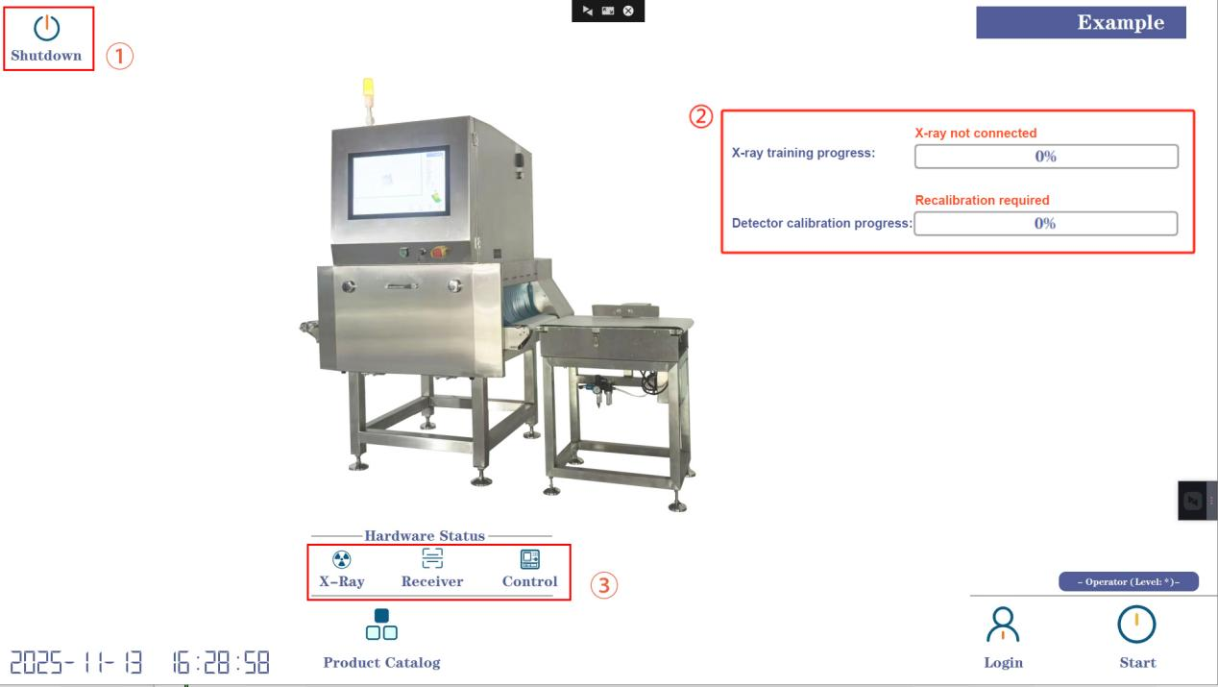The first screen is the software startup screen, a preparation screen before starting the program. Clicking it will take you to the second screen for logging into administrator mode.
Label ①: Software Exit Area, including a one-click shutdown button. After one-click shutdown, the host and background processes will shut down. The host power can be cut off via a rotary switch after approximately one minute. The exit button exits the software and returns to the system desktop, but it only appears after logging in as an admin.
Label ②: Visualizes the X-ray warm-up progress and detector calibration progress. If the device has not been powered on for more than three days, the software will automatically perform X-ray warm-up upon restarting; otherwise, no warm-up is required and the progress will be 100%. The longer the device has been idle, the longer the X-ray warm-up time, typically kept within 50 minutes. Normally, the detector needs to be calibrated after each power-on; clicking the button will perform the calibration. The detector calibration progress can be viewed via a progress bar. The software can be launched when the detector calibration progress reaches 100%.
Label ③: Check if all hardware (X-ray, detector, transmission controller) is properly connected. A normal connection is grayed out, and an abnormal connection is blue.
  - Product Selection
Click the "Inspection Library" button on the first screen to open the product selection interface. 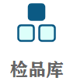The inspection library can store information on over 1000 products. Select the product to test (or produce), and click the "Select and Exit" button to load the selected product. All parameters of the currently selected product can be adjusted on the third screen.
Other button descriptions：
Add to current line：Add a new product at the position of the currently selected row.
Add to last line：Add a new product at the end of the table.
Export to desktop: Convert the report to Excel format and save it to your desktop.
Delete selected: Delete the currently selected product.
Copy selected: Create a new product and copy all parameters of the currently selected product. All parameters will be identical in both.
Additional notes：
1) After the software opens, it will default to selecting the last produced product.
2) The delete button will only appear after logging in with admin privileges.
3) Product name and product batch number are required fields when creating a product for the first time. Both fields only support alphanumeric input by default.

3.4 Second Interface
The second interface is the main operation interface during the production process.
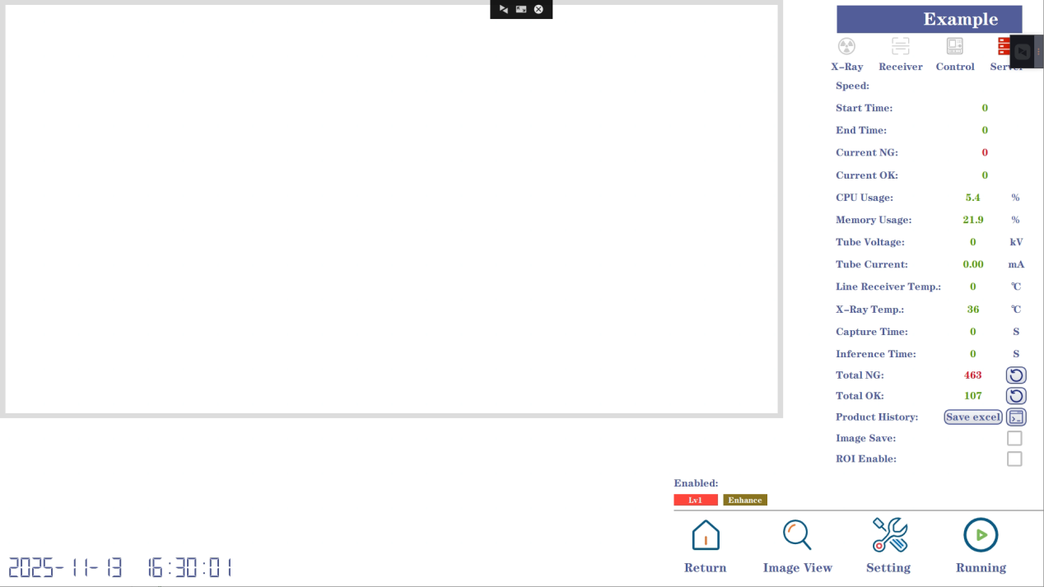
Label ①: Real-time display interface. When a product passes through the X-ray machine, the image will be displayed in the current area.
Label ②: Hardware status during operation, including the light source, detector, transmission, and algorithm. After clicking the start button, red indicates normal operation, and gray indicates abnormal operation.
Label ③: Real-time status of other parameters during equipment operation, which can be used for equipment maintenance, status monitoring, and assessment of unknown errors.
Other button descriptions：
Production Mode: When checked, transmission will not stop even in the event of any unforeseen circumstances (such as partial hardware power failure).
Background Storage: When checked, the original images will be saved to a RAW file named after the current date. This option is only effective when the Culling Mode is set to 1.
：Open the folder of abnormal images for the day. 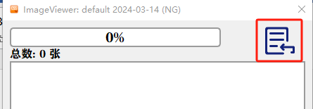Click the button shown in the red box to select the image folder you want to browse.
：Open the third interface.
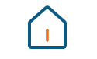：Return to the first screen.
：Control the start and stop of the detection.
Detector calibration progress:：It is displayed synchronously with ② on the first screen, and disappears automatically when the progress reaches 100%.

3.4 Third Interface
The third interface is the operation interface for adjusting the current product parameters.
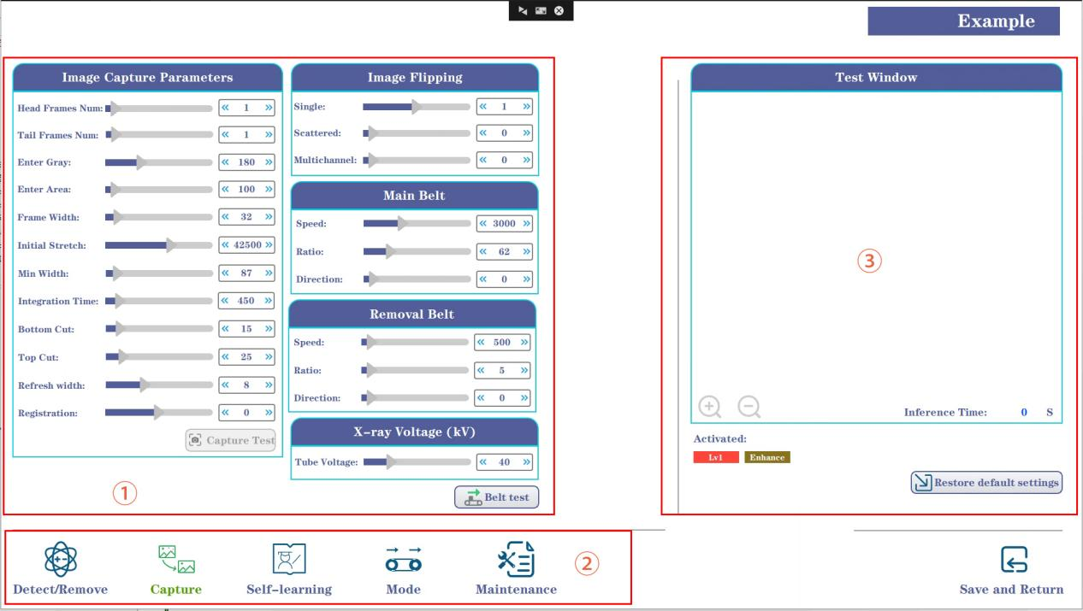
Label ①: Used for adjusting recognition parameters. Foreign object detection has three algorithms (Lv1 for shape detection, Lv2 for brightness detection, and Lv3 for gradient detection) to meet different detection needs. Sealing detection and loose material detection are optional; these functions are not available for packaging-type foreign object detectors.

Label ②: Function option bar; clicking it switches between different pages.

Label ③: Test window. The image in the current window is synchronized with the image in label ① on the second interface. It can also be manually selected via buttons. Sliding the progress bar in the recognition parameters will automatically display the detection effect of the current parameters in the test window.
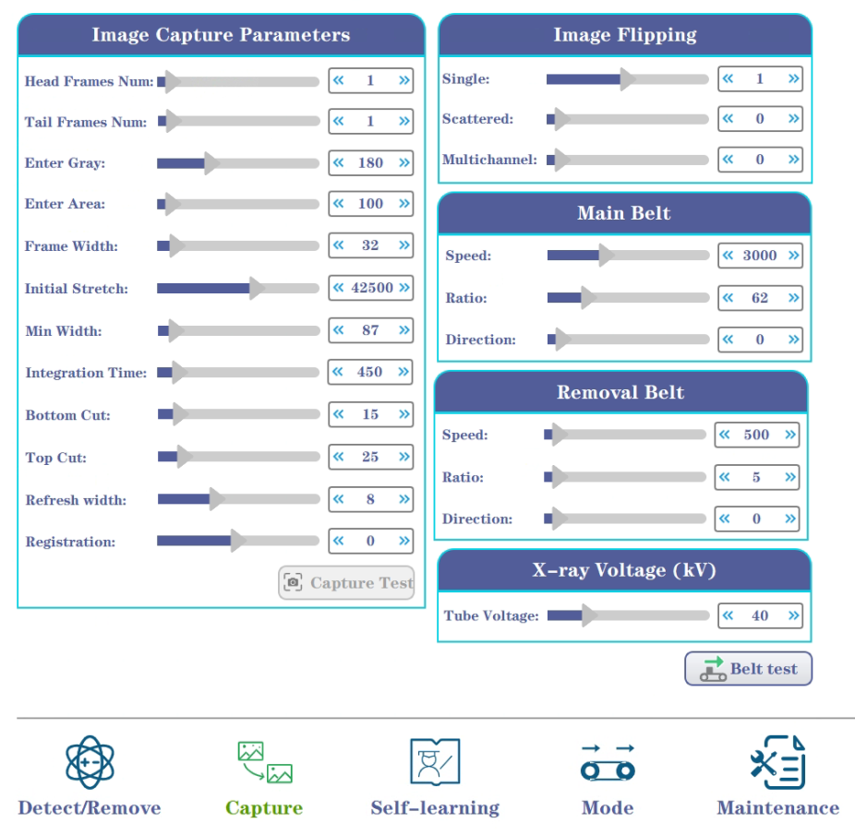
Identification parameters: used to control the detection accuracy of foreign objects.
Foreign object detection—Lv1：
Sensitivity Level: The higher the level, the stricter the foreign object detection; the lower the level, the more lenient the foreign object detection.
Maximum Gray Scale: The target's gray scale must be less than this value to be detected.
Maximum Density: The deviation between the target's center and its surroundings must be greater than this value to be detected.
Enable Lv1 Area Masking: Checking this option will mask targets smaller than the minimum area.
Minimum Area: The boundary of Lv1 area masking.
Foreign object detection—Lv2：
Attenuation Level: Only foreign objects with a grayscale value less than this value will be detected.
Density: Only foreign objects with an area greater than this value will be detected.
Foreign object detection—Lv3：
Decision level: Only foreign objects with a grayscale value less than this value will be detected.
Attenuation level: Only foreign objects with a gradient greater than this value will be detected.
Note: All parameters for foreign object detection can be automatically set by the self-learning function.
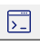：Manually import the test image.
Image parameters: Used to control the process of acquiring product images.
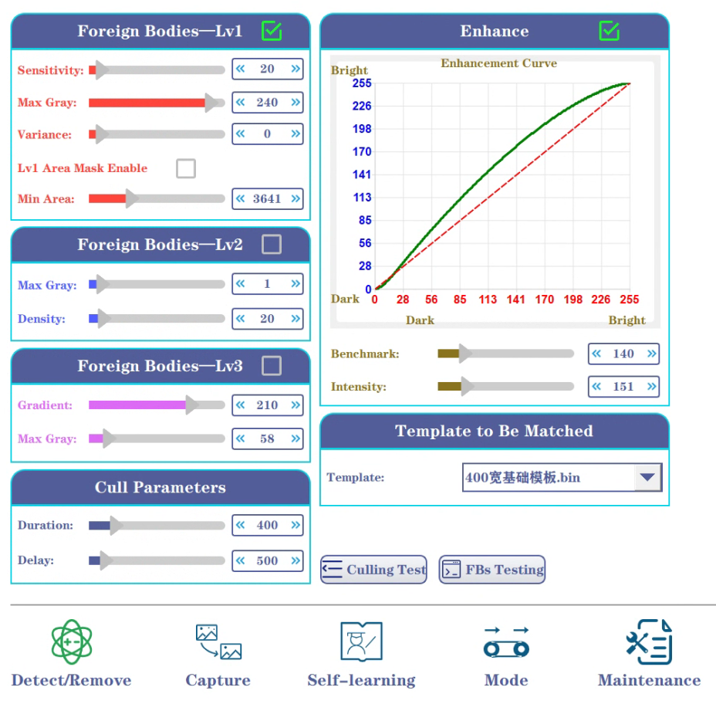
Image Emphasis: Used to adjust the brightness and contrast of the image. Non-administrators should adjust with caution.
Click to enable the Image Emphasis function.
Emphasis Baseline: Controls the image emphasis baseline.
Emphasis Intensity: Controls the degree of image emphasis; the higher the intensity, the greater the image contrast.
Image Acquisition Parameters: Controls the raw image acquisition process.
Local Magnification Enable: The image will be magnified; unchecked by default.
Acquisition Test: Click and wait for a period of time; the image with the current parameters will appear in the test window. Generally used for development and maintenance.
Segmentation Threshold: The threshold for local magnification; the higher the threshold, the higher the image magnification.
Magnification Margin: The white margin margin after local magnification; the higher the margin, the more white margin remains.
Front/Rear Frame Count: Controls the left and right white margin margins of the current image during acquisition. Except for sealing inspection machines, the default is 1.
Background Judgment: The image grayscale threshold when a product is present; if the grayscale value is less than this value, a product is considered to have passed.
Single Frame Column Count: The number of columns in a single frame of data acquired.
Raw Stretching: Controls the contrast of the sensor's raw data. Width Limit: No image will be formed if the image width is less than this value, to eliminate potential anomalies in the channel or conveyor belt.
Integration Time: The detector's exposure time, which must be correctly matched to the transmission speed.
Image Cropping: The top and bottom cropping of the acquired image, used to address situations where the detector's ends are not illuminated by the X-ray.
Image Capture Mode: The image display mode, which automatically changes according to the rejection mode.
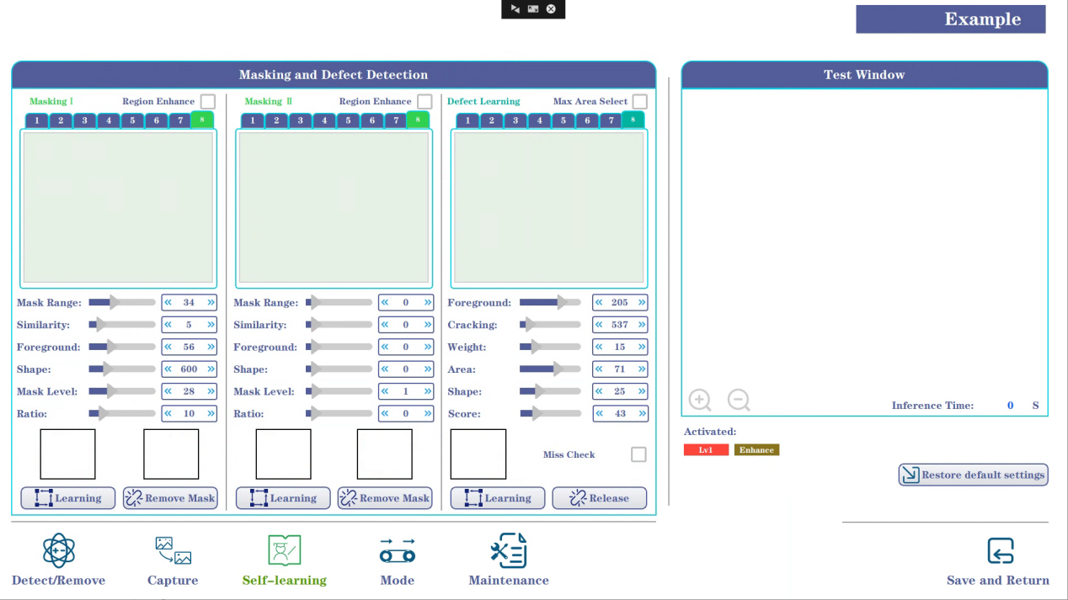
 Self-Learning:
Self-Learning Task Creation: Once the device is calibrated and ready, the "Start Self-Learning" button will light up. Clicking this button will start the device, allowing you to place various situations that may occur with the current product (different shapes, stacked packages, wrinkles, etc.). It will automatically stop after 8 learning cycles. The "Body Shielding Learning" function is enabled by default to prevent the machine from mistakenly learning areas that should be shielded.
Subject Masking: XSS software supports two different subjects to be masked. You can either manually select the subject by importing the image and then using the capture button, or you can automatically learn the subject through the self-learning function.
：Used to remove the entity that needs to be blocked.
Masking Level: Used to determine the morphological similarity between the object and the anomaly. The smaller the level, the stricter the determination.
Masking Range: Used to determine the area similarity between the object and the anomaly. The smaller the area, the stricter the determination.
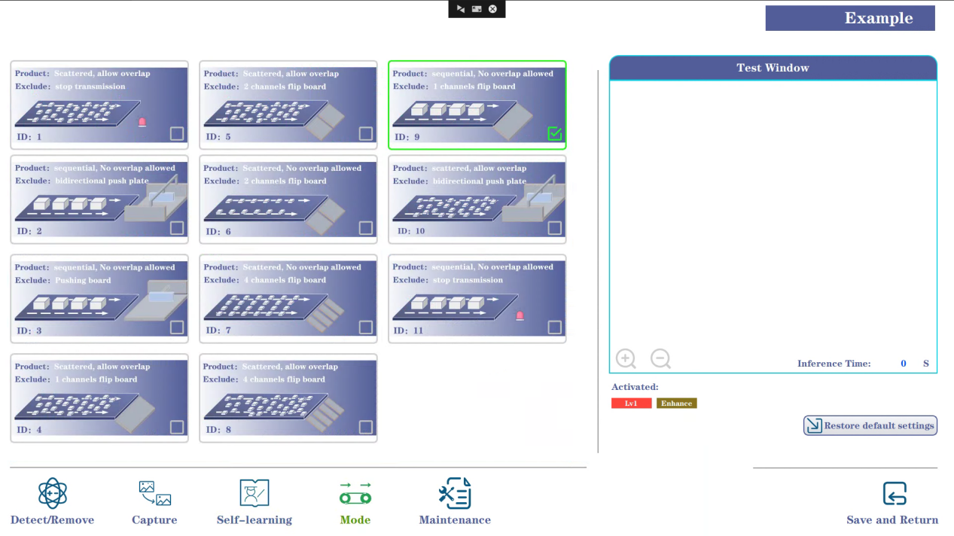
Hardware configuration: Set various hardware-related parameters.
Rejection Parameters:
Action Duration: How long the rejection action lasts before resetting. Unit: milliseconds.
Rejection Delay: The delay between detecting the anomaly and starting the rejection process. Unit: milliseconds.
Time Alignment: Used to address inaccurate rejection issues caused by time deviations in the algorithm or sampling. The default value is 20. Unless there are specific requirements, non-professionals should not adjust this value.
Rejection Mode: See the software for details. Modes marked "Loose Material" are for small products passing in piles, while modes without "Loose Material" are for single-item passing. Standard machines mostly use modes 1, 2, and 8; others require special scenarios and hardware configurations.
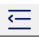：Clicking the button allows you to test the hardware's rejection performance.
X-ray tube voltage (kV):
Tube Voltage: Adjusts the X-ray energy value. For thicker products, a voltage of 55-65kV is recommended. For thinner products, a voltage of 40kV is recommended. It should be noted that the tube current is not accessible via an interface in the CSS series software and can be dynamically adjusted during operation. Specific adjustment strategies are shown in the table below:
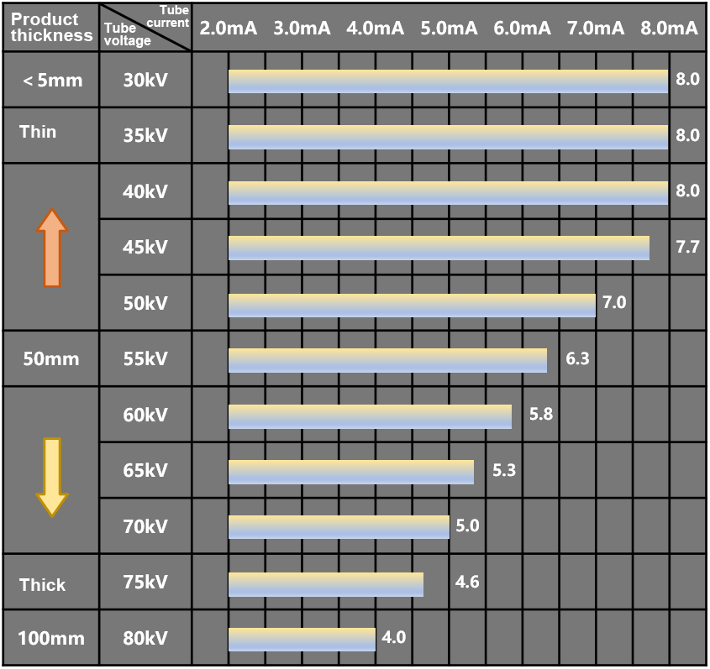
Conveyor:
Transmission Speed: Controls the transmission speed. The standard machine defaults to 4000mm/min. Changes must be synchronized with the integral time.
Transmission Ratio: Controls the motor drive of the conveyor belt.
Direction: Controls the running direction of the conveyor belt.
Bulk Material Hardware Parameters: Proprietary for bulk material handling machines; not available for packaging machines.
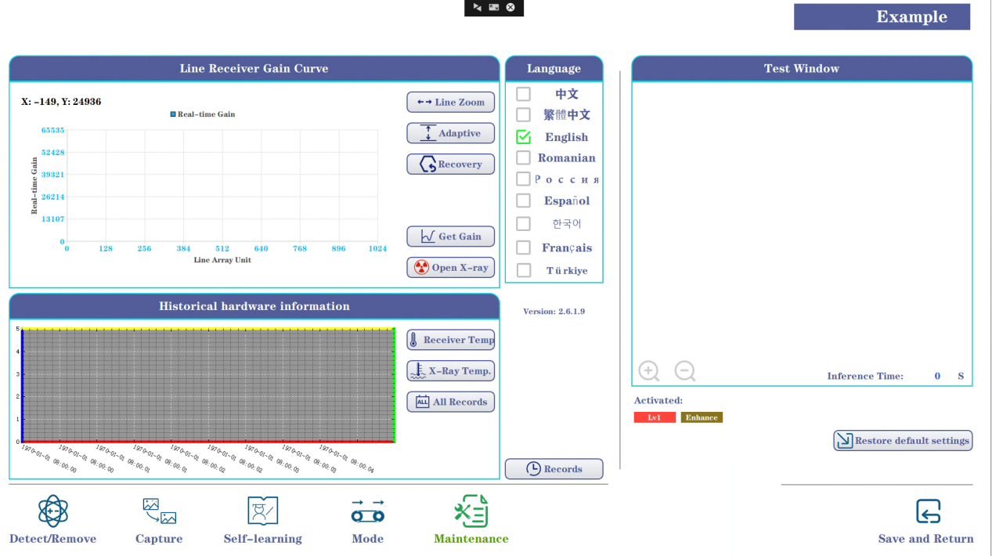Maintenance:
Detector Gain Curve:
Read Gain: Reads the detector's response data and displays it in the window.
X-ray On: Turns X-rays on and off to view the detector's bias and gain values ​​respectively.
Horizontal Axis Zoom: Increases the spacing of the horizontal axis.
Adaptive Adjustment: Adaptively adjusts the vertical axis response.
Restore: Restores the window to its initial coordinate position.
Historical Hardware Statistics:
Historical Detector Temperature: Click to view the detector temperature curves for the last three days.
Historical X-ray Temperature: Click to view the X-ray temperature curves for the last three days.
All Historical Records: Click to select a historical file and visualize it (one data file is created for every three days).
Language Selection: Switches between Chinese and English. Additional dependent components require customization and selection.
Record View: Click to switch to the second record maintenance interface, as shown in the image below. Click the icon shown in the red box in the image to update the software usage record, X-ray usage record, and total X-ray irradiation time. Press the Exit Record button to exit the record maintenance page. Error history is used to refresh the log interface.
- Introduction to Main Operating Procedures
  - When the product has already been entered
The software will open automatically after powering on.


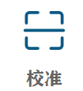
Method 1: After the software starts, it will automatically switch to the sample selected before the last shutdown -> Click Calibration -> Click Start -> Click Startup
Method 2: Click on the sample library -> Click on the product you want to test -> Click on select and exit -> Click on calibration -> Click on start -> Click on launch
  - When the product is a new type
-> Click on the Inspection Library -> Click on the last row to add -> Double-click on the column containing the product name and enter the product name -> Double-click on the column containing the product batch number and enter the product batch number
-> Click Select and Exit -> Log in with Level 2 Administrator privileges (Username: worker Password: 000, then press Enter on your keyboard).
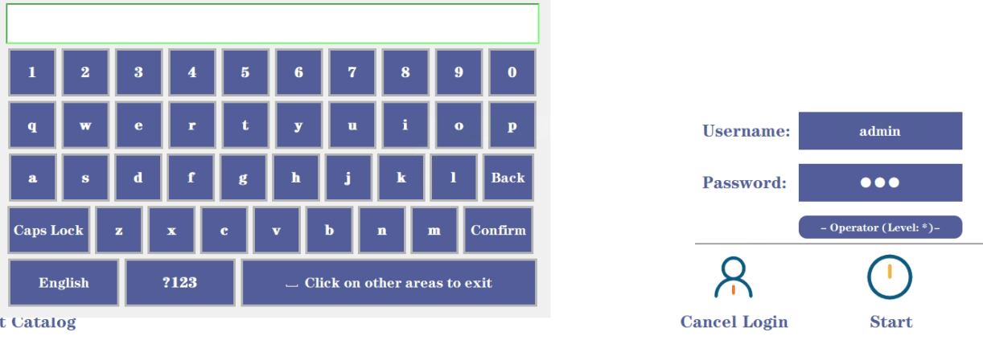
Click Start -> Click Parameters, click Hardware Parameters, adjust the tube voltage to an appropriate value according to the difficulty of product testing and product thickness, and then click Calibrate.

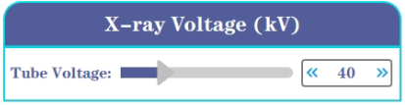
-> After clicking Save and Return, click Start


  - Self-learning function
This function needs to be enabled when the default parameters have a high false detection rate or when there are objects that need to be shielded, such as desiccants or aluminum clips.
-> Click on the sample library -> Click on the product you want to test -> Click on Select and Exit -> Click on Calibration
Log in with administrator privileges (username: admin, password: 123, then press Enter on your keyboard).
Click Start -> Click Parameters
-> Click Self-Learning -> Check the Ontology Mask Learning Enable -> Click Start Self-Learning (it will automatically stop after learning 8 times, and the software will automatically calculate the algorithm parameters).
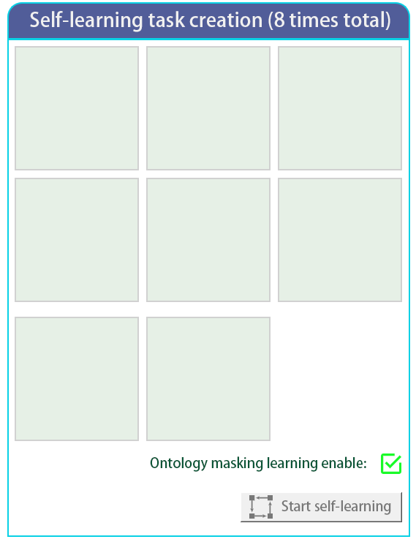
-> Click Close, then click Start
  - Image Emphasis
Log in with level 2 administrator privileges (username: admin, password: 123, then press Enter on your keyboard).
Click Start -> Click Parameters
-> Click Image Parameters -> Check Enhancement Enable -> Adjust the Emphasis Baseline and Emphasis Intensity sliders, and observe when the contrast between the foreign object and the image is at its maximum.
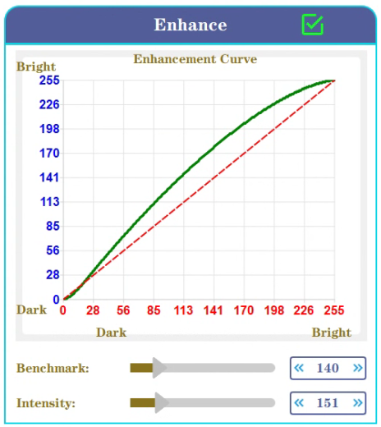
  - Maintenance Guide
- Solution when clicking "calibrate" or "start" is ineffective: Check if the light source, detector, and transmission on the main interface are all properly connected (normal connection is grayed out, abnormal connection is blue).
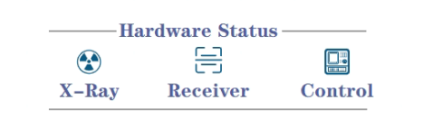
2. Solution for oversaturated or underexposed images after successful calibration and startup:
-> First, check if enhancement is enabled. If so, turn it off.
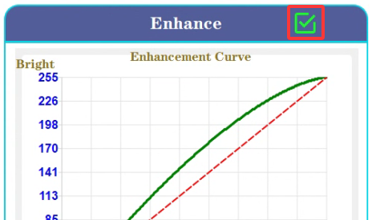

If the first step is ineffective, click on Image Parameters and adjust the image stretching factor to around 42500.
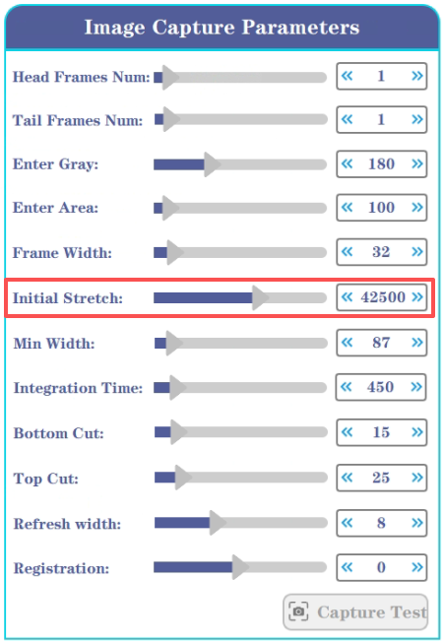
2. Solution when no graph appears during use:
-> First check if the light source, detector, transmission, and algorithm are all normal (red indicates normal after startup, gray indicates abnormal).
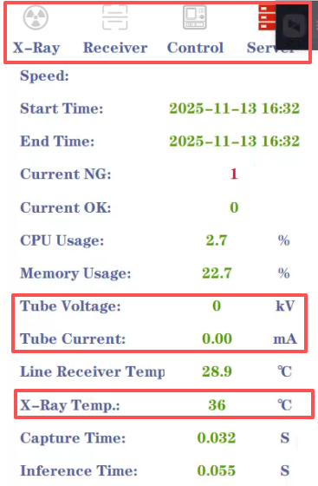
-> If the first step is normal, check if the tube current and tube voltage are greater than 0%.
-> If the second step is normal, check if the light source temperature and detector temperature are overheating (an alarm will sound and the machine will shut down if they exceed 52℃).
- Solution when no image is displayed upon startup:
-> Possible scenario 1: The detector is not illuminated by radiation on either side; the image cropping parameter can be slightly increased.
Image cropping：
-> Possible scenario 2: The original stretching parameters are too large. Please adjust them to around 42500.
-> Possible scenario 3: There is interference in the conveyor channel, requiring shutdown to clean the belt and channel and recalibrate.
  - Turn off the X-ray foreign object detection machine
1. Technical operators can directly shut down the computer by clicking the "One-Click Shutdown" button, or the administrator (maintenance engineer) can exit the software and shut down the computer through the Windows Power Management interface in the lower left corner.
2. Close the right-side security lock (rotate 90 degrees counterclockwise);
3. Perform a safety check (power supply, etc.).
- Access Control
Each XSS series software requires a dedicated dongle; the software will only function correctly when the dongle is properly plugged into the USB port.

Guangdong SameGram Intelligent Equipment Co., Ltd.
Email：sale@samegram.com
WhatsApp：https://wa.me/8613713346108
WeChat: yan270126

