  - First Interface
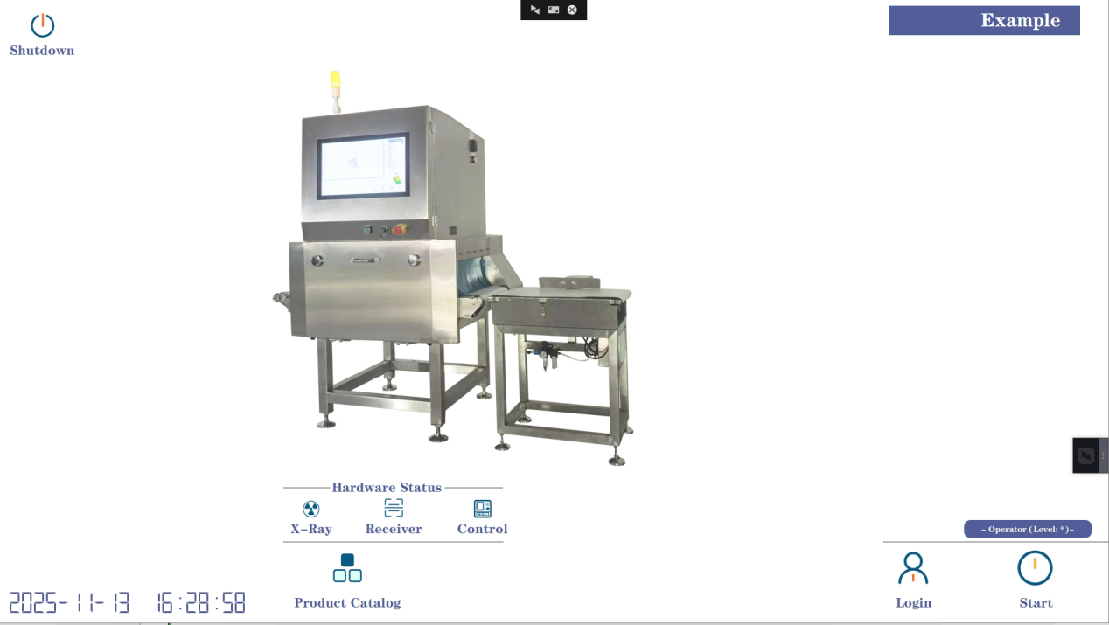The first screen is the software startup screen, a preparation screen before starting the program. Clicking "Start" will take you to the second screen, used to log in as an administrator (username: admin, password: 123).
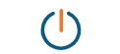Software Exit Area, including a one-click shutdown button. After one-click shutdown, the host and background processes will shut down. The host power can be cut off via a rotary switch after approximately one minute. The exit button exits the software and returns to the system desktop, but it only appears after logging in as an admin.
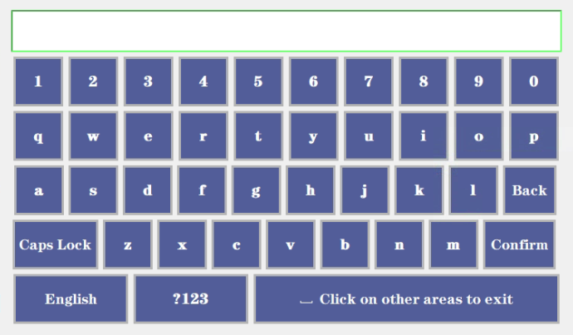
Upon logging into the management system, a software keyboard that allows switching between Chinese and English will pop up.
The current software has three levels of access. At level one, without logging in, the system can only run the detection function; the parameter page cannot be accessed.
The second-level permission account is "admin" with the password "123". After logging in, users can adjust parameters.
The third-level permission account is "super" with the password "888". After logging in, users can set a default password and also change the password. (See section 2.3 for product selection permissions.)
Check that all hardware (X-ray machine, detector, transmission controller) is properly connected. A normal connection is grayed out, and an abnormal connection is blue.
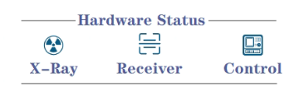
  - Product Selection
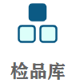Click the "Inspection Library" button on the first screen to open the product selection interface. The inspection library can store information on over 1000 products. Select the product to test (or produce), and click the "Select and Exit" button to load the selected product. All parameters of the currently selected product can be adjusted on the third screen.
Click the "Inspection Library" button on the first screen to open the product selection interface. The inspection library can store information on over 1000 products. Select the product to test (or produce), and click the "Select and Exit" button to load the selected product. All parameters of the currently selected product can be adjusted on the third screen.
Other button descriptions：
Add to current line：Add a new product at the position of the currently selected row.
Add to last line：Add a new product at the end of the table.
Export to desktop: Convert the report to Excel format and save it to your desktop.
Delete selected: Delete the currently selected product.
Copy selected: Create a new product and copy all parameters of the currently selected product. All parameters will be identical in both.
Additional notes：
1) After the software opens, it will default to selecting the last produced product.
2) The delete button will only appear after logging in with admin privileges.
3) Product name and product batch number are required fields when creating a product for the first time. Both fields only support alphanumeric input by default.
  - Second Interface
The second interface is the main operation interface during the production process.
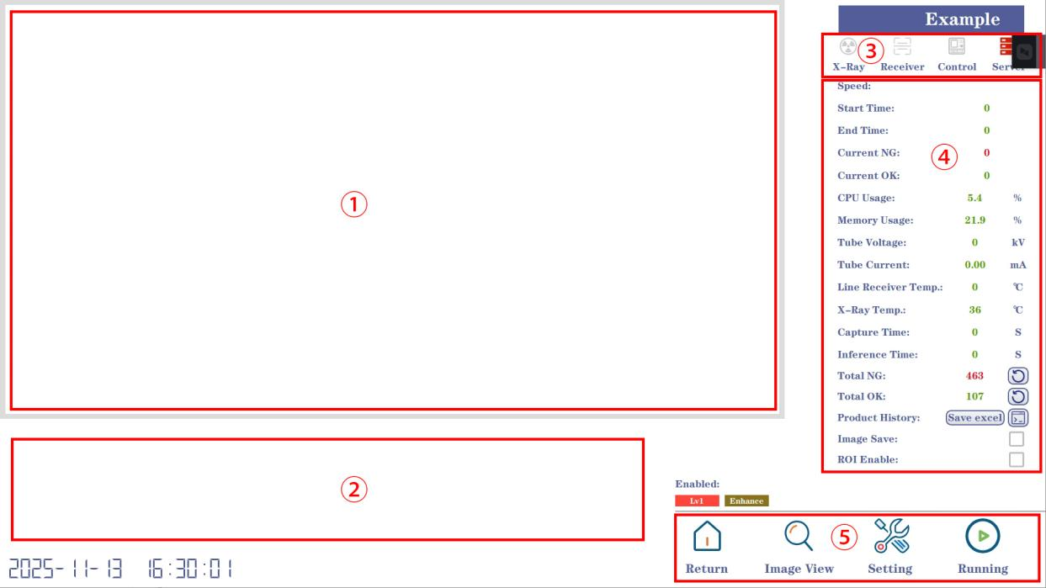
Label ①: Real-time display interface. When a product passes through the X-ray machine, the image will be displayed in this area.
Label ②: Stores thumbnails of recently abnormal products. Click to enlarge and view ①. Note that this is only visible when a product passes through; it is a blank area immediately upon startup.
Label ③: Hardware status during operation, including the light source, detector, transmission, and algorithm. After clicking the start button, red indicates normal operation, and gray indicates abnormal operation.
Label ④: Real-time status of other parameters while the equipment is running, which can be used for equipment maintenance, status monitoring, and assessment of unknown errors.
Label ⑤: 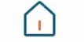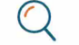Different function selection areas. Click to return to the first page. Click to view the stored image. Click to enter the parameter selection page. Note that only the first page of parameters is visible when the equipment is running. To view all parameters, please stop the device.
Other button descriptions:
：When checked, the original image will be saved to a RAW file named after the current date. Additionally, all defective products will be automatically saved in a folder named after the current date, and the detection results will be in the NG and original RAW folders.
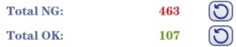：The total number of defects and total number of good products will be calculated from the time the software is started. Clicking the red area will reset the number of defects and the number of good products to zero respectively.
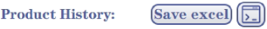：Record the product's testing information. Clicking the red area will bring up a pop-up window.
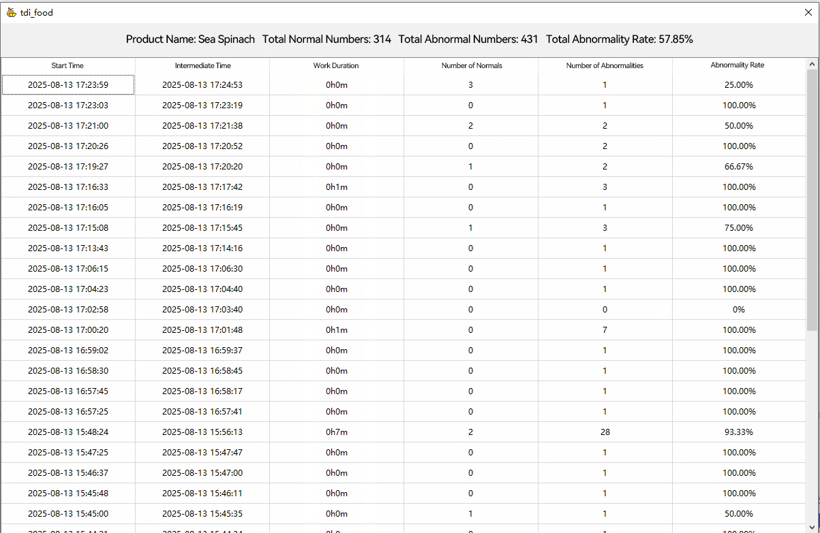
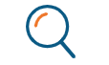：Open the folder of abnormal images for the day. 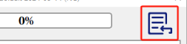Click the button shown in the red box to select the image folder you want to browse.
：Open the third interface.
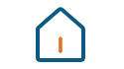：Return to the first screen.
：Control the start and stop of detection.
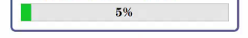：It calibrates automatically every time the device is turned on, and disappears automatically when the progress reaches 100%.
：Zoom in/out on the image labeled ①.
  - Third Interface
The third interface is the operation interface for adjusting the current product parameters.
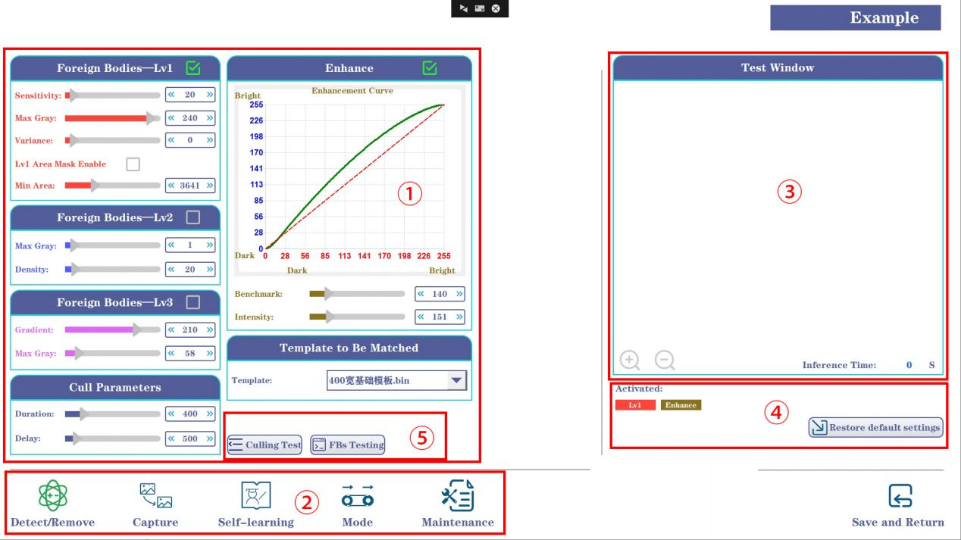Label ①: Used for adjusting recognition parameters. Foreign object detection has three algorithms (Lv1 for shape detection, Lv2 for brightness detection, and Lv3 for gradient detection) to meet different detection needs. Sealing detection and loose material detection are optional; these functions are not available for packaging-type foreign object detectors.
Label ②: Function option bar; clicking it switches between different pages.
Label ③: Test window. The image in the current window is synchronized with the image in label ① on the second interface. Manual selection is also possible via buttons. Sliding the progress bar in the recognition parameters will automatically display the detection effect of the current parameters in the test window.
Label ④: Enabled Algorithms: This box displays the algorithms already loaded in label ①. Restoring default parameters restores all parameters of the current product to their default values.
Label ⑤: Rejection Test: Performs a rejection test. For foreign object testing, select an image and load it into label ③ for testing.
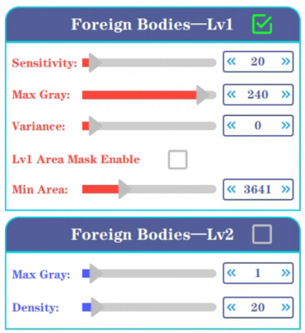
Clicking on the text area of the parameters page will bring up the software system's numeric keypad.
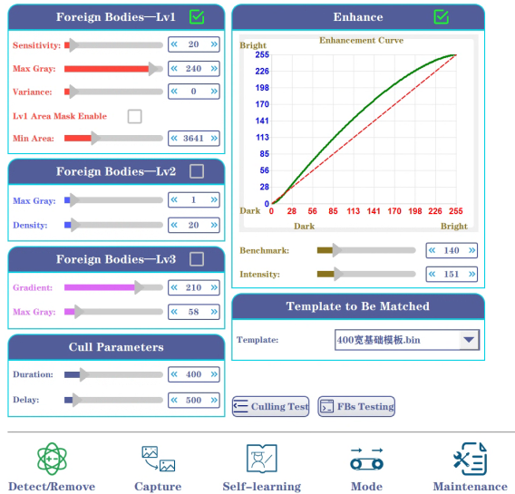
Identification and rejection: Used to control the detection accuracy of foreign objects.
Foreign Object Detection—Lv1:
Sensitivity Level: The higher the level, the stricter the foreign object detection; the lower the level, the more lenient the foreign object detection.
Maximum Gray Scale: The target's gray scale must be less than this value to be detected.
Maximum Density: The deviation between the target's center and its surroundings must be greater than this value to be detected.
Enable Lv1 Area Masking: Checking this option will mask targets smaller than the minimum area.
Minimum Area: The boundary of Lv1 area masking.
Foreign Object Detection—Lv2:
Attenuation Level: Only foreign objects with a grayscale value less than this value will be detected.
Density: Only foreign objects with an area greater than this value will be detected.
Foreign Object Detection—Lv3:
Decision Level: Only foreign objects with a grayscale value less than this value will be detected.
Attenuation Level: Only foreign objects with a gradient greater than this value will be detected.
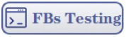：Manually import the test image.
Rejection Parameters:
Action Duration: Total time for the rejection device to perform rejection.
Rejection Delay: The larger this value, the later the rejection process begins. If rejection is too late, please reduce this value.
Image Emphasis: Used to adjust the brightness and darkness of the image. Non-administrators should adjust this with caution.
：Click to enable the image emphasis function.
Emphasis Base: Controls the image emphasis baseline.
Emphasis Intensity: Controls the degree of image emphasis; a higher intensity results in greater image contrast.
Template Selection: Templates are available for different production lines. A 40mm wide template corresponds to a 400mm wide basic template, while smaller templates are available for multi-channel applications. Custom templates can also be created for specific scenarios.
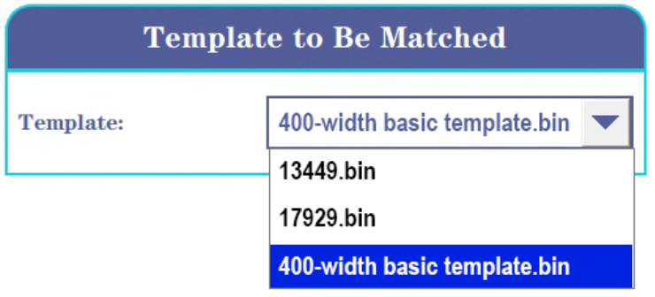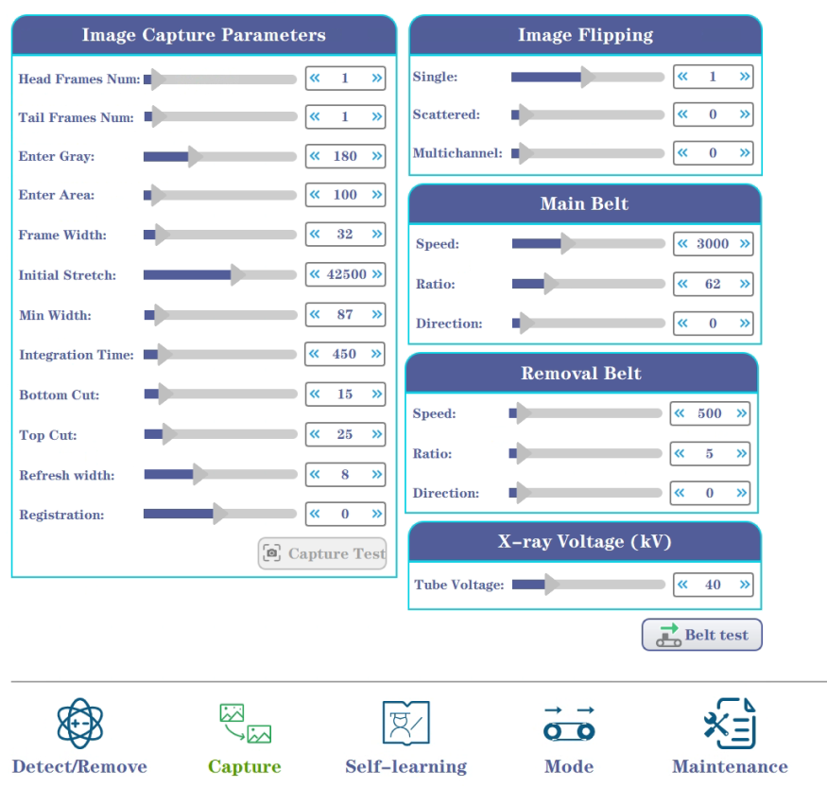
Image capture parameters: These are used to control the raw image acquisition process.
Local Magnification Enable: The image will be magnified. This is unchecked by default.
Acquisition Test: Click and wait a while; the image with the current parameters will appear in the test window. Generally used for development and maintenance.
Segmentation Threshold: The threshold for local magnification. The larger the threshold, the higher the image magnification.
Magnification Margin: The white margin margin after local magnification. The larger the margin, the more white margin remains.
Before/After Frames: Controls the left and right white margins of the current image during acquisition. Except for sealing inspection machines, the default is 1.
Entry Grayscale: The grayscale threshold for the image when a product is present. If the grayscale value is less than this value, a product is considered to have passed through.
Number of Columns per Frame: The number of columns in a single frame of data acquired.
Original Stretching: Controls the contrast of the sensor's raw data.
Width Limit: No image is formed when the image width is less than this value to eliminate potential anomalies in the channel or belt.
Integration Time: The detector's exposure time, which must be correctly matched to the conveyor speed.
Image Cropping: The top and bottom cropping of the acquired image, used to address situations where the detector's ends are not exposed to X-rays.
Batch Material Refresh Width: Image display width in batch material mode. A smaller value results in smoother refresh; the default is 8 and modification is not recommended.
Image Flip: Adjusts the image display format.
Single/Batch/Multi-Channel Imaging: In single/batch/multi-channel detection modes, the image displayed in the detection window is forward, reversed, or mirrored.
Conveyor Control: Control of the conveyor belt.
Transmission Speed: The current belt speed. 4000 corresponds to 40 m/min.
Gear Ratio: The ratio of the motor's input speed to its output speed. A smaller gear ratio results in a faster motor speed.
Direction: The direction in which the motor controls the belt's rotation.
Rejection Machine Control: Similar to belt control.
X-Tube Voltage: A parameter controlling the X-ray voltage. The thicker the object being inspected, the larger this value; do not exceed the maximum voltage.
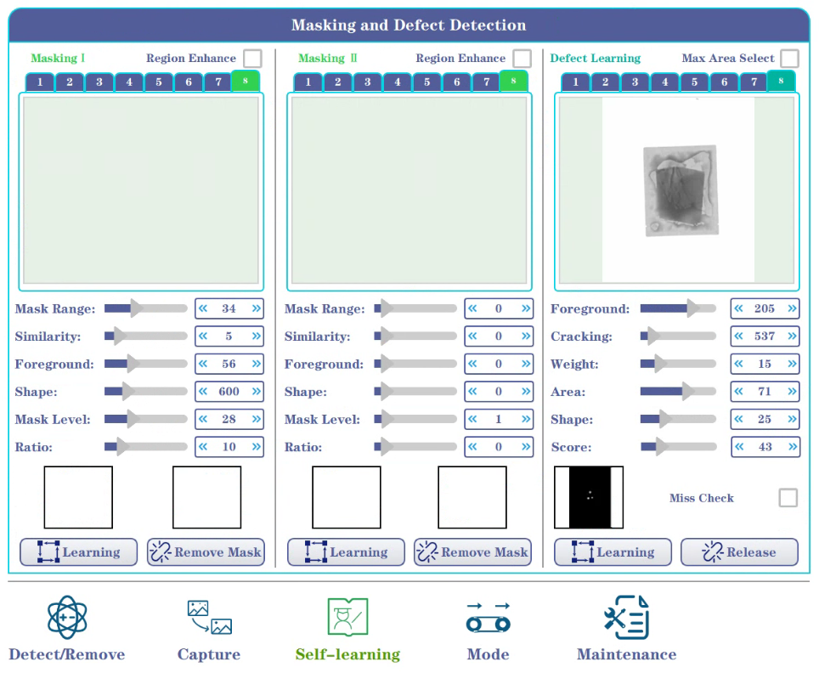Self-learning:
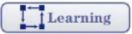Click to start the corresponding learning program. If you want to change products, please click to unblock and then start self-learning again.
Region Masking: Please note that the current software supports region masking for two different types of objects. Each region masking algorithm can only learn one corresponding shape and cannot be confused. If foreign objects are detected during the learning process, please relearn!
Region Enhancement: This can be selected when the area to be detected is very similar to the background. However, please do not select this option for objects that are easily distinguishable from the background, such as desiccants!
Mask Range: A value of around 20-30 is recommended here. If the height and width of the object vary significantly, please adjust it to between 40-60.
Similarity: This value can effectively mask small foreign objects within the area, such as glass under a desiccant or small stainless steel balls. A smaller value means smaller foreign objects can be detected, but this can also lead to false positives. A value between 3-10 is recommended. Please refer to the following:
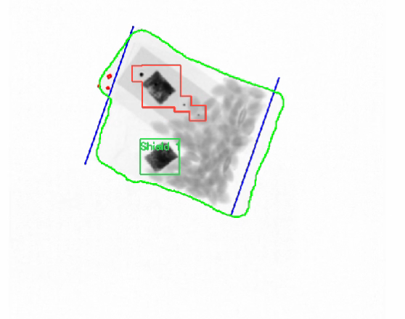
Foreground threshold: The purpose here is to obtain the area to be masked. Please refer to the image below. The left side is the original region, and the right side is the result segmented according to the selected foreground threshold.
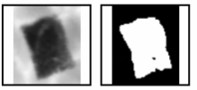
Please ensure that the white area in the small image on the right has the same shape as the area to be masked in the original image on the left. The darker the measured area, the lower the corresponding foreground threshold. For example, the value for the desiccant in the image should be between 70 and 80. Please note that accurate segmentation is crucial here. If you find the segmentation results inaccurate during the self-learning process, please relearn!
Shape Score: A value of around 500 is recommended. If the shape of the measured object varies greatly, please use the maximum value directly.
Mask Level: A value of around 20 is recommended. If the measured object is too small, such as the seal of a sausage, or has a large shape difference, please use a value of 40-60. For example, the masking value for the sausage seal shown below is recommended to be 40. Please refer to this if you have similar objects.
Ratio: Recommended value is 5-10.
Defect Self-Learning: Please ensure there are no impurities during the learning process. Ensure the accuracy of the learned information. Additionally, to identify object fractures, please check the "Maximum Area Selection" box! Do not check this box if not needed!
Foreground Threshold: This is used to obtain the area to be learned. Using the image below as an example, the value range is around 140. The foreground result will be displayed within the square box below. Please ensure that the white area within the box matches the shape of the object being learned! Consistency is crucial; carefully observe the changes in the white area during the self-learning process.
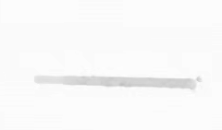
Fragmentation Detection: When detecting object fracture, check the "Maximum Area Selection" option in the upper right corner. This value will update automatically during the learning process. If a false positive occurs, increase this value until no false positives occur.
Weight: Generally set around 15. Reduce it for higher sensitivity. The same applies to area.
Shape: If shape differences are minor, set it around 85. If there are significant shape variations, set it between 60-80. If shape detection is not required, such as for loose packaging, set it to 0.
Missing Shield Area Detection: Checking this option will return an error if no learned object is shielded in an image or if more than one learned object is detected. This function helps determine the number of objects in the shielded area.
Example: Using sunflower seeds as an example, the foreground threshold should be adjusted between 120-150. Do not check "Maximum Area Selection." Set both weight and area to 15, and shape to 0 to complete defect detection.
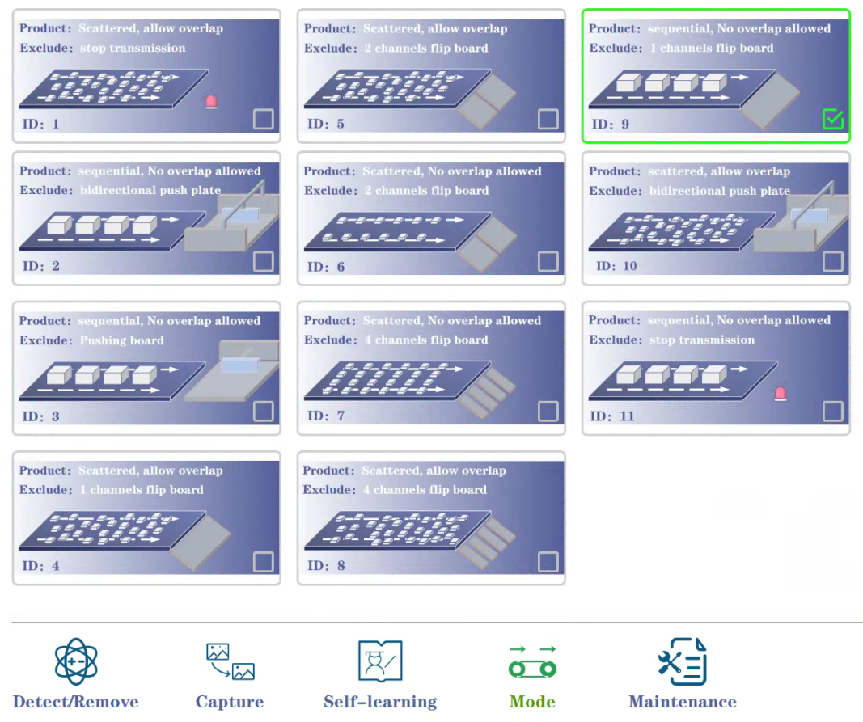
Mode Selection: Corresponds to different production line modes.
ID1: Corresponds to single-channel stackable loose materials; automatically stops upon the presence of foreign objects.
ID2: Single-channel sequential material flow; rejected by a bidirectional pusher.
ID3: Single-channel sequential material flow; rejected by a unidirectional pusher.
ID4: Corresponds to single-channel stackable loose materials; rejected by a flip-plate upon the presence of foreign objects.

ID5: Corresponds to dual-channel stackable loose materials; rejected by a flip-plate in the corresponding channel upon the presence of foreign objects.
ID6: Corresponds to loose materials + defect detection in self-learning; rejected by a flip-plate in the corresponding channel upon the presence of foreign objects.
ID7: Corresponds to loose materials + defect detection in self-learning; rejected by a flip-plate in the corresponding channel upon the presence of foreign objects. (Four-channel rejection is more accurate)
ID8: Corresponds to stackable loose materials; rejected by a flip-plate in the corresponding channel upon the presence of foreign objects.
ID9: Single-channel sequential material flow; rejected by a flip-plate upon the presence of foreign objects.
ID10: Corresponds to stackable loose objects; a two-way pusher will remove any foreign objects.
ID11: Corresponds to objects passing through a single channel sequentially; it will automatically stop if a foreign object is detected.

