Dynamic weighing scale

User Manual

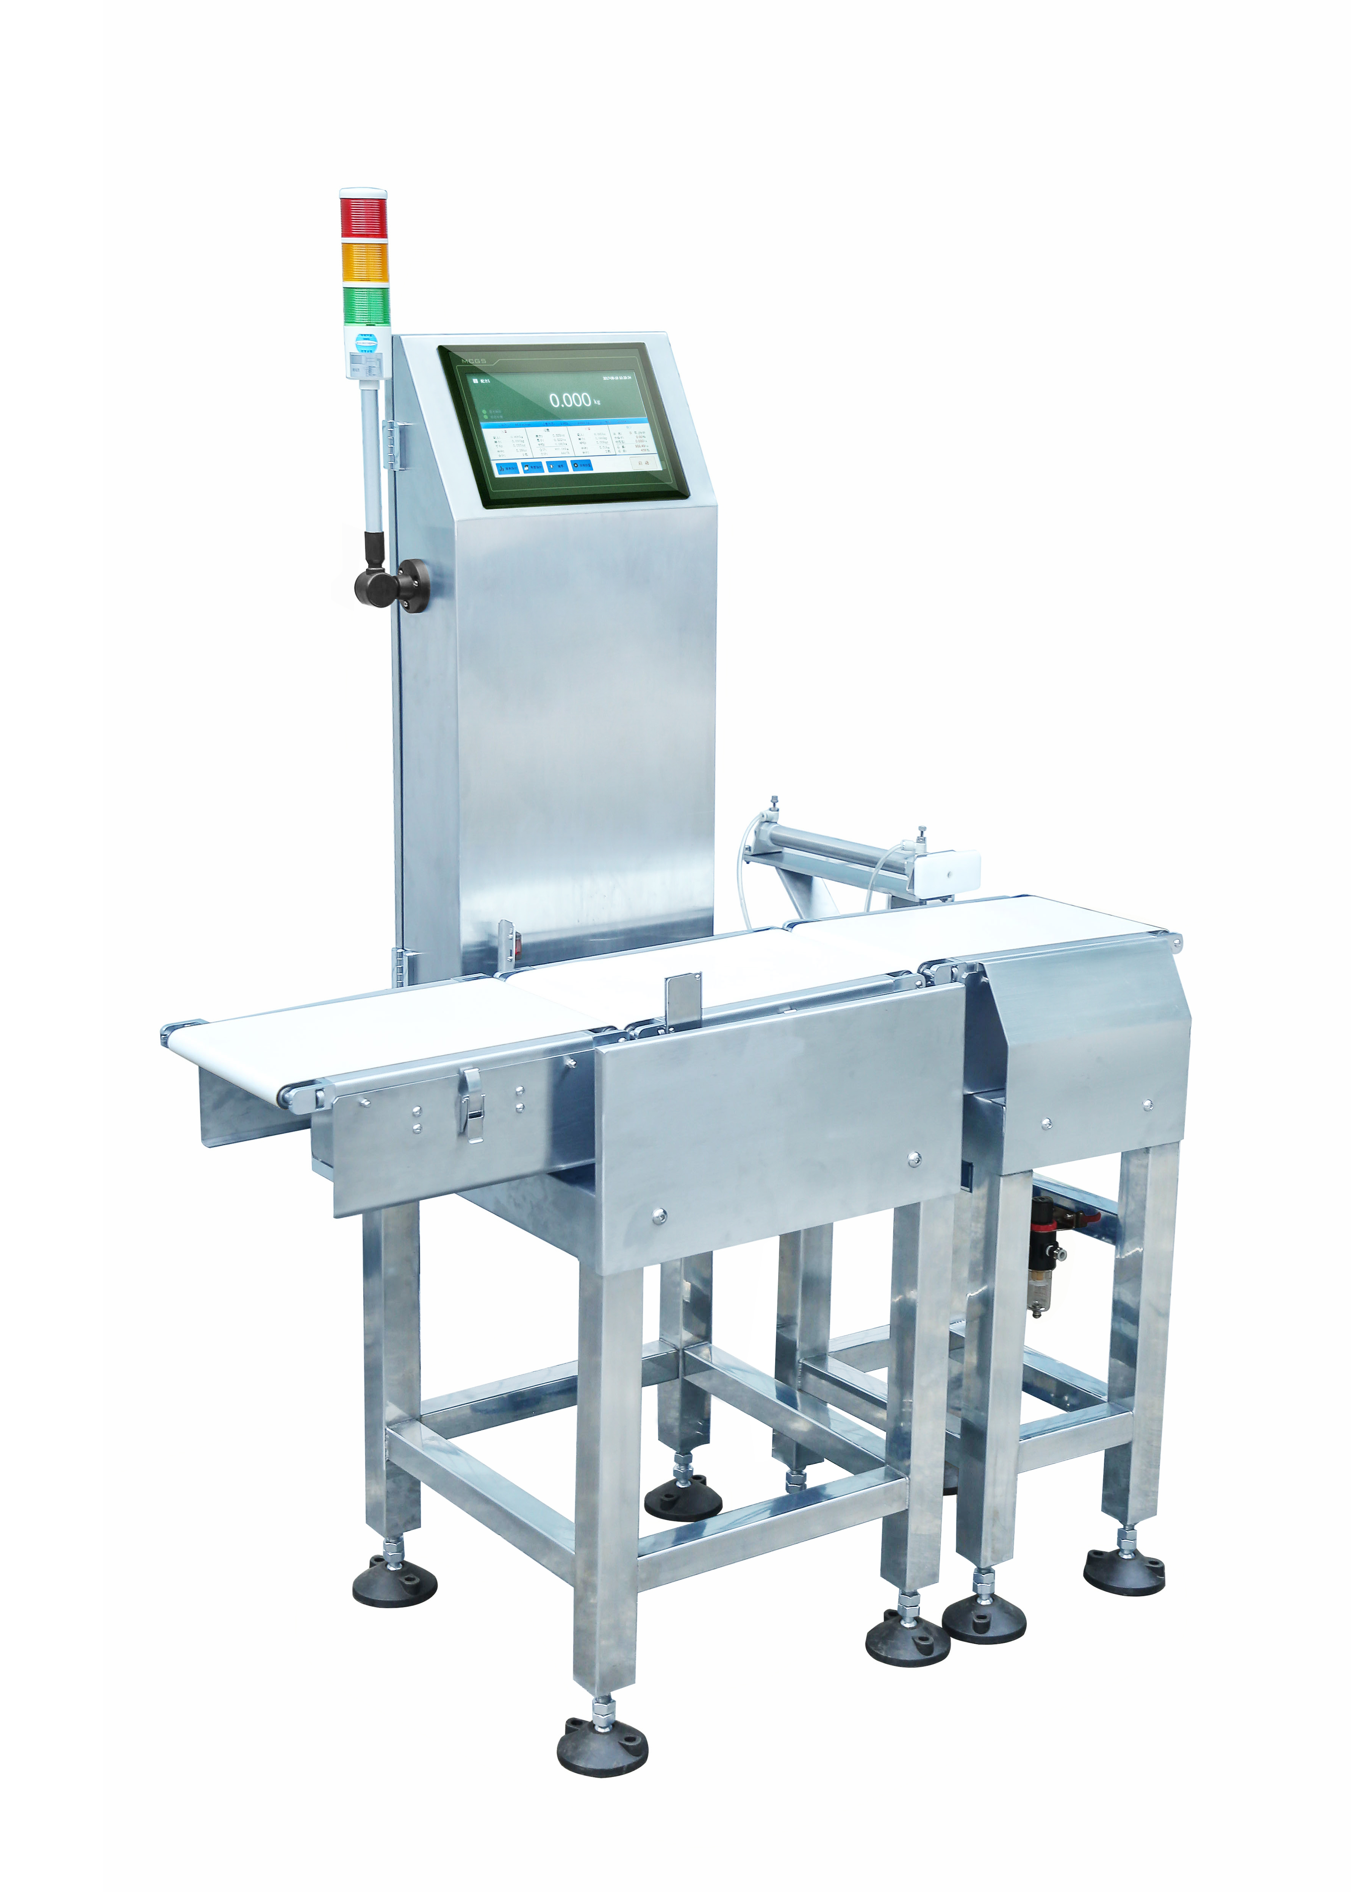

Date of preparation: August 8, 2018

Version: V1.0. 5

**catalogue**

1. Preface 1

2. Overview 1

3. Safety Precautions 2

3.1 Safety matters 2

3.2 Main power connection 2

3.3 Precautions 2

4. Introduction of mechanical structure and function 3

4.1 Intermediate Weighing Mechanism 3

4.2 Equipment Installation 3

5. Operation instructions of man-machine interface 4

5.1 Startup Matters 4

5.2 Introduction to Main Interface 6

5.2. 1 About equipment 8

5.2. 2 Formula Setting 9

5.2. 3 Weighing Settings 15

5.2. 4 Device Setting (System Administrator Permission Required) 16

5.2. 5 Motor setup (system administrator authority is required) 18

5.2. 6 Speed correction (system administrator authority is required) 19

5.2. 8 Report Statistics 20

6. Troubleshooting 21

7. Maintenance 22

1. **Preface**

**Thank you very much for buying our series of products.**

* Before using this product, you should read the instruction manual carefully, and please follow all operation and safety instructions to ensure safe and correct use of this product.
* Please keep this instruction manual properly and refer to it in case of doubt or failure. If you can't solve it, please contact us.
* The details of this manual will be revised due to product upgrades without prior notice. Please understand

1. **Overview**

Automatic weight sorting machine is the leading product of our company, which can be used for online weight detection or weight sorting of various products. The machine has the characteristics of high precision, stable performance, simple and practical operation, and can meet the online weighing requirements of food, Japanese goods, pharmaceutical, chemical and other industries

**3. Safety Precautions**

**3.1 Safety matters**

* The safe operation of the sorting machine of our company is related to the operation, maintenance and adjustment of the operator, and affects other people working nearby.
* It is hoped that the safety tips will be thoroughly read and the meanings of the words used in this specification will be fully understood.
* Master the equipment situation, safety information and precautions skillfully before using it.

The inspection and maintenance of this equipment shall be carried out by qualified persons with sufficient mechanical and motor knowledge.

**3.2 Main power connection**

* Before plugging in the power plug, please make sure that the voltage of the power supply is the same as that of the machine.
* Make sure that the main power supply is firmly fixed when connected to the electric control box.
* Do not connect the main power supply of the machine when the voltage does not conform.
* **Moisture should be avoided near the power supply, and the machine should be grounded in advance.**
* All wiring work of the machine must be completed by professional personnel.

**3.3 Precautions**

* Ensure that the power supply used by the machine is correct. Please use alone, do not use too long or too thin extension cord, so as to avoid danger.
* The machine should not be installed in hot and humid places, and the input power supply should be grounded to avoid electric shock.
* Electrical installation shall be handled by electricians or engineers and technicians. Without permission, the electric control box or wiring shall not be opened.
* Do not use corrosive products for machine maintenance, which is easy to cause damage to various parts.
* When the machine is running, do not put irrelevant objects on the machine and do not contact all parts of the body with moving or rolling parts.
* In case of abnormal action during the operation of the machine, please press down the stop button of the red emergency switch.

Do not flush the machine, electric control box or electrical components directly with water to avoid damage or leakage.

**4. Introduction of mechanical structure and function**

**4.1 Intermediate Weighing Mechanism**

This part is the most critical part of the whole mechanical system, and its structural design and installation accuracy directly affect the measurement accuracy of the system. It consists of a conveying motor, a photoelectric detection part and a weighing sensor. Complete the dynamic weighing of the object.

**4.2 Equipment Installation**

Before equipment installation, keep away from vibration sources; When installing, please install the scale platform;



**5. Operation instructions of man-machine interface**

**5.1 Startup Matters**

Rotate the change-over switch on the right side of the electric control box, turn on the power supply, the touch screen displays the startup screen, and wait for a period of time before entering the main operation interface.

Before starting up, please confirm that the equipment is grounded, the installation level of the equipment and the delivery screw have been removed, otherwise the stability and accuracy of the equipment will be affected.

**5.2 Introduction to Main Interface**

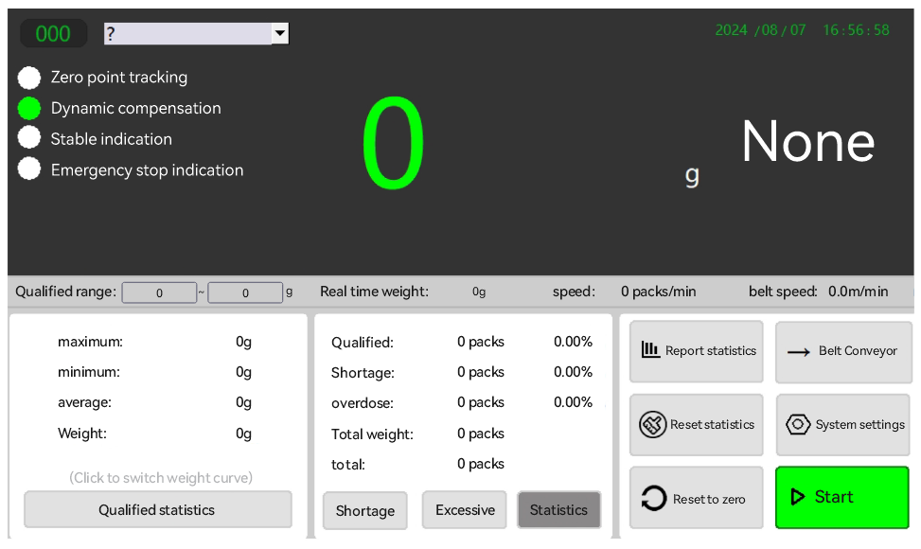**System Settings**

Login permission is required for system settings. Different permissions will present different setting items. The default login information is as follows:

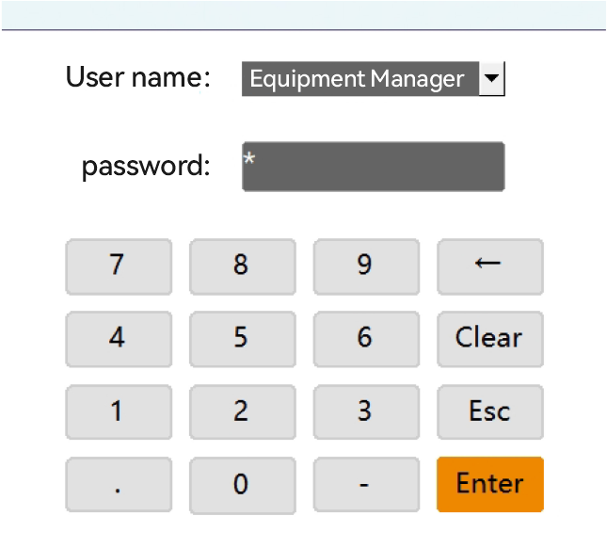

Default password of the person in charge of the equipment: none, confirm it directly;

Default password of system administrator: 111111;

Super Administrator: This user is debugged by the manufacturer and is not open;

**5.2. 1 About equipment**

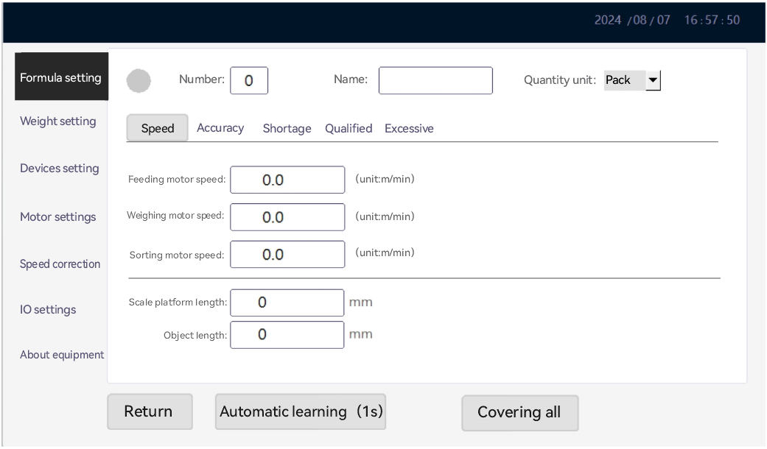Change Password: Change the password of the currently logged in user.

Change Time: The date and time when the system was changed.

User Management: When logging in as system administrator, you can manage users, add, delete and modify ordinary users and administrator users.

Manufacturer Information: When logging in as a system administrator, you can enter factory information for the equipment, and you can fill in the equipment model, equipment manufacturer name, factory date, expiration date, service telephone number and official website.

Factory Date: When logging in as a system administrator, you can set the function that the device automatically stops working when it expires. After expiration, the start button in the main interface will disappear and the device cannot be started. The set date format must be 2016-01-01. If the format is incorrect or empty, it is invalid. After expiration, changes and cancellations can only be made through the system administrator account.

**5.2. 2 Formula Setting**

**1) Speed Setting**

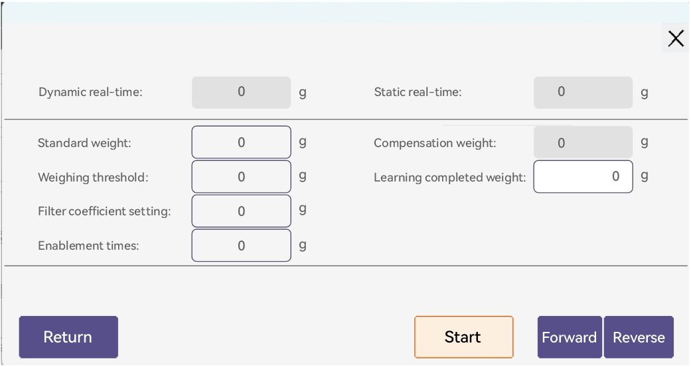

The system supports up to 20 formulas, can switch formulas, change formula names and quantity units, and can set the corresponding speed and accuracy of equipment for different formulas. (Please contact our company for more formula)

Formula Name: It is recommended to enter less than 16 characters.

{b Quantity Unit}: default quantity unit is {b Package}; it can be changed to display corresponding quantity units for different recipes. Supported quantity units are bags, bags, pieces, boxes, boxes, only, strips, pieces, bottles, cans and barrels.

Weight checking speed: the speed of feeding table motor, weighing table motor and sorting table motor can be set in combination, so as to realize the control of weight checking speed.

1. **Precision Setting**

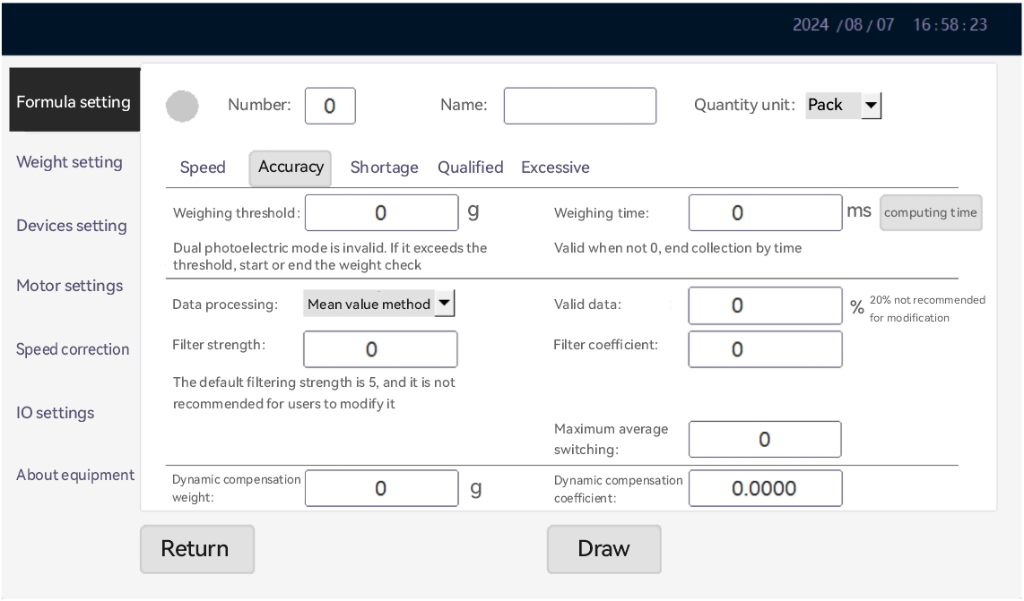

Weight Checking and Weighing Threshold: When the weight is greater than this threshold, the system performs weight checking.

Weight detection and weighing time: the time from the time when the photoelectric detection signal is matched with the photoelectric mode to the time when the weight is discharged.

Weighing data processing: the default is the maximum value method, which can be set as the average value method, and the percentage of valid data can be set.

Filter intensity setting: the default is 5, and the range is 3 ~ 18.

Filter coefficient setting: 45 by default, ranging from 30 to 100.

Dynamic compensation value: When weight deviation occurs in dynamic weighing, dynamic compensation can be carried out by setting this value.

Dynamic compensation coefficient: default to 1, range from 1 to 100.

**4) Automatic learning**

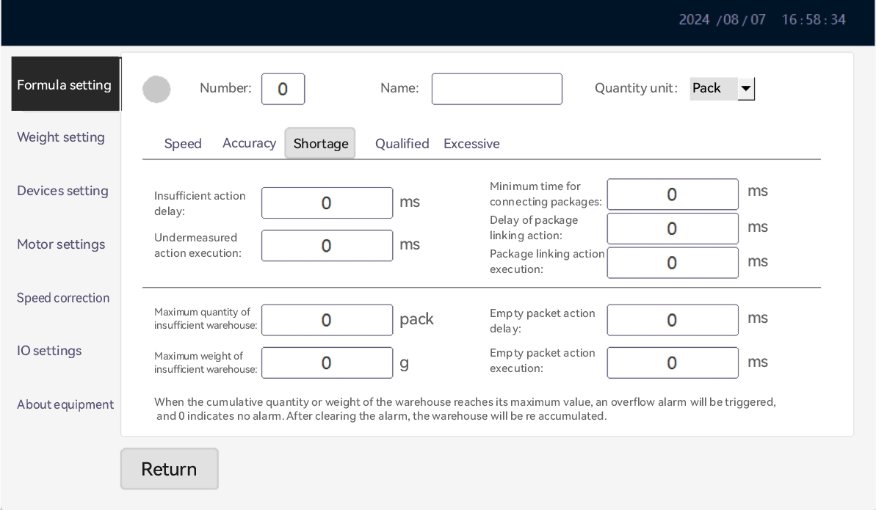Click "Automatic Learning" to enter this function;

Learn Standard Weight: The weight of an object when it is still on the scale.

Weighing threshold: Generally set to 25% of the learning standard weight, the smaller the learning, the more accurate the learning.

Filter coefficient setting: before setting, fill in more than 80, and automatically modify after learning results.

Learning downtime delay: Automatic downtime after learning.

Learning enable times: automatic learning times, the more learning times, the higher the accuracy.

5) Qualification Setting

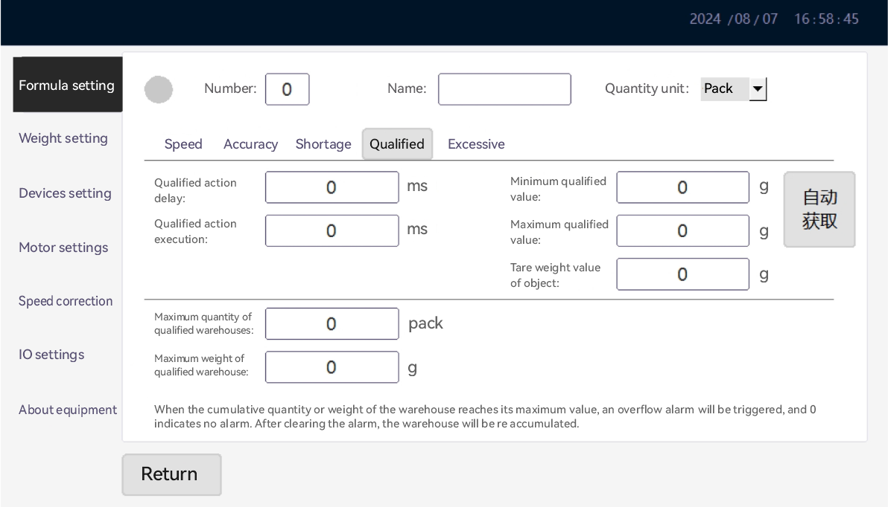Appropriate minimum value: The minimum value of the qualified range of weighing object weight, i.e. the lower limit of weight.

Appropriate maximum value: the maximum value of the qualified range of weighing object weight, i.e. the upper limit of weight.

Action Delay Time: Corresponding to the delay time of a certain sorting action, the corresponding delay time should also be changed after the motor speed of the weighing table is changed.

Action execution time: corresponding to the execution time of a certain sorting action, the specific execution time usually depends on the mode and structure of the mechanical part.

{b Maximum Qty of Sorting Warehouse}: when the cumulative quantity of the sorting result is greater than this value, the system will give an alarm; the default value is 0, which means the function will not be started.

Maximum Weight of Sorting Warehouse: when the cumulative weight of the sorting result is greater than this, the system will give an alarm. The default value is 0, which means that the function will not be started.

Under-quantity and over-quantity are equivalent to above.

**5.2. 3 Weighing Settings**

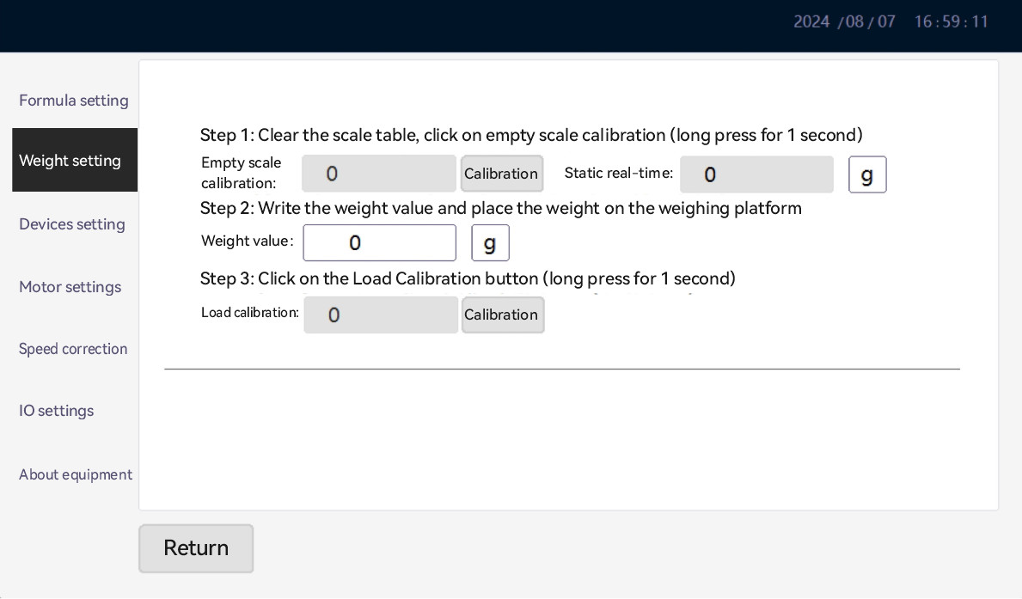No-load calibration: calibrate the empty scale.

Loading calibration: Place the weight on the scale for calibration.

Weight value: fill in the weight value of the corresponding weight.

Manual reset range: set the range of manual reset (relative to the percentage of maximum/minimum range). The default is that manual reset is prohibited, and the "Reset" button will not be displayed in the main operation interface;

Zero Tracking Range: range of indexing values for which zero value can be tracked; default to 0.

Zero tracking rate: the input format is 5420d/s, that is, 5.4 d/2. 0s means that the zero value can be tracked by drifting within 5.4 indexing values within 2 seconds, and the default is 0.

Continuous Weight Checking Alarm: When the continuous quantity of the corresponding weight checking result reaches the set number, the system will give an alarm. It can realize the function of alarming when the continuous N packets are out of time.

**5.2. 4 Device Setting (System Administrator Permission Required)**

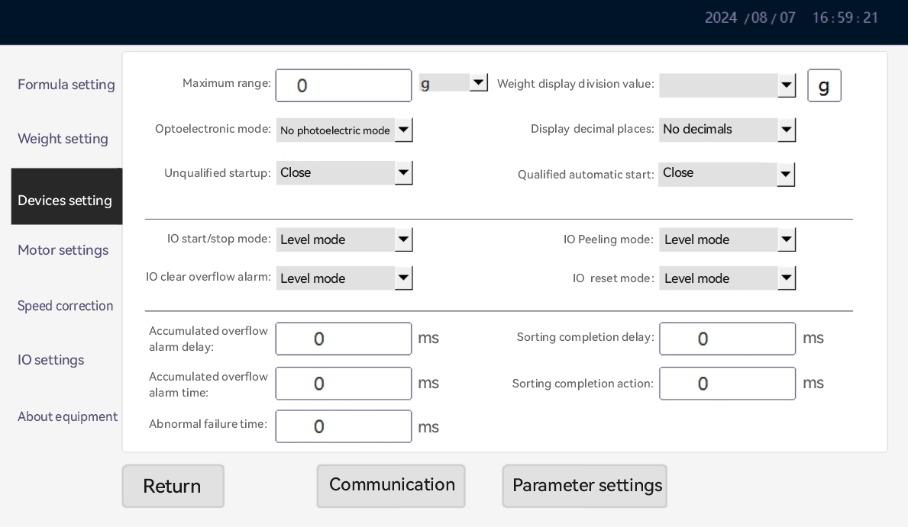Maximum range: It is the maximum weighing range of the weighing platform. Weight units can be selected, and g and kg are supported.

Weight Display Index Value: The weight value used for smooth display can realize the function of stable weight display.

Display decimal places: Use it in conjunction with the graduation value to select. The unit G is generally set to one decimal value and the unit KG is generally set to three decimal places.

Photoelectric mode: According to the photoelectric access mode of the equipment, no photoelectric mode, double photoelectric mode, photoelectric in mode and photoelectric out mode can be set. After setting, the corresponding indicator light will be lit on the operation interface.

IO startup mode: The system can access external startup buttons and select startup mode according to different button types. Selectable level mode and pulse mode.

IO Stop Mode: The system can access the external stop button and select the stop mode according to different button types. If the IO start mode is selected to level mode, the IO stop button is invalid. Selectable level mode and pulse mode.

IO Clear Overflow Alarm Mode: The system can access external buttons to clear overflow alarm status (effective when turning on overflow alarm in the recipe), and select stop mode according to different button types.

Overflow Alarm Duration: The duration of overflow alarm can be specified by setting this value. The unit is milliseconds, i.e. the output duration corresponding to IO (valid when the overflow alarm in the recipe is turned on).

**5.2. 5 Motor setup (system administrator authority is required)**

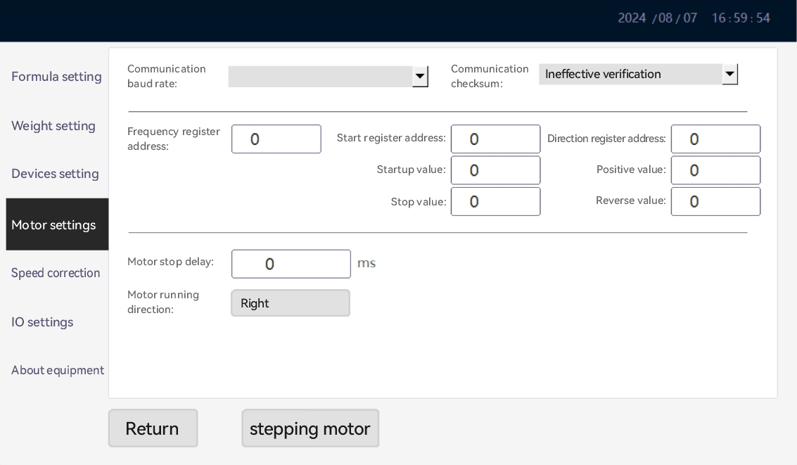Motor control type: supports analog voltage output and RS485 Modbus RTU. When RS485 Modbus RTU is selected, the frequency register address, start register address, start value and stop value of feeding table frequency converter, weighing table frequency converter and weight checking table frequency converter can be set respectively.

**When the motor control uses analog voltage output, this page does not use any settings**

**5.2. 6 Speed correction (system administrator authority is required)**

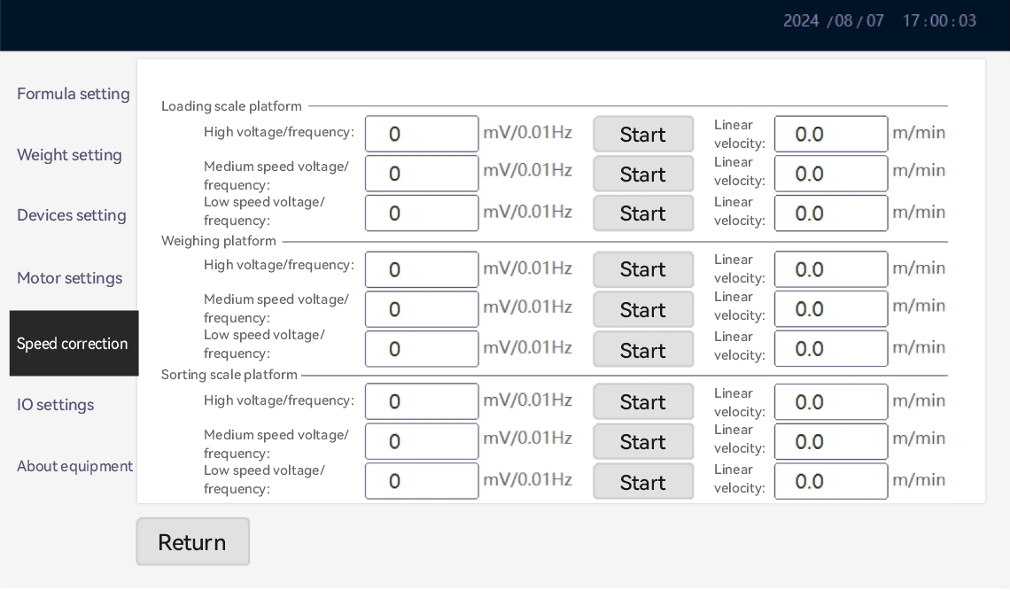Linear speed: Use the speed test table to measure the belt speed of the corresponding voltage and fill it in.

5.2. 7 IO settings (system administrator privileges are required)

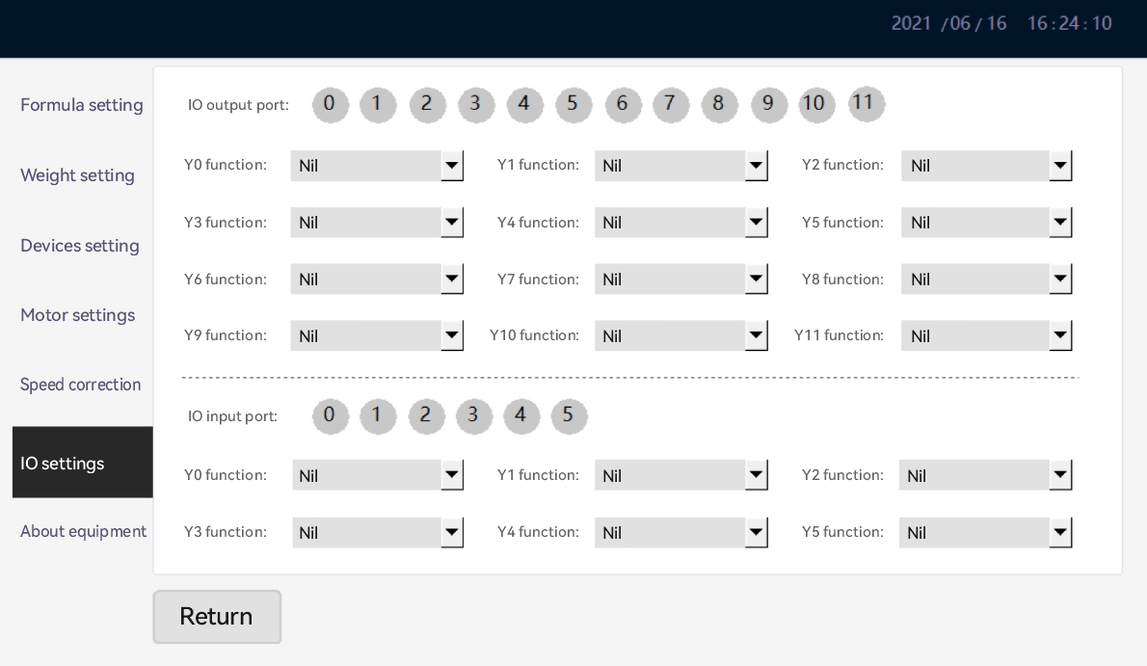IO Input/Output Port: Debugging can be carried out by clicking on the corresponding IO port number. When lit up, it indicates that the IO port is connected.

Y0 ~ Y7 functions: the output function corresponding to each IO port can be set. the output port can be set to start operation state, hierarchical cumulative overflow alarm, weight detection failure alarm, hierarchical 1 action, hierarchical 2 action, hierarchical 3 action, hierarchical 4 action, hierarchical 5 action, hierarchical 6 action and hierarchical 7 action.

X0 ~ X5 functions: the input function corresponding to each IO port can be set; The input port can be set as start input button, stop input button, photoelectric detection, photoelectric detection, clear alarm, positive full material detection and reverse full material detection;

**5.2. 8 Report Statistics**

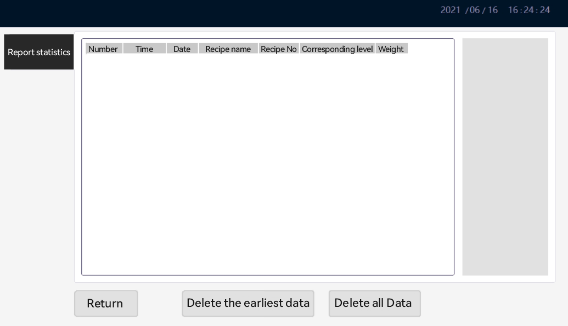Data Report: View all weight detection data. The corresponding grade is 1, which indicates underquantity, the corresponding grade is 2, which indicates appropriate amount, and the corresponding grade is 3, which indicates excessive amount; You can also set up to view historical data for different time periods.

Delete All Data: All saved data will be cleared.

Data Export: Start and end dates can be set, and data can be exported to U disk, which can be saved by overwriting or appending.

**6. Troubleshooting**

|  |  |  |  |
| --- | --- | --- | --- |
| **Serial Number** | **Problem** | **Reason** | **Exclusion Method** |
| 1 | The power lamp is not on | 1. The power supply is used incorrectly. | 1. Connect the correct power supply. |
| 2. Circuit breaker trips. | 2. Push on the circuit breaker brake. |
| 3. The fuse is damaged. | 3. Replace the fuse of the same model. |
| 2 | Static weighing instability | 1. Check whether the four legs of the equipment are unbalanced. | 1. Adjust and set the four legs to balance. |
| 3 | Large deviation of dynamic weighing | 1. Check the filter coefficient settings.  2. Check the proportion of valid data. | 1. If the parameter is too small, please increase the parameter setting appropriately  2. The proportion of valid data has increased. |
| 4 | Large deviation between static and dynamic values | 1. The dynamic compensation parameters may be wrong. | 1. Please set the dynamic compensation parameters again or manually enter the weighing compensation parameters. |
| 5 | Inaccurate static weighing value | 1. The equipment may not be calibrated correctly. | 1. Please calibrate the equipment again. |
| 6 | Dynamic Sorting No Data | 1. The position of the photoelectric switch may change.  2. The photoelectric switch is damaged. | 1. Adjust the position of the photoelectric switch to be able to collide.  2. Change the photoelectric switch of the same model. |
| 7 | The motor does not rotate after starting | 1. The shutdown time may be too short.  2. The motor interface may be loose. | 1. After each abnormal shutdown, wait for one minute before starting the machine  2. Connect the loose motor interface wire. |
| 8 | Eliminate no action | 1. Pneumatic device pressure may be too low. | 1. Please increase the air pressure of the pneumatic device. |
| 9 | Touch screen prompts to press emergency stop | Check whether the lower emergency stop switch is pressed | 1. Loosen |

**7. Maintenance**

* When the machine is undergoing maintenance, please turn off the main power supply.
* During mechanical cleaning, please avoid water or any liquid splashing on the electric control box or other electrical components.
* Please pay attention to the wear cycle and service life of its parts. When it reaches a certain degree of wear, please maintain or replace it regularly.