Dynamic drum scale

User manual

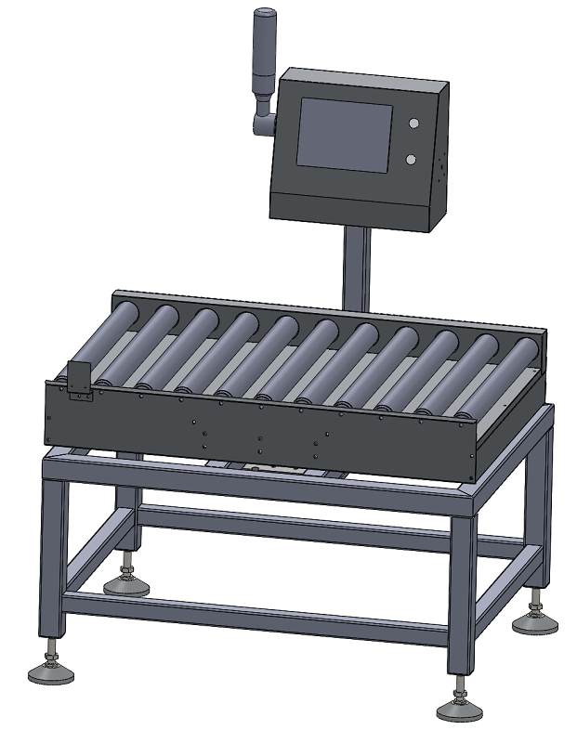

Date of writing：2021.6.11

V1.5

**catalogue**

1. anaphora 1

2. summary 1

3. Safety precautions 2

3.1 Safety matters 2

3.2Main power connection 2

3.3Matters needing attention 2

4. Mechanical structure and function are introduced 3

4.1Weighing mechanism 3

4.2 Equipment installation 3

5. Man-machine interface operation instructions 4

5.1Welcome screen 4

5.2Main interface introduction 5

5.2.1 6

5.2.2Recipe setting 7

5.2.3Weighing setting 10

5.2.4 Device Settings (System administrator permissions required) 11

5.2.5 IO Settings 13

5.2.6 Statement statistics 14

6. the troubleshooting process 15

7. maintenance 15

# anaphora

**Thank you very much for your purchase of our products.**

* Before using this product, please read the instructions carefully and follow all operation and safety instructions to ensure safe and correct use of this product.
* Please keep this instruction manual safe and refer to it in case of doubt or failure. If not, please contact us.
* Please understand that the details of this manual are subject to revision due to product upgrade without prior notice

# summary

Drum dynamic scale, the company's leading products, for a variety of products online weight detection or weight selection. The machine has the characteristics of high precision, stable performance, simple and practical operation, and can meet the requirements of online weighing in food, Japanese goods, pharmaceutical, chemical and other industries.

# 3. Safety precautions

## 3.1 Safety matters

* The safe operation of the separator is related to the operation, maintenance and adjustment of the operator, and affects other people working nearby.
* Please read the safety tips carefully and fully understand the meaning of the words in this manual.
* Familiarize yourself with the condition, safety information and precautions of the equipment before use.

The inspection and maintenance of this equipment shall be carried out by qualified persons with adequate mechanical and electrical knowledge.

## 3.2Main power connection

* Before plugging in the power plug, make sure that the voltage of the power supply is the same as that of the machine.
* Ensure that the main power supply is securely connected to the electric cabinet.
* Do not connect the main power supply of the machine when the voltage is inconsistent.
* Keep damp away from the power supply and ground the machine in advance.
* All wiring work of the machine must be completed by professional personnel.

## 3.3Matters needing attention

* Make sure that the power supply of the machine is correct. Please use alone, do not use too long or too thin extension cord, so as to avoid danger.
* Do not install the machine in a hot or humid place. The power supply should be grounded to avoid electric shock to the human body.
* Electrical installation must be handled by electricians or engineering technicians. Do not open the electric control box or connect cables without permission.
* Do not use corrosive products for machine maintenance, easy to cause damage to the parts.
* When the machine is running, do not place irrelevant objects on the machine and do not touch any parts of the body with moving or rolling parts.
* In case of abnormal operation of the machine, press down the red emergency switch stop button.
* Do not directly flush the machine, electric control box or electrical components with water to avoid damage or leakage.

# 4. Mechanical structure and function are introduced

## 4.1Weighing mechanism

This part is the most critical part of the whole mechanical system, and its structural design and installation accuracy directly affect the measurement accuracy of the system. It is composed of stainless steel unpowered roller and weighing sensor.

## 4.2 Equipment installation

Before installing the device, keep it away from the vibration source and wind source. When installing, ensure that the scale is at a horizontal level; All four feet bear the load and are fastened; After installation, need to check the scale;



# **Man-machine interface operation instructions**

## 5.1Welcome screen

Power on, the touch screen displays the startup screen, wait for a period of time to enter the main interface.

【 Note 】Before starting the device, ensure that the device is grounded, the device is installed on the horizontal plane, and the delivery screw is removed. Otherwise, the stability and accuracy of the device will be affected.

## 5.2Main interface introduction

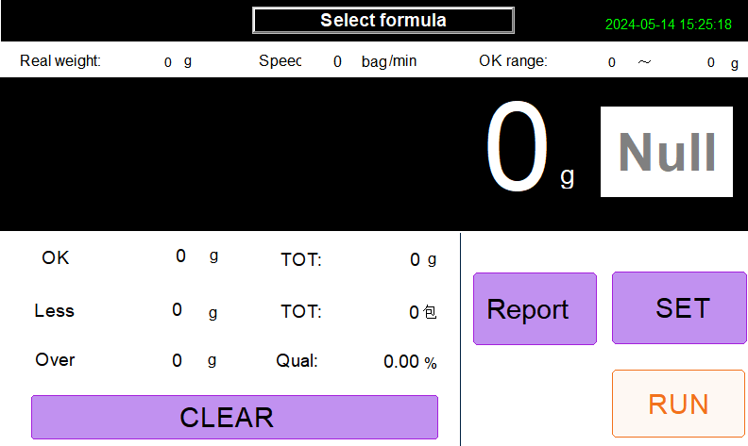

**System setting**

Login permissions are required for system Settings. Different permissions will display different Settings. The default login information is as follows:

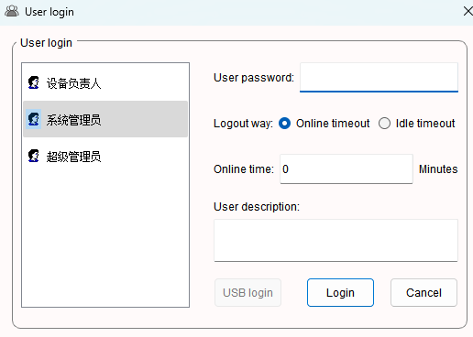

Device owner password: none

System Administrator Password:000000

**5.2.1About the device**

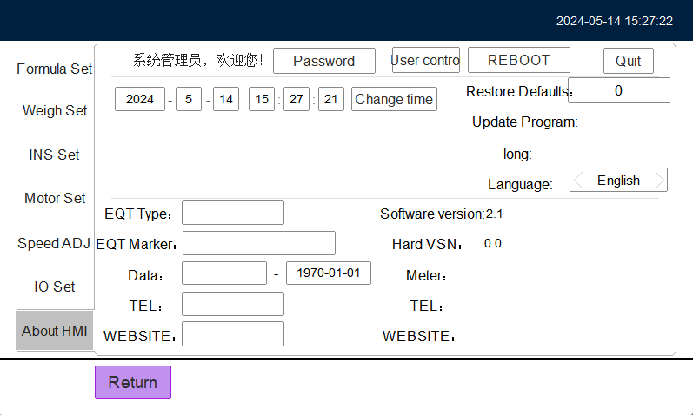

Change Password: Change the password of the currently logged in user.

Change Time: Change the system date and time.

User management: When logging in as a system administrator, you can perform user management, add, delete and modify ordinary users and administrator users.

Manufacturer information: When logging in as a system administrator, you can enter the factory information for the device. You can fill in the device model, device manufacturer name, factory date, expiration date, service phone number, and official website.

Factory date: When logging in as a system administrator, you can set the function of the device to automatically stop working when it expires. After expiration, the start button in the main running interface will disappear and the device cannot be started. The setting date format must be 2016-01- The format of 01 is invalid if the format is incorrect or empty. After expiration, changes and cancellations can only be made through the system administrator account.

### 5.2.2Recipe setting

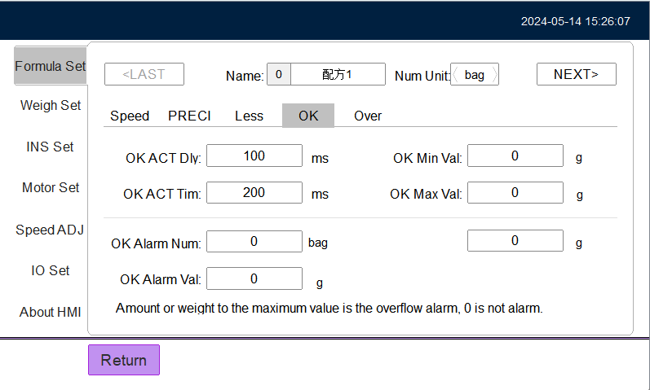

The system supports up to 20 formulations, can switch formulations, change formulations names and quantity units, and can set the speed and accuracy of the equipment for different formulations.

**Formula name**: Support Chinese pinyin input, it is recommended to enter less than 16 characters.

Quantity unit: The default quantity unit is "packet", which can be changed to display the corresponding quantity unit for different recipes. The supported quantity units are bags, bags, pieces, boxes, cases, only, strips, individual, bottles, cans, and barrels.

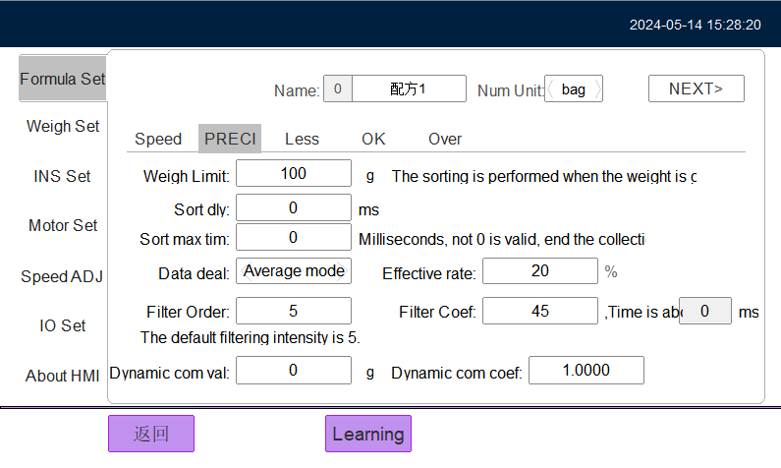

**Weight threshold:** When the weight is greater than the threshold, the system checks the weight.

**Sorting collection time:** The default is 0, when set to other values, weighing starts to perform, to this setting time, output weighing results.

Dynamic compensation value: When there is a weight deviation in dynamic weighing, you can set this value for dynamic compensation.

Dynamic compensation coefficient: The default value is 1 and the value ranges from 1 to 100.

**The minimum value of the right amount:** the minimum value of the qualified range of the weight of the weighing object, that is, the lower weight limit.

**Appropriate maximum:** the maximum of the weight range of the weight of the object, that is, the upper limit of weight.

**Action delay time:** For the delay time of a certain checking action, usually after changing the speed of the motor of the check table, the corresponding delay time should also be changed.

**Action execution time:** The execution time of a certain checking action, which usually depends on the mode and structure of the mechanical part.

**Maximum quantity of the sorting warehouse:** When the total quantity of the sorting result is greater than this value, the system alarms. The default value 0 indicates that the function is not enabled.

**The maximum weight of the sorting warehouse:** when the total weight of the sorting result is greater than the system alarm, the default value 0 indicates that the function is not enabled.

### 5.2.3Weighing setting

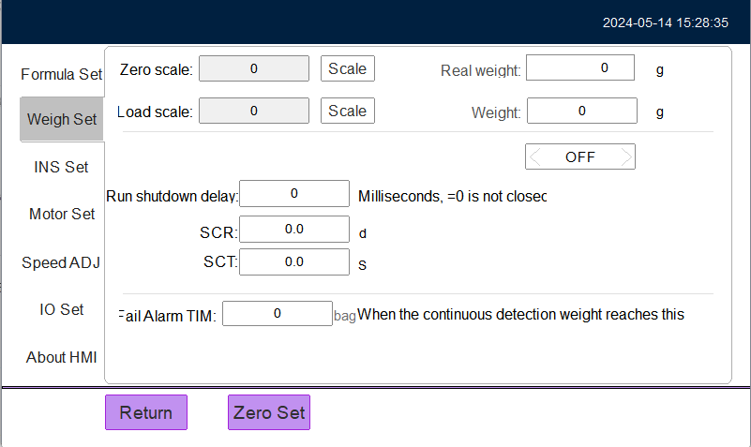

**No-load calibration:** calibration and calibration of the empty weighing platform.

**Load calibration:** Place the weight on the scale for calibration and calibration.

**Weight value:** Enter the weight value of the corresponding weight.

**Manual clearing range:** Set the range of manual clearing (relative to the percentage of the maximum/minimum range). By default, manual clearing is prohibited. The "Clear" button will not be displayed on the main interface when running.

**Zero tracking range:** The range of indexing values in which zero values can be tracked. The default value is 0.

**Zero tracking rate:** The input format is 5420d/s, that is, 5.4D /2.0s indicates that the zero value can be tracked within 5.4 index values within 2 seconds. The default value is 0.

**Continuous weight check alarm:** When the corresponding weight check result continuous number to the set number system alarm. It can realize the function of alarm when the continuous N packet check is not fit.

### 5.2.4 Device Settings (System administrator permissions required)

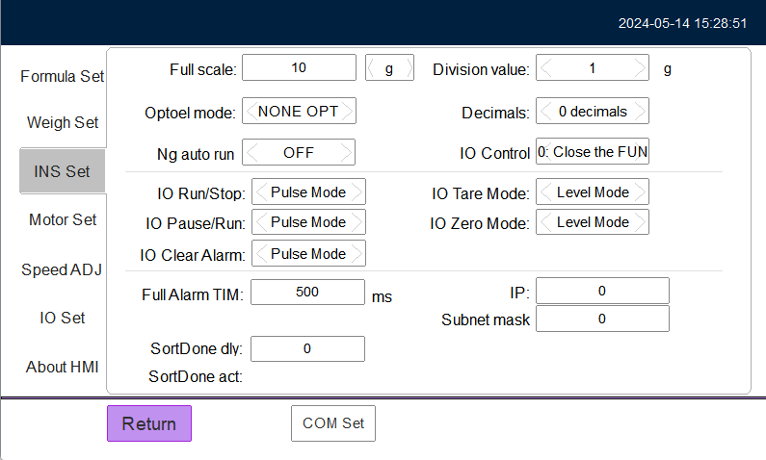

**Maximum range:** It is the maximum weighing range of the scale table, and the weight unit can be selected, supporting g and kg.

**Weight display index value:** used to smooth the display of weight value, can achieve stable weight display function.

**Display decimal places:** used with the indexing value, to select, the unit g is generally set to a small value, the unit Kg is generally set to 3 decimal places.

**Opto-electronic mode:** You can set the opto-electronic mode, dual-opto-electronic mode, opto-electronic in mode, or opto-electronic out mode according to the opto-electronic access mode of the device. After the setting, the corresponding indicator will be on the running screen.

**IO boot mode:** The system can access an external boot button. Select a boot mode based on the button type. Optional level mode and pulse mode.

**IO Stop mode:** The system can access an external stop button. Select a stop mode based on the button type. If the IO start mode is set to level mode, the IO stop button is invalid. Optional level mode and pulse mode.

**IO Clear overflow alarm mode:** The system can access the external clear overflow alarm button (effective when the overflow alarm is turned on in the formula), and select the stop mode according to different button types.

**Overflow alarm duration:** The overflow alarm duration can be specified by setting this value, in milliseconds, that is, the output duration of the corresponding IO (valid when the overflow alarm in the recipe is turned on).

5.2.5 IO Settings**(requires system administrator rights)**

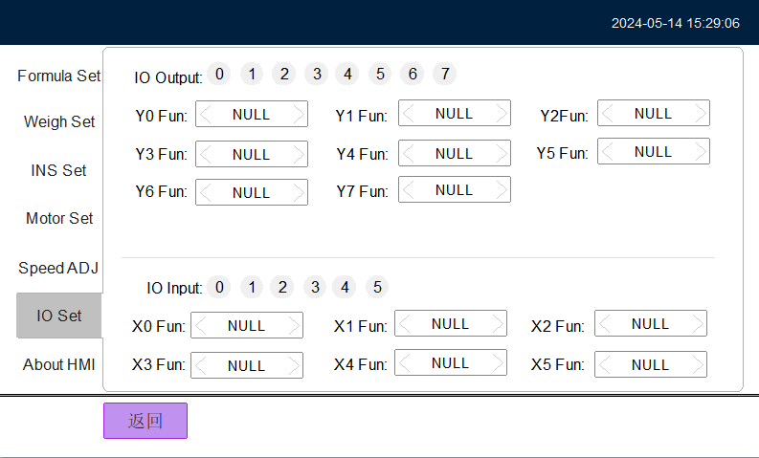

**IO input/Output port:** You can click the corresponding I/O port number to debug. If the I/O port is on, it indicates that the I/O port is connected.

Y1 to Y4 function: You can set the corresponding output function of each I/O port. The output port can be set to the start and running state, tier overflow alarm, retry failure alarm, tier 1 action, tier 2 action, tier 3 action, and tier 4 action.

**X1~X2 function:** you can set the corresponding input function of each IO port. The input port can be set to start input button, stop input button, photoelectric detection in, photoelectric detection out, clear alarm, forward full material detection, reverse full material detection;

### 5.2.6 Statement statistics

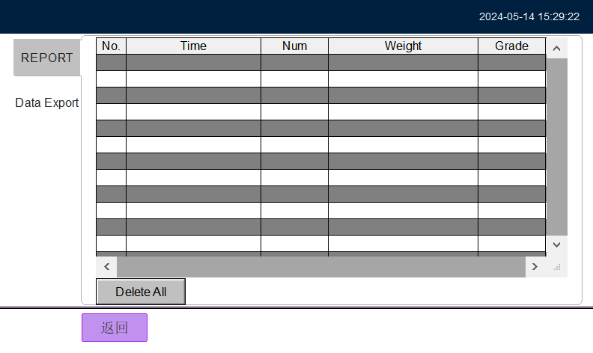

**Data report:** View all the weight data. The corresponding tier 1 indicates insufficient, the corresponding tier 2 indicates appropriate, and the corresponding tier 3 indicates excessive. You can also view historical data in different time periods.

**Delete All data:** Deletes all saved data.

**Data export:** You can set the start date and end date, and export the data to the USB flash drive. You can save the data in overwrite or append mode.

# 6. the troubleshooting process

|  |  |  |  |
| --- | --- | --- | --- |
| **Serial number** | **problem** | **reason** | **Elimination method** |
| 1 | The power light is off | 1. The power supply is incorrect. | 1. Connect to the correct power supply. |
| 2. Circuit breaker trips. | 2. Turn on the circuit breaker. |
| 3. The fuse is damaged. | 3. Replace the fuse of the same model. |
| 2 | Static weighing is unstable | 1. Check whether the four legs of the device are unbalanced. | 1. Adjust the setting four feet to balance. |
| 3 | The deviation between static and dynamic values is large | 1. The dynamic compensation parameters may be incorrect. | 1. Please set the dynamic compensation parameters again or manually enter the weighing supplement parameters. |
| 4 | The static weighing value is inaccurate | 1. The device may be incorrectly calibrated. | 1. Please calibrate the device again. |
| 5 | Dynamic sorting without data | 1. The position of the photoelectric switch may change.  2. The optical switch is damaged. | 1. Adjust the position of the photoelectric switch.  2. Change the optical switch of the same model. |
| 6 | Elimination inaction | 1. The pressure of pneumatic device may be too low. | 1. Please increase the air pressure of the pneumatic device. |

# 7. maintenance

* Turn off the main power supply when the machine is being serviced.
* When mechanical cleaning, please avoid water or any liquid splash and electric cabinet or other electrical components.
* Please pay attention to the wear cycle and service life of its parts, to a certain degree of wear, please maintain or replace regularly.