Tech Pack Template (Reference Template)

Purpose: Official production guideline to ensure consistency between pre-production samples and bulk goods.

Sheet 1: General Product Info
Style No.: UO-STYLE-________Style Name: ________Season: ________Target Group: ________Designer / Pattern Maker: ________Version & Date: ________

Sheet 2: Flat Sketch
Front View / Back View / Detail Views (Pocket, Zipper, Hood, Cuff)
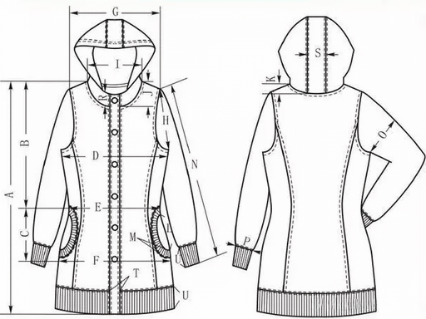

Sheet 3: Size Specification Chart (Unit: cm)
Size | Length | Chest | Waist | Shoulder | Sleeve Length | Cuff | Collar | Hood Circumference
S
M
L
XL
XXL

Sheet 4: BOM List (Fabric & Accessories)
Category | Name | Composition | Specification | Color Code | Usage Per Piece | Supplier | Remarks
Main Fabric
Lining
Zipper |  |  | Size #5 YKK |  | 1 PC
Hook & Loop |  |  | 2cm Width
Woven Label |  |  | Custom Logo |  | 1 Set

Sheet 5: Sewing & Construction Specs
1）Main body: Plain seam, 1cm seam allowance, double stitching
2）Pocket: Reinforced bartack at opening
3）Zipper: Smooth sliding, fixed at both ends
4）Cuff: Adjustable with elastic or hook & loop
5）Waterproof taped seams: 20mm width, high-temperature sealing
6）Printing & Embroidery: Accurate position, washable & durable

Sheet 6: Quality & Testing Requirements
Fabric Test: Color fastness ≥ Grade 4, Shrinkage ≤ 3%Garment Inspection: No damage, stain, color difference or defective stitching

Sheet 7: Sample Confirmation Record
First Sample Date: ________ Feedback: ________Revised Sample Date: ________ Feedback: ________Final Approved Sample Date: ________ Sealed Sample No.: ________

Notice:This template is provided for reference purposes only.Please formulate your work plan based on your own specific circumstances.

