PO#：
订单编号Order number
出货国家（地区）
Country (region) of shipment
检查日期
Check the date
验货资料  Inspection information | 工艺单、包装指示单、装箱单、大货样  Process sheet, packing instruction sheet, packing list, bulk sample
检查情况  Check the situation | 环境 Environment
 | 光线Light
 | 天气The weather

检验说明Inspection instructions：
产品名称
Product name
检验类型
Type of validation
订单数量
Number of orders
总箱数
Total number of boxes
抽验数量
Sampling quantity
抽检箱数
Number of boxes sampled
 | 验货标准  Inspection criteria | MIL-STD-105E

检验结果Test results：
可以出货 PASS

Salesman：
Q C：

订单明细 Order details:
类别Category | 颜色Color | 尺寸Size | 数量Quantity
示例：  护脚踝  Ankle sleeves | 白色  white | 均码一双包  ONE SIZE | 实际发货数量  Actual quantity delivered
/ | / | 合计Total

抽检数量Sampling quantity：
类别/颜色  Category/Color | 尺码  Size | 计划检验Plan inspection |  | 实际检验Actual inspection
 |  | 数量Quantity | 箱数Number of boxes | 数量Quantity | 箱数Number of boxes
示例：  白色  white | 均码一双包  ONE SIZE | 40 | 1 | 40 | 1
合计Total

检验标准Inspection standards：
检验标准Inspection standards | ANSI/ASQZ1.4 (MIL-STD-105E)
抽样方法  Sampling method | 随机抽取  Random sampling |  | 抽检数量Sampling quantity
Maj: 2.5, Min: 4.0 |  | 严重Seriously |  | 主要  Maj | 一般  Min |  | 合计 Total
 | 最大允许数Maximum allowable quantity
 | 次品数Quantity of defective goods
最终检验结果 Final test results |  | 在允许范围内  To the extent that is permitted

疵点明细Details of defects：
No | 疵点描述Description of defects | 严重Seriously | 主要Maj | 一般Min
1 | 示例：表面油污 Surface Oil
2
3
4

疵点照片 Defect photos：
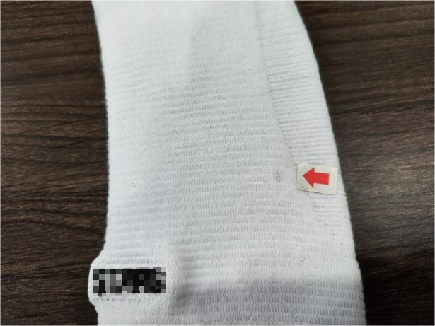
示例：表面油污 Surface Oil

测量、称重、扫码、核对等记录
Measure, weigh, scan code, check and so on
名称  Name | 尺码  Size | 测量部位Measuring position | 工艺要求Process requirements | 实际测量  Actual measurement | 判定Judgment
示例：外箱  Cartons | 全部  All of it | 外箱箱规  Box gauge | 长*宽*高CM | 长*宽*高CM | PASS
示例：外箱  Cartons | 白色  white | 箱唛  Shipping marks | 工艺单  Process sheet | OK | PASS
示例：产品  Products | 白色护脚踝  white Ankle sleeves AB2 | 一双净重  AB2 N.W | 工艺单Process sheet | 克重g | PASS

辅料Accessories：

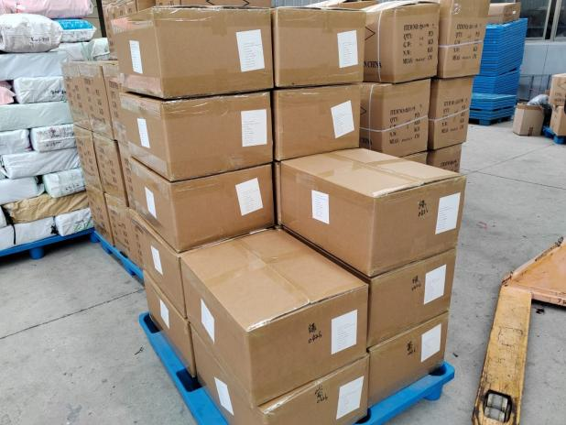
示例：货堆-1 Cargo pile-1
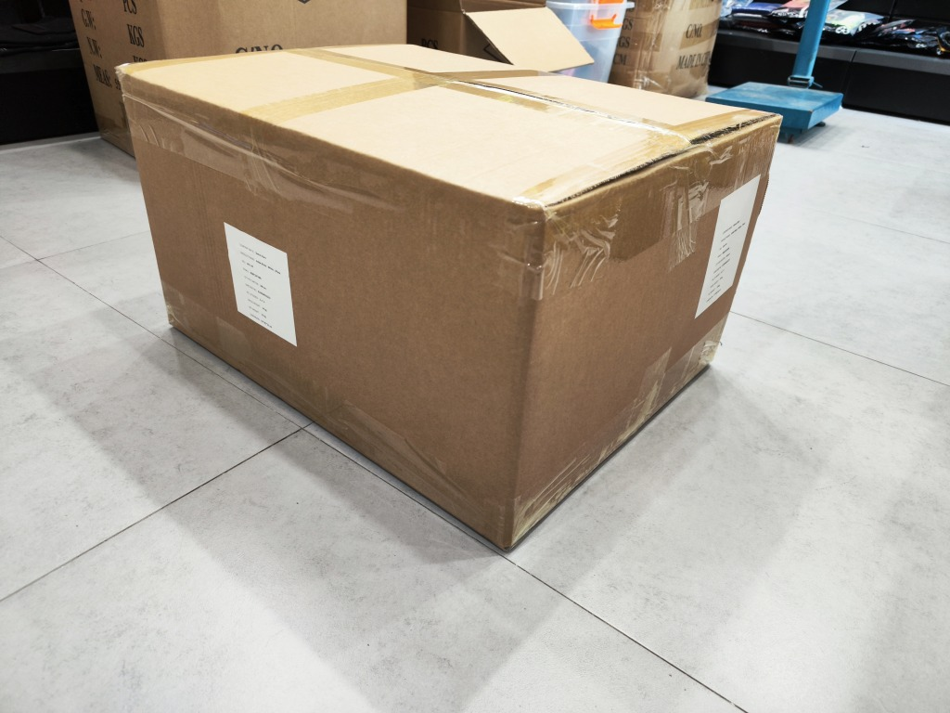
示例：外箱Cartons
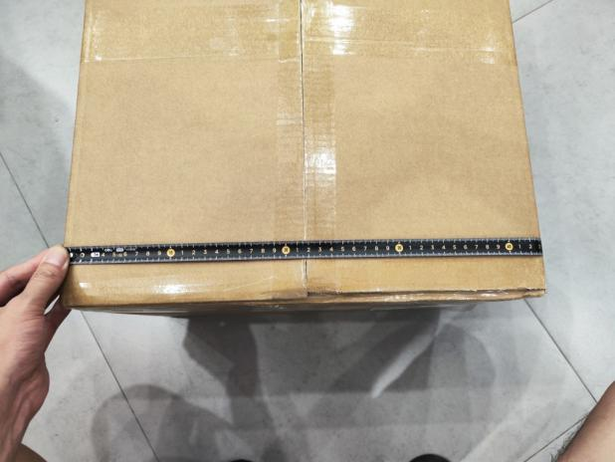
示例：外箱-宽Cartons-Width
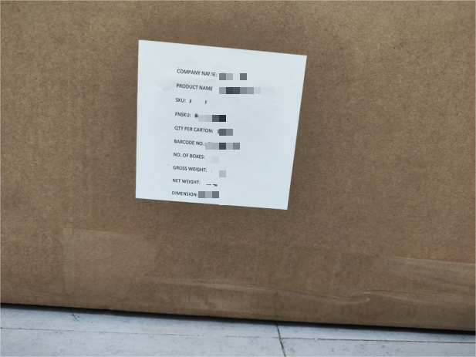
示例：正唛-1 Positive mark-1
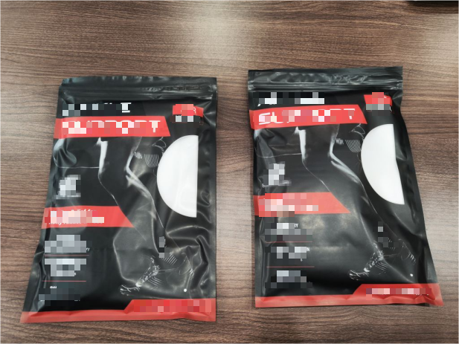
示例：包装袋-正面Packing bags-Heads
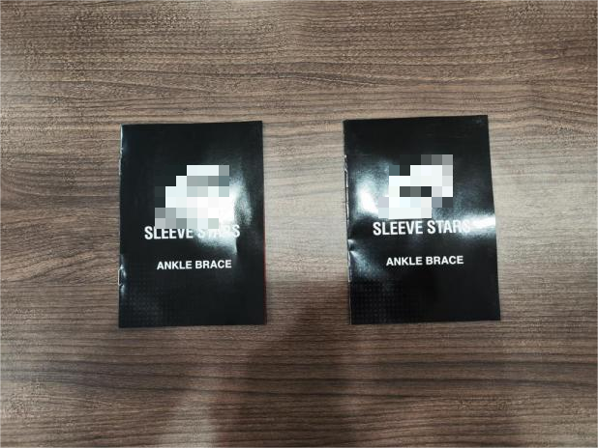
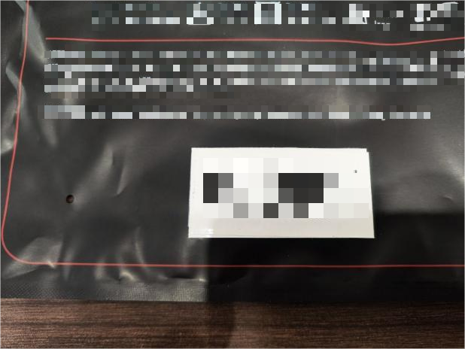

产品细节Product details：

示例：白色 一双包 white
示例：外箱Cartons
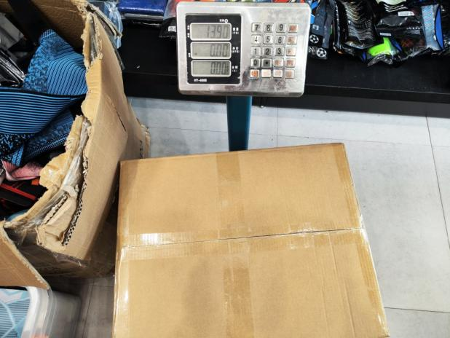
示例：外箱毛重 Cartons G.W
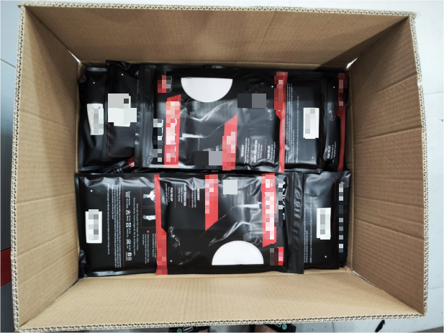
示例：开箱 Open the box
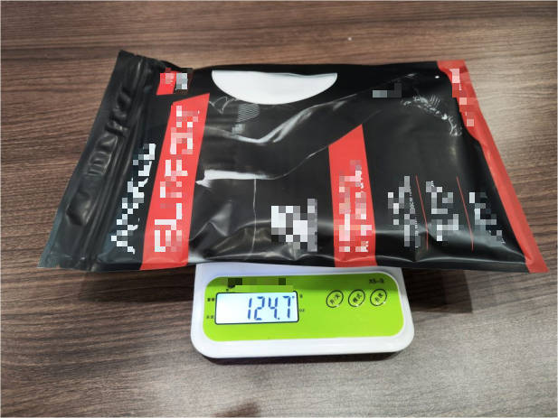
示例：一双包称重A pair G.W
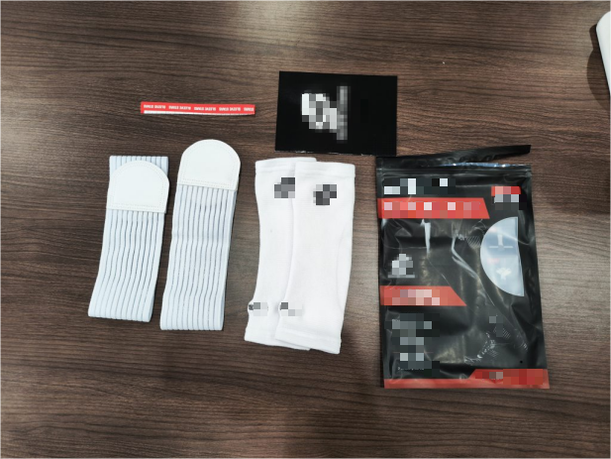
示例：包装内容-Packaging content
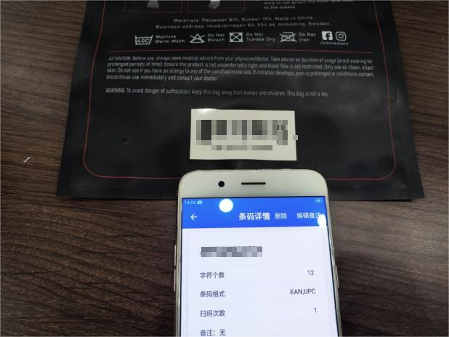
示例：条形码扫码核对BAR code check
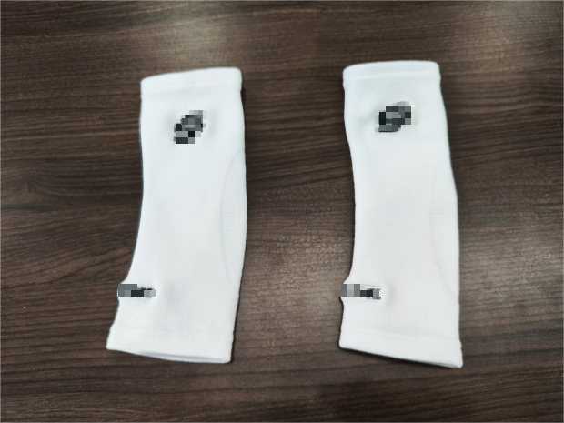
示例：产品细节-1 Product details-1

示例：紫色 一只包 Purple

示例：绿色 一只包 Green

示例：浅粉色 Light Pink

--The End of Report--

