

EDS Series Communication Protocol
V1.0.1​​​

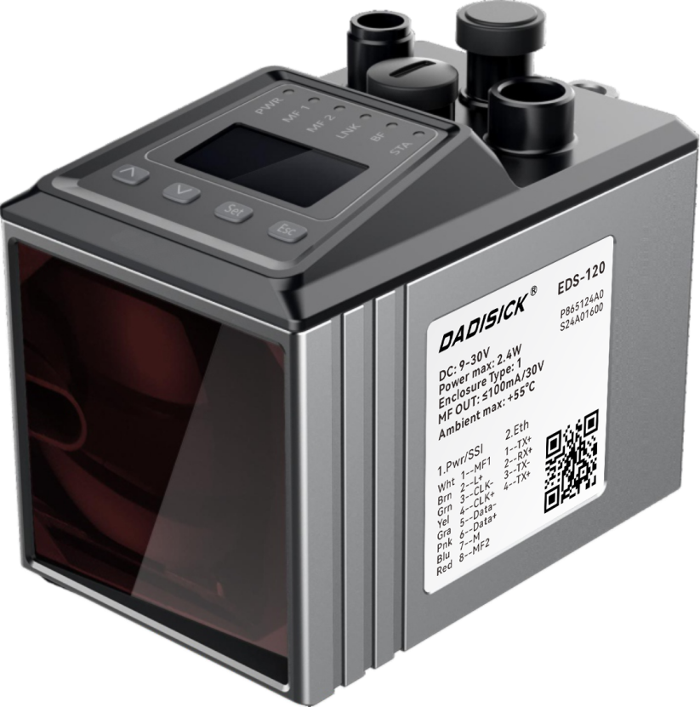
Table of contents
1 Protocol Overview 6
1.1 Basic Architecture of the Protocol 6
1.2 Other protocols 6
2 Device Scanning Protocol 8
2.1 Device Scan 8
2.1.1 Scanning Broadcast 8
2.1.2 Reply Broadcast 8
2.2 Modify network address information 9
2.2.1 Modify IP address request 10
2.2.2 Modify Mask Request 11
2.2.3 Modify Gateway Request 12
2.2.4 Modify multiple parameter requests 13
3 Data Exchange Protocol 15
3.1 Data Types 15
3.2 Variable/Method Number 15
3.3 Command Format 16
3.3.1 Write Command 16
3.3.2 Read Command 18
3.3.3 Different types of data formats 20
3.4 Error Code and Error Return Format 26
3.4.1 Error code 26
3.4.2 Error return format 27
3.5 Variable 28
3.5.1 DeviceIdent(0x0000) 29
3.5.2 SerialNumber(0x0003) 30
3.5.3 FirmwareVersion(0x0004) 31
3.5.4 Distance (0x000a) 32
3.5.5 Acceleration (0x000c) 33
3.5.6 Temperature (0x001e) 34
3.5.7 dbLevelComm(0x002d) 35
3.5.8 publicSoftwareVersion(0x004a) 36
3.5.9 readyStatus(0x0051) 37
3.5.10 warningStatus(0x0052) 38
3.5.11 errorStatus(0x0053) 39
3.5.12 laserOnStatus(0x0055) 40
3.5.13 mf1ActiveStatus(0x0056) 41
3.5.14 mf2ActiveStatus(0x0057) 42
3.5.15 averagedVelocity(0x00a2) 43
3.5.16 laserServiceStateSSI(0x00a4) 44
3.5.17 temperatureServiceStateSSI(0x00a5) 45
3.5.18 levelServiceStateSSI(0x00a6) 46
3.5.19 publicSoftwareVersionFpga(0x00a8) 47
3.5.20 plausibilityServiceStateSSI(0x00a9) 48
3.5.21 displayedConfigEthernetIP(0x00ad) 49
3.5.22 displayedConfigEthernetNM(0x00ae) 50
3.5.23 displayedConfigEthernetGW(0x00af) 50
3.5.24 laserError(0x00ca) 51
3.5.25 temperatureError(0x00cb) 52
3.5.26 levelError(0x00cc) 53
3.5.27 plausiblityError(0x00cd) 54
3.5.28 laserPrefailWarning(0x00ce) 55
3.5.29 temperaturePrefailWarning(0x00cf) 56
3.5.30 levelPrefailWarning(0x00d0) 57
3.5.31 plausiblityPrefailWarning(0x00d1) 58
3.5.32 productPartNo(0x00de) 59
3.5.33 laserServiceState(0x00e6) 60
3.5.34 temperatureServiceState(0x00e7) 61
3.5.35 levelServiceState(0x00e8) 62
3.5.36 readyServiceState(0x00e9) 63
3.5.37 plausiblityServiceState(0x00eb) 65
3.5.38 mf1ServiceState(0x00ec) 66
3.5.39 mf2ServiceState(0x00ed) 67
3.5.40 operatingHours(0x00ef) 68
3.5.41 distanceOffset(0x014a) 69
3.5.42 distancePreset(0x014b) 70
3.5.43 globalFunctionMF(0x014d) 71
3.5.44 functionMF1 (0x014e) 73
3.5.45 mf1ActiveState (0x014f) 74
3.5.46 functionMF2 (0x0150) 75
3.5.47 mf2ActiveState (0x0151) 77
3.5.48 thresholdDistanceMF1 (0x0152) 78
3.5.49 hysteresisDistanceMF1 (0x0153) 79
3.5.50 thresholdVelocityMF1 (0x0154) 80
3.5.51 velocityModeMF1 (0x0155) 82
3.5.52 mf1LaserServiceSetup (0x0156) 83
3.5.53 mf1LevelServiceSetup (0x0157) 84
3.5.54 mf1TempServiceSetup (0x0158) 85
3.5.55 mf1PlausibServiceSetup (0x0159) 86
3.5.56 mf1ReadyServiceSetup (0x015a) 88
3.5.57 mf1switchCounter(0x015c) 89
3.5.58 thresholdDistanceMF2(0x015d) 90
3.5.59 hysteresisDistanceMF2(0x015e) 91
3.5.60 thresholdVelocityMF2 (0x015f) 93
3.5.61 velocityModeMF2 (0x0160) 94
3.5.62 mf2LaserServiceSetup(0x0161) 96
3.5.63 mf2LevelServiceSetup(0x0162) 97
3.5.64 mf2TempServiceSetup(0x0163) 98
3.5.65 mf2PlausibServiceSetup(0x0164) 100
3.5.66 mf2ReadyServiceSetup(0x0165) 101
3.5.67 mf2switchCounter(0x0167) 102
3.5.68 averageFilterDistance(0x0168) 103
3.5.69 errorRejection(0x016a) 105
3.5.70 ssiProtocol (0x016b) 107
3.5.71 ssiResolution (0x016c) 108
3.5.72 ssiLaserServiceSetup (0x016d) 110
3.5.73 ssiTemperatureServiceSetup (0x016e) 111
3.5.74 ssiLevelServiceSetup (0x016f) 112
3.5.75 ssiReadyServiceSetup (0x0170) 113
3.5.76 ssiPlausibilityServiceSetup (0x0171) 115
3.5.77 ssiM f 1ServiceSetup (0x0173) 116
3.5.78 ssiM f 2ServiceSetup (0x0174) 117
3.5.79 averageFilterVelocity(0x01a0) 118
3.6 Methods 120
3.6.1 ResetMf1Activations(0x00da) 120
3.6.2 ResetMf2Activations(0x00db) 121
3.6.3 ResetParamters(0x00ce) 123
3.6.4 Reboot (0x00c8) 124
3.6.5 LaserOn(0x00e0) 125
3.6.6 LaserOff(0x00e1) 126
4 SSI Protocol 128
4.1 Basic 128
4.2 Data Format 129
4.2.1 Resolution 129
4.2.2 Error bit 129
4.2.3 Data Representation 130

Revision History
date | content | Version
June 1 , 2024​​​ | Document first release | 1.0.0
August 26 , 2024​ | Detailed description of data format and length | 1.0.1​

Protocol Overview

Basic architecture of the protocol
This protocol describes the communication protocol between the host computer and EDS series, including the "device scanning protocol" based on UDP and the "data exchange protocol" based on TCP.
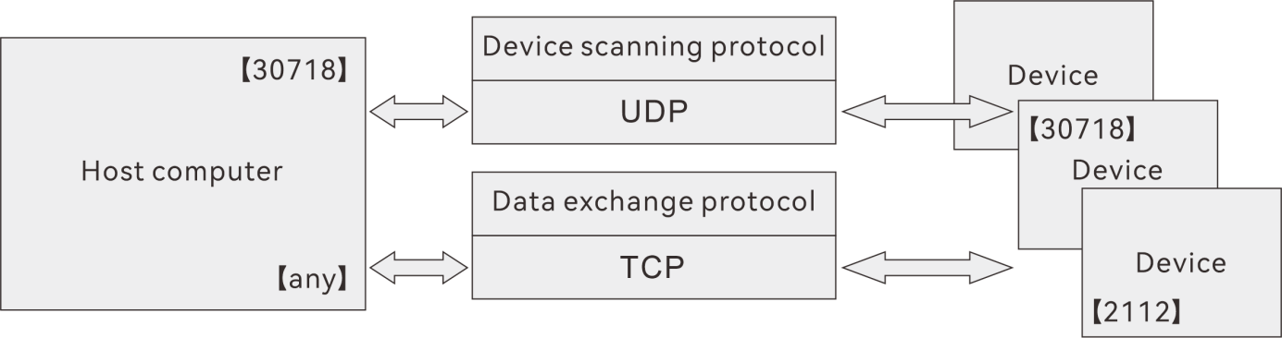
- Device scanning protocol: based on UDP broadcast
This protocol is used to scan EDS series devices. The host computer sends a device scan broadcast to a specific port, and the slave computer responds to the scan command to achieve device discovery.
The port occupied by the device scanning protocol is 30718. The host computer and the device use this fixed port for device scanning and replying. The port cannot be changed .
- Data exchange protocol: based on TCP
The data communication between the host computer and the slave computer is based on the TCP protocol. The default listening port of the device is 2112, which cannot be changed by the user .
Within the framework of the agreement, there are two concepts:
- Variable
Variables store information such as the device's status, parameters, and measurement data. Variables have two attributes: read and write. For readable and writable variables, the host computer can read and write; for read-only variables, the host computer can only read.
- Method
The method is called by the host computer and executed by the lower computer. The host computer sends the called method and parameters to the lower computer, and the lower computer replies with the method call result and return value.

Other protocols
The EDS series device also supports the following protocols:
- ICMP protocol. This protocol corresponds to the Ping command.
The lower computer can respond to the Ping command.
- ARP protocol.
- The lower computer can reply to the ARP request.
- When the lower computer is just started, it sends an ARP request to the outside so that the upper computer can update its routing table in time.
- If the device has no TCP connection, no Ping, and no device scan command, it will interact with the outside world once every 10 seconds.
- The type of ARP is Gratuitous ARP.

Device Scanning Protocol
The main characteristics of the device scanning protocol are:
- The host computer uses the LAN broadcast address 255.255.255.255 to scan the devices in the network, and the port used is 30718.
- After receiving the broadcast content from the upper computer, the lower computer also replies at the broadcast address 255.255.255.255, and the port it uses is also 30718.

Device Scan

Scan Broadcast
Scan broadcast is used by the host computer or other devices to scan and discover EDS series. The format is as follows:
Head: 10 Bytes, fixed content is 0x10 0x00 0x00 0x08 0xff 0xff 0xff 0xff 0xff 0xff
Serial: 4 Bytes, a 4-byte random number. This random number will be used in the broadcast reply and returned to the host computer that issued the scan broadcast for identification. The random number is generated by the host computer.
Command: 2 Bytes, fixed bytes, content is 0x01 0x02
Host IP: 4 Bytes, host IP address, such as 0xc0 0xa8 0x64 0x64 (192.168.100.100)
Host Mask: 4 Bytes, host subnet mask, 0xff 0xff 0xff 0x00 (255.255.255.0)

Reply Broadcast
Reply broadcast is used to feed back the basic device information of DS series to the host computer or scanning device. The format is as follows:
Head: 4 Bytes, fixed value is 0x90 0x00 0x02 0x67
Device MAC: 6 Bytes, such as 0x00 0x06 0x77 0x28 0xd1 0x82
Serial: 4 Bytes, same as the value of "Scan Broadcast"
Reserved: 2 Bytes, currently fixed at 0x00 0x00
XML Content: Delivers basic device information in the form of an XML document. Its content is:
<?xml version="1.0" ?>
<NetScanResult MACAddr="00:06:77:28:D1:82">
<Item key="IPAddress" value="192.168.100.236" readonly="FALSE" />
<Item key="IPMask" value="255.255.255.0" readonly="FALSE" />
<Item key="IPGateway" value="0.0.0.0" readonly="FALSE" />
<Item key="DeviceType" value=" DS series " readonly="TRUE" />
<Item key="FirmwareVersion" value="V001.002.081" readonly="TRUE" />
<Item key="SerialNumber" value="18040010" readonly="TRUE" />
<Item key="LocationName" value="" readonly="TRUE" />
<Item key="IPConfigDuration" value="10000" readonly="TRUE" />
<Item key="HasDHCPClient" value="FALSE" readonly="TRUE" />
</NetScanResult>

The EDS series device's response contains the following elements:
MACAddr : MAC address of the device
IPAddress : IP address of the device
IPMask : The subnet mask of the device
IPGateway : Gateway of the device
DeviceType : Device type
FirmwareVersion : The firmware version of the device
SerialNumber : SN of the device , serial number
LocationName : The location information of the device, usually empty.
IPConfigDuration HasDHCPClient : Whether the device supports DHCP .
These elements make it easy for the host computer to establish a TCP connection with the device to obtain data.

Modify network address information
Modifying network address information includes:
- Modify IP address
- Modify Mask
- Modify Gateway
Its basic structure is:
Modification Request:
Modified reply:
Head: The Head value is different for different commands.
- Modifying IP, Mask, and Gateway Head are different
- Modify the reply header to be the same
Serial: The serial number of the modification request is generated by the host computer, and the serial number of the modification reply is the same as that of the host computer.
Command: Indicates whether it is a modification request or a modification reply. The modification request command is 0x01 0x02, and the modification reply command is 0x00 0x00
Request XML: Modify the request XML document
Response XML: Modify the response XML document
- Modify IP, modify Mask, modify Gateway Request XML format is the same
- The Response XML format of replying to modify IP, replying to modify Mask, and replying to modify Gateway is the same

Modify IP address request
Modification Request:
Head: 0x11 0x00 0x01 0x04
MAC: 0x00 0x06 0x77 0x28 0xd1 0x82 (this value is different for different devices)
Serial: Randomly generated (4 bytes)
Command: 0x01 0x02
Request XML:
<?xml version="1.0" encoding="UTF-8"?>
<IPconfig MACAddr="00:06:77:28:d1:82">
<Item key="IPMask" value="255.255.255.0"/>
<Item key="DHCPClientEnabled" value="FALSE"/>
<Item key="IPGateway" value="0.0.0.0"/>
<Item key="IPAddress" value=" 192.168.100.236 "/>
</IPconfig>

Modified reply:
Head: 0x91 0x00 0xa3 0x00
MAC: 0x00 0x06 0x77 0x28 0xd1 0x82
Serial: Same as the Serial number of the modification request
Command: 0x00 0x00
Response XML:
<?xml version="1.0" ?>
<IPConfigResult MACAddr="00:06:77:28:D1:82">
<Item key="Success" value=" TRUE " />
<Item key="IPConfigDuration" value="10000" />
</IPConfigResult>
If the modification fails, the value of the "Success" field is "FALSE".

Modify Mask Request
Modification Request:
Head: 0x11 0x00 0x01 0x02
MAC: 0x00 0x06 0x77 0x28 0xd1 0x82
Serial: Randomly generated (4 bytes)
Command: 0x01 0x02
Request XML:
<?xml version="1.0" encoding="UTF-8"?>
<IPconfig MACAddr="00:06:77:28:d1:82">
<Item key="IPMask" value=" 255.255.0.0 "/>
<Item key="DHCPClientEnabled" value="FALSE"/>
<Item key="IPGateway" value="0.0.0.0"/>
<Item key="IPAddress" value="192.168.100.236"/>
</IPconfig>

Modified reply:
Head: 0x91 0x00 0xa3 0x00
MAC: 0x00 0x06 0x77 0x28 0xd1 0x82
Serial: Same as the Serial number of the modification request
Command: 0x00 0x00
Response XML:
<?xml version="1.0" ?>
<IPConfigResult MACAddr="00:06:77:28:D1:82">
<Item key="Success" value=" TRUE " />
<Item key="IPConfigDuration" value="10000" />
</IPConfigResult>
If the modification fails, the value of the "Success" field is "FALSE".

Modify Gateway Request
Modification Request:
Head: 0x11 0x00 0x01 0x0a
MAC: 0x00 0x06 0x77 0x28 0xd1 0x82
Serial: Randomly generated (4 bytes)
Command: 0x01 0x02
Request XML:
<?xml version="1.0" encoding="UTF-8"?>
<IPconfig MACAddr="00:06:77:28:d1:82">
<Item key="IPMask" value="255.255.255.0"/>
<Item key="DHCPClientEnabled" value="FALSE"/>
<Item key="IPGateway" value=" 192.168.100.1 "/>
<Item key="IPAddress" value="192.168.100.236"/>
</IPconfig>

Modified reply:
Head: 0x91 0x00 0xa3 0x00
MAC: 0x00 0x06 0x77 0x28 0xd1 0x82
Serial: Same as the Serial number of the modification request
Command: 0x00 0x00
Response XML:
<?xml version="1.0" ?>
<IPConfigResult MACAddr="00:06:77:28:D1:82">
<Item key="Success" value=" TRUE " />
<Item key="IPConfigDuration" value="10000" />
</IPConfigResult>
If the modification fails, the value of the "Success" field is "FALSE".

Modify multiple parameter requests
If the host computer wants to modify 2 or 3 parameters of IP, Mask, Gateway at the same time,
Modification Request:
Head: 0x11 0x00 0x01 0x08
MAC: 0x00 0x06 0x77 0x28 0xd1 0x82
Serial: Randomly generated (4 bytes)
Command: 0x01 0x02
Request XML:
<?xml version="1.0" encoding="UTF-8"?>
<IPconfig MACAddr="00:06:77:28:d1:82">
<Item key="IPMask" value="255.255.255.0"/>
<Item key="DHCPClientEnabled" value="FALSE"/>
<Item key="IPGateway" value=" 192.168.100.1 "/>
<Item key="IPAddress" value=" 192.168.100.236 "/>
</IPconfig>

Modified reply:
Head: 0x91 0x00 0xa3 0x00
MAC: 0x00 0x06 0x77 0x28 0xd1 0x82
Serial: Same as the Serial number of the modification request
Command: 0x00 0x00
Response XML:
<?xml version="1.0" ?>
<IPConfigResult MACAddr="00:06:77:28:D1:82">
<Item key="Success" value=" TRUE " />
<Item key="IPConfigDuration" value="10000" />
</IPConfigResult>
If the modification fails, the value of the "Success" field is "FALSE".

Data exchange protocol
In the protocol, all data is represented in binary.

Data Types
All data in the protocol belongs to a certain type, as shown in the following table:
Name | Description | Range Of Values
Bool | boolean(8 bits) | True(1), False(0)
UInt8 | unsigned short(8 bits) | (0...255)
UInt16 | unsigned int(16 bits) | (0...65535)
UInt32 | unsigned double int(32 bits)
UInt64 | unsigned long int(64 bits)
Int8 | signed short(8 bit) | (-128..127)
Int16 | signed int(16 bits)
Int32 | signed double int(32 bits)
Int64 | signed long int(64 bits)
Real | IEEE-754 single-precision floating point number (32 bit) (float)
Double | IEEE-754 double-precision floating point number (64 bit) (double)
Enum8 | short enumeration (8 bits)
Enum16 | short enumeration (16 bits)
FixString | bits per character )
FlexString | Variable length string. There is length information before the character, and the length type is UInt (8 bits per character )

Variable/Method Number
In the data exchange protocol, all data is transmitted in the form of "command" reading, writing and response .
The concepts involved in data exchange are:
- variable
The various parameters of the device exist in the form of variables, and each variable has a number (Index). When the upper read command specifies the number of a variable to be read, the lower computer replies with the value of the variable corresponding to the number.
If the upper computer specifies the number of a variable to be written in the write command, the lower computer will modify the corresponding variable.
- method
Each method has a corresponding number (Index). The host computer calls a method with the number (Index) corresponding to the method, and the lower computer returns the method return value corresponding to the number after executing the method.
- serial number
Variables and methods are identified by numbers (Index). The Index data type is UInt16, which occupies 2 bytes and 16 bits. For example, the Index of the variable "Firmware Version Number" = 0x0004.
The command types are listed in the following table:
Client (host computer) | Server (device) | Order
sRI{SVIdx} | sRA{SVIdx}{variable value} | Read the variable marked by SVIdx
sWI{SVIdx} | sVIdx | Write to the variable marked with SVIdx
sMI{MIdx}{parameters} | sMA{Mldx}{return values} | Calling MIDx marked method
 | sFA{error code} | The device returns an error code
R stands for Read
W stands for Write
M stands for Method
V stands for Variable
Idx means Index
sRI: Read the variable marked with SVIdx, the binary value is: 0x73 0x52 0x49.
sRA: Reply the variable value marked with SVIdx, the binary value is: 0x73 0x52 0x41.
sWI: Write to the variable marked with SVIdx, the binary value is: 0x73 0x57 0x49.
sWA: Reply the variable write result marked with SVIdx, the binary number is: 0x73 0x57 0x41.
sMI: Call the method marked with MIdx, the binary code is: 0x73 0x4D 0x49.
sMA: Reply to the method call result marked with SVIdx, the binary number is: 0x73 0x4D 0x41.
sFA: Returns an error code, the binary code is: 0x73 0x48 0x41.

Format
There are three main types of commands: read commands, write commands, and methods.

Write Command
Write Request
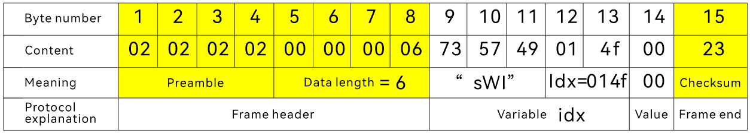
A "write request" consists of the following fields:
- Preamble
4 bytes, fixed at 0x02 0x02 0x02 0x02.
- Data length
4 bytes, which refers to the length of the data content including "command type", "number", and "value", excluding the checksum.
- Command Type
3 bytes, here is "write command sWI" 0x73 0x57 0x49
- serial number
2 bytes, indicating which variable the host computer needs to write to, and "number" refers to the number of the variable.
- value
The length is not fixed, and varies according to the variable type.
- Check code
1 byte, the XOR value of all bytes starting from "Command Type" (excluding "Preamble" and "Data Length" fields).

Write a reply
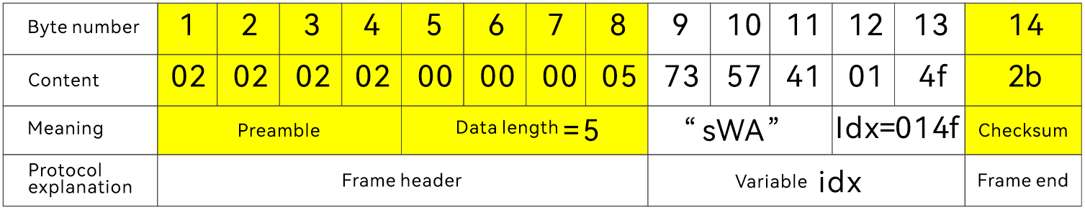
"Write Reply" consists of the following fields
- Preamble
4 bytes, fixed as 0x02 0x02 0x02 0x02.
- Data length
4 bytes, which refers to the length of the data content including "command type" and "number", excluding the check code.
- Command Type
3 bytes, here is "write reply sWA" 0x73 0x57 0x41
- serial number
2 bytes, the value of which variable the lower computer responds to when it is written successfully.
- Check code
1 byte, the XOR value of all bytes starting from "Command Type" (excluding "Preamble" and "Data Length" fields).

Read Command
Read Request
A read request consists of the following fields:
- Preamble
4 bytes, fixed as 0x02 0x02 0x02 0x02
- Data length
4 bytes, including the length of the data content including "command type" and "number", excluding the checksum
- Command Type
3 bytes, here is "read command sRI" 0x73 0x52 0x49
- serial number
2 bytes, indicating which variable the host computer needs to read, and "number" refers to the number of the variable.
- Check code
1 byte, the XOR value of all bytes starting from "Command Type" (excluding "Preamble" and "Data Length" fields), in this example, including sRI, Idx
For example:
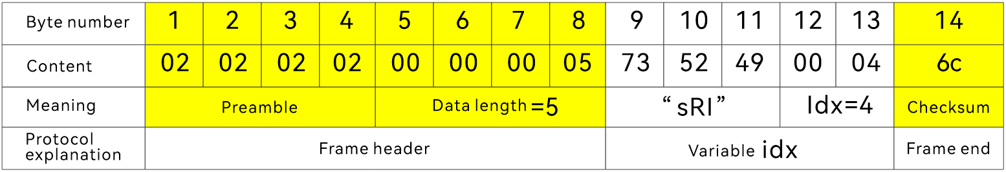
- Preamble code, fixed to 0x02 02 02 02
- Data length: "sRI" length is 3, idx length is 2, total length is 5
- Command type: "sRI" indicates a read command
- Number: Read variable number 4, which here means requesting the "firmware version".
- Check code: XOR value of all bytes including "sRI", "Idx" = 0x6c
Read Reply
- Preamble
4 bytes, fixed value 0x02 02 02 02
- Data length
4 bytes, including "command type", "number", and "reply content"
- Command Type
3 bytes, here is "read return sRA" 0x73 0x52 0x41
- serial number
2 bytes, indicating which variable is being replied to, each variable corresponds to an index
- Reply content
The length is determined by the "Number" field
- Check code
1 byte, the XOR value of all bytes starting from "Command Type" (excluding the "Preamble" and "Data Length" fields), these fields include: "Command Type", "Number", "Reply Content".
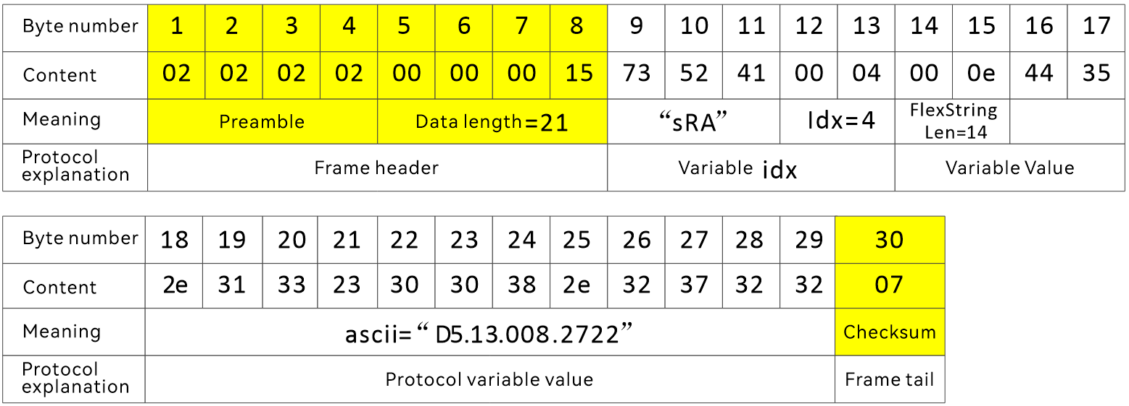
- Preamble code, fixed to 0x02 02 02 02
- Data length, including the length of "command type", "number", and "reply content"
- Command type, "sRA", indicates reply to read variable request
- Number, Idx=4, means reply "firmware version"
- The reply content is the firmware version, which is represented by ASCII code, i.e. "D5.13.008.2722".
- Checksum, the XOR value of all bytes starting from "Command Type" (excluding "Preamble" and "Data Length" fields).

Different types of data formats

Bool
Reading variables
Read Command
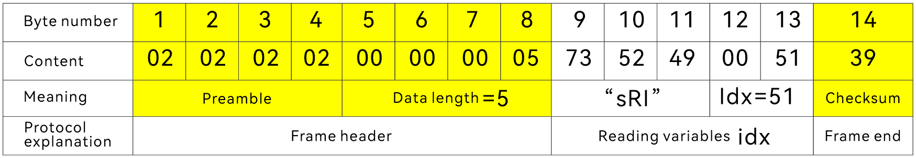
Read Return
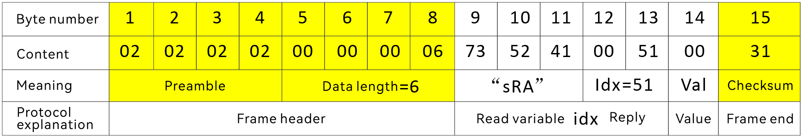
Writing to variables
Write Command
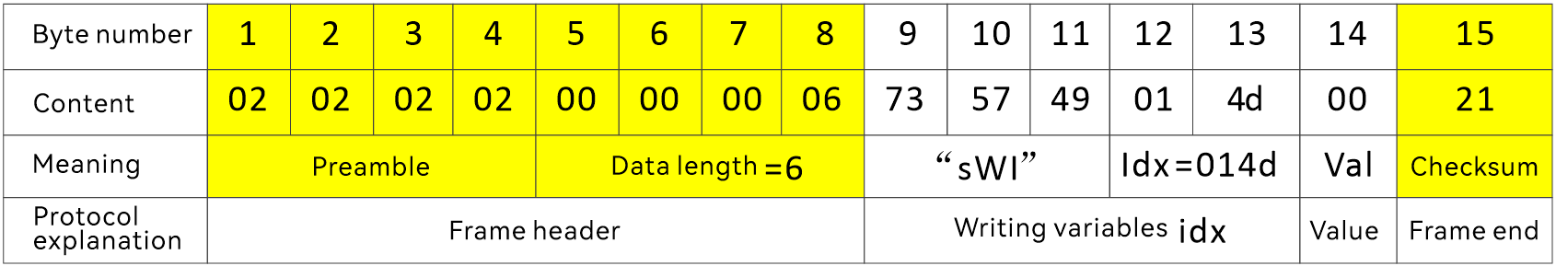
Write Return
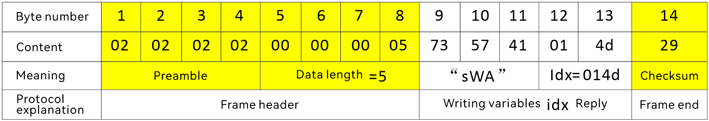

UInt8
Reading variables
Read Command
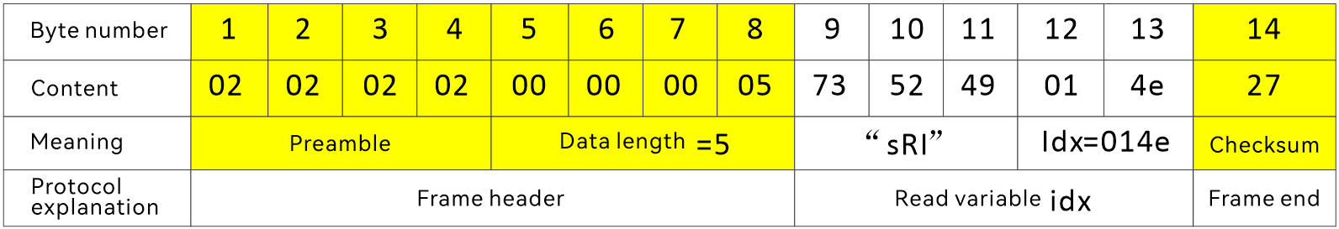
Read Return
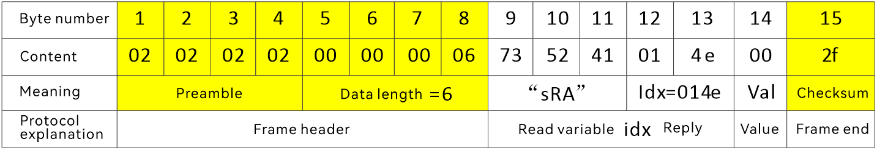
Writing to variables
Write Command
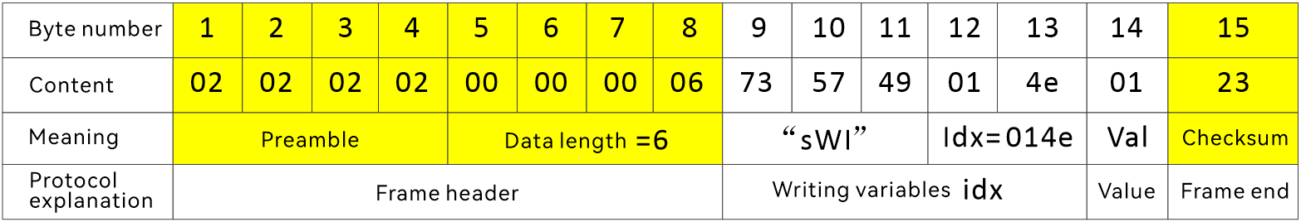
Write Return
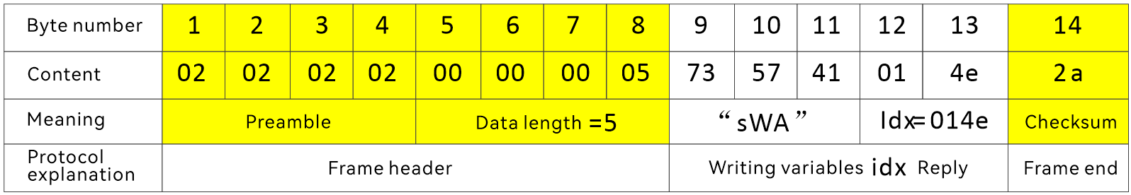

UInt16
There is currently no UInt16 data reading or writing.

UInt32
Reading variables
Read Command
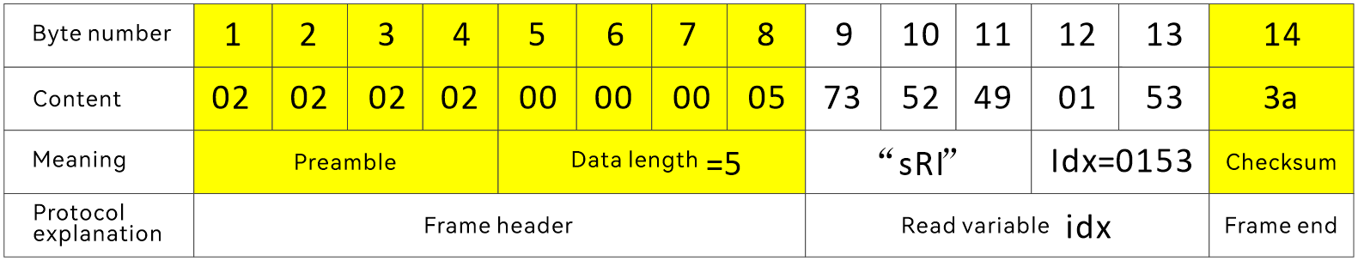
Read Return
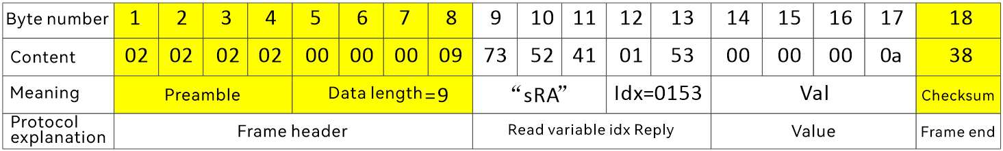
Writing to variables
Write Command
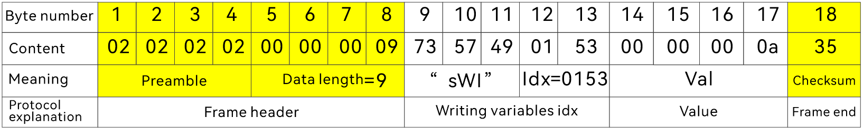
Write Return
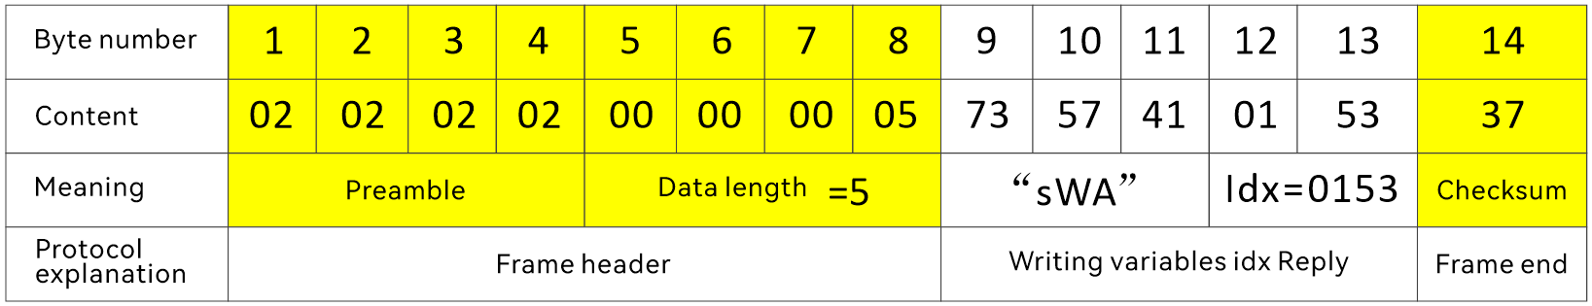

Int8
Reading variables
Read Command
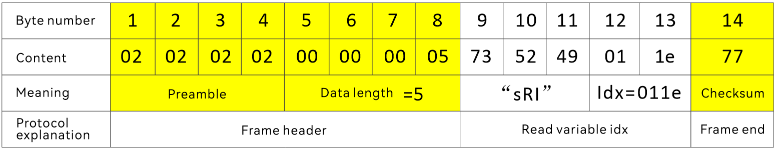
Read Return
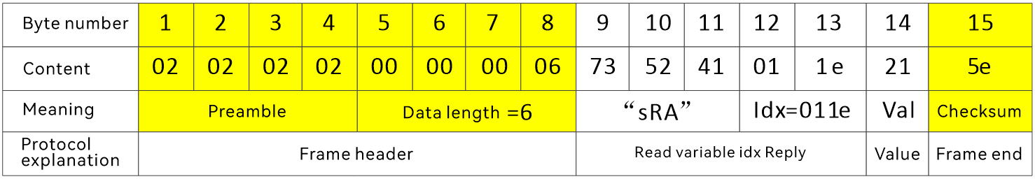
No "write variable" usage

Int16
Reading variables
Read Command
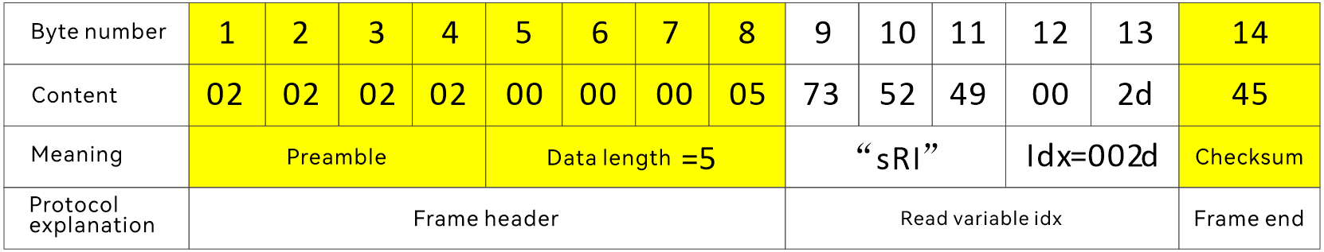
Read Return
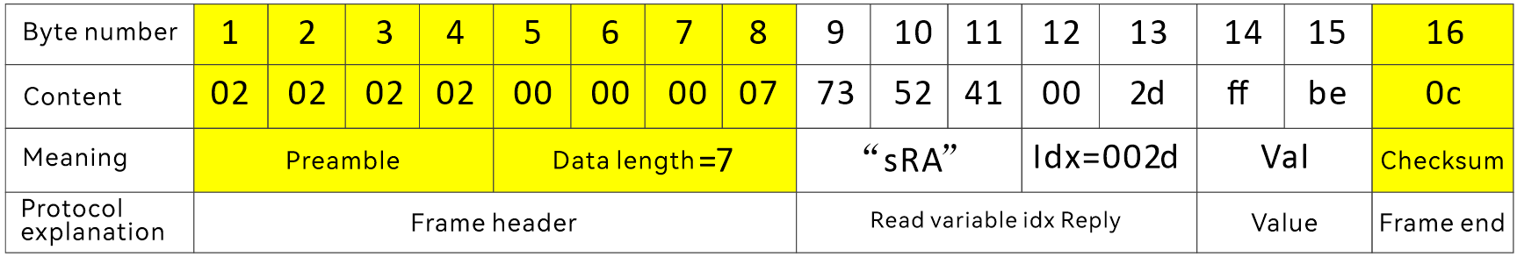
No "write variable" usage

Int32
Reading variables
Read Command
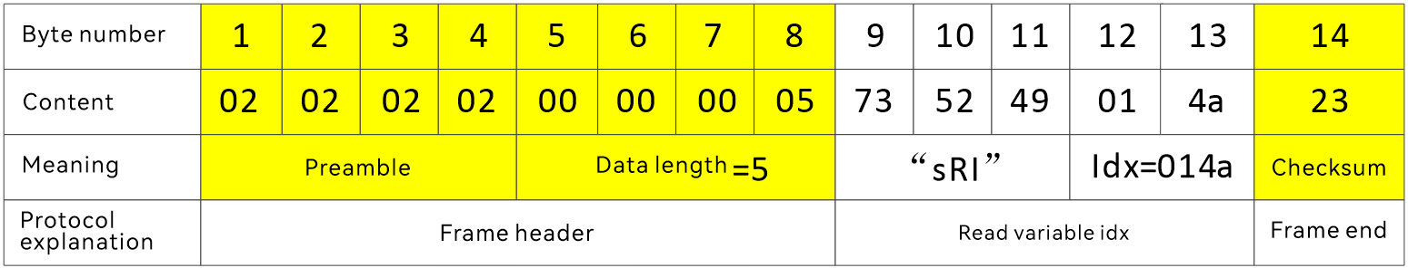
Read Return
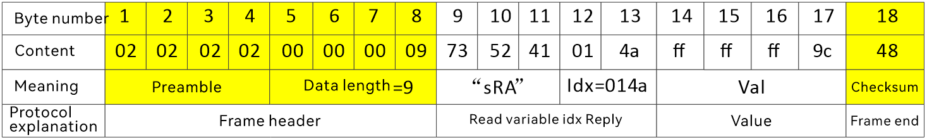
Writing to variables
Write Command
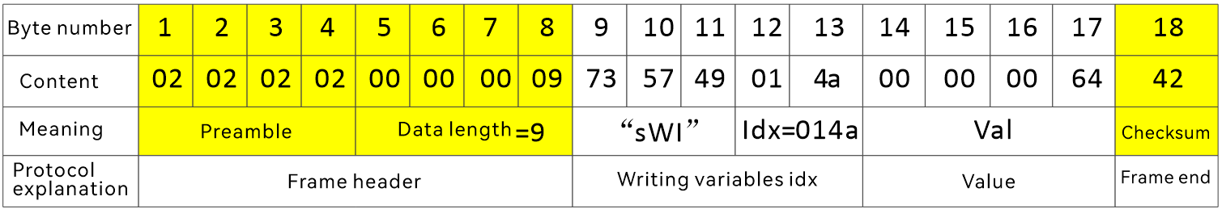
Write Return
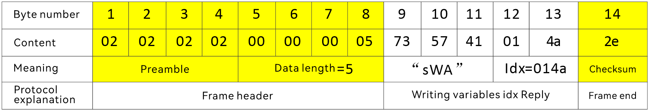

Float32
Reading variables
Read Command
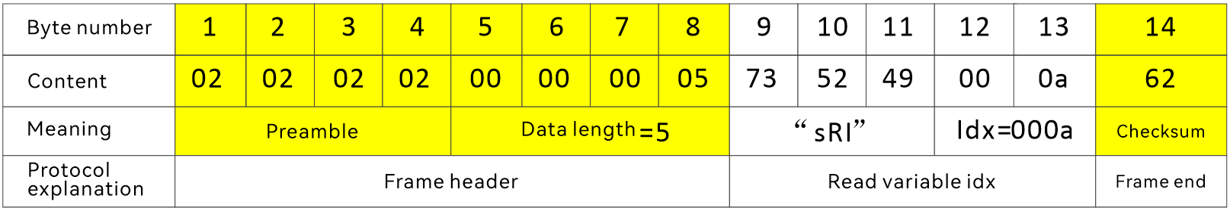
Read Return
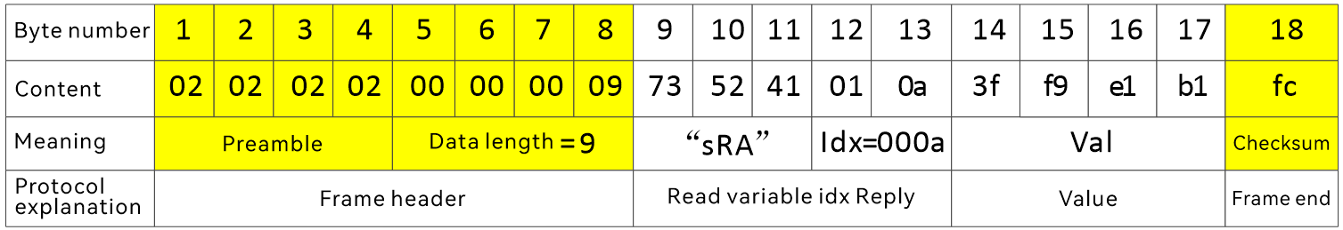
No "write variable" usage

FixString
Reading variables
Read Command
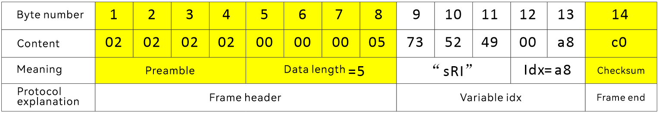
Read Return
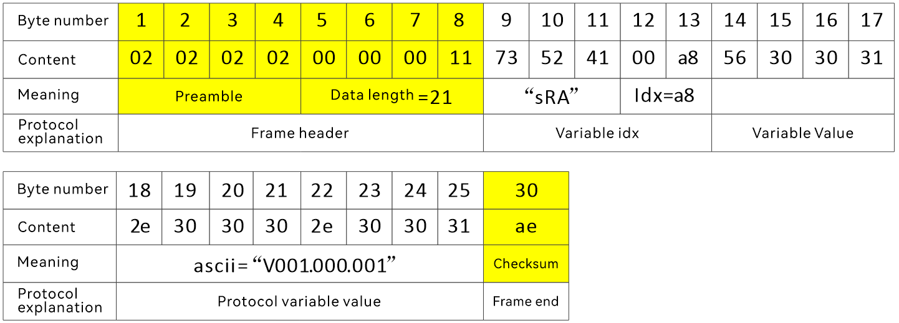

FlexString
Reading variables
Read Command
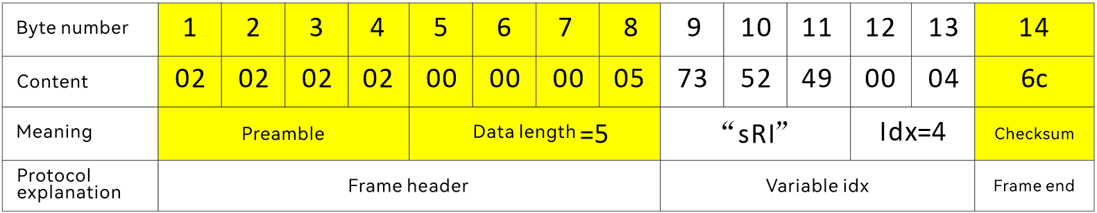
Read Return
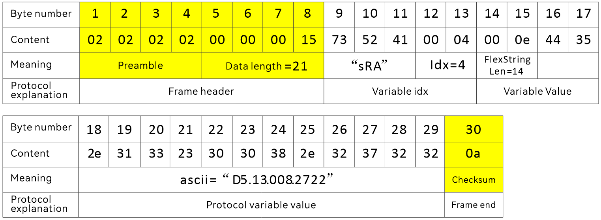
Writing to variables
Write Command
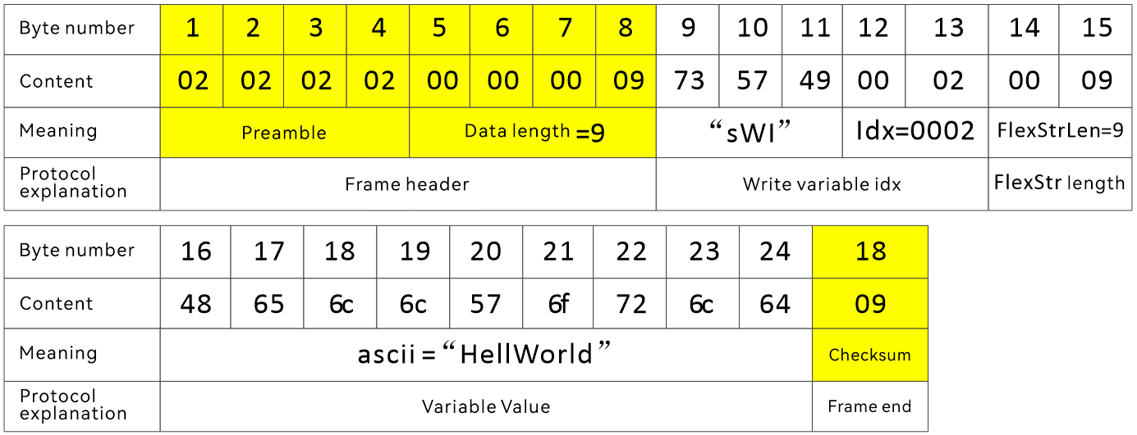
Write Return
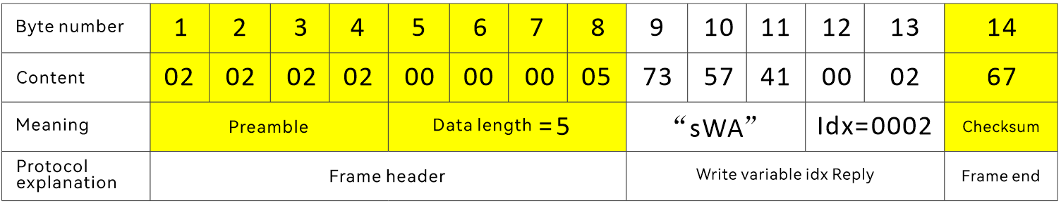

Error code and error return format
When the host computer operates EDS series, there may be errors in the command format or parameters. When an error occurs, the device will return an error code to the host computer. Error messages are returned by triggering, and no error is returned.

Error Code
The meanings of the error codes are shown in the following table.
Error Code | meaning
0x00 | NoError
0x01 | Method: Access restrictedMethodInvokeDenied
0x02 | Method: The method number does not exist UnknownMethod
0x03 | Variable: variable number UnknownIndex does not exist
0x04 | ParameterUnavailable
0x05 | Invalid Data
0x0a | Variable: Read-only, not writableWriteAccessDenied
>0 | Other Errors
illustrate:
- Error code 0x00: indicates no error. However, the device will not send an sFA message with an error code of 0x00 to the host computer. Here, only an error code value is defined.
- Error code 0x01: indicates that the user does not have permission to access this method.
- Error code 0x02: Indicates that the method indicated by the index field in the method call command does not exist.
- Error code 0x03: Indicates that the variable indicated by the index field in the read or write command does not exist.
- Error code 0x04: Indicates that the value written to a variable exceeds its defined range.
- Error code 0x05: The triggered event is not found and is not used yet .
- Error code 0x0a: When a variable is read-only, if the host computer tries to write the variable.
- CheckSum error: When a command sent by the host computer has a CheckSum error, the device discards the command without replying.
- Data length error: When the command data length sent by the host computer is incorrect, the device will discard the command without replying.

Error return format
This section describes how the device returns error codes to the host computer. Error codes 0x03 and 0x0a are used as examples. Other error codes are similar.

UnKnownIndex(0x03)
The host computer reads the variable through sRI: Index is 0x0666
02 02 02 02 00 00 00 05 73 52 49 06 66 08
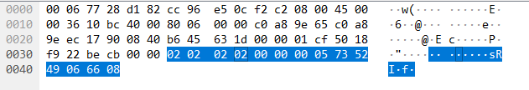
The device returns sFA + error_code (0x03)
02 02 02 02 00 00 00 05 73 46 41 00 03 77
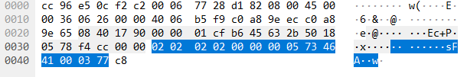
The host computer writes variables through sWI: Index is 0x6666
02 02 02 02 00 00 00 09 73 57 49 66 66 00 00 75 30 28
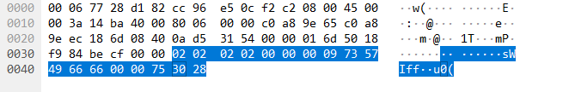
The device returns sFA + error_code (0x03)
02 02 02 02 00 00 00 05 73 46 41 00 03 77
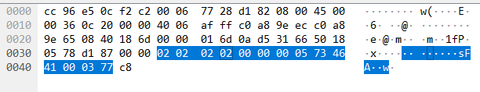

WriteAccessDenied (0x0a)
The host computer writes variables through sWI: Index is 0x001e (indicates temperature, a read-only variable)
02 02 02 02 00 00 00 06 73 57 49 00 1e 27 54
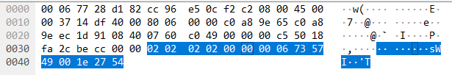
The device returns sFA + error_code (0x0a)
02 02 02 02 00 00 00 05 73 46 41 00 0a 7e
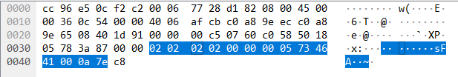

variable
The variable in brackets represents a scalar Index .
Note:
- index corresponding to the variable is in brackets .
- The binary screenshot is the data format captured by Wireshark .
- DADISICK " produced by Dadi Electronics .

DeviceIdent(0x0000)
Data Type:
FlexString + FlexString
meaning:
Device Identification, which indicates the self-identification (identity) of the device. Unique Identification of device.
Device name (FlexString) + Device version number (FlexString)
example:
"(length 0x05) DS series (length 0x0c) V001.002.082"
Data format:
read
Read Request:
02 02 02 02 00 00 00 05 73 52 49 00 00 68
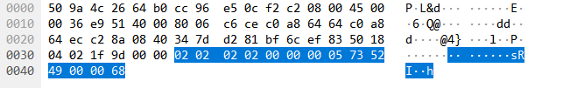
Read Response:
02 02 02 02 00 00 00 1a 73 52 41 00 00 00 05 44
4c 31 30 30 00 0c 56 30 30 31 2e 30 30 32 2e 30
38 32 3f
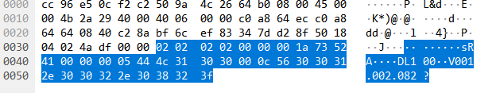
Device Name: EDS series
Device version number: V001.002.08 2
Not writable
DADISICK corresponding relationship:
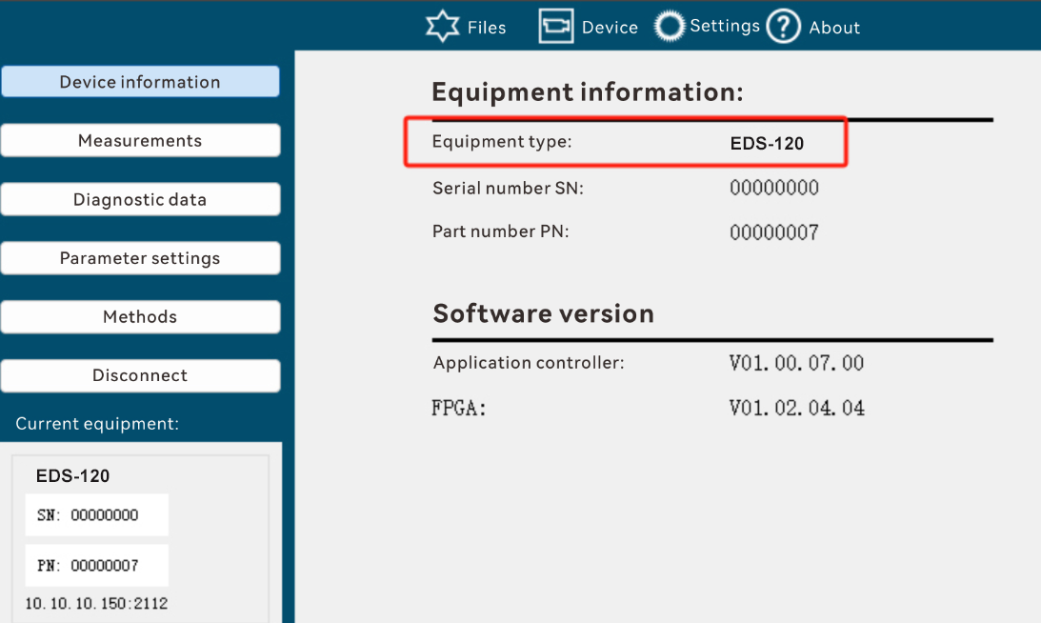

SerialNumber(0x0003)
Data Type:
FlexString
Length: 0-12
meaning:
Serial Number
Data format:
read
Read Request:
02 02 02 02 00 00 00 05 73 52 49 00 03 6b
Read Response:
02 02 02 02 00 00 00 0f 73 52 41 00 03 00 08 31 39 33 30 30 32 32 32 62
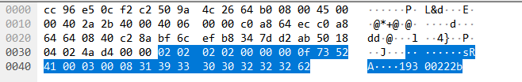

Not writable

DADISICK corresponding relationship:
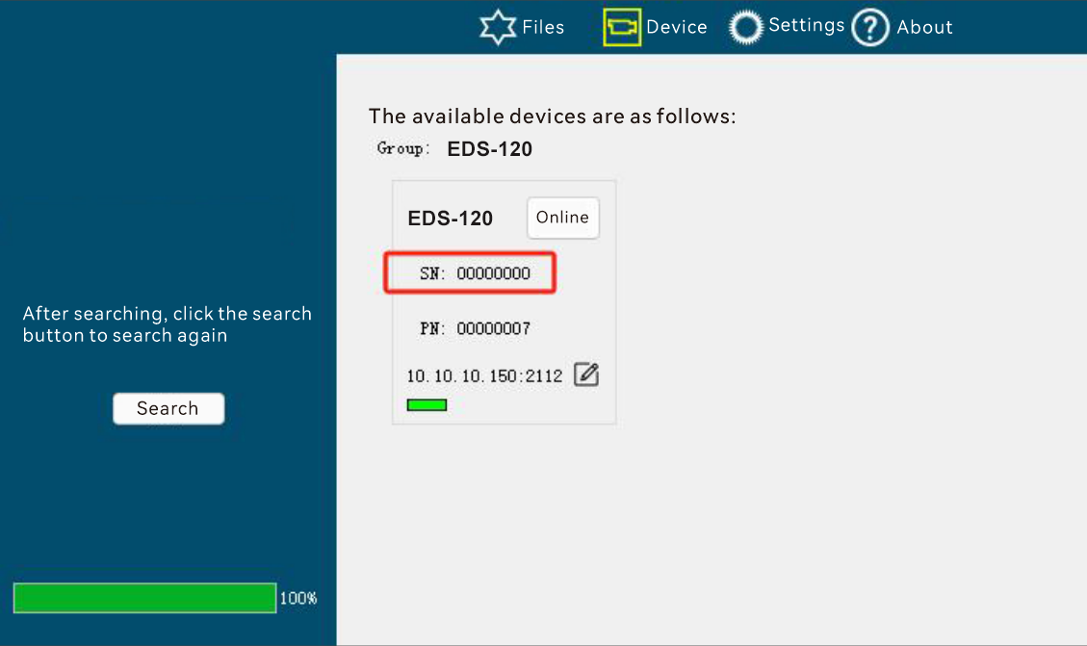

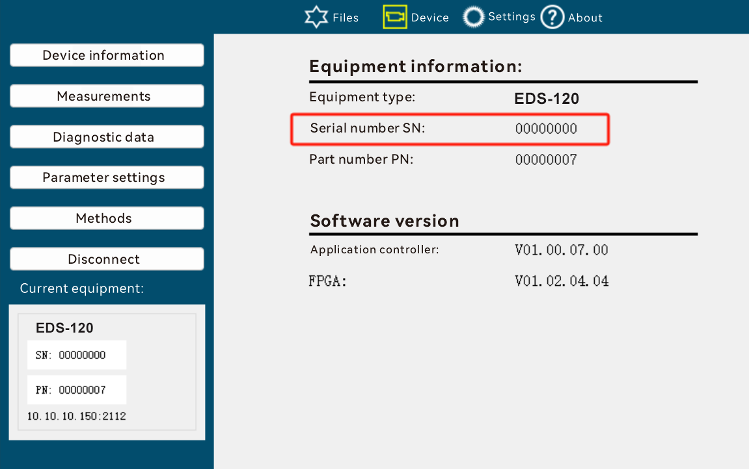

FirmwareVersion(0x0004)
Data Type:
FlexString
Length: 0-15
meaning:
Firmware version
Data format:
read
Read Request:
02 02 02 02 00 00 00 05 73 52 49 00 04 6c
Read Response:
02 02 02 02 00 00 00 13 73 52 41 00 04 00 0c 56 30 30 31 2e 30 30 32 2e 30 38 32 07
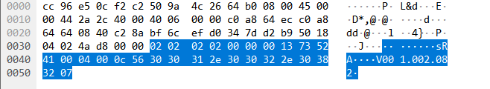

Not writable

DADISICK corresponding relationship:
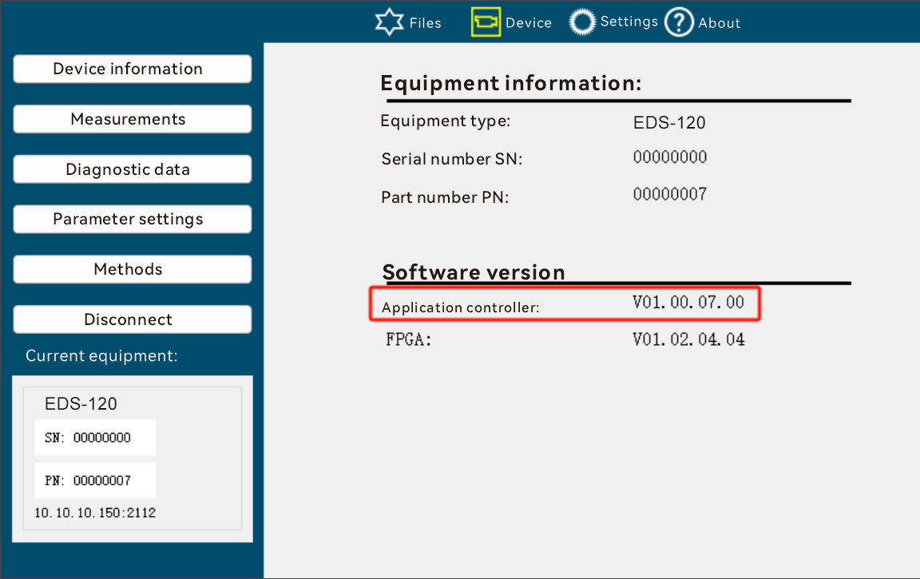

Distance(0x000a)
Data Type:
Float32
Note: The distance is expressed in IEEE-754 floating point format.
Unit: m
meaning:
Distance measured by DS series
Data format:
read
Read Request:
02 02 02 02 00 00 00 05 73 52 49 00 0a 62
Read Response:
02 02 02 02 00 00 00 09 73 52 41 00 0a 3f f9 e1 b1 fc
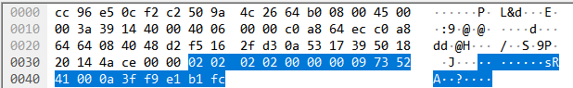

Not writable

DADISICK corresponding relationship:
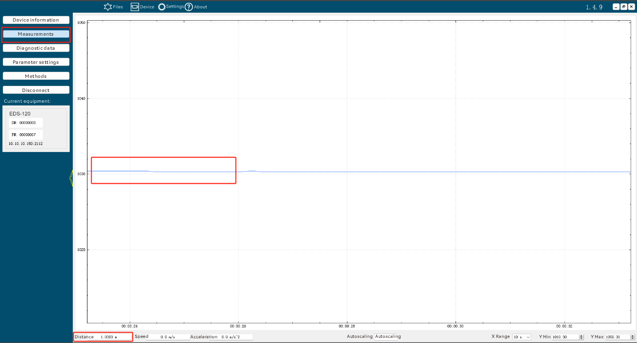

Acceleration (0x000c)
Data Type:
Float32
meaning:
Object acceleration measured by DS series
Data Format:
read
Read Request:
02 02 02 02 00 00 00 05 73 52 49 00 0c 64
Read Response:
02 02 02 02 00 00 00 09 73 52 41 00 0c 40 40 00 00 6c
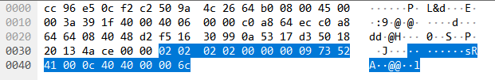

Not writable

DADISICK corresponding relationship:
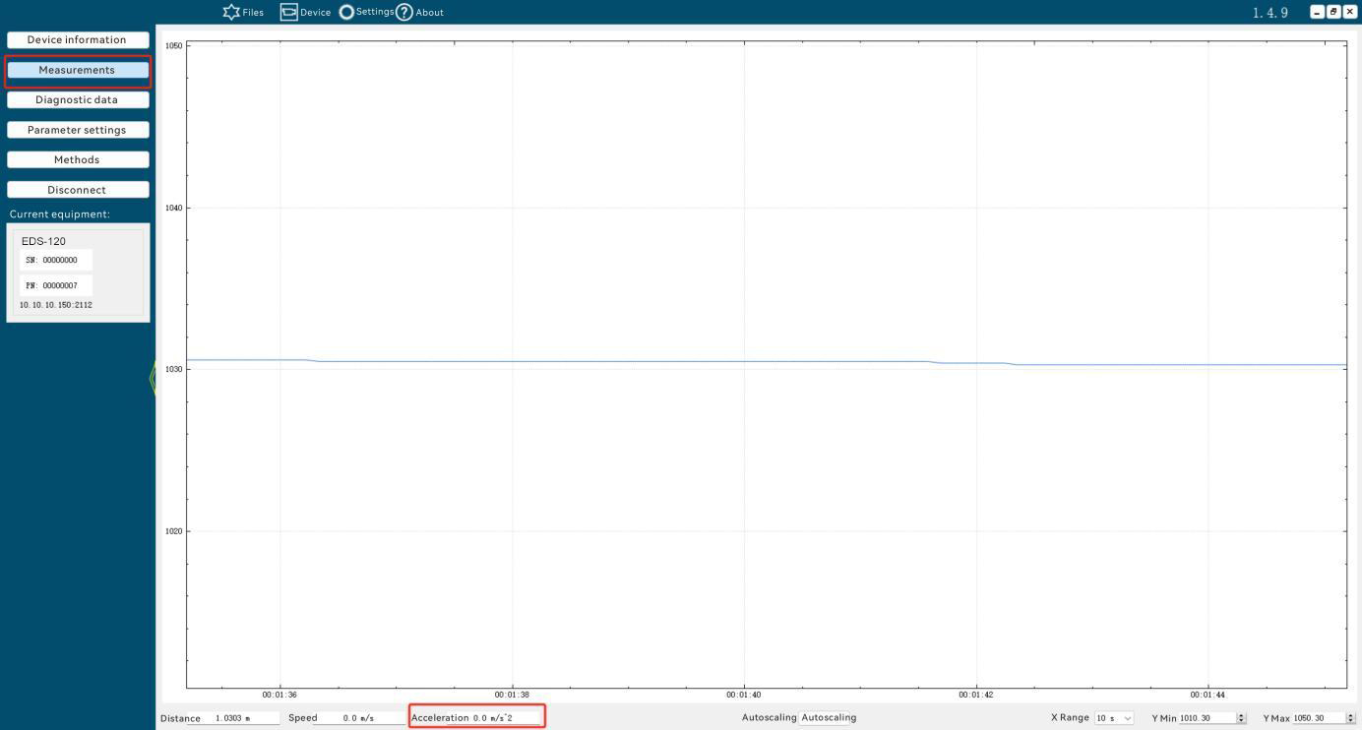

Temperature(0x001e)
Data Type:
Int8
meaning:
EDS series device internal temperature
Data format:
read
Read Request:
02 02 02 02 00 00 00 05 73 52 49 00 1e 76
Read Response:
02 02 02 02 00 00 00 06 73 52 41 00 1e 21 5f

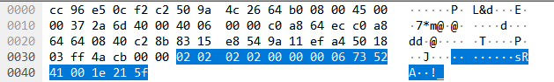
Not writable
DADISICK corresponding relationship:
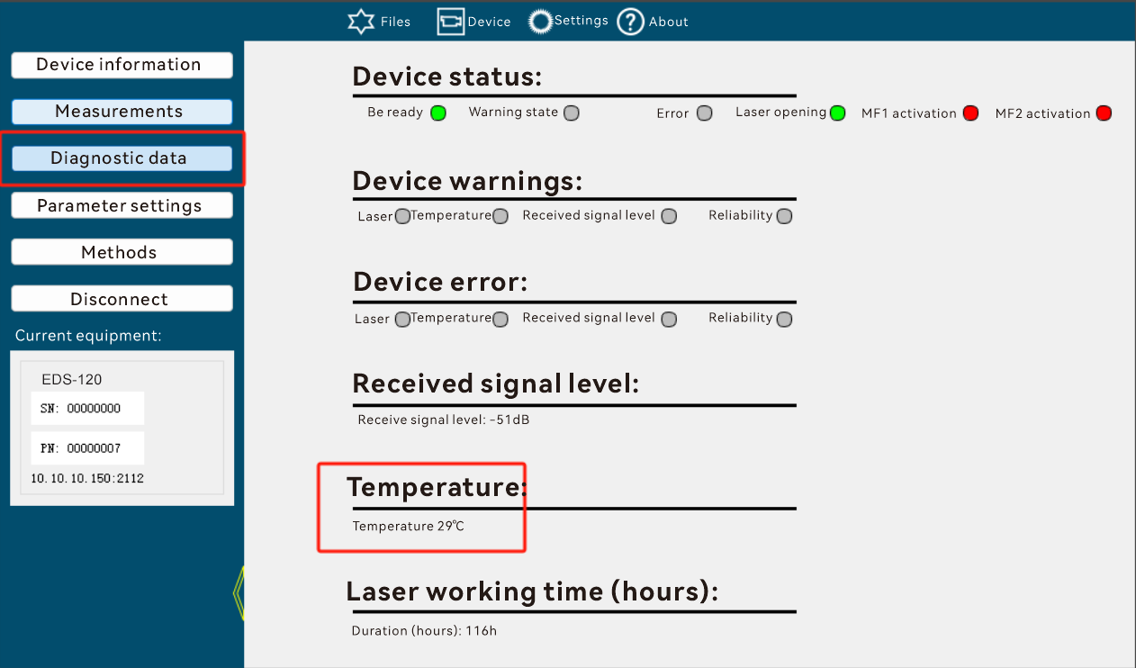

dbLevelComm(0x002d)
Data Type:
Int16
meaning:
Communication port: received reflected signal level attenuation, unit: dB
Data format:
read
Read Request:
02 02 02 02 00 00 00 05 73 52 49 00 2d 45
Read Response:
02 02 02 02 00 00 00 07 73 52 41 00 2d ff be 0c
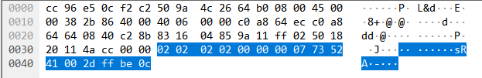
Not writable
DADISICK corresponding relationship:
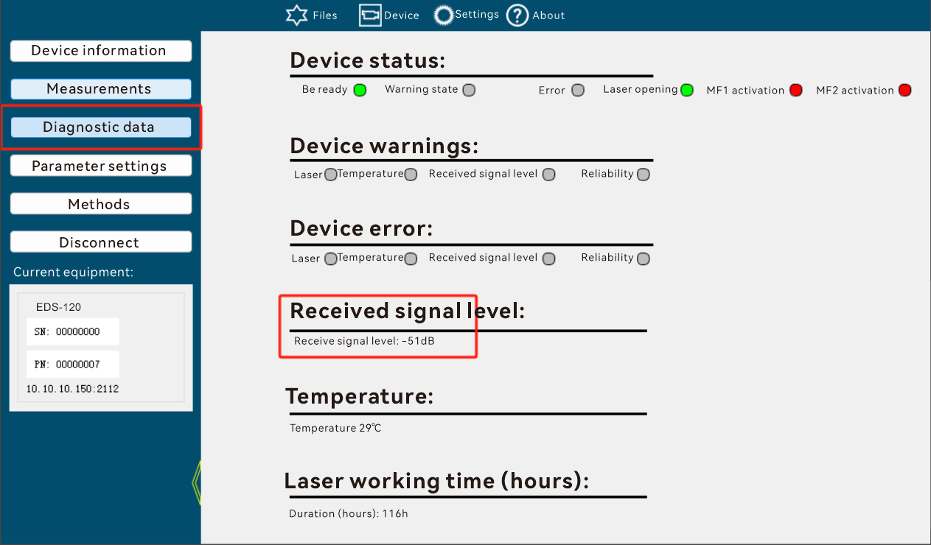

publicSoftwareVersion(0x004a)
Data Type:
FixString, length 12
meaning:
The software public version number. The format is: V001.002.081.
Data format:
read
Read Request:
02 02 02 02 00 00 00 05 73 52 49 00 4a 22
Read Response:
02 02 02 02 00 00 00 11 73 52 41 00 4a 56 30 30 31 2e 30 30 32 2e 30 38 31 46
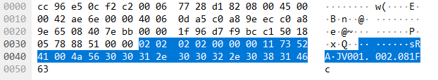

Not writable

DADISICK corresponding relationship:
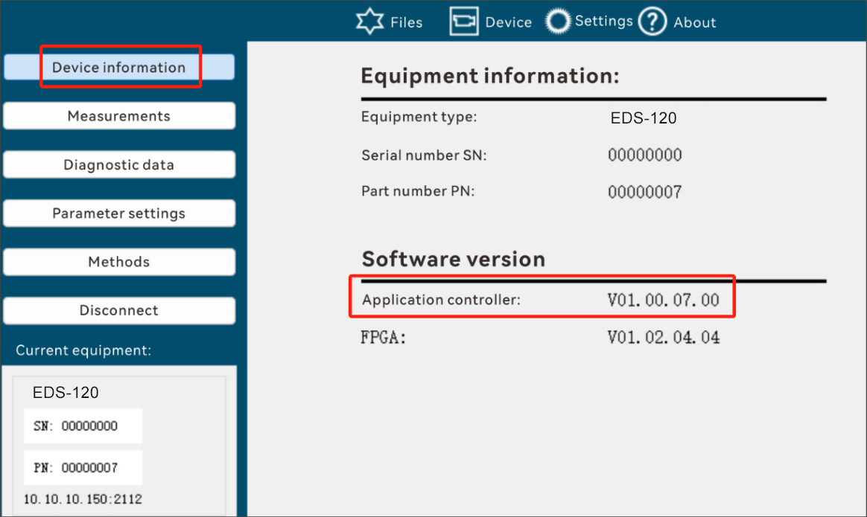

readyStatus(0x0051)
Data Type:
Bool
meaning:
Device status: whether the device is ready
0: Not ready
1: Ready
Data format:
read
Read Request:
02 02 02 02 00 00 00 05 73 52 49 00 51 39
Read Response:
02 02 02 02 00 00 00 06 73 52 41 00 51 00 31
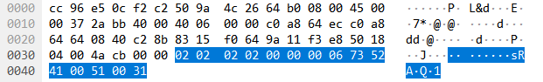

Not writable

DADISICK corresponding relationship:
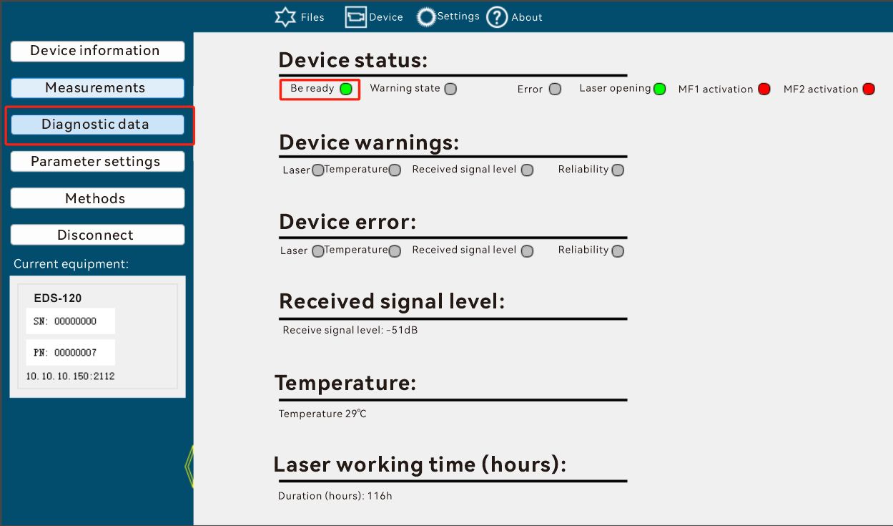

warningStatus(0x0052)
Data Type:
Bool
meaning:
Device status: whether there is any warning on the device
0: No warning
1: With warning
Data format:
read
Read Request:
02 02 02 02 00 00 00 05 73 52 49 00 52 3a
Read Response:
02 02 02 02 00 00 00 06 73 52 41 00 52 00 32
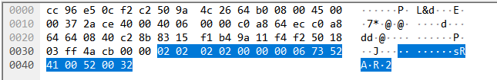

Not writable

DADISICK corresponding relationship:
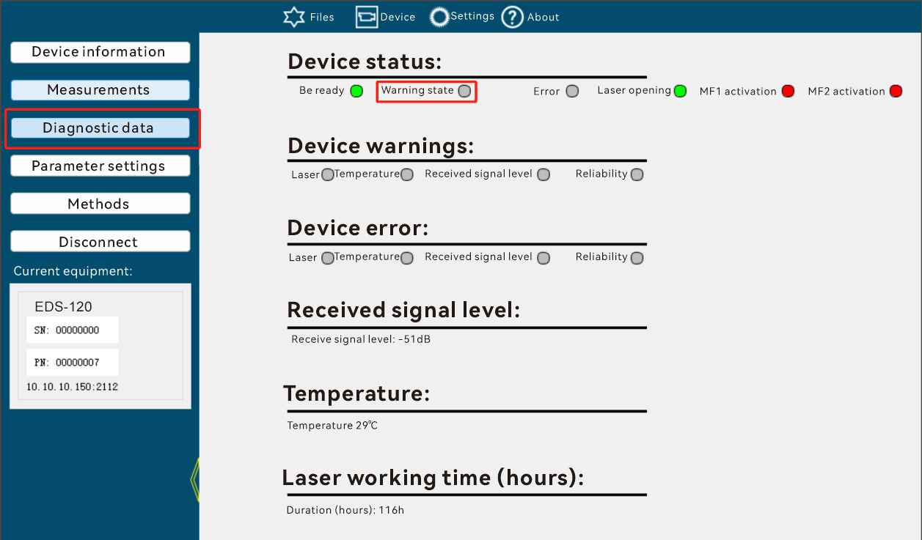

errorStatus(0x0053)
Data Type:
Bool
meaning:
Device status: whether there is any error in the device
0: No error
1: There is an error
Data format:
read
Read Request:
02 02 02 02 00 00 00 05 73 52 49 00 53 3b
Read Response:
02 02 02 02 00 00 00 06 73 52 41 00 53 00 33
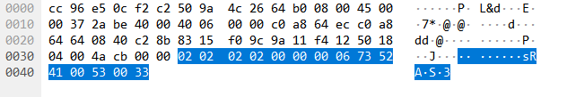

Not writable

DADISICK corresponding relationship:
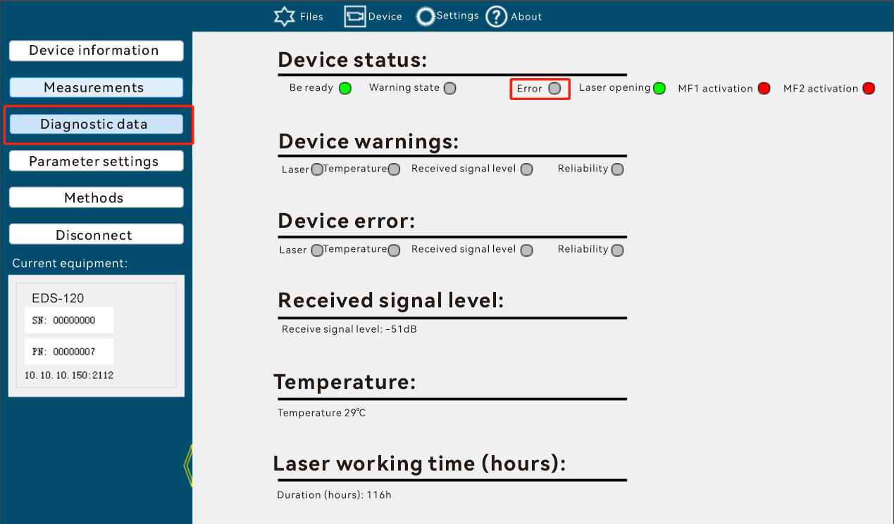

laserOnStatus(0x0055)
Data Type:
Bool
meaning:
Is the laser emitting light?
0: No light
1: Glow
Data format:
read
Read Request:
02 02 02 02 00 00 00 05 73 52 49 00 55 3d
Read Response:
02 02 02 02 00 00 00 06 73 52 41 00 55 01 34
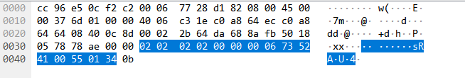

Not writable

DADISICK corresponding relationship:
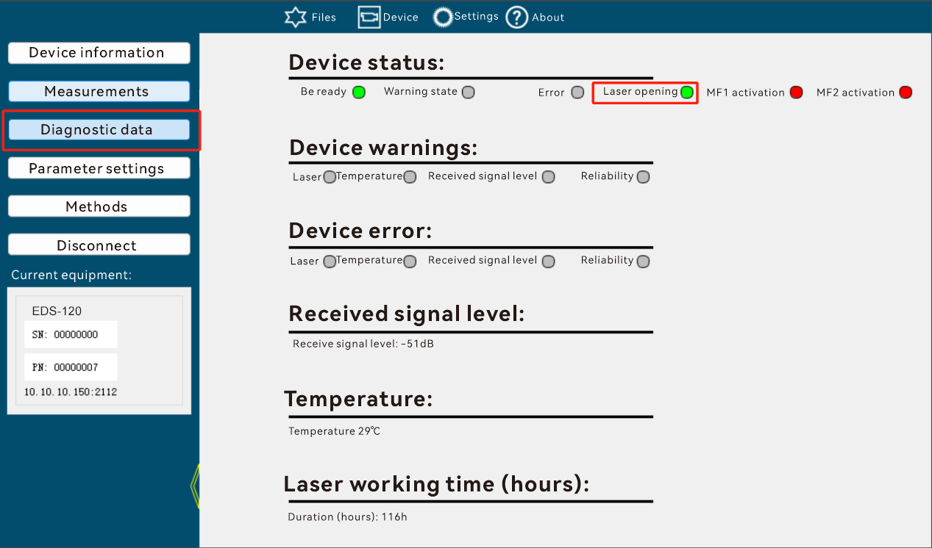

mf1ActiveStatus(0x0056)
Data Type:
Bool
meaning:
MF1 is activated
0: Not triggered
1: Triggered
Data format:
read
Read Request:
02 02 02 02 00 00 00 05 73 52 49 00 56 3e
Read Response:
02 02 02 02 00 00 00 06 73 52 41 00 56 00 36
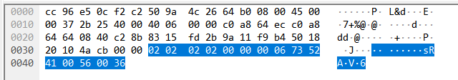

Not writable

DADISICK corresponding relationship:
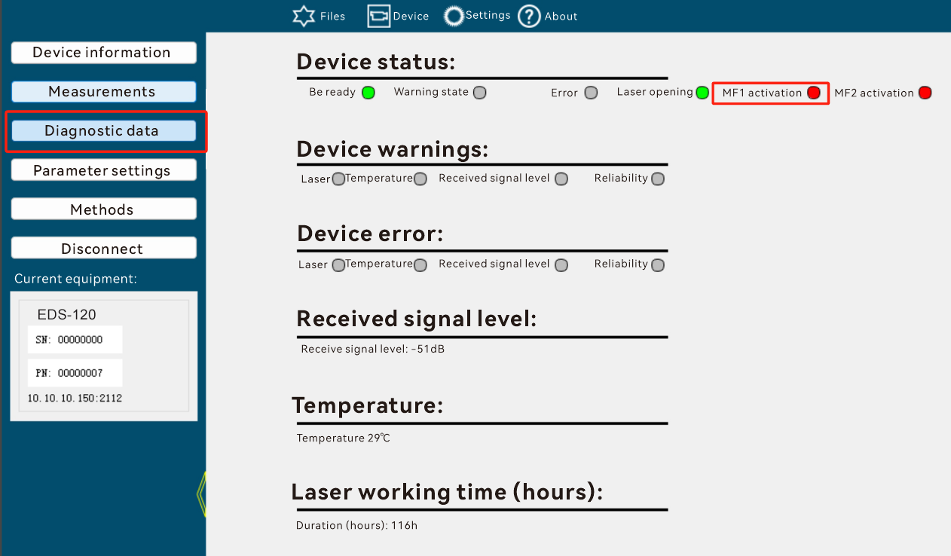

mf2ActiveStatus(0x0057)
Data Type:
Bool
meaning:
MF2 is activated
0: Not triggered
1: Triggered
Data format:
read
Read Request:
02 02 02 02 00 00 00 05 73 52 49 00 57 3f
Read Response:
02 02 02 02 00 00 00 06 73 52 41 00 57 01 36
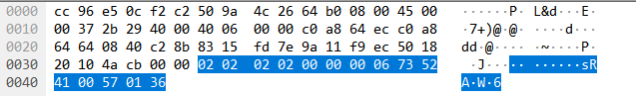
Not writable
DADISICK corresponding relationship:
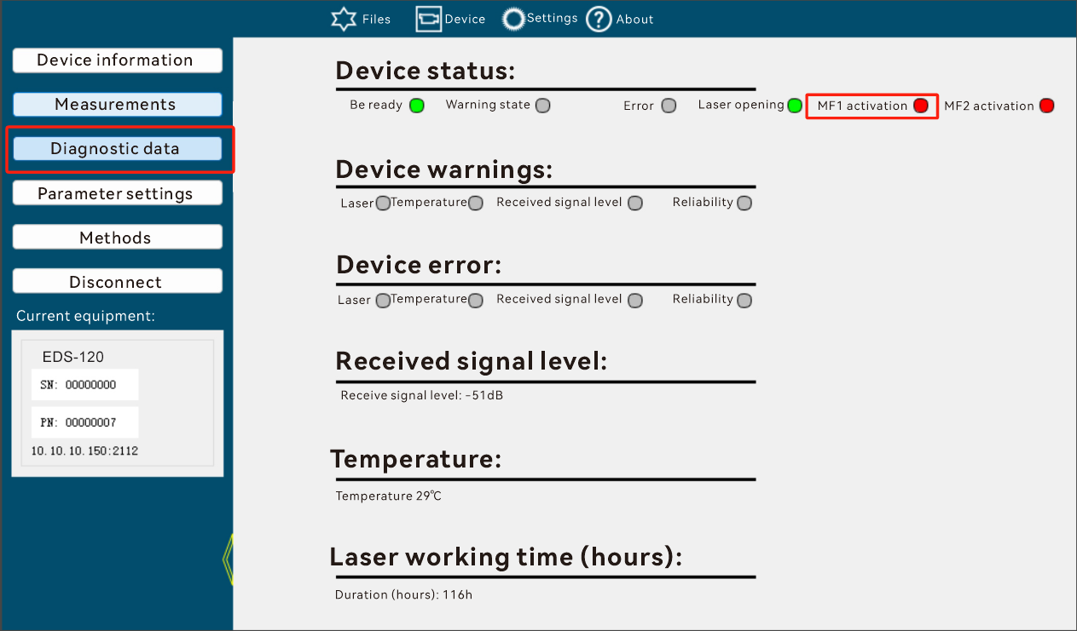

averagedVelocity(0x00a2)
Data Type:
Float32
meaning:
The average speed of the object measured by EDS series is the speed obtained when the host computer draws the picture.
Data format:
read
Read Request:
02 02 02 02 00 00 00 05 73 52 49 00 a2 ca
Read Response:
02 02 02 02 00 00 00 09 73 52 41 00 a2 40 00 00 00 82
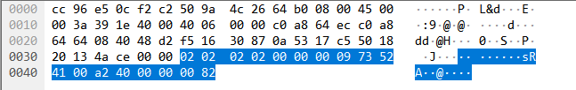

Not writable

DADISICK corresponding relationship:
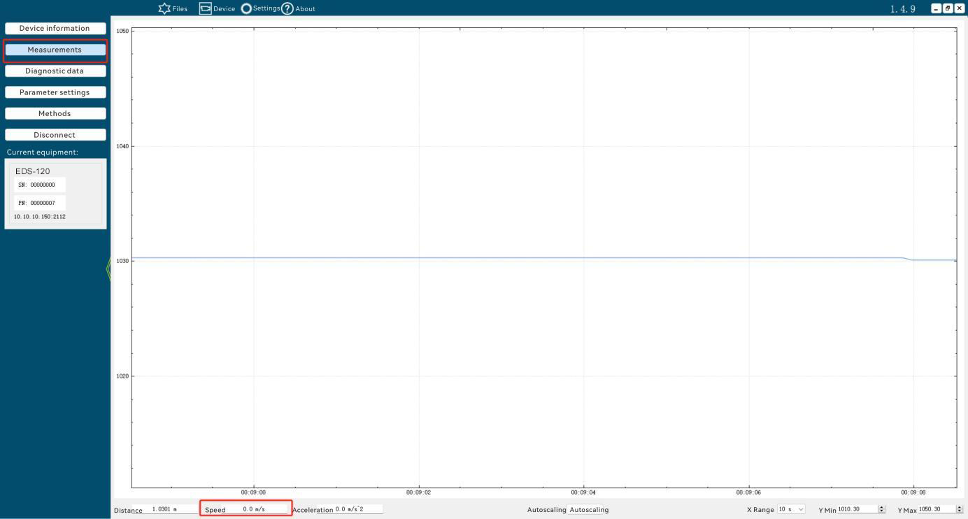

laserServiceStateSSI(0x00a4)
Data Type:
Bool
meaning:
Is SSI in LaserWarning state?
Data format:
read
Read Request:
02 02 02 02 00 00 00 05 73 52 49 00 a4cc
Read Response:
02 02 02 02 00 00 00 06 73 52 41 00 a4 00 c4
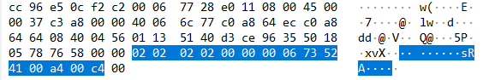

Not writable

DADISICK corresponding relationship:
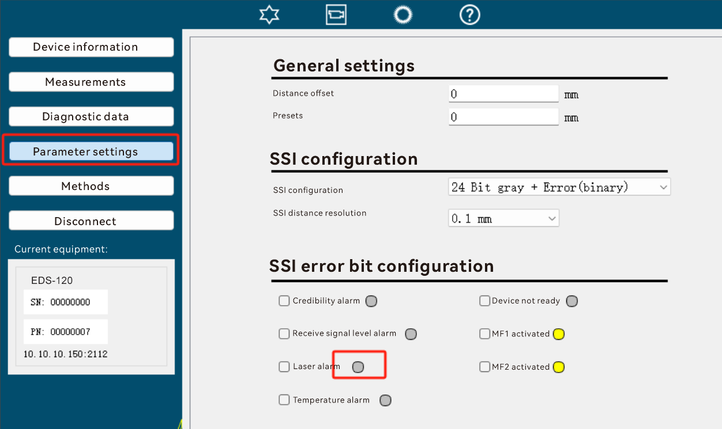
Note: When configuring the Error Bit of SSI, only configure the Warning state, not the Error state.

temperatureServiceStateSSI(0x00a5)
Data Type:
Bool
meaning:
Is SSI in TemperatureWarning state?
Data format:
read
Read Request:
02 02 02 02 00 00 00 05 73 52 49 00 a5 cd
Read Response:
02 02 02 02 00 00 00 06 73 52 41 00 a5 00 c5
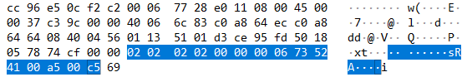

Not writable

DADISICK corresponding relationship:
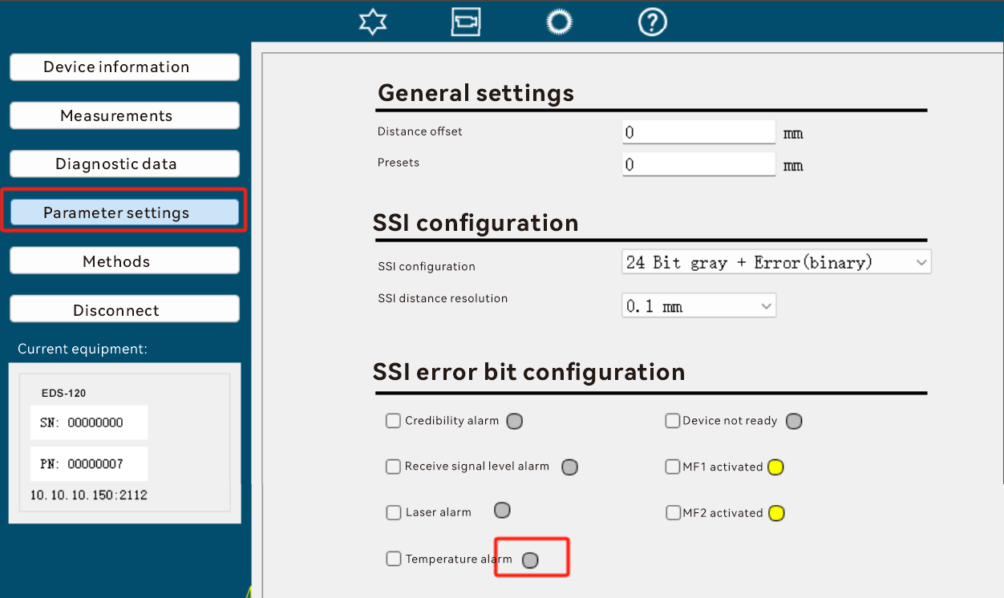

levelServiceStateSSI(0x00a6)
Data Type:
Bool
meaning:
Is SSI in LevelWarnings state?
Data format:
read
Read Request:
02 02 02 02 00 00 00 05 73 52 49 00 a6 ce
Read Response:
02 02 02 02 00 00 00 06 73 52 41 00 a6 00 c6
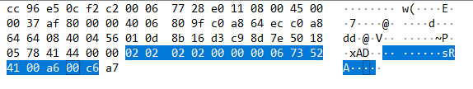

Not writable

DADISICK corresponding relationship:
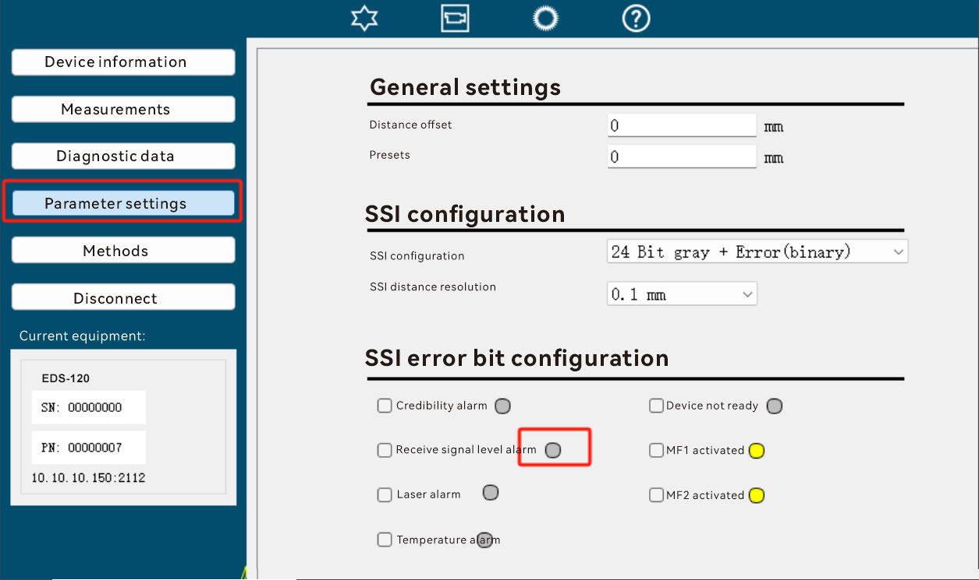

publicSoftwareVersionFpga(0x00a8)
Data Type:
FixString, length 12
meaning:
Fpga version number. Its format is: V001.000.001.
Data format:
read
Read Request:
02 02 02 02 00 00 00 05 73 52 49 00 a8 c0
Read Response:
02 02 02 02 00 00 00 11 73 52 41 00 a8 56 30 30 31 2e 30 30 30 2e 30 30 31 ae
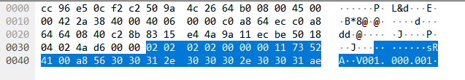

Not writable

DADISICK corresponding relationship:
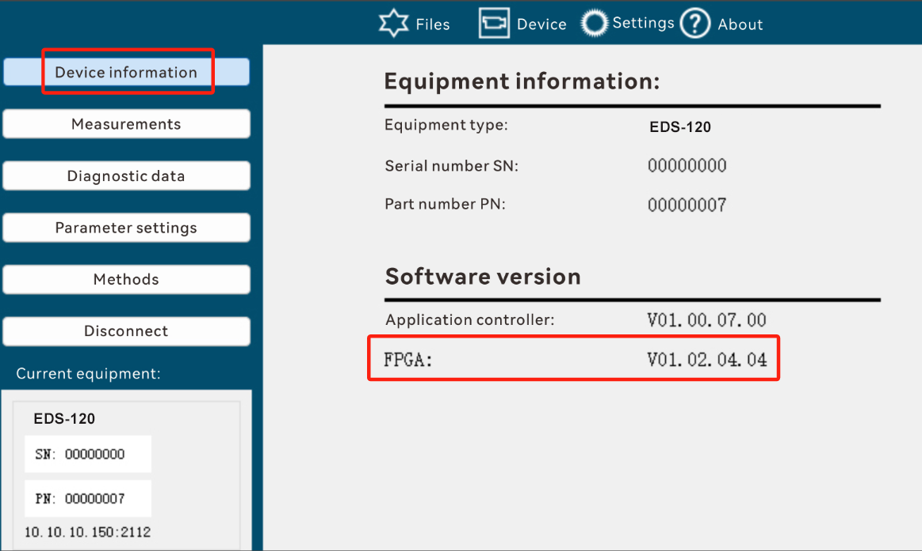

plausibilityServiceStateSSI(0x00a9)
Data Type:
Bool
meaning:
Is SSI in PlausibilityWarnings state?
Data format:
read
Read Request:
02 02 02 02 00 00 00 05 73 52 49 00 a9 c1
Read Response:
02 02 02 02 00 00 00 06 73 52 41 00 a9 00 c9
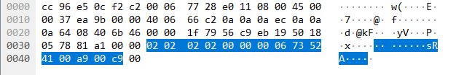

Not writable

DADISICK corresponding relationship:
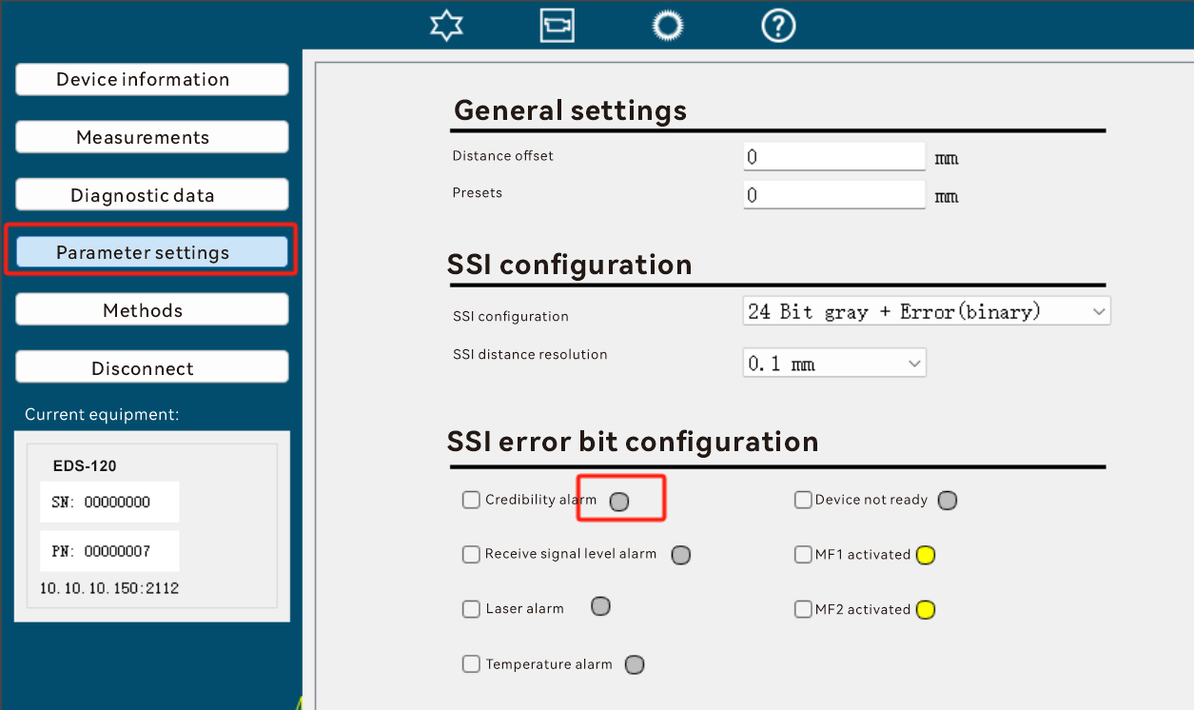

displayedConfigEthernetIP(0x00ad)
Data Type:
FixString, length 15
meaning:
Device IP address
Data format:
read
Read Request:
02 02 02 02 00 00 00 05 73 52 49 00 ad c5
Read Response:
02 02 02 02 00 00 00 14 73 52 41 00 ad 31 39 32 2e 31 36 38 2e 31 30 30 2e 32 33 36 e0
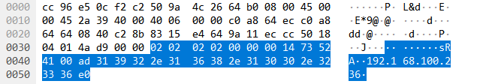

Not writable

Note: The IP address must be 4 three-digit numbers, such as "192.168.100.125". If the IP address is less than three digits, it should be supplemented. For example, if the IP address is " 10.10.10.6 " , the lower computer should return " 010.010.010.006 " . As shown below:
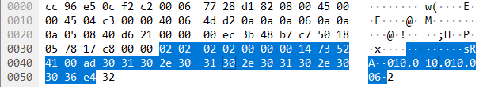

displayedConfigEthernetNM(0x00ae)
Data Type:
FixString, length 15
meaning:
Device IP address subnet mask
Data format:
read
Read Request:
02 02 02 02 00 00 00 05 73 52 49 00 ae c6
Read Response:
02 02 02 02 00 00 00 14 73 52 41 00 ae 32 35 35 2e 32 35 35 2e 32 35 35 2e 30 30 30 e2
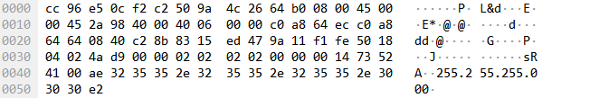

Not writable

displayedConfigEthernetGW(0x00af)
Data Type:
FixString, length 15
meaning:
Device gateway address
Data format:
read
Read Request:
02 02 02 02 00 00 00 05 73 52 49 00 af c7
Read Response:
02 02 02 02 00 00 00 14 73 52 41 00 af 31 39 32
2e 31 36 38 2e 31 35 38 2e 30 30 31 e9
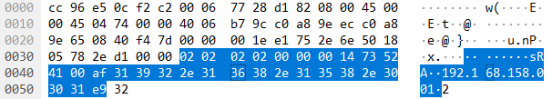

Not writable

laserError(0x00ca)
Data Type:
Bool
meaning:
Is the laser wrong?
Data format:
read
Read Request:
02 02 02 02 00 00 00 05 73 52 49 00 ca a2
Read Response:
02 02 02 02 00 00 00 06 73 52 41 00 ca 00 aa
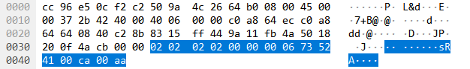

Not writable

DADISICK corresponding relationship:
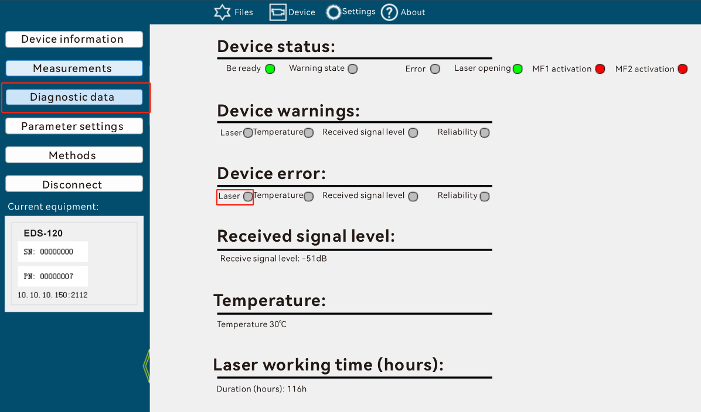

temperatureError(0x00cb)
Data Type:
Bool
meaning:
Is there an error in the temperature measurement?
Data Format:
read
Read Request:
02 02 02 02 00 00 00 05 73 52 49 00 cb a3
Read Response:
02 02 02 02 00 00 00 06 73 52 41 00 cb 00 ab
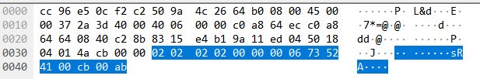

Not writable

DADISICK corresponding relationship:
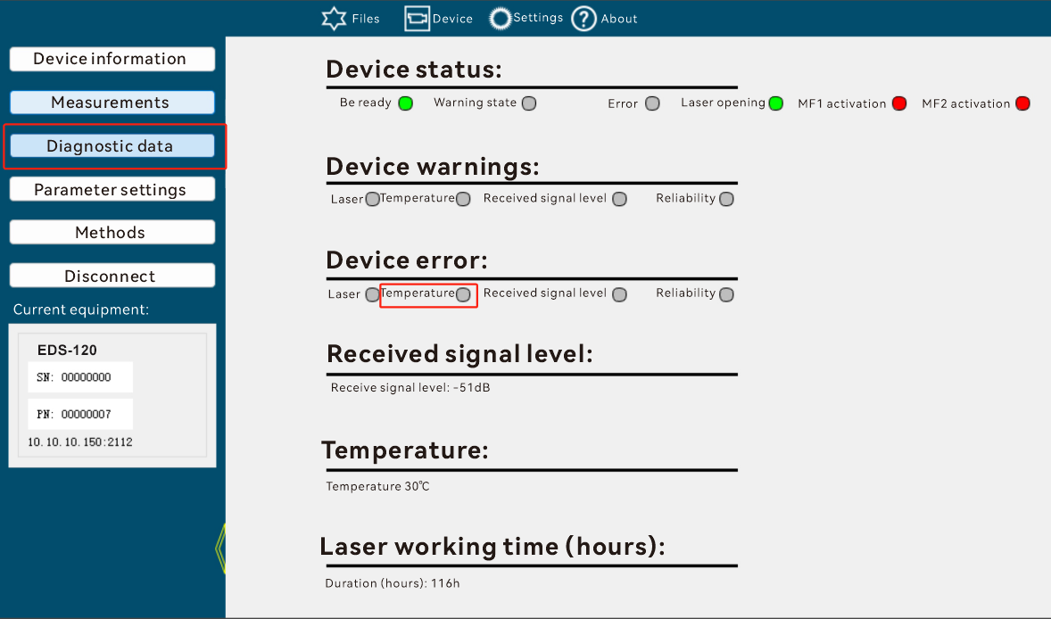

levelError(0x00cc)
Data Type:
Bool
meaning:
Is there any error in the received reflected signal level?
Data format:
read
Read Request:
02 02 02 02 00 00 00 05 73 52 49 00 cc a4
Read Response:
02 02 02 02 00 00 00 06 73 52 41 00 cc 00 ac
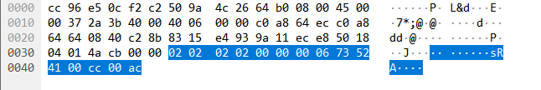

Not writable

DADISICK corresponding relationship:
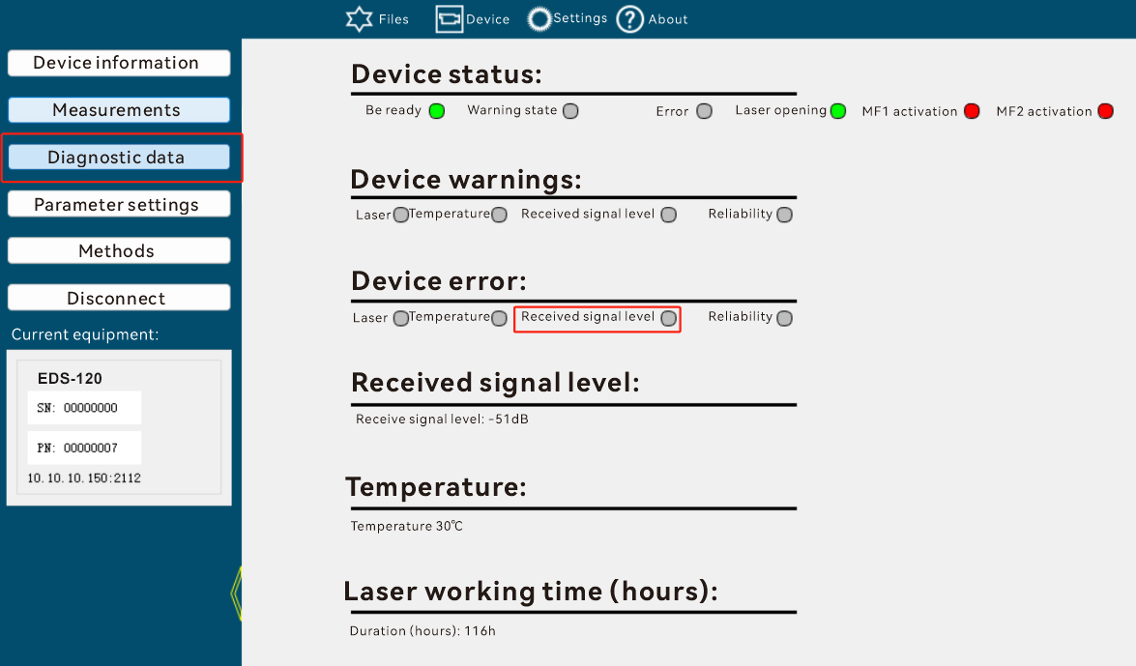

plausiblityError(0x00cd)
Data Type:
Bool
meaning:
Is there an error in equipment reliability?
Data format:
read
Read Request:
02 02 02 02 00 00 00 05 73 52 49 00 cd a5
Read Response:
02 02 02 02 00 00 00 06 73 52 41 00 cd 01 ac
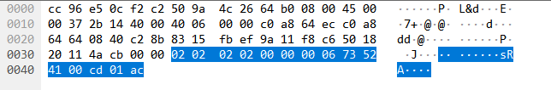

Not writable

DADISICK corresponding relationship:
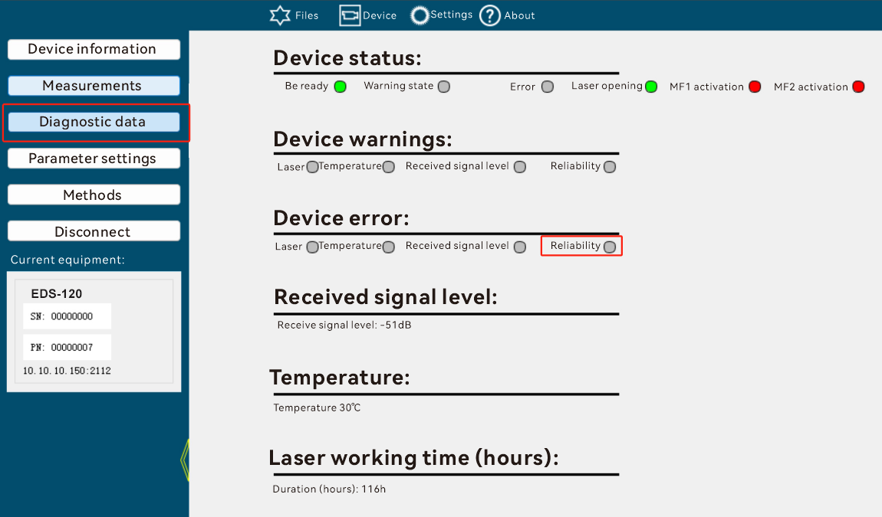

laserPrefailWarning(0x00ce)
Data Type:
Bool
meaning:
Is there an alarm for the laser?
Data format:
read
Read Request:
02 02 02 02 00 00 00 05 73 52 49 00 ce a6
Read Response:
02 02 02 02 00 00 00 06 73 52 41 00 ce 00 ae
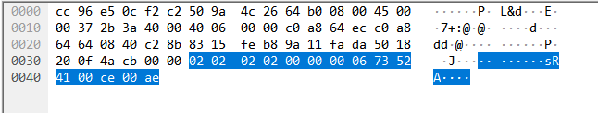
Not writable
DADISICK corresponding relationship:
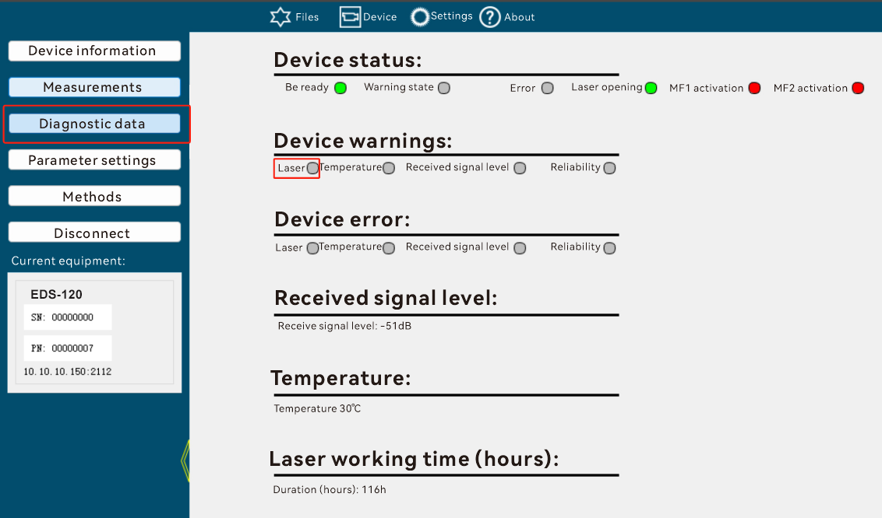

temperaturePrefailWarning(0x00cf)
Data Type:
Bool
meaning:
Is there an alarm for temperature measurement?
Data format:
read
Read Request:
02 02 02 02 00 00 00 05 73 52 49 00 cf a7
Read Response:
02 02 02 02 00 00 00 06 73 52 41 00 cf 00 af
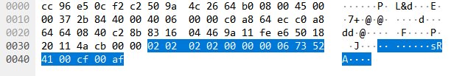
Not writable
DADISICK corresponding relationship:
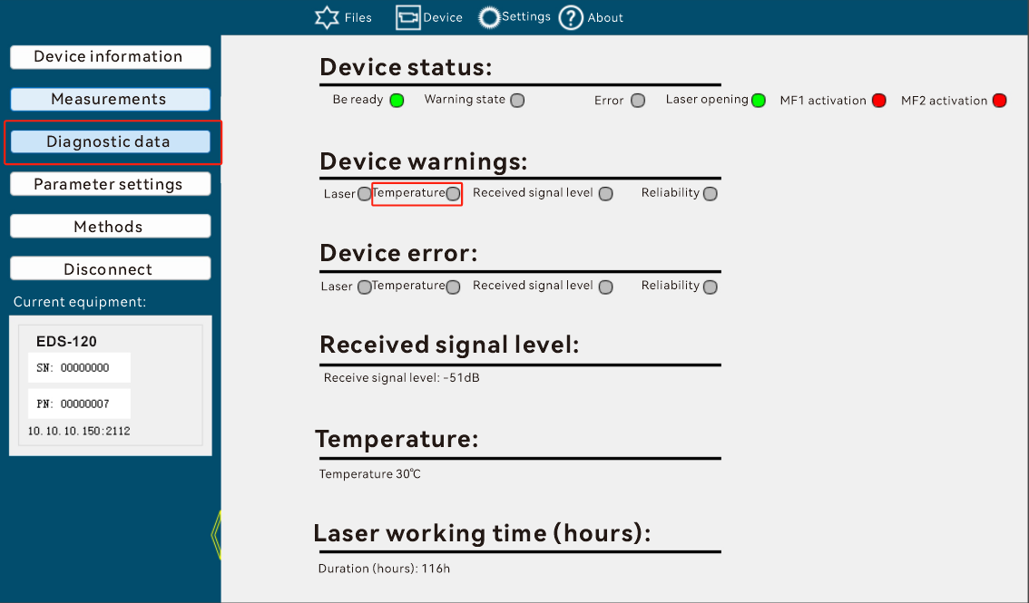

levelPrefailWarning(0x00d0)
Data Type:
Bool
meaning:
Laser level alarm
Data format:
read
Read Request:
02 02 02 02 00 00 00 05 73 52 49 00 d0 b8
Read Response:
02 02 02 02 00 00 00 06 73 52 41 00 d0 00 b0
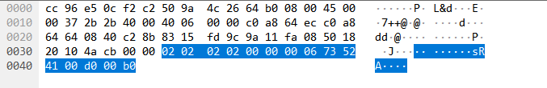

Not writable

DADISICK corresponding relationship:
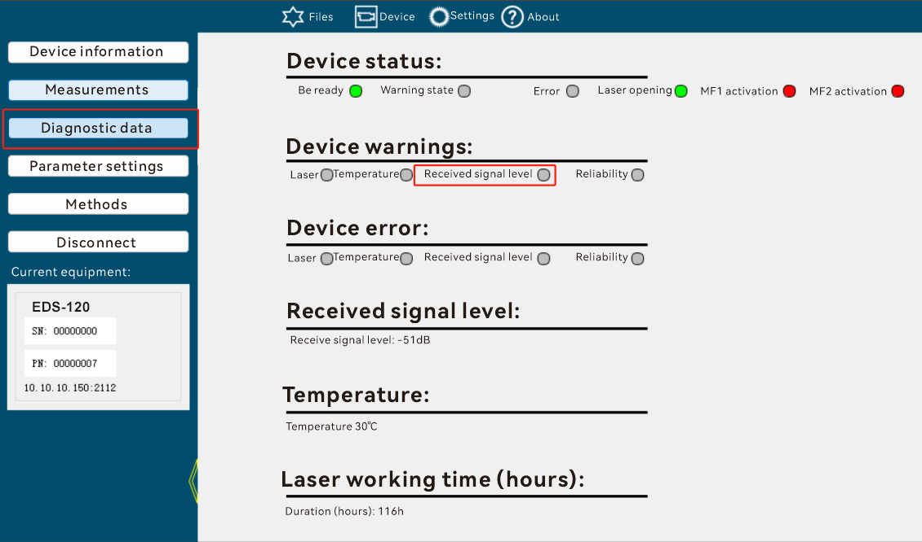

plausiblityPrefailWarning(0x00d1)
Data Type:
Bool
meaning:
Equipment reliability alarm
Data format:
read
Read Request:
02 02 02 02 00 00 00 05 73 52 49 00 d1 b9
Read Response:
02 02 02 02 00 00 00 06 73 52 41 00 d1 01 b0
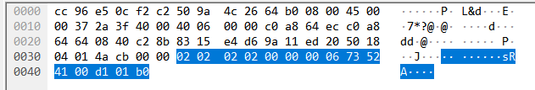

Not writable

DADISICK corresponding relationship:
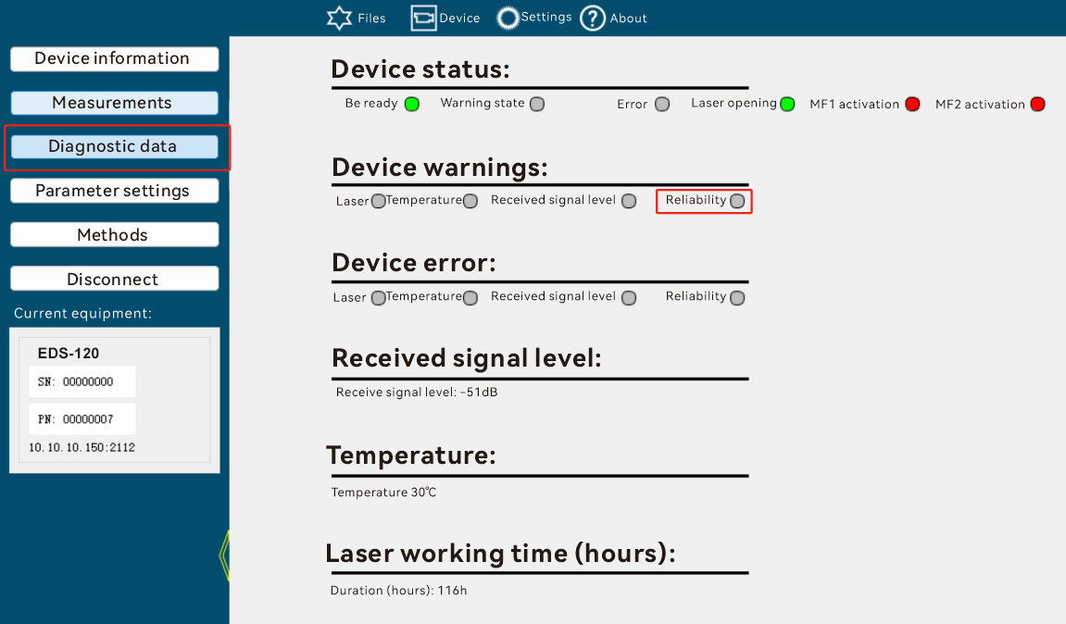

productPartNo(0x00de)
Data Type:
FlexString
meaning:
EDS series Device Part Number
Data format:
read
Read Request:
02 02 02 02 00 00 00 05 73 52 49 00 de b6
Read Response:
02 02 02 02 00 00 00 0e 73 52 41 00 de 00 07 31 30 35 32 36 39 30 80
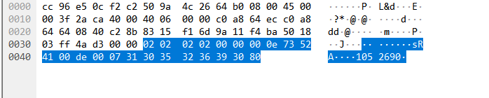

Not writable

DADISICK corresponding relationship:
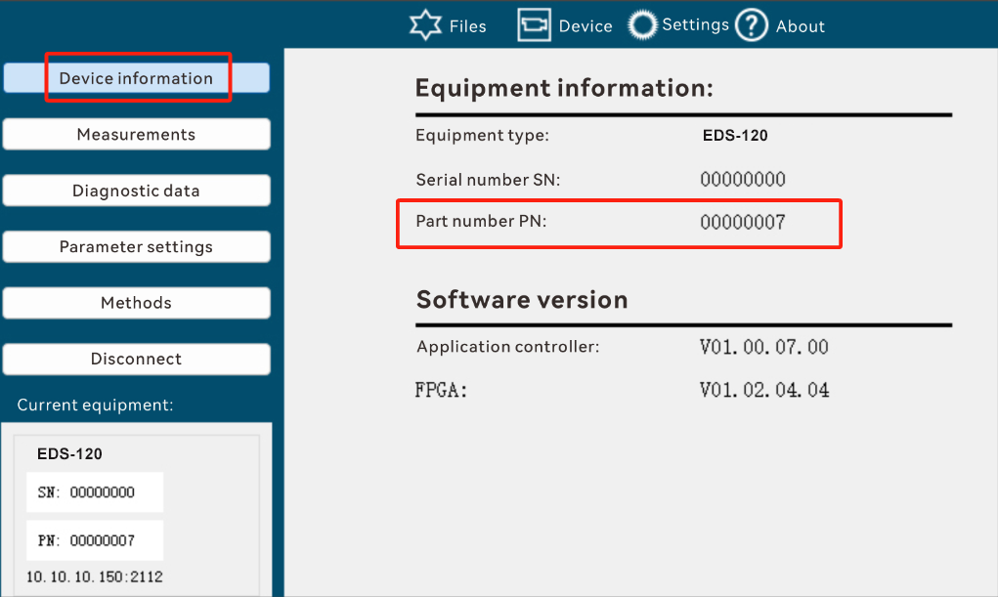

laserServiceState(0x00e6)
Data Type:
Bool
meaning:
Whether the device is in Laser Warning or Error state, and MFx is triggered. If MF1 is configured to respond to Laser error or warning, MF1 is triggered; if MF2 is configured to respond to Laser error or warning, MF2 is triggered.
Data Format:
read
Read Request:
02 02 02 02 00 00 00 05 73 52 49 00 e6 8e
Read Response:
02 02 02 02 00 00 00 06 73 52 41 00 e6 00 86
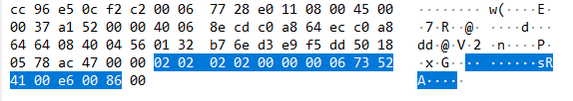
Not writable
DADISICK corresponding relationship:
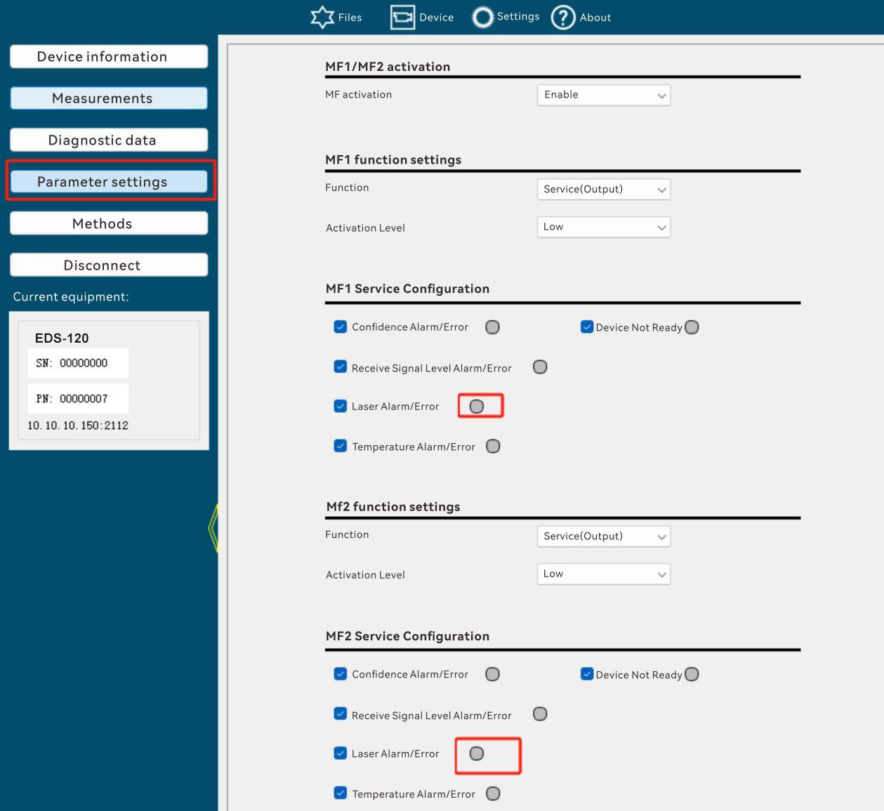

temperatureServiceState(0x00e7)
Data Type:
Bool
meaning:
Whether the device is in Temperature Warning or Error state, and MFx is activated. If MF1 is configured to respond to temperature error or warning, MF1 is activated; if MF2 is configured to respond to temperature error or warning, MF2 is activated.
Data format:
read
Read Request:
02 02 02 02 00 00 00 05 73 52 49 00 e7 8f
Read Response:
02 02 02 02 00 00 00 06 73 52 41 00 e7 00 87
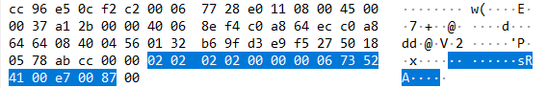

Not writable
DADISICK corresponding relationship:
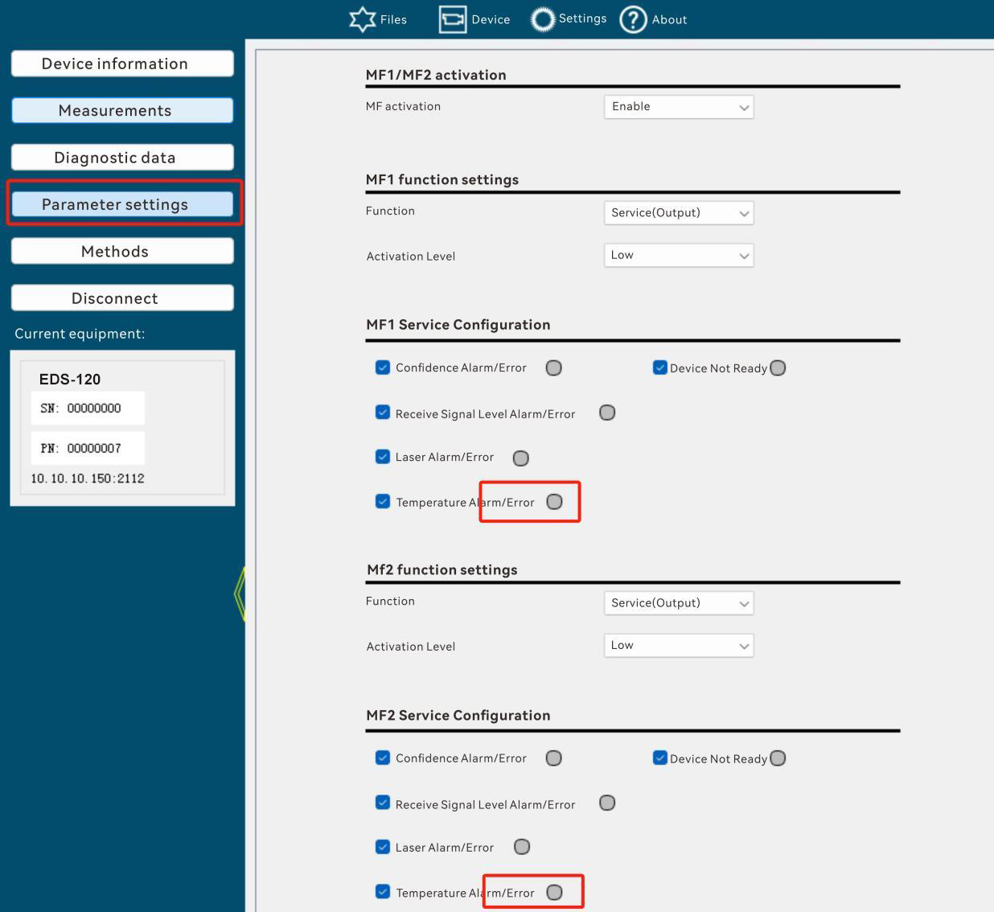

levelServiceState(0x00e8)
Data Type:
Bool
meaning:
Whether the device is in Level Warning or Error state, and MFx is triggered. If MF1 is configured to respond to level error or warning, MF1 is triggered; if MF2 is configured to respond to level error or warning, MF2 is triggered.
Data format:
read
Read Request:
02 02 02 02 00 00 00 05 73 52 49 00 e8 80
Read Response:
02 02 02 02 00 00 00 06 73 52 41 00 e8 00 88
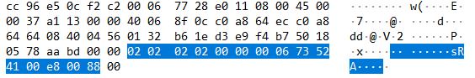
Not writable
DADISICK corresponding relationship:
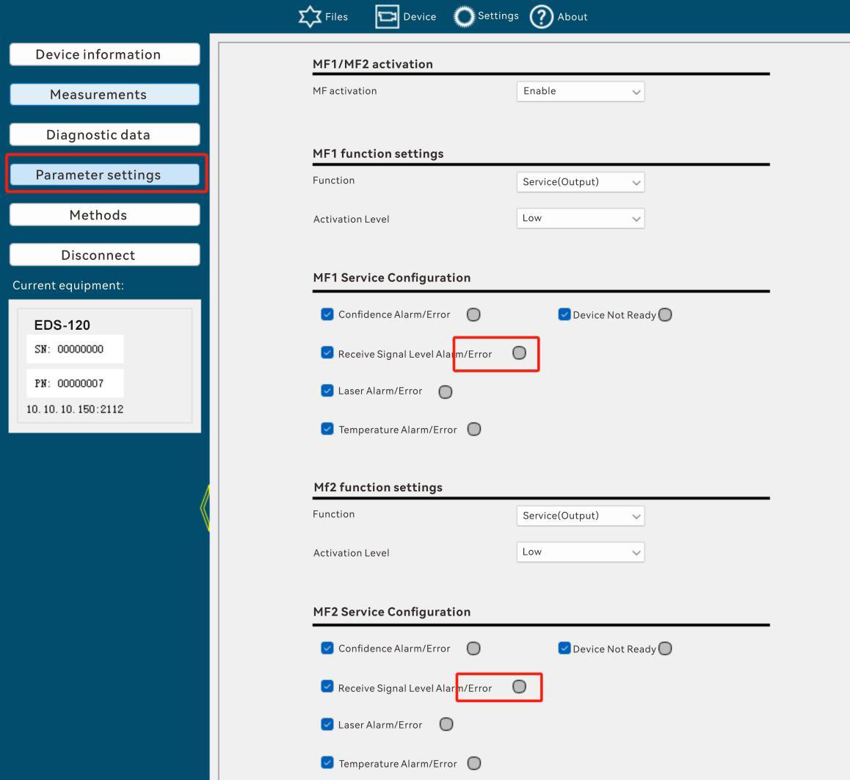

readyServiceState(0x00e9)
Data Type:
Bool
meaning:
Whether the device is in Device Not Ready state and MFx or SSI Error Bit is stimulated.
Data format:
read
Read Request:
02 02 02 02 00 00 00 05 73 52 49 00 e9 81
Read Response:
02 02 02 02 00 00 00 06 73 52 41 00 e9 01 88
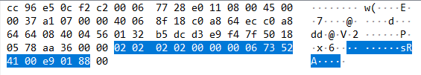
Not writable
Mfx, SSI state both use this identifier
DADISICK corresponding relationship:
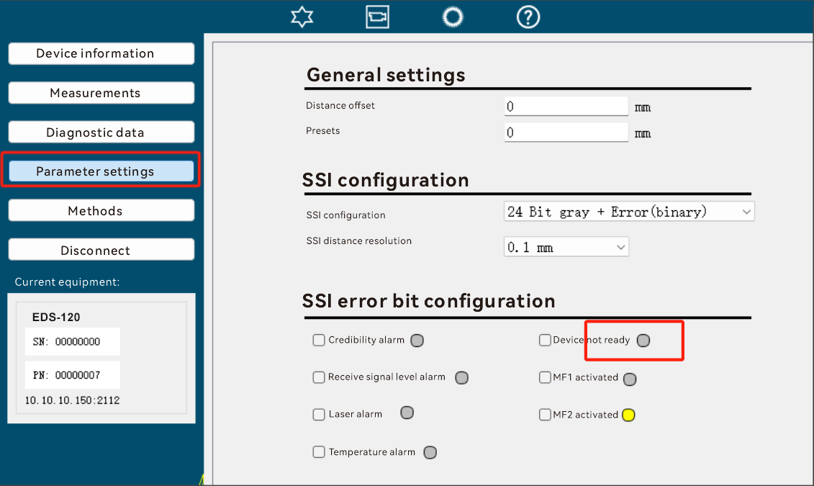
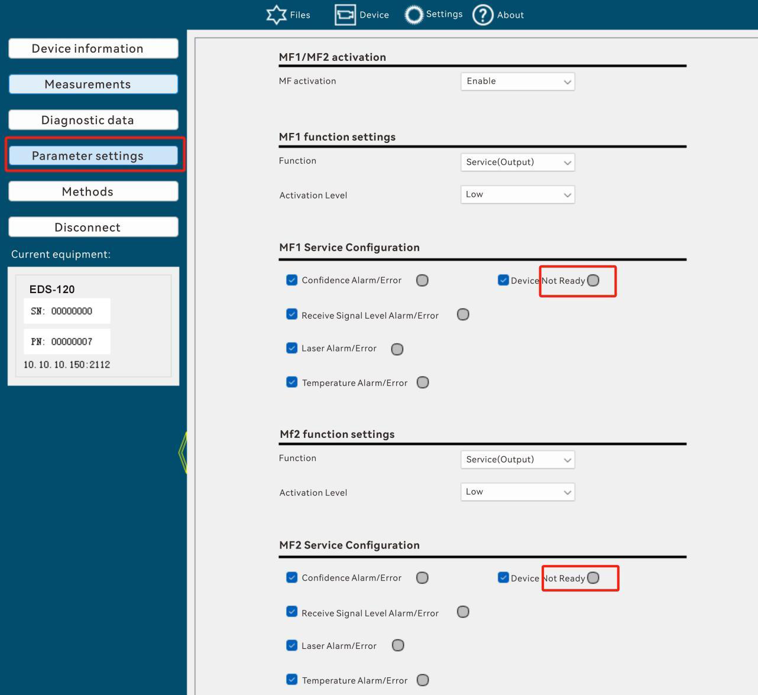

plausiblityServiceState(0x00eb)
Data Type:
Bool
meaning:
Whether the device is in Plausibility Warning or Error state, and MFx is triggered. If MF1 is configured with plausibility error or warning, MF1 is triggered; if MF2 is configured with response plausibility error or warning, MF2 is triggered.
Data format:
read
Read Request:
02 02 02 02 00 00 00 05 73 52 49 00 eb 83
Read Response:
02 02 02 02 00 00 00 06 73 52 41 00eb 00 8b
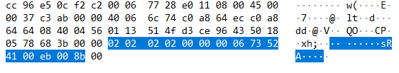

Not writable

DADISICK corresponding relationship:
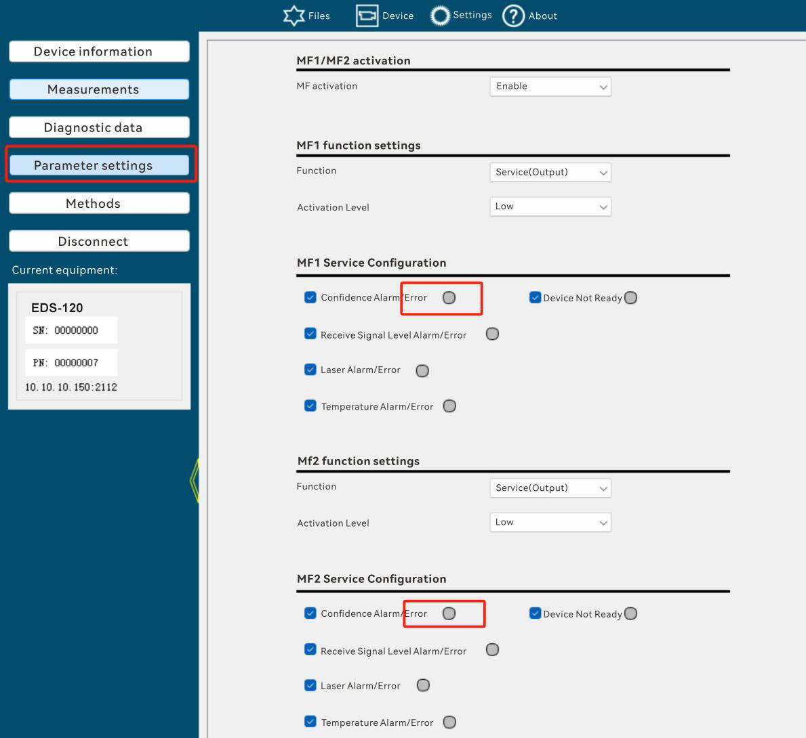

mf1ServiceState(0x00ec)
Data Type:
Bool
meaning:
Whether Mf1 is excited using a high level or a low level, or whether it is at a high level or a low level when excited.
Data format:
read
Read Request:
02 02 02 02 00 00 00 05 73 52 49 00 ec 84
Read Response:
02 02 02 02 00 00 00 06 73 52 41 00 ec 01 8d
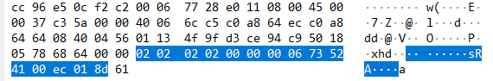
Not writable
DADISICK corresponding relationship:
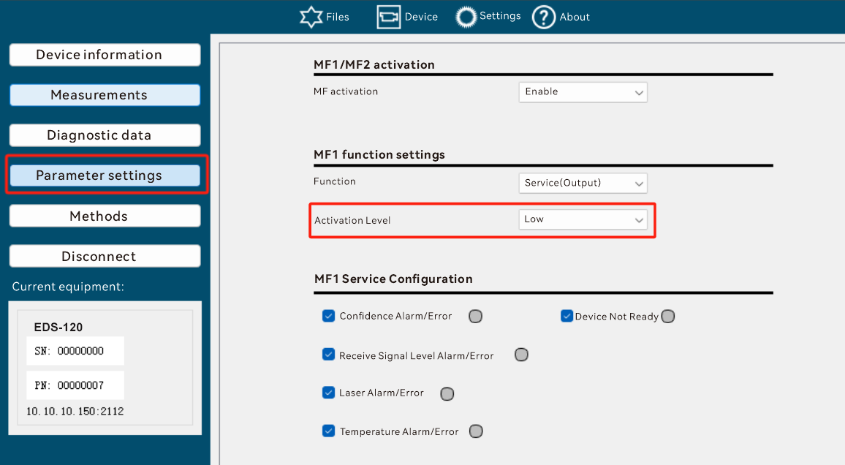

mf2ServiceState(0x00ed)
Data Type:
Bool
meaning:
Whether Mf2 is at a high level or a low level when it is excited.
Data format:
read
Read Request:
02 02 02 02 00 00 00 05 73 52 49 00 ed 85
Read Response:
02 02 02 02 00 00 00 06 73 52 41 00 ed 00 8d
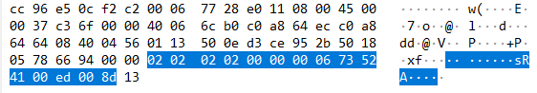
Not writable
DADISICK corresponding relationship:
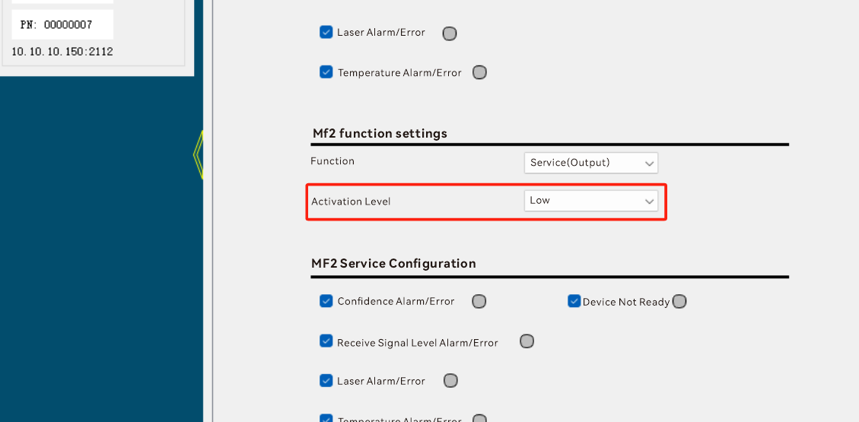

operatingHours(0x00ef)
Data Type:
UInt32
meaning:
Total equipment working time
Data format:
read
Read Request:
02 02 02 02 00 00 00 05 73 52 49 00 ef 87
Read Response:
02 02 02 02 00 00 00 09 73 52 41 00 ef 00 00 03 37 bb
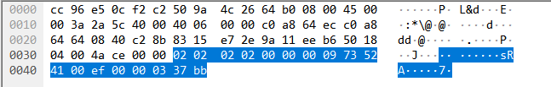

Not writable

DADISICK corresponding relationship:
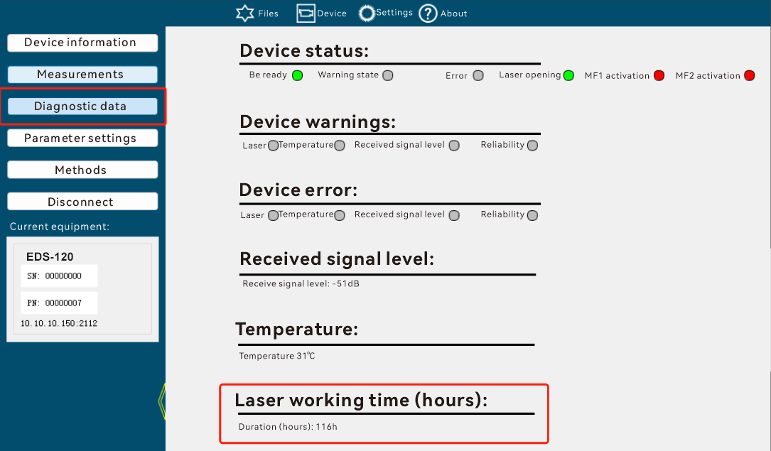

distanceOffset(0x014a)
Data Type:
Int32
meaning:
Distance offset. Range –600,000 … +300,000 [mm]
The compensation value is added to the determined distance value. The compensation value is effective for all outputs and for the distance display on the display.
Unit: [mm]
Default value: 0
Data format:
read
Read Request:
02 02 02 02 00 00 00 05 73 52 49 01 4a 23
Read Response:
02 02 02 02 00 00 00 09 73 52 41 01 4a ff ff ff 9c 48
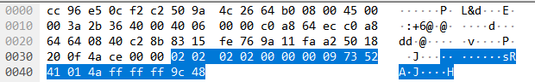

Write
Write Request
02 02 02 02 00 00 00 09 73 57 49 01 4a 00 00 00 64 42
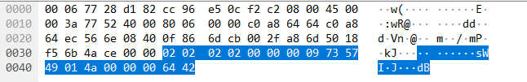
Write Response
02 02 02 02 00 00 00 05 73 57 41 01 4a 2e
DADISICK corresponding relationship:
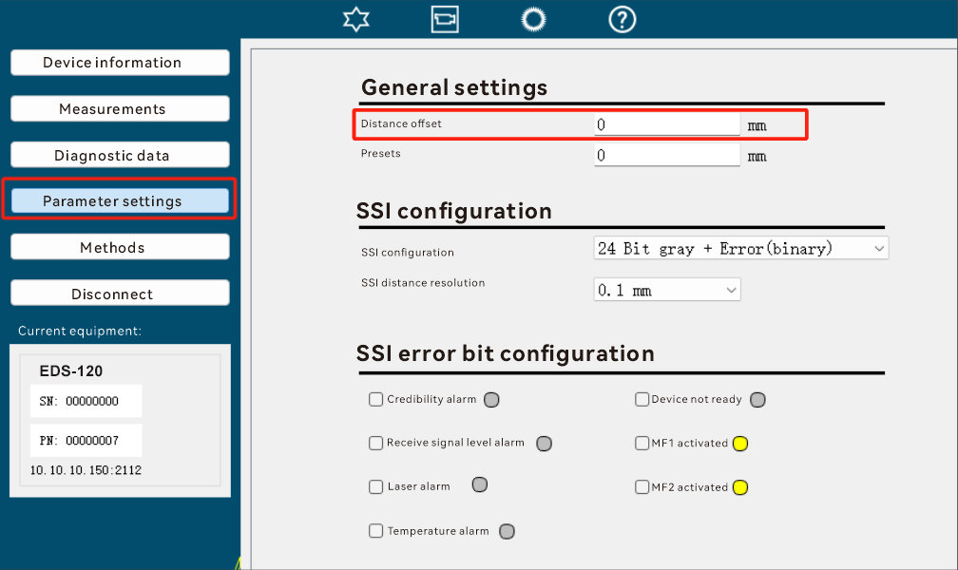

distancePreset(0x014b)
Data Type:
Int32
meaning:
Preset distances, range –600,000 … +300,000 [mm].
Unit: [mm]
Default value: 0
Data format:
read
Read Request:
02 02 02 02 00 00 00 05 73 52 49 01 4b 22
Read Response:
02 02 02 02 00 00 00 09 73 52 41 01 4b ff ff ff 38 ed
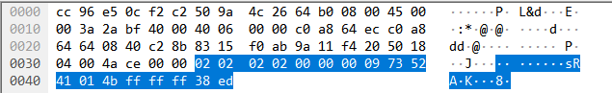
Important: Relationship between Preset and Offset
Compensation value = preset - measured distance value, that is:
Offset = Preset - Distance
In the final distance, final distance = measured distance + Offset
Distance = TestedDistance + Offset

Write
Write Request
02 02 02 02 00 00 00 09 73 57 49 01 4b ff ff ff 9c 44
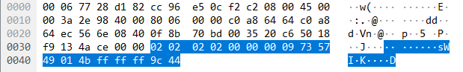
Write Response
02 02 02 02 00 00 00 05 73 57 41 01 4b 2f

DADISICK corresponding relationship:
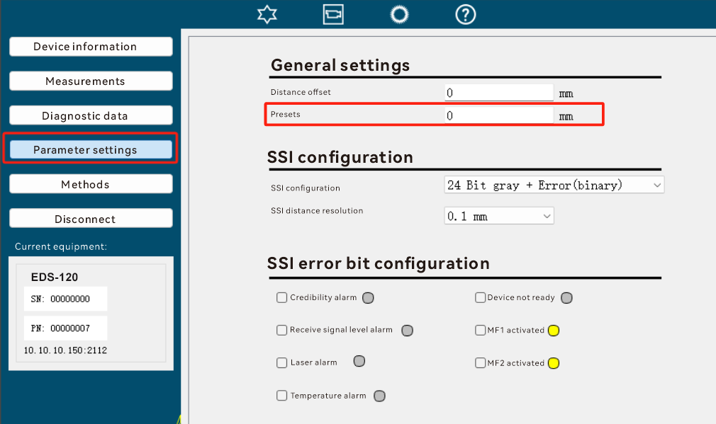

globalFunctionMF(0x014d)
Data Type:
Bool
meaning:
Whether to enable the MF1/MF2 function
- Disable MF1/MF2
- Enable MF1/MF2
default value:
1, indicating that MF1/MF2 is enabled
Data format:
read
Read Request:
02 02 02 02 00 00 00 05 73 52 49 01 4d 24
Read Response:
02 02 02 02 00 00 00 06 73 52 41 01 4d 01 2d
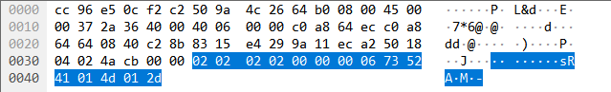

Write
Write Request
02 02 02 02 00 00 00 06 73 57 49 01 4d 00 21
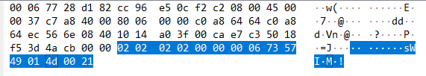
Write Response
02 02 02 02 00 00 00 05 73 57 41 01 4d 29
DADISICK corresponding relationship:
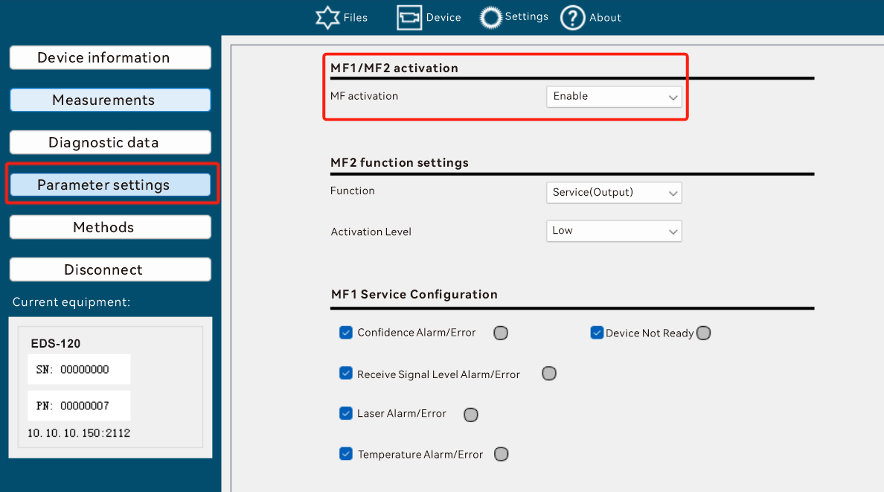

functionMF1 (0x014e)
Data Type:
UInt8
meaning:
Configuring MF1 Functions
0: Distance : used as output signal distance switching device
1: Velocity : used as a speed output signal switching device
2: Service : used as service output port
3: Laser off : used to turn off the laser input
4: Preset : Will be used as input to activate a static preset
default value:
0: Distance
Data format:
read
Read Request:
02 02 02 02 00 00 00 05 73 52 49 01 4e 27
Read Response:
02 02 02 02 00 00 00 06 73 52 41 01 4e 00 2f
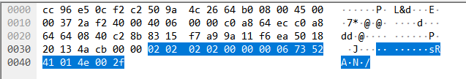

Write
Write Request
02 02 02 02 00 00 00 06 73 57 49 01 4e 01 23
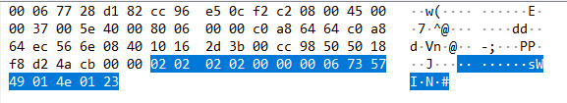
Write Response
02 02 02 02 00 00 00 05 73 57 41 01 4e 2a
DADISICK corresponding relationship:
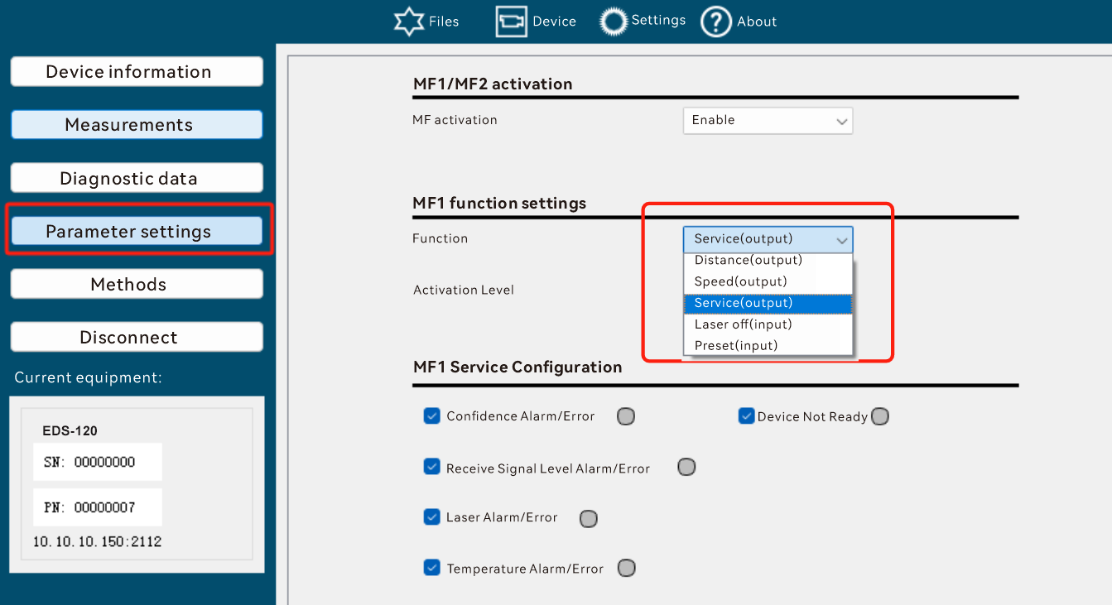

mf1ActiveState (0x014f)
Data Type:
Bool
meaning:
Configure MF1 excitation state
0: High level
1: Low level
default value:
1: Low level
Data format:
read
Read Request:
02 02 02 02 00 00 00 05 73 52 49 01 4f 26
Read Response:
02 02 02 02 00 00 00 06 73 52 41 01 4f 01 2f
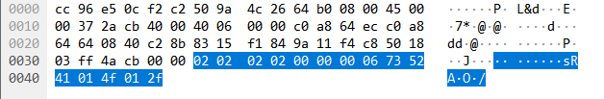
Write
Write Request
02 02 02 02 00 00 00 06 73 57 49 01 4f 00 23
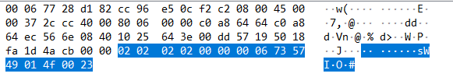
Write Response
02 02 02 02 00 00 00 05 73 57 41 01 4f 2b
DADISICK corresponding relationship:
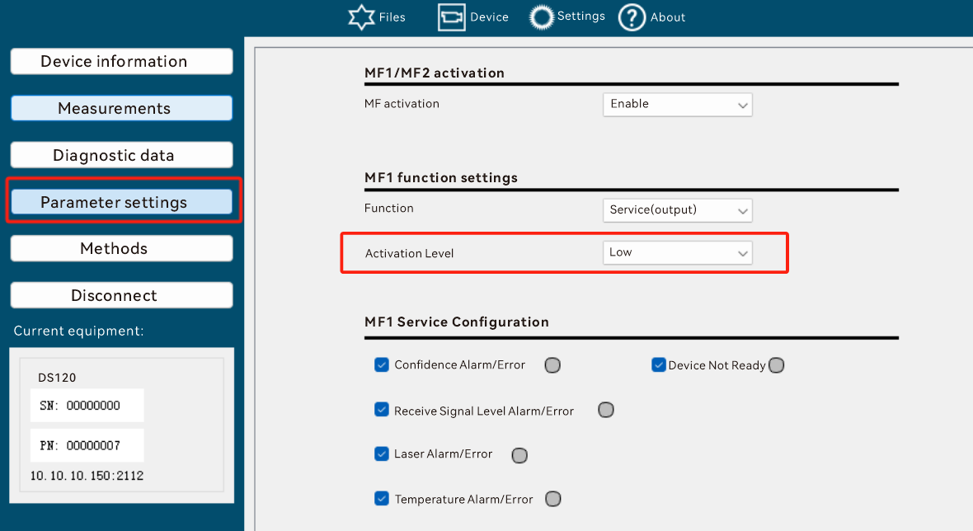

functionMF2 (0x0150)
Data Type:
UInt8
meaning:
Configuring the MF2 Function
* 0: Distance
* 1: Velocity
* 2: Service
default value:
2: Service
Data format:
read
Read Request:
02 02 02 02 00 00 00 05 73 52 49 01 50 39
Read Response:
02 02 02 02 00 00 00 06 73 52 41 01 50 01 30
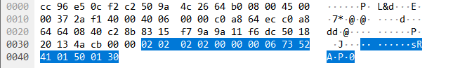

Write
Write Request
02 02 02 02 00 00 00 06 73 57 49 01 50 01 3d
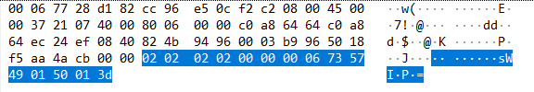
Write Response
02 02 02 02 00 00 00 05 73 57 41 01 50 34

DADISICK corresponding relationship:
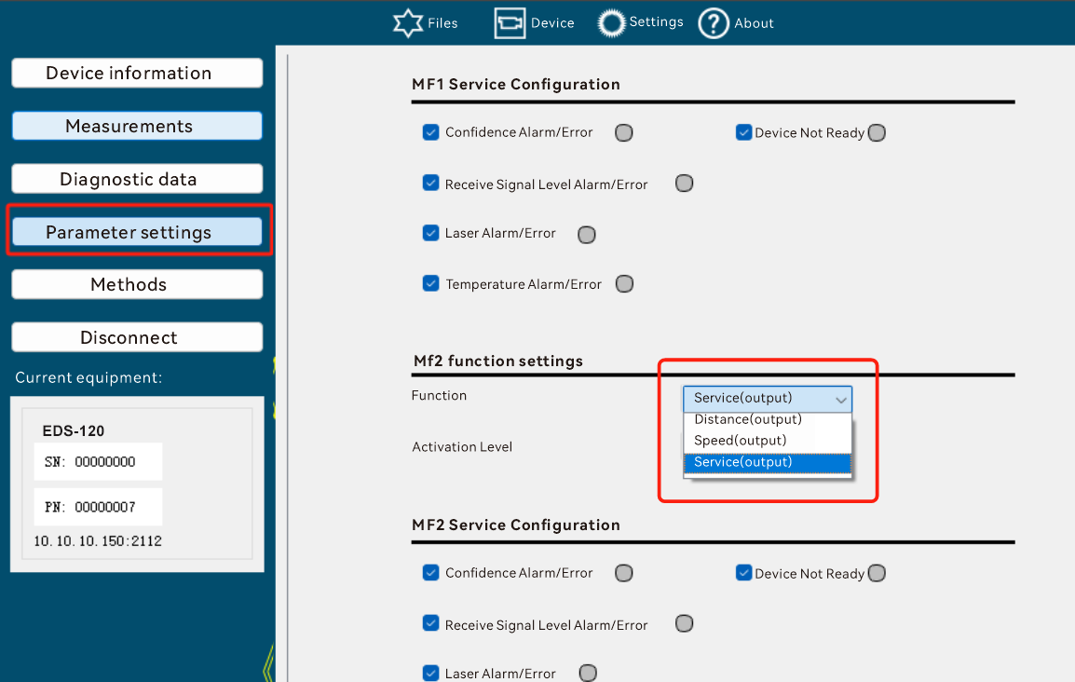

mf2ActiveState (0x0151)
Data Type:
Bool
meaning:
MF2 excitation state
0: High level
1: Low level
default value:
1: Low level
Data format:
read
Read Request:
02 02 02 02 00 00 00 05 73 52 49 01 51 38
Read Response:
02 02 02 02 00 00 00 06 73 52 41 01 51 01 31
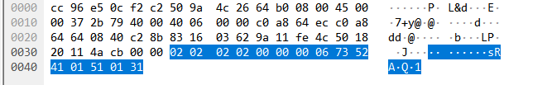

Write
Write Request
02 02 02 02 00 00 00 06 73 57 49 01 51 00 3d
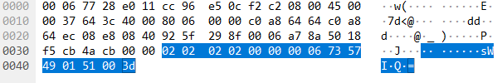
Write Response
02 02 02 02 00 00 00 05 73 57 41 01 51 35
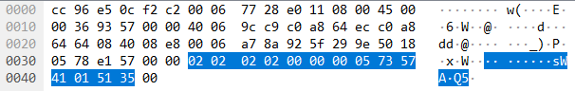
DADISICK corresponding relationship:
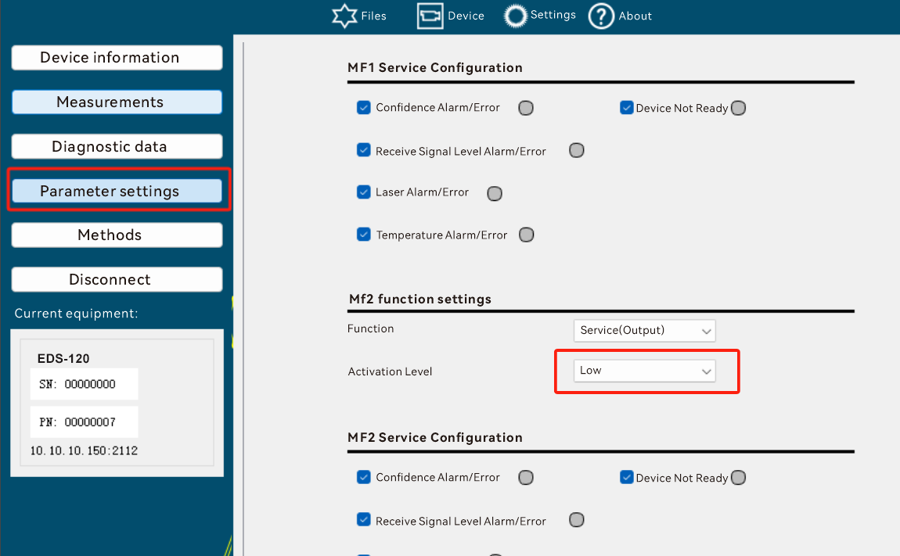

thresholdDistanceMF1 (0x0152)
Data Type:
Int32
meaning:
MF1 is configured as a distance alarm, the switching threshold of the distance value
Setting range: –300,000 … +300,000 [mm]
Unit: [mm]
default value:
Factory setting: 1,990 [mm]
Data format:
read
Read Request:
02 02 02 02 00 00 00 05 73 52 49 01 52 3b
Read Response:
02 02 02 02 00 00 00 09 73 52 41 01 52 00 00 00 64 57
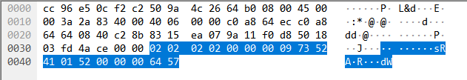

Write
Write Request
02 02 02 02 00 00 00 09 73 57 49 01 52 00 00 07 d0 e9
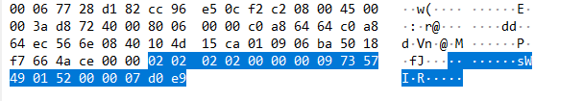
Write Response
02 02 02 02 00 00 00 05 73 57 41 01 52 36
DADISICK corresponding relationship:
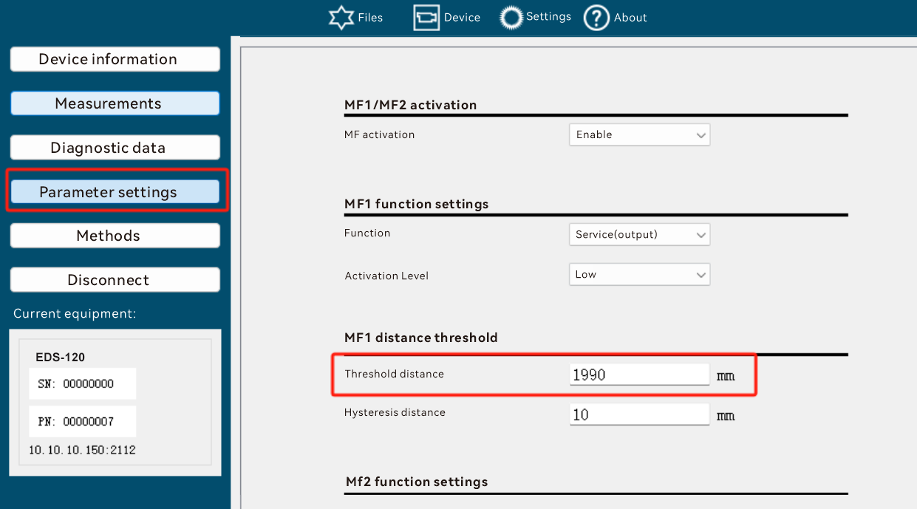

hysteresisDistanceMF1 (0x0153)
Data Type:
UInt32
meaning:
Distance switch threshold hysteresis
Setting range: 1… +300,000 [mm]
Unit: [mm]
default value:
10[mm]
Data format:
read
Read Request:
02 02 02 02 00 00 00 05 73 52 49 01 53 3a
Read Response:
02 02 02 02 00 00 00 09 73 52 41 01 53 00 00 00 0a 38
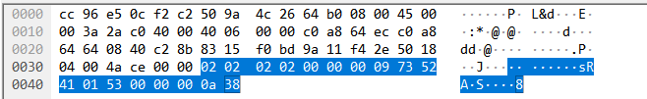

Write
Write Request
02 02 02 02 00 00 00 09 73 57 49 01 53 00 00 00 0a 35
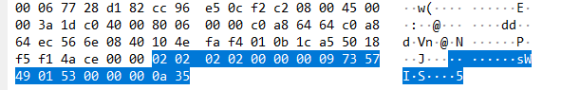
Write Response
02 02 02 02 00 00 00 05 73 57 41 01 53 37

DADISICK corresponding relationship:
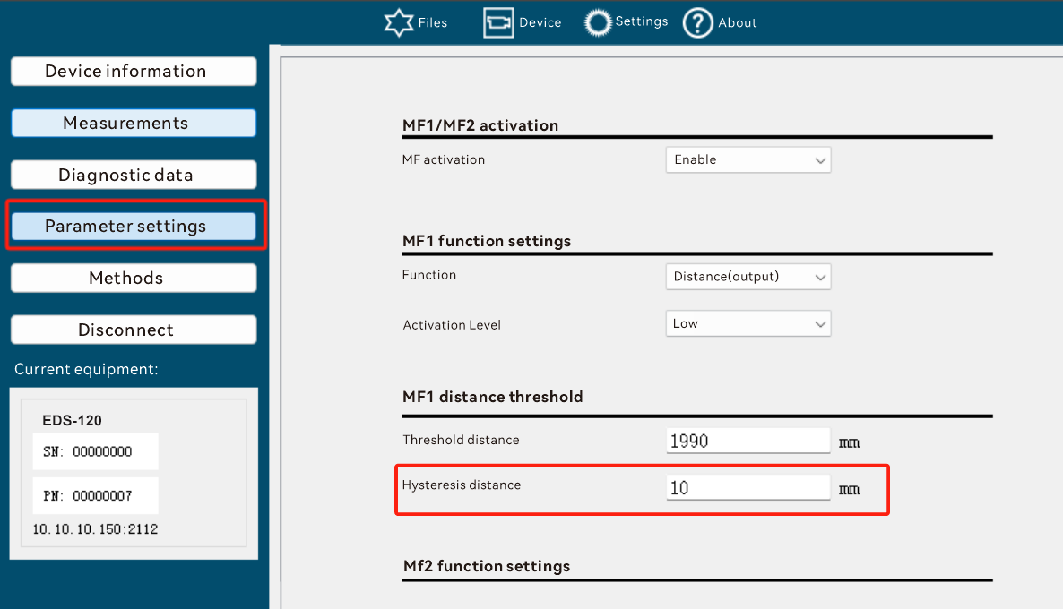

thresholdVelocityMF1 (0x0154)
Data Type:
UInt16
meaning:
When MF1 is set to speed excitation, the excitation threshold
Setting range: 50 … 15,000 [mm/s]
The switching hysteresis is fixed to 100 mm/s
Unit: [mm/s]
default value:
Factory setting: 5,000 [mm/s]
Data format:
read
Read Request:
02 02 02 02 00 00 00 05 73 52 49 01 54 3d
Read Response:
02 02 02 02 00 00 00 09 73 52 41 01 5f 00 00 03 e8d5
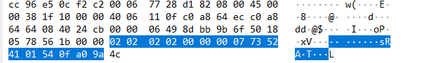

Write
Write Request
02 02 02 02 00 00 00 07 73 57 49 01 54 0f a0 97
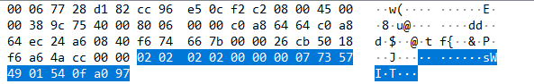
Write Response
02 02 02 02 00 00 00 05 73 57 41 01 54 30
DADISICK corresponding relationship:
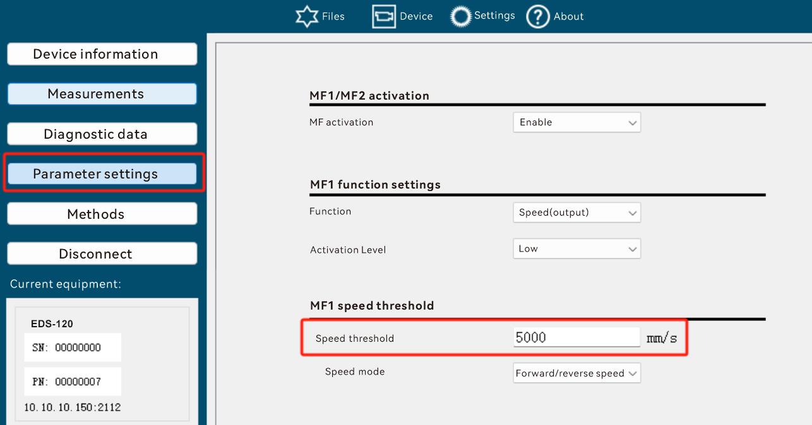

velocityModeMF1 (0x0155)
Data Type:
UInt8
meaning:
When set to velocity excitation, is it forward velocity excitation, reverse velocity excitation, or bidirectional excitation?
* 0: increasing
* 1: decreasing
* 2: in creasing /decreasing
default value:
Factory setting: 2 + / – (bidirectional excitation)
Data format:
read
Read Request:
02 02 02 02 00 00 00 05 73 52 49 01 55 3c

Read Response:
02 02 02 02 00 00 00 06 73 52 41 01 55 00 34
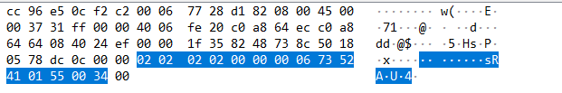

Write
Write Request
02 02 02 02 00 00 00 06 73 57 49 01 55 00 39

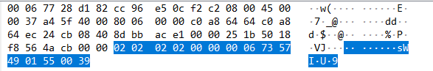
Write Response
02 02 02 02 00 00 00 05 73 57 41 01 55 31

DADISICK corresponding relationship:
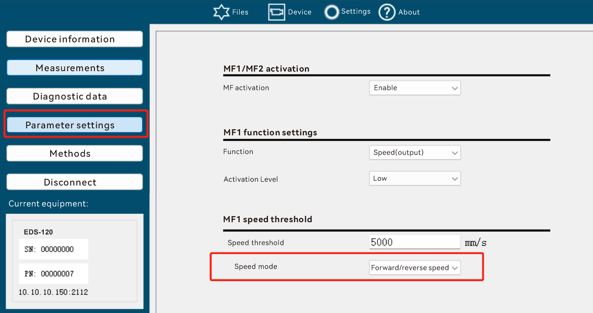

mf1LaserServiceSetup (0x0156)
Data Type:
Bool
meaning:
When MF1 is configured as a Service, whether to respond to Laser warnings and errors.
default value:
1: on, indicating that MF1 responds to Laser warnings/errors
Data format:
read
Read Request:
02 02 02 02 00 00 00 05 73 52 49 01 56 3f
Read Response:
02 02 02 02 00 00 00 06 73 52 41 01 56 00 37
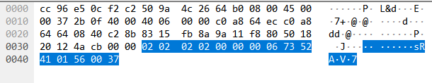
Write
Write Request
02 02 02 02 00 00 00 06 73 57 49 01 56 00 3a
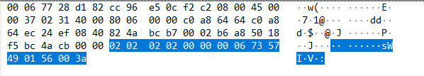
Write Response
02 02 02 02 00 00 00 05 73 57 41 01 56 32

DADISICK corresponding relationship:
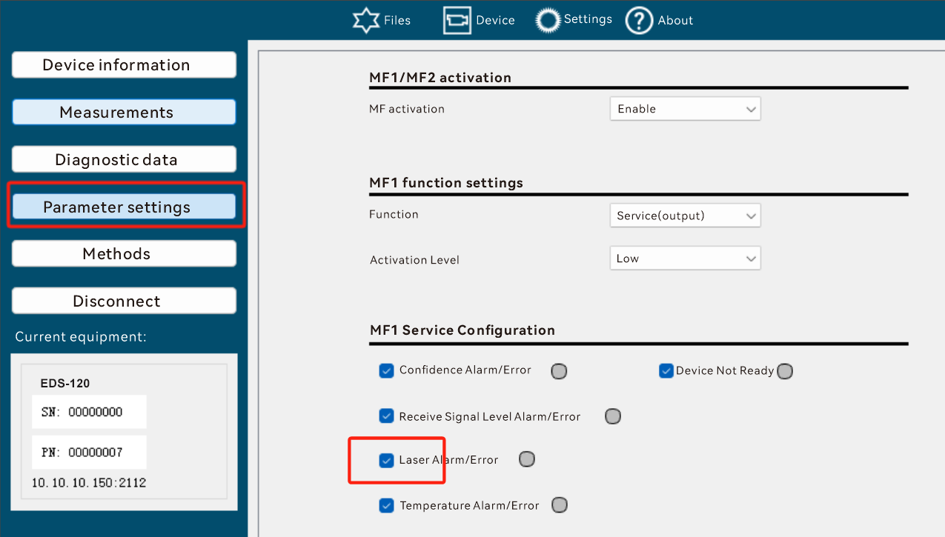

mf1LevelServiceSetup (0x0157)
Data Type:
Bool
meaning:
When MF1 is configured as a Service, whether to respond to Level warnings and errors.
default value:
1: on, indicating that MF1 responds to Level warning/error
Data format:
read
Read Request:
02 02 02 02 00 00 00 05 73 52 49 01 57 3e
Read Response:
02 02 02 02 00 00 00 06 73 52 41 01 57 00 36
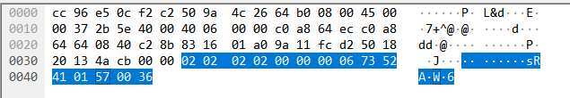

Write
Write Request
02 02 02 02 00 00 00 06 73 57 49 01 57 00 3b
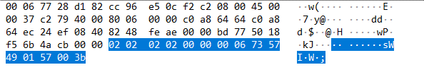
Write Response
02 02 02 02 00 00 00 05 73 57 41 01 57 33
DADISICK corresponding relationship:
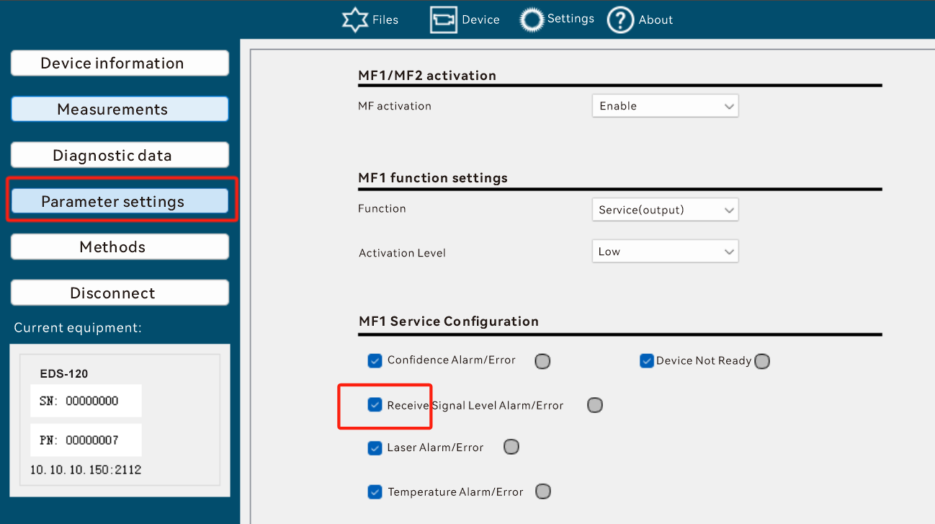

mf1TempServiceSetup (0x0158)
Data Type:
Bool
meaning:
When MF1 is configured as a Service, whether to respond to Temperature warnings and errors.
default value:
1: on, indicating that MF1 responds to Temperature warning/error
Data format:
read
Read Request:
02 02 02 02 00 00 00 05 73 52 49 01 58 31
Read Response:
02 02 02 02 00 00 00 06 73 52 41 01 58 00 39
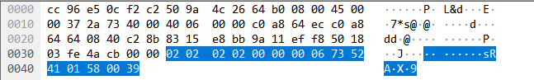

Write
Write Request
02 02 02 02 00 00 00 06 73 57 49 01 58 00 34
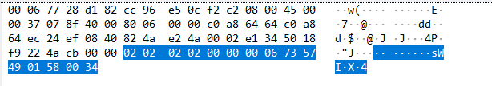
Write Response
02 02 02 02 00 00 00 05 73 57 41 01 58 3c

DADISICK corresponding relationship:
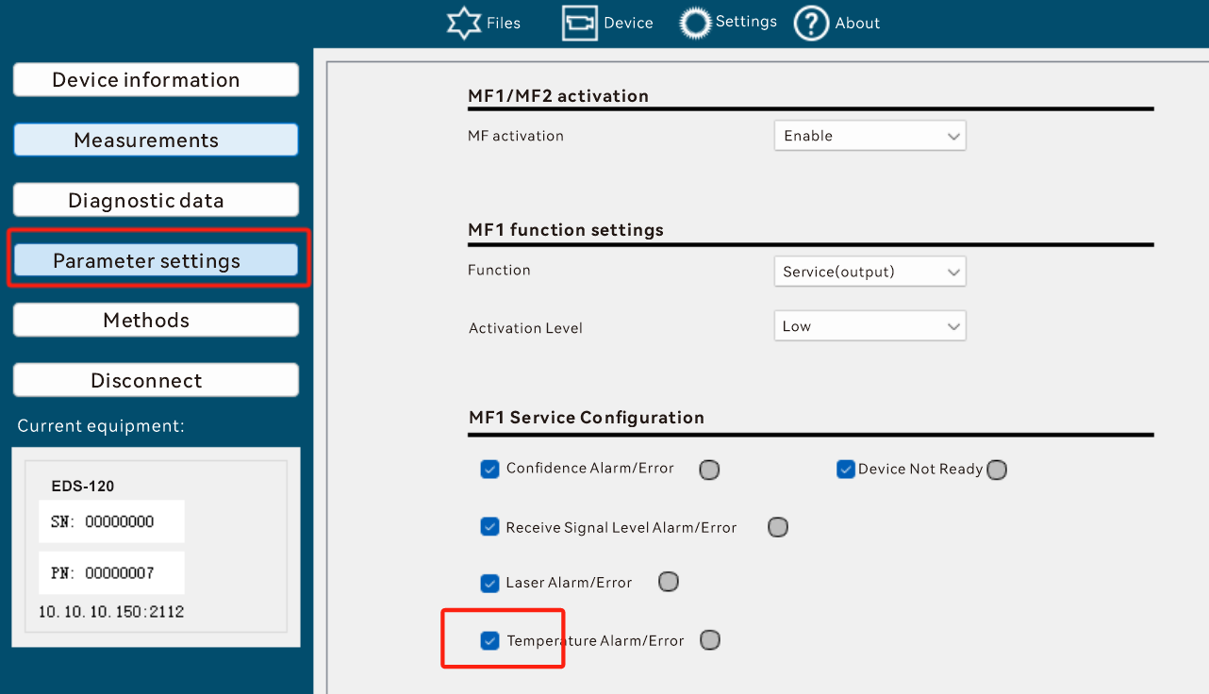

mf1PlausibServiceSetup (0x0159)
Data Type:
Bool
meaning:
Whether to respond to Plausibility warnings/errors when MF1 is configured as a Service.
default value:
1: on, MF1 responds to Plausibility warnings/errors
Data format:
read
Read Request:
02 02 02 02 00 00 00 05 73 52 49 01 59 30
Read Response:
02 02 02 02 00 00 00 06 73 52 41 01 59 00 38
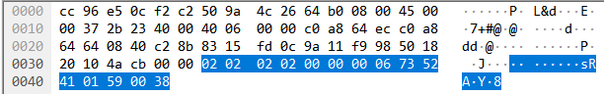

Write
Write Request
02 02 02 02 00 00 00 06 73 57 49 01 59 00 35
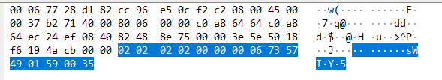
Write Response
02 02 02 02 00 00 00 05 73 57 41 01 59 3d
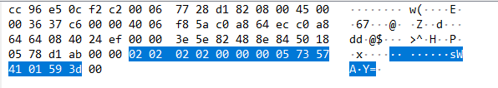

DADISICK corresponding relationship:
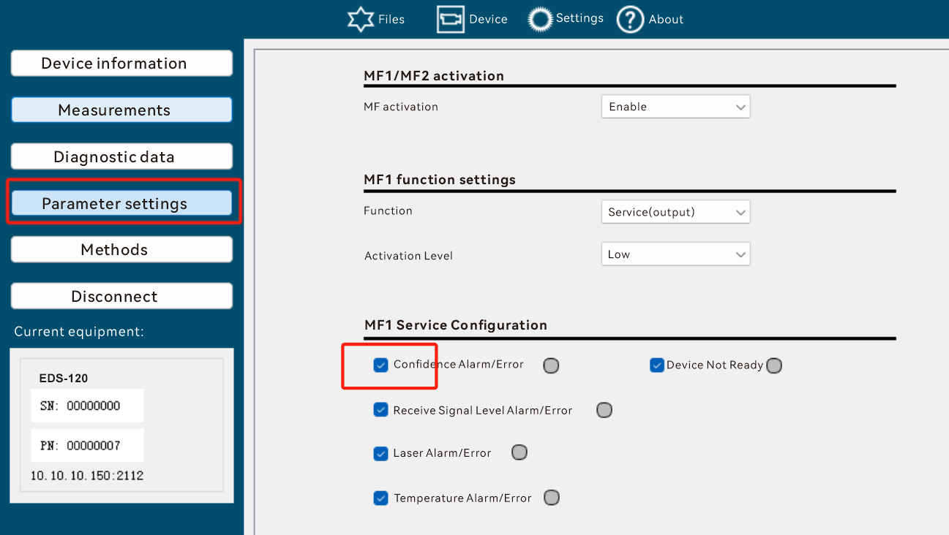

mf1ReadyServiceSetup (0x015a)
Data Type:
Bool
meaning:
Whether to respond to DeviceNotReady warnings when MF1 is configured as a Service.
default value:
1: on, indicating that MF1 responds to TemperatDeviceNotReadyure warning/error
Data format:
read
Read Request:
02 02 02 02 00 00 00 05 73 52 49 01 5a 33
Read Response:
02 02 02 02 00 00 00 06 73 52 41 01 5a 00 3b
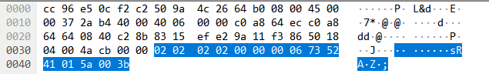

Write
Write Request
02 02 02 02 00 00 00 06 73 57 49 01 5a 00 36
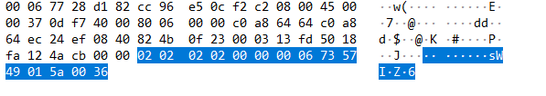
Write Response
02 02 02 02 00 00 00 05 73 57 41 01 5a 3e

DADISICK corresponding relationship:
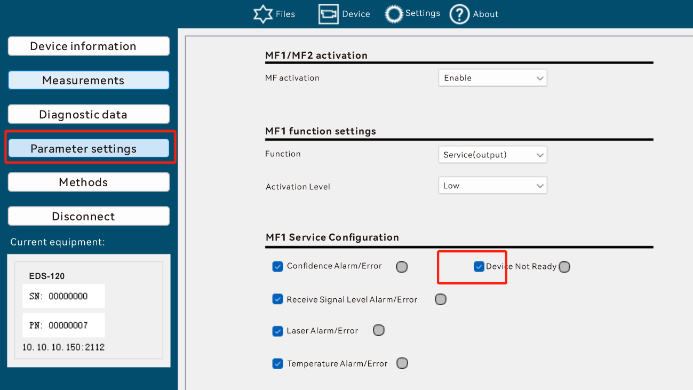

mf1switchCounter(0x015c)
Data Type:
UInt32
meaning:
Number of MF1 excitations.
Data format:
read
Read Request:
02 02 02 02 00 00 00 05 73 52 49 01 5c 35
Read Response:
02 02 02 02 00 00 00 09 73 52 41 01 5c 00 00 00 04 39
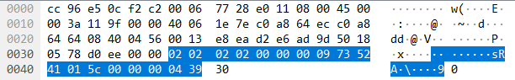

Not writable

DADISICK corresponding relationship:
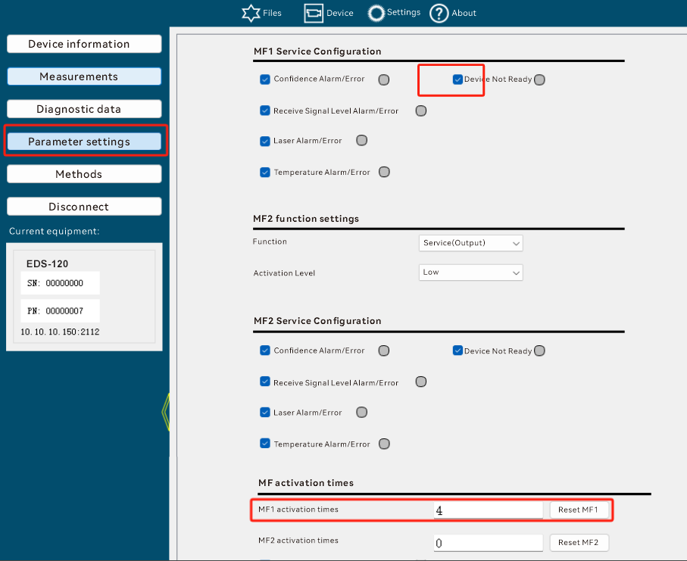

thresholdDistanceMF2(0x015d)
Data Type:
Int32
meaning:
MF2 is configured as a distance alarm, and the switching threshold of the distance value
Setting range: –300,000 … +300,000 [mm]
Unit: [mm]
default value:
Factory setting: 1,990 [mm]
Data format:
read
Read Request:
02 02 02 02 00 00 00 05 73 52 49 01 5d 34
Read Response:
02 02 02 02 00 00 00 09 73 52 41 01 5d 00 00 07 d0 eb
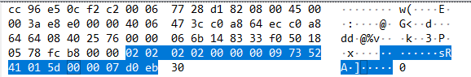

Write
Write Request
02 02 02 02 00 00 00 09 73 57 49 01 5d 00 00 07 d0 e6
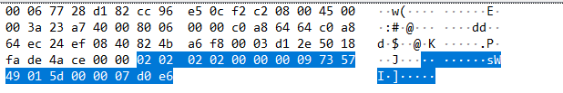
Write Response
02 02 02 02 00 00 00 05 73 57 41 01 5d 39
DADISICK corresponding relationship:
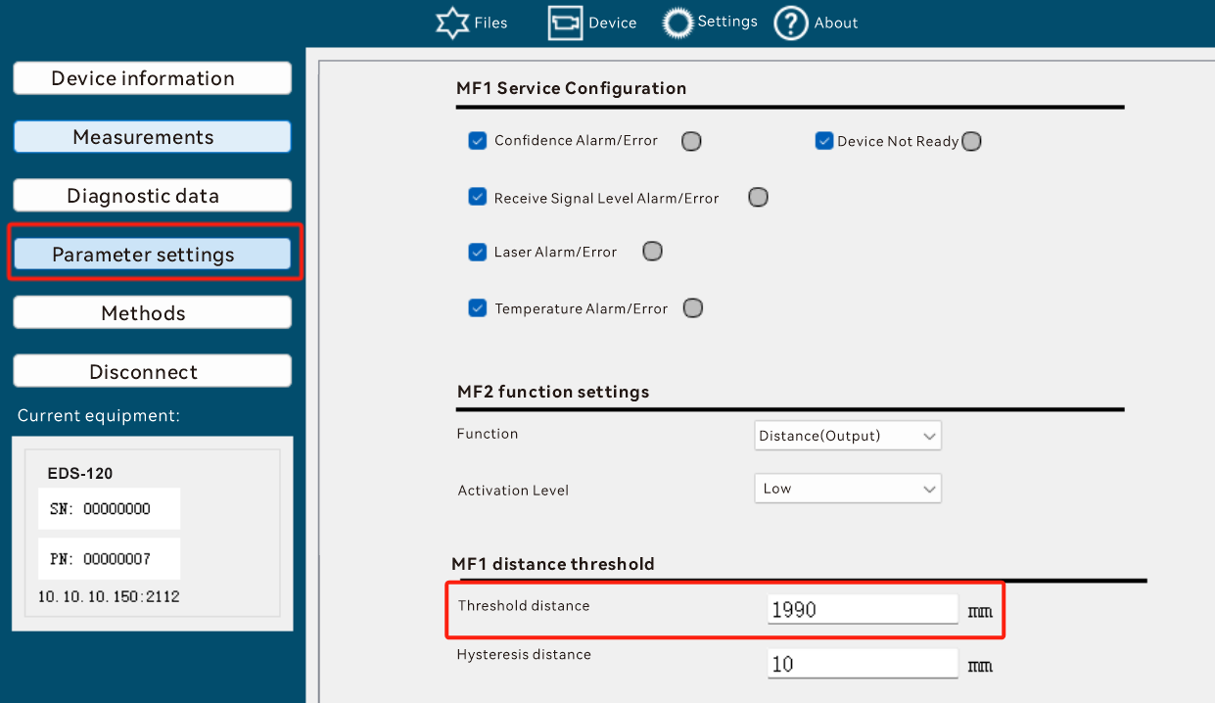

hysteresisDistanceMF2(0x015e)
Data Type:
Int32
meaning:
Distance switch threshold hysteresis
Setting range: 1… +300,000 [mm]
Unit: [mm]
default value:
10[mm]
Data format:
read
Read Request:
02 02 02 02 00 00 00 05 73 52 49 01 5e 37
Read Response:
02 02 02 02 00 00 00 09 73 52 41 01 5e 00 00 00
0a 35
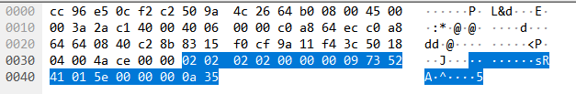

Write
Write Request
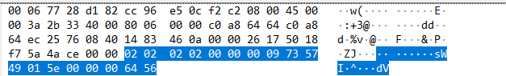
Write Response
02 02 02 02 00 00 00 05 73 57 41 01 5e 3a

DADISICK corresponding relationship:
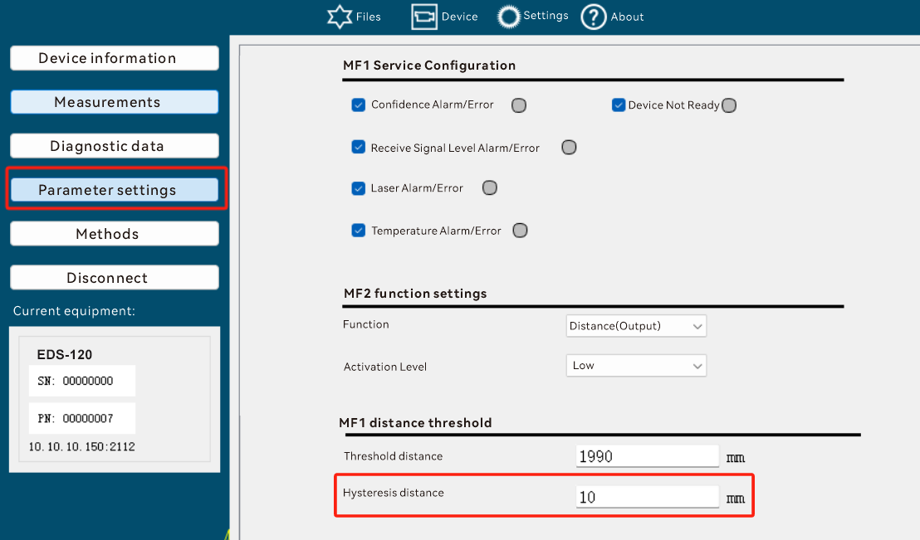

thresholdVelocityMF2 (0x015f)
Data Type:
UInt16
meaning:
When MF2 is set to speed excitation, the excitation threshold
Setting range: 50 … 15,000 [mm/s]
The switching hysteresis is fixed to 100 mm/s
Unit: [mm/s]
default value:
Factory setting: 5,000 [mm/s]
Data format:
read
Read Request:
02 02 02 02 00 00 00 05 73 52 49 01 5f 36
Read Response:
02 02 02 02 00 00 00 07 73 52 41 01 5f 0f a0 91
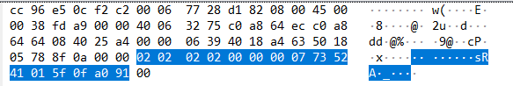

Write
Write Request
02 02 02 02 00 00 00 07 73 57 49 01 5f 0f a0 9c

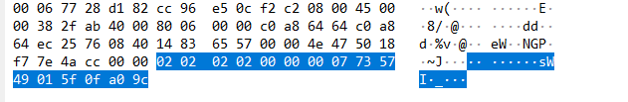
Write Response
02 02 02 02 00 00 00 05 73 57 41 01 5f 3b

DADISICK corresponding relationship:
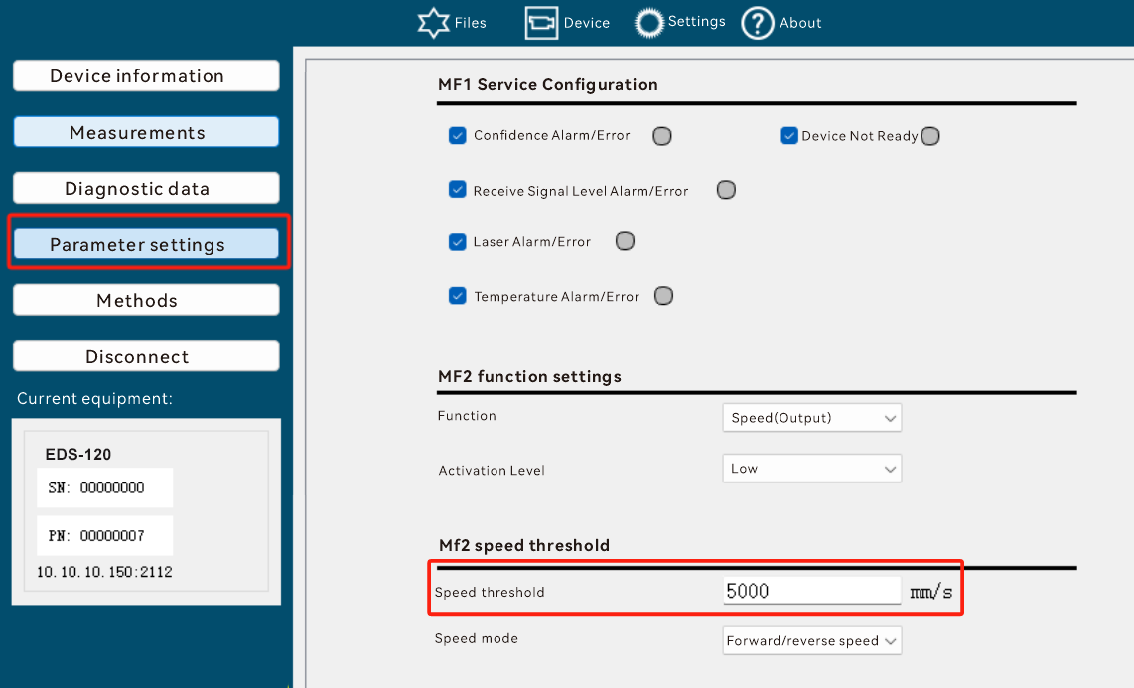

velocityModeMF2 (0x0160)
Data Type:
UInt8
meaning:
When set to velocity excitation, is it forward velocity excitation, reverse velocity excitation, or bidirectional excitation?
* 0: increasing
* 1: decreasing
* 2: in-/decreasing
default value:
Factory setting: 2 + / – (bidirectional excitation)
Data format:
read
Read Request:
02 02 02 02 00 00 00 05 73 52 49 01 60 09
Read Response:
02 02 02 02 00 00 00 06 73 52 41 01 60 02 03
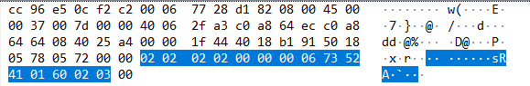

Write
Write Request
02 02 02 02 00 00 00 06 73 57 49 01 60 00 0c
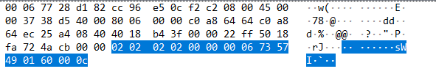

Write Response
02 02 02 02 00 00 00 05 73 57 41 01 60 04

DADISICK corresponding relationship:
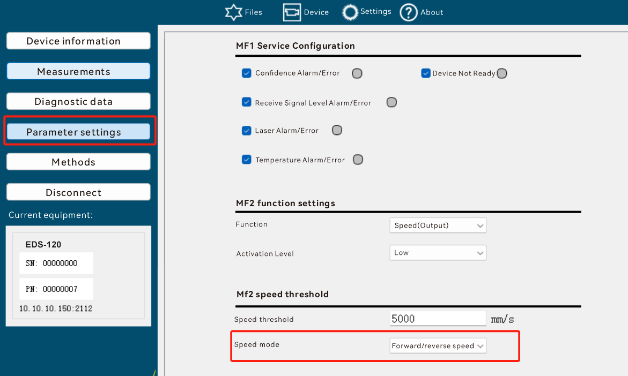

mf2LaserServiceSetup(0x0161)
Data Type:
Bool
meaning:
Whether to respond to Laser warnings/errors when MF2 is configured as a service.
default value:
1: on, indicating that MF2 responds to Laser warnings/errors
Data format:
read
Read Request:
02 02 02 02 00 00 00 05 73 52 49 01 61 08
Read Response:
02 02 02 02 00 00 00 06 73 52 41 01 61 00 00
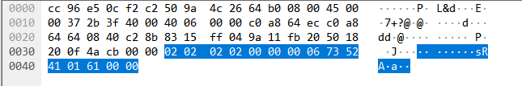

Write
Write Request
02 02 02 02 00 00 00 06 73 57 49 01 61 00 0d

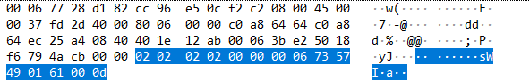
Write Response
02 02 02 02 00 00 00 05 73 57 41 01 61 05

DADISICK corresponding relationship:
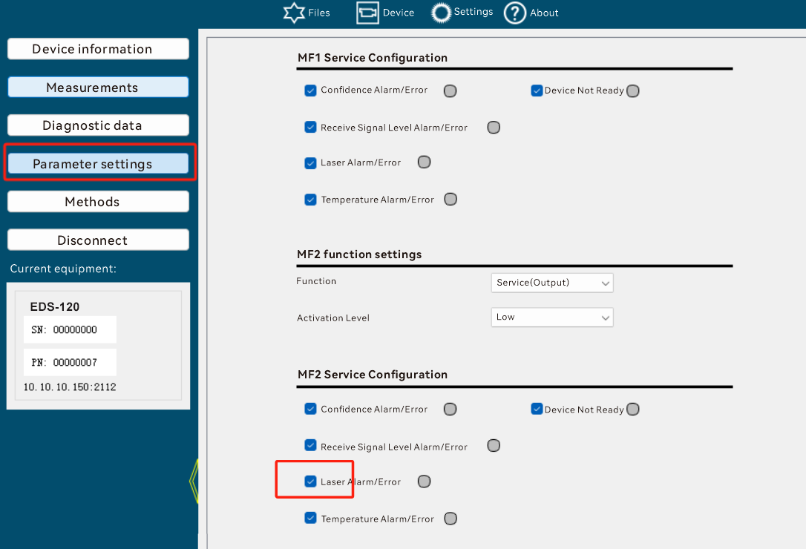

mf2LevelServiceSetup(0x0162)
Data Type:
Bool
meaning:
Whether to respond to Level warning/error when MF2 is configured as a service.
default value:
1: on, indicating that MF2 responds to Level warning/error
Data format:
read
Read Request:
02 02 02 02 00 00 00 05 73 52 49 01 62 0b
Read Response:
02 02 02 02 00 00 00 06 73 52 41 01 62 00 03
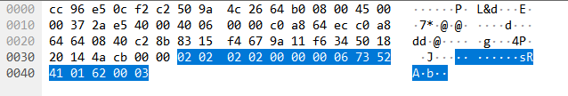

Write
Write Request
02 02 02 02 00 00 00 06 73 57 49 01 62 00 0e

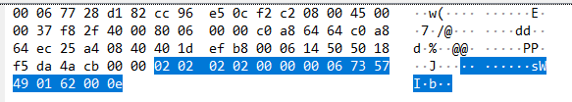
Write Response
02 02 02 02 00 00 00 05 73 57 41 01 62 06

DADISICK corresponding relationship:
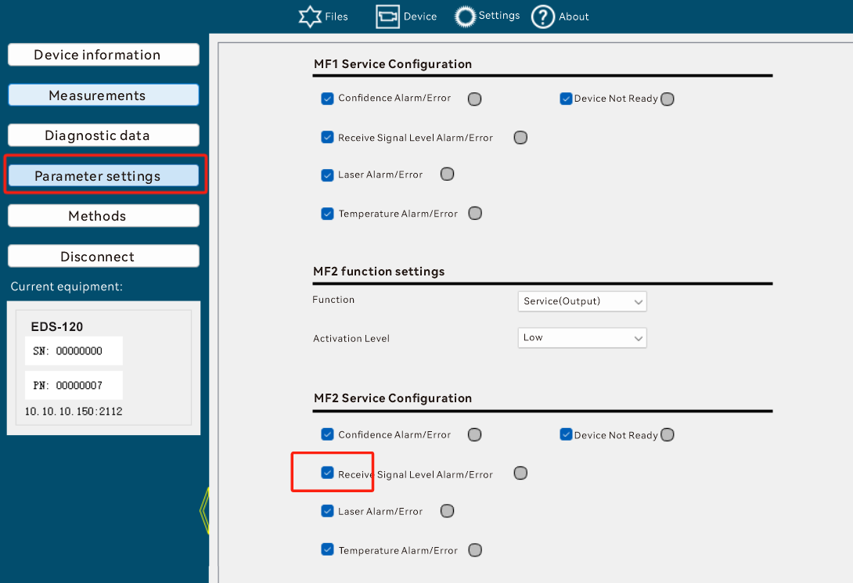

mf2TempServiceSetup(0x0163)
Data Type:
Bool
meaning:
Whether to respond to Temperature warnings/errors when MF2 is configured as a service.
default value:
1: on, indicating that MF2 responds to Temperature warning/error
Data format:
read
Read Request:
02 02 02 02 00 00 00 05 73 52 49 01 63 0a
Read Response:
02 02 02 02 00 00 00 06 73 52 41 01 63 00 02
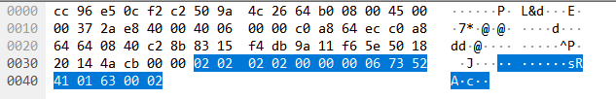

Write
Write Request
02 02 02 02 00 00 00 06 73 57 49 01 63 00 0f
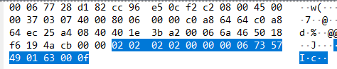
Write Response
02 02 02 02 00 00 00 05 73 57 41 01 63 07

DADISICK corresponding relationship:
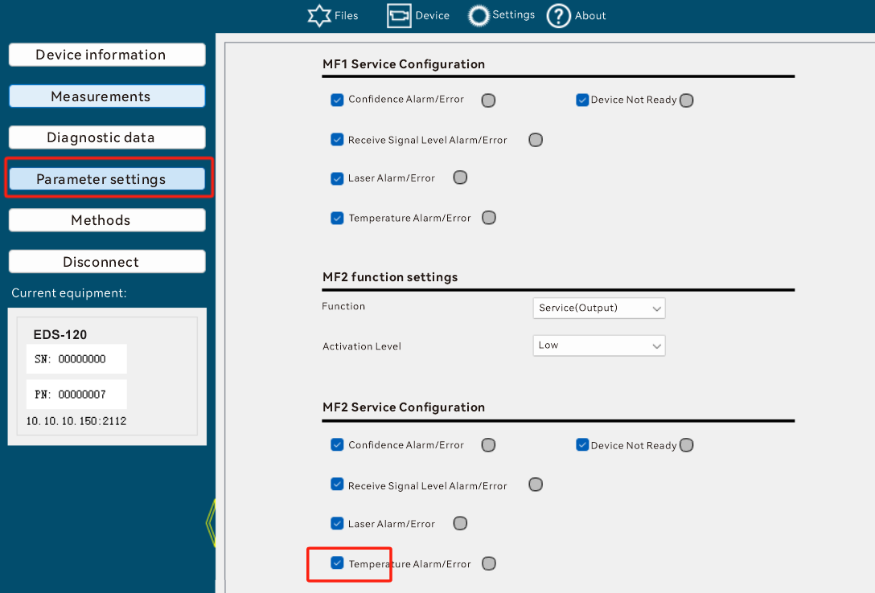

mf2PlausibServiceSetup(0x0164)
Data Type:
Bool
meaning:
Whether to respond to Plausibility warnings/errors when MF2 is configured as a service.
default value:
1: on, MF2 responds to Plausibility warnings/errors
Data format:
read
Read Request:
02 02 02 02 00 00 00 05 73 52 49 01 64 0d
Read Response:
02 02 02 02 00 00 00 06 73 52 41 01 64 00 05
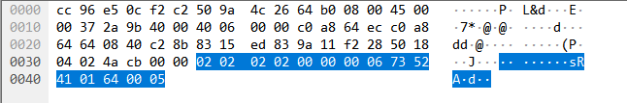

Write
Write Request
02 02 02 02 00 00 00 06 73 57 49 01 64 00 08
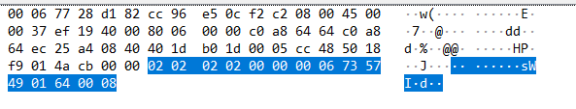
Write Response
02 02 02 02 00 00 00 05 73 57 41 01 64 00

DADISICK corresponding relationship:
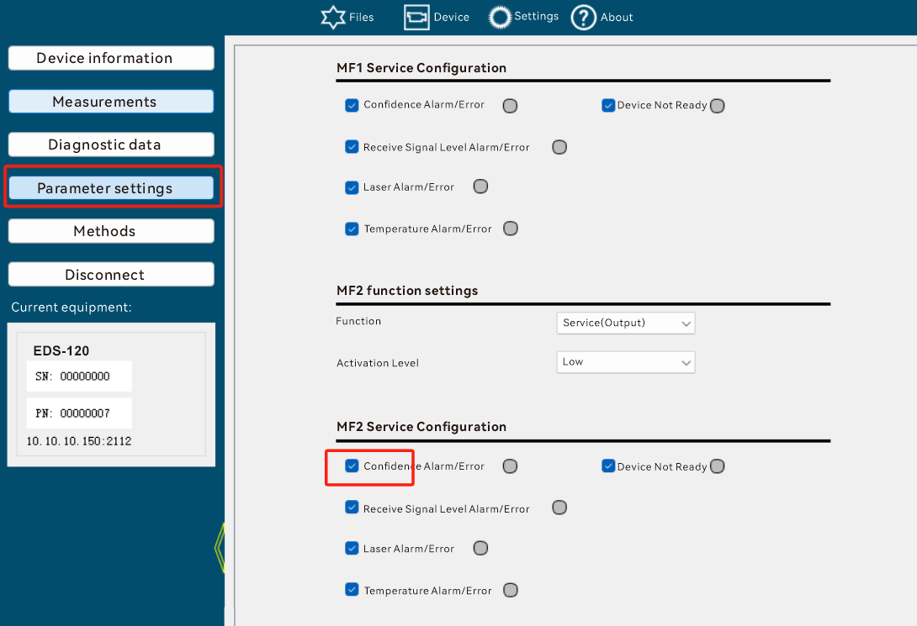

mf2ReadyServiceSetup(0x0165)
Data Type:
Bool
meaning:
Whether to respond to DeviceNotReady warnings when MF2 is configured as a service.
default value:
1: on, indicating that MF2 responds to DeviceNotReady warning/error
Data format:
read
Read Request:
02 02 02 02 00 00 00 05 73 52 49 01 65 0c
Read Response:
02 02 02 02 00 00 00 06 73 52 41 01 65 00 04
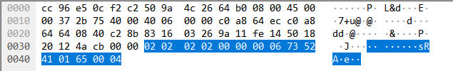

Write
Write Request
02 02 02 02 00 00 00 06 73 57 49 01 65 00 09

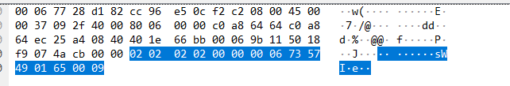
Write Response
02 02 02 02 00 00 00 05 73 57 41 01 65 01
DADISICK corresponding relationship:
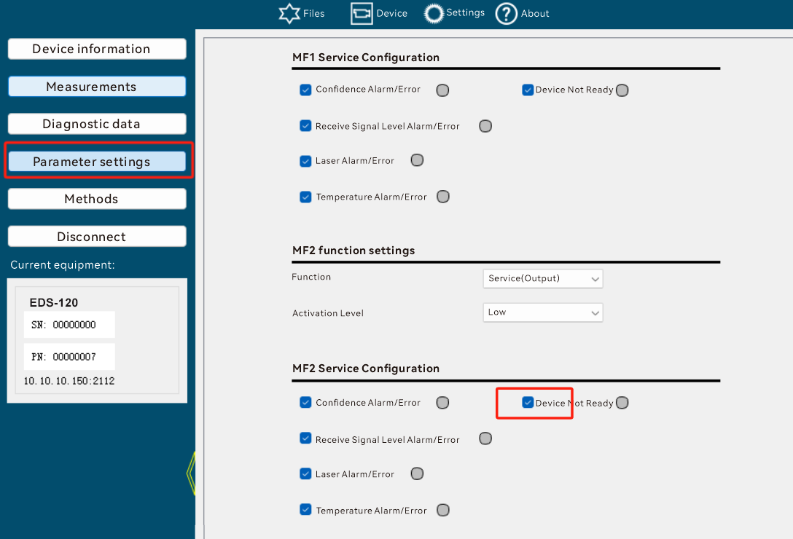

mf2switchCounter(0x0167)
Data Type:
UInt32
meaning:
Number of MF2 excitations.
Data format:
read
Read Request:
02 02 02 02 00 00 00 05 73 52 49 01 67 0e
Read Response:
02 02 02 02 00 00 00 09 73 52 41 01 67 00 00 00 a9 af
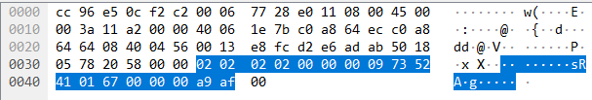

Not writable

DADISICK corresponding relationship:
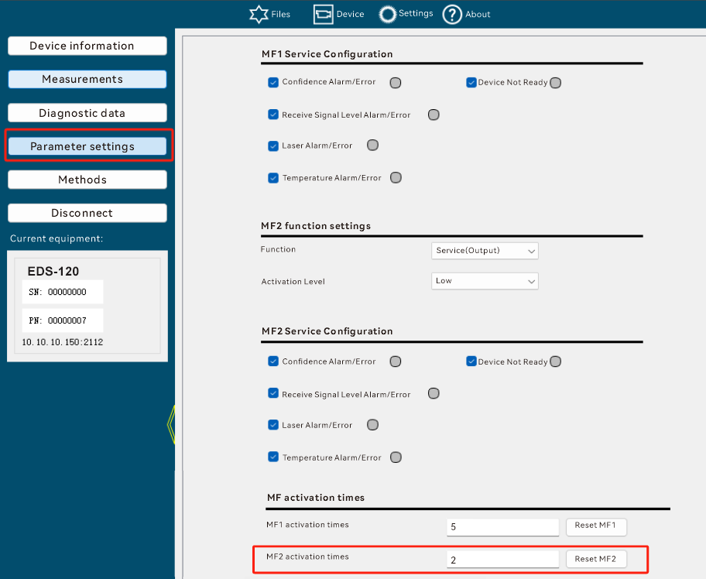

averageFilterDistance(0x0168)
Data Type:
UInt8
meaning:
Selecting filter characteristics for distance measurements
0: Fast filtering
1: Medium speed filtering
2: Slow filtering
default value:
1: Medium speed filtering
Data format:
read
Read Request:
02 02 02 02 00 00 00 05 73 52 49 01 68 01
Read Response:
02 02 02 02 00 00 00 06 73 52 41 01 68 02 0b
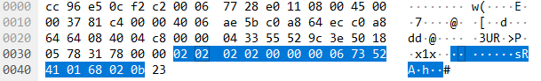

Write
Write Request
02 02 02 02 00 00 00 06 73 57 49 01 68 01 05
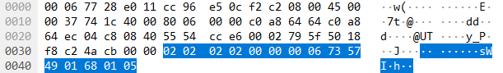
Write Response
02 02 02 02 00 00 00 05 73 57 41 01 68 0c
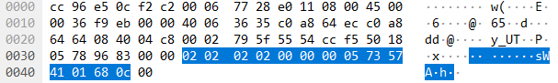

DADISICK corresponding relationship:
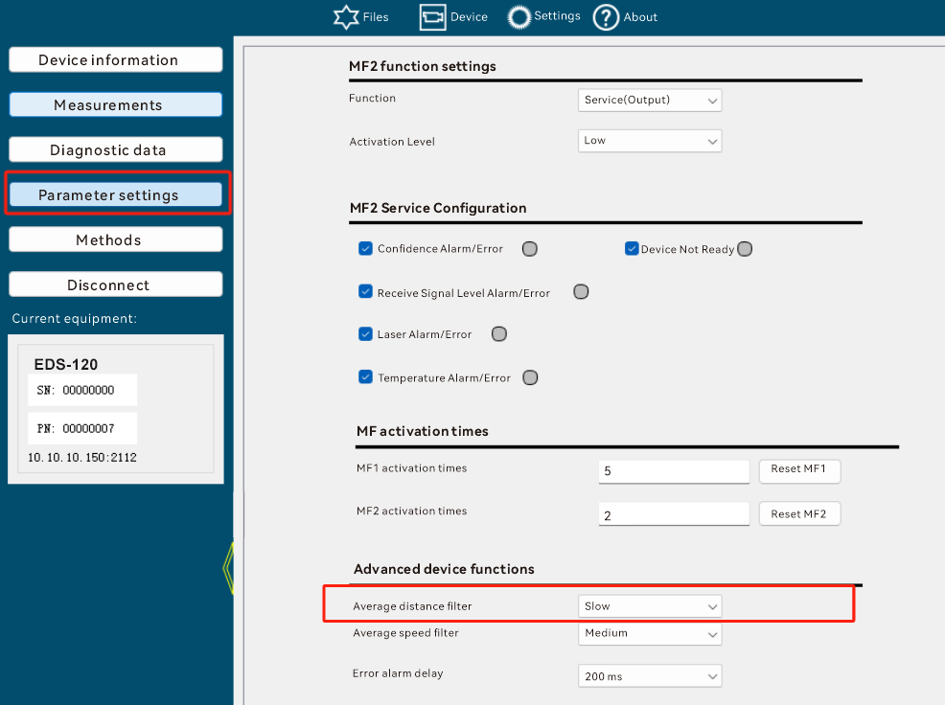

errorRejection(0x016a)
Data Type:
UInt8
meaning:
Select the maximum error suppression time. If a measurement is not possible due to a fault (e.g. a brief light beam interruption), the measured value is extrapolated at most until the end of the set error suppression time. During this time, the WrnPlb plausibility warning is output. If measurement is still not possible after the error suppression time has expired, a measured value of 0, a plausibility error ErrPlb and possibly other faults (eg level error ErrLvl) are output.
0: off
1: 50ms
2: 200ms
default value:
2: 200ms
Data format:
read
Read Request:
02 02 02 02 00 00 00 05 73 52 49 01 6a 03

Read Response:
02 02 02 02 00 00 00 06 73 52 41 01 6a 00 0b

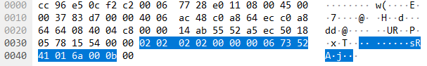

Write
Write Request
02 02 02 02 00 00 00 06 73 57 49 01 6a 02 04
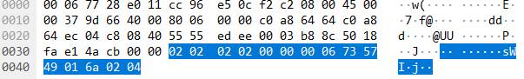
Write Response
02 02 02 02 00 00 00 05 73 57 41 01 6a 0e
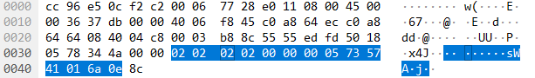
DADISICK corresponding relationship:
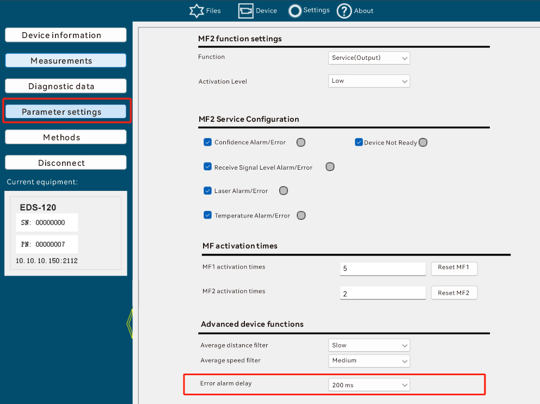

ssiProtocol (0x016b)
Data Type:
UInt8
meaning:
SSI communication protocol type
*0: twenty four Bit gray + Error(binary)
*1: twenty four Bit gray
*2: 25 Bit gray
*3: twenty four Bit binary + Error(binary)
*4: twenty four Bit binary
*5: 25 Bit binary
default value:
0, indicating Gry24E
Data format:
read
Read Request:
02 02 02 02 00 00 00 05 73 52 49 01 6b 02

Read Response:
02 02 02 02 00 00 00 06 73 52 41 01 6b 00 0a
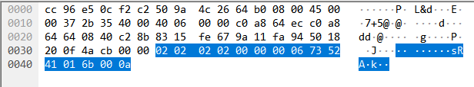

Write
Write Request
02 02 02 02 00 00 00 06 73 57 49 01 6b 01 06

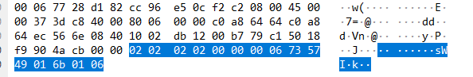
Write Response
02 02 02 02 00 00 00 05 73 57 41 01 6b 0f
DADISICK corresponding relationship:
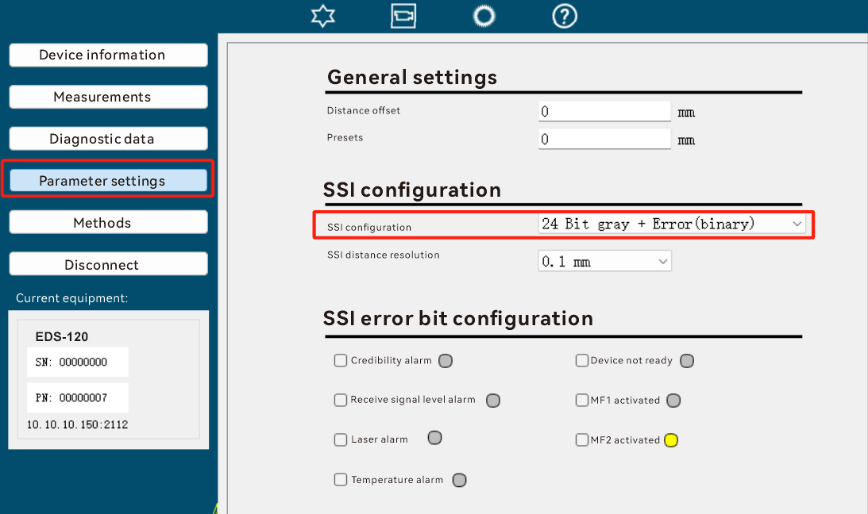

ssiResolution (0x016c)
Data Type:
UInt8
meaning:
Select distance resolution
0:0.1mm,
1:0.125mm,
2:1mm,
3:10mm,
4:100mm
default value:
0, means 0.1mm.
Data format:
read
Read Request:
02 02 02 02 00 00 00 05 73 52 49 01 6c 05
Read Response:
02 02 02 02 00 00 00 06 73 52 41 01 6c 00 0d
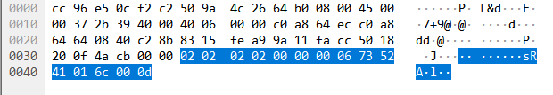

Write

Write Request
02 02 02 02 00 00 00 06 73 57 49 01 6c 02 02
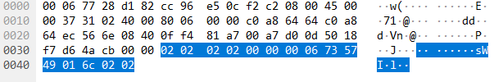
Write Response
02 02 02 02 00 00 00 05 73 57 41 01 6c 08

DADISICK corresponding relationship:
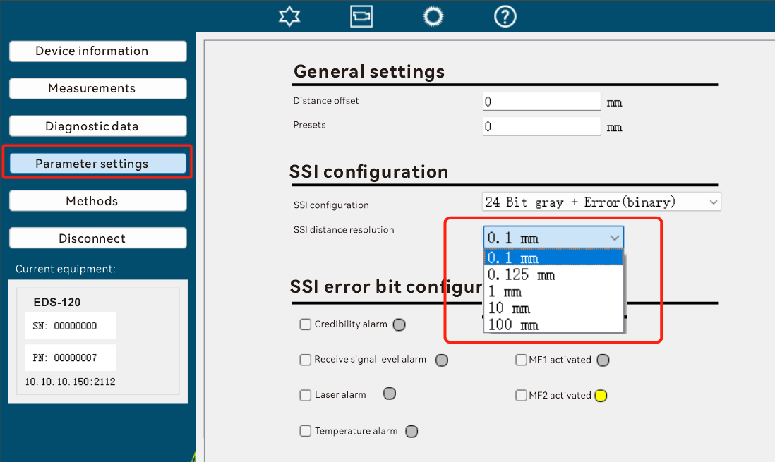

ssiLaserServiceSetup (0x016d)
Data Type:
Bool
meaning:
SSI error code configuration, whether to alarm when there is LaserWarning.
Data format:
default value:
0
read
Read Request:
02 02 02 02 00 00 00 05 73 52 49 01 6d 04
Read Response:
02 02 02 02 00 00 00 06 73 52 41 01 6d 00 0c
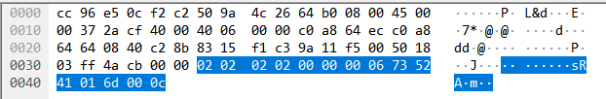

Write
Write Request
02 02 02 02 00 00 00 06 73 57 49 01 6d 01 00
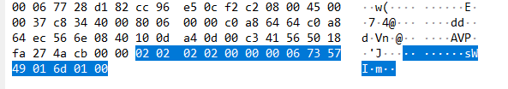
Write Response
02 02 02 02 00 00 00 05 73 57 41 01 6d 09
DADISICK corresponding relationship:
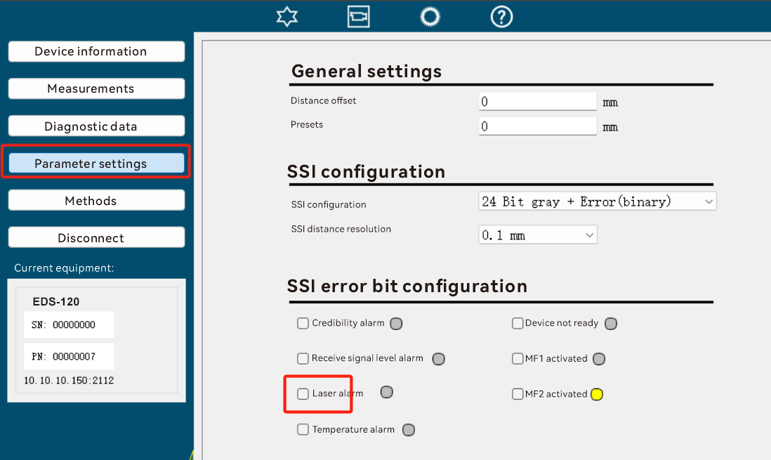

ssiTemperatureServiceSetup (0x016e)
Data Type:
Bool
meaning:
SSI error code configuration, whether to alarm when there is a TemperatureWarning.
default value:
0
Data format:
read
Read Request:
02 02 02 02 00 00 00 05 73 52 49 01 6e 07
Read Response:
02 02 02 02 00 00 00 06 73 52 41 01 6e 00 0f
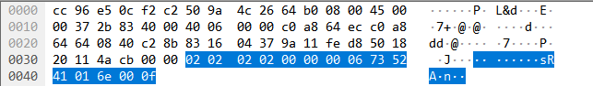

Write
Write Request
02 02 02 02 00 00 00 06 73 57 49 01 6e 01 03
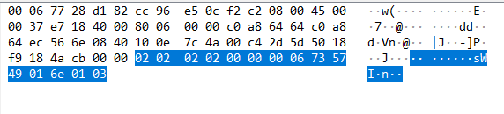
Write Response
02 02 02 02 00 00 00 05 73 57 41 01 6e 0a

DADISICK corresponding relationship:
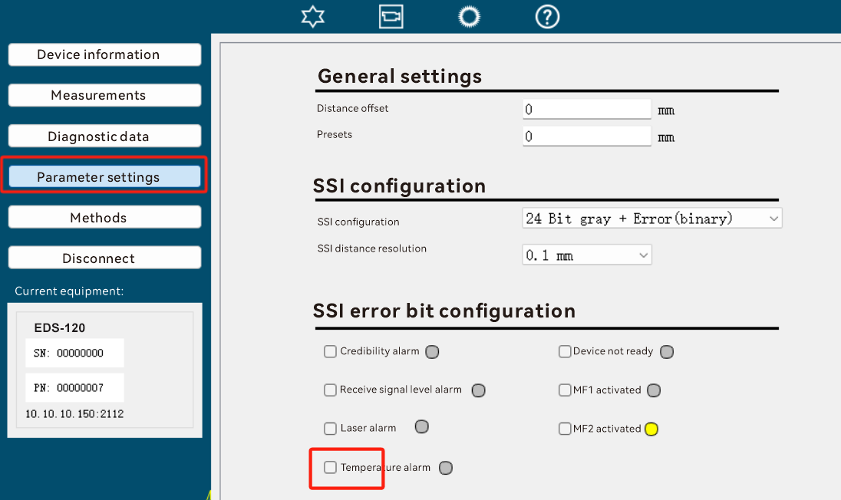

ssiLevelServiceSetup (0x016f)
Data Type:
Bool
meaning:
SSI error code configuration, whether to alarm when there is LevelWarning.
default value:
0
Data format:
read
Read Request:
02 02 02 02 00 00 00 05 73 52 49 01 6f 06
Read Response:
02 02 02 02 00 00 00 06 73 52 41 01 6f 00 0e
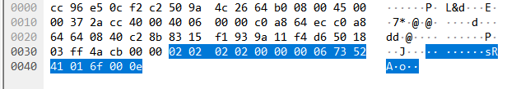

Write
Write Request
02 02 02 02 00 00 00 06 73 57 49 01 6f 01 02
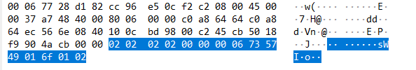
Write Response
02 02 02 02 00 00 00 05 73 57 41 01 6f 0b

DADISICK corresponding relationship:
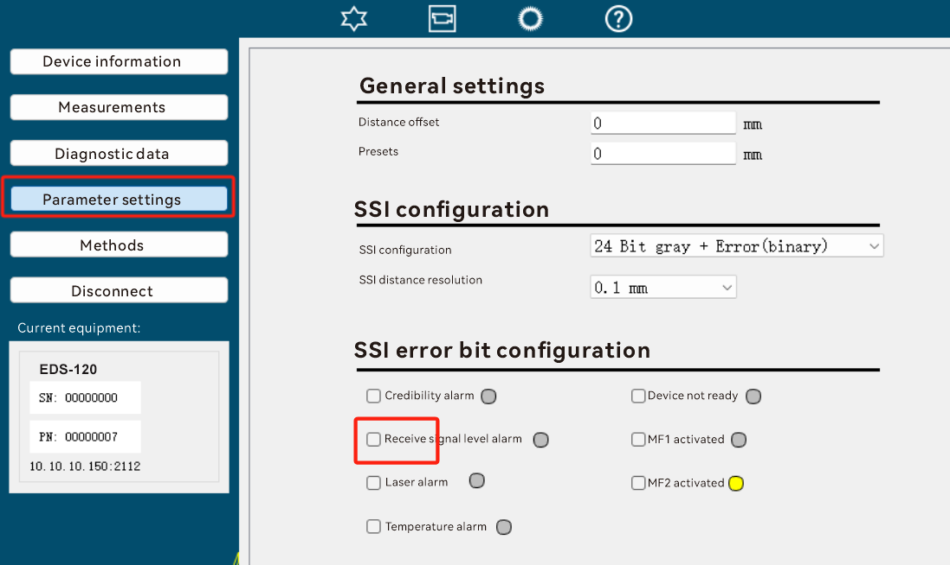

ssiReadyServiceSetup (0x0170)
Data Type:
Bool
meaning:
SSI error code configuration, whether to alarm when there is DeviceNotReadyWarning.
default value:
0
Data format:
read
Read Request:
02 02 02 02 00 00 00 05 73 52 49 01 70 19
Read Response:
02 02 02 02 00 00 00 06 73 52 41 01 70 00 11
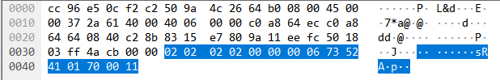

Write
Write Request
02 02 02 02 00 00 00 06 73 57 49 01 70 01 1d
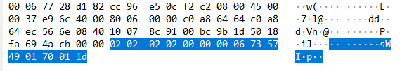
Write Response
02 02 02 02 00 00 00 05 73 57 41 01 70 14

DADISICK corresponding relationship:
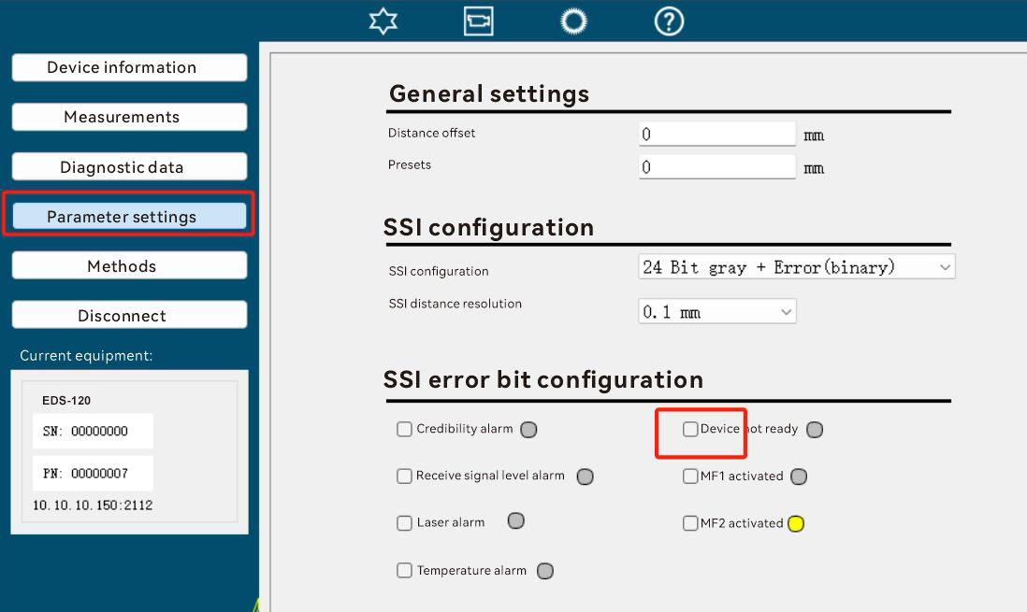

ssiPlausibilityServiceSetup (0x0171)
Data Type:
Bool
meaning:
SSI error code configuration, whether to alarm when PlausibilityWarning occurs.
default value:
0
Data format:
read
Read Request:
02 02 02 02 00 00 00 05 73 52 49 01 71 18
Read Response:
02 02 02 02 00 00 00 06 73 52 41 01 71 00 10
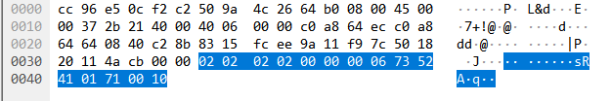

Write
Write Request
02 02 02 02 00 00 00 06 73 57 49 01 71 01 1c
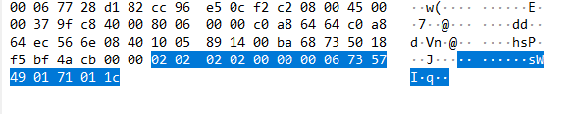
Write Response
02 02 02 02 00 00 00 05 73 57 41 01 71 15

DADISICK corresponding relationship:
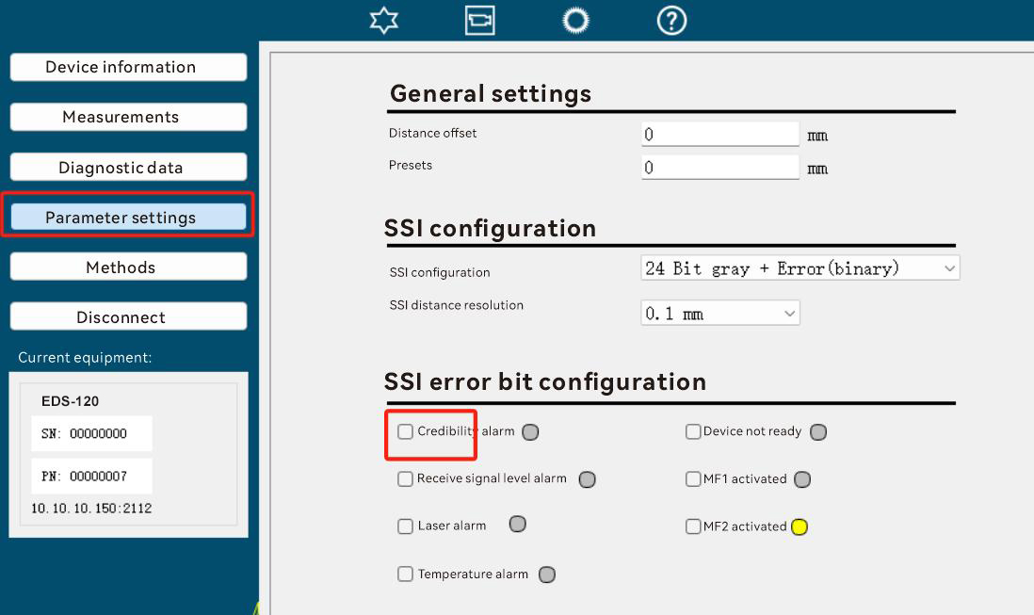

ssiMf1ServiceSetup ( 0x0173 )
Data Type:
Bool
meaning:
SSI error code configuration, whether to alarm when MF1 is triggered.
default value:
0
Data format:
read
Read Request:
02 02 02 02 00 00 00 05 73 52 49 01 73 1a
Read Response:
02 02 02 02 00 00 00 06 73 52 41 01 73 01 13
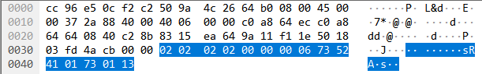

Write
Write Request
02 02 02 02 00 00 00 06 73 57 49 01 73 01 1e
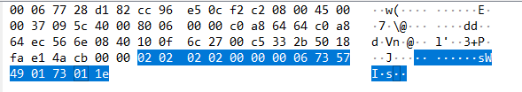
Write Response
02 02 02 02 00 00 00 05 73 57 41 01 73 17

DADISICK corresponding relationship:
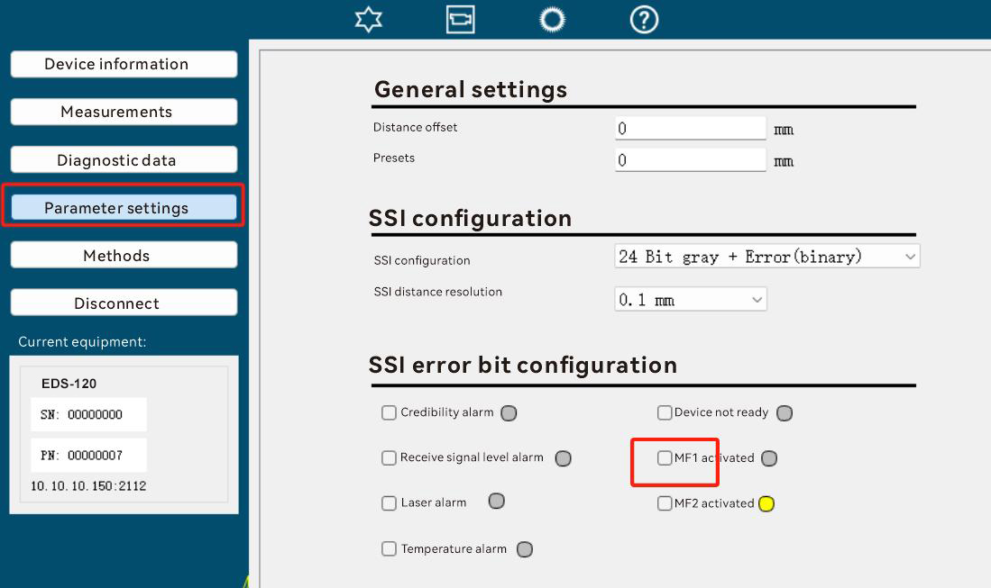

ssiMf2ServiceSetup ( 0x0174 )
Data Type:
Bool
meaning:
SSI error code configuration, whether to alarm when MF2 is triggered.
default value:
0
Data format:
read
Read Request:
02 02 02 02 00 00 00 05 73 52 49 01 74 1d
Read Response:
02 02 02 02 00 00 00 06 73 52 41 01 74 01 14
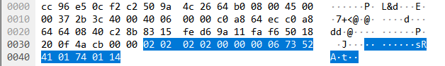

Write
Write Request
02 02 02 02 00 00 00 06 73 57 49 01 74 01 19
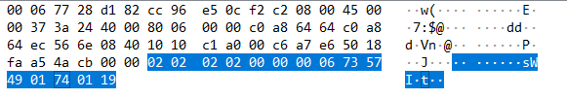
Write Response
02 02 02 02 00 00 00 05 73 57 41 01 74 10

DADISICK corresponding relationship:
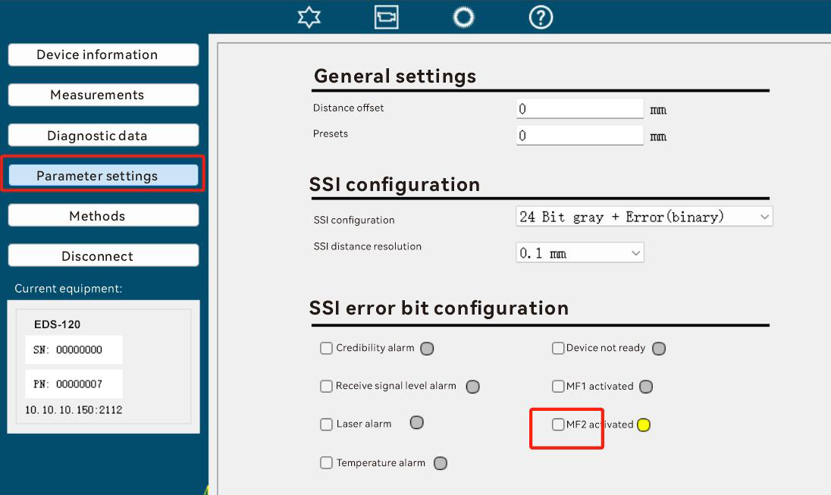

averageFilterVelocity(0x01a0)
Data Type:
UInt8
meaning:
Selecting filter characteristics for speed measurements
0: Fast filtering
1: Medium speed filtering
2: Slow filtering
default value:
1: Medium speed filtering
Data format:
read
Read Request:
02 02 02 02 00 00 00 05 73 52 49 01 a0 c9
Read Response:
02 02 02 02 00 00 00 06 73 52 41 01 a0 00 c1
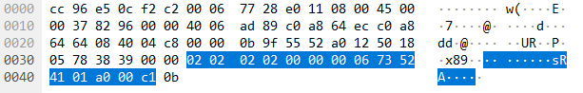

Write
Write Request
02 02 02 02 00 00 00 06 73 57 49 01 a0 01 cd
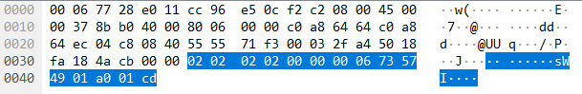
Write Response
02 02 02 02 00 00 00 05 73 57 41 01 a0 c4
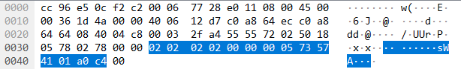

DADISICK corresponding relationship:
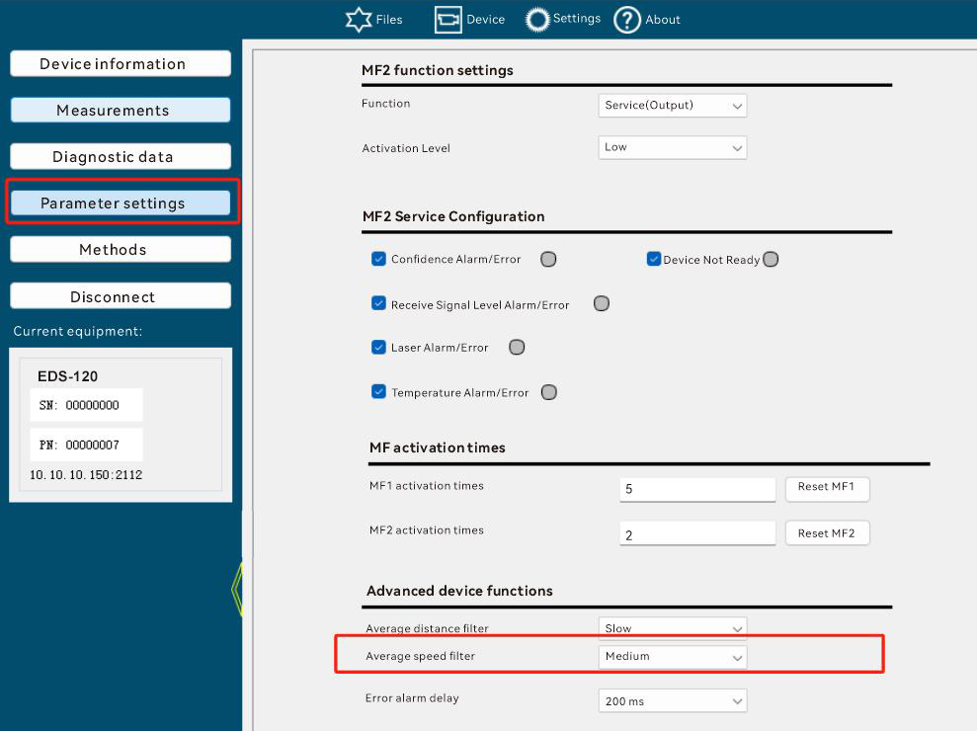

method
Used to operate the radar, similar to a function.

ResetMf1Activations(0x00da)
parameter:
none
Return value:
none
meaning:
Reset MF1 excitation times. This parameter is automatically initialized to 0 when powered on.
Format:
Call:
02 02 02 02 00 00 00 05 73 4d 49 00 da ad
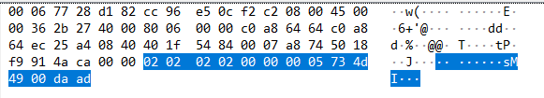

Return:
02 02 02 02 00 00 00 05 73 41 49 00 da a1
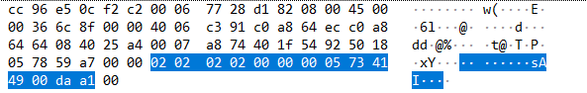

DADISICK corresponding relationship:
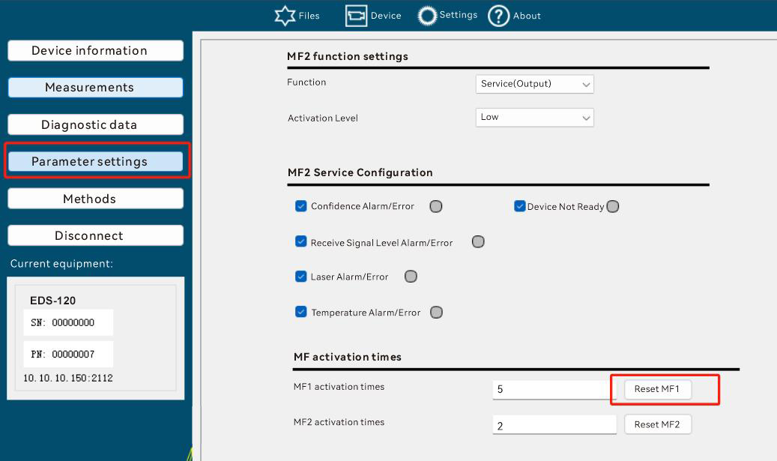

ResetMf2Activations(0x00db)
parameter:
none
Return Value
none
meaning:
Reset the MF2 excitation times. This parameter is automatically initialized to 0 when powered on.
Format:
Call:
02 02 02 02 00 00 00 05 73 4d 49 00 db ac
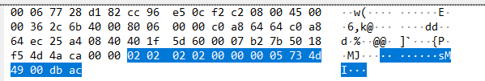

Return:
02 02 02 02 00 00 00 05 73 41 49 00 db a0
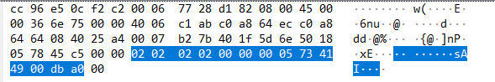

DADISICK corresponding relationship:
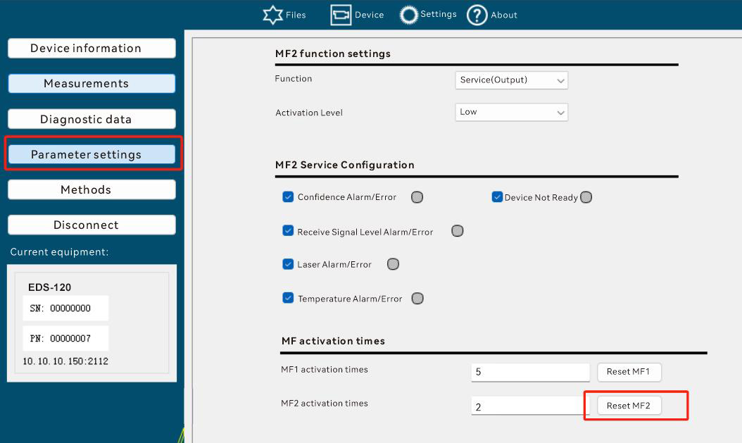

ResetParamters(0x00ce)
parameter:
none
Return Value
none
meaning:
Reset parameters to default values. The default values here refer to the default values saved in the device when the device is manufactured.
Format:
Call:
02 02 02 02 00 00 00 05 73 4d 49 00 ce b9
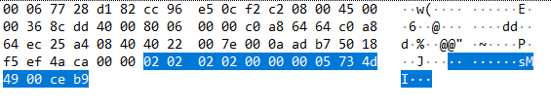

Return:
02 02 02 02 00 00 00 05 73 41 49 00 ce b5
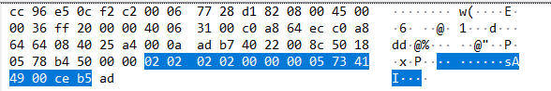

DADISICK corresponding relationship:
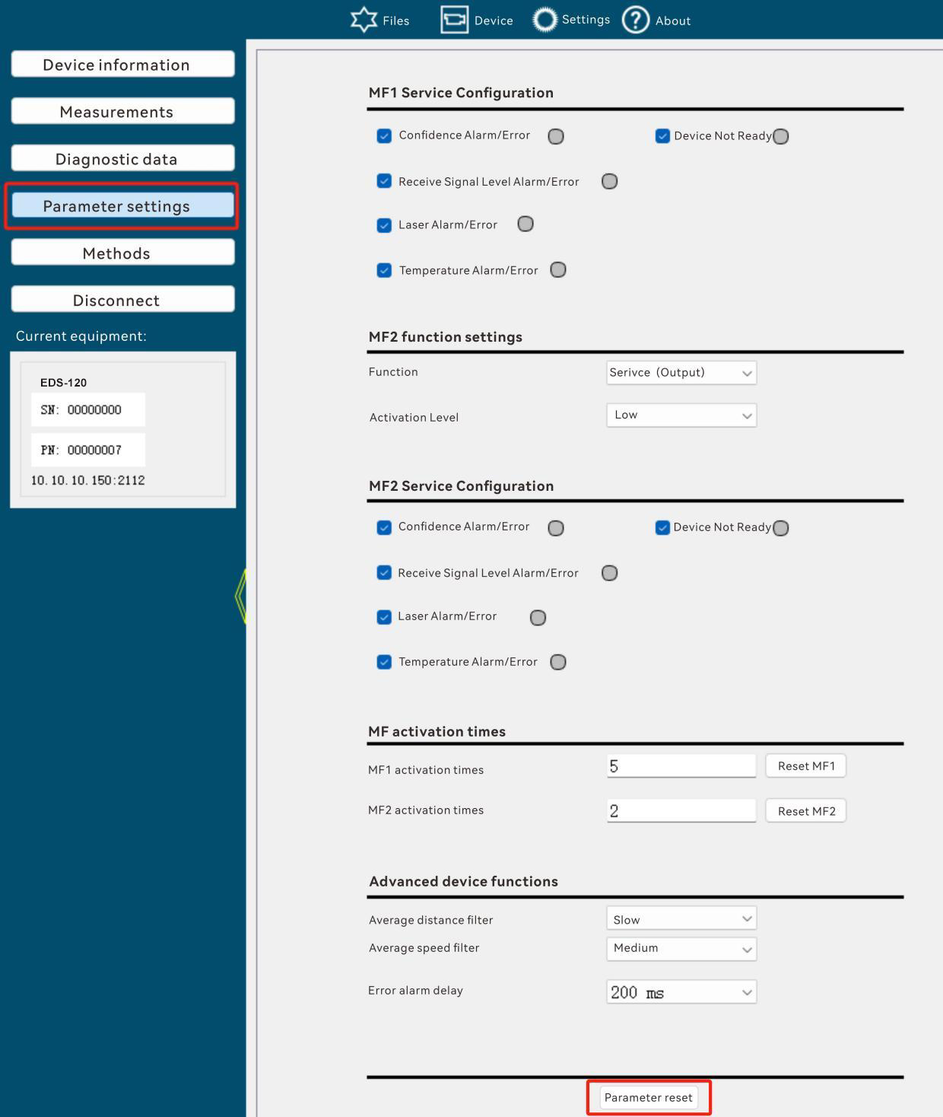

Reboot(0x00c8)
parameter:
none
Return Value
none
meaning:
Restart your device
Format:
Call:
02 02 02 02 00 00 00 05 73 4d 49 00 c8 bf
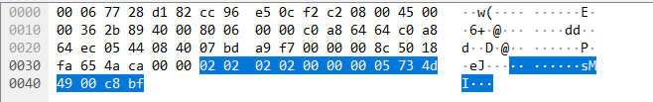

No Return.

DADISICK corresponding relationship:
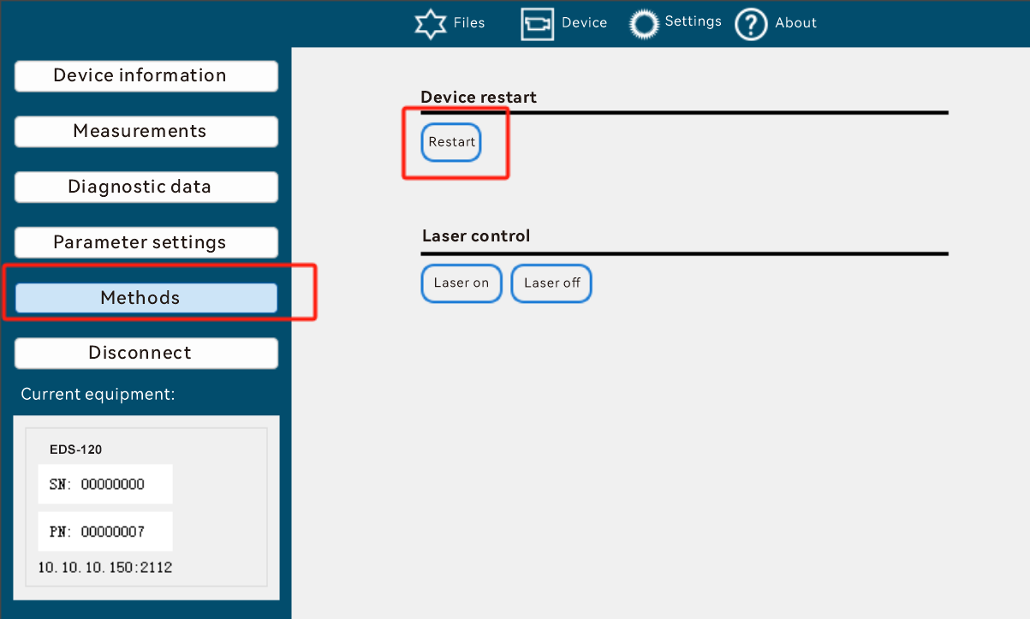

LaserOn(0x00e0)
parameter:
none
Return Value
none
meaning:
Start the laser (the laser emits light at this time)
Format:
Call:
02 02 02 02 00 00 00 05 73 4d 49 00 e0 97
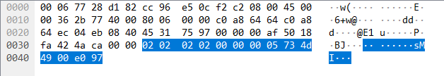

Return:
02 02 02 02 00 00 00 05 73 41 49 00 e0 9b
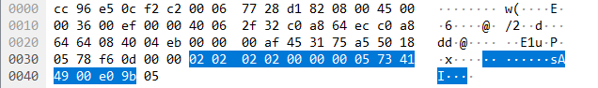
DADISICK corresponding relationship:
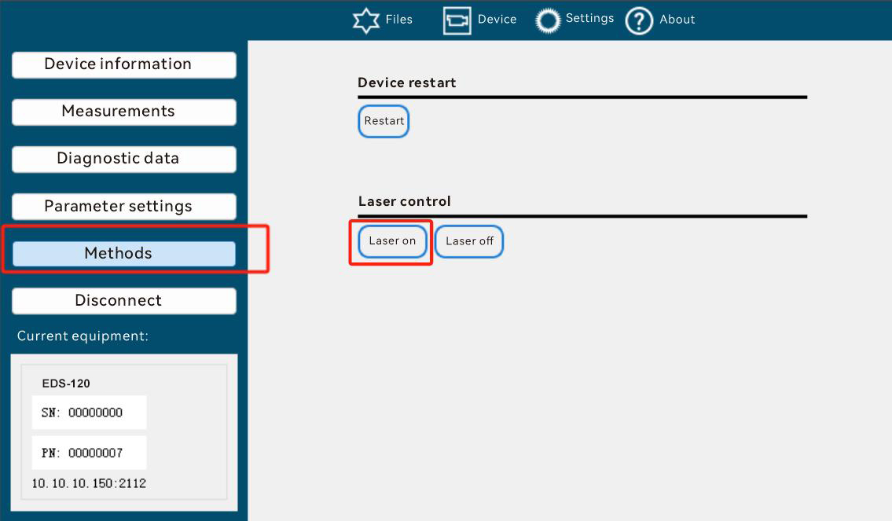

LaserOff(0x00e1)
parameter:
none
Return Value
none
meaning:
Turn off the laser (the device does not emit light at this time)
Format:
Call:
02 02 02 02 00 00 00 05 73 4d 49 00 e1 96
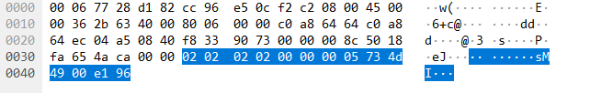

Return:
02 02 02 02 00 00 00 05 73 41 49 00 e1 9a
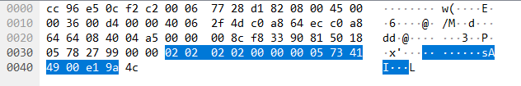

DADISICK corresponding relationship:
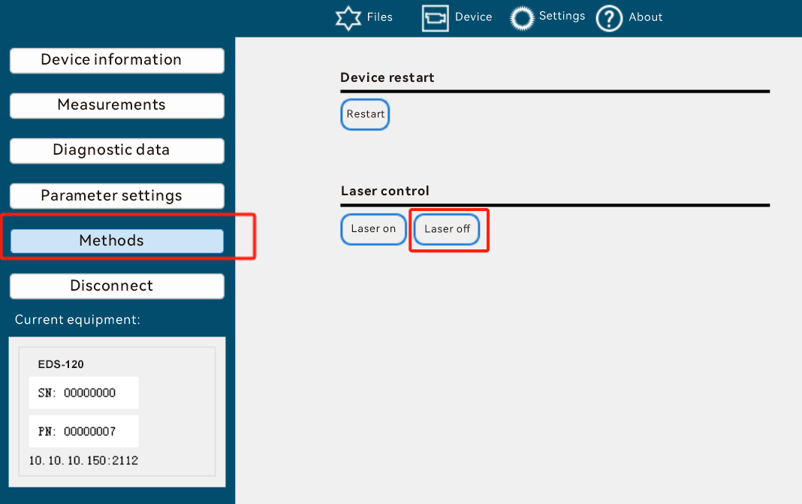

SSI Protocol

Base
The SSI (Synchronous Serial Interface) interface provides absolute information about the position via serial data transmission. Both the clock signal and the data are transmitted via this interface.
The data transmission takes place at the request of the control system, where the cycle time and the transmission speed can be set within a wide range of limits. For this purpose, the connected control system adds a clock sequence to the receive input of the device. With each positive clock edge, a data bit is pushed to the transmit cable of the device, starting with the bit with the highest value. There is a clock pause of at least 30 μs between two clock sequences. The bit clock is between 70 kHz and 500 kHz, depending on the cable length.
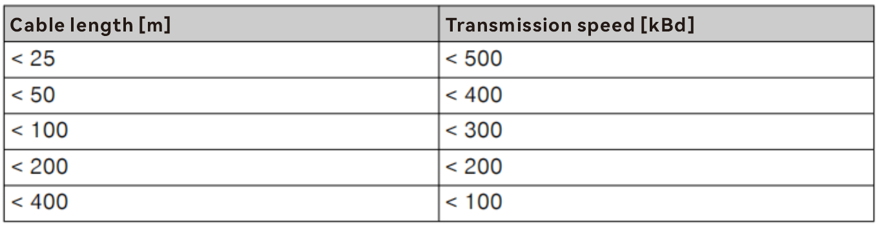One of the performance parameters of the device is "measurement cycle time: 1ms" , so the maximum rate of the device must be adapted to 1000 distance value transmissions per second. Considering that the future data format has 24Gr + 8E and 24B + 8E mode extensions, the maximum data transmission rate should not be less than 1000 * 32 bps ≈ 32kbps.
According to the table above, when the cable length is less than 25m, the transmission speed is required to reach 500kBd (kBd here can be understood as 500kbps). Within a measurement cycle, the external device may read the distance value multiple times through SSI. The device must handle the situation where the external device reads data according to the following logic:
- If the device keeps valid measurement and the reading frequency of the external device is greater than the measurement frequency, the device outputs the last valid measurement data.
- If the device maintains valid measurement all the time, but the reading frequency of the external device is less than the measurement frequency, the device discards the original measurement data and keeps the latest measurement data.
- If the device measurement fails (i.e. the level is lower than the effective value, which means that the laser does not hit the reflector), the effective measurement value is retained for 2ms (this parameter corresponds to another performance parameter of the device, response time/measurement value aging: 2ms ).

Data Format
The SSI communication protocol supports the following types:
*0: twenty four Bit gray + Error(binary)
*1: twenty four Bit gray
*2: 25 Bit gray
*3: twenty four Bit binary + Error(binary)
*4: twenty four Bit binary
*5: 25 Bit binary
The various formats of data are as follows:
Gry24E and Bin24E: 24 data bits, Gray code/binary code + 1 error bit, binary
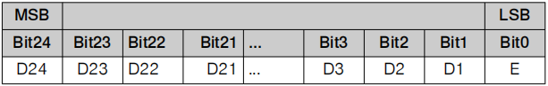
Gry24 and Bin24: 24 data bits, Gray code/binary code
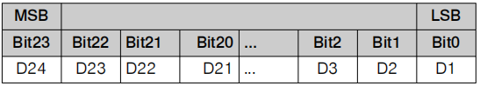
Gry25 and Bin25: 25 data bits, Gray code/binary code
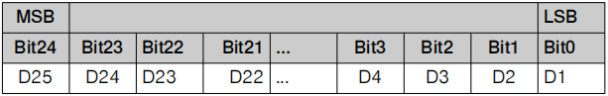

Resolution
The SSI communication data resolution can be set to 0.1mm, 0.125mm, 1mm, 10mm, and 100mm.
There are two ways to set the resolution:
- Through the communication protocol between the host computer and the MCU.
- By operating directly on the machine.

Error bit
When SSI selects the Gry24+E or Bin24+E format, the last digit (i.e., E) indicates that an error has occurred in the device. The errors include:
DeviceNotReady
Plausibility Warning
Level Warning
Laser Warning
Temperature Warning
MF1 activation
MF2 Activation
If any of the above events or warnings occurs, the E bit is set to 1, otherwise it is 0.

Data Expression
There are 3 types of measurement values for this device:
- distance
- speed
- Acceleration
Data D0~D24, D0~D25 represent the measured distance value , not the speed and acceleration.

The data format is divided into 24-bit and 25-bit, and is logically encoded in binary.
The device range is designed to be 300m, so the maximum value is 300 * 1000 / 0.1 = 3,000,000 = 0x2D C6C0. Therefore, from MSB to LSB, all unused bits are set to 0.
example
- The measurement data resolution of DS series is 0.1mm. For example, the actual measurement data is 2.5388m. Select Bin24 type. The transmission value at 0.1mm resolution is 25388/1=25388, and the corresponding binary is 0000 0000 0110 0011 0010 1100.
- At a resolution of 0.125mm, the transmission value is 25388/1.25=20310, and the corresponding binary value is 0000 0000 0100 1111 0101 0110. At a resolution of 1mm, the transmission value is 25388/10=2538, and the corresponding binary value is 0000 0000 0000 1001 1110 1010.
- At a resolution of 10mm, the transmission value is 25388/100=253, and the corresponding binary value is 0000 0000 0000 0000 1111 1101. At a resolution of 100mm, the transmission value is 25388/1000=25, and the corresponding binary value is 0000 0000 0000 0000 0001 1001.

The FPGA is only responsible for data measurement and transmission to the MCU. The resolution setting and SSI expression of the data are handled by the MCU.

