# Analog Voltage Output Sensor Instructions

## 1. Safety precautions

When using this instrument, please comply with the specifications, functions and precautions in the instruction manual. Exceeding the scope of use will affect the safety performance of the instrument.

## **Product content introduction**

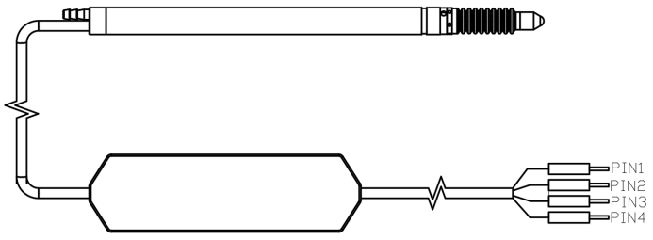

Analog voltage output sensor

The analog voltage output sensor consists of an contact digital displacement sensor and a transmitter, which converts the output signal of the displacement sensor into a voltage signal. The contact digital displacement sensor can be 10mm air push type, 10mm rebound type, 5mm rebound type, etc. according to customer needs. The measurement results are output in the form of voltage analog quantity, connected to the AD sampling module of the PLC, or equipped with an AD collector that meets the accuracy requirements. It is recommended to use a 16-bit or higher AD acquisition card.

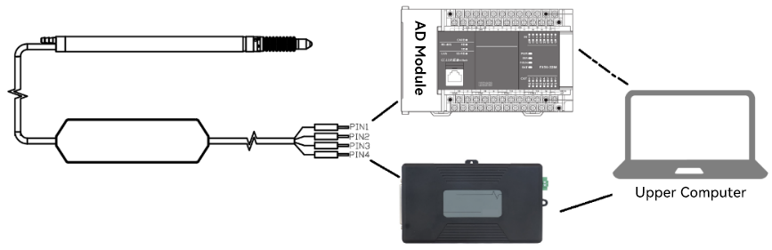

1. **Features:**

* Easy to connect and easy to wire
* Cable length can reach 2m+2m
* The maximum measuring range is ±5mm
* Output the measurement results in the form of analog voltage output and connect to the AD sampling module

## Lead Description

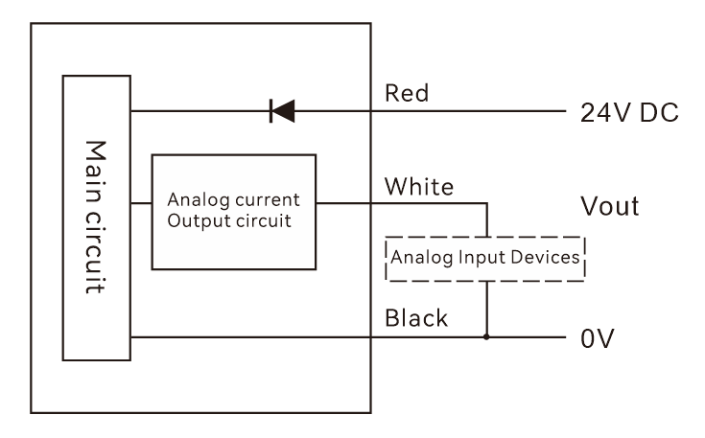

|  |  |
| --- | --- |
| PIN1-Red | DC24V |
| PIN2-Black | GND |
| PIN3-White | OUTPUT-P（Vout Voltage output） |
| PIN4-Silver | Shielded wire EARTH |
| Note: The signal output is a pseudo-differential voltage signal output. OUTPUT-P is connected to the acquisition channel of the AD acquisition card. If the AD acquisition card is a single-ended input, OUTPUT-P is connected to the acquisition channel, and the GND of the sensor and the GND of the AD acquisition card are grounded. If the AD acquisition card is a differential input, OUTPUT-P is connected to the acquisition channel, and the GND of the sensor is connected to the AGND of the AD acquisition card. | |

1. **Size**

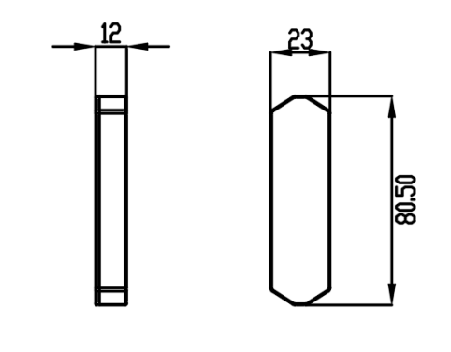

## Technical specifications

|  |  |
| --- | --- |
| Product type | Analog voltage output sensor |
| Resolution | 0.1um  (requires customer AD acquisition card ≥ 16 bits) |
| Voltage | DC24V |
| Output mode | Analog voltage output,  10mm range 0~10V，  5mm range 0~5V，  1mm range 0~5V |
| Measurement data output | Depends on AD sampling frequency |