# Analog Current Output Sensor Instructions

# Safety precautions

## When using this instrument, please comply with the specifications, functions and precautions in the instruction manual. Exceeding the scope of use will affect the safety performance of the instrument.

## Product Contents

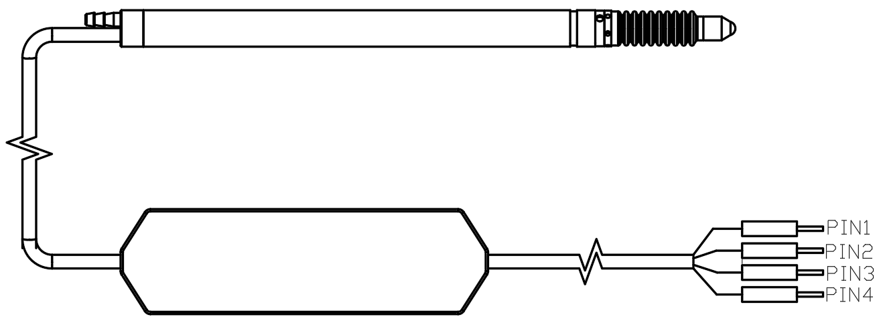

Analog Current Output Sensor

The analog current output sensor consists of an contact digital displacement sensor and a transmitter, which converts the output signal of the displacement sensor into a current signal. The contact digital displacement sensor can be 10mm air push type, 10mm rebound type, 5mm rebound type, etc. according to customer needs. It outputs the measurement results in the form of current analog quantity, connects to the AD sampling module of the PLC, or is equipped with an AD collector that meets the accuracy requirements. It is recommended to use a 16-bit or higher AD acquisition card.

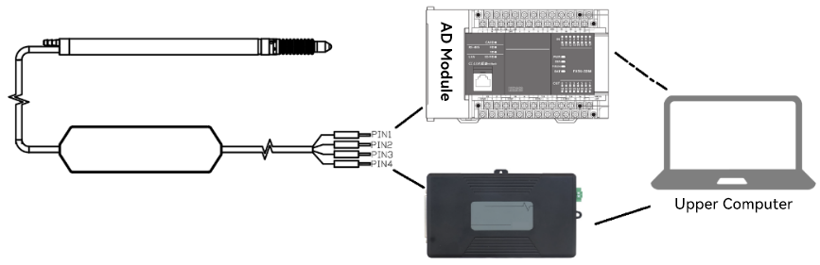**1. Features:**

* 1. Convenient wiring and simple connection；
  2. The cable length can reach 2m+2m；
  3. The maximum range can reach ±5mm；
  4. The measurement results can be output in the form of analog current output and connected to the AD sampling module.

**2. Lead Description**

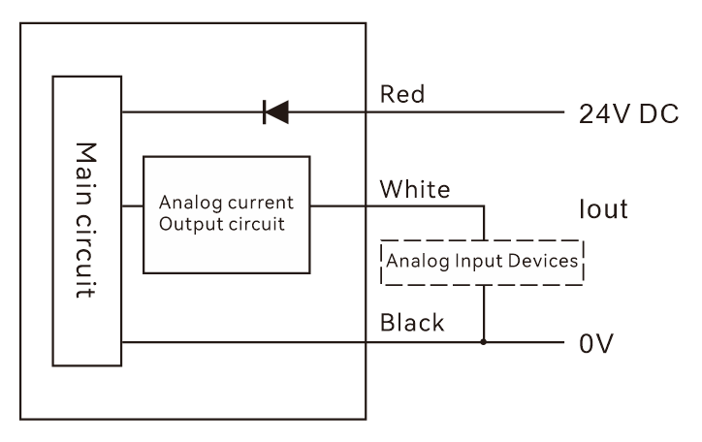

|  |  |
| --- | --- |
| PIN1-Red | DC24V |
| PIN2-Black | GND |
| PIN3-White | OUTPUT-P（Iout Current output） |
| PIN4-Silver | Shielded wire EARTH |
| Remark | Note: The signal output is a pseudo-differential signal output. OUTPUT-P is connected to the acquisition channel of the AD acquisition card. If the AD acquisition card is a single-ended input, OUTPUT-P is connected to the acquisition channel, and the GND of the sensor and the GND of the AD acquisition card are grounded. If the AD acquisition card is a differential input, OUTPUT-P is connected to the acquisition channel, and the GND of the sensor is connected to the AGND of the AD acquisition card. |

**3. Size**

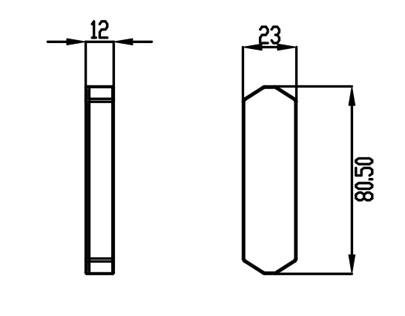

**4. Technical specifications**

|  |  |
| --- | --- |
| Product type | Analog current output sensor |
| Resolution | 0.1um (requires customer AD acquisition card ≥16 bits) |
| Supply voltage | DC24V |
| Output mode | Analog current output, 4~20mA |
| Measurement data output | Depends on AD sampling frequency |