**LD-50G series lidar communication protocol**

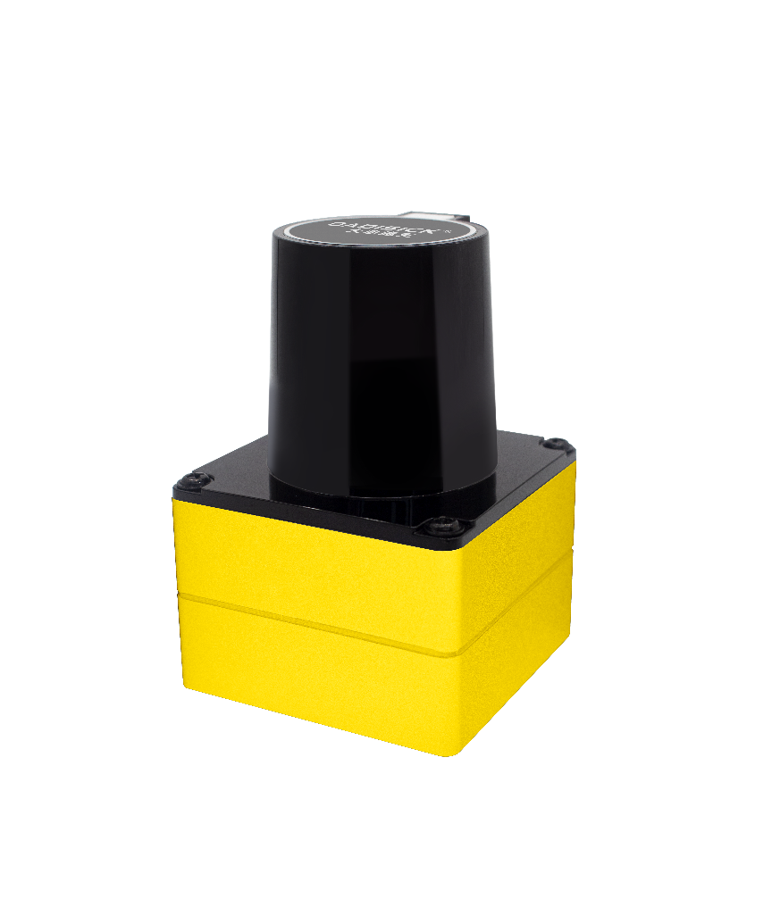

# letter of agreement

The communication between the LD-50G series radar and the host adopts Ethernet medium and UDP protocol, and there are two types of output packets: MSOP packets and DIFIOP packets. The factory adopts the default fixed IP and port number mode, according to the following table 1:

|  |  |  |  |
| --- | --- | --- | --- |
|  | IP address | MSOP packet port number | DIFIOP packet port number |
| radar | 192.168.1.201 | 2368 | 8080 |
| the host | 192.168.1.77 |

Table 1 Factory Default Network Configuration Table

The default IP address of the device has been set at the factory initialization.

When using the device, you need to set the IP of the host to 192.168.1.77 and the subnet mask to 255.255.255.0. If you do not know the network configuration information of the device, please connect to the device and use wireshark to capture the output packets of the device for analysis.

The communication protocols between the LD-50G series radar and the host are mainly divided into two types, see Table 2.

The main data stream output protocol MSOP encapsulates the distance, angle, reflectivity and other information scanned by the lidar into data packets and outputs them to the host.

The device information output protocol DIFIOP outputs various configuration information of the current state of the lidar to the host, and can re-modify some configuration parameters according to its own needs.

|  |  |  |  |  |
| --- | --- | --- | --- | --- |
| (protocol/package) name | abbreviation | Function | type | packet size |
| Main data stream output protocol | MSOP | scan data output | UDP | 1206 |
| Device information Input/Output protocol | DIFIOP | Device information input and output | UDP | 1033 |

Table 2 List of equipment protocols

# 1.Master Stream Protocol

Main data stream output protocol: Main data Stream Output Protocol, referred to as: MSOP.

I/O type: device output, host resolution.

The default port number is 2368.

The MSOP package completes the output of two-dimensional measurement-related data, including laser ranging values, echo reflection values, and horizontal rotation angle values. The payload length of the MSOP packet is 1248 bytes, including a 42byte UDP header, a 1200byte data block interval (a total of 12 100byte data blocks), and a 6byte frame tail .

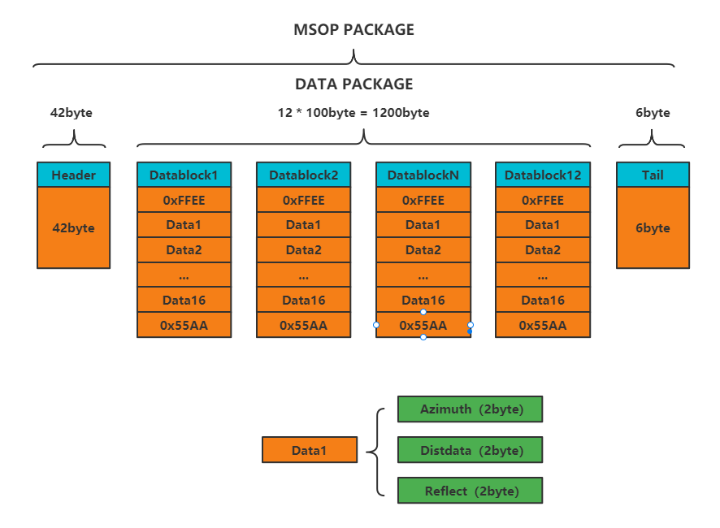

Figure 1 MSOP package data packet format

# 2.Data block range

The data block interval is the measured value part of the sensor in the MSOP packet, a total of 1200bytes. It consists of 12 data blocks, each data block contains frame header, frame tail and 16 ranging points. The frame header is 2 bytes of 0XFFEE, and the frame tail is 2 bytes of 0X55AA. Each ranging point is 6 bytes, including 2 bytes of angle value, 2 bytes of ranging distance value, and 2 bytes of reflectivity information. Total number of bytes=2+6*16+2=100 bytes. Among them, the angle value and the ranging distance value are low byte first and high byte last. The reflectance information is the first byte, and the following bytes are ignored.

## 2.1 Angle value (Azimuth) definition

The angle value is 2byte, as shown in Table 3.

|  |  |
| --- | --- |
| Azimuth (2 bytes) | |
| Angle[ 7:0] | Angle[ 15:8] |

Table 3 Angle value data definition

In each block, the horizontal angle value output by the LD-50G series lidar is the angle value of the ranging data in the block. The angle value comes from the angle encoder, the zero position of the angle encoder is the zero point of the angle, and the resolution of the horizontal rotation angle value is 0.01 degrees.

For example, the calculation method of the angle value of the packet is:

The hexadecimal number of the angle value in the acquired data packet: 0X00, 0X11.

The data is composed of 16bit, which is 16bit unsigned integer data. Represented as: 0X1100.

Converted to a decimal number: 4352.

Divide by 100.

Result: 43.52°.

Therefore, the laser emission angle value this time is 43.52°.

## 2.2 The distance value ( Distdata ) definition

The ranging value is 2byte, as shown in Table 4.

|  |  |
| --- | --- |
| Disdata (2 bytes) | |
| Distance[ 7:0] | Distance[ 15:8] |

Table 4 Range value data definition

Distance is 2byte, the unit is cm, and the resolution is 0.25cm.

For example, how to calculate the distance value of a packet:

The hexadecimal number of the distance value in the obtained data packet: 0XE8, 0X03.

The data is composed of 16bit, which is 16bit unsigned integer data. Represented as 0X03E8.

Converted to a decimal number: 1000.

Result: 250 cm, converted to 2.5m.

## 2.3 Reflect (Reflect) definition

The reflectivity is 2byte, as shown in Table 5.

|  |  |
| --- | --- |
| Reflect (2 bytes) | |
| reflect[ 7:0] | null |

Table 5 Reflectance data definition

The actual reflect is 1 byte, occupying the first 1 byte of data defined by reflect.

## 2.4 Data Packet Demonstration Data

Figure 2 MSOP package data package demonstration data

# Device Information Input and Output Protocol (DIFIOP)

Device information output protocol, Device information Input/Output protocol, abbreviated as DIFIOP.

I/O type: device input and output, host write and read.

The default port number is 8080.

DIFIOP can regularly send the relevant configuration information of the device to the user, and the user can reconfigure the parameters by modifying the writable value in the read information and returning it.

A complete DIFIOP Package has a total of 1075 bytes, of which the UDP header is 42 bytes, and there are 1033 data configuration areas, of which 4 bytes are headers, 1 bytes are command bits, 1024 bytes are configuration data, and 4 bytes are tails.

|  |  |  |  |  |
| --- | --- | --- | --- | --- |
| paragraph division | serial number | read-write mode | Offset | Length (byte) |
| Header | 0 | read only | 0 | 4 |
| cmd | 1 | readable and writable | 4 | 1 |
| hardware version number | 2 | read only | 5 | 2 |
| FPGA version number | 3 | read only | 7 | 4 |
| Motor speed | 4 | read only | 11 | 2 |
| motherboard temperature | 6 | read only | 15 | 2 |
| Device IP address | 7 | readable and writable | 57 | 4 |
| motor stop | 12 | readable and writable | 69 | 1 |
| Set motor speed | 13 | just write | 70 | 2 |
| Serial number (S/N) | 14 | read only | 517 | 14 |

Table 6 DIFIOP package data format agreement

Note: Writable configuration parameters need to be filled in after obtaining from the DIFIOP package, and then sent back to the radar.

Header (DIFIOP identification header): 0X54, 0X3F, 0X51, 0XA5

Header (DIFIOP identification tail): 0X55, 0XA1, 0X0F, 0X41

CMD: 0X07 is read information, 0X09 is write information. The value read by default is 0X07, if you want to modify the configuration parameters, be sure to modify CMD to 0X09.

Hardware version number: 2 bytes in total, the lower 3 bits represent the information of the current hardware.

FPGA version number: 4 bytes in total, including 4 main pieces of information, mainly Major, Minor, Patch, and Debug. Major refers to the version number of the hardware version information, Minor refers to the version number of new functions, Patch refers to the version number of bug fixes, and debug refers to the version number of the promotion test .

Motor speed: 2byte, the high byte is behind the combination bit, and the low byte is in front of the combination bit. For example, 0X58, 0X02, combined into data is 0X0258, converted to decimal is 600, which means the current real-time speed is 600rpm.

Motherboard temperature value: 2byte, the high byte is behind the combination bit, and the low byte is in front of the combination bit. Its temperature calculation formula: current temperature (°C) = (APD temperature value/4096*3300-500)/10. For example, 0X00, 0X04, the combined data is 0X0400, converted to decimal is 1024, the current temperature = (1024/4096*3300-500)/10=32.5°C, which means the current motherboard temperature is 32.5°C.

Device IP address: Set the IP address of the current device, the default IP address of the device is 192.168.1.201. Users can modify the IP address according to their needs.

Motor stop: 1byte, 0X00 means the motor is running, 0X01 means the motor is stopped. The user can control the rotation and stop status of the motor by modifying it.

Motor speed: 2byte, the default is 600rpm. 0X58, 0X02 set the speed to 600rpm. 0X84, 0X03 set the speed to 900rpm. 0XB0, 0X04 set the speed to 1200rpm. The user can modify this value according to the needs to make the radar reach the corresponding frequency, where 600rpm corresponds to 10Hz, 900rpm corresponds to 15Hz, and 1200rpm corresponds to 20Hz.