TOP FILL ULTRASONIC HUMIDIFIER
MODEL NO.: UG100A

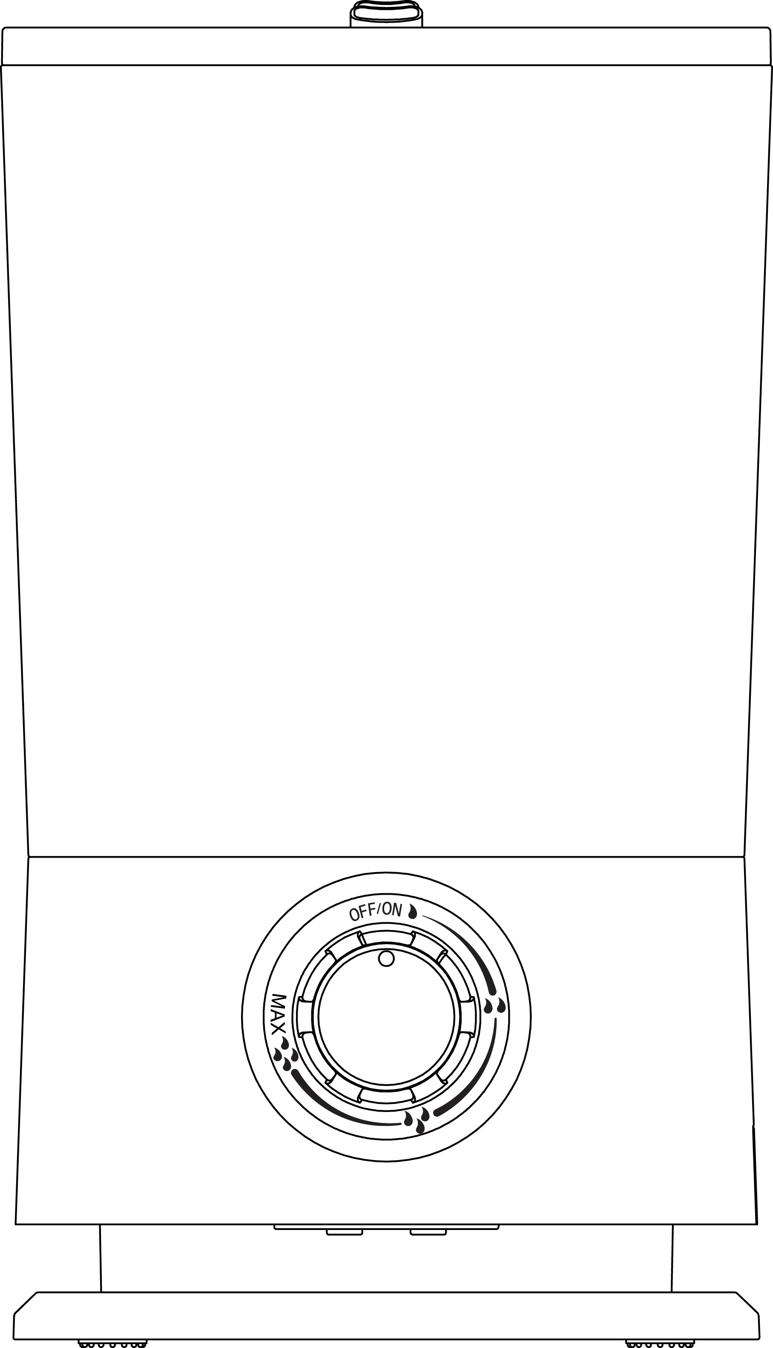

INSTRUCTION MANUAL

Please read this instruction manual carefully before use.
- SPECIFICATIONS:

Voltage: 100-240V~50/60Hz
Power: 25W
Water Tank: 6.5L
Mist Output: 360ml/h(+-10%)

- COMPONENTS
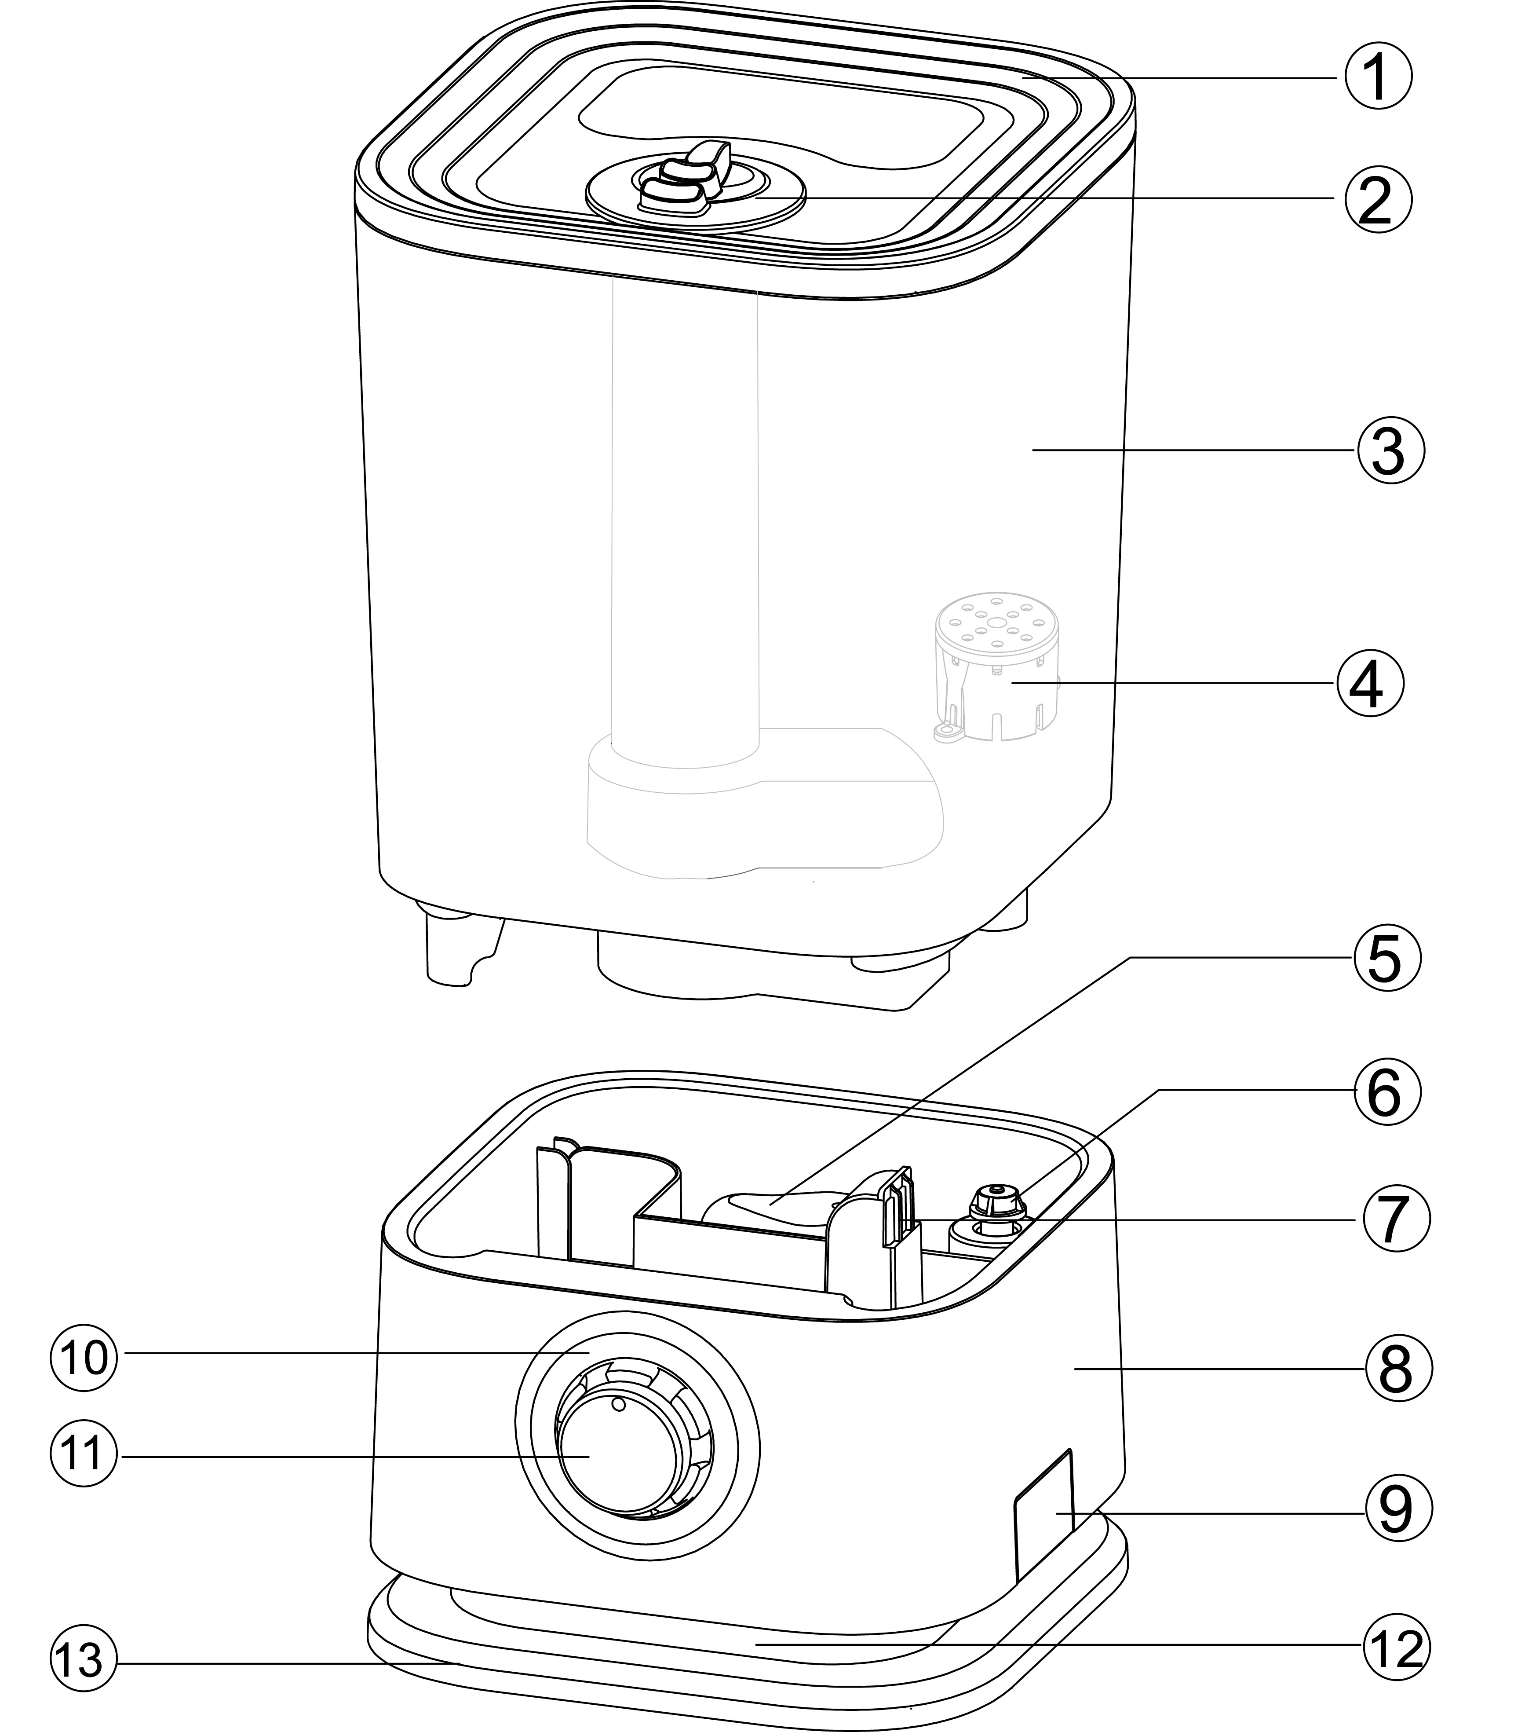

1 - Lid of tank 2 - Mist nozzles 3 - Water tank
4 - Water filter 5 - Water level detector 6 - Reed switch detector
7 - Air outlet 8 - Engine base 9 - Aroma oil box
10 - Indicator light 11 - Switch knob 12 - Middle layer
13 - Bottom

- GENERAL INTRODUCTION
Humidifier UG100A is made of recyclable plastic. It works continuously 16 hours around(when max mist output). Smooth mist, anion-refreshing, power saving, quiet, auto-stop and long service life are its main features.
- HOW IT WORKS?
As per the vibrating theory of ultrasonic waves, the humidifier divides water drops into particles sized 1 – 5 µm. Then the particles are diffused by motor-driven devices - fan. During this course, a large quantity of anions are produced and diffused. That’s how this humidifier works to humidify and refresh the air.

- HOW TO USE?
  - Firstly, open the package, take out your humidifier; Specially, in engine base (8) of machine, there is one white EPE under movable water level detector (5), please lift tank, to take away this white EPE (its picture as follows); Afterwards please put water tank (3) back onto engine base (8)
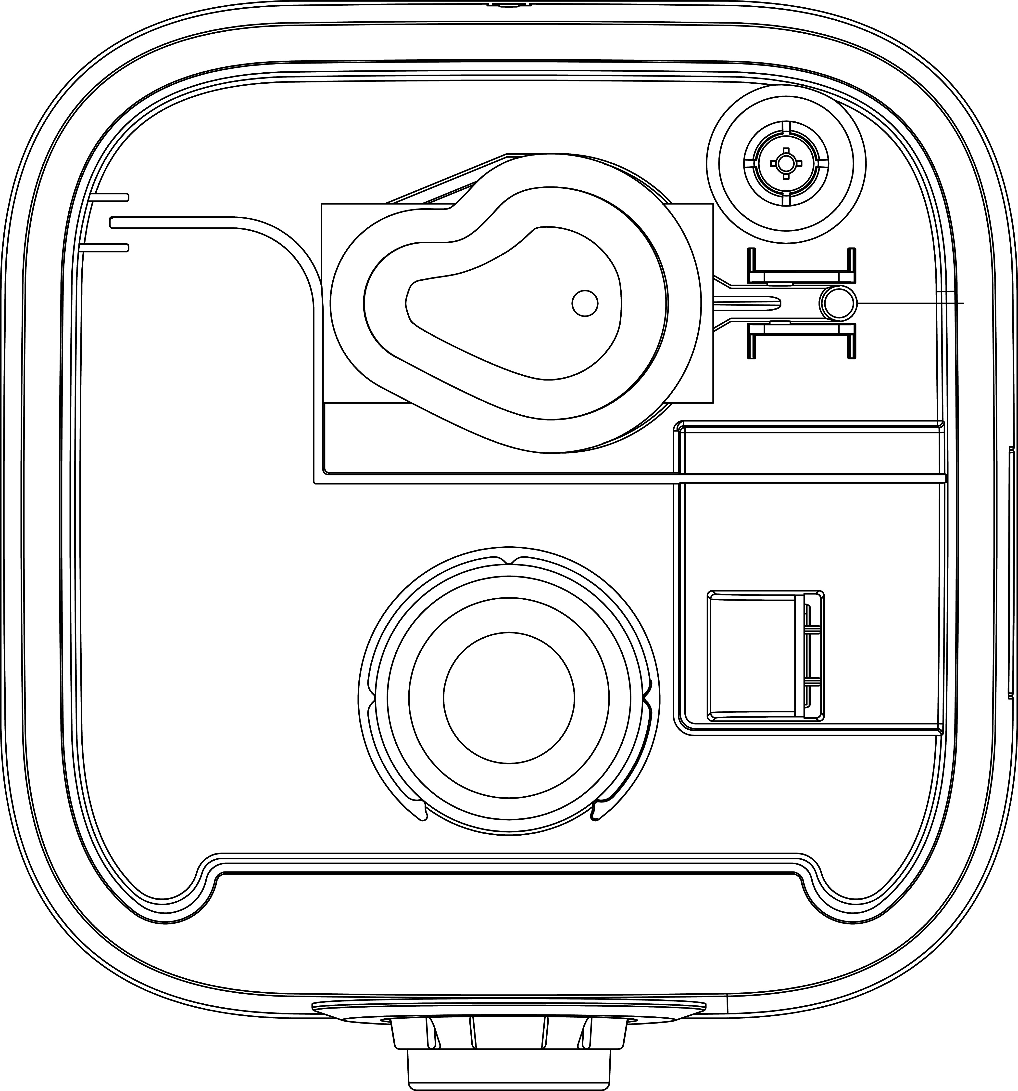
white EPE
  - The best environment temperature for the humidifier is ranged from 0℃ to 40℃. Place it in a room for half an hour before the first use.
  - It is recommended to use softened and boiled water or distilled water. The water temperature should be no more higher than 40℃.
  - Open lid of tank (1), to fill in water, picture as follows; Tank has handle for carrying;
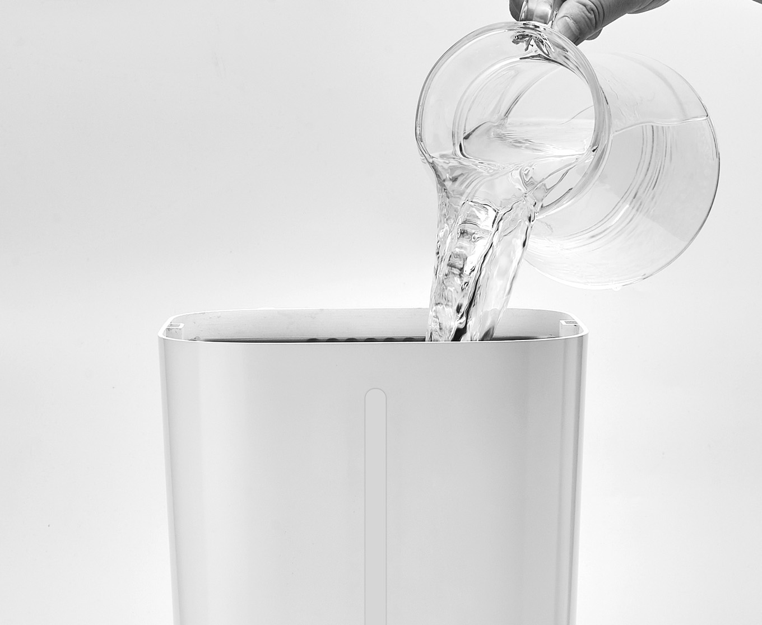
Water also can be re-filled from the lid directly, picture as follows;
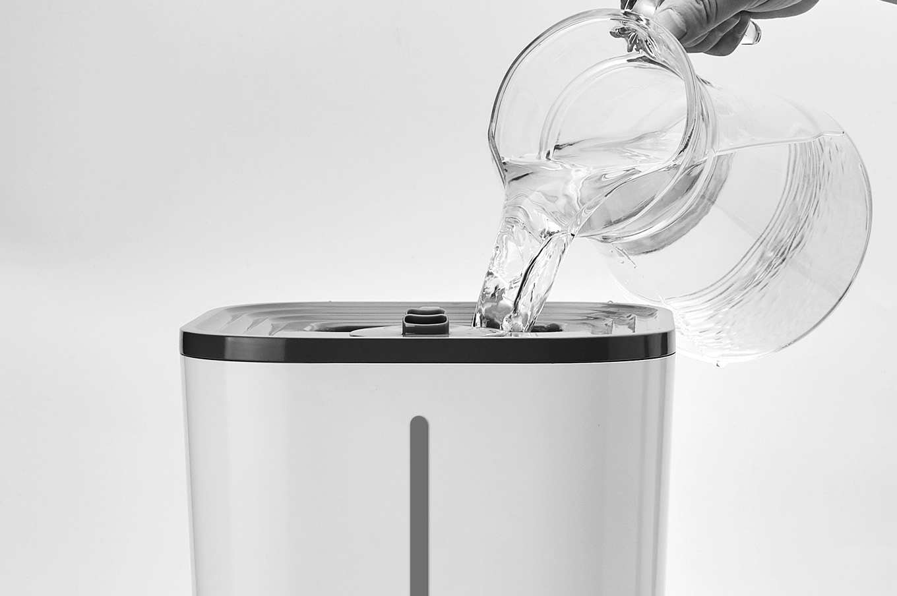
  - Connect to power supply, then turn on switch knob (11), to set proper mist intensity by turning switch knob.
  - Indicator light is Blue when works normally; And Indicator light is Red when water run out.

- AROMA FUNCTION
To drip essential oil into aroma oil box (9), for aroma function;
Or to drip Water-Soluble essential oil into water tank (3) directly, for aroma function.

- WATER FILTER (4) IN TANK
This water filter is to purify water, which to filtering organic matter / heavy metal / suspensions / colloid substances / impurity substances in water.
Warning ! If no this filter in the tank, there is potential risk of water leakage.

- CLEANING AND MAINTENACE

WATER TANK
    - The water tank should be cleaned frequently. It is recommended to clean once every 3 days.
    - Water should be changed frequently. It should not be kept in the water tank more than 2 days.

TRANSDUCER
Due to geographic factors, water quality may differ from place to place. Some places have hard water, which contains a large quantity of calcium and magnesium ions. Furthermore, the use of bleaching power (to purify water) also increases the hardness of water. When this kind of water is used to humidify the air, calcium and magnesium ions are diffused together with the mist. As time goes on, there will be sediments of scale on the object surfaces and ground. Meanwhile, there will also be sediments on the transducer and the water groove, which is to affect the functioning of the humidifier. To clean the transducer, please:

    - Add some cleanser (about 0.5g) on the transducer, add some water, and wait for 2-5 minutes.
    - Use a soft brush to clean the surface of the transducer. Don’t use hard tools to scratch its surface.
    - Use cleanser as packed with the appliance or other scale cleansers to be purchased in the market.
    - Do not use soap or other alkaline substances to clean the transducer.

BASE
    - If the water groove and water level detector have scale sediments too, please use the cleanser to clean, and then wash the water groove with clean water.
    - Do not immerse the base in water and make sure that no water enters the vent.

- STORAGE
The original package is the best to store the unit. Make sure to clean all the parts and have them dried before storage. Meanwhile, please loose the silicon washer to secure its service life.

- DO YOU KNOW?
Do you know that different place has different humidity, and object needs its own humidity too? Please find the following:

The Best Humidity for Human Body: 45%RH – 65%RH
The Best Humidity for Disease Preventing and Treatment: 40%RH – 55%RH
Furniture and Musical Instrument: 40%RH – 60%RH
Computer and Communication Apparatus: 45%RH – 60%RH
Dance Hall, Bar, and Other Public Places of Entertainment: 40%RH – 65%RH
Library, Art Gallery, Museum: 40%RH – 60%RH

- ATTENTIONS
  - It is not recommended to use additives like perfume, essence, etc. It is prohibited to add alkaline substances into the water tank.
  - When working, do not touch the water in the groove or other parts, lest electric shock may happen due to unexpected electric leakage.
  - Do not direct the sprayer nozzle to children, furniture and walls, etc. Adjust it to empty space instead.
  - Make sure it works far away from other home appliances.
  - Do not leave it work on unstable surfaces. When working, do not tilt or overturn it.
  - In case of abnormal noise or smell, please turn it off and unplug it from socket immediately.
  - When cleaning or moving the unit, please turn it off and remove the water tank. Shaking may lead to overflow of water into the base, so as to affect its function.
  - Do not place it in sun-lighted places for a long time.
  - Do not repair or replace parts by yourself; send it to professionals or designated service center for help. Unauthorized modifications or re-structure of the humidifier may lead to inconveniences or dangers.
  - If it is not to be used for a long time, please unplug and store it properly.
- TROUBLE SHOOTINGS

TROUBLES | REASONS POSSIBLE | SOLUTIONS
No breeze, no mist | - No power supply.  - Power switch is off.  - Water level of the groove is too high.  - Leakage of the water tank. | - Connect to power supply.  - Turn on the power switch.  - Lower the water level by reducing water in the groove.  - Tighten the water lid.
Breeze, but no mist | - No water in the water tank.  - Water level detector is not in the right position.  - The temperature of the unit is too low. | - Fill water into the water tank.  - Re-mount the water level detector.  - Place the unit in a room for half an hour before use.
Odd mist smell | Water in the tank is kept for too long a time. | Clean the water tank and re-fill it with clean water.
Low intensity | - Too much water in the water groove  - Mist intensity controller is on the minimum side.  - Scale sediments on the transducer  - The water is too cold.  - The water is not clean. | - Empty the water in the groove and place the water tank again.  - Adjust the controller.  - Clean the transducer  - Use water of ordinary temperature.  - Clean the water tank and re-fill it with clean water.
Mist spurts no high | - Mist intensity controller is on the minimum side  - Water tank and the base are not rightly touched.  - Fan does not work properly | - Adjust the controller.  - Make sure water tank and the base are touched rightly.  - Ask professionals to check the fan inside the base.
Noise | - Resonance caused by too less water in the water tank.  - Resonance caused by unstable surfaces. | - Add water into the water tank.  - Lay the unit on stable surfaces.

