
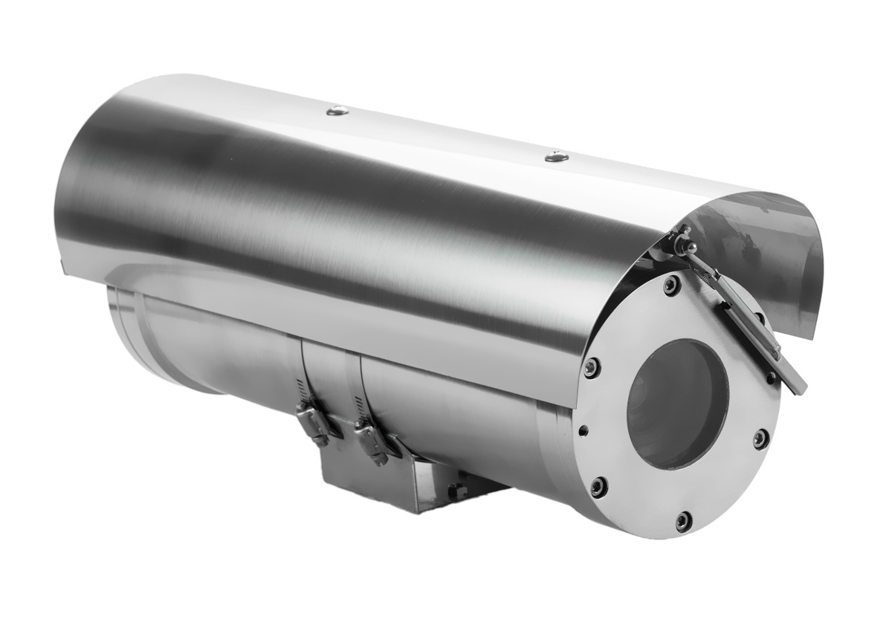
CZ100-□
Explosion Proof Fixed Camera
Features

·ATEX, IECEx Certified;
·Applicable for Gas Zone 1, Zone 2,
Class II A, IIB, IIC, T1-T6 group)
Dust Zone 21, 22.
·Certified for the latest standards IEC/EN60079 (2014)
·Stainless steel 304 or 316L enclosure
CZ100-A
·Surface optional electro-polished or painting
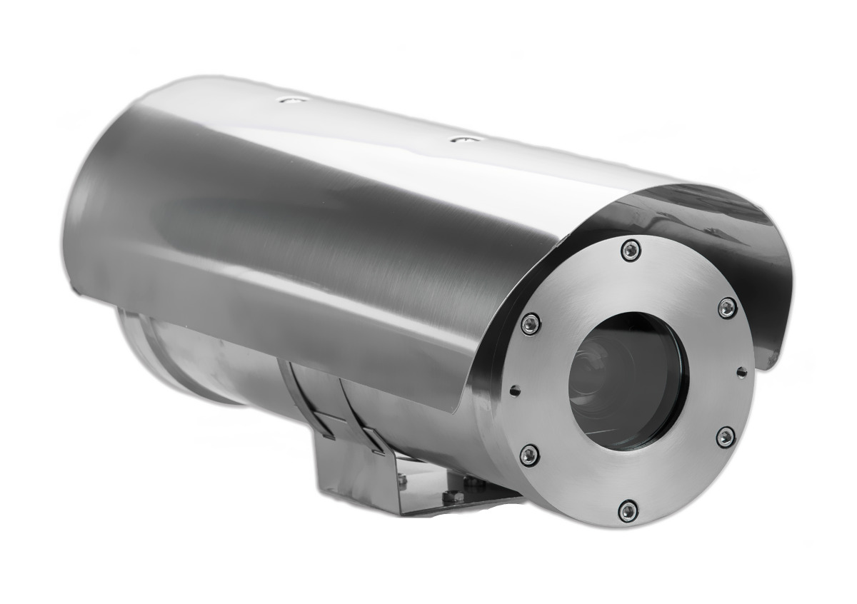
·Weather Proof IP68(1.2m/45min)
·Wide voltage input: AC100-240V or AC24V
·Strong tempered glass, fit for hydrofluoric acid area
·Intelligent window defroster design
·Auto temperature adjust kit for aggressive area
·High precision wiper , support user-defined
·Fit for various brand cameras
·Wall, pole, ceiling mounted way
CZ100-B
Application

CZ100-□ is a ZUOAN designed classic explosion-proof camera, which can load various camera.The explosion proof camera can apply for Zone 1 and Zone 2 hazardous areas that explosive mixture of group IIA, IIB, IIC, T1~T6 gases, vapors and air may exist, Zone 21 and Zone 22 hazardous areas that explosive dust may exist. It’s applicable for refining and chemical industry, oil extraction, gas production, fireworks production, grain production and storage, petrol station and so on.








CZ100-□ EXPLOSION PROOF FIXED CAMERA

MECHANICAL
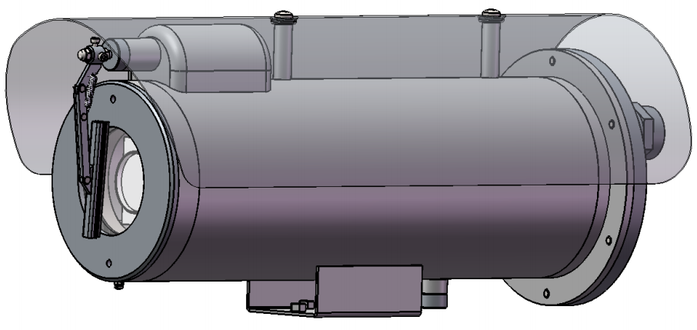
Material: Stainless steel 304/316L
Ingress protection: IP68
Cable glands: M25x1.5, or M27×1.25
Cable entry: 2pcs
Dimension: see fig
Net Weight: CZ100-A,14kg; CZ100-B,12.5kg.
Mount: wall, pole (or customer tailored)

CZ100-A

ELECTRICAL
Voltage: 100~240V AC or 24V AC；Max. 1.5A
Power: ≤36W（without heat,fan）

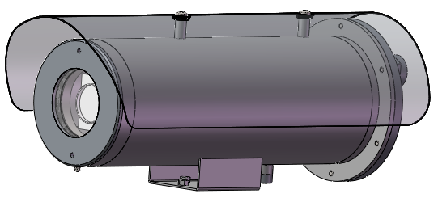
EX-PROOF MARKING
WALL BRACKET
Explosion proof marking:
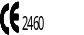  Ⅱ2G Ex db ⅡC T6 Gb,
Ⅱ2D Ex tb is ⅢC T80 ºC Db
Standards: IEC/EN60079

CZ100-B
ENVIRONMENT
Ambient temperature: -40℃～+60℃
Atmosphere pressure: 80kPa～120kPa
Relative humidity: ≦95%RH（+25℃）

ACCESSORIES
Wall Bracket: ZAZ100B
Ex Junction Box: ZA-JXD4
Ex Control Box: CZ300






Certificate
ATEX Certificate Mark |   Ⅱ2G Ex db ⅡC T6 Gb,  Ⅱ2D Ex tb ⅢC T80 ºC Db
Certificate | Presafe 17 ATEX 11326X, IECEx PRE18.0012X
Standards | IEC/EN60079
Mechanical
Housing | Stainless steel 304 or 316L
Surface | Optional electro-polish or painting
Ingress protection | IP68 (1.2m/ 45min)
Cable thread hole | 2pcs M25×1.5 (or M27*1.25)
Electrical
Voltage | AC100V～AC240V or AC24V
Power | 15W/25W (with thermostat)
Surge Protect | Optional, TVS6000V surge protect
Optical Fiber output | Optional, multimode or single mode
Optical Video signal | 1-way video output
Optional network signal | RJ45
Optical Audio | 1-way input, 1-way output
Optical Alarm | 2-way alarm input, 1-way alarm output
Address code: | 0/1
Trail cable | 2m integrated cable
Ambient
Ambient temperature | -25°～+60°/-40℃～+60℃
Air pressure | 80Kpa to 110Kpa
Relative Humidity | ≦95% (no condensation)
Communication
Communication type | RS485
Protocol | Pelco-D, Pelco-P
Communicate Rate | 2400~19200bps adjustable
485 Communication | Support
General
Model | CZ100-A | CZ100-B
Sun-shield | Yes | Yes
Wiper | Yes | No
Overall dimension | 524*179*215mm | 524*179*208mm
Net Weight | 14kg | 12.5kg

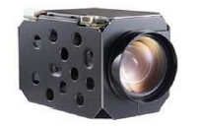

DAY & NIGHT ANALOG ZOOM CAMERA
Image Sensor | 1/4-type EXview HAD™ CCD (Progressive Scan)
Effective pixel | 440,000 pixels (PAL)， 380,000 pixel (NTSC)
Min. Illumination | 0.7lx (typical)(F1.4, 50IRE)
Shutter Time | 1/1 to1/10,000 s,22 steps
Day&Night | Auto ICR
Horizontal resolution | 500TVL (color), 520TVL (B&W)
S/N ratio | ＞50dB（AGC off）
Lens
Focal Length | 18x optical zoom f=4.1mm wide~73.8(tele) | 36x optical zoom f=3.4mm wide~122.4mm(tele)
Angle of View | 48.0° (wide end) to 2.8° (tele end) | 57.8° (wide end) to 1.7° (tele end)
Min. Working Distance | 10 mm* (wide) ~ 800 mm (tele)  *Default: 290 mm | 10 mm* (wide) ~ 1500 mm (tele)  *Default: 320 mm
Zoom Speed | Approx. 3s(Optical, Wide-Tele)
Day & Night | ICR
Function
Focus Mode | Auto/Manual/One touch
Exposure Mode | Auto/Aperture Priority/Shutter Priority/Manual
Day & Night Mode | Auto/Color/BW
Shutter Time | 1/50(1/60) sec~ 1/10,000 sec
White Balance | Auto /Indoor/Outdoor/Manual/auto tracking
BLC | ON/OFF
Privacy | Off/on
Exposure Compensation | 10 levels adjustable
Gain | Auto/manual
Gain Limitation | 16 levels adjustable
Contrast | 8 levels adjustable
Saturation | 8 levels adjustable
Mirror | Off/no
Slow shutter | X256 MAX
Anti-shake | Off/ on
Digital WDR | ON/OFF, 15 levels adjustable
Image Setting | Saturation, Brightness, Contrast, Sharpness adjustable
Lens Initialization | Internal
External connection | 9 Pin FFC

DAY & NIGHT NETWORK ZOOM CAMERA
Image Device | 1/2.8" Progressive Scan CMOS
Effective Pixels  /Resolution | 50HZ:25fps(1920x1080) 60HZ:30fps(1920x1080)  50HZ:25fps(1280x720) 60HZ:30fps(1280x720)
Optical zoom | 20X ,4.7-94mm |  | 30X, 4.5-135mm
Digital Zoom | 12X
Aperture Range | F1.6-F3.5 |  | F1.6-F4.4
Angle of view | 61.4-29 degree (wide -tele) |  | 65.1-2.34 degree (wide -tele)
Min. Working distance | 10mm-1500mm(wide-tele)
Zoom speed | Approx 3s (optical, wide-tele)
Day&night | ICR
Focus mode | Auto/manual/one touch
Day&night mode | Auto/color/BW
Shutter Time | 1/1sec-1/30,000 s
White balance | Auto 1/Auto 2/Indoor/Outdoor/Manual/Sodium Lamp/Fluorescent Lamp
BLC | ON/OFF
Exposure compensation | 10 levels adjustable
Gain | 16 levels adjustable
Gain limitation | 16 levels adjustable
DNR | 3D DNR
mirror | support
Digital WDR | ON/OFF, 15 levels adjustable
Imaging setting | Saturation, brightness, contrast, sharpness adjustable
Video compression | H.264 main profile/MJPEG
Video bit rate | 32kbps-16mbps
Audio compression | G.722.1/G.711-a law/G.711-u law/MP2L2/G.726
Imaging setting | Zoom camera module function can be adjustable by client software ore web browser
alarm | Motion detection, tampering alarm, storage full, storage exception
protocol | TCP/IP, HTTP, DHCP, DDNS, RTP, RTSP, PPPoE, SMTP, NTP, UPnP, SNMP, FTP, 802.1*, QoS, HTTPS, IPv6(SIP, SRTP optional)
standard | ONVIF, PSIA, CGI, ISAPI
Communication interface | 1 RJ45 10M/100M self-adaptive Ethernet interface, 1 RS-485.
Video output | Dual core 1Vp-p Composite Output (75Ω）
Lens value | Distance: 10mm-1500mm(Wide-Tele)  Angle: 58.3-3.2 degree(Wide-Tele)
S/N ratio | More than 52dB
Minimum illumination | Color: 0.05Lux @ (F1.6, AGC ON)  B/W: 0.01Lux @ (F1.6, AGC ON)

Dimension
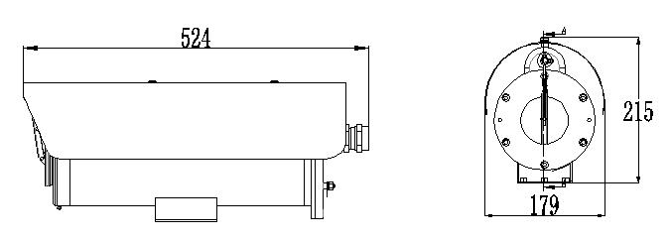

CZ100-A
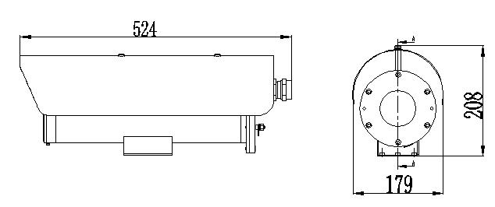
CZ100-B

Relatives
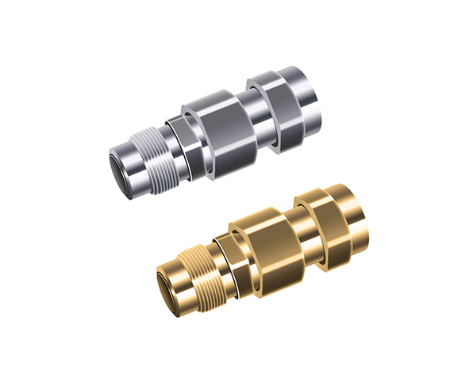
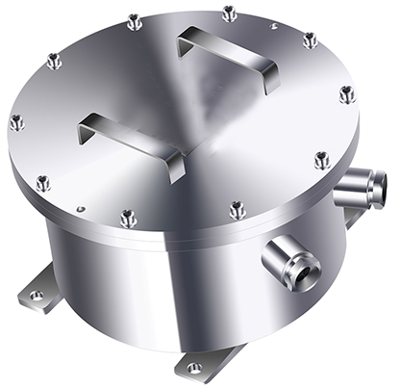

CZ300 ATEX Ex Optical Box ZAEX02 ATEX Ex glands

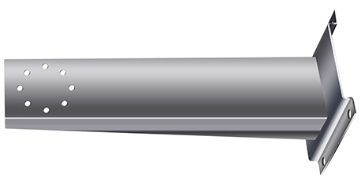
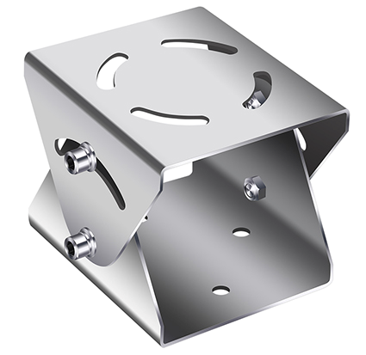

ZAZ100B Wall bracket with mount adapter

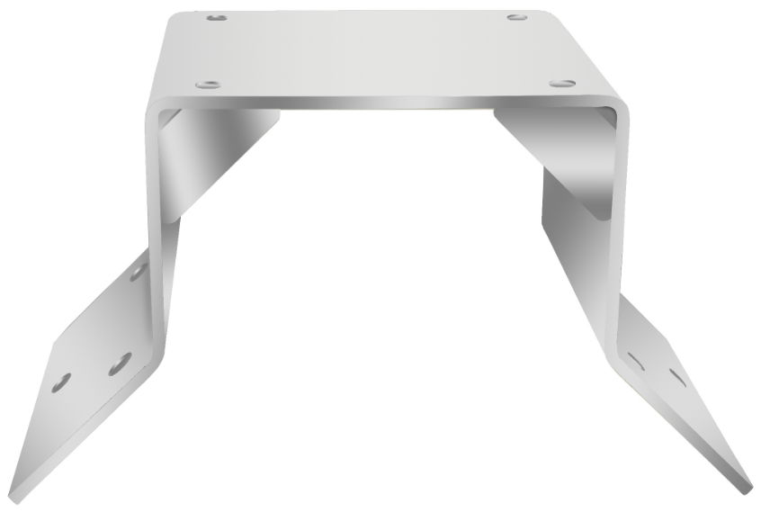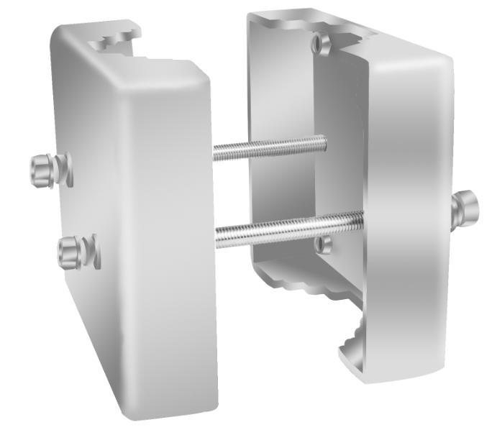
ZAZ100-C corner bracket ZAZ100-PMB Pole mount adapter

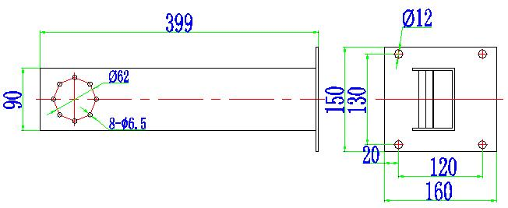

General type ZAZ100B Wall bracket

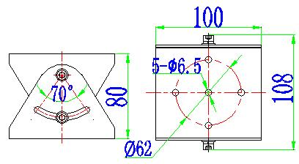

ZAZ100W Mount adapter

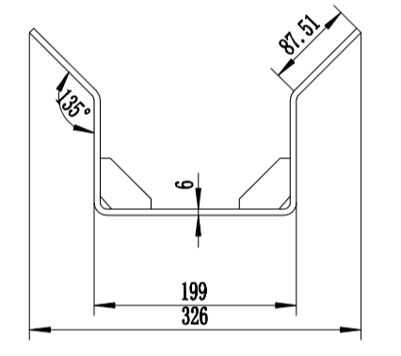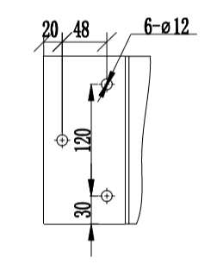
ZAZ100C corner bracket
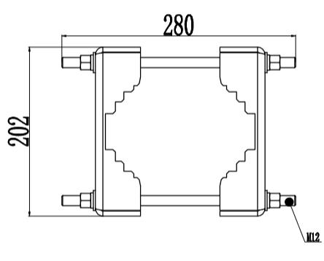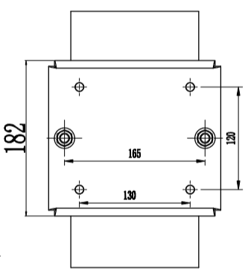
ZAZ100-PMB pole mounted bracket

