商务报价§技术参数
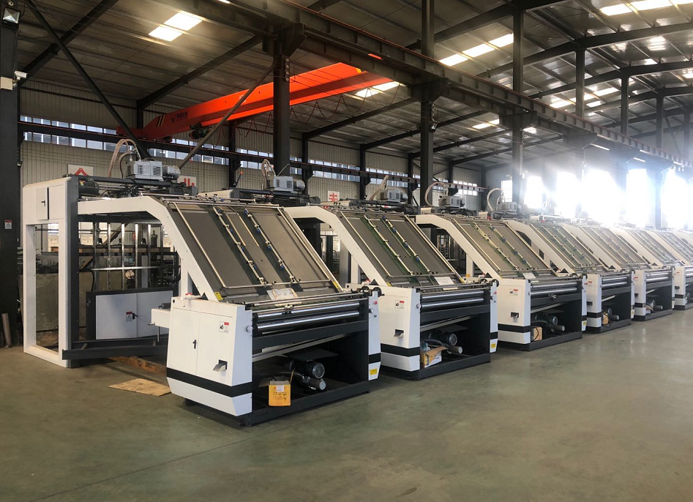

东光恒创利纸箱机械制造有限公司
Hebei Dongguang Hengchuangli Carton Machinery Co., Ltd Company

公司地址：河北沧州东光县城南2.5公里105国道西侧

产品特性 CHARACTERISTICS:
■ 先进的自动跟踪技术，根据纸张大小自动调节相关参数，使机器运转始终保持在最佳状态；
Advanced automatic tracking technology, according to the size of the paper automatically adjust the relevant parameters,so that the machine is always running in the best condition
■ 独特的前规定位系统，定位精确，底纸永不超前；面纸超前量可调；
Unique front gauge positioning system, accuracy and the bottom paper never exceed; top paper exceed adjustable
■ 配备高精密高速飞达送纸，加强型送纸装置，送纸平滑顺畅。
Equipped with high precision high speed automatic feeder, strengthening type paper feeding device, feeding smoothly.
■ 备用堆纸台可在不停机状态下堆好下一堆面纸，沿导轨推入升降台，工作效率高；
Standby stack table can pile paper under non-stop situation, along the rail into the elevator, high working efficiency
■ 进口电器元件，确保电路系统工作稳定。PLC跟踪技术，故障自动报警；
Imported electrical components, to ensure the stability of the circuit system. PLC tracking technology, automatic fault alarm;
■ 全自动胶水补充系统，可自动补充损失的胶量，并配合胶水循环回收；
Fully automatic glue supplementary system, can automatically replenish the loss of the amount of glue, and cooperated with the glue recycling
■ 独立水箱控制水循环方式，保证底纸背面干爽，同时清洗上胶辊、接胶槽、回胶槽；
Independent water tank control cycle, ensure the bottom paper back dry, at the same time cleaning up roller、glue receive tank and back glue tank;
■ 采用单边调节各压力辊的压力，并配有压力刻度表显示，更换底纸规格调节一步到位；
Single side adjustment of the roller pressure, and equipped with a dial gauge, the replacement of the bottom paper one-step-to- reach.

分部介绍 BRANCH INTRODUCTION:
- 飞达系统 TOP SHEET FEEDING MECHANISM
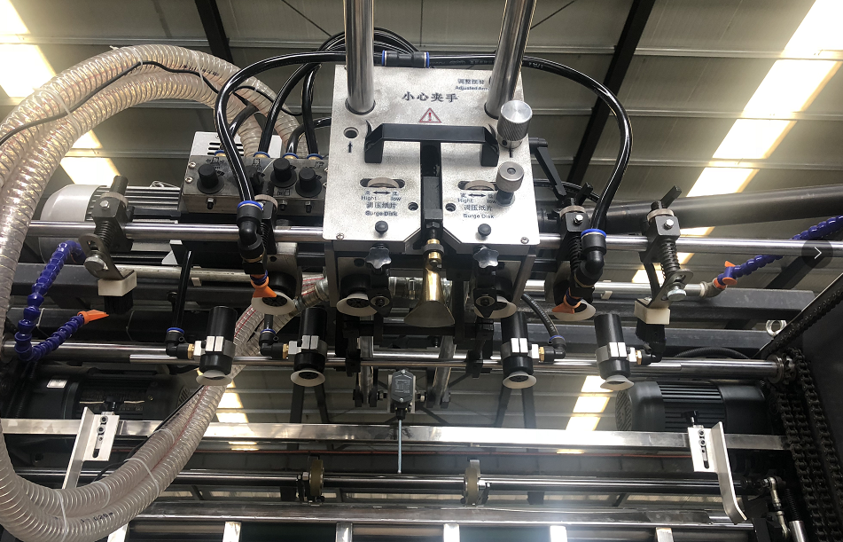

高精密高速飞达送纸，送纸平滑顺畅。
加强型送纸装置，吸嘴角度可自由调节，适应不同类型面纸
High precision high speed automatic feeder, , feeding smoothly.
Strengthening type paper feeding device, nozzle angle is adjustable, suitable for different type of papers

2. 电器系统 ELECTRICAL SYSTEM
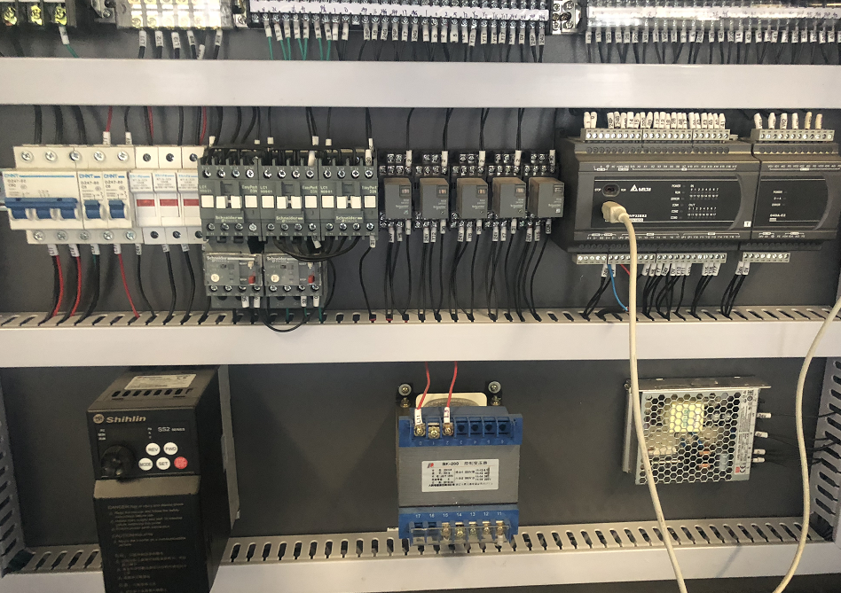

主要电器元件采用进口品牌
PLC跟踪技术，故障自动侦测
Main electrical components are imported brands
PLC tracking technology, automatic fault detection

3.压力调节系统 PRESSURE REGULATION POSITIONING

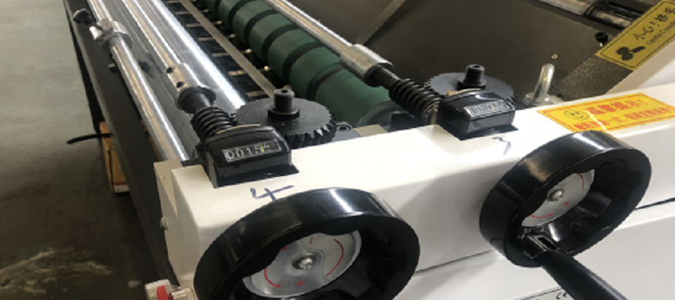

压力单边调节，确保二边压力一致
带压力刻度表显示，更换纸张规格时调节轻松简便
Single pressure regulation, to ensure that the two side pressure be same
With the display of dial gauge, it is easy to adjust when change the paper

4. 传动系统 TRANSMISSION
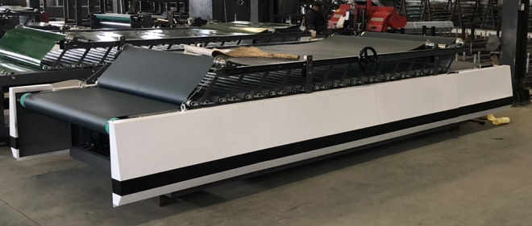

浮动式压床设计，无需调节压床压力
加高设计，利于厚瓦楞纸板的顺畅工作
Floating design of press, no need to adjust the pressure
Heightening design, smooth working for thick corrugated paperboard

5. 预堆纸部分 PRE-STACK PART
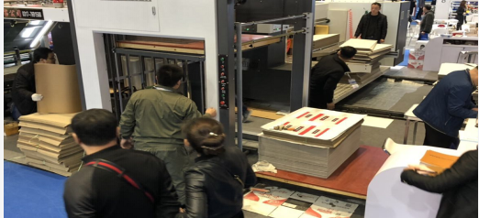

备用堆纸台可在不停机状态下堆好下一堆面纸，沿导轨推入升降台，工作效率高；
预堆台采用“工”字型设计，推入升降台后预堆台即可退回，人工省力；
Standby stack table can pile paper under non-stop situation, along the rail into the elevator, high working efficiency.
Using the "working" font design, the platform can be used to push and easy back, labor saving.

※技术参数Technological parameter

型号Model | HRB-1300A | HRB-1600A
最大过纸尺寸  Max size of cover face | 1300X1250mm | 1600X1250mm
最小过纸尺寸  Mix size of cover face | 330mmX400mm | 400mmX400mm
面纸厚度  Top paper thickness | 140-800g | 140-800g
底纸厚度  Bottom sheet thickness | 2/4 ply A/B/C/E/F Flute | 2/4 ply A/B/C/E/F Flute
机器速度  Max speed | 0-8000pcs/h  5000m/h | 0-8000pcs/h  5000m/h
精度Precision | ±1mm | ±1mm
电压Power | 14kw | 14kw
外形尺寸Size | 12m x 2m x 2.8m | 13.5m x 2.3m x 2.8m
重量Weight | About 4.5T | About 5.5T

※主要电器及零部件Main electrica AND PARTS
序号N/M | 名称NAME | 型号MODEL | 厂家BRAND
1 | 变频器INVERER | NE200-4T0022G | 日系尼得科 Nidec-japan  台湾士林 TAIWAN SHILIN
2 | 变频器INVERER | NE200-4T0015G | 日系尼得科 Nidec-japan  台湾士林 TAIWAN SHILIN
3 | 变频器INVERER | NE200-4T0007G | 日系尼得科 Nidec-japan  台湾士林 TAIWAN SHILIN
4 | 伺服 Servo | SV-DA200-1R5-4-1R | 英威腾 Invt / 众辰 Zhongchen
5 | 可编程控制器 PLC | DVP32ES200T | 台达 Delta
6 | 直流电源 AC support | PTM-24V100W2BA | 台湾 TAIWAN
7 | 人机界面 Screen | 7062TD | 昆仑通态 MCGS
8 | 中间继电器 relay | ZYS4N-JDC24V | 西门子 Siemens /施耐德 Schneider
9 | 中间继电器 relay | ZYS4N-JDC24V | 西门子 Siemens /施耐德 Schneider
10 | 中间继电器 relay | ZYS4N-JDC24V | 西门子 Siemens /施耐德 Schneider
11 | 中间继电器 relay | ZYS4N-JDC24V | 西门子 Siemens /施耐德 Schneider
12 | 中间继电器 relay | ZYS4N-JDC24V | 西门子 Siemens /施耐德 Schneider
13 | 中间继电器 relay | ZYS4N-JDC24V | 西门子 Siemens /施耐德 Schneider
14 | 中间继电器 relay | ZYS4N-JDC24V | 西门子 Siemens /施耐德 Schneider
15 | 中间继电器 relay | ZYS4N-JDC24V | 西门子 Siemens /施耐德 Schneider
16 | 接触器 contactor | 3TS30 01E | 西门子 Siemens /施耐德 Schneider
17 | 接触器 contactor | 3TS30 01E | 西门子 Siemens /施耐德 Schneider
18 | 接触器 contactor | 3TS30 01E | 西门子 Siemens /施耐德 Schneider
19 | 接触器 contactor | 3TS30 01E | 西门子 Siemens /施耐德 Schneider
20 | 接触器 contactor | 3TS30 01E | 西门子 Siemens /施耐德 Schneider
21 | 接触器 contactor | 3TS30 01E | 西门子 Siemens /施耐德 Schneider
22 | 中间继电器座 relay base | 13Y9W1 | 欧姆龙 Omron
23 | 中间继电器座 relay base | 13Y9W1 | 欧姆龙 Omron
24 | 中间继电器座 relay base | 13Y9W1 | 欧姆龙 Omron
25 | 中间继电器座 relay base | 13Y9W1 | 欧姆龙 Omron
26 | 中间继电器座 relay base | 13Y9W1 | 欧姆龙 Omron
27 | 中间继电器座 relay base | 13Y9W1 | 欧姆龙 Omron
28 | 中间继电器座 relay base | 13Y9W1 | 欧姆龙 Omron
29 | 中间继电器座 relay base | 13Y9W1 | 欧姆龙 Omron
30 | 接线端子 terminal blocks | TD 1560 | 正泰 Chint
31 | 接线端子 terminal blocks | TD1530 | 正泰 Chint
32 | 制动电阻 brake resister | 500瓦 50欧姆 | 合资 Hezi
33 | 空气开关 Air switch | NXB-63 C100 | 正泰 Chint
34 | 空气开关 Air switch | NXB-63 C3 | 正泰 Chint
35 | 电机热保护 MTH | JRS1-09-25/Z 10A-13A | 正泰 Chint
36 | 电机热保护 MTH | JRS1-09-25/Z 10A-13A | 正泰 Chint
37 | 电机热保护 MTH | JRS1-09-25/Z 2.5A-4A | 正泰 Chint
38 | 电机热保护 MTH | JRS1-09-25/Z 2.5A-4A | 正泰 Chint
39 | 光电传感器 Sensor | E3FA-DN12 | 欧姆龙 Omron
40 | 接近开关 Proximity Switch | GAM4-12GK-N1 | 倍福宁 BFN
41 | 接近开关 Proximity Switc | GAM4-12GK-N1 | 倍福宁 BFN
42 | 接近开关 Proximity Switc | GAM4-12GK-N1 | 倍福宁 BFN
43 | 接近开关 Proximity Switc | GAM4-12GK-N1 | 倍福宁 BFN
44 | 接近开关 Proximity Switc | GAM4-12GK-N1 | 倍福宁 BFN
45 | 接近开关 Proximity Switc | GAM4-12GK-N1 | 倍福宁 BFN
46 | 固态继电器 Solid relay | LRSSR-DD | 利瑞德 LRD
47 | 交流变压器  AC transformor | BK-200 | 上海  Shanghai
48 | 液位继电器 Liquid relay | C61F-GP | CKC/ 韩国KAIKUN
49 | 按钮 Button | LA-38 11/203 | 江阴 Jiangyin
50 | 按钮 Button | LA-38 11/203 | 江阴 Jiangyin
51 | 按钮 Button | LA-38 11/203 | 江阴 Jiangyin
52 | 按钮 Button | LA-38 11/203 | 江阴 Jiangyin
53 | 按钮 Button | LA-38 11/203 | 江阴 Jiangyin
54 | 急停 Emergency Stop | LA-38 11ZS/203 | 江阴 Jiangyin
55 | 急停 Emergency Stop | LA-38 11ZS/203 | 江阴 Jiangyin
56 | 急停 Emergency Stop | LA-38 11ZS/203 | 江阴 Jiangyin
57 | 旋钮 Switch | LA-38 11X2/203 | 江阴 Jiangyin
58 | 旋钮Switch | LA-38 11X2/203 | 江阴 Jiangyin
59 | 旋钮Switch | LA-38 11X2/203 | 江阴 Jiangyin
60 | 指示灯 Light | APT | 正泰 Chint

质量保证Quality assurance and service assurance
1. 产品设计听从用户意见，不断改良，从设计角度保证了整机稳定性和人性化；

2. 公司的品管部门对采购、加工、组装的各个环节进行质量监督和管理，从多角度管理来保证公司产品质量管理的落实。
3. 公司品管部对每一台成品按照出厂产品标准进行检验。

4. 强大的技术力量和高效的售后服务队伍保证解决客户使用过程中的各种问题，完善的质量信息反馈管理，使产品快速改进，并始终处于技术领先。

- The product design obeys the user's opinion, constantly improves, and ensures the stability and humanization of the whole machine from the design point of view.

- The company's quality control department to purchase, processing, assembly of all aspects of quality supervision and management, multi-angle management to ensure the implementation of the company's product quality management.

- The company quality control department to each finished product in accordance with the factory product standards for inspection.

4.Strong technical strength and efficient after-sales service team guarantee to solve all kinds of problems in the process of customer use, perfect quality information feedback management, make the product improve quickly, and always be in the leading position of technology.

技术培训Technically training
我公司派专业操作工程师负责对设备整体的安装调试工作，调试过程中，在需方工厂内为用户培训操作工，内容为：机械结构介绍，设备各部件的调整方式，电气操作开关的使用方法和注意事项，设备的日常维护和保养等，以确保设备以后的正常运转；

本产品售后服务由本公司在当地最近的的服务中心与经销商负责：本公司拥有强大的技术人员和售后服务人员队伍，定期与经销商和用户的技术人员进行交流，并根据市场情况不定期对经销商售后服务人员进行培训。
保修和服务承诺

Our company sends the professional operation engineer to be responsible for the installation and debugging of the equipment as a whole. During the debugging process, we train the operator for the user in the factory of the customer. The contents are: introduction of the mechanical structure, adjustment of the components of the equipment, etc. The use of electrical operation switches and precautions, equipment daily maintenance and maintenance, in order to ensure the normal operation of the equipment in the future;

This product after-sales service is the responsibility of our company in the local nearest service center and the distributor: the company has the strong technical personnel and the after-sales service personnel team, carries on the exchange with the dealer and the user technical personnel regularly, And according to the market situation to the distributor after-sales service personnel training from time to time.

一年保修 终生维护 One-year warranty life time maintenance

自购机之日起，我公司一年之内向用户提供一次调试、由于质量原因引起维修及配件更换服务（易损件和验收后的技术支持不在保修范围）；但属人为操作不当，非机械质量问题造成的事故，我公司将收取主要部件的成本费；

自购机之日起一年以后，用户的设备出现一些故障，我公司将为用户提供有偿的服务，包括技术支持、故障维修和原厂配件更换。

Since the date of purchase of the machine, our company will provide installation, due to quality causes maintenance and replacement services (vulnerable parts and technical support after acceptance is not in the warranty scope); But human improper operation, non-mechanical quality problems caused by the accident, our company will charge the cost of the main components;

One year from the date of purchase, there are some failures in the customer's equipment. Our company will provide paid services to the customer, including technical support, fault maintenance and replacement of the original factory accessories.

