WJ150-1800 -I type three layer corrugated board production line
WJ150-1800-Ⅰ型单层瓦楞纸板生产线
Equipment configuration and technical specification
设备配置及技术说明

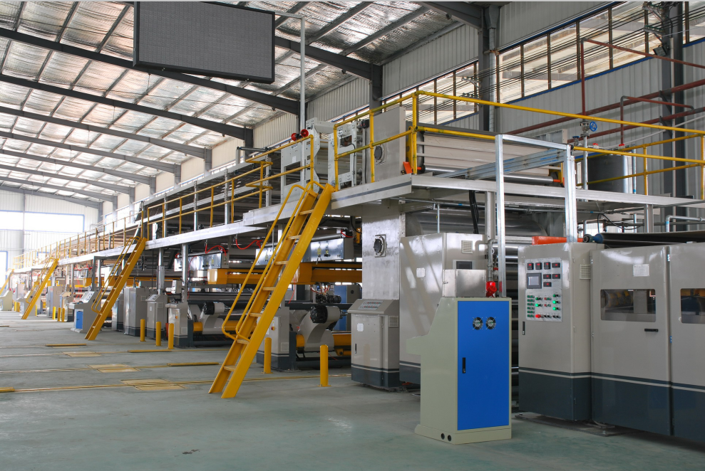
已通过ISO：9001-2008标准质量管理体系认证
创新包装科技，打造一流品牌

Add:the eastern of 104 national highway,3km the south of city Dongguang county, Cangzhou county, Hebei province.
工厂地址：河北沧州东光县城南3公里104国道西侧
Production line configuration list
生产线配置清单
Models规格型号 | Name  设备名称 | QTY  数量 | Unit price  单价  （万元） | Remark  备注
ZJ-V5B | Hydraulic shaftless mill roll stand  全液压无轴  纸架 | 2台  （set） |  | Spindle ¢ 240mm, hyperbolic heavy rocker, expand chuck , multi-point brake, hydraulic drive lifting, panning left and right on the middle.  主轴￠240mm，双曲线重型摇臂，齿式夹纸头，多点式刹车,液压驱动升降，左右平移，对中等。  导轨长度6000mm，采用中板焊接。
 | Rail and Tracks  上纸小车 | 2台  （set） |  | The guide track is 6000mm and the trolley is welded with 10mm。  导轨长度6000mm，小车采用10mm中板焊接。
SF-320C | Fingerless type single facer  单面瓦楞机 | 2台  （set） |  | Corrugated main roller ￠320mm，material with 48CrMo Tile roll modular group lifting transfer.Airbag ballasting structure，import main bearing，PLC automatic control glue，HMI touch screen，Breaks automatic parking relief，steam heating way.瓦楞主辊￠320mm，材质采用48CrMo合金钢。瓦辊模块式成组吊换。气囊压载结构，进口主轴承，PLC自动控胶，人机界面触摸屏，断纸自动停车卸压，蒸气加热方式。
RG-2-900 | RG-1-900 top（core）paper preheater  R09B  面（芯）纸预热器 | 2台  （set） |  | Roller ￠900 mm, Pressure vessel certificate Electric adjustment package Angle.Angle can be adjusted within the range of 360 ° paper heated area.  辊筒￠900mm，含压力容器证书。电动调整包角。包角可在360°范围内调节纸张受热面积。
ZDF | Conveyor bridge  输送过桥 | 1套  （set） |  | Adopt independent variable frequency motor drive, pull paper adsorption tensioning device.  采用独立变频电机驱动，牵纸吸附式张紧装置。
DHE-180 | Single watt crosscut cutter (spiral knife crosscut, full servo crosscut, hanging basket stacking)  单瓦纵横切纸机（螺旋刀横切，全伺服纵切，吊篮堆码） | 1台  （set） |  | Full AC servo control spiral knife structure, touch screen display. The paper receiving machine adopts grading and adjustable counting to output cardboard, with the maximum stacking length of 1.6 meters. The motor of pulling paper feed and transverse output is variable frequency speed regulation.  全交流伺服控制螺旋刀结构，触摸屏显示。收纸机采用分级可调计数输出纸板，最大堆积长度1.6米。牵纸输纸横出电机均为变频调速。
合计 | RMB ex-factory price人民币出厂价： （含税价） ￥：
Self-contained part
客户自备部分
1、Steam heating system：proposal with 4000Kg/Hr of a steam boiler pressure:1.25MPa steam pipeline。蒸汽供热系统：建议配4000Kg/Hr蒸汽锅炉一套， 压力为1.25Mpa，蒸汽管道。
2、Air compressed machine、air pipeline、glue conveying pipe。
空气压缩机、空气管道、胶液输送管道。
3、Power supply、wires connected to the operation panel and line pipe。
电源、电线接至操作柜及线路管道。
4、Water sources、water pipelines、buckets and so on。水源、输水管道、水桶等。
5、Water, electricity, gas flush mounting civil foundation。水、电、气地基平面安装土建工程。
6、Test with the base paper、corn starch (potato)、Industrial use caustic soda、borax and other material。试车用原纸、玉米（薯类）淀粉、工业用烧碱、硼砂等材料。
7、Oil equipment、lubricating oil、hydraulic oil、lubricating grease。
设备用机油、润滑油、液压油、润滑脂。
8、Installation、commissioning of food, accommodation。And provide installers with the installation.安装、调试人员的饮食、住宿。并提供安装工人配合安装。

※Configuration instructions for single machine
单机配置说明

1、ZJ-V5B hydraulic shaftless mill roll stand 全液压无轴纸架
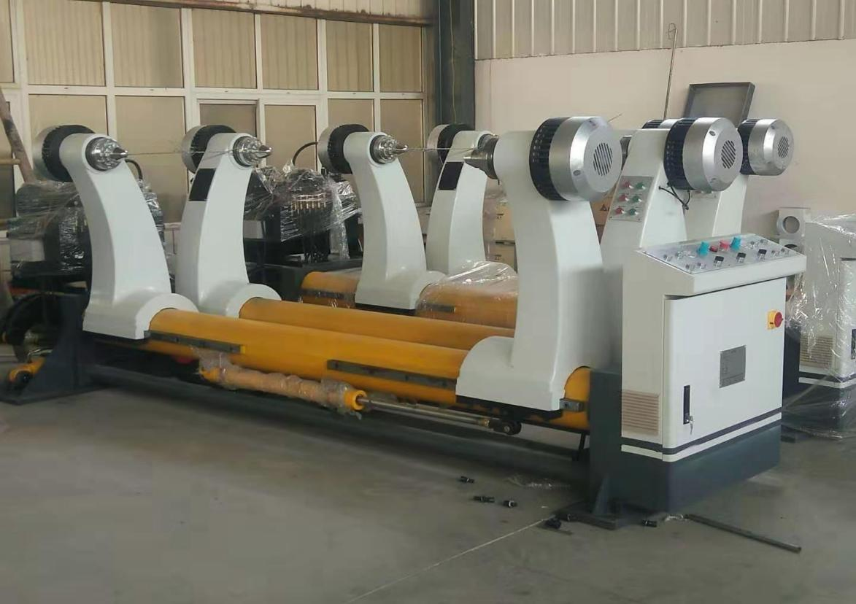
ⅰ、Structural features结构特点：
★Adopt hydraulic drive to complete the paper clamping, loosen, remove for the medium, translation left and right and others，the lifting of the paper adopts hydraulic drive.
采用全液压驱动来完成原纸夹紧、松开、移动对中、左右平移等动作，原纸升降采用液压驱动。
★Brake adjustable adopts multipoint braking system.
刹车调整采用多点式刹车系统。
★Each paper rack is equipped with two paper carts that can be served simultaneously from both sides. 每台纸架配两台上纸小车从两侧可同时上纸。
ⅱ、Technical parameter技术参数：
- Paper clip range maximum : 1800mm minimum : 1000mm
夹纸范围：最大： 1800mm 最小：1000mm
- Folder diameter maximum : 1500mm minimum : 350mm
夹纸直径：最大：￠1500mm 最小：￠350mm
3、Main shaft diameter of paper holder：￠240mm 纸架主轴直径：￠240mm
4、Gas source work pressure（Mpa）：0.4---0.8Mpa 气源工作压力（Mpa）：0.4---0.8Mpa
ⅲ、 Hydraulic system parameters 液压系统参数：
- Work pressure（Mpa）:16---18Mpa 工作压力（Mpa）:16---18Mpa
- Lifting hydraulic cylinder：￠100×440mm 升降液压缸：￠100×440mm
- Clamping hydraulic cylinder：￠63×1300m 夹紧液压缸：￠63×1300mm
- Hydraulic station motor power：3KW --380V -- 50Hz 液压站电机功率：3KW --380V -- 50Hz
- Solenoid valve voltage：220V 50 Hz 电磁阀电压：220V 50 Hz

2、paper trolley、track上纸小车、导轨
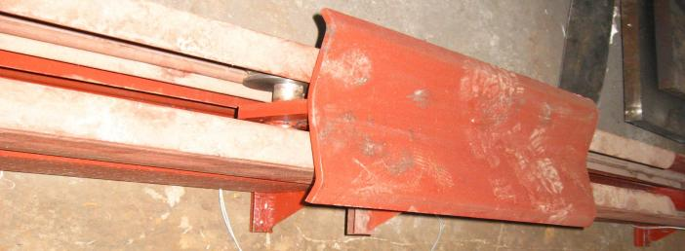
ⅰ、Structural features结构特点：
★Push the roller in place将卷筒纸推送到位。
★Track whole buried, The main frame of the 14th channel with ¢ 20mm cold drawn round welding，the track length 6000mm。
轨道整体埋地，主架为14号槽钢与￠20mm冷拔圆钢焊接，地轨长度6000mm。
★Each paper with two stage paper trolley,and the paper from the two sides at the same time。每台纸架配两台上纸小车从两侧可同时上纸。
3.SF-320C fingerless type single facer SF-320C吸附式单面机

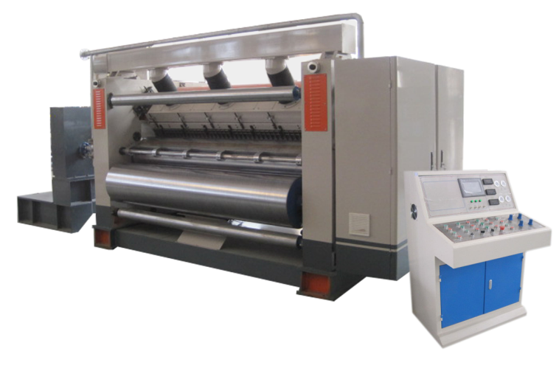
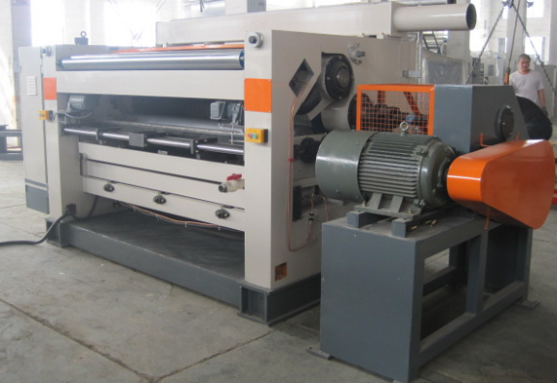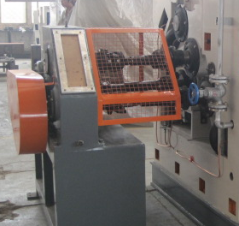
ⅰ、Structural features结构特点：
★Adopt hood suction structure，matched high pressure powerful fan. Gas supply and electrical control cabinet to focus on the same operation, the operating side full cover closed.
采用罩吸式结构，配高压强力风机。气源及电气控制集中于同一操作柜，操作侧全封闭全罩。
★High quality resin sand casting，wall thickness 200mm。Adopt independent gear box, Universal joint transmission structure.
优质树脂砂铸件，墙板厚度200mm。采用独立变速箱，万向节传动结构。
★install the lifting trolley on the conveyor bridge,Need to use the car will tile roll assembly and pressure roller, such as convenient and quick.
在输送天桥上面加装了吊装小车，需要时利用该车将瓦辊总成及压力辊等取出，方便快捷。
★Glue roller unit structure with the overall relocation，Maintenance can sway the machine at the overall maintenance，improve the working efficiency。
涂胶辊单元采用整体外移式结构，维护时可整体侧移出机处进行维护，提高了工作效率。
★The humidity control apparatus equipped with a spray, so flute type to maintain good stability of deformation, avoid dry。
配用喷雾调湿装置，使瓦楞楞型保持良好的变形稳定性，避免干裂。
★Automatic circulation system for glue, two-cylinder pneumatic gluing device, with good cushioning effect.
采用自动循环式供胶系统，双气缸气动上胶装置，具有良好的缓冲效果。
★Glue department using integrated slide structure，Glue roller surface after grinding engraved with 32 lines and pit-style textured hard chrome plating.
涂胶部采用整体式滑板结构，涂胶辊表面经精磨后刻有32线凹坑式网纹并镀硬铬处理。
★Corrugated roller adopt tungsten carbide dealing，diameter of the main corrugated roller¢ 320mm，Quenched→rough car→bore fine boring→shaft head shrunk-on→welding → tempering to stress→fine cars→coarse grinding→IF quenching→CNC grinding machine grinding→tungsten carbide dealing，hardness of surface is HV58degrees。
瓦楞辊材质48CrMo合金钢，瓦楞主辊直径¢ 320mm，经调质→粗车→内孔精镗→轴头烘装→焊接 → 回火去应力→精车→粗磨→中频淬火→数控磨床精磨→碳化钨处理。
★Active force variable frequency motor drive, energy efficient, low failure rate。
主动力采用变频电机驱动，节能高效，故障率低。
★Glue wide electric adjust to changes in the width of the paper used。
涂胶宽幅电动调整，以适应所用原纸宽度变化。
★Amount of glue size with electric adjustment, touch screen display and operation of the encoder transmission coating gap, high accuracy。
涂胶量大小采用电动调整，触摸屏显示及操作，通过编码器传输涂胶间隙，精确度高。
★Power and operating parts with a safety net to ensure the safety of personnel in the operation of machinery。
动力及操作部位配有安全防护网，以确保人员在机器运转时的安全。
ⅱ、Technical parameter技术参数：
★Effective width：1800mm 工作幅宽：1800mm
★Operation direction：left or right（determined in accordance with customer plant）
操作方向：左置或右置（根据客户厂房确定）
★Design speed：150m/min 设计速度：150m/min
★Temperature range：160—180℃ 温度范围：160—180℃
★Corrugated flute:（UV type or UVV type） 瓦楞楞型（UV型或UVV型）：
ⅲ、Roller diameter parameter辊类直径参数：
★Corrugated roll diameter瓦楞辊直径： up￠313mm down￠316mm
★Pressure roll diameter压力辊直径： ￠320mm
★Glue roller diameter涂胶辊直径： ￠240mm
★ Fixed paste roller定糊辊： ￠140mm
★Preheater diameter预热器直径： ￠402mm
ⅳ、Powered motor parameters动力电机参数：
★Main frequency drive motor：18.5KW 主变频驱动电机：18.5KW
★Suction motor：11KW 吸风电机:11KW
★Glue reducer：100W 调胶减速机：100W
★Glue adjusting motor：200W*2 隔胶调整电机：200W *2
★Glue pump motor：2.2KW 胶泵电机：2.2KW
4、RG-1-900 top（core）paper preheater
R09B面（芯）纸预热器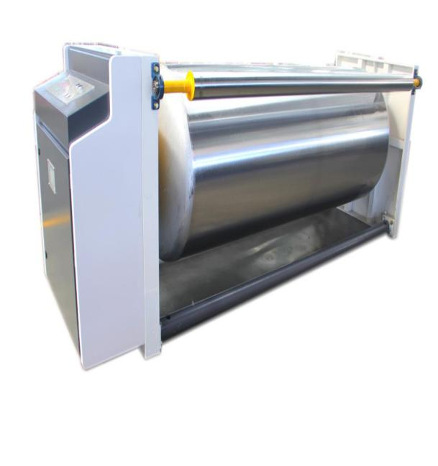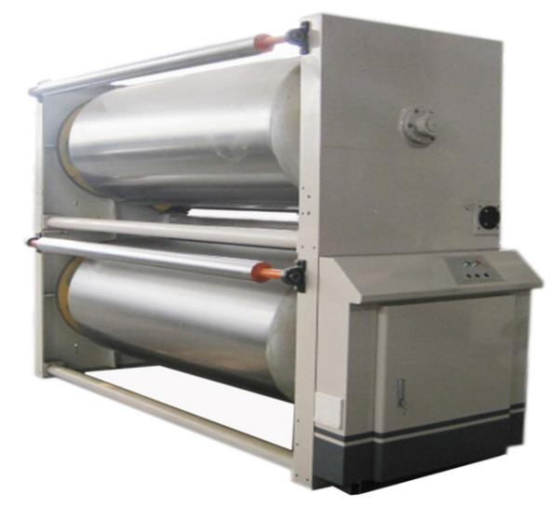
ⅰ、Structural features结构特点：
★The preheating roller is designed with butterfly head, which conforms to the first class national standard of pressure vessel and has the certificate of pressure vessel.
预热辊采用蝶型封头设计，符合一类压力容器国家标准，并附有压力容器证书。
★The roll surface after precision grinding, fine grinding and hard chromium plating processing，surface friction is small and durable。
各辊表面经精密磨削后精磨并镀硬铬处理，表面摩擦力小，耐用。
★Electric adjustment wrap angle , wrap angle can be rotated within 360 °to adjust the paper heat area . 电动调整包角，包角可在360°范围内旋转调节纸张受热面积。
ⅱ、Technical parameter技术参数：
★Effective width：1800mm 工作幅宽：1800mm
★Diameter of the preheat roller：￠900mm 预热辊直径：￠900mm
★Diameter of the angle：￠110mm×2 包角轴直径：￠110mm×2
★Steam temperature：150-200 ℃ 蒸汽温度：150-200℃
★Steam pressure：0.8-1.3Mpa 蒸汽压力：0.8-1.3Mpa
★Motor power：250W short（S2）work system 电机功率：250W 短时（S2）工作制

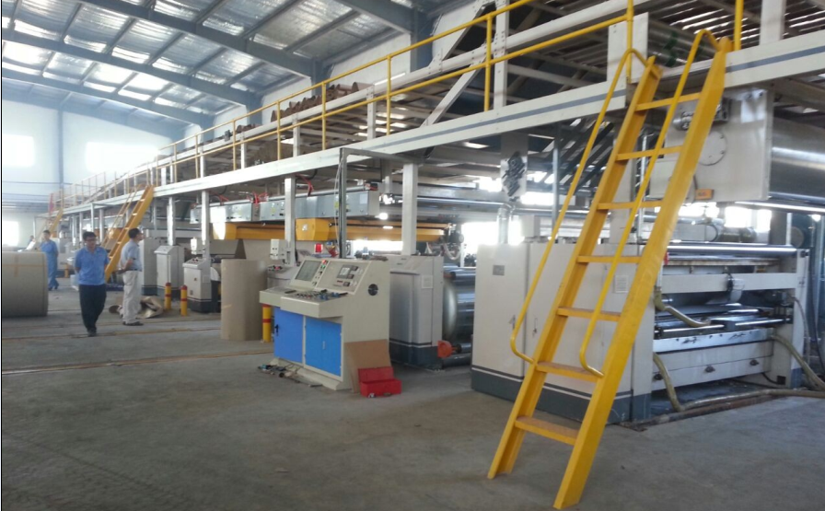
5、ZDF conveyor bridge 输送过桥
ⅰ、Structural features结构特点：
★This part is the main beam of the 20th channel, 16-beam, angle iron 63, column, etc. are connected.
本部分是主梁为20号槽钢、16号工字钢、63号角钢、立柱等连接而成。
★Both sides of the security fence, ladder , high-strength save people the word pedals, ensure the safety of personnel and easy to operate.
两侧均有安全护栏、梯子（用8号小槽钢制作）、高强度人字踏板，确保人员的工作安全以及操作方便。
★Pull the paper shaft surface tension axis, feeding shaft by grinding hard chrome plated.
牵纸轴、张紧轴、输纸轴等表面经磨削加工镀硬铬处理。
★Vacuum tension control, 5-inch suction tube, plus regulating valves, air flow can be infinitely adjustable.
真空吸附张力控制，吸风管5寸，加调节阀门，风量可无级可调。
★Dual front bezel correction guide column positioning, screw driver, fast and accurate positioning, walking steadily.
纠偏挡板前采用双导向柱定位，丝杠驱动，定位快速准确，行走平稳。
ⅱ、Roller diameter parameter辊类直径参数：
★Paper roll and a tension roller diameter:￠130mm 上纸辊及张紧辊直径：￠130mm
★Conveying roller diameter：￠180mm 输送辊直径：￠180mm
★Active tension roller diameter：￠85mm 主动张紧辊直径：￠85mm
★Diameter of over paper rollers and guide rollers：￠110mm 过纸辊及导纸辊直径：￠110mm
★Paper towing shaft diameter：￠110mm 上纸拖带轴直径：￠110mm
ⅲ、Powered motor parameters动力电机参数
★Corrugated single paper lift motor：2.2KW 单面瓦楞纸提升电机：2.2KW
★The bridge adsorption motor：2.2KW 过桥吸附风机：2.2KW
★Wide motor tune cardboard：250W 调纸板宽幅电机：250W

- Dhe-180 computer single watt vertical and horizontal paper cutter
DHE-180型电脑单瓦纵横切纸机
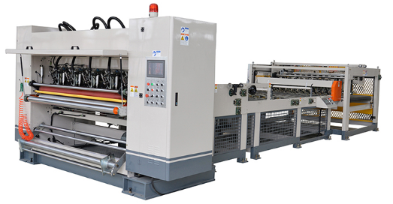
- Technical parameters 技术参数：
Working width: 1800mm 工作幅宽：1800mm
Design speed: 180m/min 设计速度：180m/min
Economic speed: 130-150m/min 经济速度：130-150m/min
Cutting paper length: 300-1600mm 切纸长度：300-1600mm
Minimum slitting width: 180m 最小纵切宽度：180m
Paper cutting precision: ±1mm (uniform speed) 切纸精度：±1mm（匀速）
Blade: 5 ￠200 thin knife 刀片：5组￠200薄刀
- Main performance features主要性能特点：
★Can store 200 groups of orders, man-machine interface, screen display information, can be consulted at any time, modify, add, cancel.
可储存200组定单，人机界面，荧屏显示资讯，可随时查阅，修改，追加，取消。
★Germany Kobe servo controller control motor drive, high performance servo motor synchronous drive.
德国科比伺服控制器控制电机驱动，高性能伺服电机同步驱动。
★The crosscutting machine adopts steel blade structure and hard tooth surface grinding gear to achieve no backlash transmission, high precision and long service life.
横切机采用镶锋钢刀片结构，硬齿面研磨齿轮实现无侧隙传动，精度高寿命长。
★The main engine wallboard adopts gray cast iron, with good rigidity and strong vibration resistance
主机墙板采用灰口铸铁，刚性好，抗振性强。
★Stacking part adopts basket platform lifting, reaches a certain number of right Angle horizontal, paper is divided into four sections, a section of roller design paper flat
堆码部采用吊篮平台升降，达到一定数量直角横出，分四段出纸，一段毛滚设计纸片平直
The output is not bent, two sections of buffer overlap with fixed length, three sections of point pneumatic separation, accelerate the output of cardboard. Improve work efficiency. The maximum stacking length is 1.6 meters. This machine is suitable for high efficiency production of color printing enterprises.
输出不弯曲，二段缓冲定长重叠，三段点数气动分离，加速输出纸板。提高工作效率。最大堆积长度1.6米。此机适合彩印企业高效率生产。
★Full servo motor control, order change fast, order change time 1-3 seconds
全伺服马达控制，换单快，换单时间1-3秒。
★Thin tungsten steel alloy knife, sharp blade, service life is more than 8 million long meters.
采用薄型钨钢合金刀，刀锋锋利，使用寿命大于800万长米。
★Knife grinding is controlled by computer, automatic or manual, which can be sharpened while cutting to improve production efficiency
磨刀为电脑控制，自动磨刀或手动磨刀，可边分切边磨刀，提高生产效率。
★Imported synchronous driving device, accurate, long life, low noise
采用进口同步带动装置，精度准，寿命长，运行噪音低。
★The computer control system is composed of high quality imported industrial computer and high performance programmable controller.
由高品质的进口工业计算机和高性能的可编程控制器构成上、下位计算机控制系统。
Main component parameters主要部件参数：
Cross cutting upper tool shaft ￠200mm dynamic balancing treatment
横切上刀轴￠200mm 调质 动平衡处理
Cross cutting tool shaft ￠200mm dynamic balancing treatment
横切下刀轴￠200mm 调质 动平衡处理
The lower pull roller ￠156mm pack silicone dynamic balance treatment
下牵纸辊￠156mm包硅胶 动平衡处理
Main dynamic parameter主要动力参数：
Main drive motor power: 22KW Voltage: 380V frequency :50HZ
主驱动电机 功率：22KW 电压：380V 频率:50HZ
Basket motor power: 3KW Voltage: 380V frequency :50HZ
吊篮马达 功率：3KW 电压：380V 频率:50HZ
Paper feeding motor power: 1.5KW Voltage: 380V frequency :50HZ
输纸电机 功率：1.5KW 电压：380V 频率:50HZ
Horizontal motor power: 0.75KW Voltage: 380V frequency :50HZ
横出电机 功率：0.75KW 电压：380V 频率:50HZ
Brand and origin of main components主要部件品牌及产地：

The serial number  序号 | The main thing that name主件名称 | Brand or place of origin  品牌或产地 | Note  备注
01 | Ac servomotor  交流伺服马达 | Shanghai futian  上海福田 | 22KW
02 | Synchronous variable frequency motor for paper feeding  输纸同步变频马达 | Taiwan city  台湾城邦
03 | bearing轴承 | Ha, Wa, Luo or Zhejiang Wanxiang  哈、瓦、洛或浙江万向
04 | When tight set of  涨紧套 | Xianyang chaoyue  咸阳超越
05 | Arrange ushering bearing  带座轴承 | Zhejiang rings  浙江五环
06 | Contactor  接触器 | 德国西门子SIEMENS
07 | Proximity switch, photoelectric switch  接近开关、光电开关 | 日本欧母龙OMRON
08 | Flying shear servo control system  飞剪伺服控制系统 | American Emerson or Kobe Bryant  美国艾默生或科比
09 | Slitting and PLC  纵切PLC | Taiwan in  台湾台达
10 | Rotary encoder  旋转编码器 | ELCO宜科
11 | Rotary encoder  输纸变频器 | Taiwan in  台湾台达
12 | The man-machine interface  人机界面 | Kunlun state  昆仑通态
13 | Round the sun  太阳轮
14 | Pneumatic components  气动元件 | Taiwan Yadeke  台湾亚德客

注：本文件提供图片仅供参考，乙方保留在不改变技术性能的前提下更改外观的权利。

恒创利售后服务承诺
东光恒创利本着“以客户的满意为追求”的服务理念，在确保设备的先进性、可靠性、稳定性的同时，不断改进服务质量，从售中到售后的交货、调试安装、设备维护管理、技术服务等各方面，保证客户能得到最好的服务，让客户满意、放心。
恒创利对所有使用我司产品的用户做出如下售后服务承诺：
- 保修期12个月（电器、易损件除外），12个月后我公司提供有偿服务。
- 如出现质量问题，通过电话或传真形式，将安排专业技术人员在规定时间内对设备故障定位，并拿出解决方案，最终排除故障。通过电话不能诊断的故障我公司将派专门工程师，1小时内响应，48小时内到达现场，72小时内解决问题。
- 用户可通过售后服务电话13001445333咨询有关技术问题及投诉售后服务问题并得到明确的解决方案。
- 使用者在国内地区正常使用中出现性能故障时，本公司承诺以上保修服务。除此之外，国家法律法规另有明确规定的，本公司依照相关法律法规执行。
- 在保修期内，如发生以下情况我司将进行有偿服务：
- 由于人为或不可抗拒的自然现象发生的损坏
- 由于操作不当而造成的故障或损坏
- 对于设备改造、分解、组装时发生的故障或损坏。
特此说明！ 东光恒创利纸箱机械有限公司
日期：2021年 月 日

