ZJZ glue station system
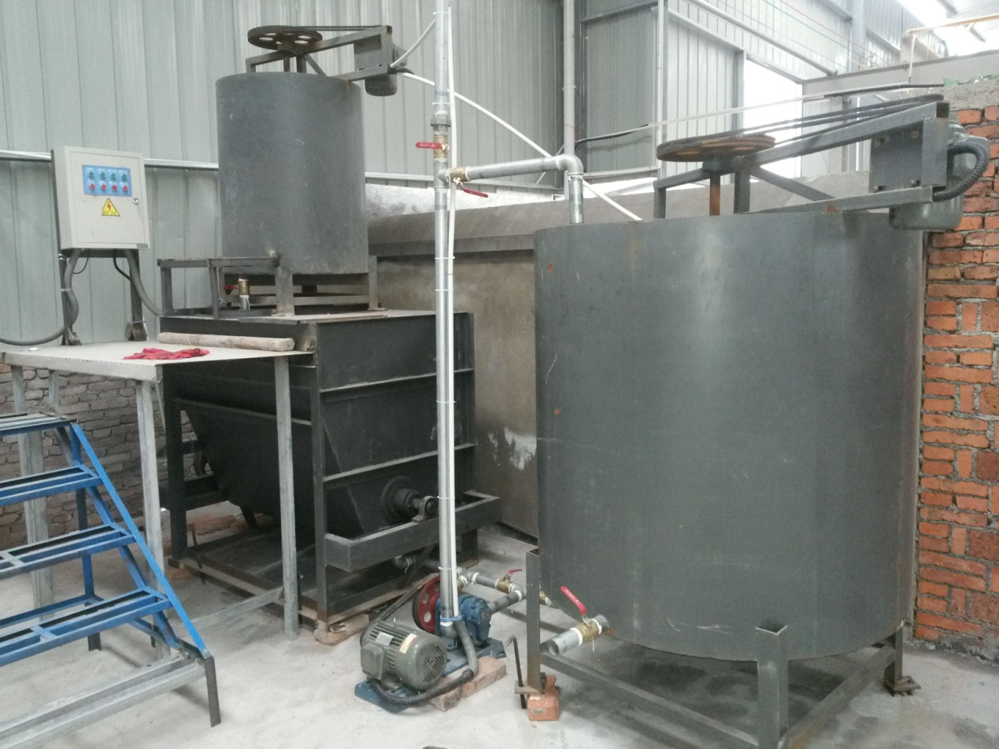
ⅰ、Structural features：
★Provide the starch adhesive to the corrugated single facer , glue machine and some other gluing equipment.
★Horizontal glue machine can meanwhile matched with main body glue and carrier glue, and mixing, glue large。
★Making room storage barrels adhesive solution was to use the glue pump rubber equipment storage barrels, adhesive solution for equipment。
★Storage barrels, plastic barrels with mixing device, avoid glue solution precipitation agglomerate。
★System unit with carrier vessel, main tank, storage tank, and send the glue pump, the back glue
pump, etc
★Glue system adopt glue cycle,rest glue go back to the glue square cylinder,Liquid level float automatic control,the back glue a bucket of glue liquid being beaten back with glue equipment storage bucket，cycle for glue，Save the glue solution，prevent the glue solution in the rubber plate pasting and caking precipitation.
★Work has been completed, the residual gum dividend total pipeline with rubber equipment rubber pumped back rubber room storage barrels, for next time use。
★Responsible for technical guidance, teaching adhesive dispensing process。
ⅱ、Technical parameter：
★Horizontal body glue mixer：one
★Carrier glue mixer：one
★Storage glue mixer：one
★Plastic buckets on coater：one
★Coating machine back plastic buckets :one
★Plastic buckets on single machine :two
★Single machine back plastic buckets：two
★Lose glue dispensing pumps：four
ⅲ、Glue barrel diameter parameters：
★Horizontal body glue mixer：1250mm×1000mm×900mm
★Carrier glue mixer diameter： ￠800mm×900mm
★Diameter plastic bucket on Glue：￠800mm×1000mm
★Plastic buckets on single machine：￠800mm×1000mm
★Storage tank diameter：￠1200mm×1200mm
ⅳ、Powered motor parameters：
★Horizontal body glue mixer：3Kw
★Carrier glue mixer：2.2Kw(Ordinary three-phase)
★Output plastic pump motor ：2.2Kw（Ordinary three-phase）
★Storage Tank Motor：1.5Kw（Ordinary three-phase）

