Automatic paper picking machine
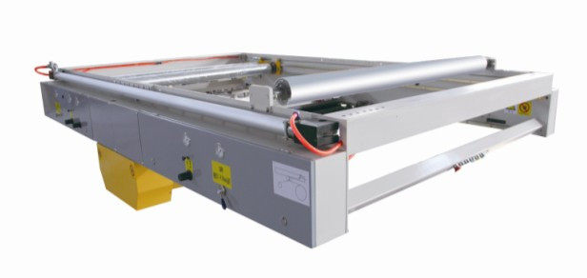
ⅰ、Structural features：
★Maximum diameter of base paper：1500mm。
★Mill roll stand with automatic tension control, high-speed paper receiving success rate.
★Paperless tail then the paper, to reduce the paper loss(Paper tape and only partially overlap with a width of 40mm.)
★When the paper car out, automatic transfer out,and the vacuum suction,easy paper loading, automatic tension control,zero error of paper receiving.
★all PLC automatic control,accurate,less failure,easy maintenance.
★The first buffer wheel pull the paper, automatic alignment, easy to pull paper.
★Machine superiority, cylinder control of the paper machine at high speed, the paper will not appear in the ordinary motor control of broken tiles, foaming phenomenon.
★Maximum paper speed 150 m / min.
ⅱ、Technical parameter：
- Effective width：1800mm
2、Operation direction：left or right（determined in accordance with customer plant）

3、Design speed：150m/min
4、Working speed：0-150m/min
5、Pressure：6bpa
6、Single machine weight：max 2300Kg
ⅲ、Roller diameter parameter：
- Up guide paper shaft：￠126mm
- Down guide paper guide： ￠126mm
- Buffer roller guide roller1： ￠118mm
- Buffer roller guide roller2：￠126mm
- Paper pinch roll： ￠99mm
- Paper roll：￠99mm

