DMT-120paper sheet delivery and side conveyor
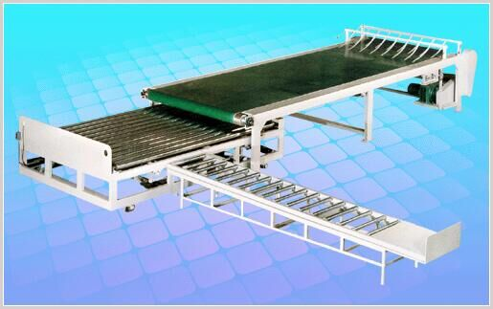
ⅰ、Structural features：
★Adopted on the 16th channel welded。Electric adjustment of cardboard the size of the lateral output pneumatic control board, electrically adjustable conveyor speed.
★Cardboard sheets to the desired number or height requirements will be controlled by a foot switch out of cardboard。
★Vertical bin using wide flat belt conveyor transport。
ⅱ、Technical parameter：
★The maximum accumulation length：3000mm
★The maximum stack height：200mm
ⅲ、Powered motor parameters：
★Main conveyor motor：3Kw adopt frequency motor
★Lateral output of the motor：1.5Kw Three-phase asynchronous motor
★Walking Motor：1.5Kw Three-phase asynchronous motor

