ridge correction machine control system configuration
窗体底端
★窗体顶端

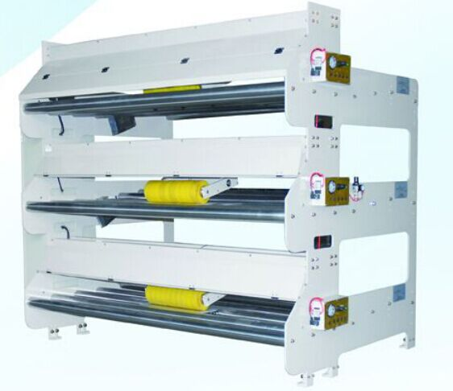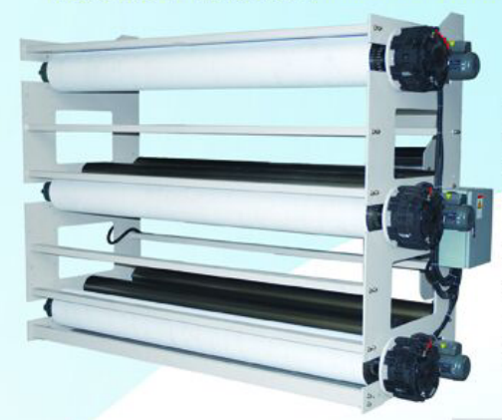
★ Non-contact detection corrugated
★High precision correction paper
★It does not require any adjustment when the width of the paper changes
★Closed-loop control, continuous operation
★Full size infrared LED detection, long life
★At the same time the center and edges of the base correction
窗体顶端
窗体底端

窗体顶端
★.bridge tension control system to ensure that there is a single corrugated paper steady tension.
★tension control manually controlled by the regulator.
★with auxiliary threading motor. In the new paper, when customer assistance.。
★with the paper through the switch. Joints over time cut the tension

