paper preheater triple preheater
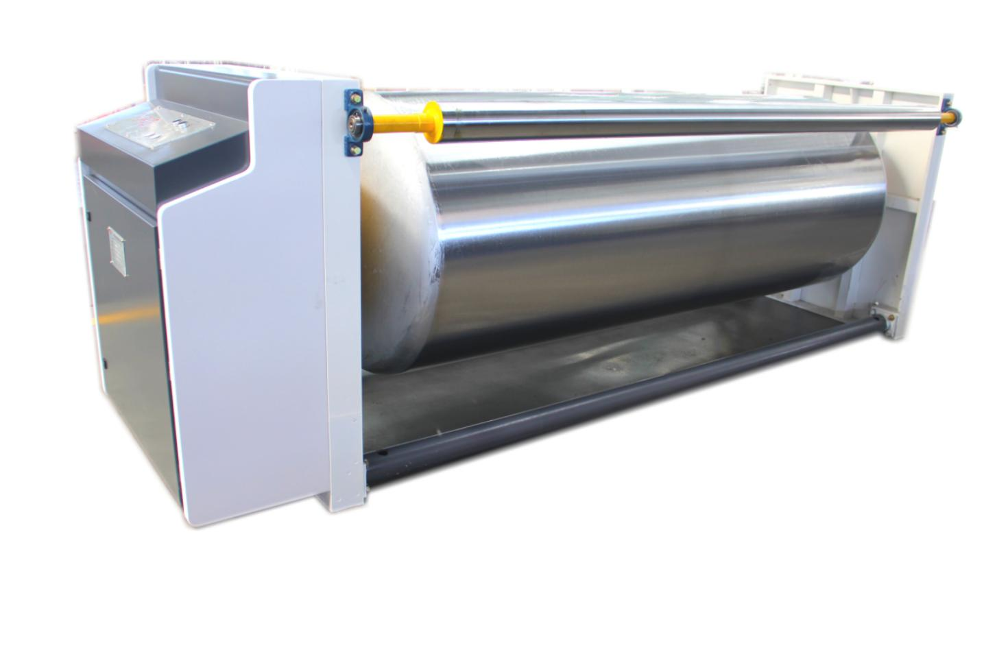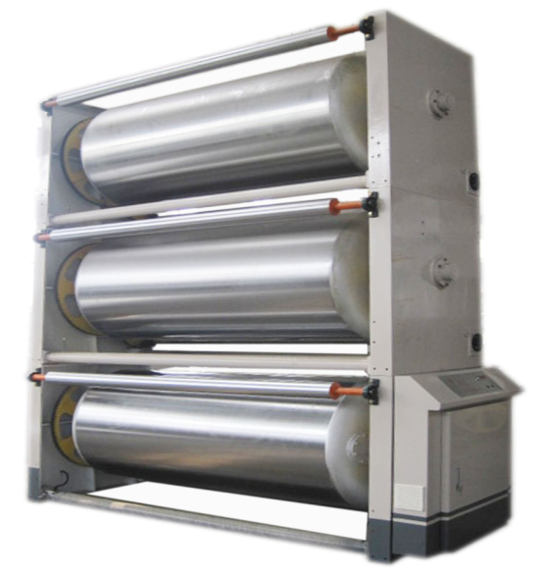
ⅰ、Structural features：
★The preheating roller is designed with butterfly head, which conforms to the first class national standard of pressure vessel and has the certificate of pressure vessel.
★The roll surface after precision grinding, fine grinding and hard chromium plating processing，surface friction is small and durable。
★Electric adjustment wrap angle , wrap angle can be rotated within 360 °to adjust the paper heat area .
★The double-stage reducer is used to adjust the angle of the package and has the function of self-locking.
ⅱ、Technical parameter：
★Effective width：1800mm
★Diameter of the preheat roller：￠600mm
★Diameter of the angle：￠85mm×2
★Steam temperature：150-200 ℃
★Steam pressure：0.8-1.3Mpa
★Motor power：250W short（S2）work system

