NC-120 NC cutter helical knives
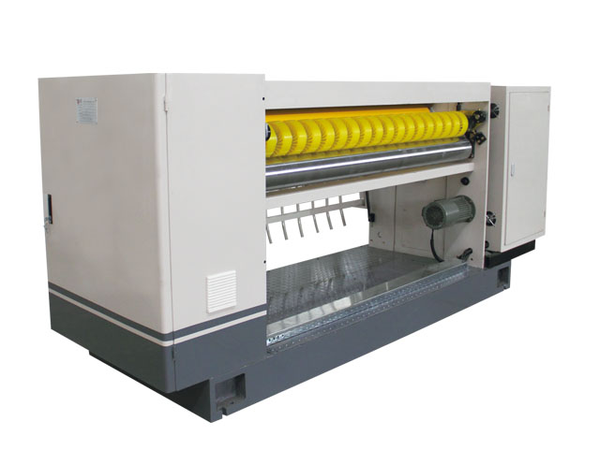
ⅰ、Structural features：
★It can store 200 units orders，replace the cutter specifications quickly and accurately，changing orders without stop,And enables networked computers to facilitate production management.
★Knife shaft drive gears are precision forged steel induction hardening, backlash-free transmission, advanced keyless connection, high transmission accuracy。
★Cutting machine adopts inlaid front steel blade knife spiral structure, serrated knife. scissors, shears, shear force, long blade life。
★Around feed rollers are used the sun gear platen way, smooth delivery, pressure evenly, easy to crush plate board or cause blockage。
★This type of brake is energy storage type (non-energy brake), so in the process of production, the average power consumption is 1 / 3 of that of the ordinary NC cutting machine, saving more than 70% of electricity and achieving the goal of saving money.
★Exact and adjustable no gap gear to ensure precise blade engagement, running balance.
★Independent oil pump and filter are used to distribute two sets of copper pipes in each gear position to feed oil, lubricate and cool.
★Knife roller: fine quality forged steel material, the balanced, with good stability.
ⅱ、Technical parameter技术参数：
★Effective width：1800mm
★Operation direction：left or right（determined in accordance with customer plant）
★Design speed: 100 m / min
★Mechanical configuration: computer helical cutter crosscutting
★Minimum cutting length：500mm
★Maximum cutting length：9999mm
★Cutter accuracy: Uniform for ± 1mm, non-uniform to ± 2mm
★Equipment size: Lmx4.2 Wmx1.2 Hmx1.4
★Single machine weight: maximum 3500kg
ⅲ、Roller diameter parameter：
★Cross on the knife shaft center distance：￠216mm
★Before the lower conveying roller diameter ￠156mm
★After the lower conveying roller diameter：￠156mm
★Roll diameter: 160mm。
★Output solar wheel diameter: 160mm
Note: all roller shafts after grinding, the surface of hard chromium plating (except upper, lower tool shaft).
ⅳ、Powered motor parameters：
★main drive motor power：12.5Kw Full AC synchronous servo
★Before feeding motor power：3Kw（Frequency Control）
★Oil pump motor power：0.25Kw

