Specification model | Equipment  name | quantity | 备注
NC-120 | Computer Spiral Knife Crosscutting Machine | 1set | Full AC servo control, energy storage brake, spiral knife structure, oil-immersed gear drive, 10.4-inch touch screen display.

NC-120 Computerized Spiral Knife Cross-cutting Machine
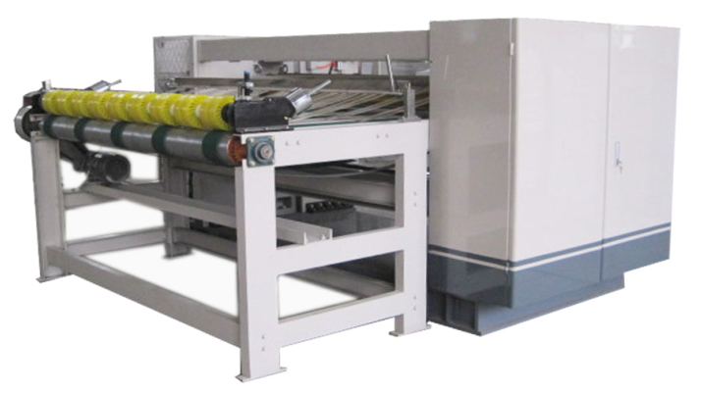
ⅰ、Structural features:
★200 sets of orders can be stored, paper cutting specifications can be changed quickly and accurately, orders can be changed without stopping the machine, and computer networking can be realized to facilitate production management.
★The knife shaft transmission gear adopts high-frequency hardening of precision forged steel material to realize backlash-free transmission, and adopts advanced keyless connection method with high transmission accuracy.
★The blade of the cross-cutting machine adopts the structure of the spiral knife inlaid with high-end steel, and the serrated knife type. Scissor cutting, small cutting force, long blade life.
★The front and rear paper feed rollers adopt the sun wheel pressing method, with stable conveying and uniform pressure, and it is not easy to crush the board or cause blockage.
★This model is energy-storage braking (non-energy-consumption braking), so it has low energy consumption during the production process. The average power consumption is 1/3 of that of ordinary NC cutting machines. It saves more than 70% of electricity and achieves the goal of saving money. .

★Precisely adjustable and backlash-free gears ensure precise meshing of the knife edges and balanced operation.
★Independent oil pump and filter are used with two sets of copper pipes distributed in each gear position for oil supply, lubrication and cooling.
★Knife roll: high-quality precision forged steel material, balanced treatment, with good stability.
ⅱ、technical parameter:
★Working width: 2200mm
★Operation direction: left or right (determined according to customer's factory)
★Design speed: 200m/min
★Mechanical configuration: computerized spiral knife cross cutting
★Minimum cutting length: 500mm
★Maximum cutting length: 9999mm
★Paper cutting accuracy: uniform speed is ±1mm, non-uniform speed is ±2mm
★Equipment size: Lmx4.2*Wmx1.2*Hmx1.4
★Single machine weight: maximum 3500Kg
ⅲ、Roller diameter parameters:
★The center distance between the upper and lower cutter shafts for transverse cutting: ￠216mm
★Diameter of front and lower conveyor roller ￠156mm
★Diameter of the lower back conveyor roller: ￠156mm
★Diameter of pulling paper roller: ￠160mm
★Output sun wheel diameter: ￠160mm
Note: After all rollers have been ground, the hard chrome-plated areas (except the upper and lower shafts) are treated.
ⅳ、Power motor parameters:
★Main drive motor power: 37KW full AC synchronous servo
★Front and rear paper conveying motor power: 3KW (frequency conversion speed regulation)

