Specification model | Equipment  name | quantity | 备注
ZJ-V5B | Full hydraulic shaftless paper holder | 3 sets | Main shaft ￠240mm, hyperbolic heavy-duty rocker arm, tooth-type paper clamping head, multi-point brake, hydraulic drive up and down, left and right translation, centering. The length of the guide rail is 6000mm, and the middle plate is welded.

ZJ-V5B Full hydraulic shaftless paper holder
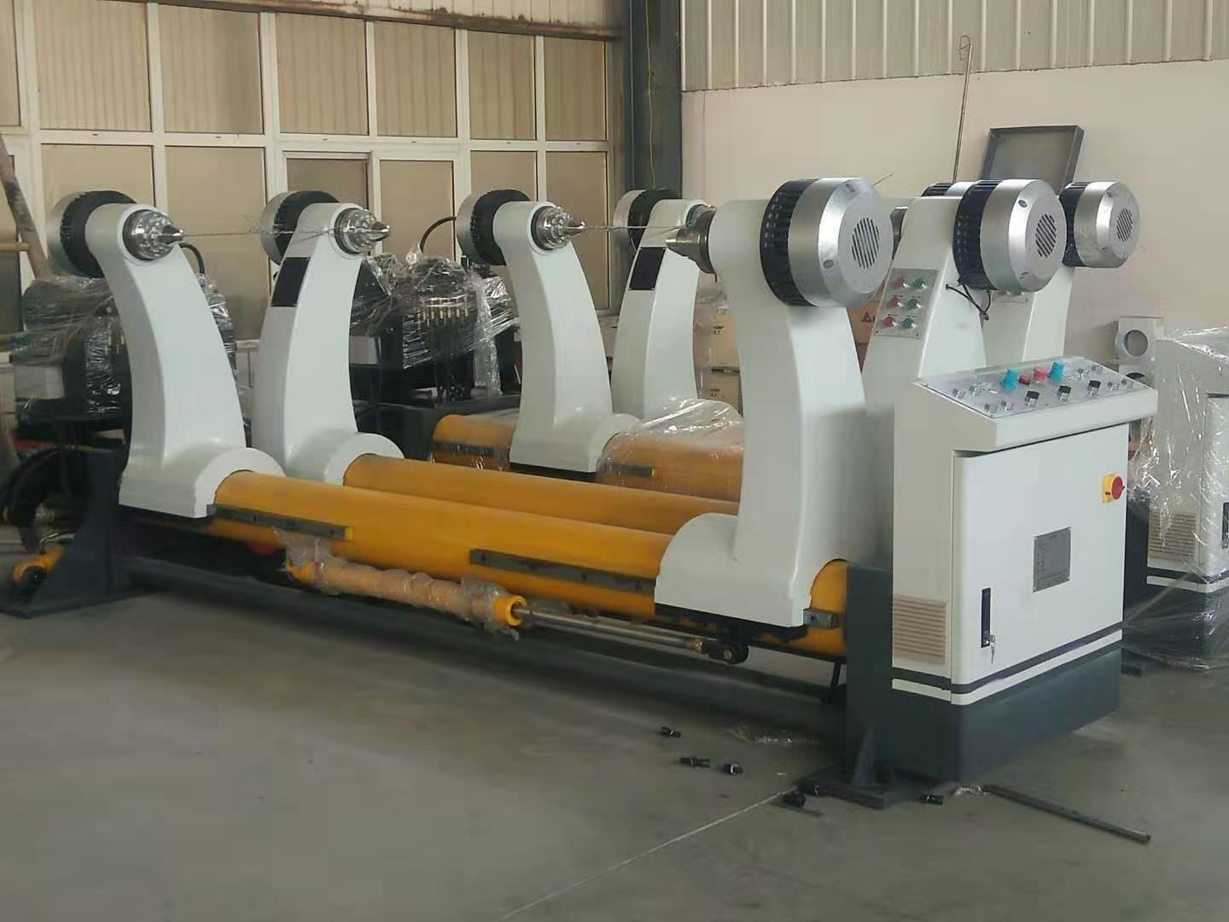
ⅰ、Structural features:
★Fully hydraulic drive is used to complete the movement of base paper clamping, loosening, moving centering, left and right translation, etc. The base paper lifting is driven by hydraulic pressure.
★刹车调整采用多点式刹车系统。
★Each paper rack is equipped with two paper loading trolleys, which can load paper from both sides at the same time.
ⅱ、technical parameter:
1. Paper jam range: maximum: 2200mm minimum: 1000mm
Diameter of paper clamp: Maximum: ￠1500mm Minimum: ￠350mm
2、Diameter of the main shaft of the paper holder: ￠240mm
3、Air source working pressure (Mpa): 0.4---0.8Mpa
ⅲ、 Hydraulic system parameters:
- Working pressure (Mpa): 16---18Mpa
- Lifting hydraulic cylinder: ￠100×440mm
- Clamping hydraulic cylinder: ￠63×1300mm液压站电机功率：3KW --380V -- 50Hz

- Solenoid valve voltage: 220V 50 Hz

