Specification model | Equipment name | quantity | 备注
SM-E | Double-sided machine | 1 set | Frame 400 mm national standard channel steel, chrome-plated hot plate 600 mm *12 pieces, the entrance adopts a curved hot plate to increase the temperature of the facial paper extremely quickly, and the whole touch plate design structure. PLC automatically controls the pressing plate. The upper and lower belts are equipped with automatic correction, temperature display, and frequency conversion motor.

SM-E 双面机
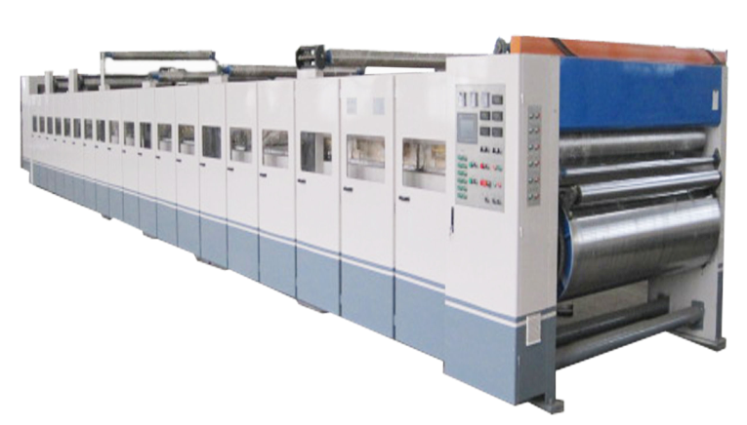

ⅰ、Structural features:
★The surface of the heating plate is grinded, the width of the heating plate is 600mm, there are 12 heating plates in total, and the cooling and shaping are 4 meters long. The heating plate is made of container plate, which meets the national first-class pressure vessel standard, and is accompanied by a pressure vessel certificate and an inspection certificate.
★The left and right correction adjustment of the upper conveyor belt adopts pneumatic automatic correction.
★The heat conduction piping of the heating plate is divided into four sections to control the temperature, with a temperature display.
★The upper cotton webbing adopts a double-cylinder S-type cotton webbing tensioning device.
★The lower belt adopts pneumatic tensioning and pneumatic correction.
★The surface of the drive roller is coated with wear-resistant rubber, which has a herringbone structure with a medium height to ensure a smooth output of the cardboard.
★The main drive motor is a variable-frequency speed-regulating motor with large low-speed torque, wide speed

range, reliable use and simple maintenance.
★The inside of the hot plate is a partition isolation structure, so that the steam flows in an S-shaped direction, and the steam and water separation function is obvious, and the steam utilization rate is improved.
ⅱ、technical parameter:
★Temperature requirement: 160—200℃
★Steam pressure: 0.8-1.3MPa
★Air source pressure: 0.6—0.9MPa
★Cooling shaping length: 4 meters
★Number of heating plates: 12
ⅲ、Roller diameter parameters:
★Diameter of the upper drive rubber roller: ￠700mm
★Diameter of the bottom drive rubber roller: ￠400mm
★Diameter of the front driven belt roller: ￠215mm
★Diameter of the driven belt roller after shaping: ￠215mm
★Diameter of pressing roller: ￠70mm
★Diameter of shaping roller: ￠86mm
★Diameter of upper belt tension roller: ￠155mm
★Diameter of upper belt deviation adjusting roller: ￠130mm
★Diameter of the lower belt carrier roller: ￠130mm
★Diameter of lower belt tension roller: ￠130mm
Note: The surfaces of all rollers are hard chrome-plated after grinding.
ⅳ、Power motor parameters:
★Main drive motor power: 30KW

