one
noodle
machine
match
Set
and
Skill
Technique
Say
bright

Specification model | Equipment  name | quantity | unit price  (Ten thousand yuan) | 备注
SF-320C | Single-sided corrugating machine | 1 set |  | Corrugated main roller ￠320mm, the material is treated with tungsten carbide, the corrugated rollers are exchanged in groups, airbag ballast structure, imported main bearing, PLC automatic control glue, man-machine interface touch screen, paper break automatic parking and pressure relief, steam heating method.

SF-320C Adsorption Single Facer
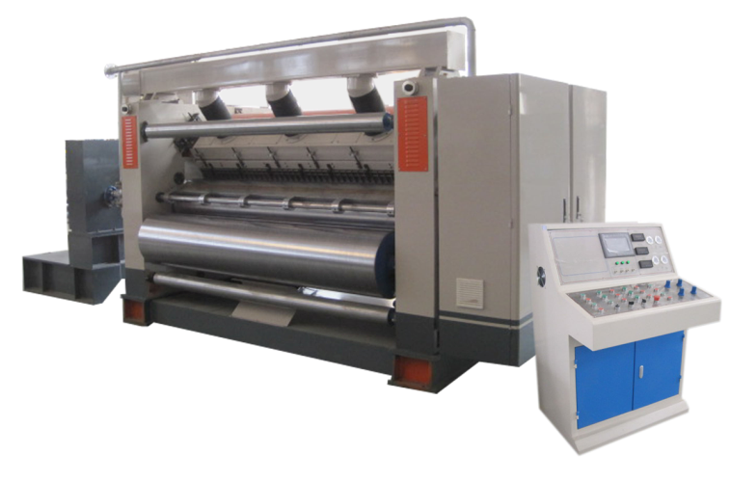

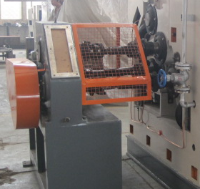
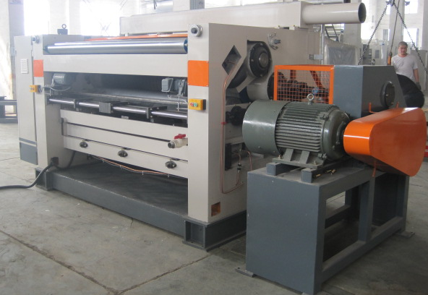

ⅰ、Structural features:
★It adopts a hood suction structure and is equipped with a high-pressure and powerful fan. The air source and electric control are concentrated in the same operation cabinet, and the operation side is fully enclosed and fully covered.
★High-quality resin sand castings, wall thickness 200mm.
★A hoisting trolley is installed on the conveying bridge, which is used to take out the tile roller assembly and pressure roller

when necessary, which is convenient and quick.
★The glue roller unit adopts an overall outward-moving structure, which can be moved out of the machine as a whole for maintenance during maintenance, which improves work efficiency.
★Equipped with spray humidity control device, the corrugated shape maintains good deformation stability and avoids dry cracking.
★It adopts an automatic circulating glue supply system and a double-cylinder pneumatic glue application device, which has a good buffering effect.
★The gluing part adopts an integral sliding plate structure, and the surface of the gluing roller is finely ground and engraved with 32-line pit-type nets and plated with hard chrome.
★The material of the corrugated roller is treated with tungsten carbide. The diameter of the main corrugated roller is ¢ 320mm. After quenching and tempering → rough turning → inner hole fine boring → shaft head baking → welding → tempering to stress → fine turning → rough grinding → intermediate frequency quenching → CNC grinding machine fine grind
★The main power is driven by a variable frequency motor, which is energy-saving and efficient, and has a low failure rate.
★The width of the glue is adjusted electrically to adapt to the change in the width of the base paper used.
★The amount of glue applied is adjusted electrically, displayed and operated on the touch screen, and the glue gap is transmitted through the encoder with high accuracy.
★The power and operating parts are equipped with safety protection nets to ensure the safety of personnel when the machine is running.
ⅱ、technical parameter:
★Working width: 2200mm
★Operation direction: left or right (determined according to customer's factory)
★Design speed: 150m/min
★ Temperature range: 160—180℃
★ Corrugated type (UV type or UVV type):
ⅲ、Roller diameter parameters:
★Corrugated roller diameter: up￠313mm down￠316mm
★Diameter of pressure roller: ￠320mm
★Diameter of rubber roller: ￠240mm

★Fixed glue roller: ￠140mm
★Diameter of preheater: ￠402mm
ⅳ、Power motor parameters:
★Main variable frequency drive motor: 18.5KW
★Suction motor: 11KW
★Glue reducer: 100W
★Glue spacer adjustment motor: 200W *2
★Glue pump motor: 2.2KW

