Dental Cone Beam Computed Tomography System(CBCT)
PLX3000A

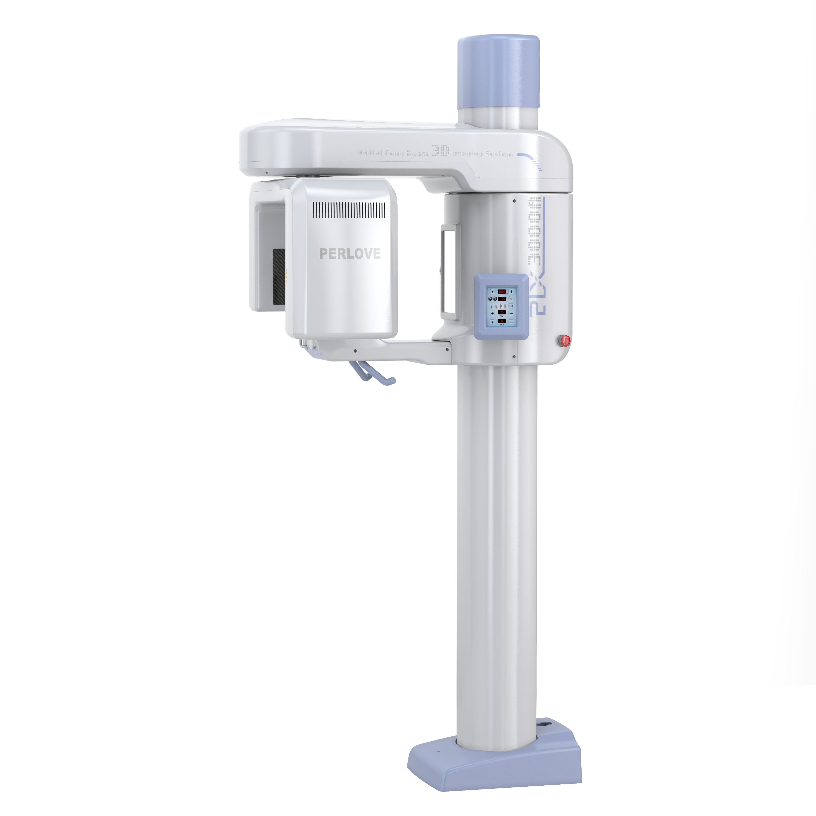

PRESENTATION OF PRODUCT

PERLOVE MEDICAL
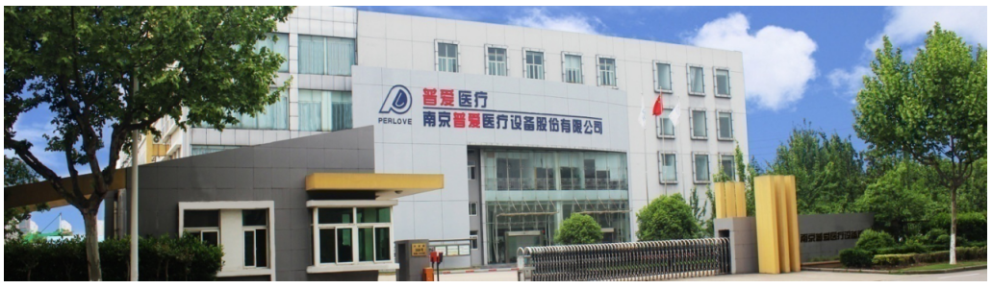Perlove Medical is a large scale and influential manufacturer of medical equipment in China. We are a group company with the overseas headquarter Nanjing Perlove in Eastern China. With years of development, Perlove Medical has found its typical corporate culture which is exactly embodied in the name of our headquarter company's name - Perlove.
★ Number of Employees: 1000(approx)
★ Area: 70,000 ㎡
★ Yearly Output Capacity ≥ 10000 sets
★ X-ray Range: Mobile, Stationary, DR, DRF, C-arm，Dental CBCT, etc.,
★ Mobile models with No. 1 market share in the past ten years
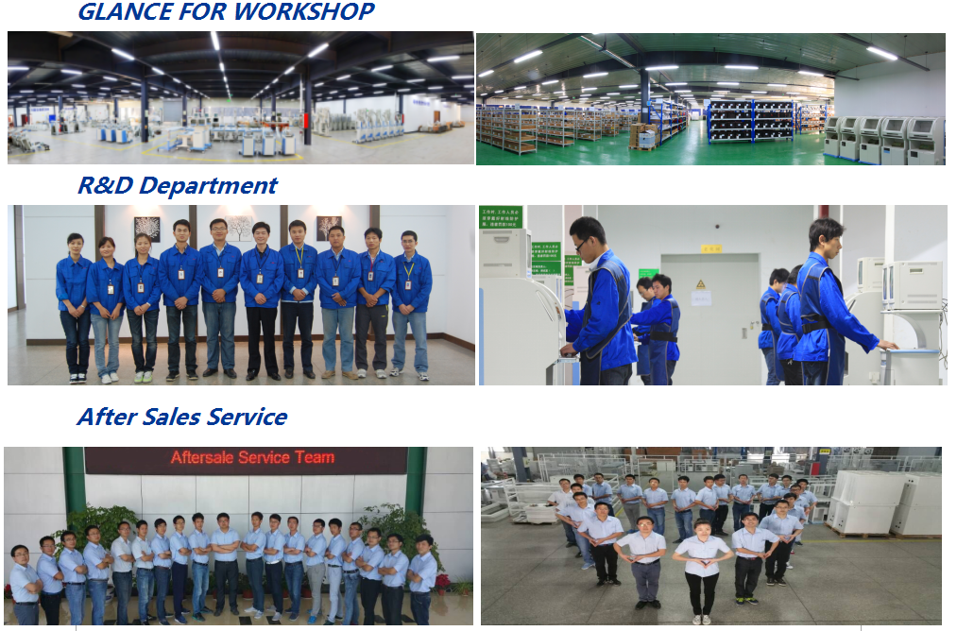

PRODUCT DESCRIPTION

Product Usage

PLX3000A is a dental cone beam computed tomography system (CBCT), which is widely used for dental CT diagnosis and is mainly for oral and maxillofacial surgeries, orthognathic surgeries, such as tooth implantation, tooth extraction, root canal therapy, etc.

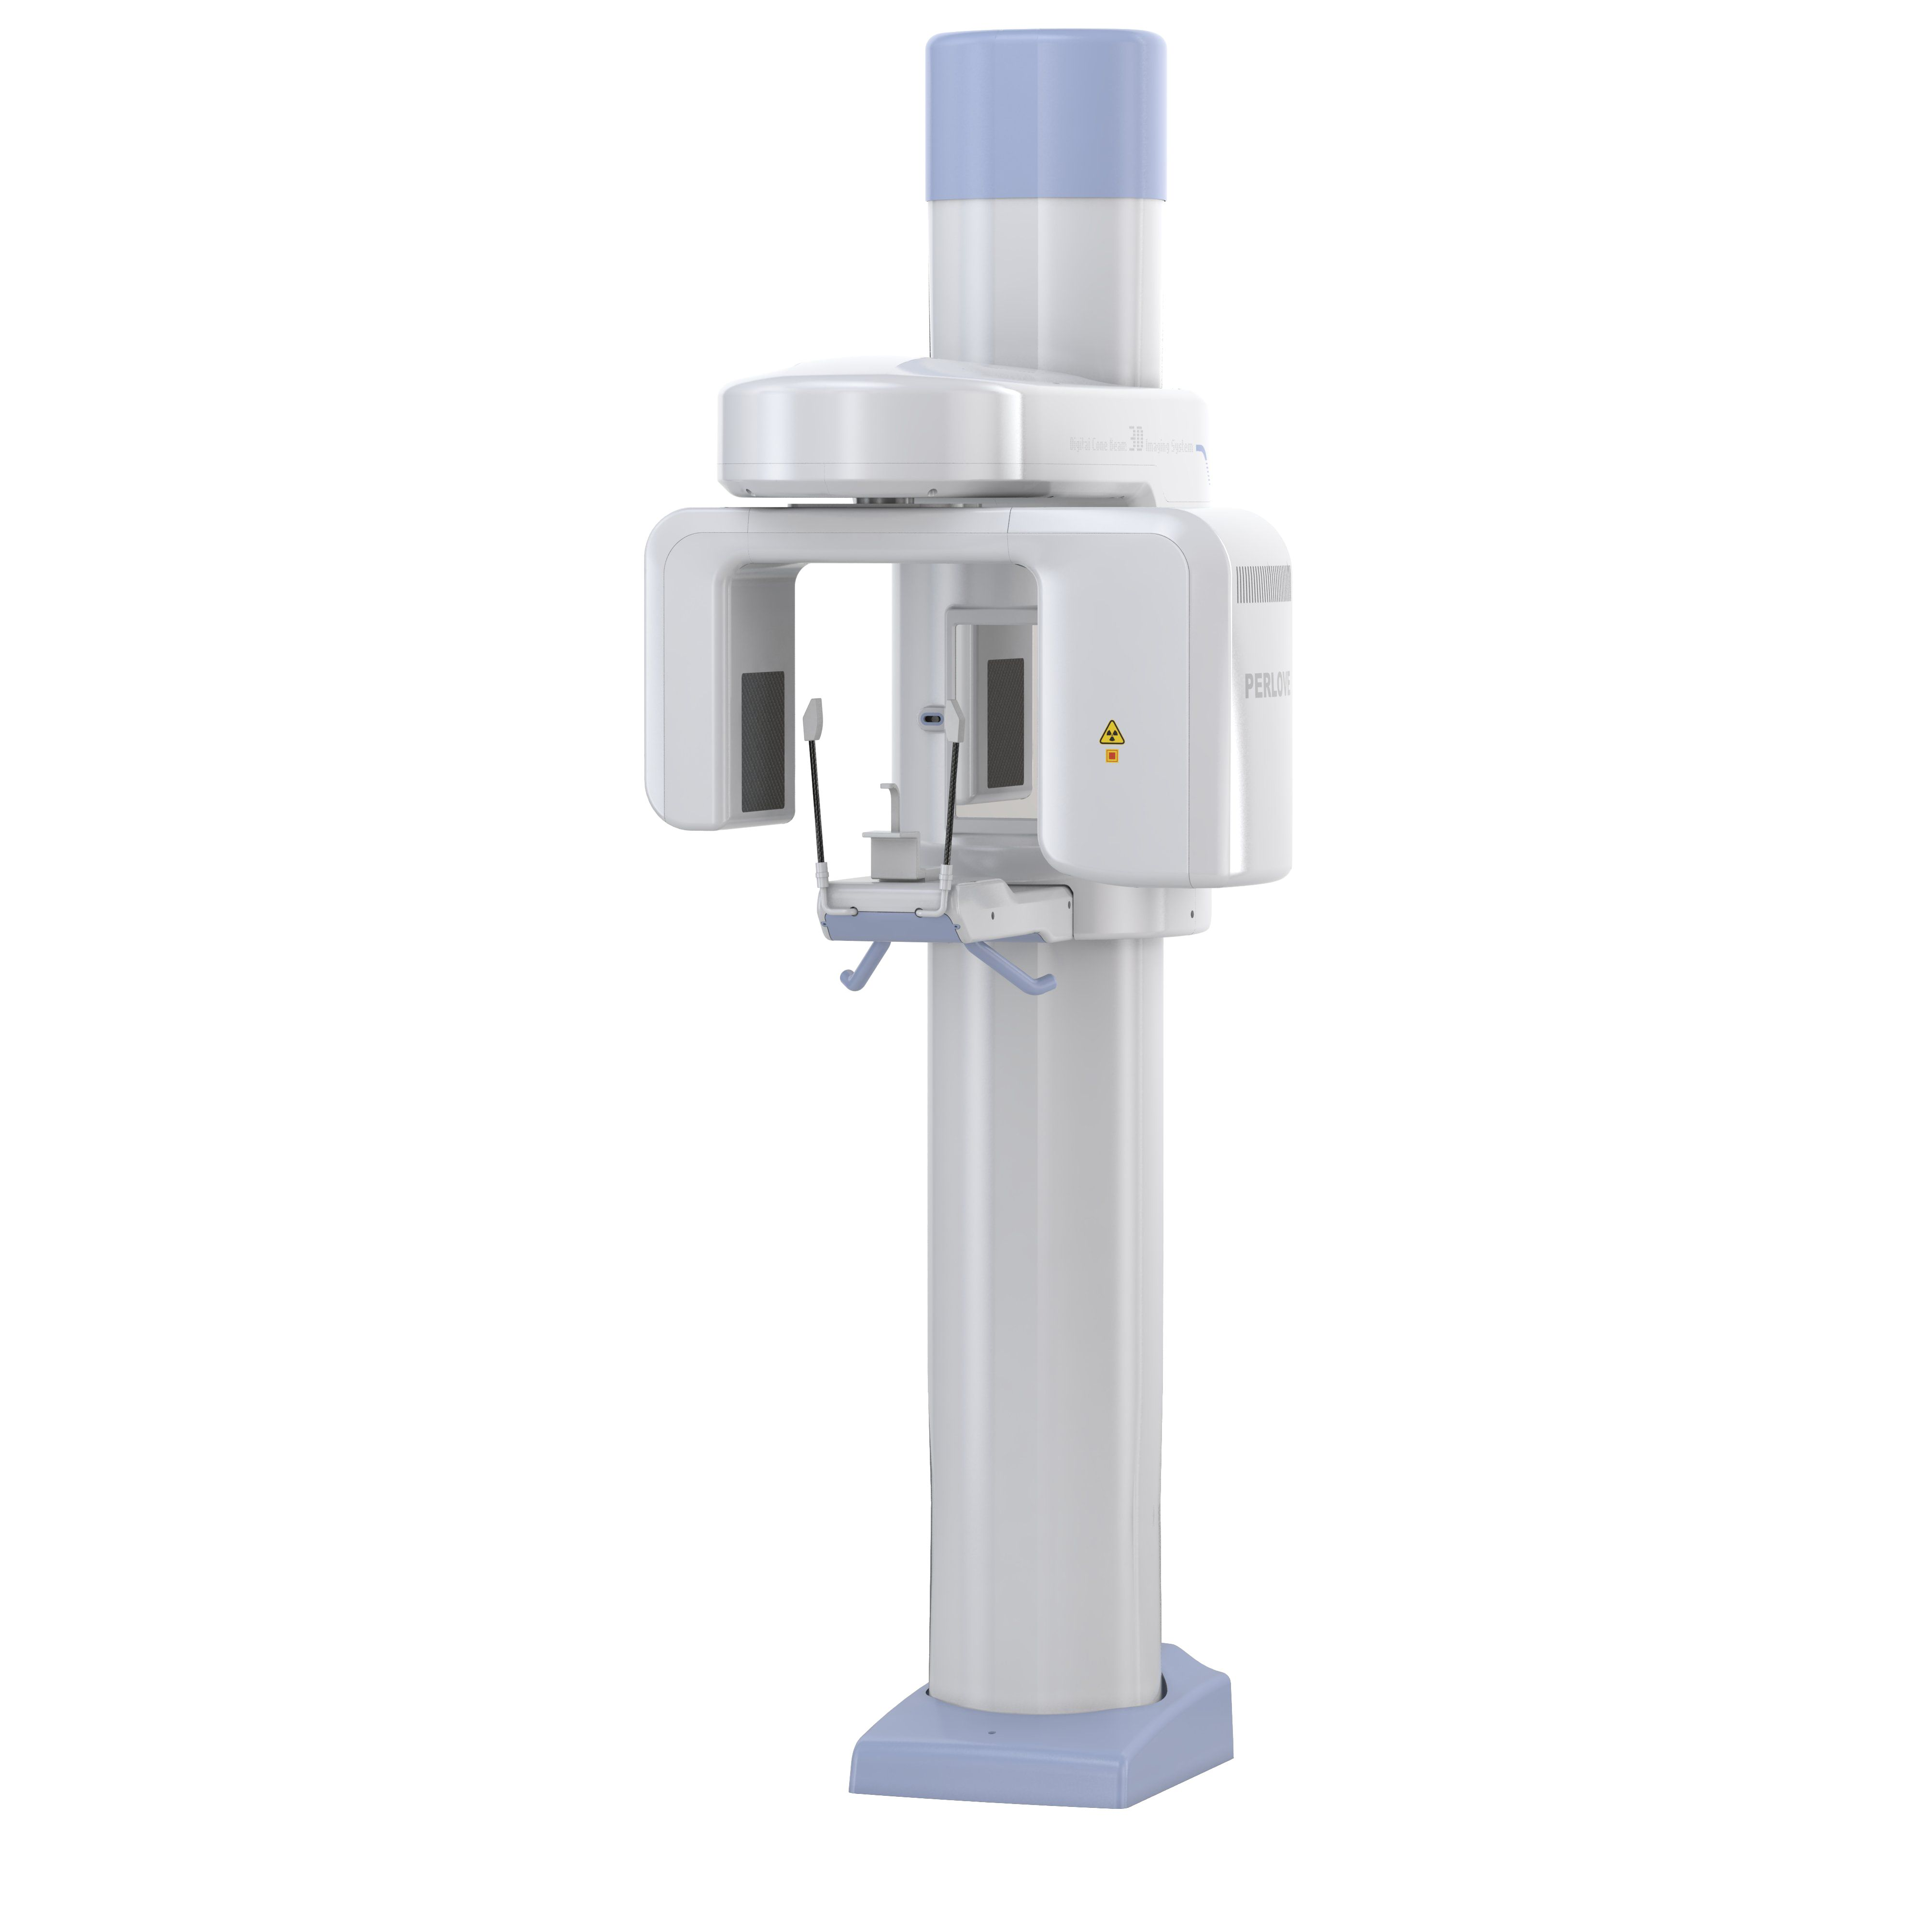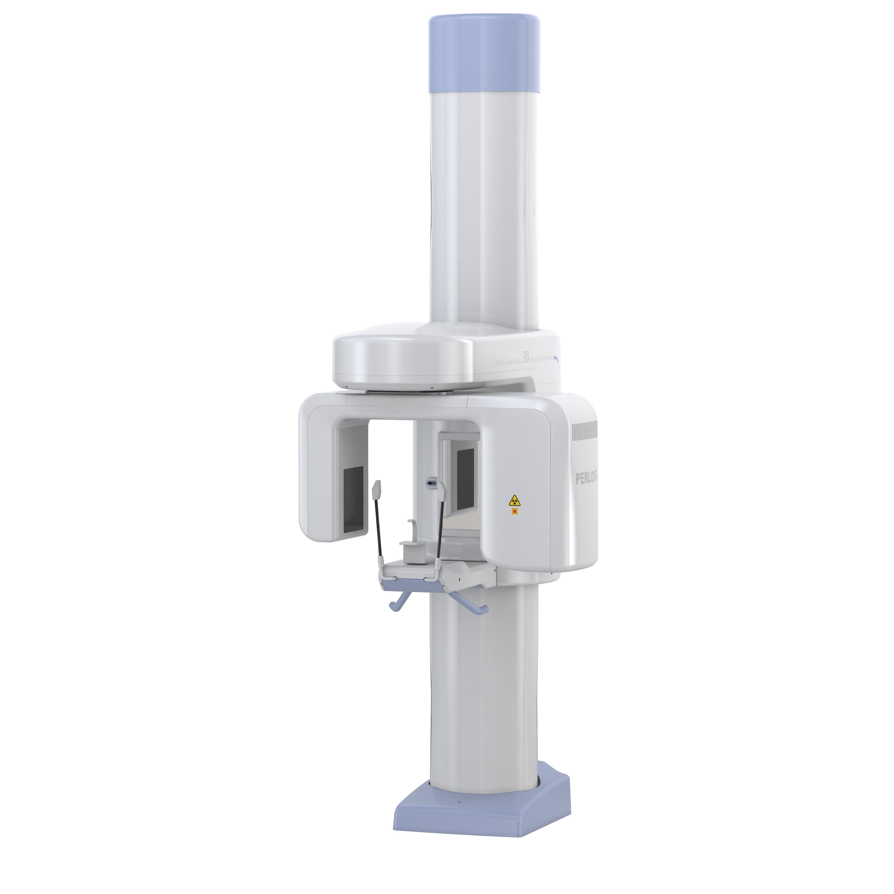

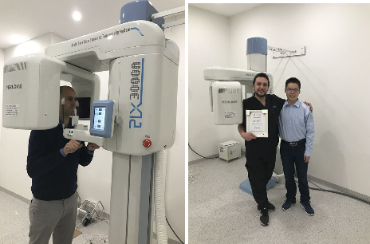

Product Specification

- Item | - Content | - Technical Parameters
Power | Voltage | 220V±10%
Power | Frequency | 50Hz±1Hz
X-ray Generator | Power | 1.38KW
X-ray Generator | Tube voltage | 60kV—92kV
X-ray Generator | Tube current | 1mA—15mA
X ray tube | Tube Focus | 0.5mm
X ray tube | Anode thermal capacity | 35KJ(50KHU)
 | Information Display | KV, MA, Lifting position information,  Laser lights indicate, body features
Digital Flat Penal Detector | Active area | 120(H)×100(V)
Digital Flat Penal Detector | Pixel matrix | 1280(H)×1024(V)
Digital Flat Penal Detector | Pixel pitch | 150 μm
Digital Flat Penal Detector | Exposure time | 6S
Digital Flat Penal Detector | Reconstruction time | ≤18s
Digital Flat Penal Detector | A / D transition | 14 bit
Digital Flat Penal Detector | Fluoroscopy Mode | Pulse Mode
Digital Flat Penal Detector | Rotation | 200°
Digital Flat Penal Detector | Scanning time | 18s
Mechanical Parameters | Information Display:KV, MA, Lifting position information,  Laser lights indicate, body features
Mechanical Parameters | Vertical Movement Distance | 1000mm
Mechanical Parameters | Size | 788mm*1090mm*2200mm
Mechanical Parameters | Weight | 260kg

Product Advantages

- X-ray Source
★ Pulse Fluoroscopy Mode, low dose, green & safe.

- Flat Panel Detector
★ High resolution, small distortion, brightness uniformity.
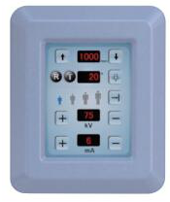
★ Effective size:12cmx15cm

- Operating Interface
★ Touch Screen
★ Ergonomics Design

- High quality Panorama Image
★ CONE BEAM scanning three-dimensional imaging technology
★ 3D volumetric image could extract oral panorama with clear, low distortion & panoramic views.
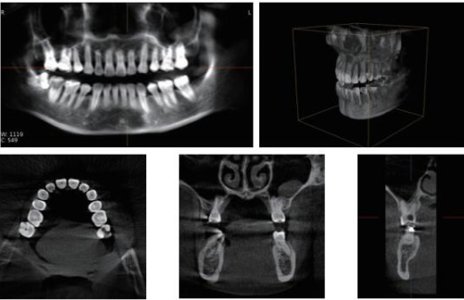

- Networked device: high quality image and output information system
★ The networking functions of PLX3000A include: Dicom storage, Dicom film printing, Dicom film transfer.
★ It has standard DICOM 3.0 interface, supporting film printing, output, storage, barrier-free docking hospital PACS system.



