Concrete pump reducer pipe
We have types of reducer pipe , one is usual reducer pipe , and the other is reducer with handle. And the reducer pipe inner wall put one layer wear resistent welding layer,, make the reducer pipe more wear resistence and service life is more longer
1.Usual concrete pump reducer pipe
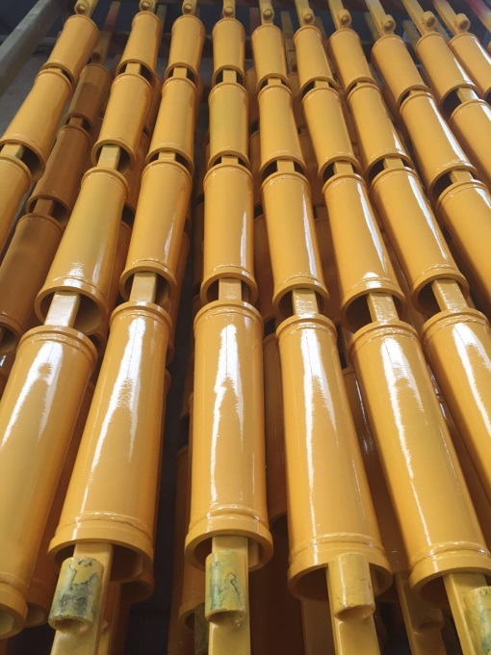
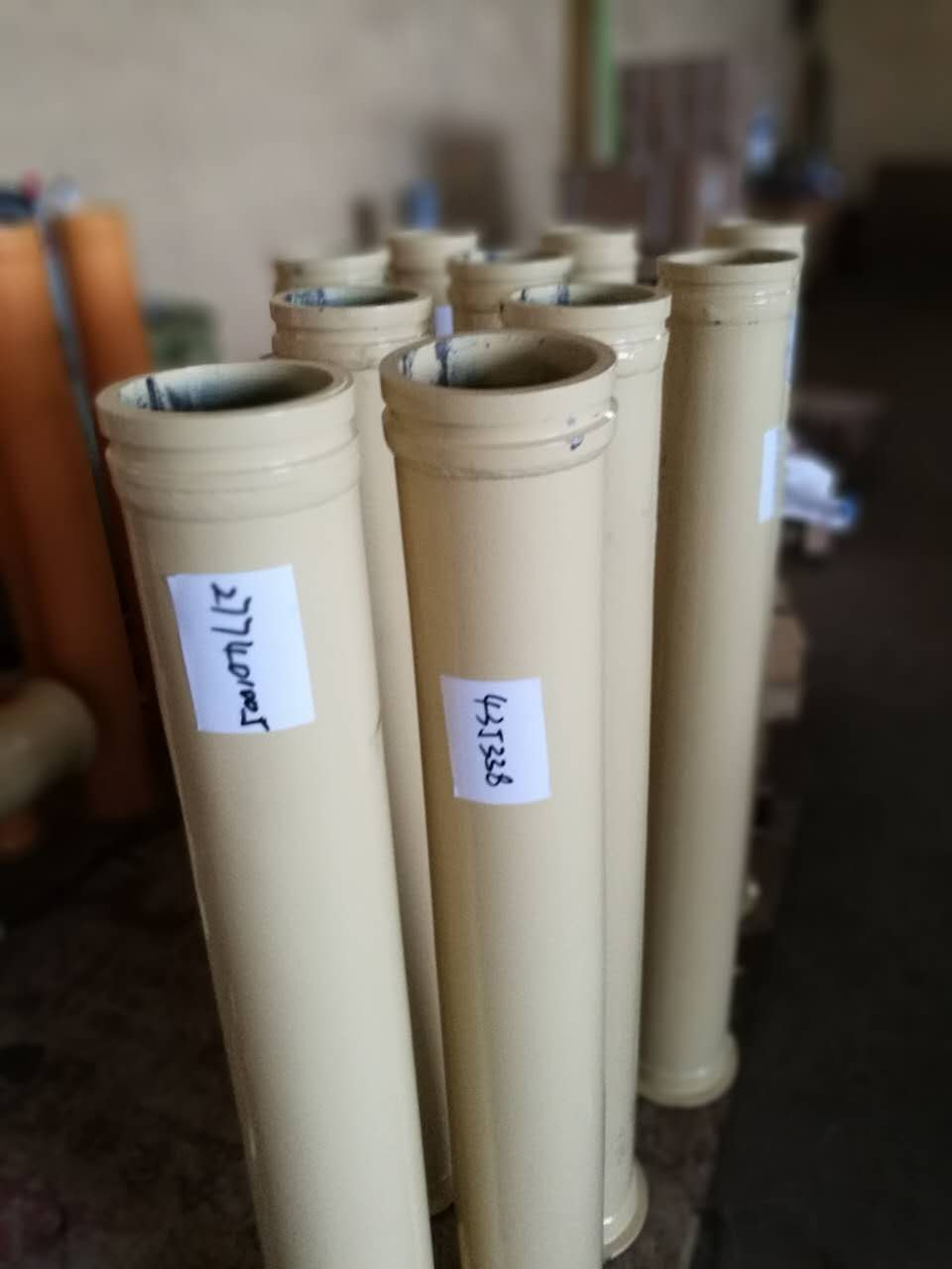

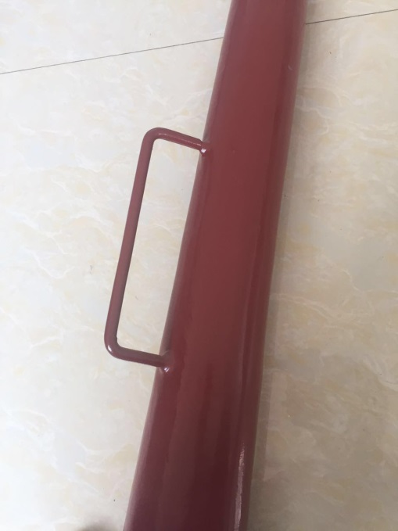
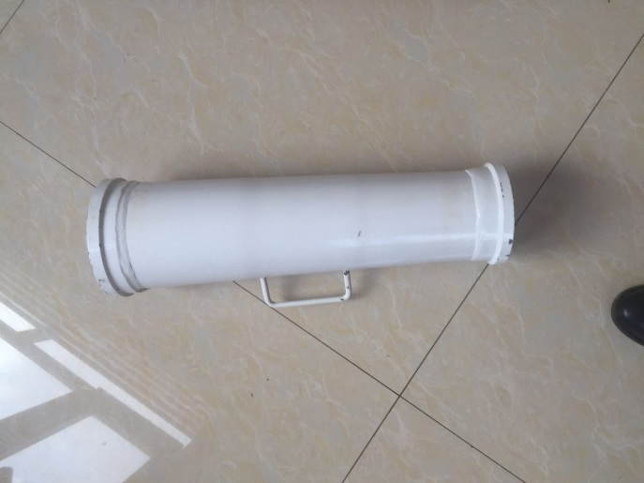
2. Concrete pump reducer pipe with handle

Our concrete pump reducer pipe inner wall put oone layerwear resistent layer, make the pipe more and more wear resistence, below picture is the wear resistent layer inner wall situation.
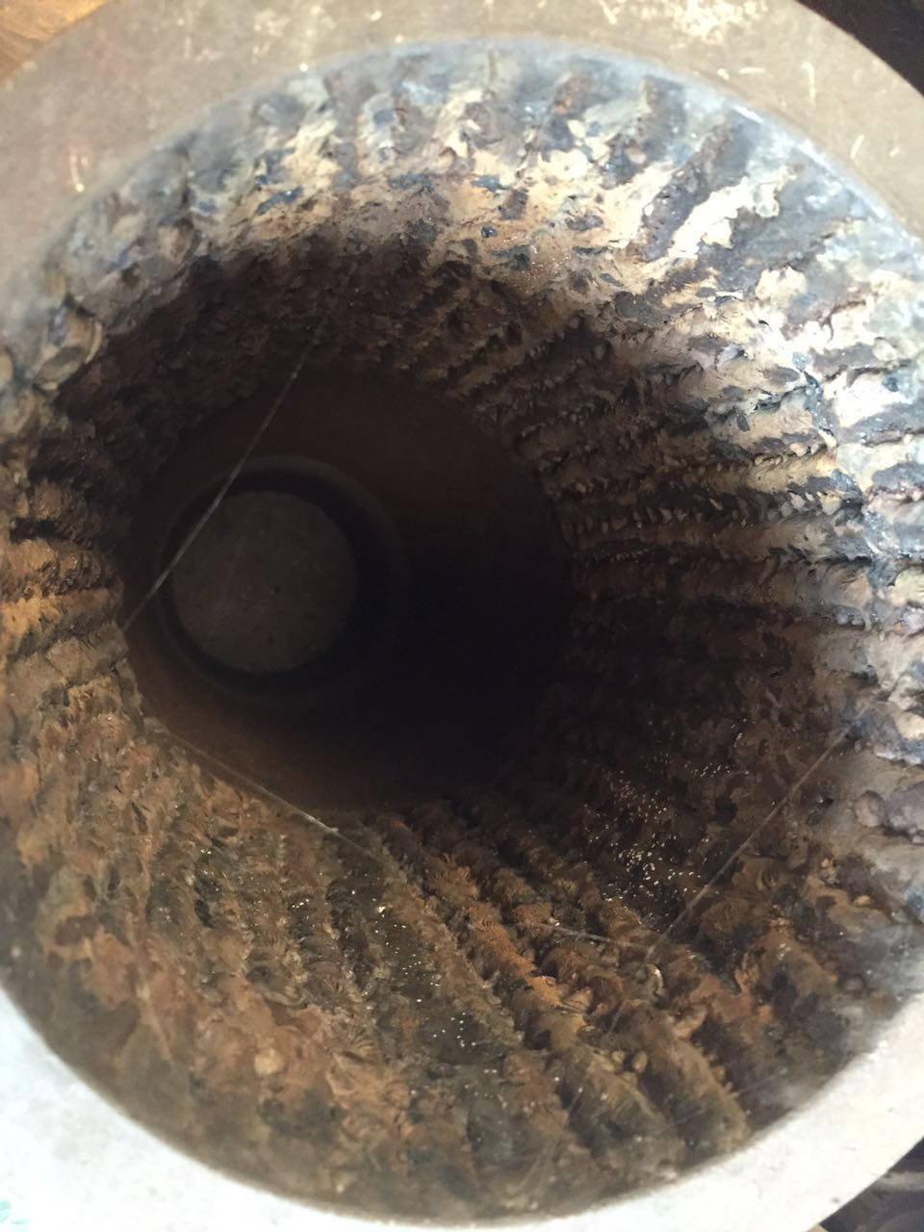
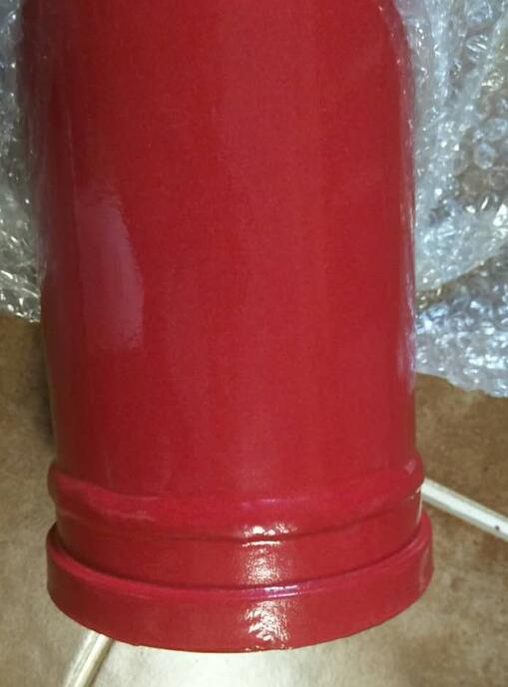
Concrete pump reducer pipe ending collar is weld on

Concrete pump reducer pipe thickness and material
Material: My reducer pipe are made from different material ,like 150-125mm reducer pipe like that , material is 37Mn5,this more is more resistence. And little size reducer pipe material is 20# or st52 material, like 4"-3",3"-2".
Thickness: About thickness,also different sizes have different thciknesses,like 150-125mm reducer pipe as an example, thickness is 7.72mm or 9.17mm. About little size reducers, thickness is 6.0mm-7.0mm. Which one you need , it depends one your idea

Below is some of our reducer pipe details, just as a reference
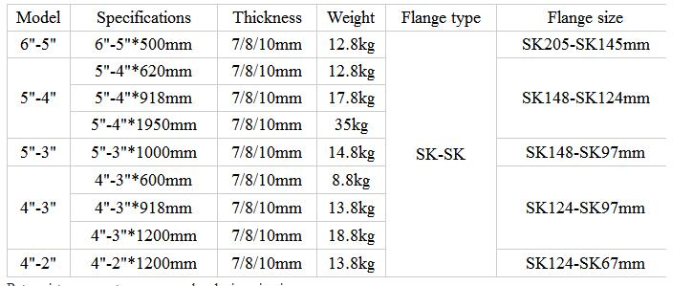

Last, we can supply OEM service , as for you send me your label , I can put your label on the pipe !

