Excavating machinery
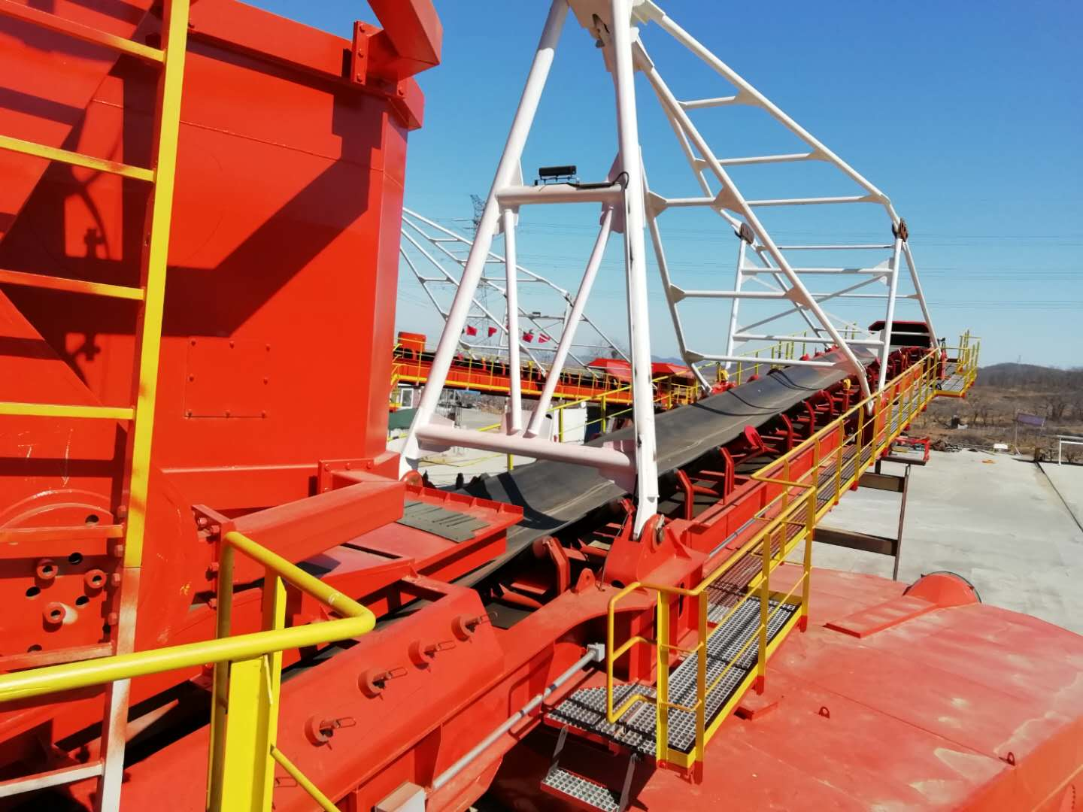
A bucket wheel excavator driven by a hydraulic engine with a diesel engine as the power source.
Uses: large open-pit coal mine stripping and coal mining projects, pollution control of rivers, rivers, lakes, large-scale long-distance inter-city water diversion projects, low-lying land reconstruction projects, land reclamation projects, tailings treatment projects, land reclamation projects, high-speed construction Highway engineering, etc.
Features: 1. Low noise, energy saving and high efficiency.
2. Reduce heavy physical labor, speed up construction and increase labor productivity.
3. Quality assurance, customized according to customer needs.
4. Can realize manual, semi-automatic, wireless remote control and remote monitoring of equipment operation.
