Machined parts
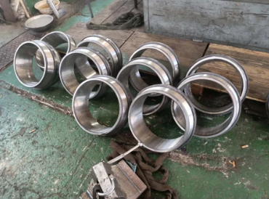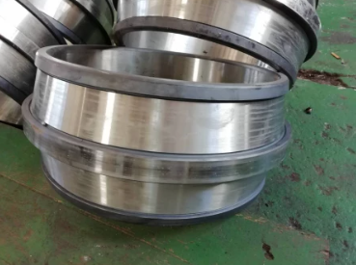
Mechanical processing refers to the process of changing the external dimensions or properties of a workpiece through a mechanical device. The machined parts have the following characteristics: 1. High precision, excellent material, solid and compact. 2. Durable and not easy to rust. 3. Corrosion resistance, high temperature resistance and long life. 4. Anti-aging and no pollution. 5. The cutting surface is smooth, no burrs, beautiful and durable. 6. Complete range, customized as required.

