Marine hardware
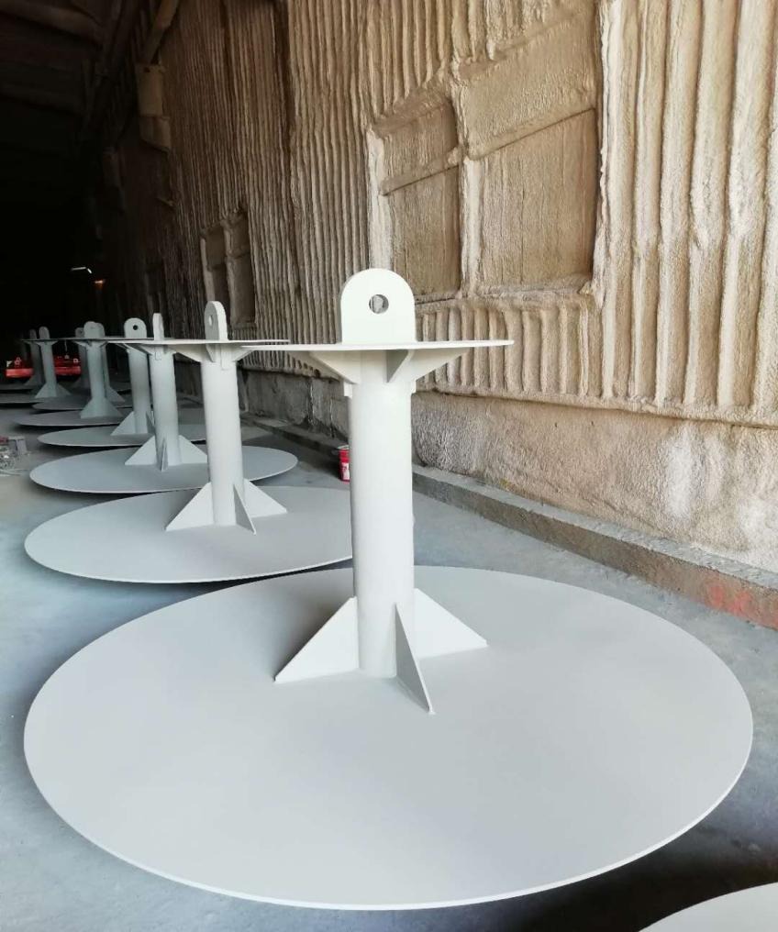
Marine hardware includes the following types of products:

1. Custom hanger metal parts: sandblasting, descaling and galvanizing on the surface. The boom is fixed on the steel structure of the building, and the angle of the adjusting member is rotated by the mechanical device, and the steel structural member is installed on the site, thereby reducing the labor intensity of the worker. Standard specifications, high hardness, no deformation, uniform force. It is not easy to slip and has the advantage of being durable.

2. U-shaped embedded parts of the terminal cable: round steel 70 * 815U type weight 57Kg round steel 48 * 586U type weight 19kg The dock rope pulls the embedded parts, fixed on the deck or the dock side to fix the pile; port crane track, street light, Traffic signs, pumps, boiler installations, embedded fixtures for heavy equipment.

3. Steel support pipes on both sides of the ship: brackets for loading and unloading cargo on the ship, stable structure; good load carrying capacity; strong corrosion resistance; high flexibility and easy disassembly.

4. Welding H-beam impact plate

5. Buoy
