Non-standard hardware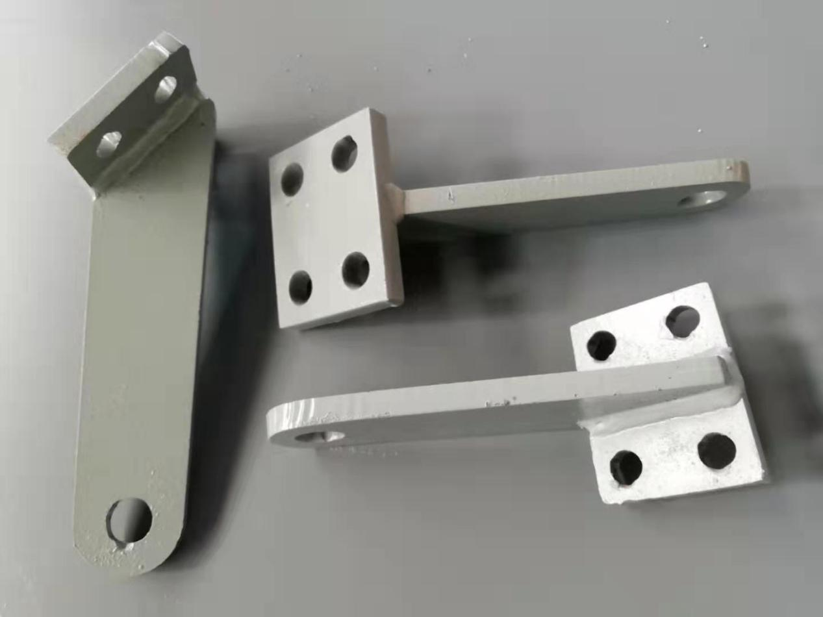
Non-standard hardware includes the following four products.

1. Durable marine multi-standard non-standard hardware: a non-standard hardware structure for marine welding. It is made of Q345B material, the specifications can be customized, the surface is sandblasted, and the rust-removing Sad3 is suitable for metallurgy, shipbuilding, engineering machinery, machine tools, etc. Durable, long service life; high temperature and corrosion resistance; smooth surface without burrs, beautiful and durable; high hardness, not easy to deform.

2. Terminal equipment fixing plate, fixed beam, column end plate: a steel plate, fixed at the end of the beam and column. With the Q235B material, the area of action can be increased and used with the “T” type screw. Smooth surface and good corrosion resistance. The utility model has the advantages of simple structure, convenient operation, strong wear resistance and long service life.

3. Dock construction embedded fasteners

4. Non-standard hardware

