Platform structure
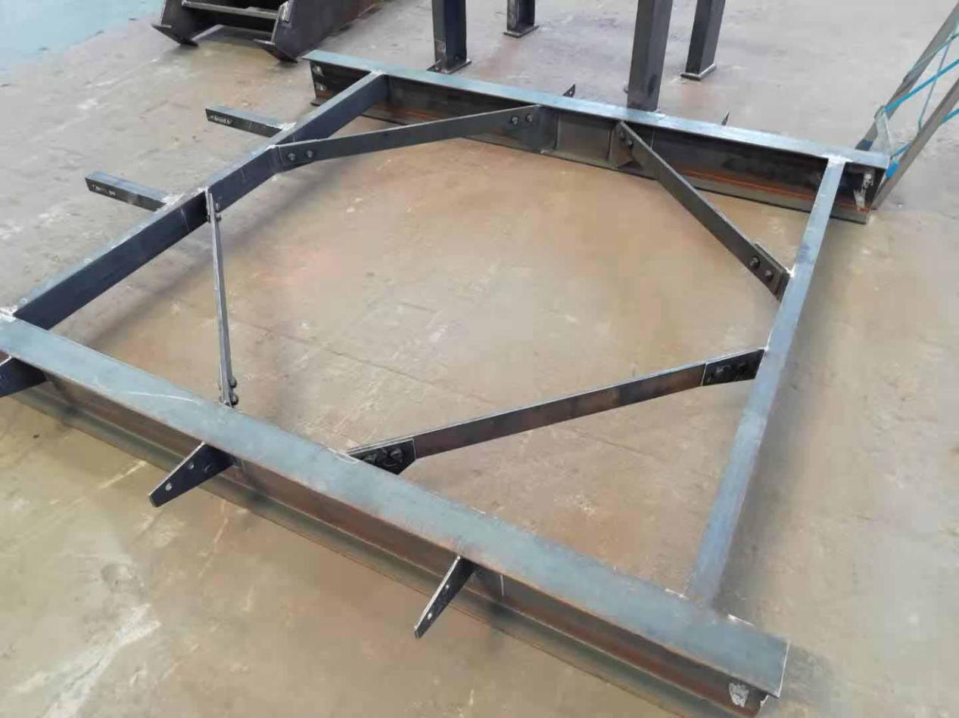
The platform structure includes the following products:

1. Steel structure equipment stand combination component: It is a kind of equipment or platform facility used in extremely harsh environments. Sand blasting and rust removal reach Sa1-Sa3 grade, and zinc-rich primer / epoxy epoxy intermediate paint / polyurethane topcoat is used for anti-corrosion treatment. Welded, bolted. The advantages are as follows: 1. Multi-layer shelves can more conveniently pick up goods, double the use of the factory, and store more goods in a limited space. 2. The welding is firm and the structure is strong.

2. Steel structure welding column and steel structure connecting piece: The platform connecting column is the equipment platform, connecting the cantilever beam and the hanging beam, and transmitting the load of the hanging beam. It can be used for the connection of steel components in steel structure plants, the connection between structural components of equipment, and the foundation connection of platforms. For workshops, warehouses, canopies and other places. Use Q235B material, paint epoxy primer, polyurethane topcoat for anti-corrosion treatment. It has the following advantages: 1. Strong ability, high stability and durability. 2. Firm welding, hard structure and good impact resistance. 3. High flexibility, environmental protection and no pollution.
