Steel structure parts
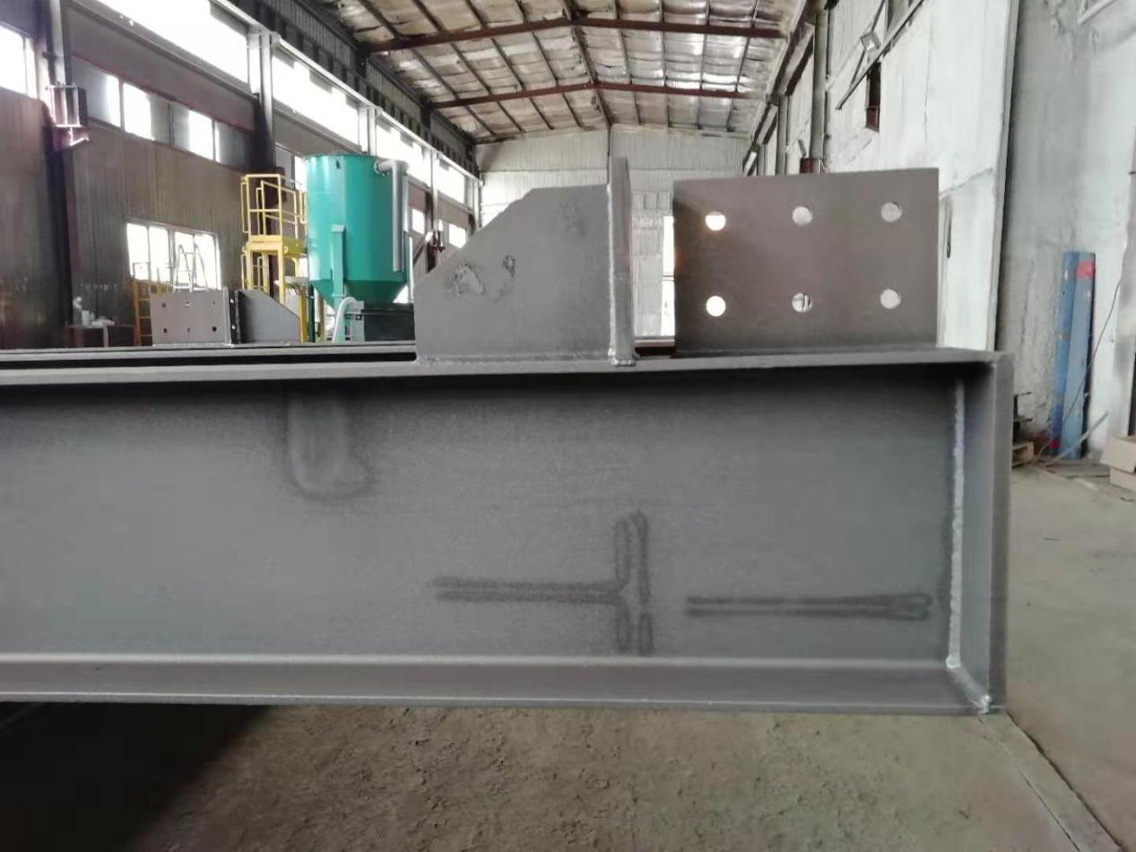
The so-called steel structural parts are all integrated into various parts by welding, riveting or bolting. These parts are connected to each other and restricted to form an organic whole. It has high material strength and light weight; steel has toughness, good plasticity, uniform material and high structural reliability; high degree of mechanization in the manufacture and installation of steel structures; and good sealing performance.

Our steel structural parts include the following products:

1. Welded columns and beams

2.Steel structure fixed ladder

3.Steel shelves

4.Custom steel columns and beams

5.Steel platform railing

6.Steel structure support foundation

7. Non-standard riveted welded steel parts

8. Welded columns and beams of steel structures

9. Box Girder Steel Structure

10.High quality steel flange

11. Welding H-beam

12. Traction equipment track sleeper

13. Steel structure equipment platform
