Steel structure workshop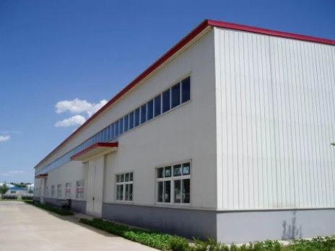
Steel structure workshop mainly refers to the main load-bearing components are composed of steel. Including steel column, steel beam, steel structure foundation, steel roof truss (of course, the span of the plant is relatively large, basically now it is steel structure roof truss), steel roof, pay attention to the steel structure wall can also be maintained by brick wall.

Performance of steel structure workshop:

Aseismic property
The roofs of low-rise villas are mostly sloped roofs. Therefore, the roof structure is basically a triangular roof truss system made of cold-formed steel members. After sealing structural plates and gypsum boards, light steel members form a very solid "plate rib structure system". This structure system has a stronger ability of anti-seismic and horizontal load resistance, which is suitable for those with an anti-seismic intensity of more than 8 degrees Area.

Wind resistance
The steel structure has the advantages of light weight, high strength, good overall rigidity and strong deformation ability. The self weight of the building is only one fifth of that of the brick concrete structure, which can resist the hurricane of 70 meters per second, so that life and property can be effectively protected.

Durability
The residential structure of light steel structure is composed of cold-formed thin-walled steel member system, and the steel bone is made of super anticorrosive high-strength cold-rolled galvanized steel plate, which effectively avoids the influence of steel plate corrosion in the process of construction and use, and increases the service life of light steel members. The structural life can be up to 100 years.

Thermal insulation
The heat preservation and insulation materials used are mainly glass fiber cotton, which has good heat preservation and insulation effect. The insulation board used for the external wall can effectively avoid the phenomenon of "cold bridge" of the wall and achieve better insulation effect. The thermal resistance of R15 insulation cotton with the thickness of about 100mm can be equivalent to the brick wall with the thickness of 1m.

Sound insulation
The sound insulation effect is an important index to evaluate the residence. The windows installed in the light steel system are all made of hollow glass, which has good sound insulation effect, with the sound insulation reaching more than 40 decibels. The wall composed of light steel keel and thermal insulation material gypsum board has a sound insulation effect of up to 60 decibels.
