Pile planting machine
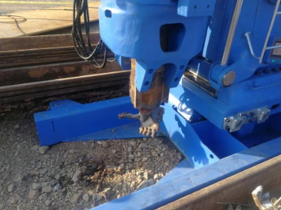
Static pile planter it is used for pressing in and pulling out steel sheet pile, as a kind of extremely mature green pile foundation construction equipment.It is used for pressing in and pulling out steel sheet pile, as a kind of extremely mature green pile foundation construction equipment.

Has the following advantages:

1.Very low noise.

2. Advantages of energy efficiency.

3. Overcoming obstacles to the construction environment.

4. Overcoming obstacles at the height of the works.
