Light Steel Villa
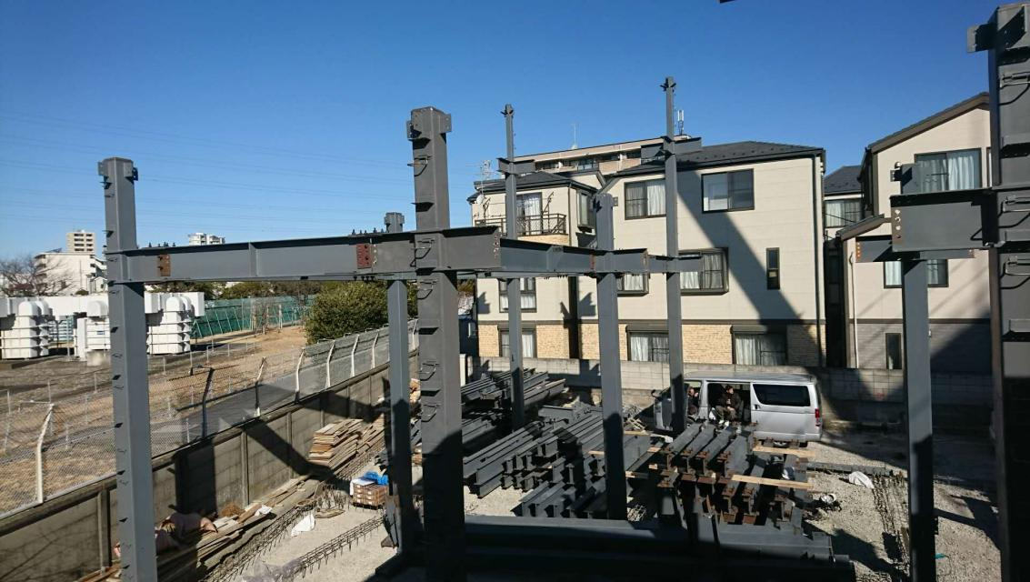
Light steel villa, also known as light steel structure house, its main material is light steel keel synthesized from hot-dip galvanized aluminum steel strip through cold rolling technology.

Advantages of light steel villa
Light steel villa is a young and vital steel structure system, which has been widely used in general industrial and agricultural, commercial and service buildings, such as office buildings, villas, warehouses, stadiums, entertainment, tourist buildings and low- and multi-storey buildings. Residential buildings and other fields can also be used in areas with inconvenient transportation, tight construction schedules, movable demolition buildings, etc., which are deeply loved by everyone, mainly with the following advantages:

Energy saving and environmental protection: The light steel structure can be 100% recycled, and the energy consumption is reduced by 65% ​​compared with the traditional brick-concrete structure

High degree of prefabrication: All building materials in the entire light-steel integrated house can be prefabricated by engineering, and the degree of mechanization is high, and it is truly industrialized.

Light weight and low material consumption: The structural material has high strength, thin thickness and low steel consumption. The overall weight of the house is light, only about 1/4 of the traditional brick-concrete structure. The transportation and hoisting costs are also greatly reduced, the foundation load is also reduced correspondingly, and the foundation

Cost: Low requirements for foundation, especially suitable for areas with complex and harsh terrain such as mountains, river beaches, sandy land, and islands.

Safe and durable: The wall and roof truss structure and the inner wall panel form a solid "slab rib structure", which greatly improves the ability to resist horizontal loads and vertical loads, so it has good seismic and wind resistance.

Practical living: Due to the use of excellent thermal insulation, sound insulation and energy-saving structures and materials, the indoor living comfort is greatly improved. The built-in pipeline and the thinning of the wall effectively increase the usable area of the house. Coupled with the characteristics of strong plasticity of the steel structure, the house shape can be complex, diverse and beautiful.

Earthquake resistance: The roofs of low-rise light steel villas are mostly sloped roofs, so the roof structure basically adopts a triangular roof truss system made of cold-formed steel components, forming a very strong "plate rib structure system". The system has stronger seismic resistance and resistance to horizontal loads, and is suitable for areas with seismic intensity above 9 degrees.

Wind resistance: Light steel villa construction is light in weight, high in strength, good overall rigidity, and strong in deformation. The weight of the building is only one-fifth of the brick-concrete structure, and it can withstand typhoons above level 12.

Durability: The light steel villa structure is all composed of cold-formed thin-wall steel component system, and the steel frame is made of super anti-corrosion high-strength cold-rolled galvanized sheet, which effectively avoids the influence of steel plate corrosion during construction and use, and increases the use of light steel components.
