Machining parts and molds
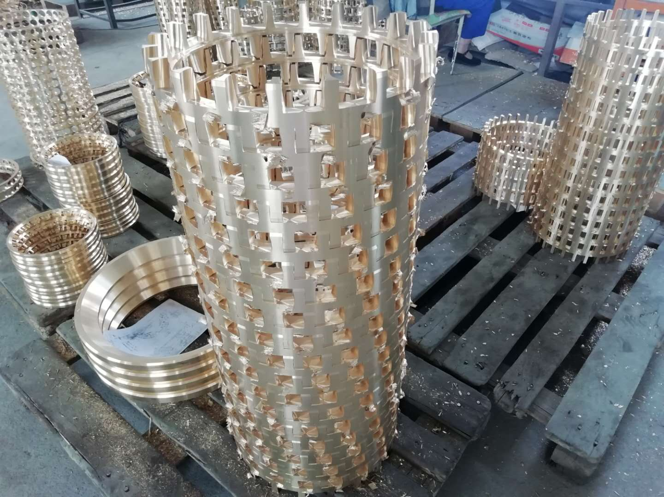
Machining refers to the process of changing the shape or performance of a workpiece through a kind of mechanical equipment. According to the difference in processing methods, it can be divided into cutting processing and pressure processing.

Application scope:
1. All kinds of metal parts processing;
2. Sheet metal, box and metal structure;
3. Titanium alloy, high temperature alloy, nonmetal and other mechanical processing;
4. Design and manufacture of marine combustion chamber;
5. Design and manufacture of non-standard equipment.
6. Mold design and manufacturing.

Commonly used equipment:
The machinery required for processing consists of digital display milling machines, digital display forming grinders, digital display lathes, electric discharge machines, universal grinders, machining centers, laser welding, middle wire, fast wire, slow wire, cylindrical grinder, internal grinder, Precision lathes, etc., can process precision parts such as turning, milling, planing, and grinding. This type of machinery is good at turning, milling, planing, and grinding precision parts, and can process various irregular-shaped parts.

