Prefabricated building
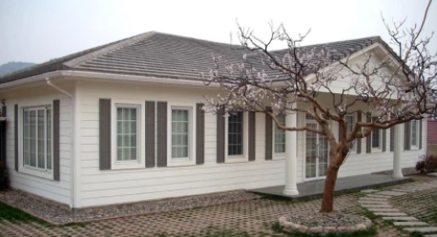
Prefabricated buildings are divided into steel structure workshops and light steel villas.

The steel structure workshop mainly refers to that the main load-bearing components are composed of steel. Including steel pillars, steel beams, steel structure foundation, steel roof truss, steel roof, note that steel structure walls can also be maintained by brick walls. Due to the increase in steel production in my country, many steel structure workshops have begun to be adopted. Specifically, it can be divided into light and heavy steel structure workshops. Industrial and civil construction facilities constructed of steel are called steel structures.
The characteristics of the steel structure workshop are: 1. The steel structure is light in weight, high in strength and large in span. 2. The construction period of steel structures is short, which reduces investment costs accordingly. 3. Steel structure buildings have poor fire resistance and corrosion resistance. Steel structures should not be used in areas with low temperature. 4. The steel structure building is easy to move, and the recycling is pollution-free.

Light steel villa, also known as light steel structure house, its main material is light steel keel synthesized from hot-dip galvanized aluminum steel strip through cold rolling technology.

Prefabricated building refers to the transfer of a large number of site work in the traditional construction methods to the factory, where the construction components and accessories (such as floor, wall panels, stairs, balconies, etc.) are processed and manufactured, transported to the construction site, and assembled and installed on site through reliable connection. Has the following advantages：

1. Convenient transportation, suitable for frequent change of construction site;
2. Rugged, all made of steel, with strong seismic, deformation resistance;
3. Good sealing performance and strict manufacturing technology make the mobile room with good water tightness;
4. mobile housing green environmental protection, save time and effort, flexible;
5. The container room is easy to disassemble and assemble, stable and firm, with good shockproof performance, waterproof, fireproof and anti-corrosion, and light weight.
6. Mobile homes can be used for indoor electricity through solar photovoltaic panels. Solar water heaters can be used for heating and water supply.

