JEET F SERIES

F Series

3D MEASUREMENT VIDEOSCOPE

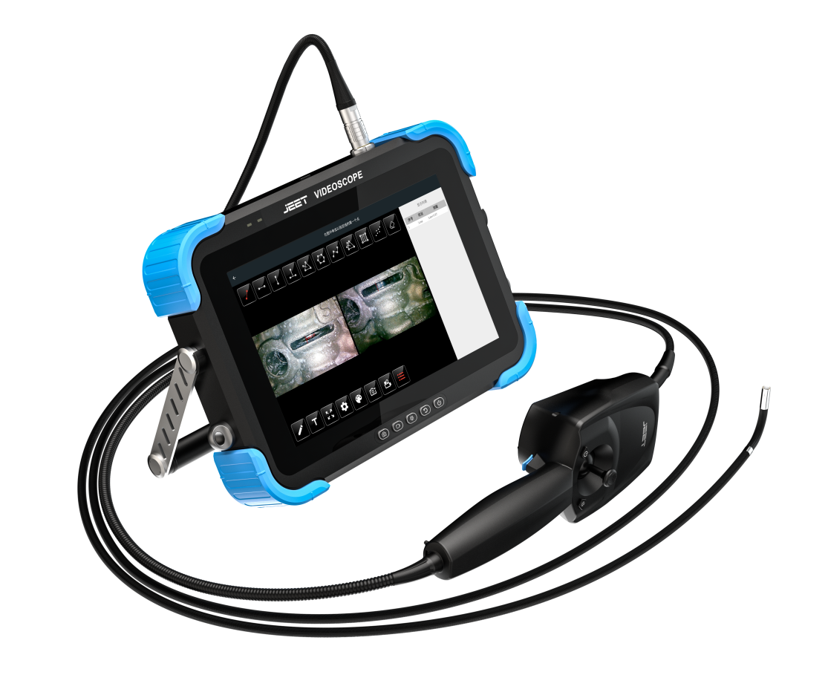

F pro 3D Measurement Videoscope

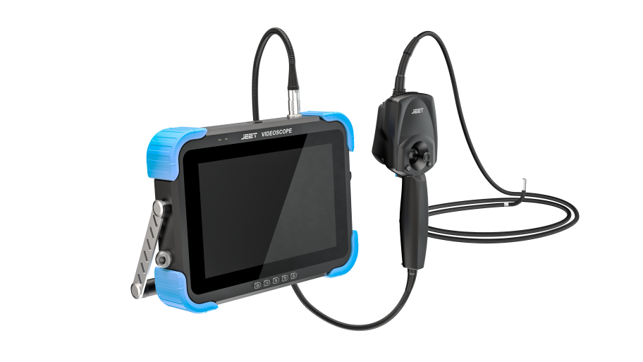

3D measurement function is a major difficulty in the endoscope industry. Whether the process selection of product appearance materials or the research to the design of software measurement algorithms, JEET R&D team made a large number of feasibility studies and simulation tests.

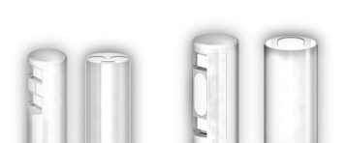
3.9mm 0°/90° camera
6.0mm 0°/90° camera

Measurement function
point-to-point/point-to-line/point to surface depth/ multiple point circumference measurement，measurement accuracy ≥ 95%

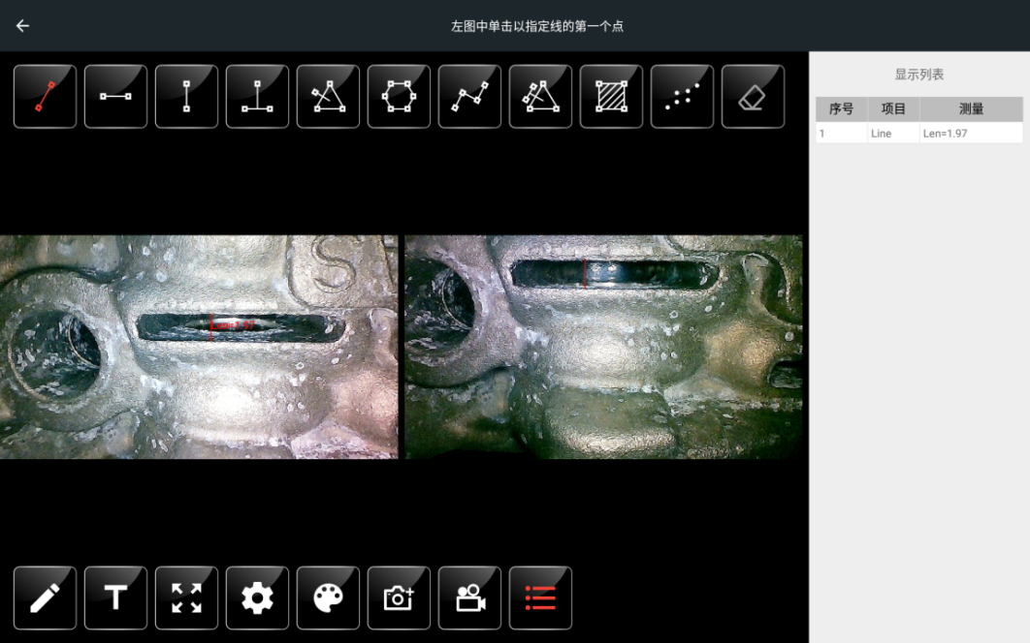
measurement modes

measurement data displays in list

zoom in/out

note text, mark, free drawing

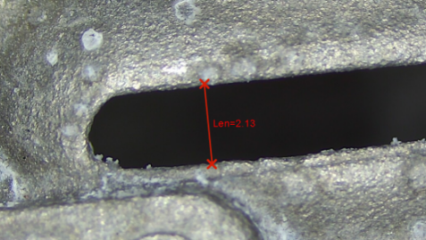
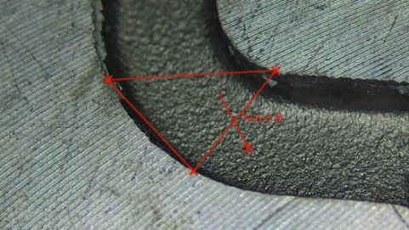
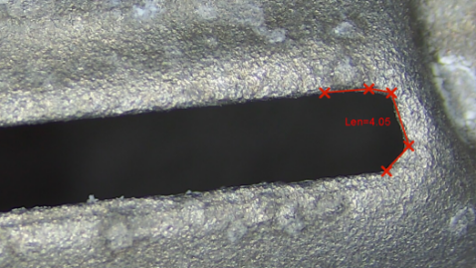
distance between two points
point -to -plane depth
multiple point circumference

intelligent operating system, accurate measurement results

Vertical depth nephogram
3D physical cloud image
High precision and fast global
scanning 3D cloud image
- Fast global scanning to view 3D physical cloud image

- Vertical depth cloud map, automatic measurement of maximum depth

- 3D cloud image XYZ coordinate display, arbitrary section view, easy to locate the depth and height difference of internal defects

- the datum plane shifts and the depth value changes in real time

Profile
Cloud 3D coordinates

Intelligent Software

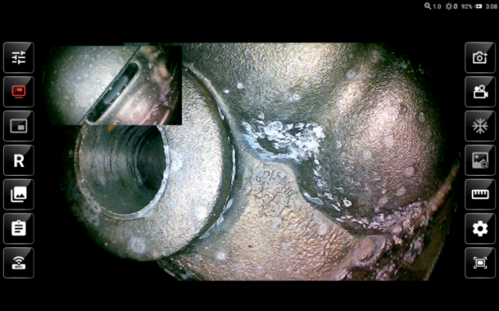

Picture in Picture
static/dynamic image comparison software

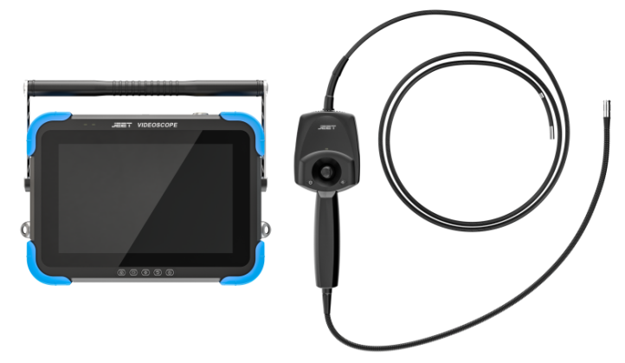

1920*1200 Super HD image, full screen

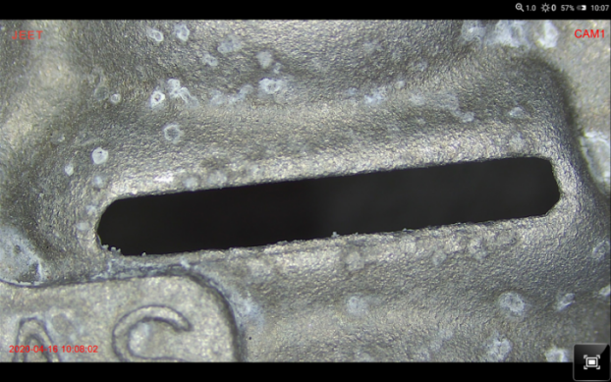

Full screen mode
Smart inspection

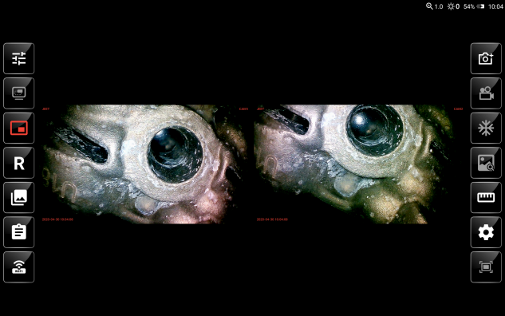

Dual-camera image

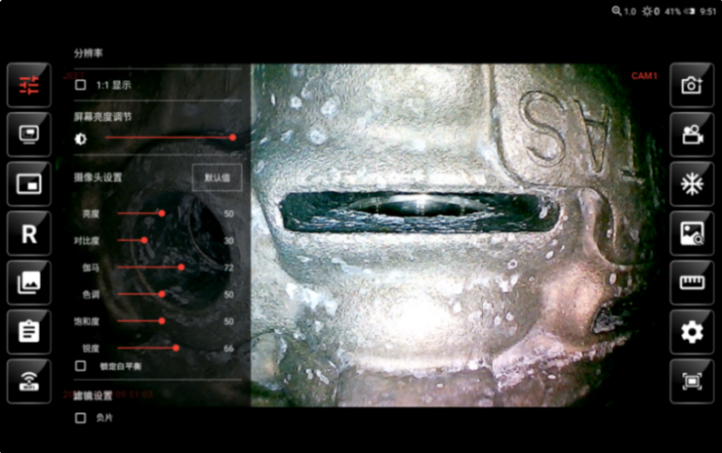
Intelligent operation system
Image adjustment: resolution options
Camera parameters setting: brightness/ contrast/ gamma/ ray/ saturation/sharpness
Image effects: auto balance/ negative film/mirror image or rotation/image freezing
Note text: annotation/free drawing/mark

Picture annotation, free drawing

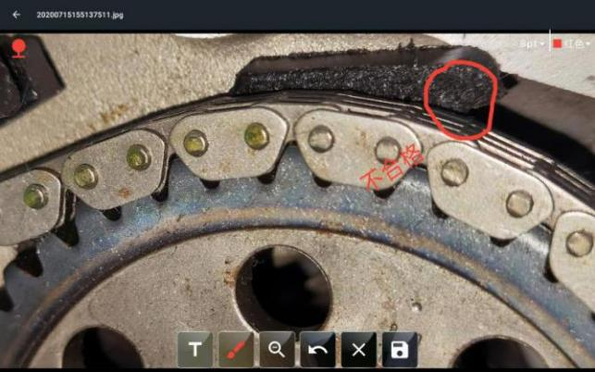
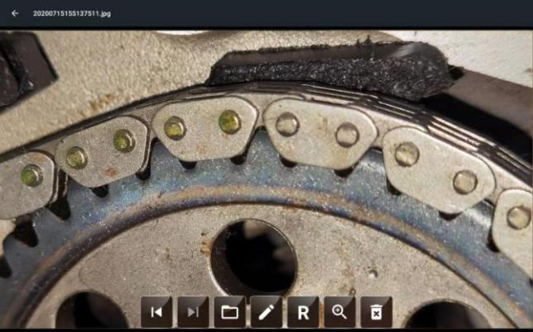
②text note or mark and ；confirm after operation to save the file.
① select pictures or freeze the image ; select “free drawing”icon.

MDI report generation

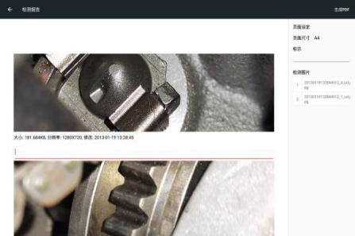
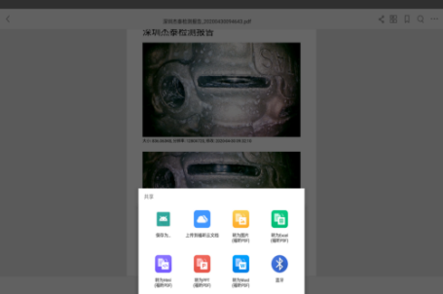
select pictures and editing the report
Treport sent to the mobile phone via bluetooth

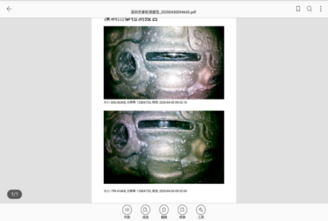
generate report in PDF file

Portable design

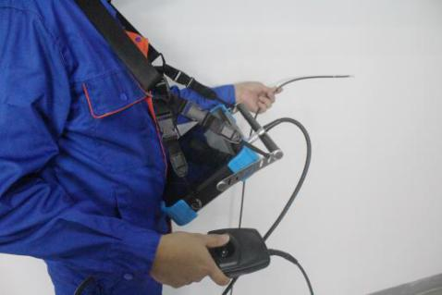
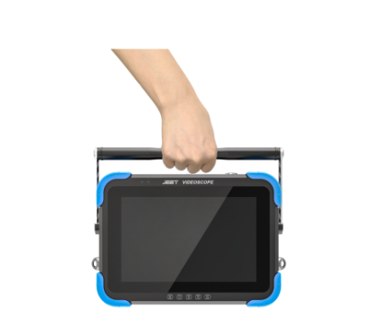
practical strap
buckle to fix monitor and handle
adjustable bracket

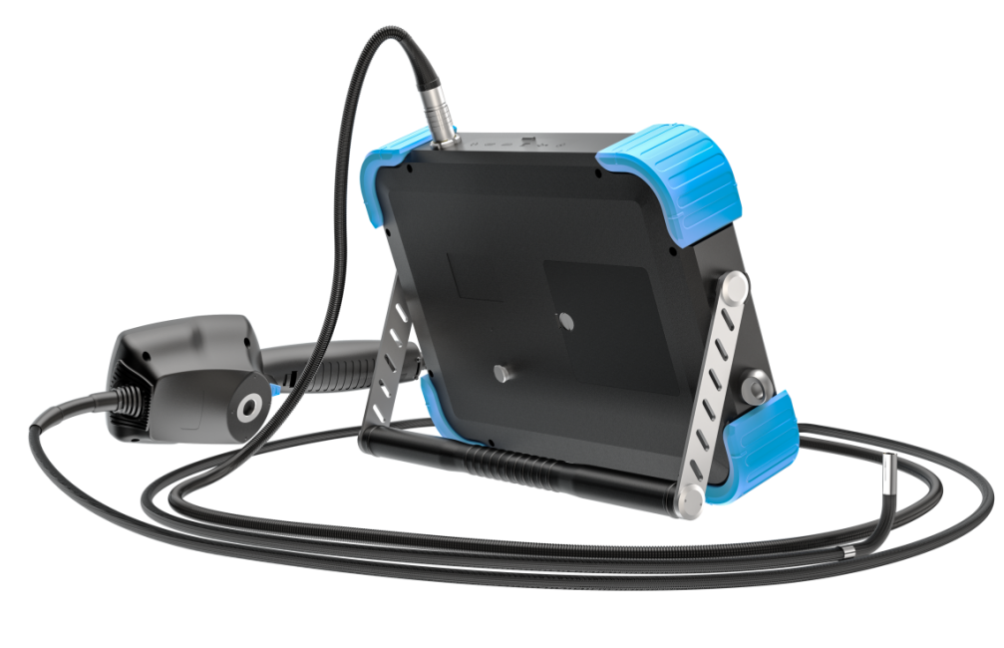

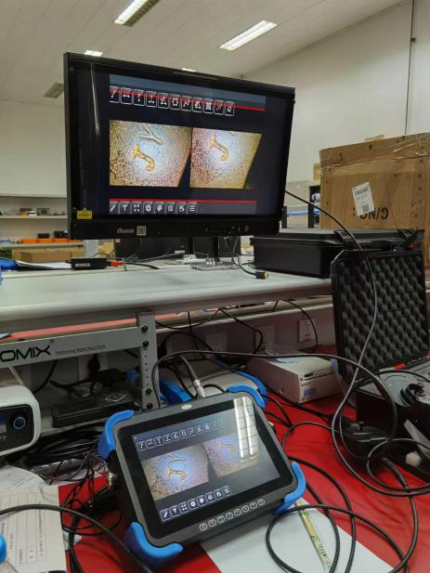
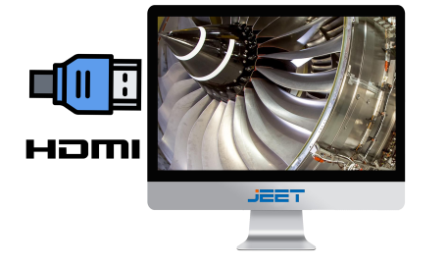
◉ HDMI image output, synchronous image display
◉ 3.0/2.0 dual USB port
◉ 32G SD card，support 128G card at maximum

Tube system

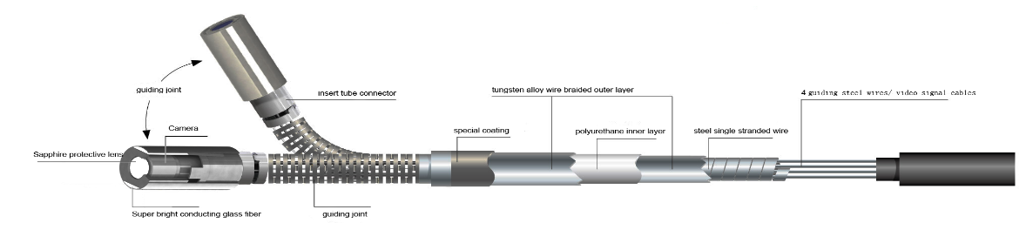

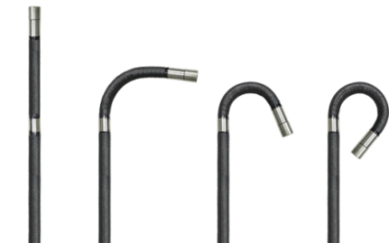
360° articulation

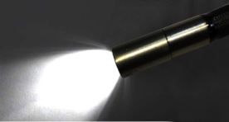
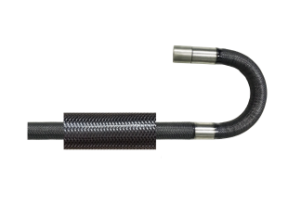
super bright ceramic light
illuminance
Wear resistant tube
5 layers of tungsten- braided tube; Wear resistance: 20 times better than ordinary probe

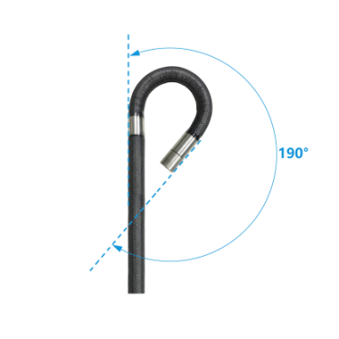
maximum bending angle:190°

Parameters

Monitor System
Monitor size | 300×220×59mm
Monitor weight | 1.9KG
Monitor material | magnesium aluminum alloy
Display resolution | 1920×1200
Joystick handle size | 235×90×70mm
Joystick handle weight | 0.4KG
Articulation | 360°
Bending angle | ≤150°
Storage | Internal memory/SD card/U disk（optional）
I/O port | Micro USB×2;mini HDMI×1;SD slot×1;Air plug×1
Video output | HDMI
Light source | Real cold light source+fiber
Brightness level | 5X
Illumination | Max 100000LX
White balance | Automatic
Battery capacity | 3000mA/3.7V ×4
Battery charging | 12V，1A
Power | 10W
Battery work time | 2.5h
DC mode | Support charging while use
Software
Operation system | Real-time intelligent multitasking operating system
User interface | Button+touch screen
File management | Intelligent file management system, support to the memory and SD card, USB storage media files and folders for the following operations: copy, cut, rename, delete, and so on
Image adjustment | Image adjustment: resolution options  Camera parameters setting: brightness/ contrast/ gamma/ ray/ saturation/sharpness  Image effects: auto balance/ negative film/mirror image or rotation/image freezing  Note text: annotation/free drawing/mark
Image zoom in/out | 8X
Image format | JPG
Video format | MP4
Text annotation | Photo text overlay, can choose the font size of the annotation text
Image annotation | Seal (default/custom), doodle, text input
Software upgrade | On-site upgrades are available via SD card and USB storage media
Language | English / French / German / Spanish / Japanese / Traditional Chinese / Simplified Chinese / Russian / Korean
Utility software | MDI report generation software  Dual video input switching software  (it shall be equipped with the direct side view switching pipeline)  Picture in picture comparison software  3D measurement software
Tube System
Probe Diameter (mm) | Camera Pixels | Tube Length | View | DOF | FOV | Light Source | Articulation
8.0mm/  6.0mm | 1mega pixels | 1m~10m | front | 10-100mm | 120° | LED/optic fiber | 360°all-way
 |  |  | side | 3-25mm/10-110mm | 90°/120° | LED | 360°all-way
 | 1mega pixels | ≤ 3m | 3D measurement | 10-100mm | 120° | optic fiber | 360°all-way  360°all-way
3.8mm | 1mega pixels | 1m~10m | front | 10-100mm | 120° | LED/fiber | 360°all-way
 |  |  | side | 3-25mm/10-110mm | 90° | LED | 360°all-way
 | 300,000pixels | ≤ 3m | 3D measurement | 5-50mm | 120° | optic fiber | 360°all-way  360°all-way
2.8mm | 300,000pixel | 1m~3m | front | 5-50mm | 120° | LED/optic fiber | 360°all-way
 |  |  | side | 5-50mm | 120° | LED | 360°all-way
2.2mm | 300,000pixel | 1m~3m | front | 5-50mm | 120° | LED/optic fiber | 360°,two-way
1.8mm | 300,000pixel | 1m | front | 5-50mm | 120° | LED/optic fiber | two-way
1.0mm | 40000pixel | 1m | front | 5-50mm | 120° | LED/optic fiber | no direction
Measurement function
Point to point distance | Measure the distance between two points
Point to line distance | Measure the distance from the point to the line
Point to surface depth | Measure the distance from the point to the surface
Multi-segment line length | Measure the total length of multiple continuous lines
Closed segment length | Measure the length of multiple closed continuous lines
Line to surface depth | Measure the depth of the line to the specified surface
Area | Measure the area of a closed polygon（pending）
Partial magnifying window assist function | 3X
picture can be measured times | Multiple measurements can be made continuously
Measuring list | Multiple measurements can be tabulated
Standard precision value | 0.1mm
Minimum precision value | 0.01mm
Accuracy | ≈95%
Model Function
Model  Function |  | FC |  | FS | FP
Photo | JPG | √ |  | √ | √
Video | MP4 | √ |  | √ | √
Zoom | 8X MAX | √ |  | √ | √
Illuminance | MAX 70,000Lx | √ |  | √ | √
Display scale adjustment | Image 1:1/full screen | √ |  | √ | √
Image effects | Negative film, standard | √ |  | √ | √
Image freezing | Freeze photo,check, mark and save | √ |  | √ | √
Image rotation, mirroring | 0°, 90°,180°, 270° mirror | √ |  | √ | √
Intelligent file management | Be able to copy, cut, rename, and delete files have been saved | √ |  | √ | √
Two photos comparison | Select photo from document, and compare the two photos on one screen | √ |  | √ | √
Review | Thumbnail review, file name display directly | √ |  | √ | √
Picture annotation，free drawing | File mark, image mark, add logo, free drawing, file output | √ |  | √ | √
Picture in Picture | Switch between main screen image and small window photo | √ |  | √ | √
Front view and side view on one screen | Front view and side view preview on one screen | × |  | √ | ×
Dual-camera image | Two images dynamic real-time display on one screen | × |  | √ | √
MDI Generate report | Select photo,free draw the photo，edit words under the photo，write the title of the file，create detection report,transfer the report via Blue-teeth | × |  | √ | √
3D measurement | Point to point,point to surface,point to surface depth/ multiple point circumference measurement,partial zoom window function（3 times calibration）,measurement data list | × |  | × | √

