1, air cooling water chiller
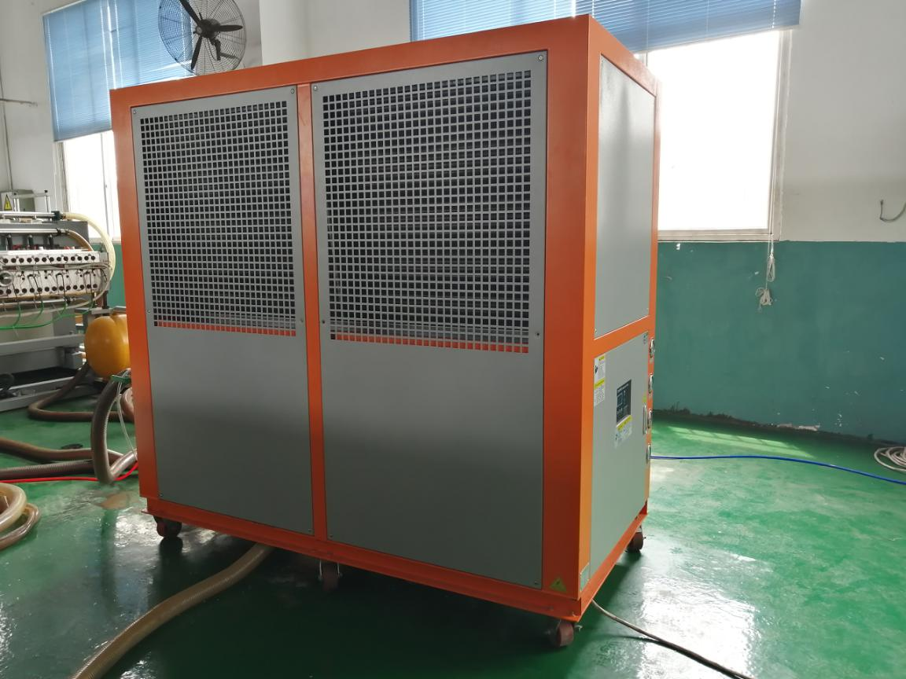

Cooling capacity | KW/H |  | 90
Total input power | KW |  | 32.2
Maximum running current | A |  | 77
Electricity |  |  | 3N 380V 50HZ
Cooling agent | Name |  | R22
 | Control type |  | The balanced thermal valve
 | Cooling circuit |  | 2
Compressor | Type |  | All-closed seroll type (Piston）
 | Power | KW | 12.5*2
Condenser | Type |  | High effective copper tube coated RVCES + low-noise outer rotating blower
 | Cooling fan power | KW | 1.6*2
 | Cooling fan capacity | M³/H | 40600
Evaporimeter | Type |  | Shell and Tube
 | Cooling water capacity | M³/H | 40
 | Diameter of inner mouth |  | G2-1/2″
Water pump | Power | KW | 4
 | pumping head | M | 30
Safety protection | Compressor over-heat protection, overcurrent protection, low or high pressure protection, over-temperature protection, flow protection, Sequence/phase lack protection, exhaust overheating protection
Blunt fluence | KG |  | 12.5*2
Machine weight | KG |  | 950
Machine size | MM |  | L2350*W1200*H2200
1. The main engine selects the brand new imported compressors, with built-in safety protection, low noise and durable power saving.
2. The electrical part is the original product of the international brand "schneider", which ensures the stable operation and long life of the machine.
3. Imported water pump from original Italian factory, high flow, high efficiency and durable.
4. Equipped with imported precision type digital temperature controller, can accurately control temperature in + / - 1 ℃, 5 ℃ to 35 ℃ set temperature range.
5. All stainless steel thick water tank type evaporator, with built-in automatic water replenishing device, easy to clean and maintain.
6. The condenser of the water chiller is bushing type with inner threaded copper pipe. The design is reasonable and the heat transfer effect is good. The air cooling unit is composed of warping plates and rows of copper tubes, which adopts the mechanical inflating pipe technology of double flanging warping sheets and the advanced heat exchanger production line to ensure high quality and efficiency.
7.Electrostatic spraying shell, European design, beautiful and graceful, the outer plate adopts quick disassembly and assembly, which is convenient for use and maintenance.

2,11kw screw type air compressor with air tank and air dryer
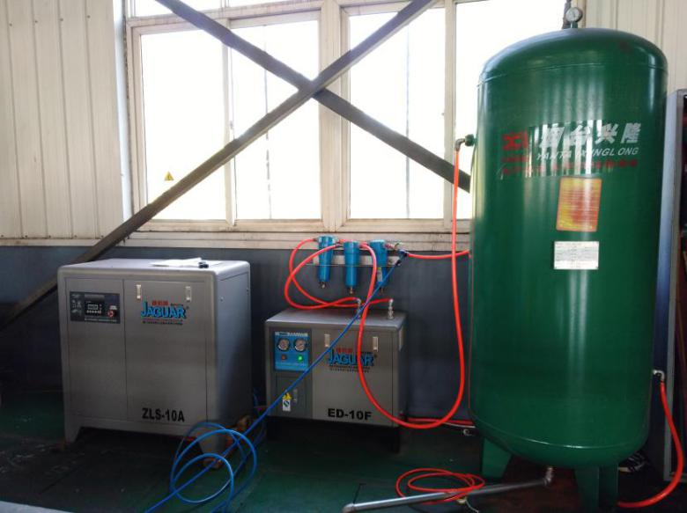
Low RPM permanent magnet VSD screw air compressor
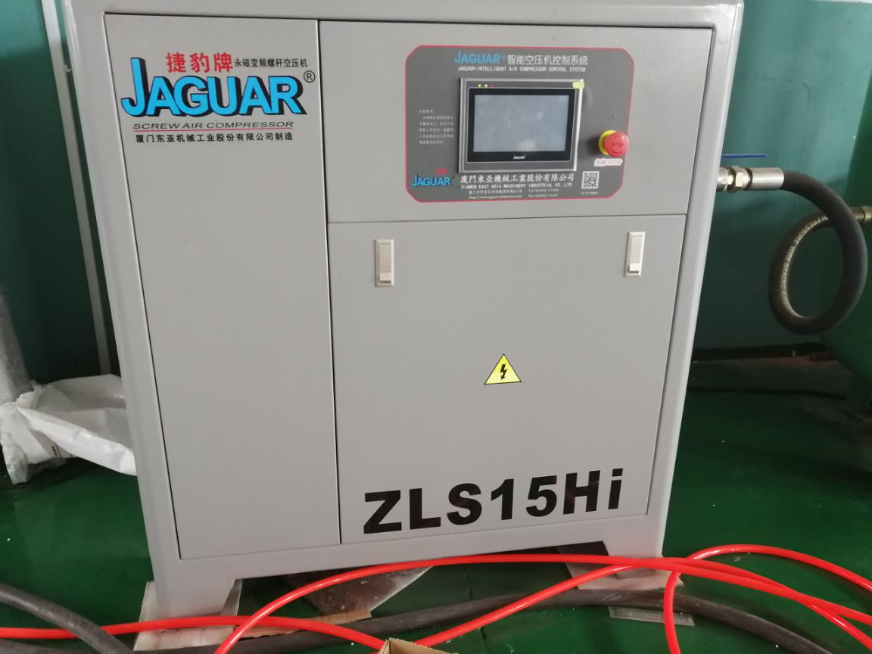
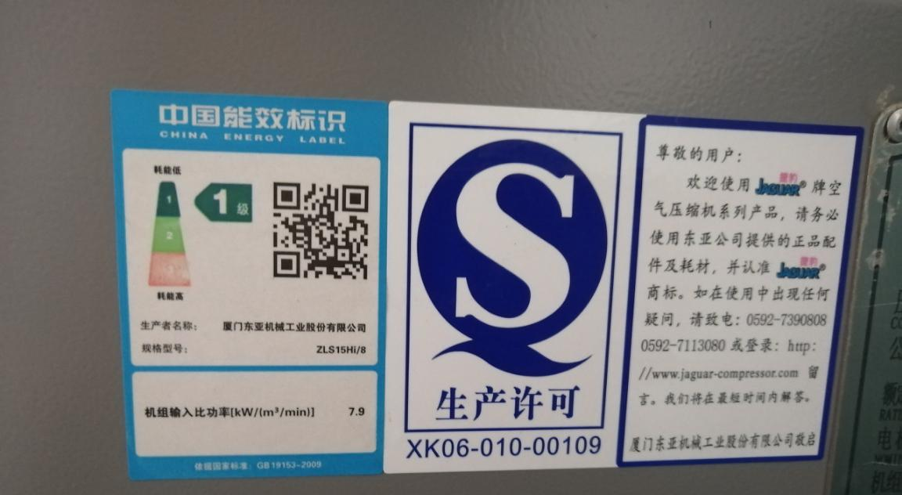
High efficiency, more energy saving (super energy efficiency), super stability

Brand |  | Taiwan JAGUAR
Type |  | Low RPM permanent magnet VSD screw air compressor
Model |  | ZLS15HI/8
Starting mode |  | Frequency conversion start
Air Displacement/  Exhaust pressure  （m3/min/Mpa） |  | 2.6/0.7
 |  | 2.5/0.8
 |  | 3.5/10.6
Motor | Nomtnal drive Power | 11KW
 | SP.PWR | 7.9KW/(m³min⁻¹)
 | Electricity | 380V/60HZ
 | Starting mode | Y-△
Noise DB（A） |  | 61±2
Diameter of out mouth（Inch） |  | 1"
Environment temperature（℃） |  | -5℃～+45℃
Exhaust temperature（℃） |  | Cooling wind< Environment temperature+10℃
Dimensions |  | 1200*800*1160mm
Weight |  | 370kg
Air tank
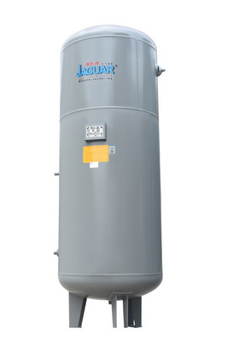
Design pressure | 0.84Mpa
Working pressure | 0.8Mpa
Design temperature | 150⁰C
Tank capacity | 1000L
Medium | Air
Life | 7 years
Inner diameter of the tank | 820mm
Total hight | 2325mm
Enter air pipe | Rp11/2’’
Outer air pipe | Rp11/2’’
Drain valve | Rp3/4’’

Refrigerated air drying base
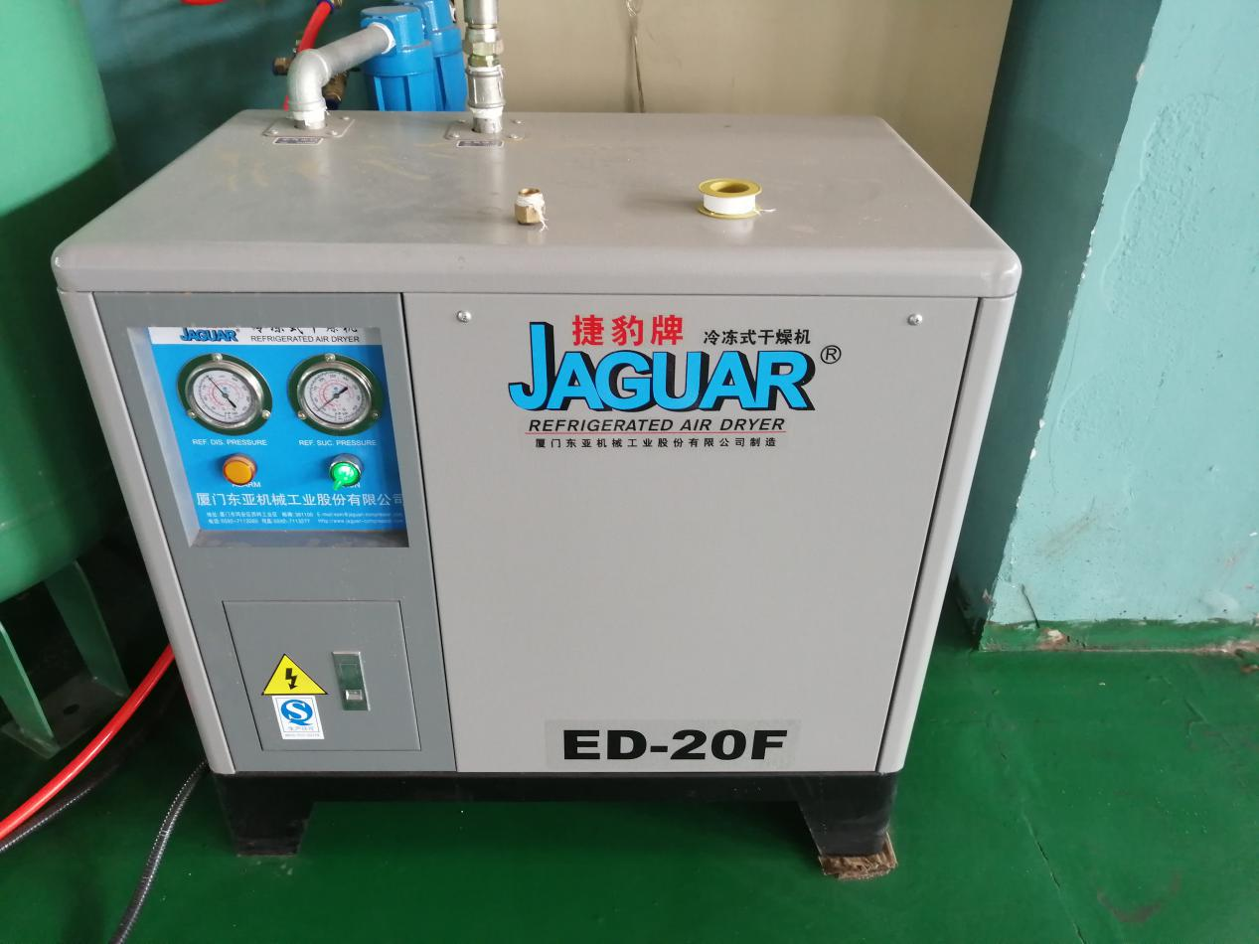
Model | ED-20F
Drying capacity | 2.8nM^{3/}min
Enter compressor | <1.0Mpa
Enter temperature | <45⁰C
Dew point temperature | 2-8⁰C
Refrigerant | R22
Power | 0.7kw
Size | 80*50*76.5cm

