Why chose the 57oz Paper Cup of SPUNTREE ?

1) High grade & biodegradable products customized available
2) Free design, free sample
3) Automatic Production & fast delivery
4) 100% responsible for the quality
5) 7days*24 hours fast response
6) Small order welcomed

Product parameters

Product Name | 57oz Paper cup
Ref NO. | YJ3004
Brand | SPUNTREE/ NEUTRAL /OEM
Material | 100%Food grade Kraft paper
Color | Monochrome or multi -colors
Size | 57oz
Package | 50pcs/ bag
Suitable temperature | -20℃-120℃
Futures | Odorless、Safety and eco-friendly
OEM | Available (Color,patterns,sizes and package can be adjusted by clients’ request)

Our standard hot cups are offered in a variety of sizes to suit multiple drink types, from a 4oz espresso to a 24oz large coffee. Standard hot cups can be custom printed so consumers can carry your logo with them on the go. This product line is also available in several stock designs.

Our customization facility makes it more relevant to our client’s interests.
We offer highly aesthetic designed Coffee Paper Cups. Processed from food grade Paper the range comes in paper thickness of 300GSM. To suit the specific requirement and visual value of our divergent client
base we offer customization facility.
We offer the range in industry leading prices. Apart from commercial establishments our coffee cups are
also sought after by clients for private get together.

Details of the 57oz paper cup：
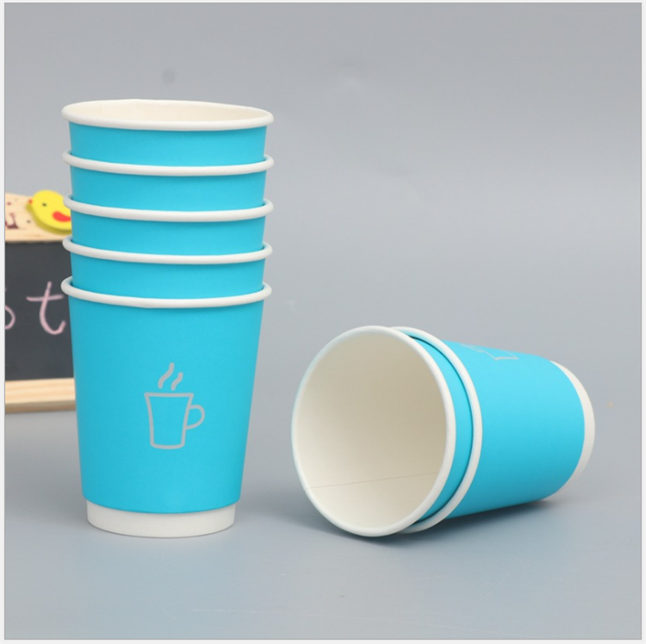
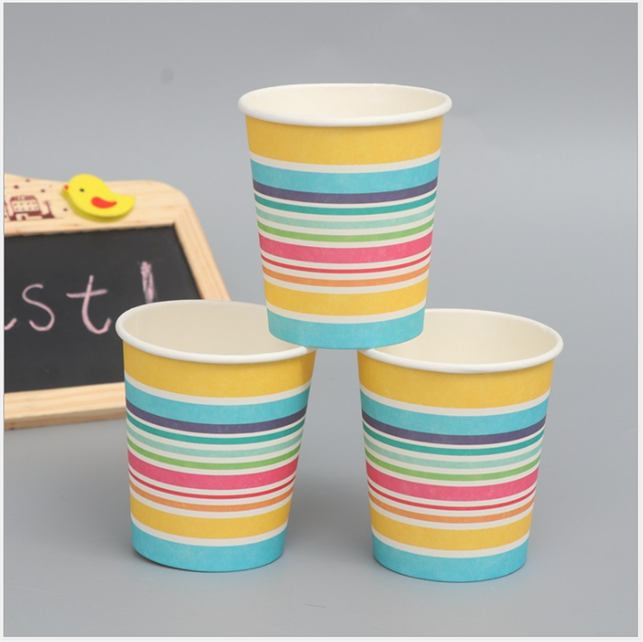
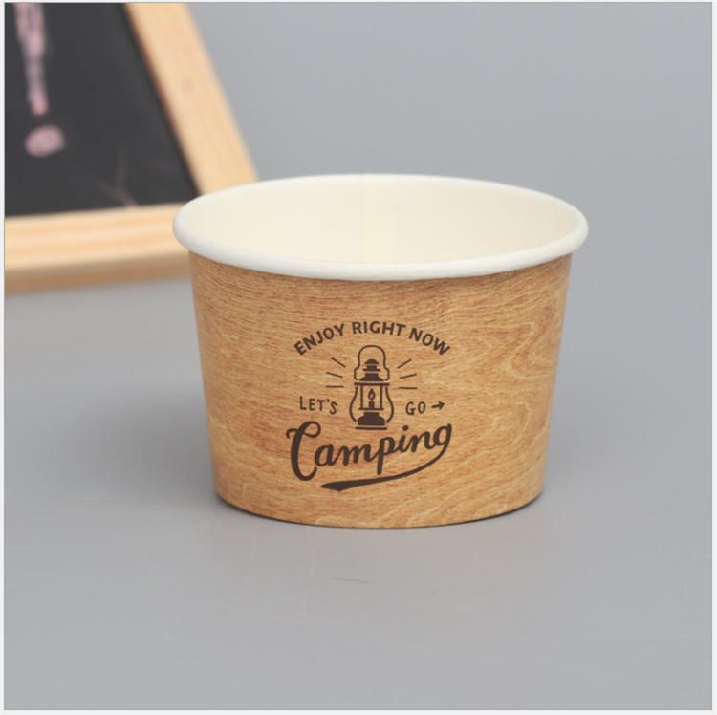

The product certification of 57oz paper cup:
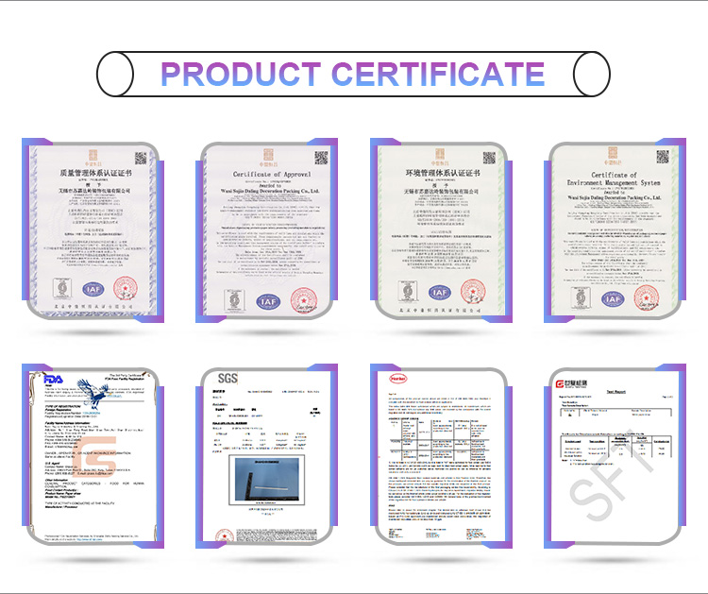

Production process：
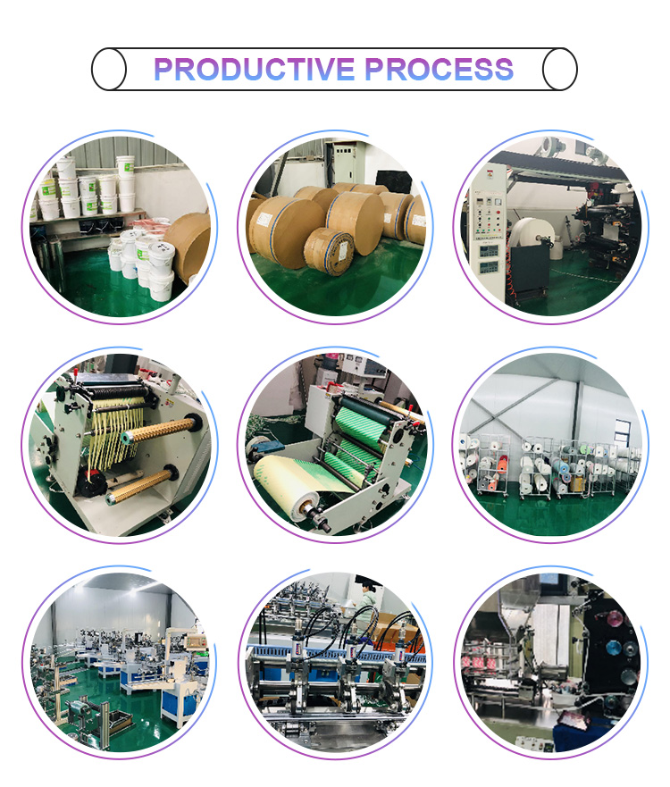

Our promise:
100% imported raw materials(paper imported from Sweden and glue imported from Germany)
Professional certificates(FDA,SGS,LFGB)
Guaranteed quality and safety

