Why chose the 6mm Reusable Drinking Straws Bamboo Straws of SPUNTREE ?

1.Competitive price with high quality
2.Best OEM service on products,package ,designs and other ideas

Product parameters

Product Name | 6mm Reusable Drinking Straws Bamboo Straws
Ref NO. | YJ2002
Brand | SPUNTREE/ NEUTRAL /OEM
Material | Bamboo
Color | Natural bamboo
Size | 6*197mm(7.75”)
Package | Color box / cloth carrying bag
Suitable temperature | -20℃-120℃l
Futures | Reusable Safety and eco-friendly
OEM | Available (Color,patterns,sizes and package can be adjusted by clients’ request)

About the product
1.A slight difference in the color of each straws is a normal phenomenon due to material are all natural.Also due to natural variance in diameter,these straws may not fit through certain travel mug lids.
2.The small diameter does not fit for drinks with granules.
3.Please note that the need to clean up the inner and outer pipe with a straws brush before the use of straw.
4.Please storage in a dry place.
5.Can be washed in Dishwasher ,No microwave oven.

Details of 6mm Reusable Drinking Straws Bamboo Straws:
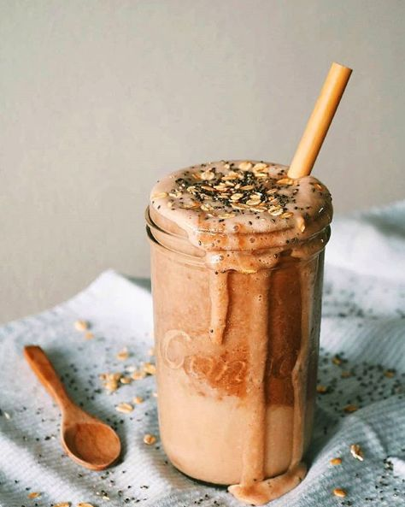
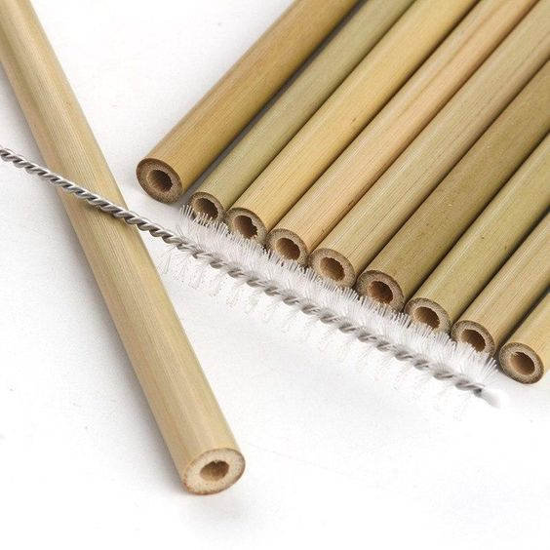
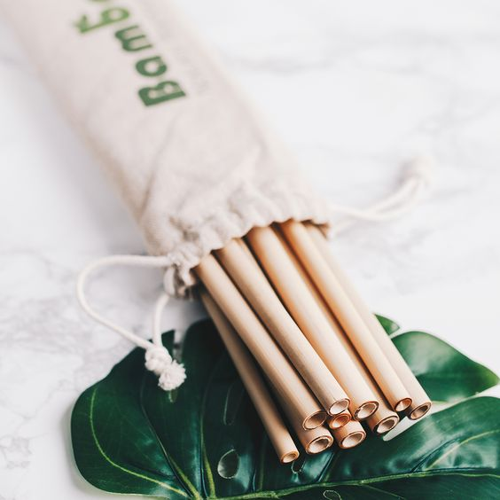

The product certification of 6mmReusable Drinking Straws Bamboo Straws:
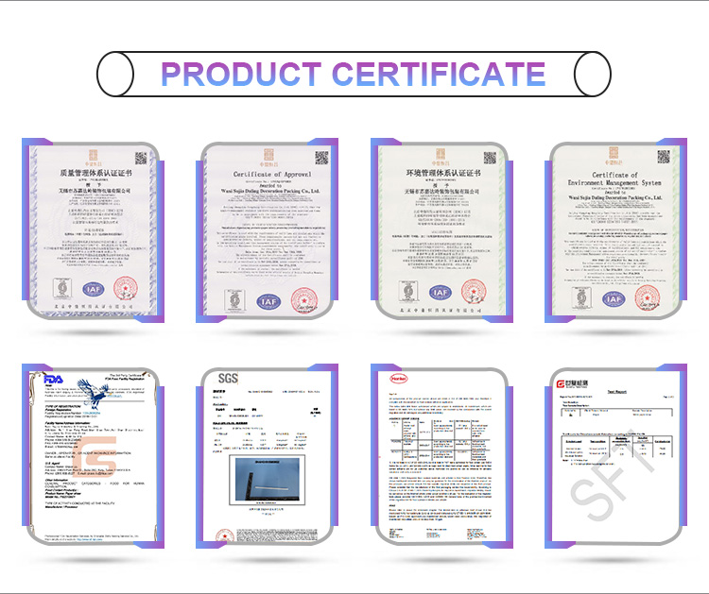

The package of 6mm Reusable Drinking Straws Bamboo Straws:

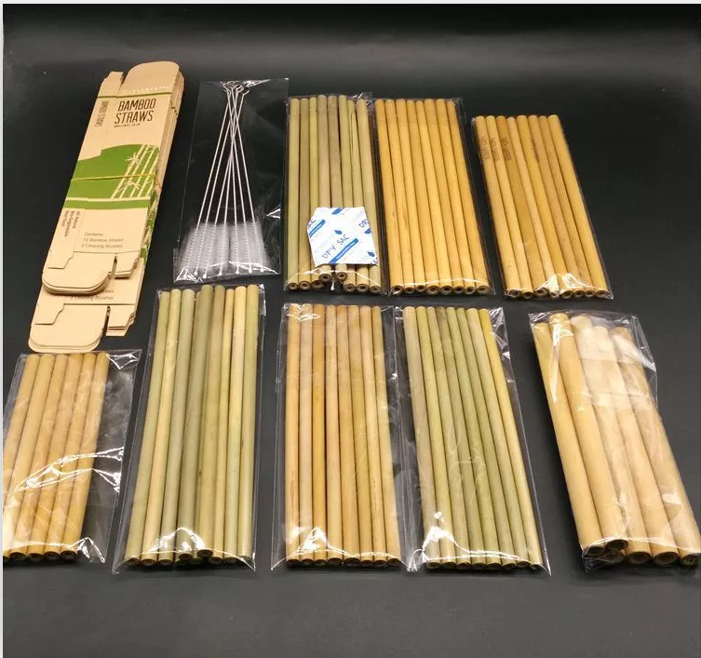

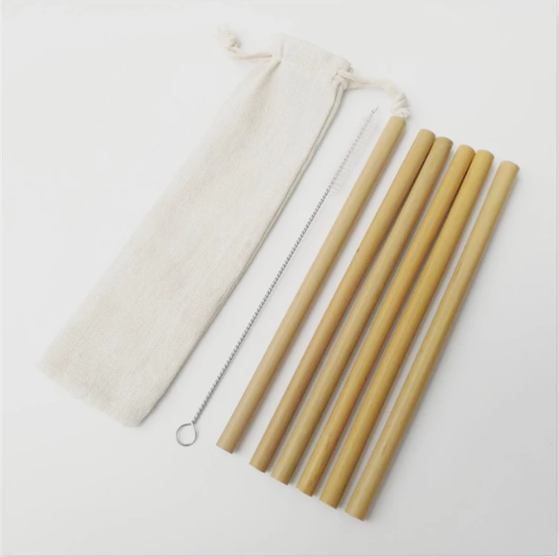

Production process：
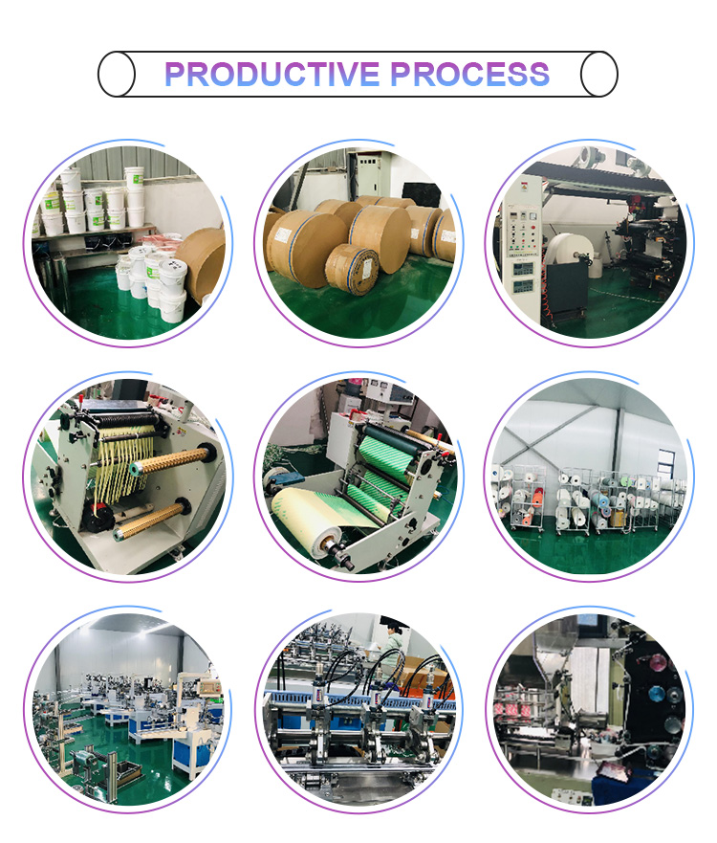

Our promise:
100% imported raw materials(paper imported from Sweden and glue imported from Germany)
Professional certificates(FDA,SGS,LFGB)
Guaranteed quality and safety

