Why chose the Dishes of SPUNTREE ?

1.This shop all products to the straw, straw, bagasse and other natural plant fiber as raw material, the production processing by the scientific method, through cleaning, disinfection, crushing and other technological mould pressing, so that the product does not contain any harmful chemicals to human body, and the retention of the original plant fiber qualities.
2.People disposable after use can be recycled for the public to feed pigs, cattle, horses, sheep and other livestock, can be buried in the soil as organic fertilizer. Because of its water vapour permeability, easy decomposition characteristics, can be processed into the nutritive bowl seedling with agriculture, can realize the degradation efficiency of 1--3 months.
3.Biodegradable Wheat Straw Fiber disposable bagasse tableware
Product parameters

Product name | The Dishes of SPUNTREE
Material | 100% Bio-degradable Bagasse / Wheat straw
Color | Natural/White
Temperature | -20℃~120℃
MOQ | 1000 Pcs in stock
Features | 1. NSF/BRC/ISO9001:2000/ISO14001/FDA, approval
 | 2. Recyclable & 3 months of naturally degradation
 | 3. Oil-proof & Waterproof, no leaking
 | 4. Non-toxic & Microwave safe
Custom | 200000 Pcs (Pattern, Logo can be customized )
Leading Time | Standard Product - 3 days in stock
 | Customized order - according to the quantity

Regular Sizes for your Reference
Standard Size For Plate | Standard Size For Bowl
D07482- φ155×10.6 (H) -- 5inch -- Striped | D07102 -- φ140×45(H) -- 220ml (8oz)
D07122 - φ155×10.6 (H) -- 6inch -- Striped | D07032 -- φ152×45.6(H) -- 340ml (12oz)
D07232 - φ155×10.6 (H) -- 6inch | D07092 -- φ135×46.6 (H)--350ml (12oz)
D07132 - φ184×14.6 (H) -- 7inch -- Striped | D07072 -- φ135×45.6(H) -- 350ml (12oz)
D07182 - φ180×18 (H) --7inch | D07112-- φ165×35(H) -- 350ml (12oz)
D07142 - φ210×18.6 (H) -- 8inch -- Striped | D07082 -- φ178×40.6(H) -- 400ml (14oz)
D07202 - φ230×20 (H) -- 9inch | D08062 -- φ160×36 (H)-- 460ml (16oz)
D07192 - φ235×20.6 (H) -- 9inch -- 3 Compartment | D07012 - φ155×54 (H)-- 500ml (17oz)
D07152 - φ261×20.6 (H) -- 10inch | D08052 -- φ189×40.6(H) -- 680ml (23oz)
D07162 - φ261×25.6 (H) -- 10inch -- 3 Compartment | D07022 -- φ170×60(H) -- 850ml (30oz)
 | D07042 -- φ260×60(H) -- 1000ml (35oz)

Product features
1.environmental health, non-toxic harmless, healthy. Product raw materials are natural plant, the production process of natural high temperature disinfection, the production process without waste, no harmful gases and waste pollution, after using, buried in the soil, 3 months of natural degradation of organic fertilizer, products meet the national requirements of environmental protection and hygiene.
2.product applicability: can be processed into various shapes, are for the whole structure, good strength, both inside and outside the smooth. Water resistance, heat resistance, oil products, sanitary, convenient, beautiful. To make up for the shortage of paper tableware is soft, easy to deformation, poor applicability.
3.suitable for microwave oven, refrigerator preservation.
4.the value of recycling, recycled paper, recycling, resource conservation.
5.variation of natural degradation mud into organic fertilizer, reduced to carbon dioxide and water, return to nature.
6.the product can improve its barrier permeability after spraying, coating, it is not sticky rice, refrigeration products not easily soft.
7.the production process without waste emissions, the product from raw material processing to the molding, the entire production process does not produce any waste, waste water and waste residue, processing if damaged, can be crushing reuse.

Details of the 57oz paper cup：
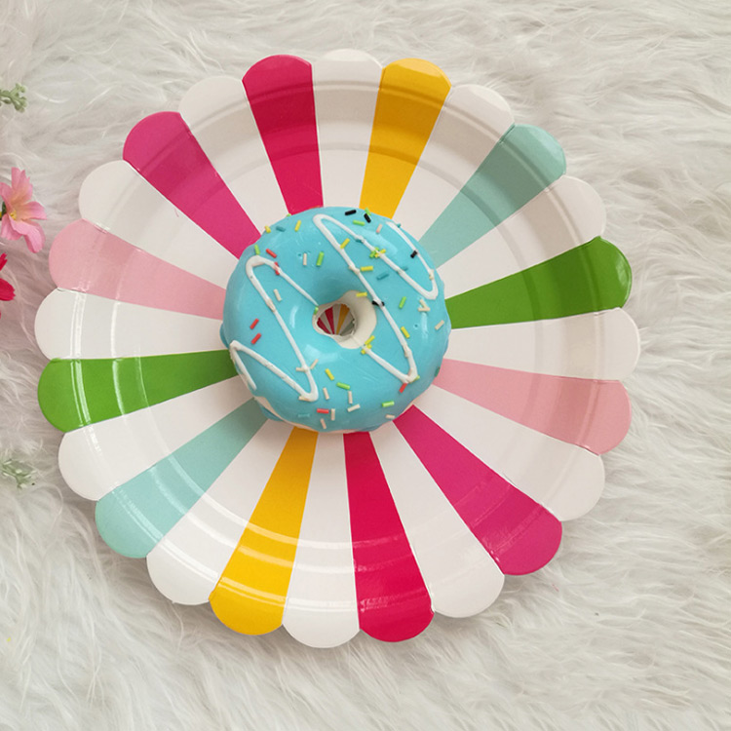
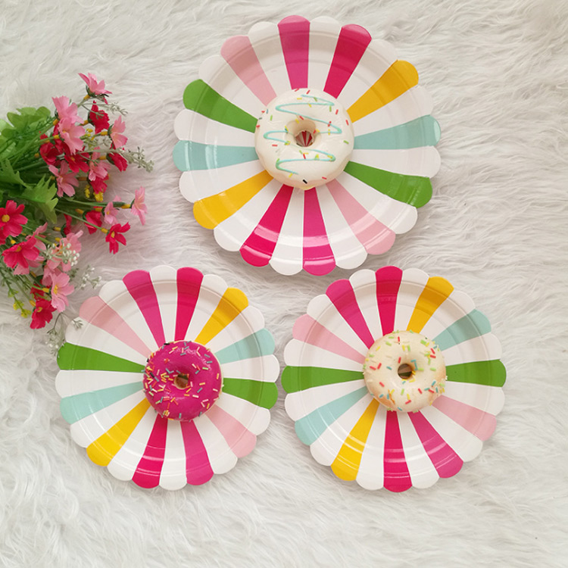
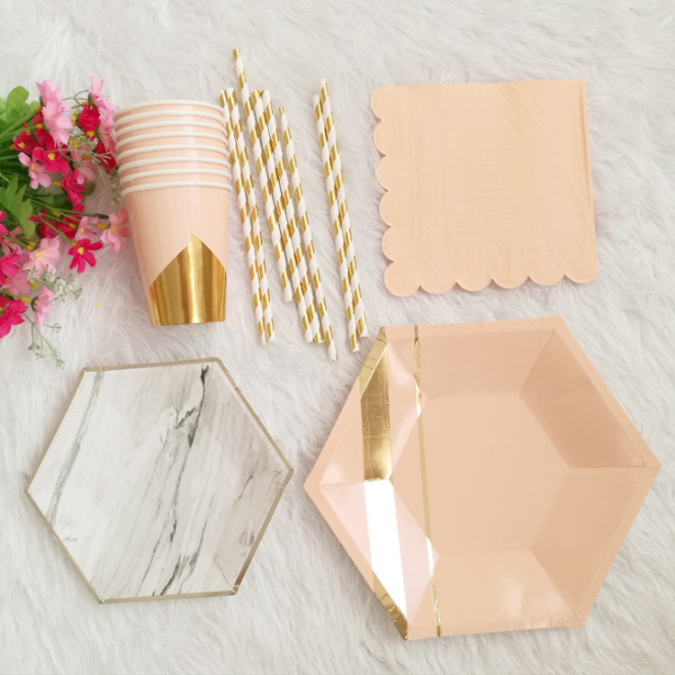

The product certification of 57oz paper cup:
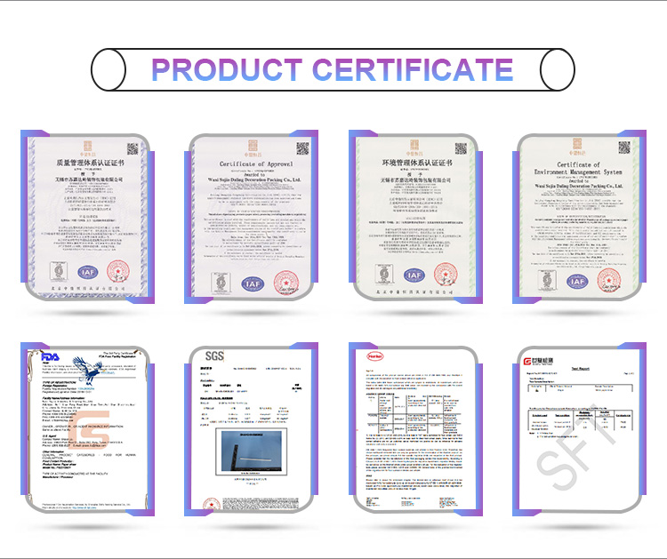

Production process：
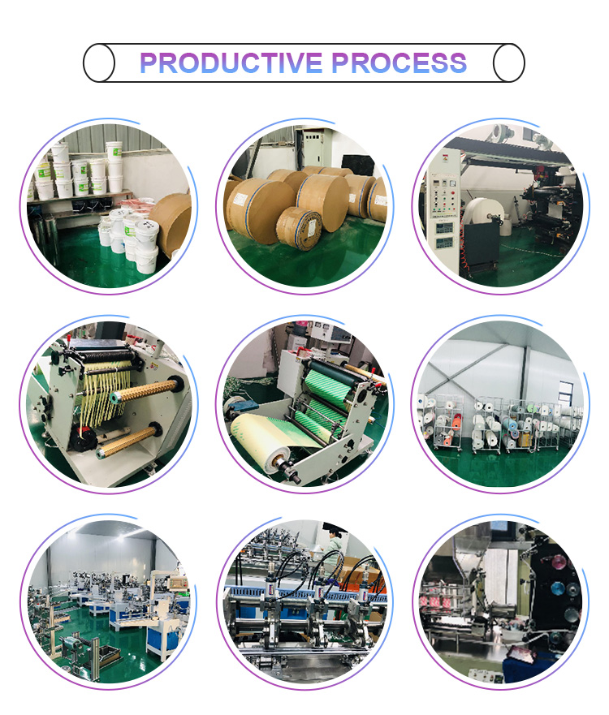

Our promise:
100% imported raw materials(paper imported from Sweden and glue imported from Germany)
Professional certificates(FDA,SGS,LFGB)
Guaranteed quality and safety

