Why chose the 6mm Red wave Paper Straw of SPUNTREE ?

1. Competitive price with high quality
2. Huge Capacity(2,200,000pcs) per day for quick delivery
3.Best OEM service on products,package ,designs and other ideas
4.Certificated with FDA,SGS/LFGB

Product parameters

Product Name | 6mm Red wave Paper Straw
Ref NO. | YJ1001C
Brand | SPUNTREE/ NEUTRAL /OEM
Material | Food grade Kraft paper(2 player 120g+1player 60g)
Color | Monochrome or multi -colors
Size | 6*197mm(7.75”)
Package | 25pcs/opp bag ,400bags/carton, or 1piece/wrapped paper bag,5000pcs/carton
Suitable temperature | ≤60℃
Futures | Odorless、Good hardness、Safety and eco-friendly
OEM | Available (Color,patterns,sizes and package can be adjusted by clients’ request)

The paper straws manufactured by SPUNTREE are ideally used for cocktail,coke,water,juice,bubble tea and other mixed drinks in restaurants,bars,hotels,homes,takeaway shops,airports and other establishments.
It is 100% degradable ,eco-friendly
They measure 197mm(7.75”) in length , 6mm(0.236”) in outer diameter and 5mm(1.97”) in inner diameter.
SPUNTREE can produce paper straws in different colors and can customize them with your branding or logo on straws,paper bags or kraft boxes.
Our wrapped or unwrapped paper straw options are biodegradable and manufactured in WUXI city ,China with FDA , SGS and LFGB approved .

Details of 6mm Red wave paper straws：
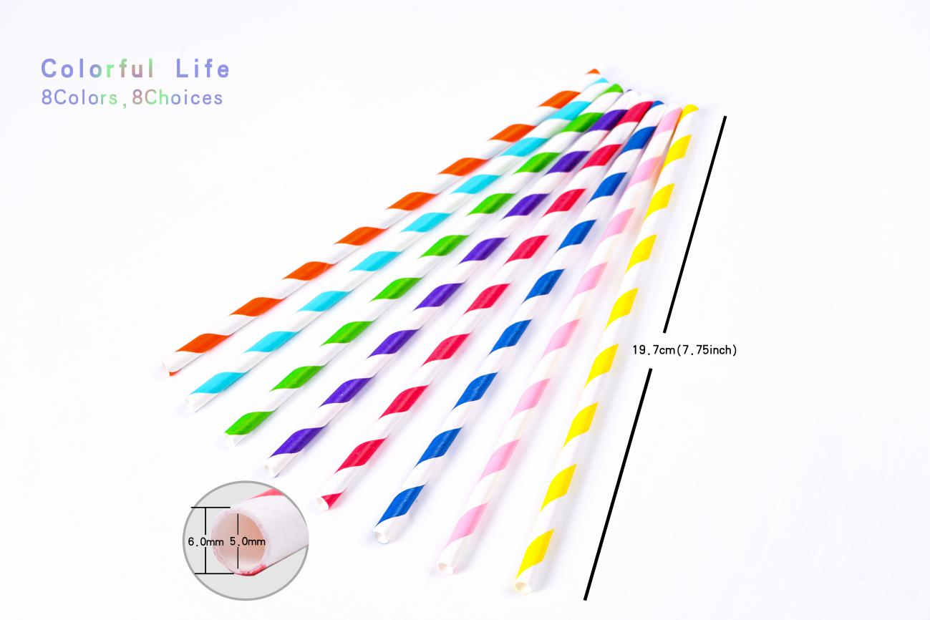
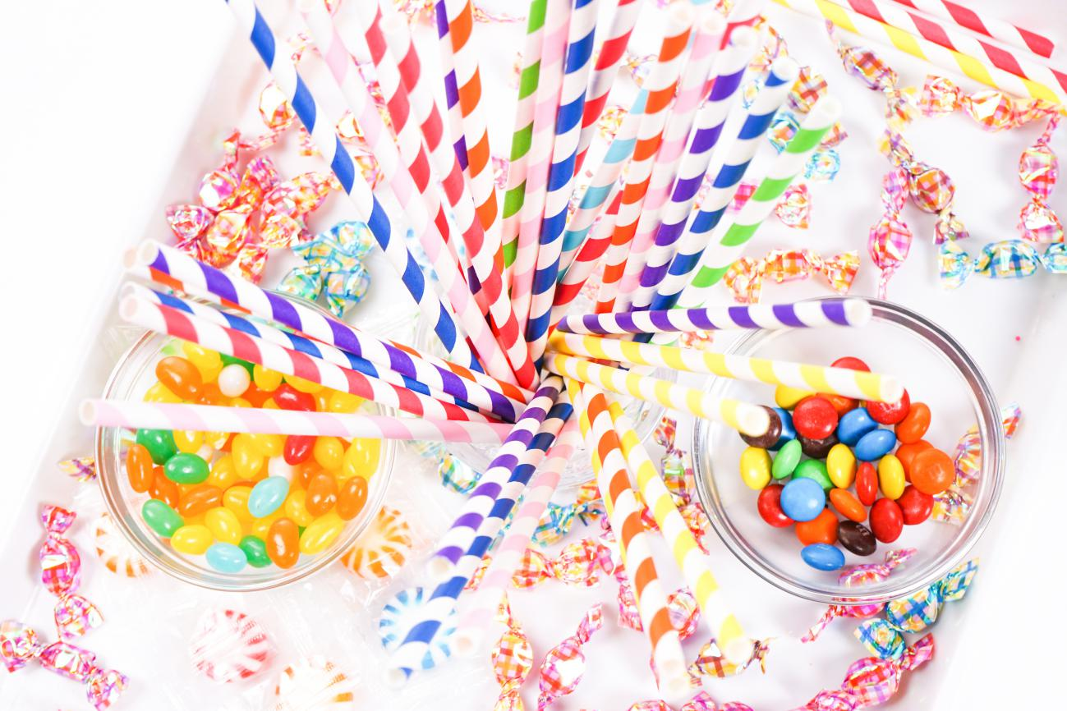

The product certification of 6mm red wave paper straws:
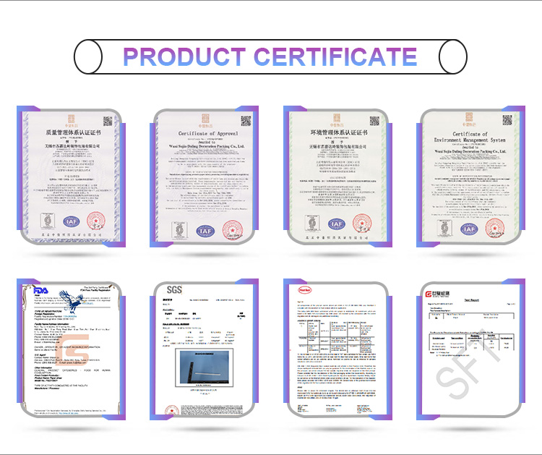

The package of 6mm Red wave paper straws:

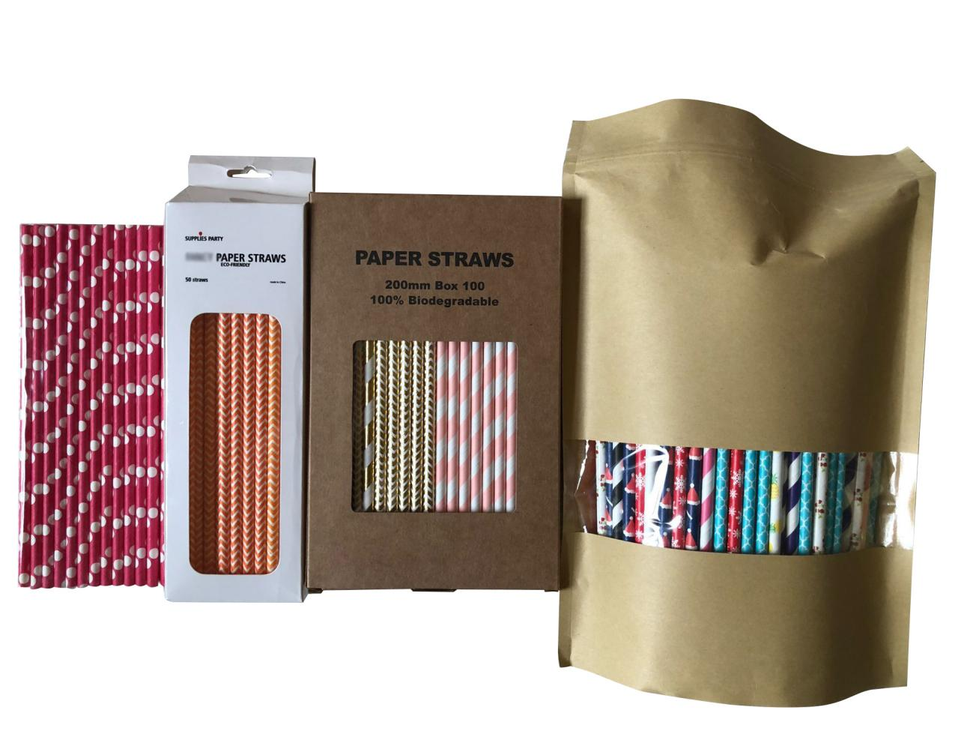

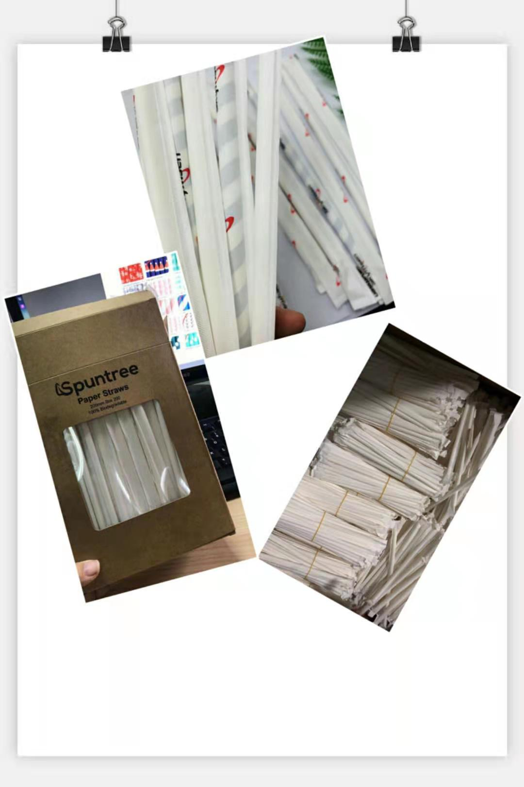

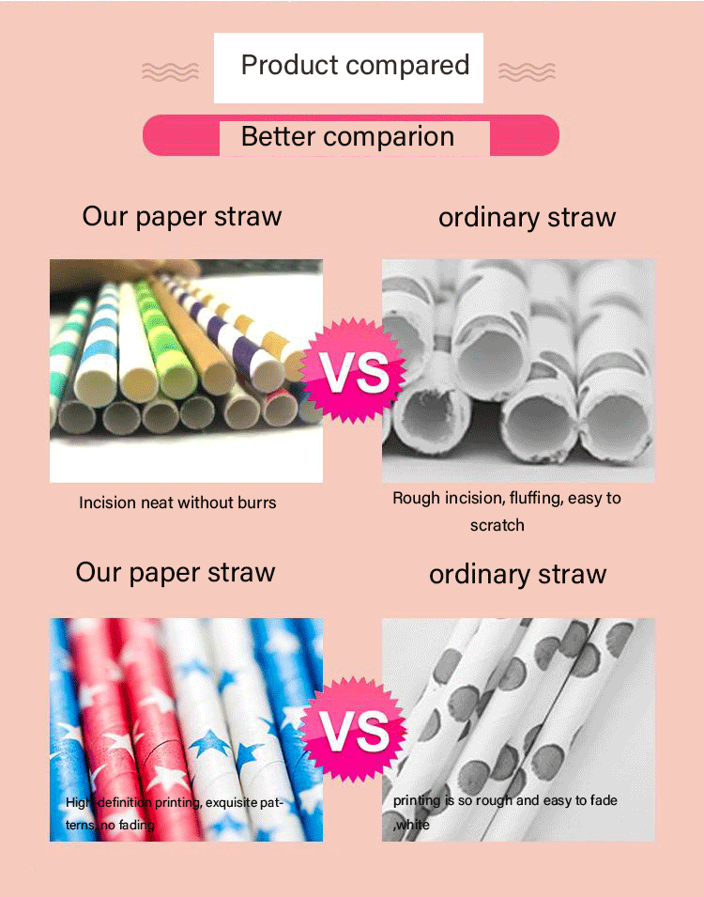

Compared with paper straws from other suppliers:
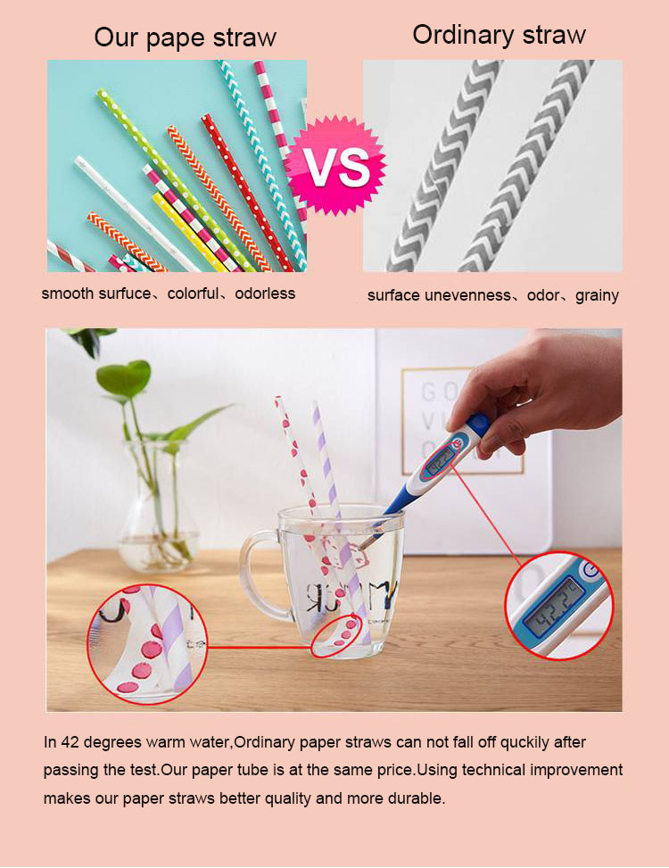

Available patterns:
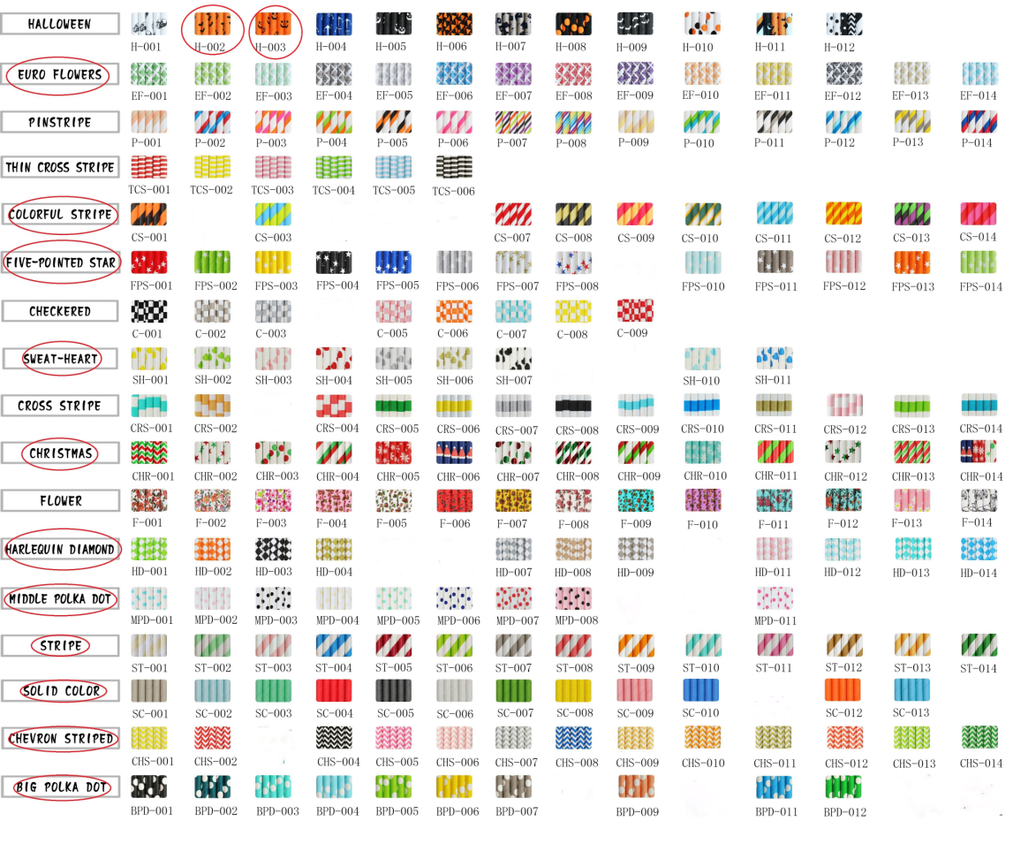

Production process：
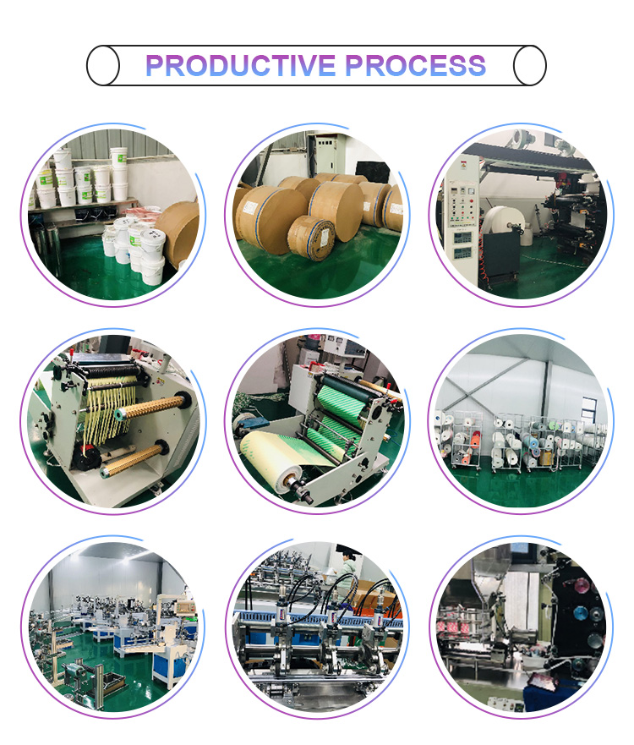

Customer word of the mouse:
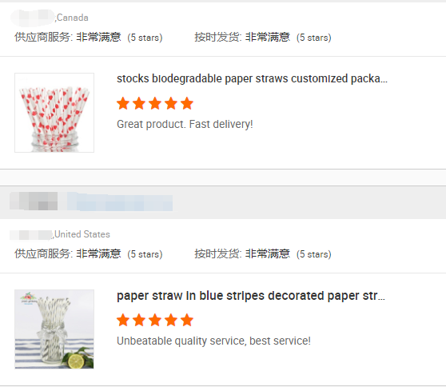
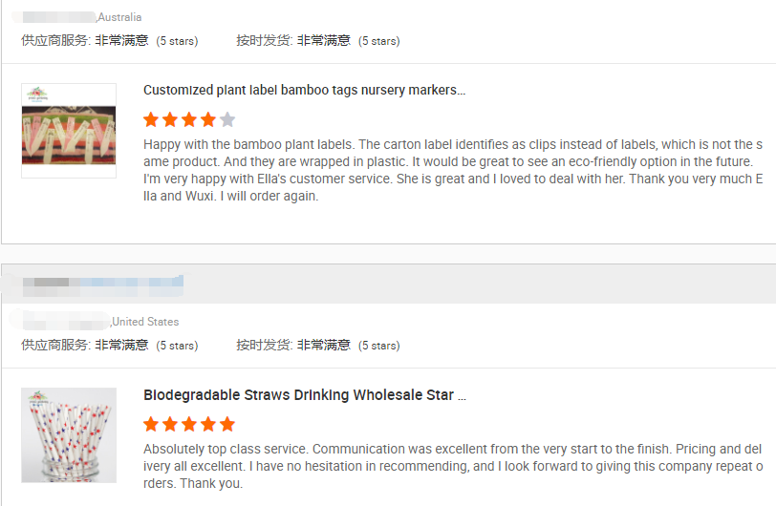

Our promise:
100% imported raw materials(paper imported from Sweden and glue imported from Germany)
Professional certificates(FDA,SGS,LFGB)
Guaranteed quality and safety

