不锈钢吸管
1.Made from premium stainless steel, non-toxic and reusable.
2.Ultralight. Easy to take it out for your outdoor activities.
3.Easy to clean after drinking, no residue under water washing.

Product parameters

Product Name | 6mm Stainless steel straw
Ref NO. | YJ2001
Brand | SPUNTREE/ NEUTRAL /OEM
Material | Premium stainless steel
Color | Monochrome or multi -colors
Size | 6*197mm(7.75”)
Package | 25pcs/opp bag ,400bags/carton, or 1piece/wrapped paper bag,5000pcs/carton
Suitable temperature | -20℃-120℃
Futures | Reusable Safety and eco-friendly
OEM | Available (Color,patterns,sizes and package can be adjusted by clients’ request)

About the product
TOP FOODGRADE 18/8 304 STAINLESS STEEL: MADE of top food grade 304 stainless steel, the drinking metal straws are the natural choice for everyone,
which is BPA free, plastic free, no metal aftertaste, no oxidation, colorfast, dishwasher safe, reusable and environmentally friendly. One set of stainless steel straws can be used for years to come - replacing hundreds or thousands of plastic straws.
FREE SCRUB BRUSH & EASY TO CLEAN: Come with 1 special scrub brush, with this banister brush, you can clean your stainless steel straws more easily
and never worry about hurting your drinking straws. You can also hang the brush easily by its annulus at the end. To clean the stainless steel straws, you just need to hold the handle of the brush and let nylon bristles come into the stainless straws, the brush is of the perfect size for these drinking straws
ECO-FRIENDLY, REUSABLE, REDUCE PLASTIC POLLUTION: No more plastic straws - ever! To protect our earth, we should use this stainless steel straws instead of plastic fast food packaging containers, to protect the environment, reduce the white pollution

Details of 6mm Stainless steel straws：
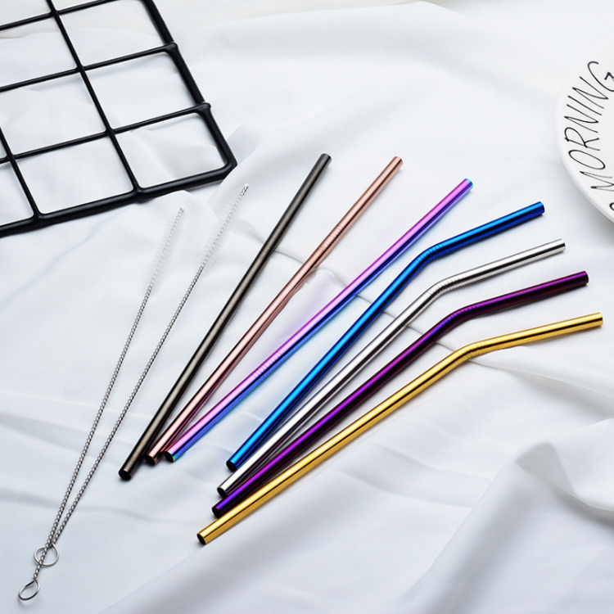
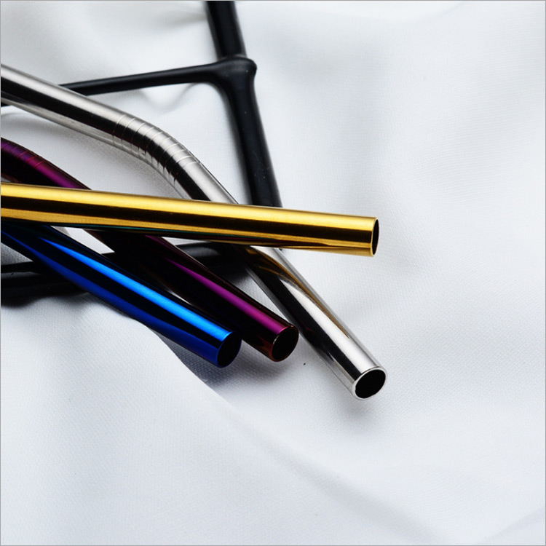
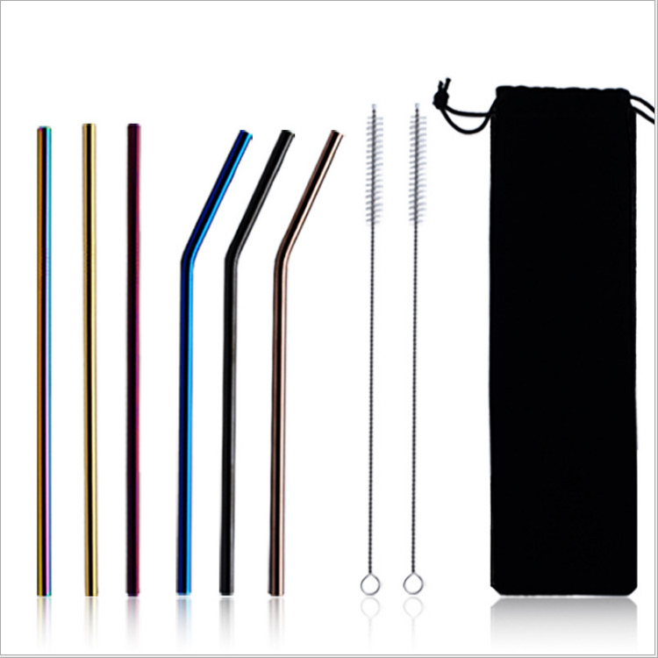

The product certification of 6mm Stainless steel straws:
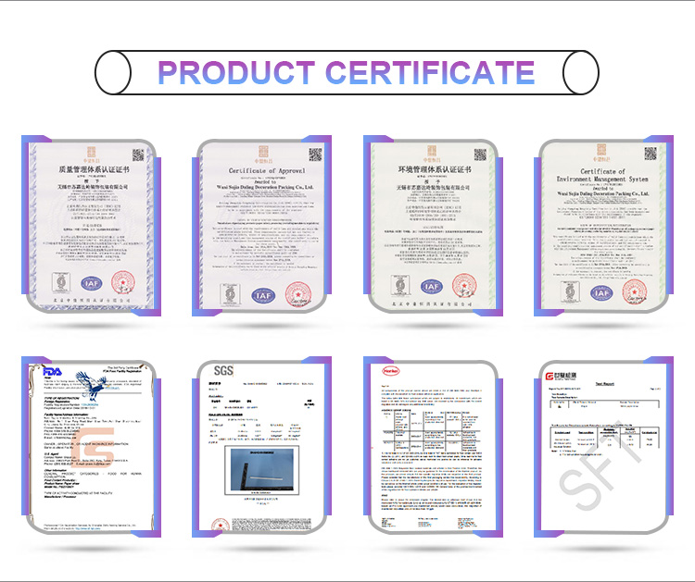

The package of 6mm Stainless steel paper straws:

Production process：
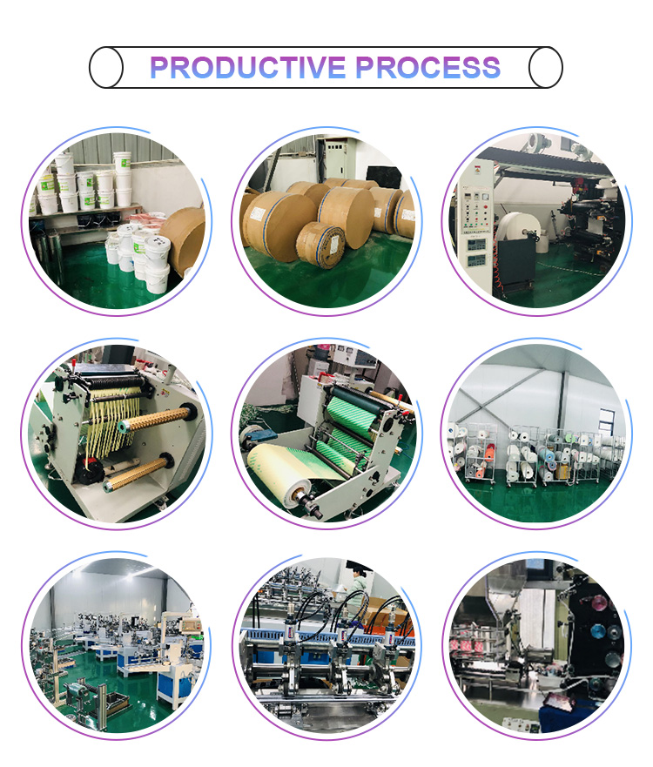

Our promise:
100% imported raw materials(paper imported from Sweden and glue imported from Germany)
Professional certificates(FDA,SGS,LFGB)
Guaranteed quality and safety

