Pile planting machine
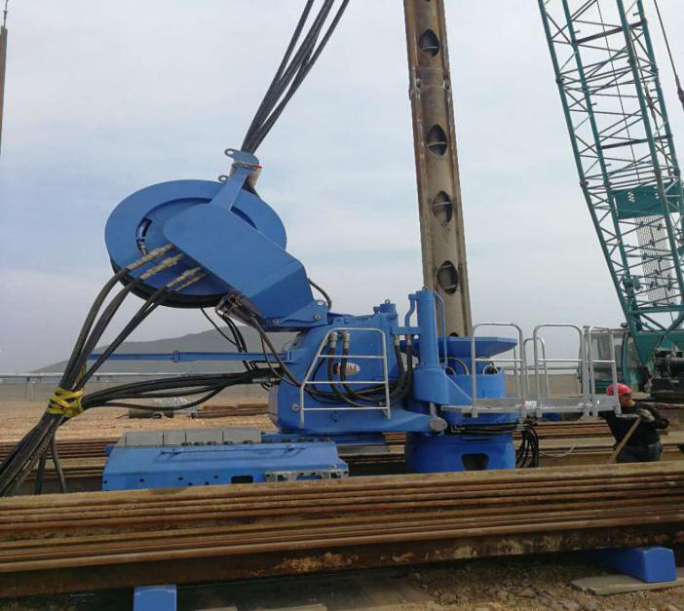

It is a very mature green pile foundation construction equipment, which is used for pressing in and pulling out steel sheet pile. It is widely used in the construction of Bored Piles for pile foundation engineering of high-rise buildings, railways, highways, bridges, airports and ports. The equipment has the advantages of high efficiency, low noise, environmental protection and energy saving, and can overcome the obstacles of construction environment and construction height.

